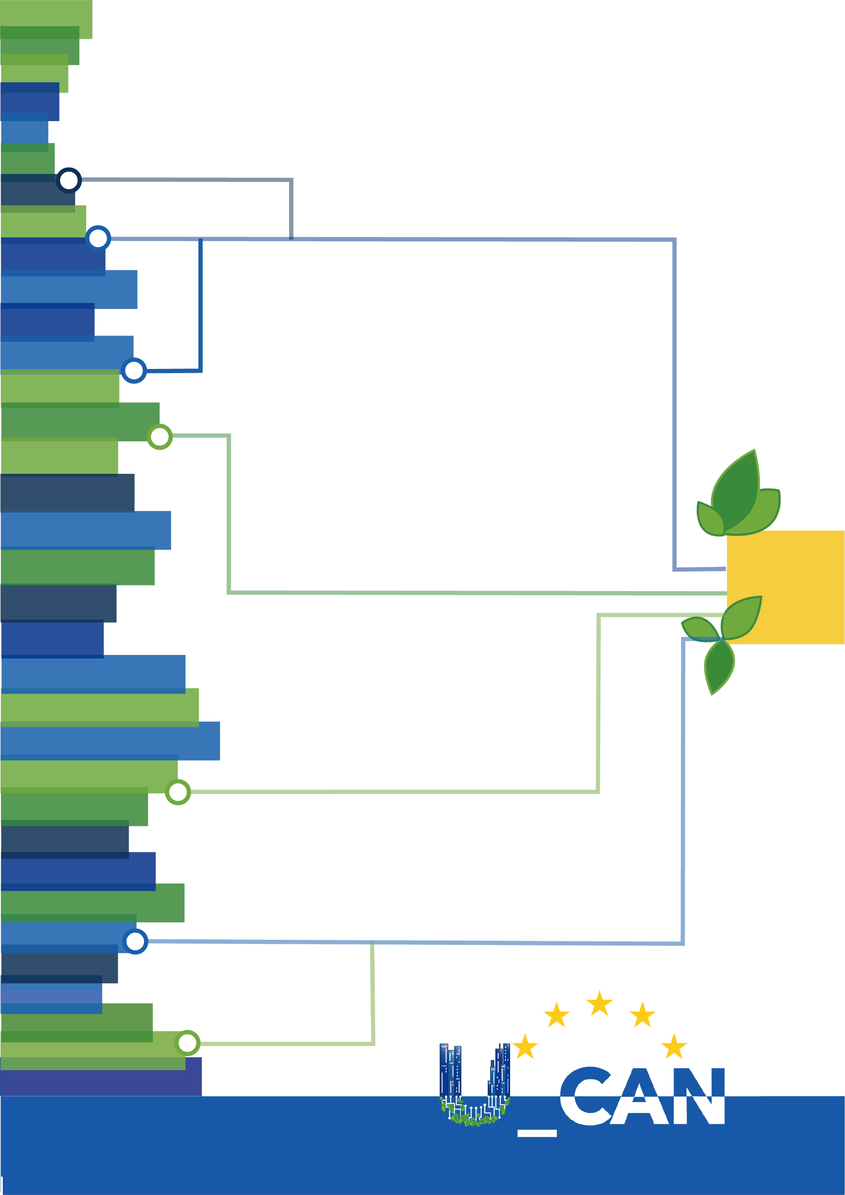

Report Title

for
U_CAN
Ukraine towards Carbon Neutrality
Grant Agreement 101148374
https://www.ucan-ukraine.eu/

Report Details

Version 0.1 as of xx.x.2025



U_CAN

Ukraine towards Carbon Neutrality

Programme: Horizon Europe Framework Programme (HORIZON)
Grant Agreement: 101148374
Call:  Topic:  Type of Action:  Project start date:  Duration: | HORIZON-MISS-2023-CIT-02  HORIZON-MISS-2023-CIT-02-01  HORIZON Coordination and Support Actions  1 May 2024  48 months
Report title
Related Work Package | WPx - Title
Dissemination Level | SEN – Sensitive or PU – Public
Version | 0.1
Date of completion | dd/mm/xxx
Lead Partner | XX
Editors | Name (Organisation)
Contributors | Name (Organisation)
Reviewers | Name (Organisation)
Approver | Name (Organisation)

Document History

Version | Date | Author/s | Organisation | Description
0.1
0.2

© 2024 U_CAN Consortium. All rights reserved.
No copying or distributing in any form or by any means is allowed without the prior written agreement. In addition to such written permission, the source must be clearly referenced.
Disclaimer
Funded by the European Union. Views and opinions expressed are however those of the author(s) only and do not necessarily reflect those of the European Union or European Commission. Neither the European Union nor the European Commission can be held responsible for them.
All U_CAN Consortium members are also committed to publish accurate and up to date information and take the greatest care to do so. However, the Consortium members cannot accept liability for any direct, indirect, special, consequential or other losses or damages of any kind arising out of the use of this information.
Acknowledgment

The U_CAN project has received funding from the European Union's Horizon Europe Framework Programme for Research and Innovation under grant agreement No. 101148374.

Table of contents
1. Explanation of the work carried out and Overview of the progress 4
1.1 Objectives 4
1.2 Explanation of the work carried out per WP 5
Work Package 1: Project Management (M1-M48, TUD) 5
Work Package 2: Creation of U_CAN project platform for knowledge sharing and networking (M1-M48, OMB) 6
Work Package 3: CNSC synergy building towards climate goals (M1-M48, WUST) 6
Work Package 4: Pilot Implementation in Ukraine, supported by European front-runners (M13-M45, CIL) 8
Work Package 5: Modernization and standardisation of technologies and practices (M4-M45, ULA) 9
Work Package 6: Capacity building and localised knowledge mobilisation in Ukraine (M18-M45, ISKPI) 9
Work Package 7: Communication, dissemination and exploitation (M1-M48, ECSA) 10
1.3 Impact 11
1.4 Update of the plan for exploitation and dissemination of results (if applicable) 12
2. Follow-up of recommendations and comments from previous review(s) 12
3. Exploitation primarily in non-associated third countries 12
4. Open science 12
5. Deviations from Annex 1 and Annex 2 (if applicable) 12
5.1 Tasks/objectives 12
5.2 Use of resources 12
5.2.1 Unforeseen subcontracting (if applicable) 12
5.2.2 Unforeseen use of in kind contributions 13

Headline 1
Text text text

Sub-headline 1
Text text text

Sub-sub-Headline 1
Text text text

Sub-sub-Headline 2
Text text text

Table 1: Labelling above table, font size 10, bold, single-spaced, 6 pt spacing above and below
Table | Description | Description

Example of illustration: Image size analogous to text width
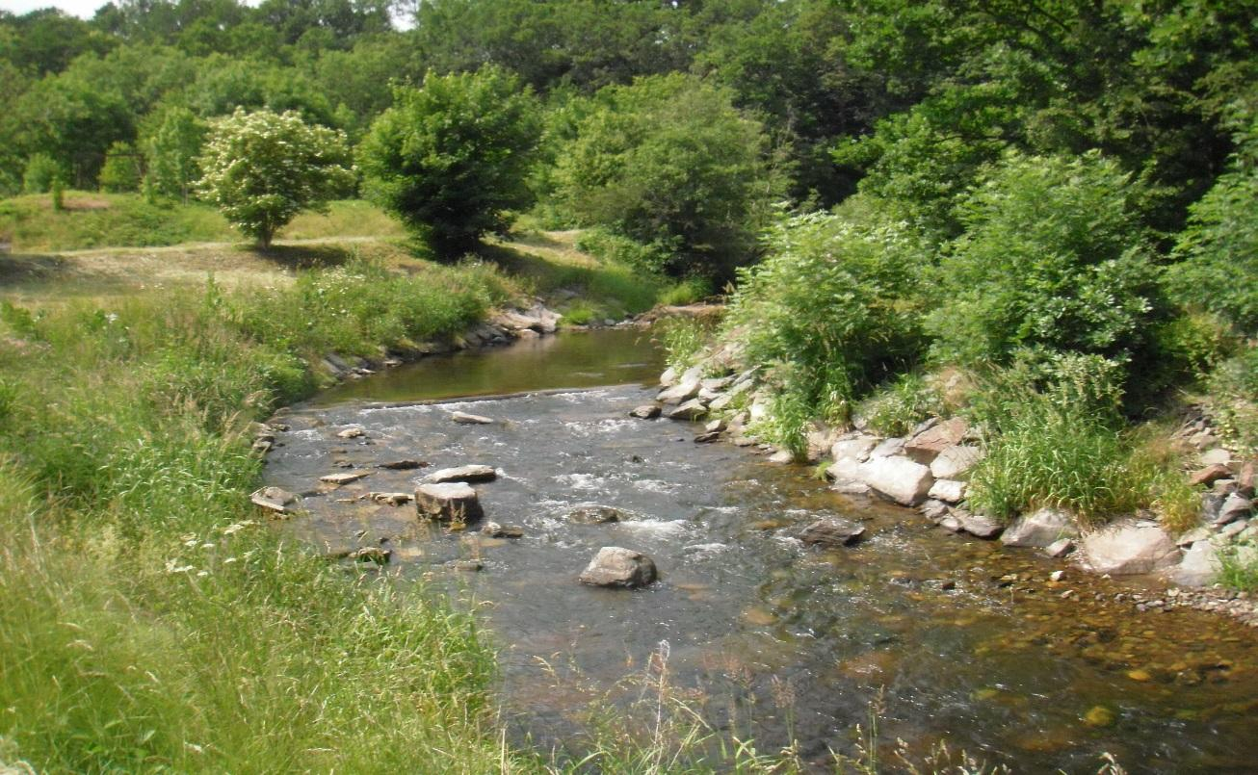
Illustration: Lettering below illustration, font size 10, bold, single-spaced, 6 pt spacing above and below

Sub-headline 2
Text text text

Sub-Headline 3
Text text text

headline 2
- Text text text

