Adaptive Cascade Clustering for Pattern-Aware Traffic-Regime Identification at Locally Constrained Urban Intersections
Vitaliy Pavlyshyn¹[0009-0003-0702-9359] Eduard Manziuk¹[0000-0002-7310-2126]
Pavlo Radiuk¹[0000-0003-3609-112X] Oleksander Barmak¹[0000-0003-0739-9678]
Iurii Krak^{2,3}[0000-0002-8043-0785]
¹ Khmelnytskyi National University, 11 Instytuts’ka str., 29016 Khmelnytskyi, Ukraine
² Taras Shevchenko National University of Kyiv, 60 Volodymyrska str., 01033 Kyiv, Ukraine
³ Glushkov Institute of Cybernetics, 40 Akademika Glushkova ave., 03187 Kyiv, Ukraine
vitaliy@ualeaders.com, manziuk.e@khmnu.edu.ua, radiukp@khmnu.edu.ua, barmako@khmnu.edu.ua, iurii.krak@knu.ua
Abstract. Intelligent transport systems increasingly rely on automated traffic analysis to support adaptive signal control, yet most pattern-recognition studies characterize traffic at the scale of an entire city network, leaving locally constrained systems, individual signalized intersections and short corridors, without a validated, intersection-level account of which recurring regime is currently active. We present a pattern-aware identification framework that couples a microscopic SUMO model of a real, locally constrained urban corridor with unsupervised traffic-regime recognition. Per-lane traffic states are aggregated into time-window descriptors and clustered by an adaptive cascade, i.e., HDBSCAN followed by k-means with a weighted-voting selector, that assigns each window to one of five recurring regimes, verified against expert ground truth. The cascade recovers these regimes with an Adjusted Rand Index of 0.73 and a V-measure of 0.79, and aggregated per-lane descriptors outperform fully concatenated temporal vectors by roughly 0.15 ARI on average for every tested algorithm. The resulting regime label is compact, interpretable and intersection-scoped, providing a validated basis on which locally adaptive control strategies, including emission-oriented objectives explored in companion work, can subsequently be conditioned.
Keywords: Intelligent transport systems, Traffic signal control, Traffic-regime identification, Pattern recognition, Cluster analysis, Locally constrained intersections.
- Introduction
Road transport underpins economic activity, but it is also one of the largest urban sources of carbon-dioxide emissions, contributing well over a third of the CO₂ released from final energy consumption in many cities. As municipalities commit to the climate-neutral and smart-city agenda promoted under the European Green Deal and the Horizon Europe missions, traffic management has become a primary lever for reconciling mobility with environmental targets [1, 2]. Among the available interventions, traffic signal control (TSC) is particularly attractive: it can suppress stop-and-go cycles and queue spill-backs without costly physical changes to the road network.
Most adaptive traffic-management studies characterize traffic at the scale of an entire city network, treating individual intersections as interchangeable nodes within a larger graph. Locally constrained systems – a single signalized junction or a short corridor with a handful of approaches – are commonly managed with one fixed control logic that does not distinguish between fundamentally different traffic situations occurring at different times of day: a morning commute, an evening dispersal, an unstructured off-peak period, or a geometrically distinct approach such as an uphill, peripheral one. Meanwhile, the traffic-pattern identification literature that could supply this distinction is mostly evaluated city-wide and is rarely validated at the resolution of an individual, locally constrained system, where the available feature space is far smaller. Closing this gap by building and validating an automatic, expert-verified regime-identification pipeline tailored to locally constrained intersection systems – is the focus of this paper.
The main contributions of this work are as follows:
- a pattern-aware identification framework for locally constrained urban intersection systems, organised as two cooperating layers (a modelling environment and a perception/regime-identification layer) within a reproducible, active-agent simulation substrate;
- an adaptive cascade clustering procedure (HDBSCAN followed by k-means with a weighted-voting selector) operating on aggregated time-window descriptors at intersection scale, which recovers expert-verified regimes with high external agreement and removes the need for manual algorithm choice;
- a validated regime taxonomy – morning peak, evening peak, mixed, off-peak/random and a geometrically distinct sloped/peripheral approach – for a locally constrained urban corridor, established against expert ground truth and quantitatively compared across seven clustering algorithms and two descriptor representations;
- a reproducible modelling environment with active agents over a real, locally constrained urban corridor built in SUMO with HBEFA emission profiles, providing the validated infrastructure on which regime-conditioned local control strategies can subsequently be built.
- Related Work
This section positions the proposed framework with respect to three strands of re-search that it brings together: adaptive control for locally constrained intersection systems, environmental and context-aware traffic management, and traffic-pattern identification.
Adaptive control for locally constrained intersection systems. Max-pressure control stabilizes the network by greedily activating the phase that maximizes local pressure, the imbalance between upstream and downstream queues [3]. Learning-based controllers generalize this idea: pressure-guided agents of the PressLight/MPLight family share parameters across intersections and scale to large arterial grids [4], whereas decentralised deep Q-networks assign one independent agent per junction [2]. Surveys of deep RL for TSC report strong delay gains across diverse network types [5–7]. In nearly all of these studies, a single control logic is applied uniformly regardless of which traffic regime is currently active, and the physical context of the site – such as an uphill approach – plays no role in the decision; locally constrained systems, whose feature space is small and whose geometry is fixed, are rarely treated as a distinct case.
A growing literature argues that environmental criteria and local physical context – such as energy-intensive uphill restarts of heavy vehicles – should inform traffic-control objectives directly [8, 9]. Large-scale studies show that data-driven signal control can substantially cut urban carbon emissions [9]. Designing and calibrating such context-aware objectives is, however, a distinct engineering problem that presupposes knowing which context or regime is currently active; we treat that recognition problem as a prerequisite contribution in its own right.
Clustering traffic flows is an established way to characterize recurring network states. Centroid methods such as k-means yield com-pact partitions, while density and hierarchical methods such as HDBSCAN determine the number of clusters automatically and tolerate noise, matching the variable-density structure of real flows [9].
Recent work builds expert-verified scenarios in simulation that supply reference labels and shows that aggregated, per-lane descriptors out-perform fully concatenated temporal vectors [10]. We adopt this benchmark view and extend it with a cascade that combines HDBSCAN's structural detection with k-means boundary refinement [11, 12]. These studies almost uniformly target city-scale networks; validating regime identification at the resolution of a single, locally constrained corridor – where the feature space is two orders of magnitude smaller and the physical context is fixed – remains comparatively unexplored, which is the gap addressed here.‬‬‬‬‬‬‬‬‬‬‬‬‬
We close that gap by building and verifying an online-capable regime-identification pipeline at intersection scale, within a SUMO-based modelling environment whose active agents separate the simulation substrate from any downstream decision logic
- Pattern-Aware Regime-Identification Framework
  - Overview
The framework has two cooperating layers (Fig. 1). A modelling-environment layer reproduces a real, locally constrained urban corridor in a microscopic simulator and streams per-lane traffic states. A perception layer aggregates these streams into time-window descriptors and identifies the prevailing regime by clustering, producing a discrete, interpretable label for each window. The resulting label stream is intersection-scoped and is intended to feed a downstream, regime-aware decision layer; designing that decision logic for a specific operational objective is outside the scope of the present identification study and is addressed elsewhere. The perception layer assigns each time window to a traffic regime $z_{t}$; the resulting label stream is intersection-scoped and is available to a downstream, regime-aware decision layer.
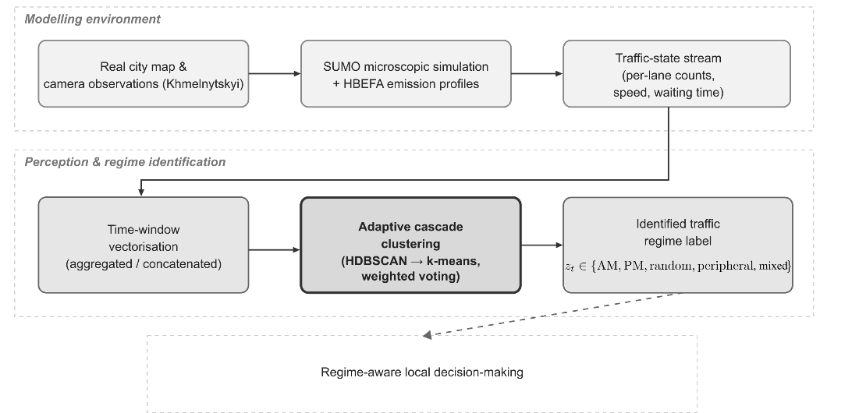
Fig. 1. Architecture of the pattern-aware regime-identification framework.
  - Modelling Environment and Active Agents
The environment is built from a real city map and camera observations of the studied corridor: geometry, permitted maneuvers and lane structure define a SUMO network, while emission accounting uses standard HBEFA profiles so that fuel use and CO₂ follow from each vehicle’s instantaneous dynamics.
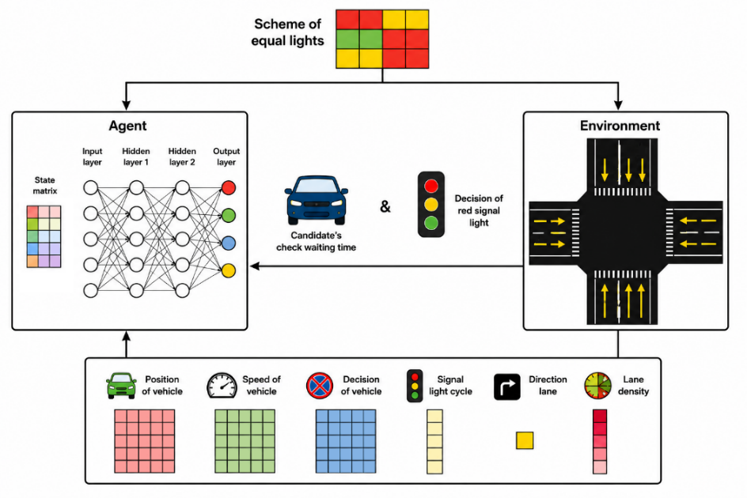
Fig. 2. Architecture of active agents in the modelling environment.
The simulation substrate is kept separate from the programmatic decision layer, which hosts active agents that observe, decide and act autonomously per intersection – making the environment adaptable and reusable across locally constrained corridors of similar structure. A share of randomized demand is superimposed on the planned flows to reproduce real unpredictability.
  - Traffic-State Representation and Regime Identification
Each intersection’s state is the per-lane vehicle count. Sampling every ten seconds over a thirty-minute window W gives, for ten signals and seventy lanes, 180 temporal slices, from which two descriptors are derived. The concatenated descriptor preserves full temporal detail,
V_{concat} = [t₁s₁l₁, … , t_{i}s_{j}l_{k}] ∈ ℝ¹²⁶⁰⁰ (1)
where t_{i}s_{j}l_{k} is the vehicle count on lane k of signal j at slice i. The aggregated descriptor instead collapses the temporal axis to a per-lane mean,
V_{avg} = [s₁l₁, … , s_{j}l_{k}] ∈ ℝ⁷⁰, s_{j}l_{k} = (1/T) ∑ t_{i}s_{j}l_{k}, (2)
with T = 180. Aggregation reduces the dimensionality by two orders of magnitude and increases robustness to short-term fluctuations, at the cost of discarding the intra-window temporal dynamics that the concatenated descriptor preserves; this is an acceptable trade-off here because regime identification targets the slowly varying daily structure rather than second-scale transients. Both descriptors are z-score normalized before clustering.
Regime identification uses an adaptive cascade: HDBSCAN first detects the structural core, fixing the number of dense groups and isolating noise; k-means, initialized from the HDBSCAN centroids, then refines the boundaries. Because the initialization is seeded only from the dense-core centroids and the points HDBSCAN flags as noise are excluded from this seeding, the refinement step is not biased by outliers, which mitigates the centroid drift that a noise-sensitive k-means initialization would otherwise incur. A weighted-voting selector compares internal validity indices and external agreement on a held-out verified subset and keeps the candidate that best balances compactness with semantic correctness, removing the need to commit to one algorithm in advance. The outcome is a discrete label z_{t} ∈ {morning peak, evening peak, mixed, off-peak / random, peripheral} ready for use by any downstream, regime-aware decision layer.
- Experimental Setup
  - Simulation-Based Identification Setup
Experiments run in SUMO with HBEFA emission profiles on a calibrated Khmelnytskyi corridor of ten signals and seventy lanes – a locally constrained urban system representative of a single coordinated intersection group rather than a full city net-work. Demand follows an eleven-hour schedule cycling through the five regimes of Table 1 with thirty per cent randomized flow; ten-second sampling and a thirty-minute window give sixty-six labelled windows for the identification study.
Table 1. Recurring traffic regimes identified in the studied locally constrained corridor and their distinguishing operational characteristics.
Regime | Temporal occurrence | Dominant flow | Distinguishing characteristic
Morning peak | early working hours | towards centre and market | high directional asymmetry, sustained peak density
Evening peak | late working hours | reverse, towards residential | reversed directional asymmetry
Mixed | shoulder periods, between peaks | simultaneous in/outbound, reduced intensity | low directional asymmetry, moderate density
Off-peak / random | midday and night | no dominant direction | low density, no dominant direction
Peripheral approach (locally designated as Hrechany) | intermittent | sloped peripheral approach | sloped approach, intermittent heavy-vehicle presence

Identification is scored against the expert labels with internal indices (Silhouette, Da-vies–Bouldin) and external indices (ARI, V-measure) for both descriptors, across seven clustering algorithms – the adaptive cascade, standalone HDBSCAN, k-means at two cluster counts, Affinity Propagation, Mean Shift, Agglomerative Clustering and a Bayesian Gaussian Mixture Model.
  - Real-World Validation Setup
To assess whether the traffic-state representation generalizes beyond synthetic data, it is additionally checked against two real, camera-observed intersections, independent of the calibrated corridor used for regime identification: a ten-lane junction with a fixed three-phase signal (30 s, 40 s and 46 s) and a seven-lane junction, each record-ed for 2 h 50 min. For every site a matching SUMO network is built (3.2 m lane width, 50 km/h free-flow speed) and fed with per-lane demand sampled every 30 s over the same interval, so that simulated and observed traffic cover an identical time horizon.
Vehicle counts from the video are obtained with a YOLOv8m detector (confidence threshold 0.2; car, truck, bus and motorcycle classes). Per-lane counting lines are calibrated to metric coordinates via a six-point homography per camera; a temporal (1.5 s) and spatial (3.0 m) deduplication window prevents double-counting a vehicle across nearby lines. The resulting per-lane counts are aggregated into the same 30-minute, 10-minute-step sliding windows used for regime identification (Section 3.3), giving fifteen comparable window pairs per intersection.
Agreement between simulated and observed traffic is scored with a composite scenario score (0–100%, combining per-lane distribution similarity, summed- and mean-flow similarity and dominant-lane agreement) together with the cosine similarity and Pearson correlation of the underlying flow vectors, evaluated at three levels of temporal aggregation: individual 30-second timestamps, individual 30-minute windows, and the full-window aggregate – the latter matching the level at which the descriptor in Eq. (2) is computed.
- Results and Discussion
  - Regime Identification
Fig. 3 reports external agreement with the expert-verified regimes on the aggregated descriptor. HDBSCAN scores highest (ARI 0.73, V-measure 0.79), with k-means at five clusters close behind (ARI 0.70).
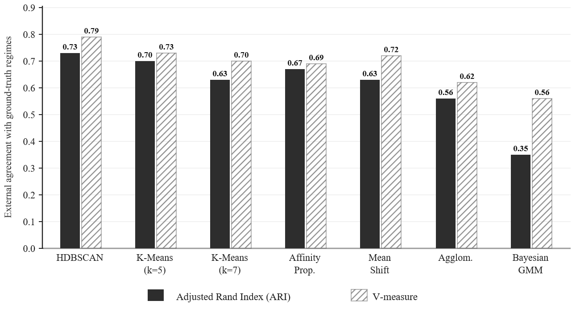
Fig. 3. Agreement of clustering algorithms with the expert-verified regimes on the aggregated descriptor (higher is better). The dashed line marks the best score, achieved by HDBSCAN; aggregated descriptors outperform concatenated ones for every algorithm (concatenated results omitted for clarity).
For every algorithm the aggregated descriptor beats the concatenated one by about 0.15 ARI on average, confirming that collapsing the temporal axis removes the curse of dimensionality without erasing discriminative structure. The cascade exploits both: HDBSCAN gives the structural skeleton and noise rejection, k-means sharpens the boundaries between adjacent regimes, and the voting selector keeps the better candidate. The recovered partitions match the five expected regimes, giving a reliable, intersection-scoped label stream for down-stream use.
  - Real-World Validation
Table 2 reports agreement between simulated and camera-observed traffic at three levels of temporal aggregation (Section 4.2). At the finest, per-timestamp resolution (30 s), agreement is moderate (scenario score 68.06%, mean cosine similarity 0.653), reflecting the intrinsic noise of frame-level detection and short-horizon stochastic variation. At the level of individual 30-minute windows, agreement is uneven across the recording – exceeding 80% in the earliest windows and falling to 47–58% later – consistent with accumulating drift between a fixed-demand simulation and real, non-stationary traffic. At the aggregated level used for regime identification, however, agreement is near-perfect: a scenario score of 99.26%, a cosine similarity of 0.999 and a Pearson correlation of 0.997. Because regime identification operates precisely at this aggregated, per-lane-mean level (Eq. 2), the result indicates that the descriptor on which the cascade is trained and evaluated is not an artefact of the simulator: a real, camera-derived traffic state is assigned a comparable position in descriptor space.
Table 2. Agreement between SUMO-simulated and camera-observed traffic at three aggregation levels, averaged over both real intersections.
Aggregation level | Scenario score | Cosine similarity | Pearson r
Per-timestamp (30 s) | 68.06% | 0.653 | –
Per-window (30 min) | 47–80%* | – | –
Aggregated (window mean) | 99.26% | 0.999 | 0.997
* Note: The range 47–80% reflects the cumulative drift between fixed-demand simulation and real-world traffic patterns over the course of the recording

It should be noted that the near-perfect agreement (99.26%) at the aggregated level reflects the inherent nature of window-mean descriptors. By averaging per-lane counts over a 30-minute window, the metric effectively smoothens transient detection noise and stochastic errors produced by the YOLOv8m detector, focusing strictly on the macro-level traffic state rather than frame-by-frame precision.
  - Discussion
The results should be read as evidence of a regime-recognition capability, not a control-performance claim. The adaptive cascade exploits complementary strengths: HDBSCAN supplies a noise-robust structural skeleton without requiring the number of regimes to be fixed in advance, while k-means, seeded only from the dense-core centroids, sharpens the boundaries between adjacent regimes; the weighted-voting selector then keeps whichever candidate best balances internal compactness with external, expert-verified correctness. The consistent ≈0.15 ARI advantage of the aggregated descriptor over the fully concatenated one confirms that, for a locally constrained system of this size (ten signals, seventy lanes), the slowly varying daily structure that defines a traffic regime can be captured without retaining second-scale temporal detail – a property that keeps the identification step computationally light enough for online.
The evaluation is simulation-based and tied to a single, calibrated corridor; transferring the cascade to a different locally constrained system would require re-verifying the regime taxonomy against local expert knowledge. The regime set itself is fixed to five ex-pert-defined categories, so richer or evolving regimes would call for an online, streaming variant of the identification pipeline. Finally, this study deliberately stops at producing a validated regime label: how that label should condition a specific down-stream control objective – for instance an emission-oriented one – is a separate design problem, addressed in dedicated work [9, 10].
- Conclusions and Future Work
We presented a pattern-aware framework for identifying recurring traffic regimes within a locally constrained urban intersection system. An adaptive HDBSCAN–k-means cascade, operating on aggregated time-window descriptors from a calibrated Khmelnytskyi corridor, recovers five expert-verified regimes – morning peak, even-ing peak, off-peak/random, mixed, and a sloped peripheral approach – with an Adjusted Rand Index of 0.73 and a V-measure of 0.79, consistently outperforming six alternative clustering algorithms and the fully concatenated descriptor representation by roughly 0.15 ARI on average. The resulting label stream is compact, interpretable and intersection-scoped, providing a validated foundation for regime-aware local decision-making.
Future work will replace the fixed regime set with an online, streaming identifier, extend the descriptor set to additional physical factors such as approach gradient and mixed-fleet composition, and validate the framework on further, independently calibrated locally constrained corridors. Conditioning a specific local control objective – including emission-oriented strategies – on the identified regime is the subject of dedicated, ongoing work.
Acknowledgments. This research was funded by the European Union’s Horizon Europe Framework Programme under grant agreement No. 101148374, project “U_CAN: Ukraine towards Carbon Neutrality.” The views and opinions expressed are the authors’ own and do not necessarily reflect those of the European Union or the funding agency, the European Climate, Infrastructure and Environment Executive Agency.
Disclosure of Interests. The authors have no competing interests to declare that are relevant to the content of this article.

References
1. Wu, K., Ding, J., Lin, J., Zheng, G., Sun, Y., Fang, J., Xu, T., Zhu, Y., Gu, B.: Big-data empowered traffic signal control could reduce urban carbon emission. Nat Commun. 16, 2013 (2025). https://doi.org/10.1038/s41467-025-56701-4.
2. Chen, C., Wei, H., Xu, N., Zheng, G., Yang, M., Xiong, Y., Xu, K., Li, Z.: Toward A Thousand Lights: Decentralized Deep Reinforcement Learning for Large-Scale Traffic Signal Control. Proceedings of the AAAI Conference on Artificial Intelligence. 34, 3414–3421 (2020). https://doi.org/10.1609/aaai.v34i04.5744.
3. Levin, M.W.: Max-Pressure Traffic Signal Timing: A Summary of Methodological and Experimental Results. Journal of Transportation Engineering, Part A: Systems. 149, 03123001 (2023). https://doi.org/10.1061/JTEPBS.TEENG-7578.
4. Wei, H., Chen, C., Zheng, G., Wu, K., Gayah, V., Xu, K., Li, Z.: PressLight: Learning Max Pressure Control to Coordinate Traffic Signals in Arterial Network. In: Proceedings of the 25th ACM SIGKDD International Conference on Knowledge Discovery & Data Mining. pp. 1290–1298. Association for Computing Machinery, New York, NY, USA (2019). https://doi.org/10.1145/3292500.3330949.
5. Haydari, A., Yılmaz, Y.: Deep Reinforcement Learning for Intelligent Transportation Systems: A Survey. Trans. Intell. Transport. Sys. 23, 11–32 (2022). https://doi.org/10.1109/TITS.2020.3008612.
6. Michailidis, P., Michailidis, I., Lazaridis, C.R., Kosmatopoulos, E.: Traffic Signal Control via Reinforcement Learning: A Review on Applications and Innovations. Infrastructures. 10, (2025). https://doi.org/10.3390/infrastructures10050114.
7. Wei, H., Zheng, G., Gayah, V., Li, Z.: Recent Advances in Reinforcement Learning for Traffic Signal Control: A Survey of Models and Evaluation. SIGKDD Explor. Newsl. 22, 12–18 (2021). https://doi.org/10.1145/3447556.3447565.
8. Schumacher, M., Adriano, C.M., Giese, H.: Challenges in Reward Design for Reinforcement Learning-based Traffic Signal Control: An Investigation using a CO2 Emission Objective. SUMO Conference Proceedings. 4, 131–151 (2023). https://doi.org/10.52825/scp.v4i.222.
9. Ryzhanskyi, O., Barmak, O., Manziuk, E., Radiuk, P., Krak, I.: Topography-Aware Deep Reinforcement Learning with Contextual Reward Engineering for Sustainable and Efficient Urban Traffic Control. Future Transportation. 6, (2026). https://doi.org/10.3390/futuretransp6020082.
10. Pavlyshyn, V., Ryzhanskyi, O., Manziuk, E., Radiuk, P., Barmak, O., Krak, I.: Establishing Patterns of the Urban Transport Flows on Clustering Analysis. CEUR Workshop Proceedings. 3974, 1–9 (2025). https://doi.org/https://ceur-ws.org/Vol-3974/paper01.pdf.
11. Barmak, O., Krak, I., Manziuk, E.: Diversity as the basis for effective clustering-based classification. In: CEUR Workshop Proceedings. pp. 53–67. CEUR, Odessa, Ukraine (2020).‬‬‬‬‬‬‬‬‬‬‬
12. Manziuk, E., Krak, I., Barmak, O., Mazurets, O., Kuznetsov, V., Pylypiak, O.: Structural alignment method of conceptual categories of ontology and formalized domain. Presented at the CEUR Workshop Proceedings (2021). https://doi.org/http://ceur-ws.org/Vol-3003/paper2.pdf.

