Bridging the Sim-to-Real Gap in Topography-Aware Traffic Control using Automated Video Analytics
Oleksander Ryzhanskyi ¹[⁰⁰⁰⁹⁻⁰⁰⁰⁰⁻⁴⁶⁶⁴⁻⁵¹⁹⁵], Oleksander Barmak ¹[⁰⁰⁰⁰⁻⁰⁰⁰³⁻⁰⁷³⁹⁻⁹⁶⁷⁸],
Eduard Manziuk ¹[⁰⁰⁰⁰⁻⁰⁰⁰²⁻⁷³¹⁰⁻²¹²⁶], Pavlo Radiuk ¹[^{0000−0003−3609−112X}]
and Iurii Krak ^{2,3}[⁰⁰⁰⁰⁻⁰⁰⁰²⁻⁸⁰⁴³⁻⁰⁷⁸⁵]
¹ Khmelnytskyi National University, 11 Institutes str., Khmelnytskyi 29016, Ukraine
² Taras Shevchenko National University of Kyiv, 64/13 Volodymyrska str., Kyiv 01601, Ukraine
³ Glushkov Cybernetics Institute, 40 Glushkov Ave., Kyiv 03187, Ukraine
oryzhanskyi@khmnu.edu.ua, barmako@khmnu.edu.ua, manziuk.e@khmnu.edu.ua, radiukp@khmnu.edu.ua, iurii.krak@knu.ua
Abstract. Reinforcement learning-based traffic signal control (TSC) has demonstrated significant potential for urban decarbonization, yet most existing models assume a perfectly flat road network and rely on idealized telemetry. In topo-graphically diverse cities, this “flat-world” assumption leads to structurally misaligned policies that ignore the high-energy cost of heavy vehicle restarts on inclines. This paper addresses the sim-to-real gap by evaluating a topography-aware Deep Reinforcement Learning framework integrated with automat-ed video analytics. While our previous work established the effectiveness of Context-Specific Reward Design (CSRD) using perfect data, this study investigates the controller’s robustness against stochastic sensor noise, specifically the misclassification of heavy vehicles common in real-world computer vision pipelines. Evaluated in the SUMO microscopic simulator with a 3.8-degree uphill approach and a 20% heavy-vehicle fleet, the results demonstrate that even with a 10% misclassification rate, the topography-aware agent achieves a 7.1% reduction in total CO2 emissions compared to the MaxPressure heuristic and a 3.2% reduction relative to a standard DQN model. The performance degradation remains minimal (1.62%) compared to the ideal-data scenario, proving that integrating physical terrain context into AI reward structures provides a stable and resilient foundation for sustainable traffic management in real-world smart city environments.
Keywords: Deep Reinforcement Learning, Traffic Signal Control, Computer Vision, Sim-to-Real Gap, Topography-Aware Modeling, Decarbonization.
- Introduction
Rapid urbanization and rising traffic intensity have intensified urban air pollution. Road transport is a major source of greenhouse-gas emissions, particularly carbon dioxide (CO2). Intelligent Traffic Signal Control (TSC) offers a non-invasive way to reduce congestion and local emissions. In recent years, deep reinforcement learning (DRL) has improved TSC by enabling traffic-light phases to adapt dynamically to changing traffic states.
However, most DRL-based traffic-management models still assume a flat road network. In cities with varied topography, this assumption can produce physically inconsistent control policies. A forced stop followed by acceleration on an uphill approach, especially for a heavy vehicle such as a truck or bus, requires much greater engine load and can sharply increase CO2 emissions compared with movement on flat terrain.
In our previous study [1], we addressed this limitation by proposing a topography-aware DRL framework with Context-Specific Reward Design (CSRD). The model explicitly incorporated longitudinal road-slope parameters and penalized stop-and-start maneuvers by heavy vehicles on uphill approaches. As a result, the specialized agent reduced total CO2 emissions while preserving intersection throughput.
Despite these results, deployment in real smart-city environments remains limited by the sim-to-real gap. Our baseline studies [1, 2], like many DRL-TSC works, used ideal simulation telemetry in which each vehicle’s presence, position, and class were known with complete accuracy. In practice, such data are obtained from video-analytics systems. Object detection and tracking pipelines are affected by occlusions, weather, lighting changes, tracking loss, and misclassification, for example when a partly occluded truck is detected as a passenger car.
This noise is critical for topography-aware control. If a heavy vehicle approaching an incline is not correctly recognized, the DRL agent may end the green phase too early and force an energy-intensive stop, weakening the environmental benefit of the reward design. The robustness of emission-oriented, topography-aware DRL controllers to computer-vision noise therefore remains insufficiently studied.
To address this gap, this paper extends the proposed TSC methodology by testing its stability within an automated Vision-to-Control pipeline. Instead of ideal telemetry, stochastic misclassification noise is injected into the simulation environment to approximate errors typical of real video analytics.
The main contributions of this study are as follows:
1. A conceptual deployment architecture is proposed that integrates real-time video analytics with a topography-aware DRL control loop.
2. The robustness of CSRD is evaluated under simulated computer-vision sensor noise, with emphasis on heavy-vehicle misclassification.
3. It is empirically shown that, despite reduced recognition accuracy, the topography-aware agent remains stable and continues to outperform standard flat-terrain controllers in CO2 emission reduction.
The remainder of the paper is organized as follows. Section 2 reviews DRL-based traffic control and environmental factors. Section 3 presents the framework, Vision-to-Control architecture, and reward-function formalization. Section 4 describes the SUMO experimental setup. Section 5 analyses the results, robustness to sensor noise, and findings. Section 6 concludes the paper and outlines future research.
- Related Works
The studies preceding this work can be divided into three key areas: the application of DRL to traffic signal control, environmentally oriented control algorithms, and the problem of bridging the sim-to-real gap through computer vision.
  - Deep Reinforcement Learning for Traffic Signal Control
In recent years, DRL methods have become a dominant paradigm for building adaptive traffic signal control (TSC) systems [3]. Unlike classical adaptive heuristics such as Max-Pressure (MP), which minimize queue imbalance through fixed mathematical rules [4], DRL agents can learn complex policies directly through interaction with a changing environment. The same shift from handcrafted signal rules to data-driven traffic-light policies is illustrated by IntelliLight, which evaluates reinforcement-learning-based traffic signal control on large-scale real traffic data collected from surveillance cameras [5]. Most existing solutions in this area use various modifications of Deep Q-Network (DQN) architectures to maximize throughput and minimize waiting time or queue length. However, traditional delay-based rewards often fail to reflect the real physical costs associated with vehicle movement over complex terrain.
  - Environmental Objectives and Topographical Context
A parallel research direction focuses on embedding environmental objectives, such as reducing CO2 emissions, into TSC systems. Researchers usually use proxy metrics, such as the number of stops or total idling time, to reduce emissions indirectly [6]. More recent low-carbon TSC studies formulate the objective more explicitly, for example by using Dueling DQN-based signal control to reduce intersection-level carbon emissions while maintaining operational efficiency [7]. However, such generalized approaches ignore the fact that fuel consumption and emissions depend strongly on the longitudinal road slope [8].
Our previous study [1] demonstrated that ignoring topography leads to a structural mismatch between standard throughput metrics and actual energy costs. To solve this problem, we introduced CSRD, which proved capable of substantially reducing CO2 emissions by minimizing stops of heavy vehicles on uphill approaches. However, this model, like many similar works, relied on ideal, error-free telemetry from the SUMO simulator.
  - Computer Vision and the Sim-to-Real Gap
In practice, modern real deployment needs camera-based state estimation; YOLO-type detectors and DeepSORT-style tracking can classify vehicles, count flows, and estimate queues [9].
The transition from idealized simulation data to noisy camera-derived data creates the so-called sim-to-real gap. This deployment concern is consistent with the broader sim-to-real transfer literature, which reports that policies trained in simulation often show degraded real-world performance because simulators inevitably model reality imperfectly [10]. Visual perception systems are prone to errors caused by occlusions from large objects, changes in lighting, and weather conditions [11]. In the context of environmentally oriented TSC on complex terrain, misclassification, such as recognizing a heavy truck as a passenger car, may lead to incorrect agent actions and, consequently, to a sharp increase in emissions on uphill approaches. To date, there is a shortage of studies that evaluate the robustness of topography-oriented DRL algorithms to errors generated by real computer-vision pipelines, which forms the main motivation for this paper.
- Pattern-Aware Eco-Control Framework
The framework links video analytics and topography-aware DRL for robust eco-oriented signal control.
  - Conceptual Vision-to-Control Architecture
The closed-loop architecture has three layers: perception, state construction, and DRL control (Fig. 1).
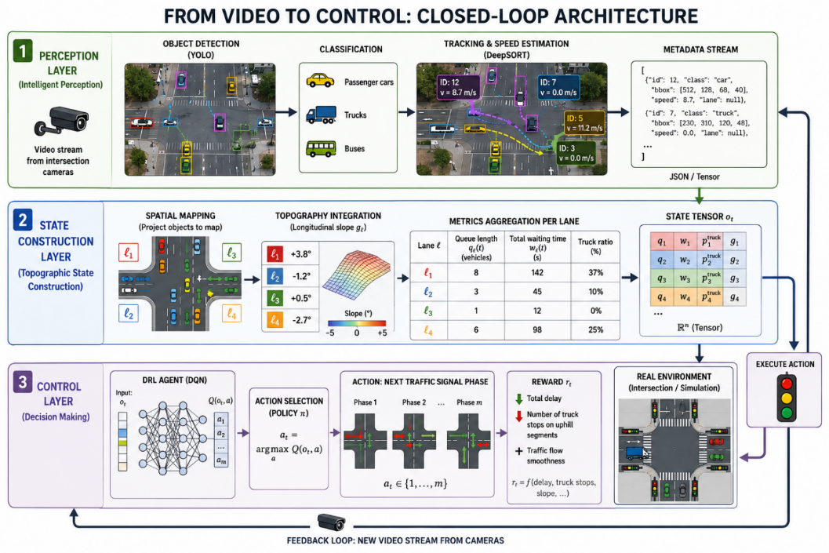
Fig. 1. Conceptual “Vision-to-Control” architecture for topography-aware traffic management.
Fig. 1 shows how camera streams are converted into a slope-enriched state vector. This allows the controller to associate detected heavy vehicles with uphill zones instead of treating terrain as a passive background parameter.
The Perception Layer uses a YOLO-family detector suitable for real-time visual tasks [12], then classifies, tracks, and assigns speed descriptors to cars, trucks, and buses. Queued vehicles are detected using a speed threshold below 0.1 m/s. The State Construction Layer maps detected objects onto lane topology, adds the static slope descriptor, aggregates queue and waiting indicators, and sends the resulting state tensor to the DRL controller. The Control Layer selects the next traffic-light phase to minimize delay while avoiding heavy-vehicle stops on uphill approaches.
After the phase is applied, the loop repeats with updated vehicle positions.
  - Mathematical Formalization of the Topography-Aware Reward
The reward function defines the training objective. Standard TSC rewards are delay-centered, whereas CSRD adds terrain-sensitive environmental costs for sloped road sections.
For an intersection with uphill approaches, the total reward is a weighted sum of waiting-time, queue-length, uphill-start, and uphill-stop penalties:
$r_{t}^{topo}=-\left(α_{1}{\tilde{W}}_{t}+α_{2}{\tilde{Q}}_{t}+α_{3}{\tilde{N}}_{start,t}^{↑}+α_{4}{\tilde{N}}_{stop,t}^{↑}\right).$ (1)
The terms respectively prevent excessive delay, lane spillback, energy-intensive uphill starts, and unnecessary uphill stops; the weights balance throughput and emissions.
For the 3.8-degree slope and 20% trucks, the calibrated weights prioritize operational efficiency while maintaining a symmetric incentive for continuous heavy-vehicle movement on the incline.
Consequently, truck stops on inclines become high-cost events that guide the agent toward an uphill green-wave policy.
  - Modeling Stochastic Classification Noise
Because SUMO exposes exact vehicle classes but real cameras do not, robustness is tested through a stochastic truck-misclassification model.
The noise model focuses on missed heavy vehicles, the most harmful perception error for uphill emissions.
For each observed vehicle, the simulator class is transformed into the class perceived by the agent with truck-to-car error probability epsilon:
$P\left(C_{obs}\left(v\right)=Car ∣ C_{true}\left(v\right)=Truck\right)=ϵ;$ (2)
$P\left(C_{obs}\left(v\right)=Truck ∣ C_{true}\left(v\right)=Truck\right)=1-ϵ.$
Passenger-car errors are ignored because false truck labels mainly over penalize, while missed trucks remove the relevant emission penalty.
The noise affects both state construction and reward calculation: a missed truck receives lower lane priority, and its stop/start event is not penalized. The error probability is from 0 to 0.2, enabling a stress test from ideal data to 20% truck-classification errors.
- Experimental Setup
  - SUMO Simulation Environment Configuration
The evaluation used SUMO 1.24.0 [13] on a four-way isolated intersection with one incoming and one outgoing lane per approach. The northern approach has a 3.8-degree uphill slope; other approaches are flat or downhill. Emissions were computed with HBEFA4 [14], and TraCI [15] linked the simulator and the DRL agent in 5-second control steps.
  - Traffic Demand and Scenario Parameters
Final testing covered 9 h (32,400 s) with 14,800 vehicles from video-derived demand. The fleet was 80% passenger cars and 20% heavy trucks; training varied low, high, and unbalanced scenarios, with Poisson arrivals in each 3600 s episode.
  - Neural Network Architecture and Hyperparameters
The controller uses DQN for discrete phase selection (see Table 1). Its slope-enriched lane tensor encodes queues, waiting times, and detected heavy vehicles; the network contains Conv2D, Flatten, two dense ReLU layers, and a four-neuron linear output [1]. Training uses a 50,000-transition replay buffer, a target network updated every 500 steps, and Adam optimization.
Table 1. Hyperparameters of the DRL agent.
Parameter | Value | Description
Learning rate ($η$) | $$1×{10}^{-4}$$ | Learning rate
Discount factor ($γ$) | 0.95 | Discount factor for future rewards
Batch size | 64 | Mini-batch size for one gradient step
Exploration ($ϵ$) | $$1.0 →0.05$$ | Exploration strategy (epsilon-greedy)
Decay steps | 10,000 | Number of steps for linear epsilon decay
Optimizer | Adam | Gradient descent algorithm
- Results and Discussion
  - Comparative Performance Analysis
For evaluation, we compared the results of our previous model operating on ideal data [1] with the new model that receives data with simulated video-analytics noise. The noise level was set at 10%, representing the probability that a truck would be perceived as a passenger car. A comparison of performance indicators at the intersection with a 3.8° slope is provided in Table 2. The data shown in Table 2 confirms the robustness of the algorithm.
Table 2. Comparison of performance indicators at the intersection with a 3.8° slope. The best results are shown in bold.
Approach | Total CO₂ emissions (10⁶ mg) | Avg. trip duration (s) | Avg. waiting time (s) | Avg. queue (auto)
MaxPressure (Baseline) | 281.03 ± 0.01 | 81.10 ± 0.01 | 17.23 ± 0.01 | 2.37 ± 0.01
Standard DQN (Ideal) | 269.76 ± 3.71 | 78.39 ± 2.41 | 18.21 ± 1.51 | 2.18 ± 0.10
Based (Ideal) [1] | 256.97 ± 2.36 | 72.09 ± 3.98 | 24.67 ± 4.50 | 1.31 ± 0.08
New (based+noise 10%) | 261.12 ± 3.15 | 74.15 ± 4.22 | 22.85 ± 3.80 | 1.52 ± 0.12
  - Analysis of Training Dynamics and Robustness
Fig. 2 compares the learning curves for CO2 emissions. It can be observed that the introduction of sensor noise (CV-Based) causes a slight increase in the emissions plateau compared with ideal data, but the convergence trend is preserved.
  - Sensitivity to Recognition Error Levels
For a deeper understanding, we conducted a stress test by varying the probability of truck misclassification from 0% to 20%.
As shown in Fig. 3, even with 20% recognition errors, CO2 emissions increase by only approximately 4.5%, allowing the system to remain within the performance range of a standard DQN controller with ideal data despite a critical level of sensor errors.
  - Discussion
The results show that the transition to automated video analytics causes a predictable but non-critical decrease in effectiveness. The noisy model showed only a 1.6% increase in emissions compared with ideal data at a 10% classification-error rate.
This is explained by the proposed mechanism: even if the agent mistakenly identifies one out of ten trucks as a passenger car, the penalties for stopping other trucks and the general focus on minimizing queues on the uphill approach make it possible to maintain an ecological corridor. The agent learned an environmental compromise strategy, in which it is willing to hold vehicles on secondary flat roads slightly longer to guarantee unobstructed passage for most heavy vehicles on the uphill approach, even under inaccurate information about each specific vehicle.
Thus, the proposed approach proves viable for real Smart City systems, where perfect sensor accuracy is unattainable.
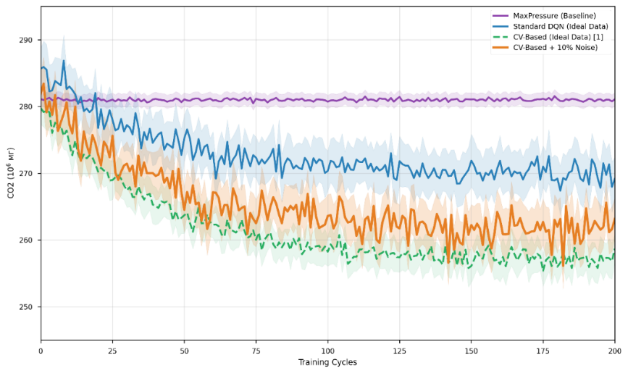
Fig. 2. Comparison of total CO_2 emissions during 200 training cycles under a 3.8-degree uphill approach. The proposed CSRD-T (CV-Based) controller, subjected to 10% vehicle misclassification noise, is evaluated against the baseline MaxPressure heuristic, a standard DQN model, and the ideal-data CSRD-T approach from previous work [1]. Shaded areas represent the standard deviation across five independent runs.
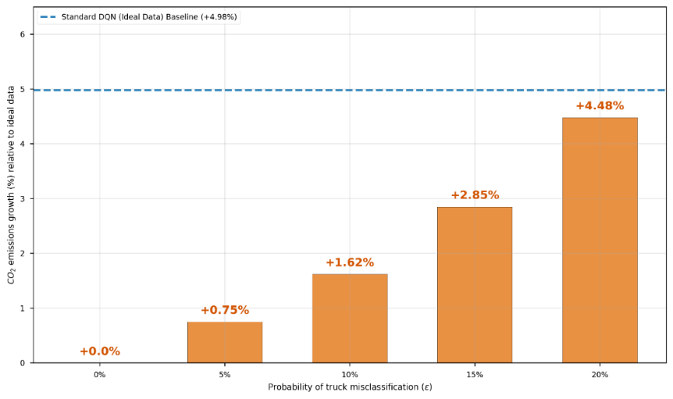
Fig. 3. Sensitivity analysis of the CSRD-T controller performance under varying levels of vehicle misclassification noise ($ϵ$). The vertical bars represent the percentage increase in total CO₂ emissions relative to the ideal-data scenario ($ϵ= 0$). The dashed horizontal line indicates the performance gap of a standard, topography-agnostic DQN model under ideal data conditions.
- Conclusions and Future Work
This work presented a topography-aware urban traffic control approach that narrows the sim-to-real gap between ideal simulation and practical Smart City deployment. Unlike prior ideal-telemetry settings, the proposed Vision-to-Control architecture incorporated automated video analytics and considered perception errors typical of real intersections. The main result is that CSRD remained robust under sensor noise. SUMO experiments showed that 10% truck-classification noise reduced environmental effectiveness by only about 1.6% compared with the ideal-data scenario. Even with this error level, the topography-aware controller still reduced total CO2 emissions more effectively than MaxPressure by 7.1% and standard DRL by 3.2%. These findings show that embedding physical context, especially road gradient, into the reward function helps preserve emission-reduction performance when visual recognition is imperfect. A limitation of the proposed approach is that robustness was tested with simulated classification noise rather than real camera streams under diverse field conditions.
Future research should validate the pipeline with real video data, extend it to multi-agent coordination across terrain-varied intersections, and integrate V2X telemetry to improve perception reliability.
Acknowledgments. This research was funded by the European Union’s Horizon Europe Framework Programme under grant agreement No. 101148374, project U_CAN: Ukraine towards Carbon Neutrality. The views expressed are solely those of the authors and not necessarily of the European Union or CINEA. Gemini Flash 3 Preview and Grammarly were used only for language editing; all scientific analysis, findings, and conclusions are the authors’ own.
Disclosure of Interests. The authors declare that they have no competing interests relevant to the content of this article.
- References
- Ryzhanskyi, O., Barmak, O., Manziuk, E., Radiuk, P., Krak, I.: Topography-aware deep reinforcement learning with contextual reward engineering for sustainable and efficient urban traffic control. Future Transportation 6(2), 82 (2026). https://doi.org/10.3390/futuretransp6020082
- Ryzhanskyi, O., et al.: AI driven traffic signal control system to reduce CO2 emissions. In: Joint Proceedings of the Workshops “YAISD 2025”, CEUR-Workshop Proceedings, Ternopil-Skomorochy, Ukraine, 8–9 May 2025, pp. 18–27. CEUR-WS.org, Aachen (2025).
- Wei, H., Zheng, G., Gayah, V.V., Li, Z.: Recent advances in reinforcement learning for traffic signal control: A survey of models and evaluation. ACM SIGKDD Explorations Newsletter 22(2), 12–18 (2021). https://doi.org/10.1145/3447556.3447565.
- Levin, M.W.: Max-pressure traffic signal timing: A summary of methodological and experimental results. Journal of Transportation Engineering, Part A: Systems 149(4), 03123001 (2023). https://doi.org/10.1061/JTEPBS.TEENG-7578.
- Wei, H., Zheng, G., Yao, H., Li, Z.: IntelliLight: A reinforcement learning approach for intelligent traffic light control. In: Proceedings of the 24th ACM SIGKDD International Conference on Knowledge Discovery and Data Mining, pp. 2496–2505. ACM, New York (2018). https://doi.org/10.1145/3219819.3220096
- Schumacher, M.E.H., Adriano, C.M., Giese, H.: Challenges in reward design for reinforcement learning-based traffic signal control: An investigation using a CO₂ emission objective. In: Proceedings of the SUMO User Conference 2023, pp. 131–151 (2023). https://doi.org/10.52825/scp.v4i.222.
- Kang, L., Huang, H., Lu, W., Liu, L.: A Dueling Deep Q-Network method for low-carbon traffic signal control. Applied Soft Computing 141, 110304 (2023). doi:10.1016/j.asoc.2023.110304.
- Coiret, A., Deljanin, E., Vandanjon, P.O.: Vehicle energy savings by optimizing road speed-sectioning. European Transport Research Review 12, 41 (2020). https://doi.org/10.1186/s12544-020-00432-8.
- Prabono, A. S., et al.: Vehicle and Queue Detection for Intelligent Traffic Light Control System Using YOLO and DeepSORT. Symmetry 13(12), 2320 (2021). https://doi.org/10.3390/sym13122320
- Ju, H., Juan, R., Gomez, R., Nakamura, K., Li, G.: Transferring policy of deep reinforcement learning from simulation to reality for robotics. Nature Machine Intelligence 4, 1077–1087 (2022). https://doi.org/10.1038/s42256-022-00573-6
- Dulac-Arnold, G., Levine, N., Mankowitz, D.J., Li, J., Paduraru, C., Gowal, S., Hester, T.: Challenges of real-world reinforcement learning: Definitions, benchmarks and analysis. Machine Learning 110(9), 2419–2468 (2021). https://doi.org/10.1007/s10994-021-05961-4
- Wang, C.-Y., Bochkovskiy, A., Liao, H.-Y.M.: YOLOv7: Trainable bag-of-freebies sets new state-of-the-art for real-time object detectors. In: Proceedings of the IEEE/CVF Conference on Computer Vision and Pattern Recognition (CVPR), pp. 7464–7475 (2023). https://doi.org/10.1109/CVPR52729.2023.00721
- Alvarez Lopez, P., Banse Bueno, O.A., Behrisch, M., Erdmann, J., Flötteröd, Y.-P., Hilbrich, R., Nippold, R., Wagner, P.: Simulation of Urban Mobility (SUMO), Version 1.24.0. Zenodo (2025). https://doi.org/10.5281/zenodo.16268320
- Notter, B., Cox, B., Hausberger, S., Matzer, C., Weller, K., Dippold, M., Politschnig, N., Lipp, S., Allekotte, M., Knörr, W., André, M., Gagnepain, L., Hult, C., Jerksjö, M.: HBEFA 4.2 Update Documentation. INFRAS, IVT TU Graz, ifeu, IFSTTAR, ADEME, IVL (2022). Available at: https://www.hbefa.net/
- Wegener, A., Piorkowski, M., Raya, M., Hellbrück, H., Fischer, S., Hubaux, J.-P.: TraCI: An Interface for Coupling Road Traffic and Network Simulators. In: Proceedings of the 11th Communications and Networking Simulation Symposium (CNS'08), Ottawa, Canada, pp. 155–163 (2008). https://doi.org/10.1145/1400713.1400740

