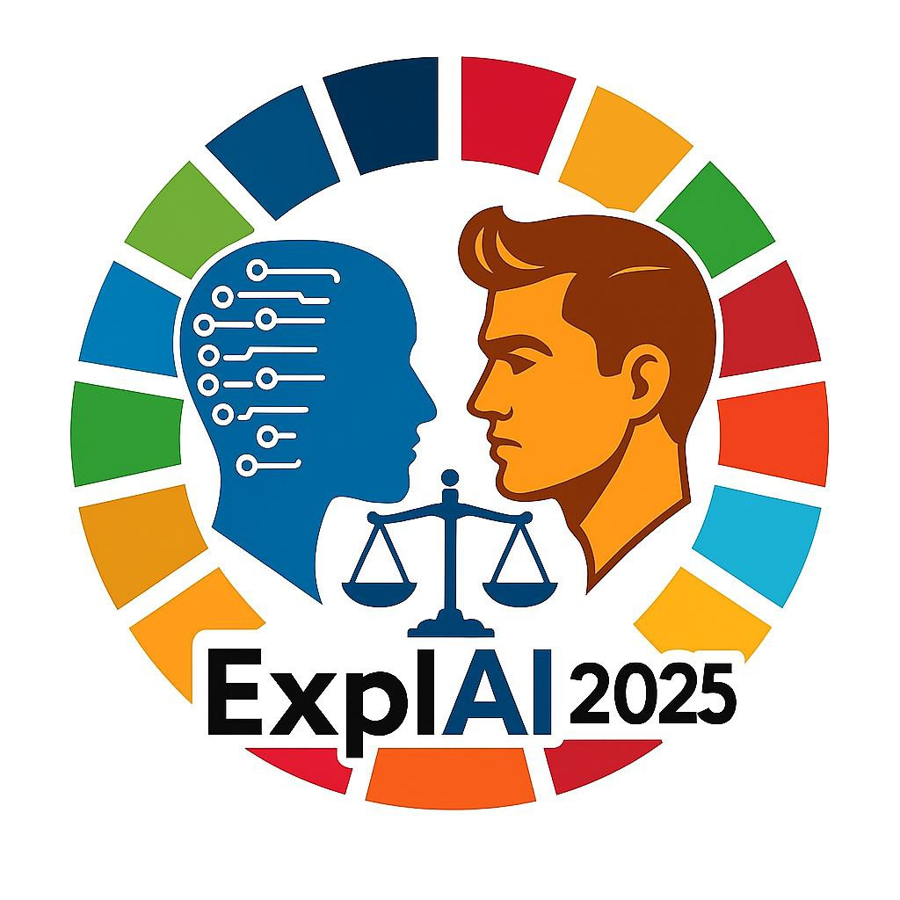 | ExplAI-2025: Advanced AI in Explainability and Ethics for the Sustainable Development Goals

ExplAI–2025: Advanced AI in Explainability and Ethics for the Sustainable Development Goals

**Khmelnytskyi, Ukraine · 7 November 2025**

Participation and publication are **free of charge**. Proceedings will be submitted to **CEUR-WS.org** (indexed in DBLP and widely covered by Scopus).

## Aim and Scope
ExplAI-2025 seeks cutting-edge research on **explainable, transparent, and trustworthy artificial-intelligence systems** that advance the **United Nations Sustainable Development Goals (SDGs)**. We welcome interdisciplinary work that fuses robust AI methodology with ethical principles, governance frameworks, and demonstrable social impact. The workshop provides an open forum for exchanging ideas, forging collaborations, and charting a path toward responsible, human‑centred innovation.

## Topics of Interest
We invite original papers on (but not limited to) theoretical and practical advances in **transparent, trustworthy, and ethical AI systems for decision-making aligned with the UN Sustainable Development Goals**.

## Important Dates

– Paper submission deadline: **20.09.2025**
– Notification of acceptance: **20.10.2025**
– Camera-ready submission: **27.10.2025**
– Workshop date: **07.11.2025**

## Submission Guidelines
– **Paper type:** Regular papers (10–15 pages), English.
– **Template (CEUR-ART, one-column):**

– LaTeX Overleaf (Recommended): [Template](https://www.overleaf.com/latex/templates/template-for-submissions-to-ceur-workshop-proceedings-ceur-ws-dot-org/hpvjjzhjxzjk)
– LaTeX ZIP: [CEURART.zip](https://ceur-ws.org/Vol-XXX/CEURART.zip)
– DOCX template: [Download](https://docs.google.com/document/d/1u4rY_r5X89K6FlfCcfnX0yxCUkrDiHYv/edit?usp=sharing&ouid=107820847572667101806&rtpof=true&sd=true)
– **Authorship limits:** ≤ 5 authors per paper.
– **Self-citation:** ≤ 20 % of references.
– **Submission system:** Submit via **Microsoft CMT** (select *ExplAI–2025* in the conference list): <https://cmt3.research.microsoft.com/Conference/Recent>.
– **Peer review:** Double-blind. Each submission will receive at least two independent reviews. Acceptance requires at least one strong accept and no rejects; a third reviewer may be invited in case of disagreement.

**Generative AI disclosure:** Authors must include the mandatory CEUR declaration regarding the use (or non-use) of generative AI tools (see CEUR policy: <https://ceur-ws.org/GenAI/Policy.html>).

**Author metadata:** Meaningful affiliations *with institutional e‑mail addresses and ORCID identifiers* (<https://orcid.org>) must be provided in the paper footer (page 1), per CEUR-ART instructions.

## Author Preparation Checklist (Strongly Recommended)
To improve acceptance likelihood and ensure CEUR compliance:
– Concise, specific title (≤ 13 words; avoid repeated words).
– Clear English; please proofread.
– Paper structure: Abstract; Keywords; Introduction; Related Work; Methods/Model; Results & Discussion; Conclusion; References.
– Reference list: ~25–30 sources typical for regular papers; majority recent (≤ 5–8 years).
– International reach: ≤ 20 % total local (same-country + self) references; self-citation ideally ≤ 15 % and in all cases ≤ 20 %.
– No «cascade» chains of >3 sequential references.
– Non-English sources must include language tags (e.g., *(in Ukrainian)*).
– Ensure uniform formatting of headings, captions, and equations; provide high-quality figure graphics with readable fonts (vector graphics are preferred).

## Author Agreement (Required)
Each accepted paper must be accompanied by a signed **CEUR-WS Open-Access Author Agreement** (hand-completed and scanned/PDF).

[Download CEUR Author Agreement (CC-BY, third-party content declaration)](https://ceur-ws.org/ceur-author-agreement-ccby-tp.pdf?ver=2025–06–10)

## Program and Organizing Committees

### General Chair
– Prof. Tetiana Hovorushchenko, Khmelnytskyi National University, Ukraine

### Program Committee Chairs
– Prof. Olexander Barmak, Khmelnytskyi National University, Ukraine
– Prof. Iurii Krak, Taras Shevchenko National University of Kyiv, Ukraine

### International Program Committee
– Prof. Eduard Manziuk, Khmelnytskyi National University, Ukraine
– Prof. Nataliia Shakhovska, Lviv Polytechnic National University, Ukraine
– Prof. Vyacheslav Kharchenko, National Aerospace University KhAI, Ukraine
– Prof. Volodymyr Lytvynenko, Kherson National Technical University, Ukraine
– Prof. Vyacheslav Kovtun, Vinnytsia National Technical University, Ukraine

– Prof. Roman Kuc, Yale University, USA
– Prof. Orken Mamyrbayev, Institute of Information and Computational Technologies, Kazakhstan
– Prof. Andrii Biloshchytskyi, Astana IT University, Kazakhstan
– Prof. Waldemar Wojcik, Lublin University of Technology, Poland
– Dr. Ivan Izonin, University of Birmingham, UK
– Prof. Sergey Yakovlev, Lodz University of Technology, Poland
– Prof. Adam Wierzbicki, Polish-Japanese Academy of Information Technology, Poland
– Prof. Sergii Babichev, Jan Evangelista Purkyne University in Usti and Labem, Czech Republic
– Dr. Dmytro Chumachenko, University of Waterloo, Canada
– Prof. Vitaly Levashenko, Zilina University, Slovakia
– Prof. Elena Zaitseva, Zilina University, Slovakia
– Dr. Miroslav Kvassay, Zilina University, Slovakia
– Dr. Artem Boyarchuk, TalTech University, Estonia
– Dr. Tomáš Sochor, University of Ostrava, Czech Republic
– Prof. Abdel-Badeeh M. Salem, Ain Shams University, Egypt
– Dr. Houda El Bouhissi, University of Bejaia, Algeria

*Additional reviewers with relevant expertise will be invited as needed.*

### Organizing Committee
– Dr. Pavlo Radiuk, Khmelnytskyi National University, Ukraine
– Dr. Oleksandr Mazurets, Khmelnytskyi National University, Ukraine
– Dr. Maryna Molchanova, Khmelnytskyi National University, Ukraine
– Dr. Olena Sobko, Khmelnytskyi National University, Ukraine

## Special Issues
Authors of high-quality workshop papers will be invited to submit **extended versions (≥ 70 % new content)** to selected journals. Confirmed opportunity:

**Sustainability**, ISSN 2071–1050, Q2 (Scimago), IF 3.3. Special Issue: [«Empowering Artificial Intelligence to Achieve Sustainable Development Goals»](https://www.mdpi.com/journal/sustainability/special_issues/KQVEZ3O6NC). Guest Editors: Prof. Dr. Olexander Barmak, Prof. Dr. Iurii Krak, Prof. Dr. Eduard Manziuk, Dr. Pavlo Radiuk.

All extended submissions will undergo the journal’s standard peer-review process.

## Contact
Questions? Please e-mail **explai.khmnu@gmail.com**.
Updates: <https://explai-2025.ai>.

---

*The Microsoft CMT service was used for managing the peer-reviewing process for this conference. This service was provided for free by Microsoft, and they bore all expenses, including costs for Azure cloud services as well as for software development and support.*

