Khmelnytskyi National University

Program
of ExplAI-2025: Advanced AI in Explainability and Ethics for the Sustainable Development Goals
ExplAI-2025
7 November 2025

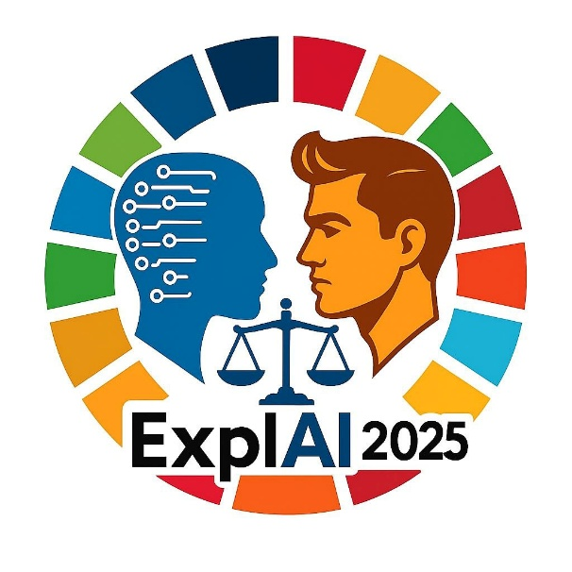

Khmelnytskyi, Ukraine, 2025

Program Committee

General Chair
– Prof. Tetiana Hovorushchenko, Khmelnytskyi National University, Ukraine

Program Committee Chairs
– Prof. Olexander Barmak, Khmelnytskyi National University, Ukraine
– Prof. Iurii Krak, Taras Shevchenko National University of Kyiv, Ukraine

International Program Committee
– Prof. Eduard Manziuk, Khmelnytskyi National University, Ukraine
– Prof. Nataliia Shakhovska, Lviv Polytechnic National University, Ukraine
– Prof. Vyacheslav Kharchenko, National Aerospace University KhAI, Ukraine
– Prof. Volodymyr Lytvynenko, Lublin University of Technology, Poland
– Prof. Vyacheslav Kovtun, Institute of Theoretical and Applied Informatics, Polish Academy of Sciences, Poland
– Prof. Roman Kuc, Yale University, USA
– Prof. Orken Mamyrbayev, Institute of Information and Computational Technologies, Kazakhstan
– Prof. Andrii Biloshchytskyi, Astana IT University, Kazakhstan
– Prof. Waldemar Wojcik, Lublin University of Technology, Poland
– Dr. Ivan Izonin, The Bartlett School of Sustainable Construction, University College London, UK
– Prof. Sergey Yakovlev, Lodz University of Technology, Poland
– Prof. Adam Wierzbicki, Polish-Japanese Academy of Information Technology, Poland
– Prof. Sergii Babichev, Jan Evangelista Purkyne University in Usti and Labem, Czech Republic
– Dr. Dmytro Chumachenko, University of Waterloo, Canada
– Prof. Vitaly Levashenko, Zilina University, Slovakia
– Prof. Elena Zaitseva, Zilina University, Slovakia
– Dr. Miroslav Kvassay, Zilina University, Slovakia
– Dr. Artem Boyarchuk, TalTech University, Estonia
– Dr. Tomáš Sochor, University of Ostrava, Czech Republic
– Prof. Abdel-Badeeh M. Salem, Ain Shams University, Egypt
– Dr. Houda El Bouhissi, University of Bejaia, Algeria

Time Difference

Relevant only for online participants.

The conference time corresponds with the EET (UTC+2) time zone, where the time in Ukraine is the reference point.

Country | Time zone | Time difference in hours in relation to Ukraine
Canada, ON | UTC-5 | -7
UK | UTC+0 | -2
Algeria | UTC+1 | -1
Poland | UTC+1 | -1
Serbia | UTC+1 | -1
Slovakia | UTC+1 | -1
Tunisia | UTC+1 | -1
Czech Republic | UTC+1 | -1
Poland | UTC+1 | -1
Ukraine | UTC+2 | 0
Estonia | UTC+2 | 0
Kazakhstan | UTC+5 | +3

General Information

– Time Zone: All times presented below are in Kyiv (EET, UTC+2).
– Presentation Format: Each presentation is allocated 15 minutes (10 minutes for the talk and 5 minutes for Q&A).
– Meeting Details: Zoom link
https://us02web.zoom.us/j/7417780578?pwd=eOKaarBgeqoVtry5SYQhaDIG3BJ5Sb.1&omn=85468583134
Meeting ID: 741 778 0578
Passcode: 2025
Moderator: Pavlo Radiuk

Workshop Schedule

09:00 AM – 09:15 AM | Welcome & Opening Remarks

09:15 AM –10:15 AM | Session 1: Explainable AI

1. Explainable Artificial Intelligence Foundations for Web-Based Sea Ice Extent Forecasting System
Tetiana Hovorushchenko, Olga Pavlova, Vitalii Alekseiko, Oleg Voichur, Valeriia Shvaiko, Artem Boyarchuk

2. CNNs are Explainable Domain-Specific Visual Embedders
Zakhar Ostrovsky, Andrii Biloshchytskyi, Dmytro Uhryn

3. Neural Network Detection of Digital Fatigue and Burnout with Interpretable Thematic Segmentation
Olexander Mazurets, Roman Vit, Maryna Molchanova, Olena Sobko, Adam Wierzbicki, Dmytro Chumachenko

4. An Explainable Artificial Intelligence Approach for Detecting Network Attacks
Dmytro Tymoshchuk, Andriy Sverstiuk, Yurii Klots, Nataliia Petliak, Vira Titova

10:15 AM –10:30 AM | Coffee Break

10:30 AM – 11:15 AM | Session 2: AI Ethics and Governance

1. A method for synthesising system architecture for IT infrastructure resistant to social engineering attacks
Sergii Lysenko, Oleksandr Bokhonko, Tomas Sochor, Olha Atamaniuk, Nadiia Lysenko, Jiri Balej

2. Linear ensemble model with winner-takes-all aggregation strategy for improved small data classification
Ivan Izonin, Roman Tkachenko, Serhii Chesanov, Yaroslav Tolstyak, Myroslav Stupnytskyi

3. An Approach to Identifying Functional and Non-Functional Requirements in IT-Project Management using Deep Learning Models
Ruslan Bahrii, Tetiana Skrypnyk, Bohdan Romanov, Elena Zaitseva, Houda El Bouhissi, Volodymyr Lytvynenko

11:15 AM –11:30 AM | Coffee Break

11:30 AM –12:30 PM | Session 3: Sustainable Development Goals

1. AutoML PyCaret and SHAP Explainable AI for ECG Signal Classification Based on Amplitude Variability
Dmytro Tymoshchuk, Iryna Didych, Andriy Sverstiuk, Lyubomyr Mosiy, Yuri Palianytsia

2. Detection of intestinal thrombosis using a hybrid method based on genetic algorithm and grey wolf optimisation
Lyubomyr Chyrun, Dmytro Uhryn, Yuriy Ushenko, Oleksii Iliuk, Yuriy Masikevych

3. A Benchmark Methodology for Urban Traffic Pattern Clustering Using SUMO-Based Expert-Verified Ground Truth
Vitaliy Pavlyshyn, Eduard Manziuk, Adnène Arbi, Nebojsa Bacanin, Iurii Krak

4. Knowledge engineering information technology for cultural-educational scenarios based on RAG
Khrystyna Lipianina-Honcharenko, Nazar Melnyk, Myroslav Komar, Pavlo Bykovyy, Khrystyna Yurkiv

12:30 PM –12:45 PM | Coffee Break

12:45 PM –13:45 PM | Session 4: Trustworthy AI

1. Vision Transformers Transfer Learning for Smoking Detection in Public Spaces with Transparent AI Decisions
Olexander Mazurets, Maryna Molchanova, Olha Zalutska, Ihor Kok, Vitaly Levashenko, Abdel-Badeeh M. Salem

2. An Approach to Matching Satellite and UAV Images for Visual Place Recognition Using Color Normalization and YOLO
Volodymyr Vozniak, Yuriy Ushenko, Orken Mamyrbayev

3. Verifiable by Construction: Evidence-Anchored LLMs for Explainable Fake News Detection
Andrii Shupta, Pavlo Radiuk, Miroslav Kvassay, Piotr Gaj

4. Hierarchical neural network model for identifying similar objects in drone images
Dmytro Borovyk, Oleksander Barmak, Pawel Komada, Sergii Babichev

13:45 PM –14:00 PM | Coffee Break

14:00 PM – 14:30 PM | Awards & Closing Remarks

