Khmelnytskyi National University

Program
of ExplAI-2025: Advanced AI in Explainability and Ethics for the Sustainable Development Goals

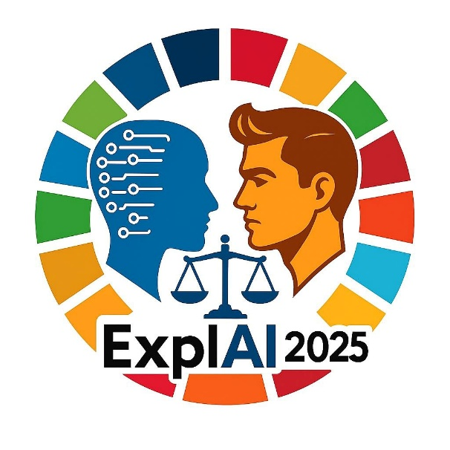

Khmelnytskyi, Ukraine, 7 November 2025

Program Committee

General Chair
– Prof. Tetiana Hovorushchenko, Khmelnytskyi National University, Ukraine

Program Committee Chairs
– Prof. Olexander Barmak, Khmelnytskyi National University, Ukraine
– Prof. Iurii Krak, Taras Shevchenko National University of Kyiv, Ukraine

International Program Committee
– Prof. Abdel-Badeeh M. Salem, Ain Shams University, Egypt
– Prof. Adam Wierzbicki, Polish-Japanese Academy of Information Technology, Poland
– Prof. Andrii Biloshchytskyi, Astana IT University, Kazakhstan
– Dr. Artem Boyarchuk, TalTech University, Estonia
– Dr. Dmytro Chumachenko, University of Waterloo, Canada
– Prof. Eduard Manziuk, Khmelnytskyi National University, Ukraine
– Prof. Elena Zaitseva, Zilina University, Slovakia
– Dr. Houda El Bouhissi, University of Bejaia, Algeria
– Dr. Ivan Izonin, University of Birmingham, UK
– Dr. Miroslav Kvassay, Zilina University, Slovakia
– Prof. Nataliia Shakhovska, Lviv Polytechnic National University, Ukraine
– Prof. Orken Mamyrbayev, Institute of Information and Computational Technologies, Kazakhstan
– Prof. Roman Kuc, Yale University, USA
– Prof. Sergii Babichev, Jan Evangelista Purkyne University in Usti and Labem, Czech Republic
– Prof. Sergey Yakovlev, Lodz University of Technology, Poland
– Dr. Tomáš Sochor, University of Ostrava, Czech Republic
– Prof. Vitaly Levashenko, Zilina University, Slovakia
– Prof. Volodymyr Lytvynenko, Kherson National Technical University, Ukraine
– Prof. Vyacheslav Kharchenko, National Aerospace University KhAI, Ukraine
– Prof. Vyacheslav Kovtun, Vinnytsia National Technical University, Ukraine
– Prof. Waldemar Wojcik, Lublin University of Technology, Poland

General Information

– Timezone: All times are in Kyiv (EET, UTC+2).
– Presentation Format: Each presentation is allocated 15 minutes (10 minutes for the talk and 5 minutes for Q&A).
– Meeting Details: Connection links and passcodes will be announced closer to the workshop date.

Workshop Schedule

09:00–09:15 | Welcome & Opening Remarks

09:15–10:15 | Session 1: Explainable AI
Moderator: Pavlo Radiuk

1. AutoML PyCaret and SHAP Explainable AI for ECG Signal Classification Based on Amplitude Variability
Dmytro Tymoshchuk, Iryna Didych, Andriy Sverstiuk, Lyubomyr Mosiy, Yuri Palianytsia

2. CNNs are Explainable Domain-Specific Visual Embedders
Zakhar Ostrovsky, Andrii Biloshchytskyi, Dmytro Uhryn

3. Neural Network Detection of Digital Fatigue and Burnout with Interpretable Thematic Segmentation
Olexander Mazurets, Roman Vit, Maryna Molchanova, Olena Sobko, Adam Wierzbicki

4. Vision Transformers Transfer Learning for Smoking Detection in Public Spaces with Transparent AI Decisions
Dmytro Chumachenko, Olexander Mazurets, Maryna Molchanova, Olha Zalutska, Ihor Kok, Vitaly Levashenko, Abdel-Badeeh M. Salem

10:15–10:30 | Coffee Break

10:30–11:15 | Session 2: AI Ethics and Governance
Moderator: Pavlo Radiuk

1. A method for synthesising system architecture for IT infrastructure resistant to social engineering attacks
Sergii Lysenko, Oleksandr Bokhonko, Tomas Sochor, Olha Atamaniuk, Nadiia Lysenko, Jiri Balej

2. Verifiable by Construction: Evidence-Anchored LLMs for Explainable Fake News Detection
Andrii Shupta, Pavlo Radiuk, Miroslav Kvassay, Piotr Gaj

3. An Approach to Identifying Functional and Non-Functional Requirements in IT-Project Management using Deep Learning Models
Ruslan Bahrii, Tetiana Skrypnyk, Bohdan Romanov, Elena Zaitseva

11:15–11:30 | Coffee Break

11:30–12:30 | Session 3: Sustainable Development Goals
Moderator: Pavlo Radiuk

1. Explainable Artificial Intelligence Foundations for Web-Based Sea Ice Extent Forecasting System
Tetiana Hovorushchenko, Olga Pavlova, Vitalii Alekseiko, Oleg Voichur, Valeriia Shvaiko, Artem Boyarchuk

2. Detection of intestinal thrombosis using a hybrid method based on genetic algorithm and grey wolf optimisation
Dmytro Uhryn, Yuriy Ushenko, Oleksii Iliuk, Lyubomyr Chyrun, Yuriy Masikevych

3. A Benchmark Methodology for Urban Traffic Pattern Clustering Using SUMO-Based Expert-Verified Ground Truth
Eduard Manziuk, Vitaliy Pavlyshyn, Adnène Arbi, Nebojsa Bacanin, Iurii Krak

4. Knowledge engineering information technology for cultural-educational scenarios based on RAG
Khrystyna Lipianina-Honcharenko, Nazar Melnyk, Myroslav Komar, Pavlo Bykovyy, Khrystyna Yurkiv

12:30–12:45 | Coffee Break

12:45–13:45 | Session 4: Trustworthy AI
Moderator: Pavlo Radiuk

1. An Explainable Artificial Intelligence Approach for Detecting Network Attacks
Dmytro Tymoshchuk, Andriy Sverstiuk, Yurii Klots, Nataliia Petliak, Vira Titova

2. An Approach to Matching Satellite and UAV Images for Visual Place Recognition Using Color Normalization and YOLO
Volodymyr Vozniak, Yuriy Ushenko, Orken Mamyrbayev

3. Hierarchical neural network model for identifying similar objects in drone images
Dmytro Borovyk, Oleksander Barmak, Pawel Komada, Sergii Babichev

4. Linear ensemble model with winner-takes-all aggregation strategy for improved small data classification
Houda El Bouhissi, Volodymyr Lytvynenko, Ivan Izonin, Roman Tkachenko, Serhii Chesanov, Yaroslav Tolstyak, Myroslav Stupnytskyi

13:45–14:00 | Awards & Closing Remarks

