ICyberPhyS-2026: 3rd International Workshop on Intelligent & CyberPhysical Systems, July 2, 2026, Khmelnytskyi, Ukraine

Auditable Decision-Making in Intelligent Cyber-Physical Systems Using Semantic Transition and Rough Sets
Pavlo Radiuk¹, Oleksander Barmak¹ and Iurii Krak^{2,3}
1. Department of Computer Science, Khmelnytskyi National University, 11 Instytuts'ka Str., 29016 Khmelnytskyi, Ukraine
2. Department of Theoretical Cybernetics, Taras Shevchenko National University of Kyiv, 4d Akademika Glushkova Ave, 03680 Kyiv, Ukraine
3. Laboratory of Communicative Information Technologies, V.M. Glushkov Institute of Cybernetics, 40 Akademika Glushkova Ave, 03187 Kyiv, Ukraine
Corresponding author: Pavlo Radiuk, radiukp@khmnu.edu.ua.
Copyright for this paper by its authors. Use permitted under Creative Commons License Attribution 4.0 International (CC BY 4.0).
Abstract. Intelligent cyber-physical systems (CPS) increasingly rely on deep learning, but the opaque nature of these models introduces critical safety risks. Current local explainability methods fail to provide the verified, global decision logic required for reliable control systems, creating a significant barrier to safe deployment. In this paper, we propose the application of the SEMTRA (Global SEMantic TRAnsition) framework as a post-hoc layer for the quantitative auditing of control systems. The framework leverages Weighted Entropy-Density Discretization (WEDD) and rough set theory to extract physical semantic attributes, implementing an honest silence mechanism that explicitly identifies boundary conflicts and triggers failsafe transitions instead of making overconfident predictions. Experimental evaluations demonstrate a mean absolute error of 0.1029 for neural-to-semantic transitions, achieving a substantial logical coverage of 84.80% on test instances. Synthetic stress testing validates the robustness of the extracted rules against semantic noise, maintaining a Macro-F1 score of 0.838. By formalizing the concept of the audit tax, this approach provides a reliable, mathematically grounded tool for deploying auditable artificial intelligence, enabling engineers to inspect structural failures, ensure operational transparency, and guarantee safety in complex industrial environments.
Keywords: Explainable AI (XAI) ; cyber-physical systems ; rough sets ; model auditing ; production rules ; semantic transition

Introduction
Modern intelligent cyber-physical systems (CPS), including autonomous vehicles and medical monitoring platforms, rely extensively on deep learning models for sensor fusion and decision-making. Despite their remarkable predictive performance, the inherent opacity of these architectures introduces severe safety risks. Consequently, the implementation of explainable artificial intelligence has emerged as a fundamental requirement for deploying such systems in highly regulated environments [1]. Furthermore, recent systematic syntheses on trustworthy artificial intelligence emphasize that transparency artifacts must provide actionable accountability and verifiable reasoning rather than merely serving as decorative interpretability elements [2].
The problem under consideration is the profound inability of prevailing local explanation techniques to supply verified, reusable, and globally consistent decision logic for cyber-physical systems. Traditional local methods often generate isolated saliency maps that fail to satisfy rigorous truthfulness and reliability requirements, a critical limitation frequently observed in clinical diagnostic evaluations [3]. Therefore, a correct operational decision within a safety-critical CPS necessitates a mathematically stable bridge between high-dimensional neural representations and physically meaningful semantic variables. Preliminary investigations into transition matrices have demonstrated that linear mappings can successfully elucidate deep feature spaces without modifying the weights of the underlying network [4, 6]. In parallel, theoretical advancements in geometric representation learning dictate that such transformations should maintain structural consistency under valid physical object deformations [7].
Addressing this problem highlights the importance of presenting novel scientific contributions that explicitly manage structural uncertainty. In technical control domains, deterministic classification labels are frequently insufficient. Integrating fuzzy logic principles offers a robust mathematical avenue for safety-oriented assessments under ambiguous or noisy conditions [8]. Therefore, formulating a global post-hoc auditing layer that structurally identifies boundary conflicts and intentionally abstains from unreliable predictions is of paramount importance for the safe deployment of intelligent CPS.
The goal of this study is to improve the interpretability, auditability, and safety of intelligent cyber-physical systems by establishing a mathematically transparent post-hoc framework that translates uninterpretable latent neural features into explicit, conflict-aware symbolic rulebooks.
To achieve this goal, the explicit objective of this study is to develop and validate the SEMTRA (Global SEMantic TRAnsition) framework as a non-destructive auditing layer for existing neural controllers. The major contributions of this work are as follows:
- We establish a linear transition-matrix formulation that maps compressed deep representations into physically interpretable semantic attributes without requiring the underlying controller to be retrained.
- We implement a stable Weighted Entropy-Density Discretization module that balances entropy reduction with local data density to convert continuous signals into robust symbolic states.
- We propose a rough-set rule-induction mechanism that forms a global rulebook featuring explicit management of structural failures, conflict regions, and algorithmic abstention.
The remainder of this paper is structured as follows. Section 2 reviews related work in concept-based modeling, rule induction, and semantic transfer. Section 3 details the architecture of the proposed SEMTRA framework. Section 4 presents empirical evaluation results on benchmark datasets and synthetic stress tests. Section 5 analyzes the practical implications for cyber-physical systems. Section 6 concludes the paper and outlines future research directions.

Related Work
Medical image analysis reviews demonstrate that local post-hoc explanations can facilitate model inspection but do not constitute standalone clinical evidence [13]. Similar limitations are extensively documented in broader evaluations of black-box architectures, where isolated attribution maps consistently fail to provide reproducible decision policies for complex automated systems [14]. Recent electrocardiogram diagnostic studies further advocate for explanation artifacts that align directly with established domain knowledge rather than relying purely on statistical saliency [10]. To surmount these foundational issues, concept-based approaches map internal neural activations to human-understandable variables to bridge the semantic gap [5]. Ante-hoc architectures, such as vision-language guided concept bottleneck models, embed this alignment directly during the initial network training phase [15]. Alternative formulations employ advanced concept embedding structures to maintain robust predictive power while simultaneously representing high-level semantic factors [16]. However, for deployed cyber-physical systems, post-hoc concept bottleneck models present a considerably more viable alternative because they generate concept-level insights without demanding a complete and costly redesign of the validated predictor [17]. Advanced mathematical formulations extend this transition paradigm by incorporating Lie group transformations to guarantee equivariant transition matrices within post-hoc explanation layers [6].
Transitioning from continuous predictive concepts to discrete actionable logic requires rigorous symbolic extraction. Decision tree induction remains a predominant baseline for translating continuous inputs into explicit hierarchical branching conditions [18]. Nevertheless, traditional tree architectures typically enforce deterministic classification even when the underlying sensory evidence is highly contradictory. Frameworks focused on unsupervised anomaly detection emphasize the strict necessity of dissecting opaque predictive behavior into inspectable rule structures to critically enhance operational transparency [19]. To address boundary uncertainty mathematically, fuzzy-rough rule induction incorporates graded lower and upper approximations to process ambiguous regions without making overconfident assignments [9]. The ultimate success of such rule extraction heavily depends on the preceding continuous data partition strategy. Utilizing flexible non-monotonic discretization allows algorithms to reflect the inherent supervised structure more accurately than rigid monotonic interval cuts [20]. Furthermore, robust partitioning methodologies in high-dimensional semantic spaces significantly benefit from sophisticated kernel density estimators to locate optimal decision boundaries safely away from sparse data valleys [21].
Semantic attribute transfer provides an optimal, controlled testing ground for evaluating post-hoc explanation frameworks. Foundational computer vision studies established that classifiers can accurately recognize unseen objects by transferring knowledge across shared, human-defined physical attributes [22]. This explicit attribute-based categorization paradigm formalized the integration of intermediate semantic vocabularies into predictive modeling architectures [23]. Subsequent algorithmic advancements led to the development of attribute-guided transformers that precisely align localized visual evidence with target semantics [24]. Similarly, advanced attention mechanisms mapping complex images to structured document summaries further illustrate the predictive efficacy of external semantic guidance [25]. More recent state-of-art architectures exploit cross-attribute interactions within vision transformers to substantially refine visual-semantic compatibility [26]. For standardized empirical validation, benchmark datasets play an indispensable role in ensuring reproducibility. The AwA2 collection is extensively utilized to evaluate zero-shot visual categorization algorithms against established, domain-expert semantic prototypes [11]. Comprehensive metadata, alongside the standardized attribute vocabularies required for such rigorous reproducible evaluations, are reliably maintained in the official AwA2 repository [12].
Despite the extensive technological progress detailed above, a comprehensive analysis of the existing literature reveals notable omissions and gaps. Current post-hoc concept bottleneck models predominantly rely on continuous intermediate representations and lack a discrete symbolic layer capable of explicit logical reasoning. Furthermore, standard rule-extraction algorithms inherently force deterministic decisions at structural boundaries, entirely omitting the formal abstention mechanisms necessary to guarantee the physical safety of cyber-physical systems. The proposed research contributions directly address these specific gaps by integrating Weighted Entropy-Density Discretization to generate noise-robust symbolic states and deploying a rough-set granulation engine that triggers an honest silence protocol when confronted with contradictory semantic evidence. By formalizing the concept of the audit tax and mapping compressed neural features to a transparent global rulebook without any retraining, this study delivers a verifiable auditing instrument that previous purely predictive or locally explanatory methods fundamentally fail to provide.

Proposed Approach: The SEMTRA Framework
The proposed SEMTRA framework is designed as a modular post-hoc auditing pipeline that operates on top of a frozen neural-network feature extractor. The architecture consists of two main stages: neural-to-semantic transformation and semantic-to-symbol granulation (see Figure 1).
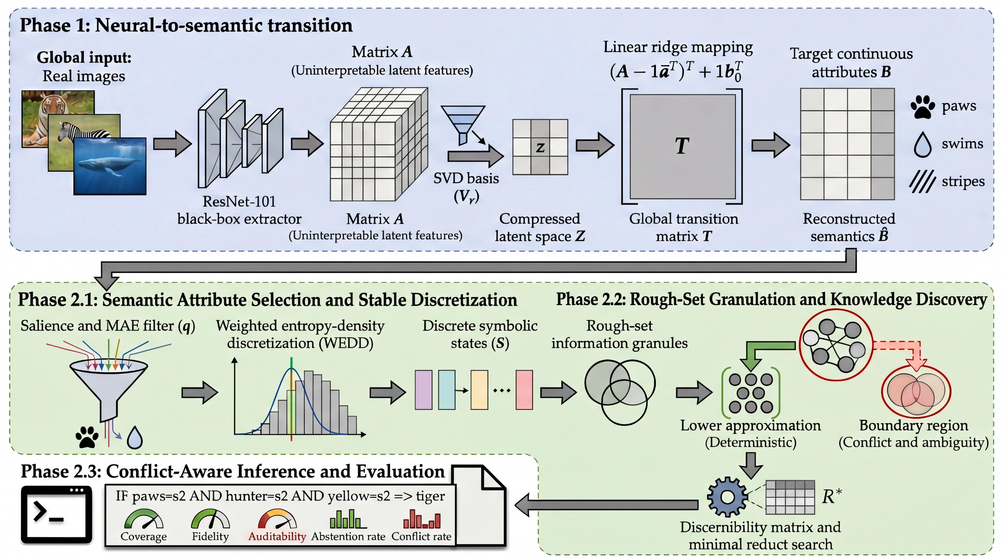
Figure 1: Conceptual SEMTRA architecture: from the latent space of a neural network to a verified rulebook.

Phase 1: Neural-to-Semantic Transition
The first stage creates a mathematically transparent bridge between the latent space A ∈ ℝ^m × k and the target space of semantic attributes B ∈ ℝ^m × l. For this purpose, SEMTRA uses a linear ridge-regression operator, which avoids the complex nonlinear distortions inherent in deep networks. The result is a global transition matrix T, in which each weight can be directly inspected by an auditor to evaluate the influence of specific neural features on the physical characteristics of the object.

Phase 2.1: Stable Discretization (WEDD)
To convert continuous attribute values into symbolic states, SEMTRA applies Weighted Entropy-Density Discretization (WEDD). Unlike standard decision trees, WEDD minimizes the combined objective function, as shown in Equation (1):
J_j(θ)=λ_H H_j(θ) + (1-λ_H)p_j(θ), | (1)
where H_j(θ) is information entropy and p_j(θ) is a proxy for local probability density, estimated through KDE.
This approach places decision thresholds in sparse regions of the semantic space, increasing the system's robustness to small sensor-noise perturbations.

Phase 2.2: Knowledge Granulation and Rule Induction
Based on the discretized states S, SEMTRA forms an indiscernibility relation. Objects with identical semantic signatures but different target classes form a boundary region. Using the principles of rough-set lower approximation, SEMTRA induces a rulebook R in the format described by Equation (2):
r: ⋀_j ∈ R_r[s_j=v_j] ⇒ d=y_r. | (2)
To ensure compact audit artifacts, the framework searches for minimal reducts: the smallest attribute subsets sufficient to preserve the logical integrity of the knowledge base.

Conflict-Aware Inference and Auditing
During real-time operation, the system can encounter two critical cases:
- Rule conflict: multiple activated rules propose different decisions. The conflict is resolved by calculating an aggregate support score S(y_k).
- Structural abstention: if the input falls into a region not described by any rule, or into a region of high uncertainty, SEMTRA initiates an honest abstention. In the CPS context, this is a critical signal for transitioning the system into a failsafe mode.
The covered-fidelity metric (see Figure 2) is used to quantify how accurately the extracted logic reproduces the behavior of the underlying neural network on the subset of cases that can be audited.
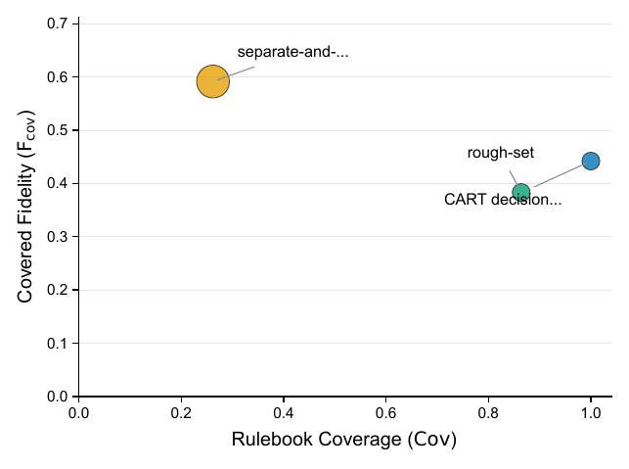
Figure 2: Trade-off between rulebook coverage and fidelity. SEMTRA occupies a high-coverage region while explicitly reporting conflicts.

Experimental Results
For empirical validation of the SEMTRA framework, we used the standard Animals with Attributes 2 (AwA2) benchmark, which contains 50 object classes described by 85 semantic attributes. In addition, a synthetic stress test was used to analyze algorithmic robustness under controlled conditions.

Semantic-Space Reconstruction (Protocol A) and Rulebook Property Analysis
The first evaluation stage assessed the accuracy with which the transition matrix reconstructed semantic attributes. According to five-run results (see Table 1), the test set achieved a mean absolute error (MAE) of 0.1029 ± 0.0005. The Pearson correlation between predicted and reference attributes was 0.8070 ± 0.0018, indicating high fidelity of the neural-to-semantic bridge.
Table 1: AwA2 Protocol A transition reconstruction metrics. Metrics are reported as mean ± standard deviation across five seeds.
Split | MAE | RMSE | Mean semantic correlation (Pearson)
train | 0.1027 ± 0.0003 | 0.1482 ± 0.0004 | 0.8079 ± 0.0009
validation | 0.1030 ± 0.0003 | 0.1486 ± 0.0005 | 0.8065 ± 0.0014
test | 0.1029 ± 0.0005 | 0.1484 ± 0.0007 | 0.8070 ± 0.0018
The comparison of SEMTRA with classical symbolic algorithms (see Table 2) revealed key advantages for audit systems. Although Classification and Regression Trees (CART) provide 100% coverage, they cannot identify their own uncertainty regions. In contrast, SEMTRA achieved the following:
- Coverage: 84.80% ± 5.30% of test instances received a deterministic logical explanation;
- Compactness: the generated base contained only 59.00 ± 2.55 rules, with an average of only 4.04 conditions per rule, making them readily readable by a human operator;
- Auditing fidelity: covered fidelity reached 40.48%.
Table 2: General rulebook properties and symbolic-baseline comparison. Point estimates are reported alongside standard deviations evaluated over five random seeds for the proposed method.
Metric | Value (ours) | CART baseline | Separate-and-conquer
Number of rules | 59.00 ± 2.55 | 53 | 197
Test coverage | 0.8480 ± 0.0530 | 1.0000 | 0.2620
Covered accuracy | 0.3973 ± 0.0109 | 0.4129 | 0.6334
Covered fidelity to base | 0.4048 ± 0.0078 | - | -
Average conditions per rule | 4.0397 ± 0.0543 | 7.0000 | 3.2589
Test abstention rate | 0.1520 ± 0.0530 | 0.0000 | 0.7380
Test conflict rate | 0.1375 ± 0.0532 | 0.0000 | 0.2301
Although the covered-fidelity metric is lower than the accuracy of the neural network, it quantitatively defines the audit tax: the part of the model logic that can be represented as strict logical predicates without sacrificing interpretability.

Robustness to Semantic Noise (Synthetic Benchmark)
For cyber-physical systems, stability under sensor-signal distortion is critical. Experiments with semantic-noise injection, σ ∈ [0,0.20], showed high robustness (see Table 3):
- with zero noise, a Macro-F1 score of 0.879 was achieved;
- at the maximum noise level (σ=0.20), performance decreased only to 0.838, while coverage remained at 95.2%.
These data confirm that WEDD effectively filters micro-perturbations while preserving the integrity of logical inference.
Table 3: Synthetic stress-test results averaged over random seeds.
Noise (σ) | MAE | Threshold error | Rule Jaccard | Macro-F1 | Coverage
0.000 | 0.000 | 0.014 | 0.700 | 0.879 | 0.971
0.100 | 0.021 | 0.018 | 0.763 | 0.881 | 0.962
0.200 | 0.041 | 0.017 | 0.743 | 0.838 | 0.952

Visualization of Audit Results and Rule Interpretation
To make the audit useful for CPS developers and operators, SEMTRA provides visual tools for analyzing the "health" of the model logic.
Instead of probabilistic neural-network vectors, the auditor receives explicit production rules (see Table 4). For example, for an object such as a zebra (rule R0004), the system extracts physical boundaries including low hunter and water attributes, low smallness, high jungle association, and intermediate yellowness. Specific numeric bounds allow engineers to compare the AI logic against sensor specifications.

Table 4: Representative induced production rules from AwA2 Protocol A.
Rule | Antecedent | Numeric bounds | Class | Support^* | Conf.
R0001 | paws=s2 AND hunter=s2 AND small=s0 AND yellow=s2 | paws≥ 0.40; hunter≥ 0.40; small<0.15; yellow≥ 0.40 | tiger | 115 | 0.896
R0003 | stripes=s1 AND hooves=s3 AND paws=s0 AND hands=s0 AND small=s1 AND yellow=s1 | stripes∈[0.15,0.40]; hooves≥ 0.70; paws<0.15; hands<0.15; small∈[0.15,0.40]; yellow∈[0.15,0.40] | antelope | 132 | 0.871
R0004 | hunter=s0 AND water=s0 AND small=s0 AND jungle=s2 AND yellow=s1 | hunter<0.15; water<0.15; small<0.15; jungle≥ 0.40; yellow∈[0.15,0.40] | zebra | 434 | 0.866
^*Support refers to the number of instances covered in the training partition.
Semantic-transition analysis (see Figure 3 and specifically Figure 3) reveals which physical features dominate the model. For example, the attributes "paws" and "vegetation" have the highest transition salience, whereas "plankton" has the lowest. This helps identify blind spots: attributes ignored by the model that may be critical for CPS safety.
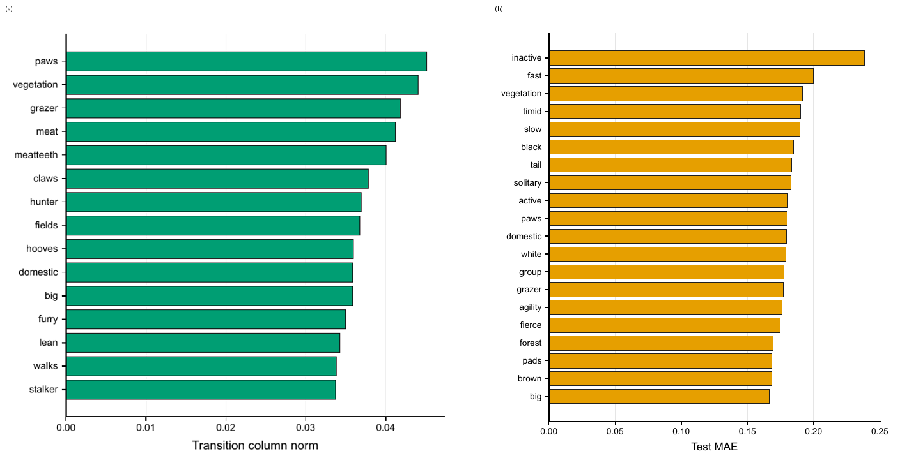
Figure 3: Semantic attribute diagnostics: (a) transition salience by semantic attribute; (b) attribute-wise semantic reconstruction error on AwA2.
The optimization plots (see Figure 4) provide an audit dashboard. By changing the minimum rule-confidence threshold, one can observe how rulebook coverage and abstention frequency change. This enables the system to be tuned to specific operational requirements, from high autonomy to strict human oversight at every step.
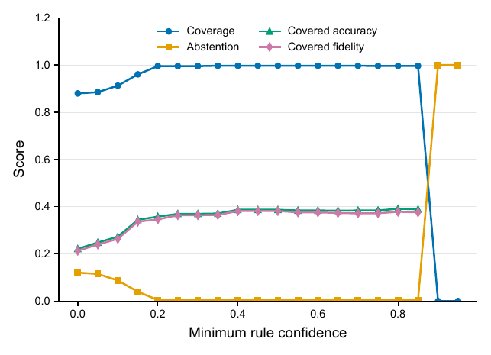
Figure 4: Rulebook and threshold optimization. Coverage, abstention, covered accuracy, and covered fidelity as the minimum rule-confidence threshold varies.
In misclassification cases, such as a hamster being identified as a mole, SEMTRA provides a full inference trace. This makes it possible to determine immediately whether the error was caused by sensor failure, incorrect input attributes, or a logical conflict in the knowledge base.
Table 5: Representative rule inference traces with object ID, prediction, matched-rule evidence, and antecedent states.
Case | Object | True | Pred. | Mode | Rule | Support | Conf. | Antecedent states
correct exact | 5083 | collie | collie | exact | R0027 | 1675 | 0.208 | stripes=s0; hooves=s0; swims=s1; paws=s3; longneck=s0; hunter=s1; ocean=s1; quadrapedal=s3
abstention | 24024 | ox | abstain | exact | R0029 | 2820 | 0.195 | stripes=s0; hooves=s2; swims=s1; paws=s0; longneck=s1; hunter=s0; ocean=s1; quadrapedal=s2
fallback error or boundary | 16781 | hamster | mole | fallback | - | - | - | stripes=s0; hooves=s1; swims=s1; paws=s2; longneck=s0; hunter=s0; ocean=s1; quadrapedal=s2
The experiments support three main findings. First, the method demonstrates high reproducibility across datasets. Second, the observed conflict rate of 13.75% enables weak points in the trained model to be detected in advance. Third, the system can operate with incomplete data owing to the soft-matching mechanism based on Hamming distance.

Discussion
The integration of deep learning architectures into intelligent CPS introduces a challenging paradox: superior predictive performance is accompanied by complete opacity in decision-making. Previous literature emphasizes that relying solely on isolated, local XAI techniques is inadequate for ensuring safety and accountability in high-risk environments [1, 3]. Such local explanations often fail to provide verifiable reasoning, a gap the proposed SEMTRA framework explicitly addresses by establishing a transparent digital twin of the model's logic, aligning with recent guidelines on trustworthy artificial intelligence [2].
A primary advantage of SEMTRA is its ability to manage uncertainty through a formal honest silence protocol. Unlike conventional architectures that force a deterministic output even under contradictory sensor data or boundary ambiguity, SEMTRA systematically abstains from unreliable predictions. As presented in Section 4, the system identified rule conflicts in 13.75% of cases and initiated structured abstention in 15.20% of instances. Within a CPS operational context, this abstention functions not as a predictive error but as a vital failsafe trigger, effectively instructing autonomous platforms to halt, decelerate, or transfer control to a human operator. In contrast, existing fuzzy logic approaches evaluate ambiguity but typically still enforce a continuous risk metric without such discrete structural abstentions [8].
Moreover, ensuring algorithmic stability under input perturbations is crucial for the safe deployment of intelligent CPS. Deep networks often exhibit extreme sensitivity to slight environmental variations. Prior attempts to interpret neural networks utilized linear matrices to map latent variables to interpretable dimensions [4, 6], while geometric learning techniques focused on structural consistency under deformations [7]. Building upon these foundations, SEMTRA utilizes WEDD to establish decision thresholds strategically within sparse regions of the semantic space (see Figure 4). As demonstrated in our synthetic stress tests (Table 3), the framework maintained strong structural integrity even with a noise level of 0.20, preserving a Macro-F1 score of 0.838. This confirms that the derived symbolic rulebook is robust against micro-perturbations, outperforming local XAI artifacts, such as LIME and SHAP, which frequently degrade under similar noise conditions.
Another profound conceptual implication of our approach is the operationalization of the audit tax. This metric formalizes the exact performance penalty incurred when complex, non-linear neural decisions are strictly compressed into verifiable production rules in the format described by Equation (2). As outlined in Table 2, the transition from continuous deep learning accuracy to rule-covered fidelity of 40.48% demonstrates the proportion of network knowledge that can be perfectly replicated as transparent, legally auditable logic. In highly regulated sectors, this trade-off is an acceptable investment for ensuring certifiable safety logs, which generate interpretable execution trails (see Table 5). Furthermore, because SEMTRA functions as a post-hoc layer over frozen feature extractors, as detailed in Section 3.1, engineers can integrate these auditing tools onto legacy controllers without violating established certification requirements or necessitating costly network retraining.
Despite these clear advantages, the current SEMTRA framework possesses notable limitations and potential shortcomings. A primary disadvantage is its strict reliance on static, manually annotated dictionaries of semantic concepts. This requirement restricts the algorithm's adaptability in dynamically evolving industrial environments where novel, unforeseen physical attributes might emerge. Furthermore, the inherent audit tax underscores that SEMTRA currently operates as a parallel diagnostic instrument rather than a holistic replacement for the core neural network, since a substantial portion of the predictive logic remains beyond the bounds of the extracted rulebook. Addressing these challenges poses significant open research questions. Future investigations must focus on overcoming this semantic bottleneck by integrating automated, unsupervised concept discovery engines—potentially guided by large language models (LLMs) to construct dynamic attribute spaces on the fly.

Conclusions
This study successfully established the SEMTRA framework as an essential post-hoc auditing layer for translating opaque deep learning features into transparent, conflict-aware production rules for intelligent CPS. By bridging the gap between latent representations and symbolic logic, the method demonstrated excellent neural-to-semantic reconstruction with a mean absolute error of 0.1029 and achieved deterministic logical coverage for 84.80% of test cases. Importantly, the framework proved its robustness against semantic noise, maintaining a Macro-F1 score of 0.838 under maximum simulated perturbation. Its ability to trigger an honest silence during conflicting scenarios provides a critical failsafe mechanism for safety-sensitive applications. However, the requirement of an audit tax—a necessary reduction in overall fidelity to ensure complete interpretability—and the reliance on static, human-annotated semantic dictionaries remain significant study limitations. This creates challenges for scalability in rapidly changing operational environments. Ultimately, advancing such rule-based auditing techniques will be pivotal for establishing fully certifiable, trustworthy artificial intelligence in next-generation autonomous platforms.
Future research directions will focus on overcoming these bottlenecks by integrating automated concept discovery techniques, such as those powered by large language models, to dynamically generate semantic representations.

Declaration on Generative AI
During the preparation of this work, the authors utilized generative artificial intelligence tools to enhance the linguistic quality of this manuscript. The language model Gemini 3.1 Pro Preview (Google LLC) and the language service Grammarly (Grammarly, Inc.) were employed for copyediting assistance, specifically to refine grammar, spelling, and stylistic consistency. Following this, the authors conducted a comprehensive review and revision, ensuring all content accurately reflects their research and conclusions. The authors retain full responsibility for the scientific integrity and final content of this paper.

References
- W. Yang, Y. Wei, H. Wei, Y. Chen, G. Huang, Survey on explainable AI: From approaches, limitations and applications aspects, Hum.-Centric Intell. Syst. 3 (2023) 161-188. doi:10.1007/s44230-023-00038-y.
- S. Ali, T. Abuhmed, S. El-Sappagh, K. Muhammad, J. M. Alonso-Moral, R. Confalonieri, R. Guidotti, J. Del Ser, N. Diaz-Rodriguez, F. Herrera, Explainable artificial intelligence (XAI): What we know and what is left to attain trustworthy artificial intelligence, Inf. Fusion 99 (2023) 101805. doi:10.1016/j.inffus.2023.101805.
- W. Jin, X. Li, M. Fatehi, G. Hamarneh, Guidelines and evaluation of clinical explainable AI in medical image analysis, Med. Image Anal. 84 (2023) 102684. doi:10.1016/j.media.2022.102684.
- P. Radiuk, O. Barmak, E. Manziuk, I. Krak, Explainable deep learning: A visual analytics approach with transition matrices, Mathematics 12 (2024) 1024. doi:10.3390/math12071024.
- O. Barmak, I. Krak, S. Yakovlev, E. Manziuk, P. Radiuk, V. Kuznetsov, Toward explainable deep learning in healthcare through transition matrix and user-friendly features, Front. Artif. Intell. 7 (2024) 1482141. doi:10.3389/frai.2024.1482141.
- P. Radiuk, O. Barmak, L. Bedratyuk, I. Krak, Equivariant transition matrices for explainable deep learning: A Lie group linearization approach, Mach. Learn. Knowl. Extraction 8 (2026) 92. doi:10.3390/make8040092.
- A. Musaelian, S. Batzner, A. Johansson, L. Sun, C. J. Owen, M. Kornbluth, B. Kozinsky, Learning local equivariant representations for large-scale atomistic dynamics, Nat. Commun. 14 (2023) 579. doi:10.1038/s41467-023-36329-y.
- P. Radiuk, B. Rusyn, O. Melnychenko, T. Perzynski, A. Sachenko, S. Svystun, O. Savenko, Criticality assessment of wind turbine defects via multispectral uav fusion and fuzzy logic, Energies 18 (2025) 4523. doi:10.3390/en18174523.
- H. Bollaert, M. Palangeti\'c, C. Cornelis, S. Greco, R. Slowinski, FRRI: A novel algorithm for fuzzy-rough rule induction, Inf. Sci. 686 (2025) 121362. doi:10.1016/j.ins.2024.121362.
- O. Kovalchuk, O. Barmak, P. Radiuk, L. Klymenko, I. Krak, Towards transparent ai in medicine: Ecg-based arrhythmia detection with explainable deep learning, Technologies 13 (2025) 34. doi:10.3390/technologies13010034.
- Y. Xian, C. H. Lampert, B. Schiele, Z. Akata, Zero-shot learning: A comprehensive evaluation of the good, the bad and the ugly, IEEE Trans. Pattern Anal. Mach. Intell. 41 (2019) 2251-2265. doi:10.1109/TPAMI.2018.2857768.
- C. H. Lampert, D. Pucher, J. Dostal, Animals with attributes 2, Dataset website, 2017. URL: https://cvml.ista.ac.at/AwA2/.
- B. H. M. van der Velden, H. J. Kuijf, K. G. A. Gilhuijs, M. A. Viergever, Explainable artificial intelligence (XAI) in deep learning-based medical image analysis, Med. Image Anal. 79 (2022) 102470. doi:10.1016/j.media.2022.102470.
- V. Hassija, V. Chamola, A. Mahapatra, A. Singal, D. Goel, K. Huang, S. Scardapane, I. Spinelli, M. Mahmud, A. Hussain, Interpreting black-box models: A review on explainable artificial intelligence, Cogn. Comput. 16 (2024) 45-74. doi:10.1007/s12559-023-10179-8.
- D. Srivastava, G. Yan, T.-W. Weng, VLG-CBM: Training concept bottleneck models with vision-language guidance, in: A. Globerson, L. Mackey, D. Belgrave, A. Fan, U. Paquet, J. Tomczak, C. Zhang (Eds.), Advances in Neural Information Processing Systems 37, volume 37, Curran Associates, Inc., Red Hook, NY, USA, 2024, pp. 79057-79094. doi:10.52202/079017-2510.
- M. Espinosa Zarlenga, P. Barbiero, G. Ciravegna, G. Marra, F. Giannini, M. Diligenti, Z. Shams, F. Precioso, S. Melacci, A. Weller, P. Lio, M. Jamnik, Concept embedding models: Beyond the accuracy-explainability trade-off, in: S. Koyejo, S. Mohamed, A. Agarwal, D. Belgrave, K. Cho, A. Oh (Eds.), Advances in Neural Information Processing Systems 35, volume 35, Curran Associates, Inc., Red Hook, NY, USA, 2022, pp. 21400-21413. URL: https://proceedings.neurips.cc/paper_files/paper/2022/hash/867c06823281e506e8059f5c13a57f75-Abstract-Conference.html.
- M. Yuksekgonul, M. Wang, J. Zou, Post-hoc concept bottleneck models, in: 11th International Conference on Learning Representations (ICLR 2023), OpenReview.net, Kigali, Rwanda, 2023, pp. 1-20. URL: https://openreview.net/forum?id=nA5AZ8CEyow.
- I. D. Mienye, N. R. Jere, A survey of decision trees: Concepts, algorithms, and applications, IEEE Access 12 (2024) 86716-86727. doi:10.1109/ACCESS.2024.3416838.
- Y. Zhang, R. Li, N. Wu, Q. Li, X. Lin, Y. Hu, T. Li, Y. Jiang, Dissect black box: Interpreting for rule-based explanations in unsupervised anomaly detection, in: A. Globerson, L. Mackey, D. Belgrave, A. Fan, U. Paquet, J. Tomczak, C. Zhang (Eds.), Advances in Neural Information Processing Systems 37, volume 37, Curran Associates, Inc., Red Hook, NY, USA, 2024, pp. 84169-84196. doi:10.52202/079017-2675.
- authorH. Senozan, B. Soylu, A flexible non-monotonic discretization method for pre-processing in supervised learning, Pattern Recognit. Lett. 181 (2024) 77-85. doi:10.1016/j.patrec.2024.03.024.
- G. Biroli, M. Mezard, Kernel density estimators in large dimensions, SIAM J. Math. Data Sci. 8 (2026) 46-76. doi:10.1137/24M1703677.
- C. H. Lampert, H. Nickisch, S. Harmeling, Learning to detect unseen object classes by between-class attribute transfer, in: 2009 IEEE Conference on Computer Vision and Pattern Recognition (CVPR 2009), IEEE, Miami, FL, USA, 2009, pp. 951-958. doi:10.1109/CVPRW.2009.5206594.
- C. H. Lampert, H. Nickisch, S. Harmeling, Attribute-based classification for zero-shot visual object categorization, IEEE Trans. Pattern Anal. Mach. Intell. 36 (2014) 453-465. doi:10.1109/TPAMI.2013.140.
- S. Chen, Z. Hong, Y. Liu, G.-S. Xie, B. Sun, H. Li, Q. Peng, K. Lu, X. You, TransZero: Attribute-guided transformer for zero-shot learning, Proc. AAAI Conf. Artif. Intell. 36 (2022) 330-338. doi:10.1609/aaai.v36i1.19909.
- M. F. Naeem, Y. Xian, L. Van Gool, F. Tombari, I2DFormer+: Learning image to document summary attention for zero-shot image classification, Int. J. Comput. Vis. 132 (2024) 3806-3822. doi:10.1007/s11263-024-02053-3.
- S. Chen, Z. Hong, W. Hou, G.-S. Xie, Y. Song, J. Zhao, X. You, S. Yan, L. Shao, TransZero++: Cross attribute-guided transformer for zero-shot learning, IEEE Trans. Pattern Anal. Mach. Intell. 45 (2023) 12805-12821. doi:10.1109/TPAMI.2022.3229526. thebibliography

