**Automation Introduction**

**TABLE OF CONTENT**

* Selenium Overview,
* Features of Java
* JDK, JRE and JVM
* Why Java for Selenium?

**1.Why Automation testing and its benefits?**

**Ans-**

*Automation testing refers to the automatic testing of the software in which developer or tester write the test script once with the help of testing tools and framework and run it on the software. The test script automatically test the software without human intervention and shows the result.*

***Benefits of Automation testing-***

1. It saves time and cost in testing and provides an increment in the efficiency of testing.
2. Automation testing improves the accuracy of testing
3. With automation, more cycles can be achieved
4. It also ensures consistency in testing
5. It's test scripts can be reusable
6. Ability to cover the test application features widely
7. Automation testing results are reliable
8. In this testing, human intervention is not required
9. Speedily executes the testing process frequently and thoroughly

**Types of Automation testing-**

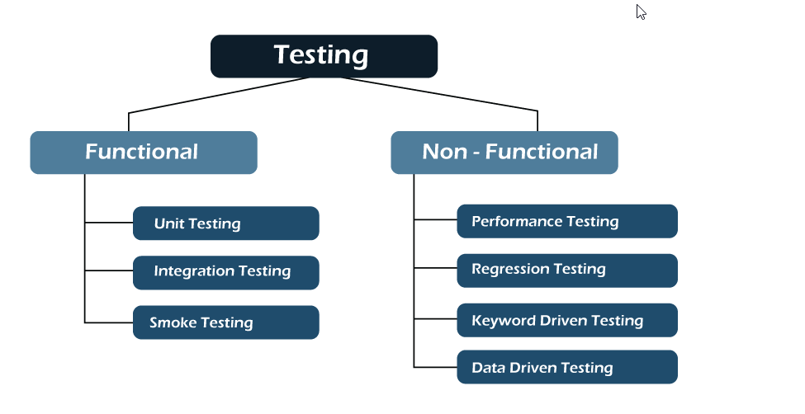

**Difference between JDK, JRE, JVM-**

**JDK-** JDK is an acronym for Java Development Kit. The Java Development Kit (JDK) is a software development environment which is used to develop Java applications and [applets](https://www.javatpoint.com/java-applet). It physically exists. It contains JRE + development tools.

The JDK contains a private Java Virtual Machine (JVM) and a few other resources such as an interpreter/loader (java), a compiler (javac), an archiver (jar), a documentation generator (Javadoc), etc. to complete the development of a Java Application.

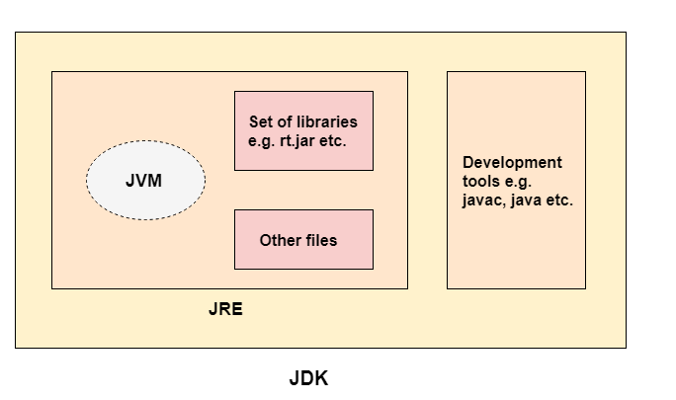

**JRE-** JRE is an acronym for Java Runtime Environment. It is also written as Java RTE. The Java Runtime Environment is a set of software tools which are used for developing Java applications. It is used to provide the runtime environment. It is the implementation of JVM. It physically exists. It contains a set of libraries + other files that JVM uses at runtime.

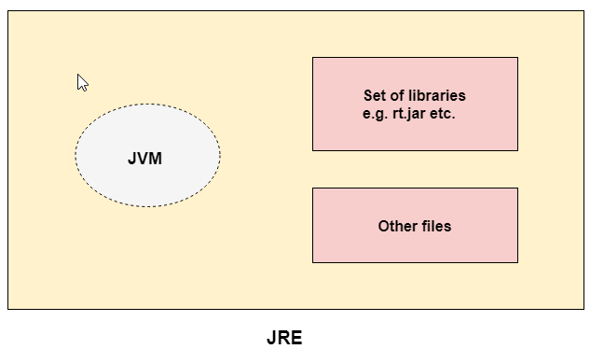

**JVM-** JVM (Java Virtual Machine) is an abstract machine. It is called a virtual machine because it doesn't physically exist. It is a specification that provides a runtime environment in which Java bytecode can be executed. It can also run those programs which are written in other languages and compiled to Java bytecode.

The JVM performs the following main tasks:

* Loads code
* Verifies code
* Executes code
* Provides runtime environment

**Features of JAVA-**

The primary objective of [Java programming](https://www.javatpoint.com/java-tutorial) language creation was to make it portable, simple and secure programming language. Apart from this, there are also some excellent features which play an important role in the popularity of this language. The features of Java are also known as Java buzzwords.

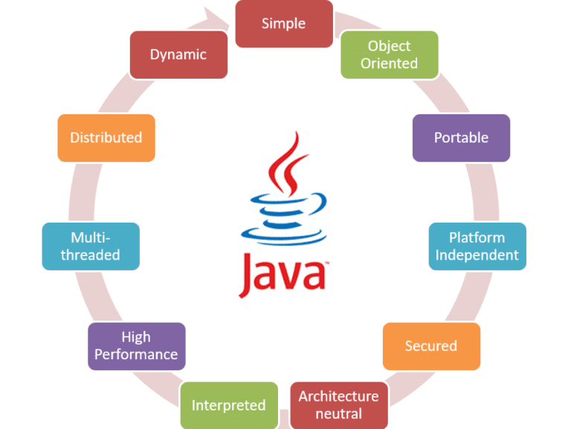

**What is Selenium and Why Java for Selenium?**

[Selenium](https://www.geeksforgeeks.org/selenium-basics-components-features-uses-and-limitations/) is a widely used tool for testing web-based applications to see if they are doing as expected. It is a prominent preference amongst testers for cross-browser testing and is viewed as one of the most reliable systems for web application automation evaluation. Selenium is also platform-independent, so it can provide distributed testing using the Selenium Network.

Selenium with Java refers to the combination of Selenium, a popular tool for automating web browsers, with the Java programming language. Selenium specifically, is used with Java to create automated tests for web applications. Java provides a robust and versatile environment for writing Selenium scripts, offering features such as object-oriented programming, extensive libraries, and platform independence. This combination enables developers and testers to automate interactions with web elements, simulate user actions, and verify expected behavior across different browsers and operating systems.

