Radiya Khondakar

Winter 2023

CIS 436 Project 4

Description:

The app I created allows users to play games about different countries. At the moment, the list of country names is limited. However, in the future if I were to expand this app, I would try to create/use an API with more country names.

There are two different games available. The first is “Guess Locations Game.” In this game, users can choose a country from the drop-down spinner and a location image is displayed. Users can then guess the location by entering a location and clicking the guess button. The app checks if the answer is correct or not and outputs feedback. If correct, the user is told the answer is correct. If incorrect, they are told that it is incorrect. If blank, they are prompted to enter location name.

The second game is “Guess Capitals Game.” In this game, users choose a country from the drop-down spinner and guess the capital by entering a capital and clicking the guess button. The app checks if the capital entered is correct and outputs feedback. If correct, the user is told the answer is correct. If incorrect, they are told that it is incorrect. If blank, they are prompted to enter the capital.

Screenshots:

**Main Fragment:**

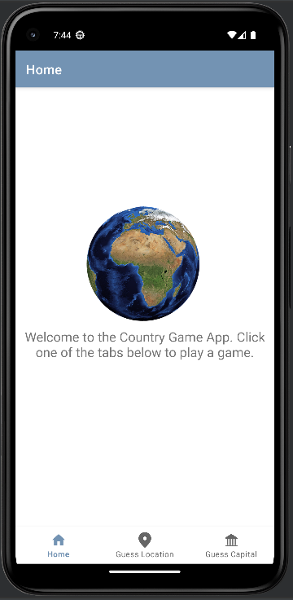

**Locations Game Fragment:**

Blank Answer:

**Capitals Game Fragment:**

Correct Answer: Incorrect Answer:

Blank Answer:

