**TUGAS 4 PRAKTIKUM**

**REKURENSI DAN PARADIGMA ALGORITMA DIVIDE & CONQUER**



**Muhammad Siradj Al Fauzi**

**140810170021**

**PROGRAM STUDI S-1 TEKNIK INFORMATIKA**

**FAKULTAS MATEMATIKA DAN ILMU PENGETAHUAN ALAM**

**UNIVERSITAS PADJADJARAN**

**2019**

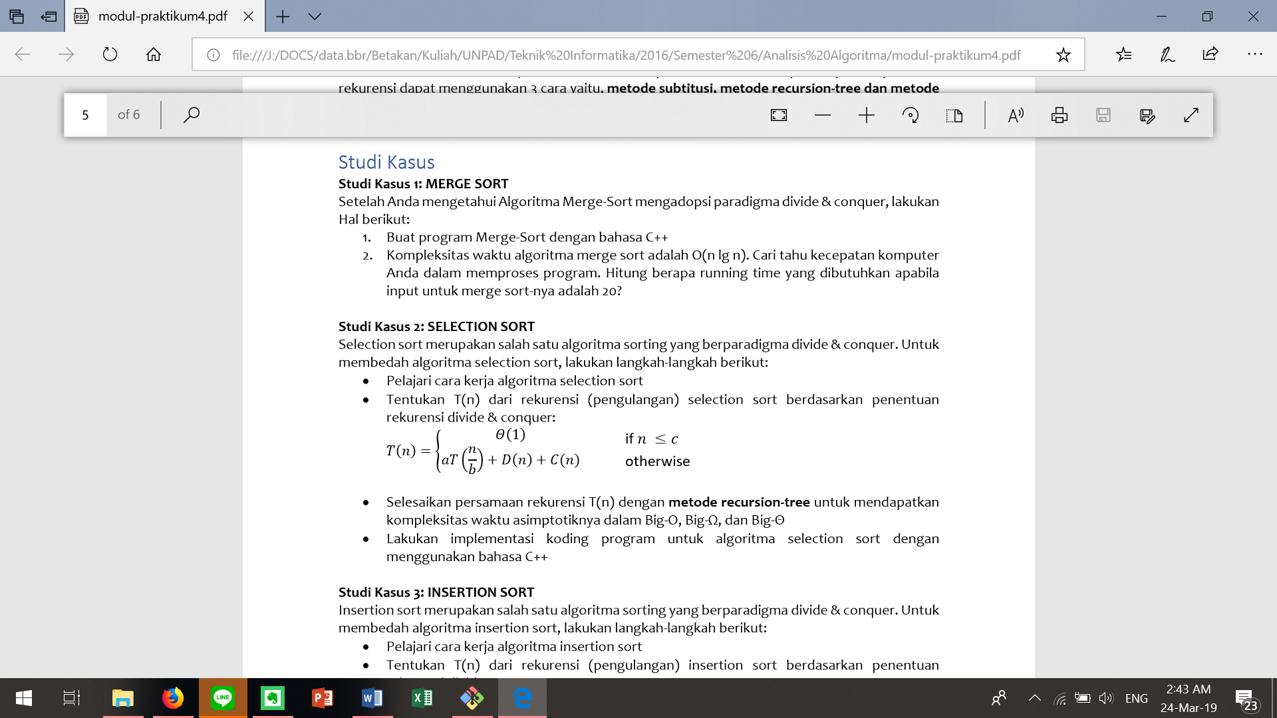

Jawab:

/*

Nama : Muhammad Siradj Al Fauzi

NPM : 140810170021

Kelas : A

*/

#include <iostream>

#include <chrono>

using namespace std;

using namespace std::chrono;

void merge (int *a, int low, int high, int mid){

int i, j, k, temp[high-low+1];

i = low;

k = 0;

j = mid + 1;

while (i <= mid && j <= high){

if (a[i] < a[j]){

temp[k] = a[i];

k++;

i++;

}

else {

temp[k] = a[j];

k++;

j++;

}

}

while (i <= mid){

temp[k] = a[i];

k++;

i++;

}

while (j <= high){

temp[k] = a[j];

k++;

j++;

}

for (i = low; i <= high; i++){

a[i] = temp[i-low];

}

}

void mergeSort(int *a, int low, int high){

int mid;

if (low < high){

mid=(low+high)/2;

mergeSort(a, low, mid);

mergeSort(a, mid+1, high);

merge(a, low, high, mid);

}

}

int main(){

int n, i;

high_resolution_clock::time_point t1 = high_resolution_clock::now();

cout<<"Masukkan jumlah elemen data yang ingin diurutkan: ";

cin>>n;

int arr[n];

for(i = 0; i < n; i++){

cout<<"Masukkan elemen ke-"<<i+1<<": ";

cin>>arr[i];

}

mergeSort(arr, 0, n-1);

cout<<"\nArray yang telah diurutkan: ";

for (i = 0; i < n; i++) cout<<" "<<arr[i];

high_resolution_clock::time_point t2 = high_resolution_clock::now();

auto duration = duration_cast<microseconds>( t2 - t1 ).count();

cout<<endl<<duration<<" microseconds"<<endl;

}

* Screenshot output:

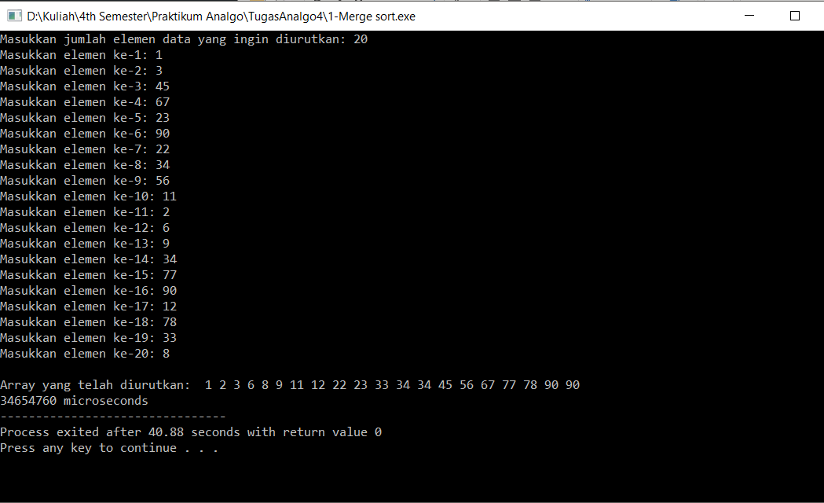

* Kompleksitas waktu:

Big-O = Big-Ω = Big-θ = n * log n

Durasi waktu yang dibutuhkan untuk 20 input: 34654760 ms = 34.65476 s

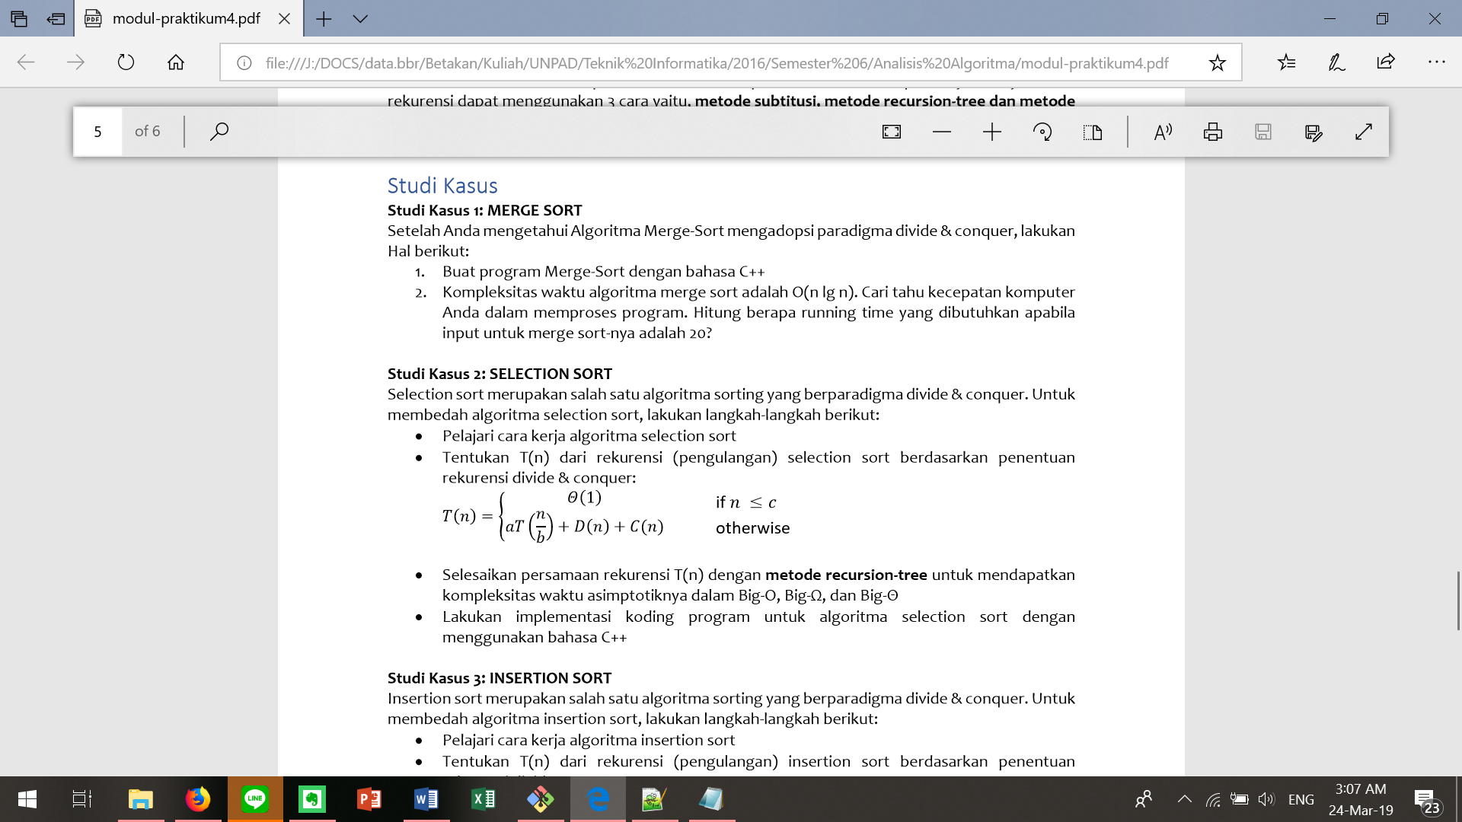



Jawab:

/*

Nama : Muhammad Siradj Al Fauzi

NPM : 140810170021

Kelas : A

*/

#include <iostream>

using namespace std;

void selectionSort (int arr[], int n){

int i, j;

for (i = 0; i < n; ++i){

for (j = i+1; j < n; ++j){

if (arr[i] > arr[j]){

arr[i] = arr[i]+arr[j];

arr[j] = arr[i]-arr[j];

arr[i] = arr[i]-arr[j];

}

}

}

}

int main(){

int n, i;

cout<<"Masukkan jumlah elemen data yang ingin diurutkan: ";

cin>>n;

int arr[n];

for(i = 0; i < n; i++){

cout<<"Masukkan elemen ke-"<<i+1<<": ";

cin>>arr[i];

}

selectionSort(arr, n);

cout<<"\nArray yang telah diurutkan: ";

for (i = 0; i < n; i++) cout<<" "<<arr[i];

}

* Screenshot output:

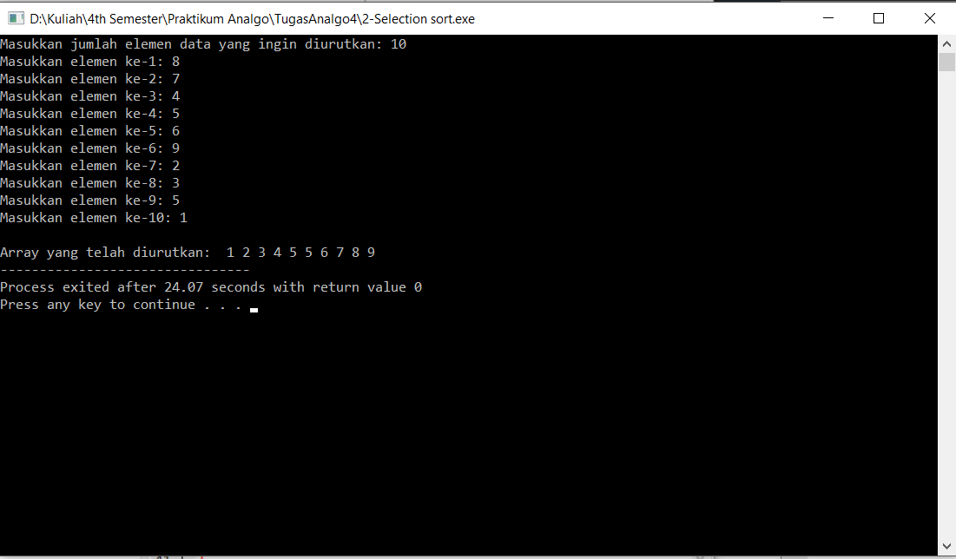

* Kompleksitas waktu:

Big-O = Big-Ω = Big-θ = n2

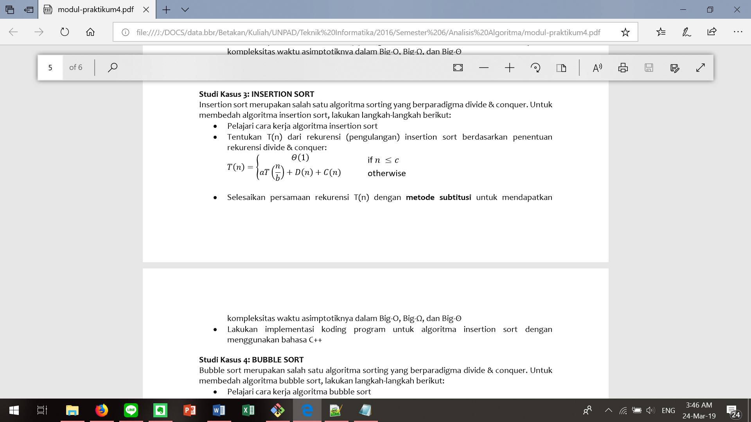





Jawab:

/*

Nama : Muhammad Siradj Al Fauzi

NPM : 140810170021

Kelas : A

*/

#include <iostream>

using namespace std;

struct list {

int data;

list *next;

};

list* InsertinList(list *head, int n){

list *newnode = new list;

list *temp = new list;

newnode->data = n;

newnode->next = NULL;

if(head == NULL){

head = newnode;

return head;

}

else {

temp = head;

if(newnode->data < head->data){

newnode->next = head;

head = newnode;

return head;

}

while(temp->next != NULL){

if(newnode->data < (temp->next)->data)

break;

temp=temp->next;

}

newnode->next = temp->next;

temp->next = newnode;

return head;

}

}

int main(){

int n, i, num;

list *head = new list;

head = NULL;

cout<<"Masukkan jumlah elemen data yang ingin diurutkan: ";

cin>>n;

for(i = 0; i < n; i++){

cout<<"Masukkan elemen ke-"<<i+1<<": ";

cin>>num;

head = InsertinList(head, num);

}

cout<<"\nArray yang telah diurutkan: ";

while(head != NULL){

cout<<" "<<head->data;

head = head->next;

}

}

* Screenshot output:

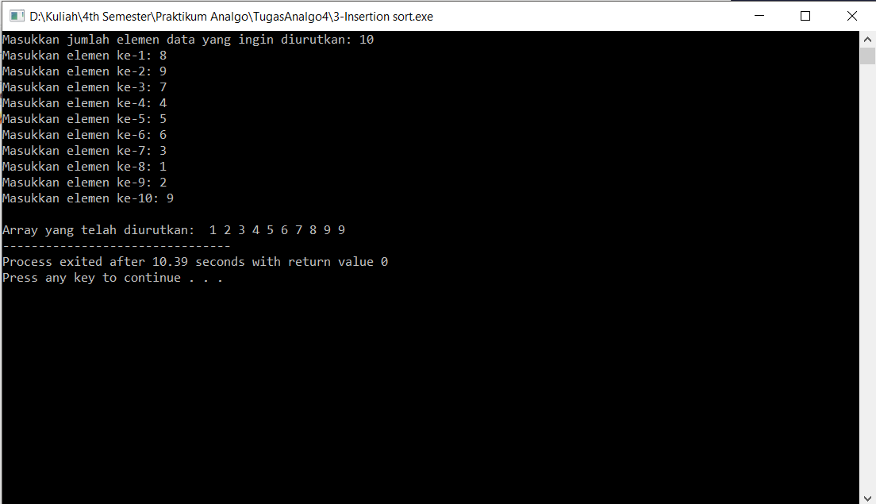

* Kompleksitas waktu:

Big-O = n

Big-Ω = Big-θ = n2

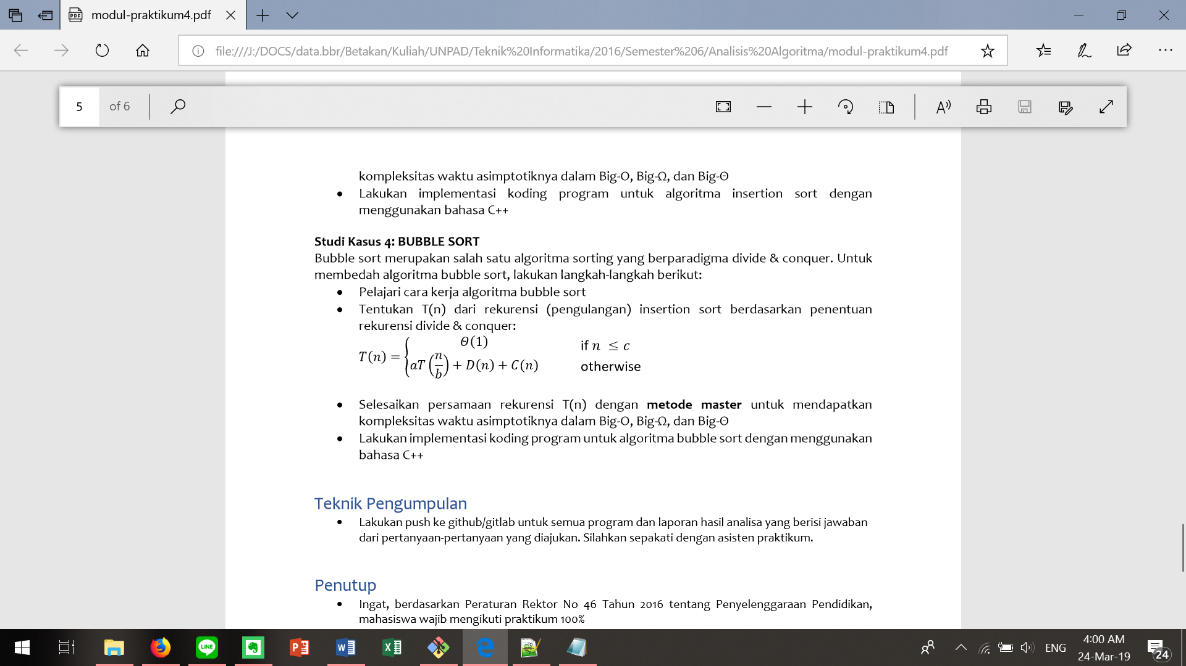

Jawab:

/*

Nama : Muhammad Siradj Al Fauzi

NPM : 140810170021

Kelas : A

*/

#include <iostream>

using namespace std;

void bubbleSort (int arr[], int n){

int i, j;

for (i = 0; i < n; ++i){

for (j = 0; j < n-i-1; ++j){

if (arr[j] > arr[j+1]){

arr[j] = arr[j]+arr[j+1];

arr[j+1] = arr[j]-arr[j + 1];

arr[j] = arr[j]-arr[j + 1];

}

}

}

}

int main(){

int n, i;

cout<<"Masukkan jumlah elemen data yang ingin diurutkan: ";

cin>>n;

int arr[n];

for(i = 0; i < n; i++){

cout<<"Masukkan elemen ke-"<<i+1<<": ";

cin>>arr[i];

}

bubbleSort(arr, n);

cout<<"\nArray yang telah diurutkan: ";

for (i = 0; i < n; i++){

cout<<" "<<arr[i];

}

}

* Screenshot output:

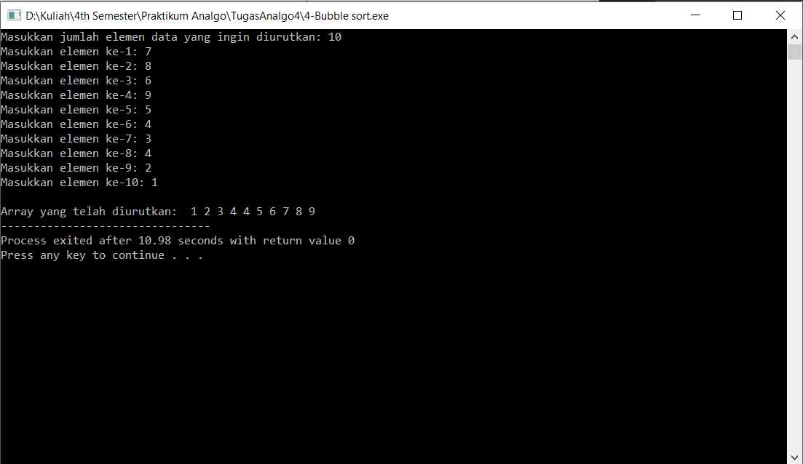

* Kompleksitas waktu:

Big-O = n

Big-Ω = Big-θ = n2