Aparatura automatyzacji
Rok 2, semestr letni 2015

Ćwiczenie nr 9: Układ sterowania ogniw słonecznych.

Exercise 9: The control system of solar cells

Data wykonania ćwiczenia: 24.03.2015
Grupa 8:
Aleksanderek Jakub
Carvetta Antonio
Radzio Łukasz

1) Workstation
The exercise involved implementing a control system with operating panel to manipulate the solar cells. The workstation contained PC with installed VisiDAQ software, 12V DC motor, light sensors, limit position sensors, 3 modules from ADAM4000 series: ADAM4018, ADAM4050, ADAM4060.

2) VisiDAQ
VisiDAQ is a software which is a newer and 32-bit version of GENIE. The overall look of the application is practically the same. The work of the program consists in translating graphical language to commands in ASCII code.

3) ADAM4000
ADAM4000 series is a set of intelligent sensor-to-computer interface
modules. They are remotely controlled through a simple set of commands issued in ASCII format and transmitted in RS-485 protocol. The modules used during exercise are:
-ADAM4018 – 8 channel analog input/output module (TC/mV/V/mA) to which light sensors and position sensors were connected
-ADAM4050 – module with 7 input and 8 output binary channels, it was used to connect the limit position sensors,
-ADAM4060 – relay module, 2 x C, 2 x A, used to control the DC motor.

4) Exercise execution
During the exercise we created the operational panel, that enabled the user to control the position of solar cells. The application provided also the current values of parameters measured be sensors. The most difficult part of the exercise was to scale the readings of position sensors. It was due to the fact that the limit position values of changed during the exercise and it took a long time to measure all four of them.

// Print Screeny

5) Automatic Control
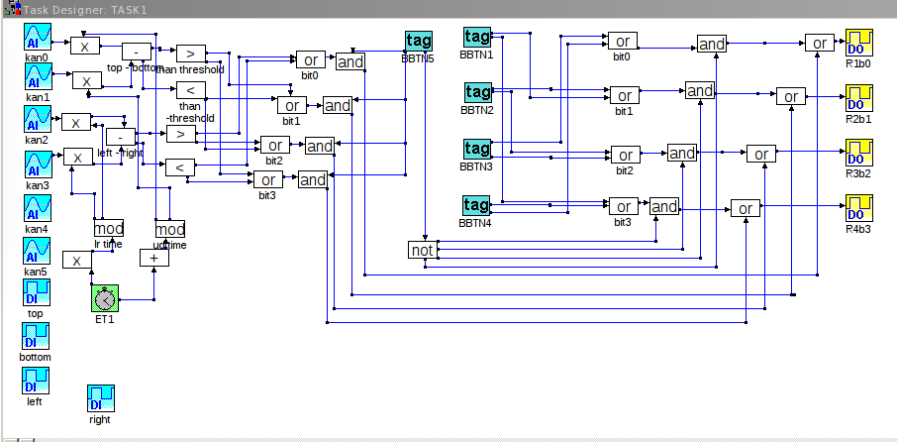
We didn't manage to implement the automatic control algorithm, but during the preparation to the exercise we came up with the idea how such a program should work.
Firstly it should compare readings of opposite sensors and check whether the difference between them is greater than a set threshold. The effect of such a comparison is a decision in which direction the solar cells should move. We have 9 states: 0, L, R, U, D, LU, LD, RU, RD. The connection of DC motor makes it impossible to move on both diagonals, so we thought to introduce a clock to the system. The task of which would be to distribute time to each diagonal. This solution enables one to easily implement automatic control using 5 states, but has major drawback which is the fact that there exists a delay between the signal and work of motor.

