Aparatura automatyzacji
Rok 2, semestr letni 2015

Ćwiczenie nr 8: Pakiet GENIE do realizacji bezpośredniego sterowania cyfrowego

Exercise 8: GENIE sofware
for direct digital control

Data wykonania ćwiczenia: 17.03.2015
Grupa 8:
Aleksanderek Jakub
Carvetta Antonio
Radzio Łukasz
1. GENIE 3.0 software
Genie 3.0 is a software dedicated to creating data acquisition and control applications for Advantech industrial control hardware. It supports, among others, ADAM-4000 and ADAM-5000 modules, and runs on older MS windows operating systems.
The program consists of four main components, as listed in manual:
- Script designer, allowing for writing own scripts in Visual Basic as well as their compilation and debug
- Task designer, where tasks can be created by arranging blocks, representing various functions
- Display designer, in which a graphical display and operating panel can be customized
- Report designer, allowing for pre-scheduled data collection.
%być może Antonio mógłby dorzucić tutaj parę zdań o ADAMach, tak dla picu
Advantages and disadvantages:

Main advantage of the software is it's simplicity – many tasks can be set up just by connecting blocks, and creating the display is similarly easy. Additionally, the application is light-weight, making it possible to run it even on rather venerable computers.
Nonetheless, GENIE has some drawbacks, notably it does not cooperate very well with modern OS,
and displays created in designer are rather crude-looking.

%powyższe być może do uzupełnienia, jeśli przyjdą ci do głowy jakieś wady i zalety

2. Exercise execution
The hardware was already set-up, it is all wires were connected to the devices in manner described in laboratory exercise manual:
- lamp was connected to digital output of ADAM 5060
- thermometer was wired to analog input of ADAM 5013
- small solar cell was connected to analog input of ADAM 5018
- all of above ADAM modules were socketed in ADAM 5000 main unit, which in turn was plugged into computer by means of RS-232 serial port

In general, task was planned (with aid of the teacher) to be as below:
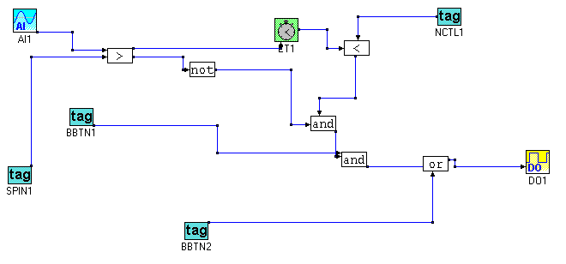
Where AI1 corresponds to analog input from lighting sensor, NCTL1 to numeric control item, controlling lighting time, SPIN1 is connected to spin controller setting light threshold BBTN1 and BBTN2 control device on/off and manual override functions, respectively, and DO1 is lamp switch.
Operating panel for the exercise is shown below.
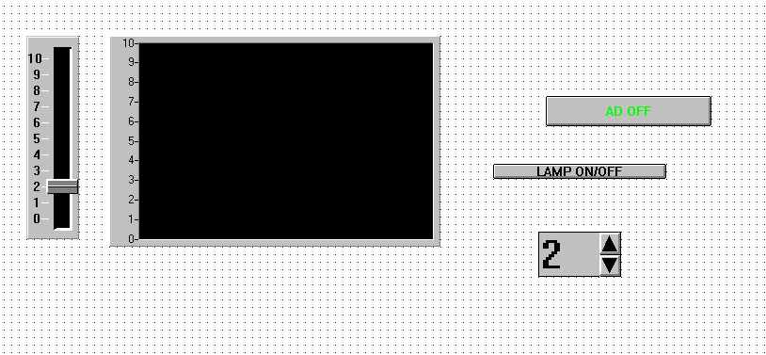
AD OFF stands for Automatic Device OFF. Button labelled LAMP ON/OFF, as expected, turns the lamp OFF, regardless of lighting level. Numerical input window to the right is used to set time of lighting, while spin to the left is responsible for setting the threshold below which the lamp is lit.

%można zapewne opisać logikę dzialania, ale tylko jeśli naprawdę się nam tego chce
3. Conclusions
During the exercises it has been observed, that with use of GENIE software, creating simple applications controlling various processes and data collection is relatively easy, even though it still requires some

