How to install SQL Server and SSMS

1. Go to link <https://www.microsoft.com/en-us/sql-server/sql-server-downloads>
2. Scroll down, and click on button under Developer like in the picture bellow (free edition)

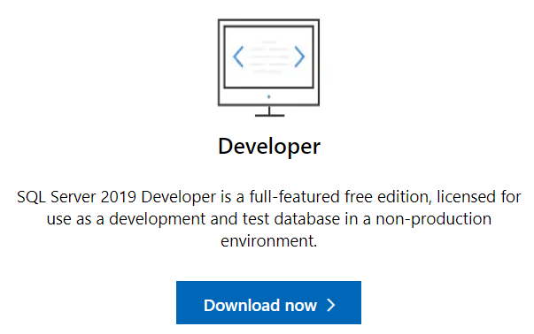

1. When the file is downloaded double click on it to run the installation
2. From the options in the picture, click on Basic

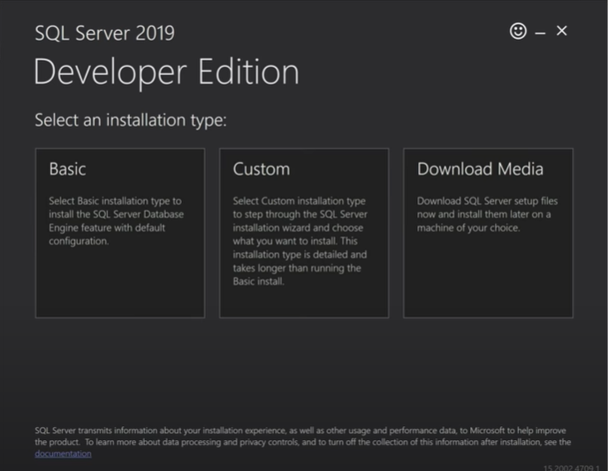

1. Next, click on accept button, and then click on Install button

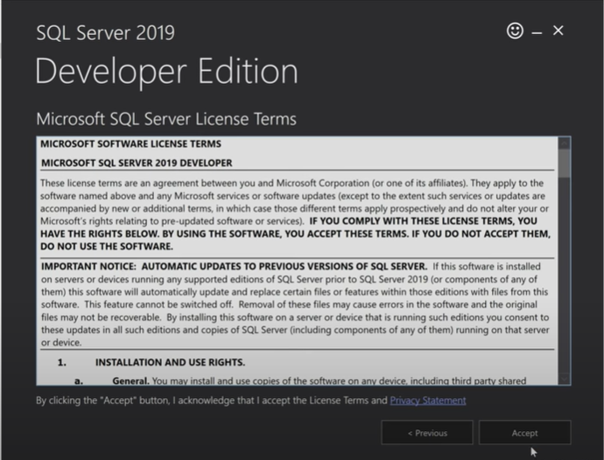

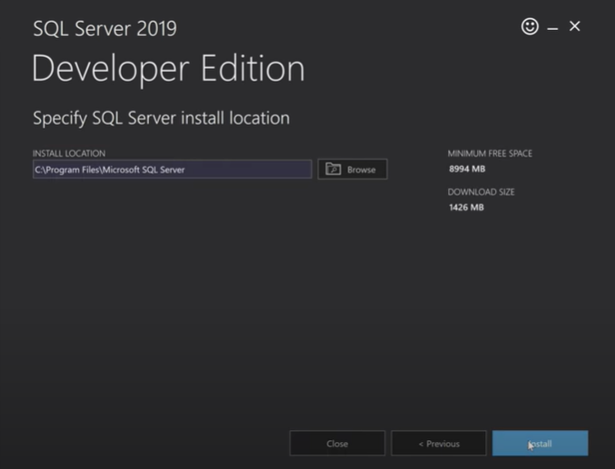

1. Next, when installation is done click on button install SSMS

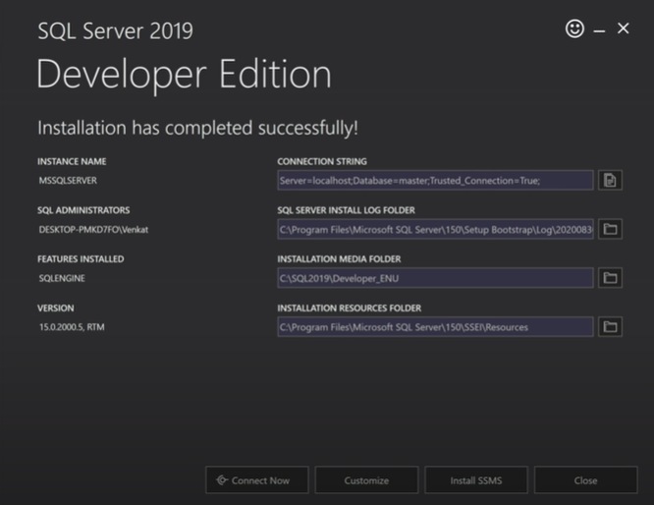

1. The button will redirect you to the official Microsoft page, and there click on the link

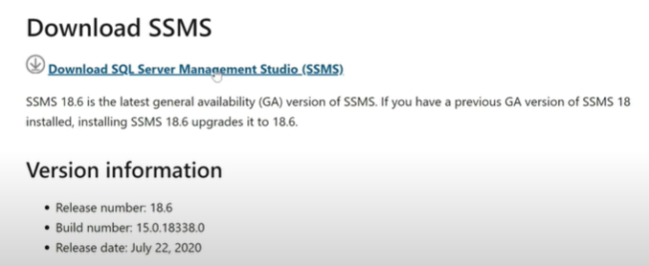

1. When the download is done, double click on the file, click accept and run the installation.
2. When the installation is done click on Close button (picture 6. from above).
3. Click on Start button, and type Services. When the list of services is opened, find the service like in the picture bellow, and make sure it is running



1. To find the SSMS, click on Start button, (bottom left), and search for Microsoft SQL Server Management Studio, or just type SSMS.
2. When you find the program, double click on it. Then try to login on localhost server, like in the picture bellow, using Windows authentication

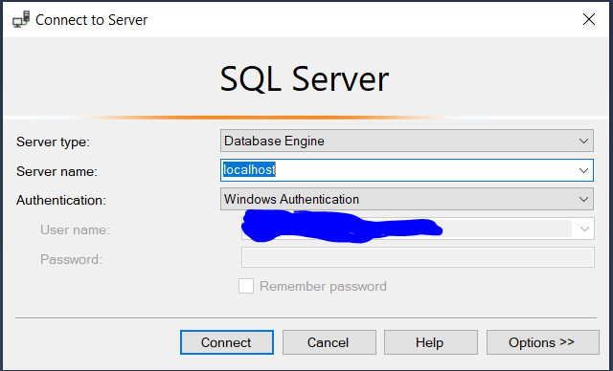

1. Click on connect, and there you go.