**PROCEDURE:**

**--------------------**

* Installed VMware workstation 17 in Laptop and create a VM with Ubuntu Jammy Jellyfish 22.04 as per the requirement from below documentation.

<https://docs.docker.com/desktop/install/linux-install/>

* Once VM is deployed, we need to install GNOME for non-GNOME linux environments. But in ubuntu 22.04 it is installed by default and it can be verified in system details.

Navigation: Settings > About > GNOME version

**CREATE REPOSITORY FOR DOCKER INSTALLATION:**

**------------------------------------------------------------------**

Before we install Docker Engine for the first time on a new host machine, we need to set up the Docker repository.

* APT- Advanced Package tool is used in the command line to configure repository or install packages in the host.

* The below commands can be used to create repository.

# Add Docker's official GPG key:  
**sudo apt-get update  
sudo apt-get install ca-certificates curl  
sudo install -m 0755 -d /etc/apt/keyrings  
sudo curl -fsSL** [**https://download.docker.com/linux/ubuntu/gpg -o /etc/apt/keyrings/docker.asc**](https://download.docker.com/linux/ubuntu/gpg%20-o%20/etc/apt/keyrings/docker.asc) **sudo chmod a+r /etc/apt/keyrings/docker.asc**

# Add the repository to Apt sources:  
**echo \  
 "deb [arch=$(dpkg --print-architecture) signed-by=/etc/apt/keyrings/docker.asc]** [**https://download.docker.com/linux/ubuntu**](https://download.docker.com/linux/ubuntu) **\  
 $(. /etc/os-release && echo "$VERSION_CODENAME") stable" | \  
 sudo tee /etc/apt/sources.list.d/docker.list > /dev/null  
sudo apt-get update**

**INSTALL THE DOCKER PACKAGE:**

**------------------------------------------**

If we use a root account to login to the VM, 'sudo' command is not required. Here I am using my own account and hence I am delegating Super User authority to my account and sudo commands.

* Use the below command to install the docker engine in the VM,

**sudo apt-get install docker-ce docker-ce-cli containerd.io docker-buildx-plugin docker-compose-plugin**

* If required you can verify the version of docker installed using the below command,

**docker --version or docker --v**

My environment is installed with the version- **"**Docker version 27.0.3, build 7d4bcd8"

* Verify if the Docker Engine installation is successful by running below command,

**sudo docker run hello-world**

**Note:** This command downloads a test image and runs it in a container. When the container runs, it prints a confirmation message and exits.

Reference: <https://docs.docker.com/engine/install/ubuntu/>

We can use any one of the method to install the docker on ubuntu as mentioned in the below documentation.

(I have used first method since the VM that I have deployed in VMware workstation is enabled with internet connection and able to reach <http://download.docker.com> to pull the required packages for Docker installation)

**WEBAPP FUNCTIONALITY:**

**-----------------------------------**

Webapp functionality is to add, edit and delete student into student database. A request to the webserver can post, put, delete the from the web browser.

Created an application code Used MongoDB, Express.js, React.js, Node.js for creating simple Student Database project

**DEPLOYING WEBAPP in DOCKER:**

**--------------------------------------------**

1. Docker is deployed in the VM using the steps described initially.
2. Used MongoDB, Express.js, React.js, Node.js for creating simple Student Database project
3. The project has server, client and database, with their respective docker file
4. Folder- " C:\my_proj\proj_docker\docker"
5. **File- "Dockerfile"** to tell the application how it is going to run. Created under the folder created and specified

* **Client side - "Dockerfile":**

***FROM node:latest AS builder***

***WORKDIR /app***

***COPY package.json .***

***RUN npm install***

***COPY . .***

***RUN npm run build***

***FROM nginx:1.25.2-alpine-slim***

* **Server side - "Dockerfile":**

***FROM node:20-alpine3.17***

***WORKDIR /app***

***COPY package.json .***

***RUN npm install***

***COPY . .***

***EXPOSE 5000***

***CMD ["npm", "start"]***

***COPY --from=builder /app/build /usr/share/nginx/html***

***EXPOSE 80***

***CMD ["nginx", "-g", "daemon off;"]***

* **Docker-Compose.yaml:**

 version: '3.8'

# Services

services:

# Server service

server:

build:

context: ./server

dockerfile: Dockerfile

container_name: backend

ports:

- "5000:5000"

env_file: ./.env

environment:

- DB_HOST=mongodb

- DB_USER=$MONGODB_USER

- DB_PASSWORD=$MONGODB_PASSWORD

- DB_NAME=$MONGODB_DATABASE

- DB_PORT=$MONGODB_DOCKER_PORT

depends_on:

- mongodb

# Client service

client:

build:

context: ./client

dockerfile: Dockerfile

container_name: frontend

ports:

- "80:80"

depends_on:

- server

# Database service

mongodb:

image: mongo:latest

container_name: mongodb_server

env_file: ./.env

environment:

- MONGO_INITDB_ROOT_USERNAME=$MONGODB_USER

- MONGO_INITDB_ROOT_PASSWORD=$MONGODB_PASSWORD

ports:

- "27017:27017"

volumes:

- ./../mydata:/data/db

# Volumes define

volumes:

mydata:

**BUILD A DOCKER IMAGE:**

**-----------------------------------**

* Navigate in terminal to path- " C:\my_proj\proj_docker\docker" and run the below command to build the docker image

**Sudo docker compose up --build .**

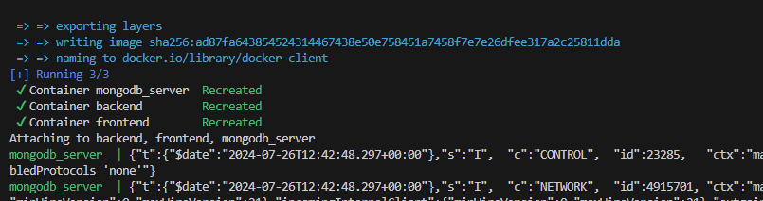

* Use the URL in local browse and confirm if it is able to fetch the image as desired.

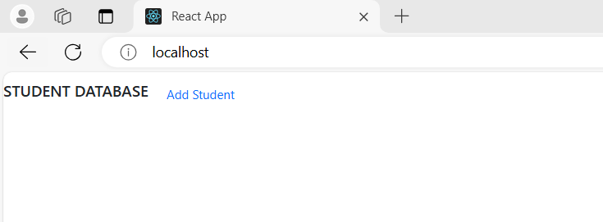

* Add student 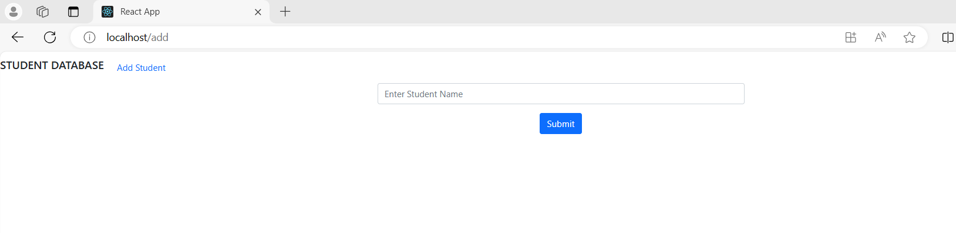
* Student added successfully

