create table students(id int primary key, fname varchar(20), lname varchar(20),city varchar(10),

department varchar(10));

create table department(d_name varchar(10),st_id int references students, fname varchar(20));

select * from students;

**TRIGGERS**

**Insert trigger**

CREATE TRIGGER ins after INSERT ON students

FOR EACH ROW insert into department values(NEW.department,NEW.id,NEW.fname);

insert into students values(1,'a','m','mumbai','cs');

insert into students values(2,'a','m','mumbai','cs');

select * from students;

select * from department;

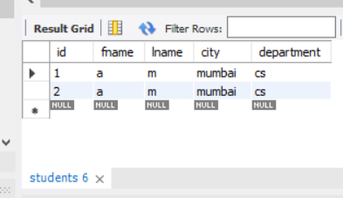

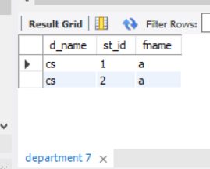

**Update trigger**

CREATE TRIGGER upda after update ON students

FOR EACH ROW

update department set d_name=new.department,fname=new.fname where st_id=new.id;

update students set fname='d' where id=1;

select * from students;

select * from department;

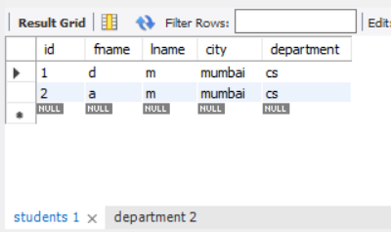

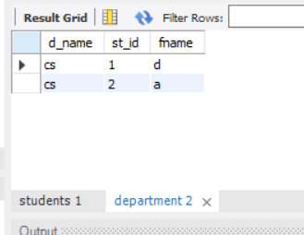

**Delete trigger:**

CREATE TRIGGER del before delete ON students

FOR EACH ROW

delete from department where st_id=old.id;

delete from students where id=1;

select * from students;

select * from department;

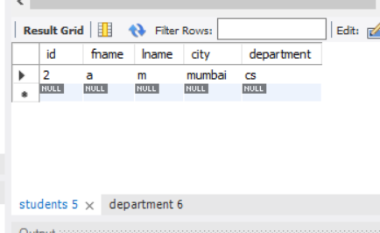

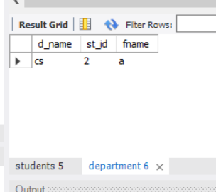

Paging:

select * from employees;

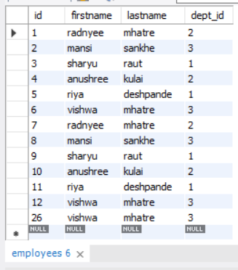

Stored procedure Paging:

CREATE DEFINER=`root`@`localhost` PROCEDURE `paging`(in Pageno int, in rowsno int)

BEGIN

DROP table IF EXISTS emp1;

create table emp1 as (SELECT id, firstname,lastname,dept_id,

ROW_NUMBER() OVER (

ORDER BY id

)

FROM

employees );

select * from emp1 where id>((Pageno-1)*rowsno) and id<=((Pageno)*rowsno);

END

call paging(3,4);

