Candidate key is (Doc no, Patient No,room No)

1NF

We seperate the entry of every doctor as per individual patient and separate the contact details.

Primary key for contact details is Doc no

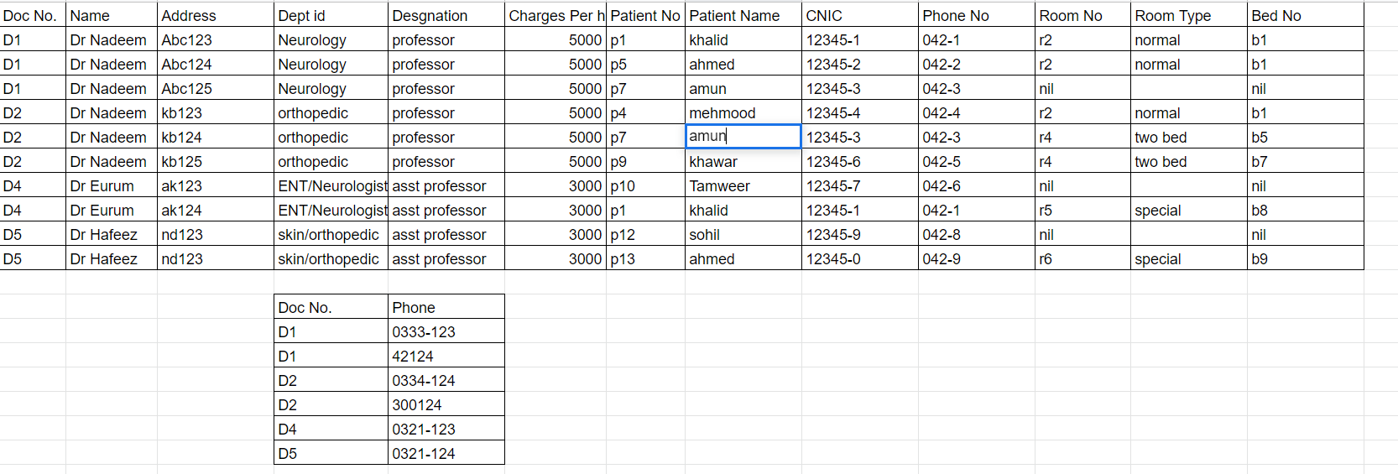

2NF

The patient details are dependent on patient No , doctor details are dependent on doctor no. and the room type is dependent on room no. so we create a seperate tables.

Bed no is dependent on Doc no , patient no, room no.

Doctor_details

Primary key:Doc no

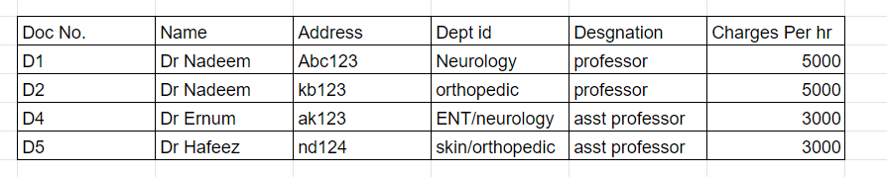

Doctor_contact

Primary Key: Doc No.

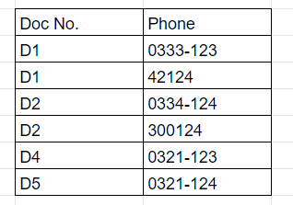

Patient_details

Primary key: Patient No

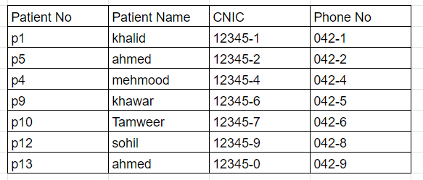

Room_details

Primary key : Room No

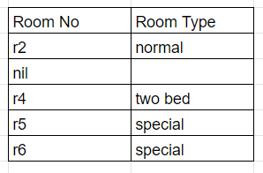

Appointments

Candidate Key:(Doc No.,Patient No., ROOM No.)

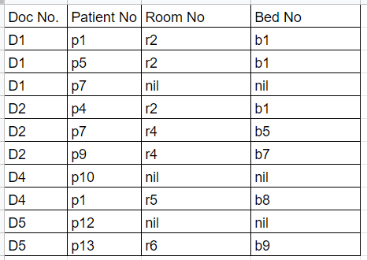

3NF

Charges per hr by doctor is dependent on their designation so we create a seperate table for it

Doctor_details

Primary key:Doc no

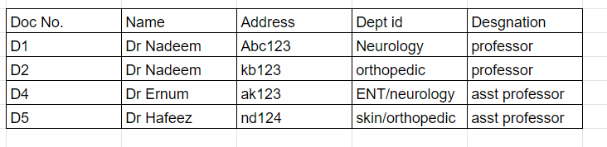

Doctor_charges

Primary key:Designation

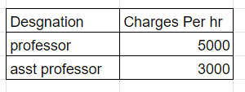

Doctor_contact

Primary key:Doc no



Patient_details

Primary key:Patient No



Room_details

Primary key:Room no



Appointments

Candidate Key:(Doc No.,Patient No., ROOM No.)



BCNF

BCNF is the same as 3NF as there are no determinant attributes in the candidate key.