Readery
USER MANUAL · VERSION 2.1
Amazon Orders
Converter
How to turn Amazon order reports into Gardners i12 .ORD order files, one file per order.
Amazon Orders Converter v2.1 · © 2026 NS Nexus Limited. All rights reserved.

Contents
Section | What it covers
1. About the converter | What it does and the six steps
2. Logging in | Log in, create your customer, reset a forgotten PIN, log out
3. Getting the reports from Amazon | Which reports to download and where to find them
4. Using the converter | Settings, uploading, reviewing, fixing warnings, downloading and order numbers
5. Settings reference | Every field in the Settings panel
6. Inside an .ORD file | How the Gardners order files are built
7. Troubleshooting | Log-in messages and other common problems
8. Daily checklist | The routine to follow every day

1. About the converter
The Amazon Orders Converter turns the order reports you download from Amazon Seller Central into Gardners i12 order files (.ORD). Each Amazon order becomes one file, ready to send to Gardners for fulfilment.
What you put in | What you get out
Unshipped Orders report (.txt) from Amazon, with customer names and addresses | One Gardners .ORD file per Amazon order
All Orders report (.txt) from Amazon, with the prices customers paid (optional) | Orders with several books become one file with a line per book

Good to know
- Customer data stays private. The reports are read inside your web browser. Customer names and addresses are never uploaded; only order numbers go to the number service on the hosting.
- Protected by your PIN. Each company logs in with its Gardners Account ID and a PIN, and has its own numbers and order history.
- Numbers are shared. The header sequence and line references come from the number service, so every computer uses the same numbers and none is ever reused.
- Files are named for you. Each file name is built from your Gardners Account ID, today’s date and the Amazon order number.
- You stay in control. Every order is shown on screen before you download it, and prices can be changed.

The six steps
- Log in with your Gardners Account ID and PIN.
- Download the Unshipped Orders and All Orders reports from Seller Central.
- Check settings, especially the shared numbers.
- Upload both report files to the converter.
- Review each order and fix anything flagged in yellow.
- Download the .ORD files, one per order or all together as a .zip.

2. Logging in
The converter opens on a log-in screen. Your Gardners Account ID is your user name; the PIN keeps your account and numbers private to your company.
Please read this manual before using the tool for the first time. The log-in screen shows the same reminder.

2.1 Log in
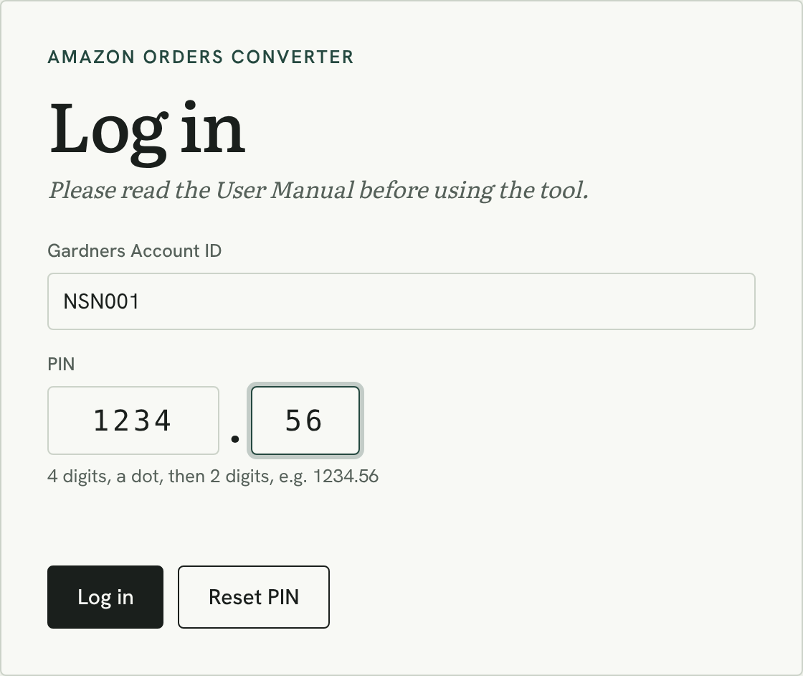
The log-in screen
- Type your Gardners Account ID, e.g. NSN001.
- Type the PIN: 4 digits in the first box and 2 digits in the second, e.g. 1234 . 56. The cursor moves to the second box by itself, and you can also paste a PIN such as 1234.56.
- Press Log in. Your account then shows at the top right of the page, next to Log out.
Logged in as NSN001, with Log out
Good to know
How long you stay logged in | 12 hours from the last use, in that browser tab. Closing the tab logs you out.
Wrong PIN | The message shows how many tries are left. After 5 wrong PINs in a row, log-in for that account is locked for 15 minutes.
Several computers | You can be logged in on several computers at once. They all use the same shared numbers.

2.2 First time: create your customer
If the Gardners Account ID has not been used before, the converter offers to create it.
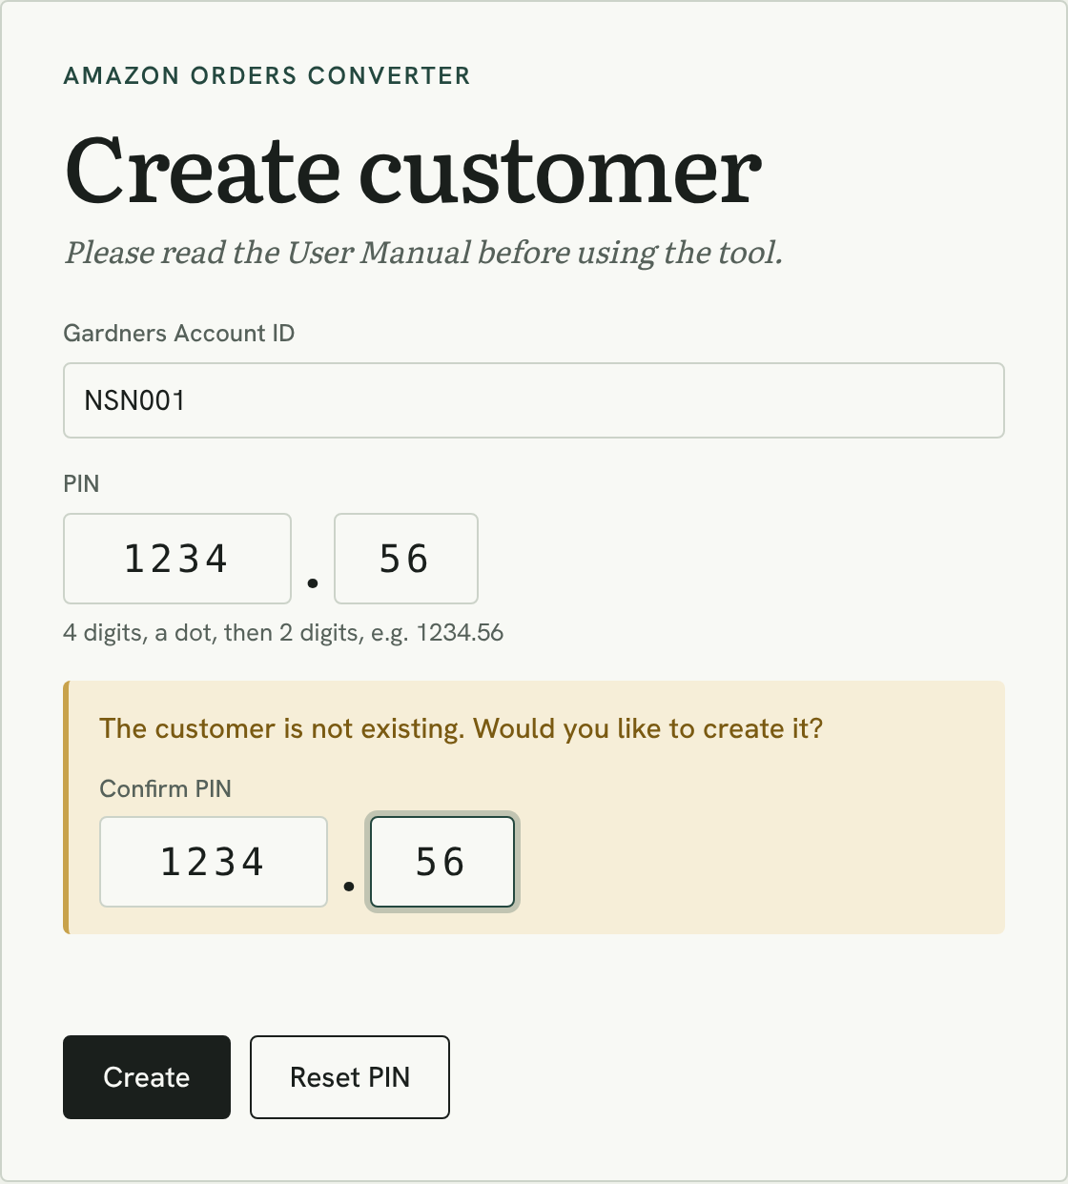
Creating a new customer
- Enter the Gardners Account ID and the PIN you want, then press Log in.
- The message “The customer is not existing. Would you like to create it?” appears.
- Type the same PIN again in Confirm PIN and press Create. You are logged in straight away.
- Go to Settings → Shared numbers and set your starting sequence number and line reference (section 4.1).
Remember your PIN. It is never stored as you type it, so nobody can look it up. If you forget it, use Reset PIN.

2.3 Forgotten PIN: Reset PIN
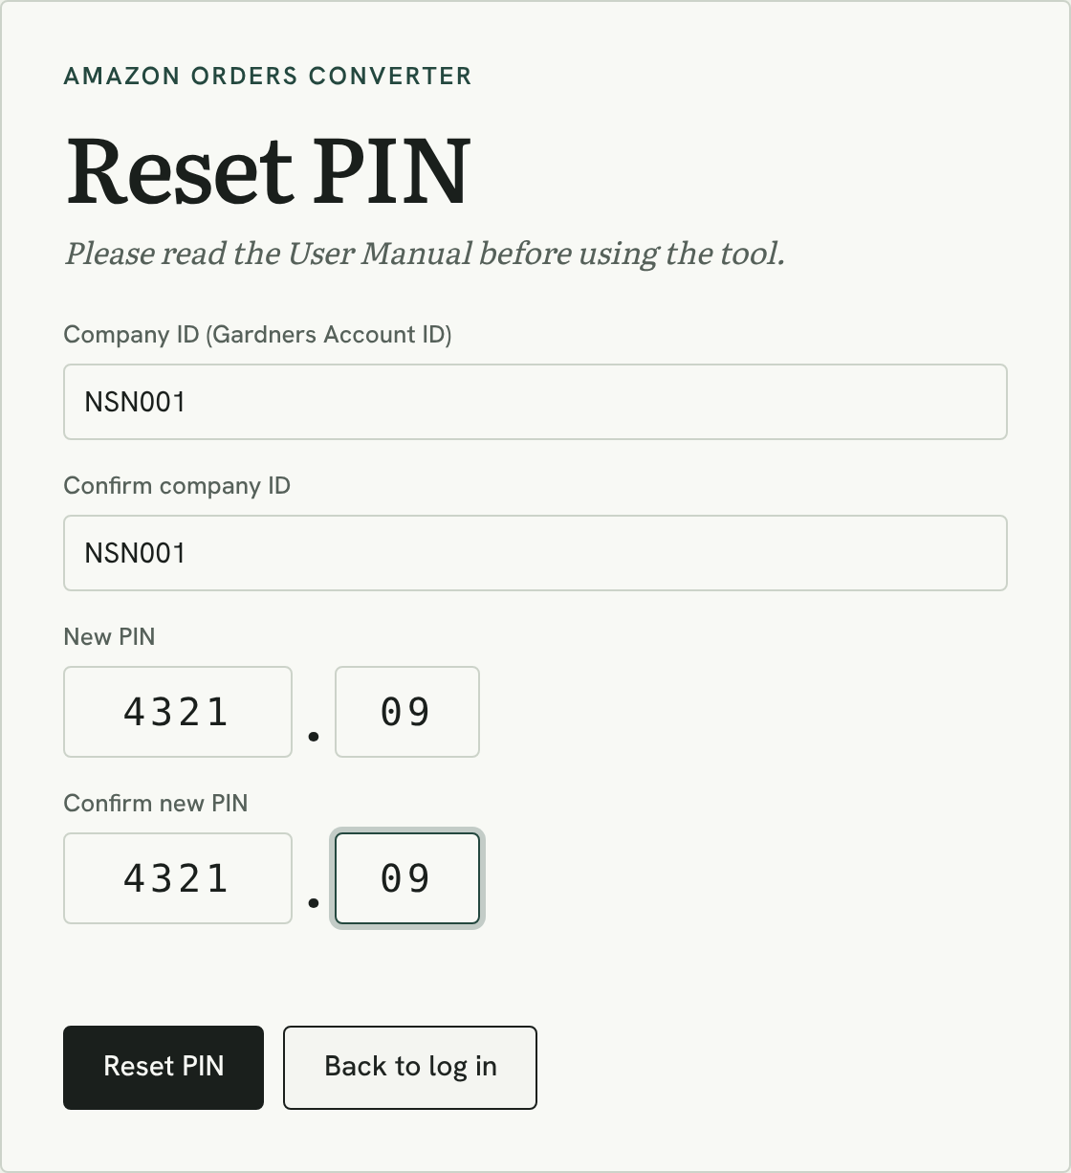
Resetting a PIN
- On the log-in screen, press Reset PIN.
- Enter the company ID (your Gardners Account ID) and confirm it.
- Enter the new PIN and confirm it, then press Reset PIN.
- You are logged in with the new PIN. Every other computer using the account is logged out.
- Check “PIN last changed”. After every log-in, Settings → Shared numbers shows when the PIN was last changed. If you didn’t change it, reset it straight away.
- Limit. A PIN can be reset 3 times per account in 24 hours.

2.4 Log out
Press Log out at the top right when you finish. The loaded reports and orders are cleared from the screen.

3. Getting the reports from Amazon
The converter needs the Unshipped Orders report. The All Orders report is optional but recommended, because it adds the price each customer paid.

3.1 Unshipped Orders report (required)
This report holds the customer’s name, delivery address, the book (SKU/ISBN) and the quantity to send. Orders are built from this report.
- In Seller Central, go to Orders → Order Reports.
- Open the Unshipped Orders tab.
- Click Request Download. After a minute or two, refresh the page and click Download.

3.2 All Orders report (optional)
This report adds the item price and any delivery charge for each book. Without it, you can type the prices in yourself.
- Go to Reports → Fulfillment, then choose All Orders under Sales.
- Set the date to Exact date and pick the day you need.
- Click Request .txt Download and download the file when it’s ready.

Tip: upload the .txt files exactly as Amazon gives them. Opening and saving them in Excel first can change order numbers and break the conversion.

4. Using the converter

4.1 Check your settings
Click Settings to open the panel. Your Gardners Account ID comes from the log-in and is written into every file and file name.
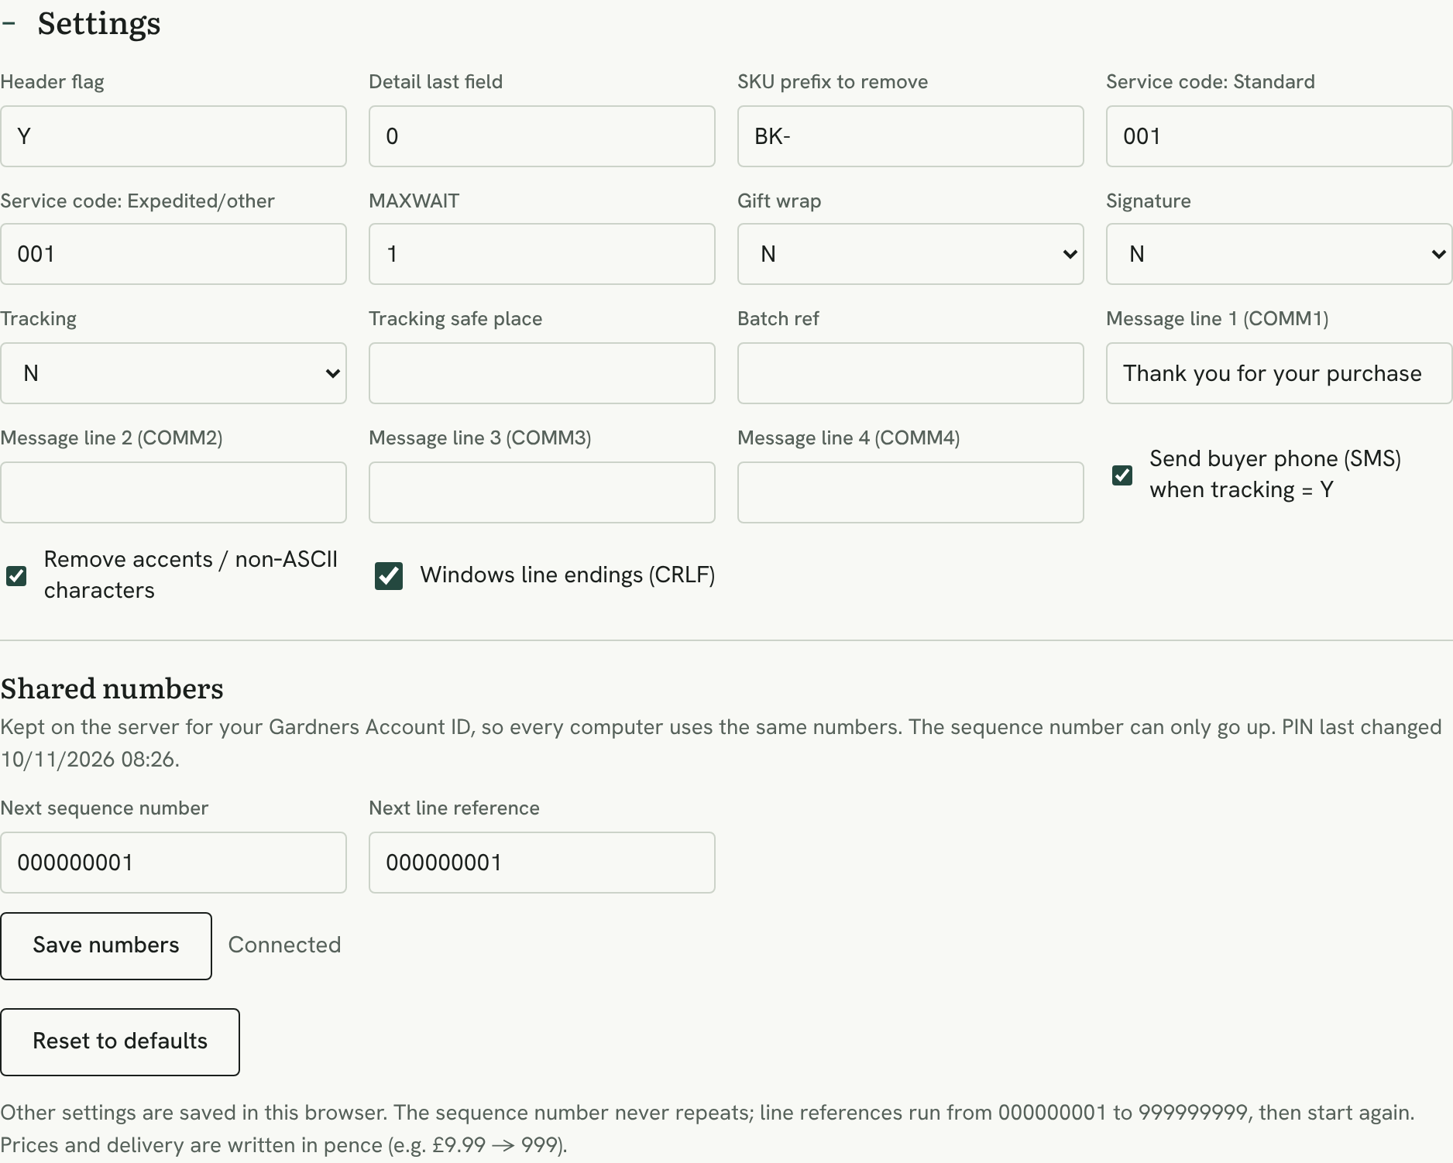
The Settings panel, with Shared numbers at the bottom
- Shared numbers. The next sequence number and next line reference are kept on the server for your Gardners Account ID. Set the starting numbers once and press Save numbers; after that they count up by themselves. The sequence number can only go up. “Connected” shows the number service is working, and the note shows when your PIN was last changed.
- Saved automatically. All other settings are remembered in your browser, so you normally set them once.
- Ready to use. All other fields are pre-filled with values from Gardners’ sample files. See section 5 for what each one does.
- Reset to defaults puts every field back to its original value.

4.2 Upload the report files
Drag both .txt files onto the upload box, or click the box and choose them. You can add them together or one at a time, in any order.
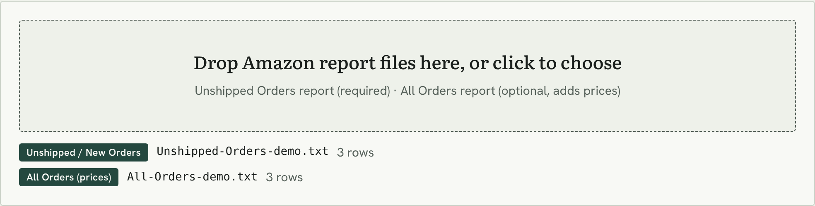
Both files uploaded and recognised
- Check the labels. Each file gets a label: “Unshipped / New Orders” or “All Orders (prices)”. A red label means the file wasn’t recognised.
- Add more at any time. New files are merged with what’s already loaded; an order that appears twice is only listed once.
- Start fresh each day. Press Clear before a new batch so yesterday’s orders don’t mix in.

4.3 Review each order
Every order appears as a card. Check it before downloading.
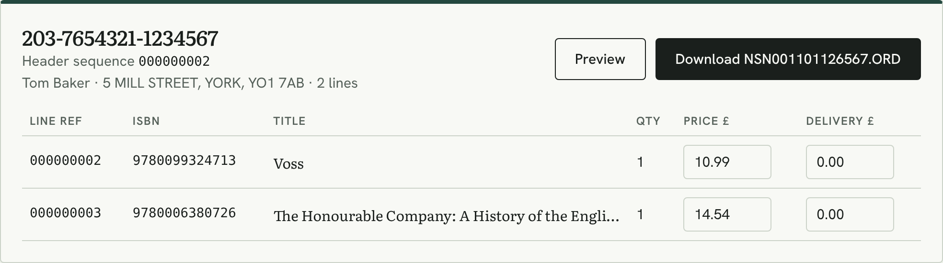
An order with two books
On the card | What it means
Amazon order number | The order as it appears in Seller Central, e.g. 203-7654321-1234567
Header sequence | The order’s unique sequence number, given when you download it
Line ref | Each book’s unique reference, given when you download the order
Name and address | The delivery details that go into the file
ISBN, title, quantity | One row per book. The ISBN comes from your SKU with the prefix removed
Price £ and Delivery £ | Taken from the All Orders report. You can change them, and your values go into the file
Preview | Shows the exact contents of the .ORD file

4.4 Fix anything flagged in yellow
A yellow box on a card means something needs your attention. The order can still be downloaded, so always check before sending it to Gardners.
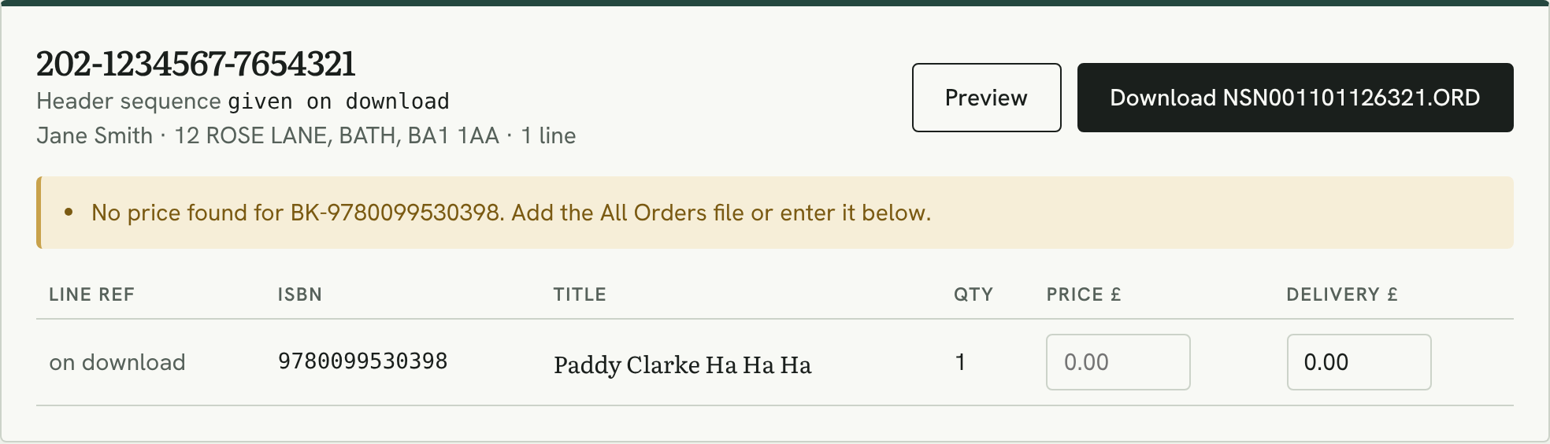
A missing price warning
Warning | What to do
No price found | Add the All Orders report, or type the price into the Price £ box
SKU doesn’t give a valid ISBN | Check the SKU in Amazon. Items that aren’t books can’t be ordered from Gardners
Delivery address line 1 is empty / Postcode is empty | Check the order’s address in Seller Central
Unknown country code | Confirm with Gardners that they can deliver to that country
Another order today ends in the same 3 digits | Both orders get the same file name. Download them one at a time
Nothing left to ship on this order | It has already been shipped, so no file is needed

4.5 Orders that were converted before
An order keeps the numbers it was first given, on any computer. When you load an order that has numbers already, its card says so.
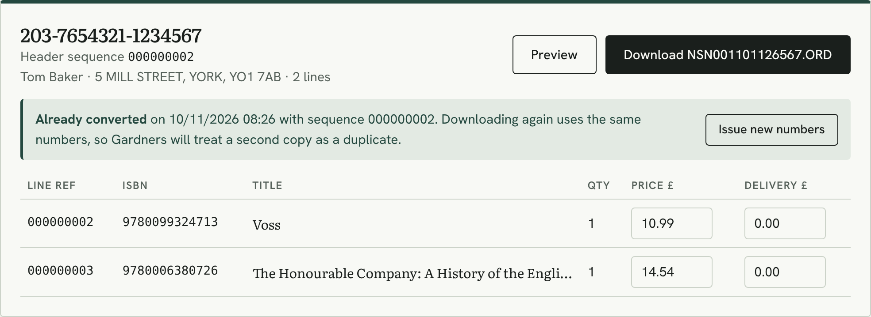
An order that was already converted
- Already converted shows when the order was converted and its sequence number. Downloading again uses the same numbers, so Gardners will treat a second copy as a duplicate and won’t send the books twice.
- Issue new numbers gives the order fresh numbers. Use it only for a deliberate resend, for example after Gardners reject a file. Click it twice to confirm.

4.6 Download the .ORD files
Use Download on an order card to save that order, or Download all (.zip) to save every ready order in one zip file.
The order summary and Download all button
Each file name is made of four parts:
Part | Example | Meaning
Gardners Account ID | NSN001 | From your log-in
Date | 091126 | Today’s date as DDMMYY (9 November 2026)
Order digits | 567 | The last 3 digits of the Amazon order number
Extension | .ORD | The Gardners order file type

Full example: NSN001091126567.ORD

Note: downloads only work when the converter can reach the number service on the hosting. If it can’t, downloads switch off so that numbers are never reused.

4.7 How order numbers work
Gardners need two kinds of numbers in every file. The converter takes both from the number service.
 | Header sequence | Line reference
Counts | One number per order file | One number per book line, across all orders
Format | 000000001, 000000002 … | 9 digits, numbers only
After 999999999 | Carries on: 1000000000 … (up to 20 characters) | Starts again at 000000001
Repeats | Never. A repeated sequence is rejected by Gardners | Only after starting again
Where it goes | HEADER line | First field of each DETAIL line (and in quotes after it)

5. Settings reference
All fields in the Settings panel. Your Gardners Account ID is not a setting any more: it comes from the log-in. Fields marked “Confirm” have a meaning that isn’t documented in Gardners’ samples; check them with Gardners before going live.
Field | Default | What it does
Header flag | Y | The 4th value on the HEADER line. Confirm its meaning with Gardners.
Detail last field | 0 | Last value on each DETAIL line. Confirm its meaning with Gardners.
SKU prefix to remove | BK- | Removed from the Amazon SKU to give the ISBN.
Service code: Standard | 001 | Gardners delivery service for Standard orders. Confirm the code list with Gardners.
Service code: Expedited/other | 001 | Service for Expedited or Next Day orders.
MAXWAIT | 1 | Likely the days to wait for stock. Confirm with Gardners.
Gift wrap | N | Y asks Gardners to gift-wrap the order.
Signature | N | Y asks for signed-for delivery.
Tracking | N | Y asks for a tracked service.
Tracking safe place | (blank) | Optional safe-place note for the courier.
Batch ref | (blank) | Optional label of your own for a group of orders.
Message lines 1 to 4 | Thank you for your purchase | Text printed on the despatch note in the parcel.
Send buyer phone (SMS) when tracking = Y | On | Adds the customer’s phone for SMS tracking. The email is always included.
Remove accents / non-ASCII characters | On | Turns é into e and similar, so names don’t break. Keep it on.
Windows line endings (CRLF) | On | Matches Gardners’ sample files. Keep it on.

Shared numbers
Kept on the server for each Gardners Account ID, so they are the same on every computer.
Field | Starts at | What it does
Next sequence number | 000000001 | The HEADER sequence the next order will get. Can only be increased.
Next line reference | 000000001 | The unique reference the next book line will get.

6. Inside an .ORD file
You don’t need to edit .ORD files, but it helps to know how they’re built. Use Preview on any order to see its file.
Line | Appears | Contains
HEADER | Once, at the top | Your Gardners Account ID, the date and the order’s sequence number
DETAIL | Once per book | The line’s unique reference (first field, repeated in quotes), ISBN and quantity, followed by the customer, address, price, delivery and service lines
TRAILER | Once, at the end | The number of DETAIL lines in the file

Single-line order (one book)
"HEADER","NSN001","09/11/2026","Y","000000001"
"DETAIL",000000001,"000000001","9780099530398",1,0
"INITIALS","J" "INAME","Smith" "IADDR1","12 ROSE LANE" ...
"PRICE",999 "DELIVERY",0 "SERVICE",001 ...
"TRAILER",000001

Multi-line order (two books, one file)
"HEADER","NSN001","09/11/2026","Y","000000002"
"DETAIL",000000002,"000000002","9780099324713",1,0
customer, address, price for book 1 ...
"DETAIL",000000003,"000000003","9780006380726",1,0
customer, address, price for book 2 ...
"TRAILER",000002

Prices are written in pence: £9.99 becomes 999.

7. Troubleshooting

Log-in messages
What you see | Why | What to do
“The customer is not existing. Would you like to create it?” | The account has never been created, or the ID is mistyped. | Check the ID. If it is new, confirm the PIN and press Create.
“Wrong Gardners Account ID or PIN” | The ID or PIN doesn’t match. | Check both. The message shows how many tries are left.
“Too many wrong PINs” | Five wrong PINs in a row. | Wait 15 minutes, or use Reset PIN.
“Your session has ended” | The log-in expired after 12 hours, or the PIN was reset. | Log in again.
“…reset too many times today” | The PIN was reset 3 times in 24 hours. | Try again the next day.

Other problems
What you see | Why | What to do
“No orders found” | Only the All Orders report is loaded. It has no addresses. | Add the Unshipped Orders report.
Download buttons are grey | No orders are loaded, or the number service can’t be reached. | Upload the Unshipped Orders report; check “Connected” in Settings.
“Can’t reach the number service” | The converter can’t contact counter.php on the hosting, so downloads are switched off. | Check your internet connection and reload the page.
“Already converted” | The order was given numbers before, on this or another computer. | Download it again only if needed. Use Issue new numbers only for a deliberate resend.
Prices are missing | Clear or a page reload empties all loaded files. | Drop the All Orders report in again.
An order is missing | Orders already marked as shipped in Amazon aren’t in the Unshipped report. | Check the order’s status in Seller Central.
A file shows a red label | The file isn’t an Amazon order report the converter recognises. | Download the report again, and don’t open or save it in Excel first.

8. Daily checklist
- Download the Unshipped Orders and All Orders reports from Seller Central.
- Open the converter, log in and press Clear.
- Drop both .txt files onto the upload box.
- Check every order card: fix any yellow warnings and note any “Already converted” orders.
- Download the .ORD files, or all of them as one .zip.
- Send the files to Gardners.

Ownership: the Amazon Orders Converter is the property of NS Nexus Limited. © 2026 NS Nexus Limited. All rights reserved.

