1 .Select item type to manipulate (All tabs are inactive unless an item has been selected)

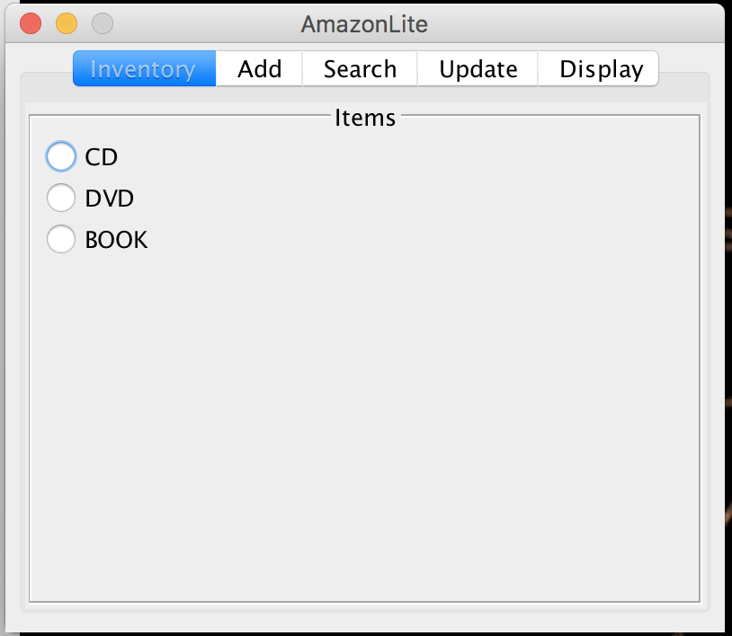

2. Adding an item

All fields should be entered. Only Release Date and Length are being validated for correct input.

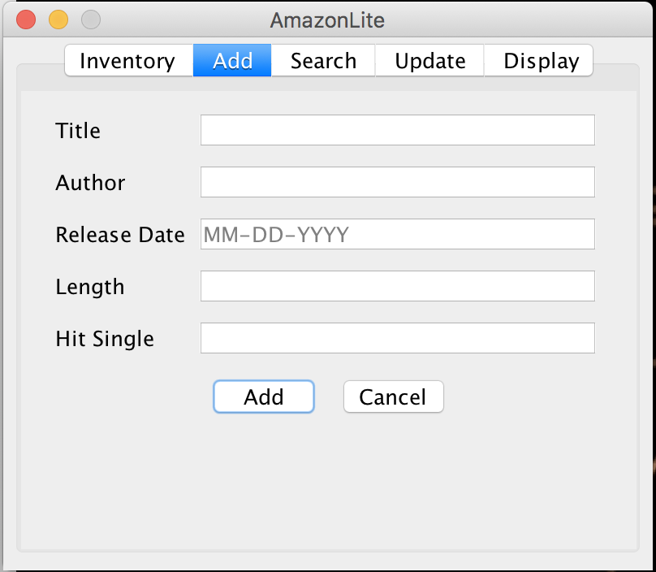

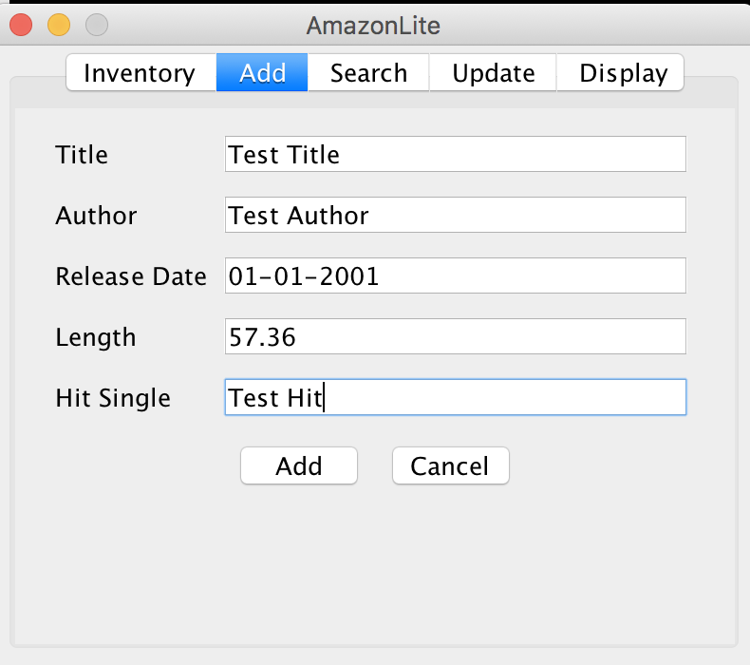

If wrong input is entered an error message will pop-up.

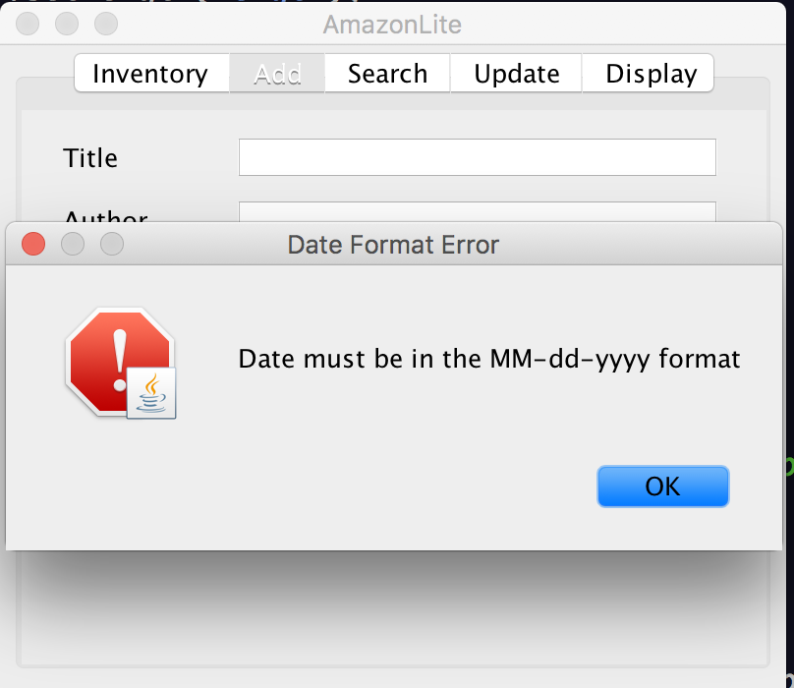

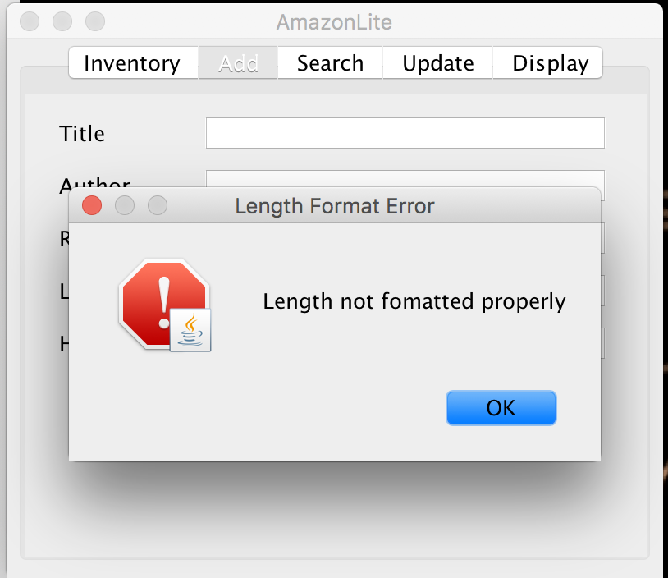

When item is added successfully a pop-up will be presented to the user (Status message may be a better solution, so the user is not being distracted by different error and success pop-ups)

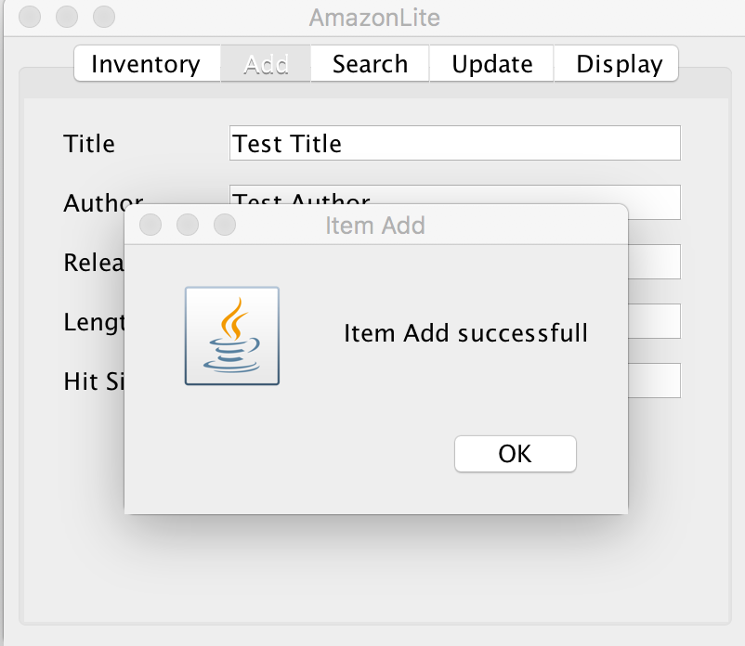

If the record did was not added successfully a message will be presented to the user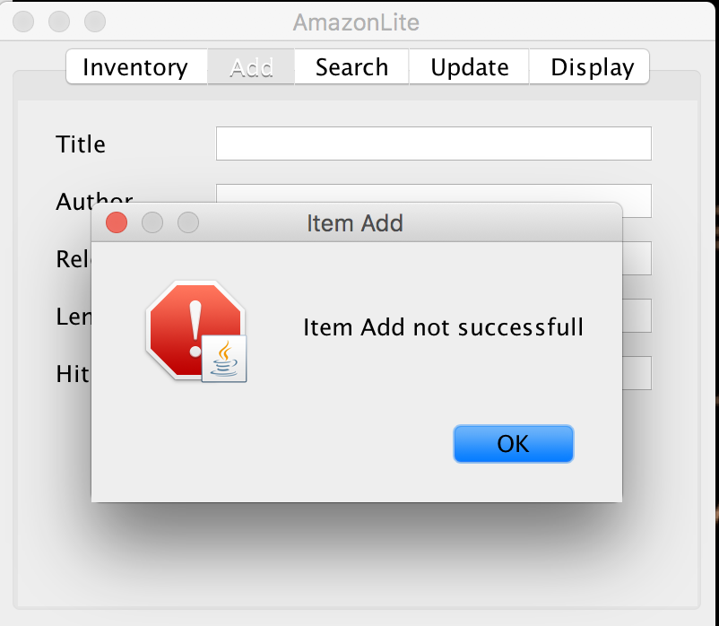

Item records can be searched for.

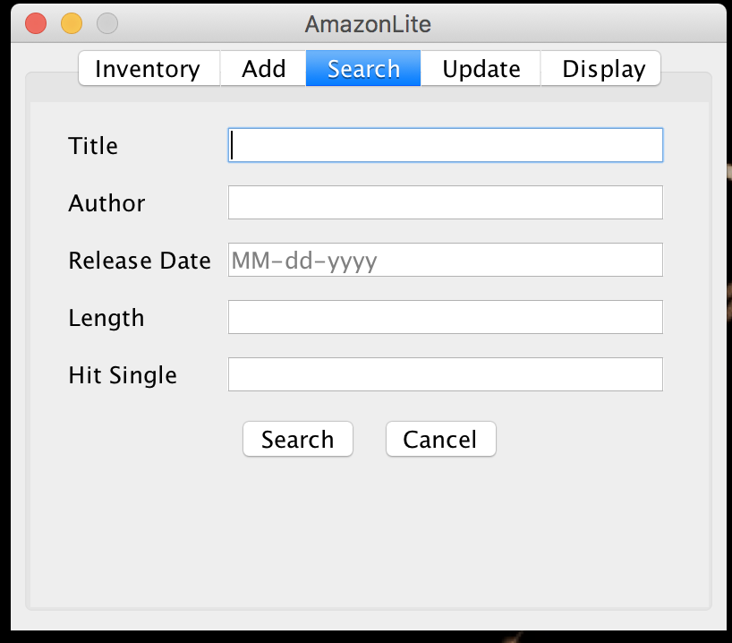

Only one attribute can be entered in the seach box. Once text is entered in any of the text fields, the rest of the text fields are disabled and the user cannot enter text. 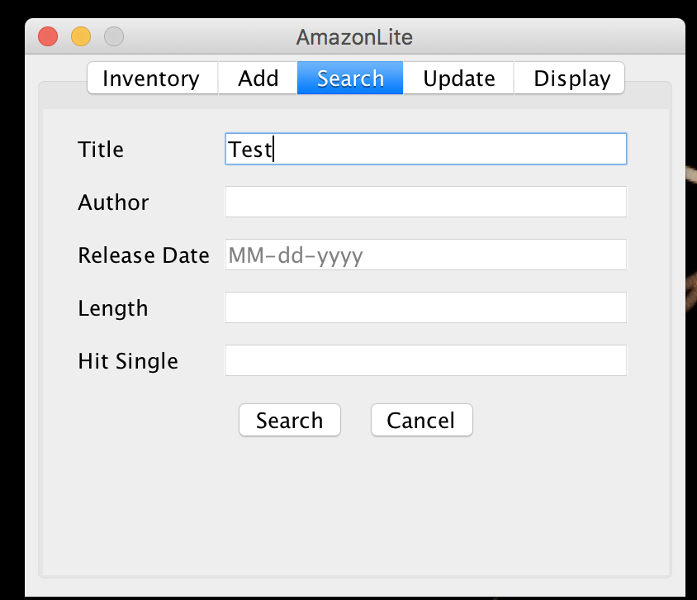

When the “Search” button is pressed. The results will be automatically displayed in the Display tab.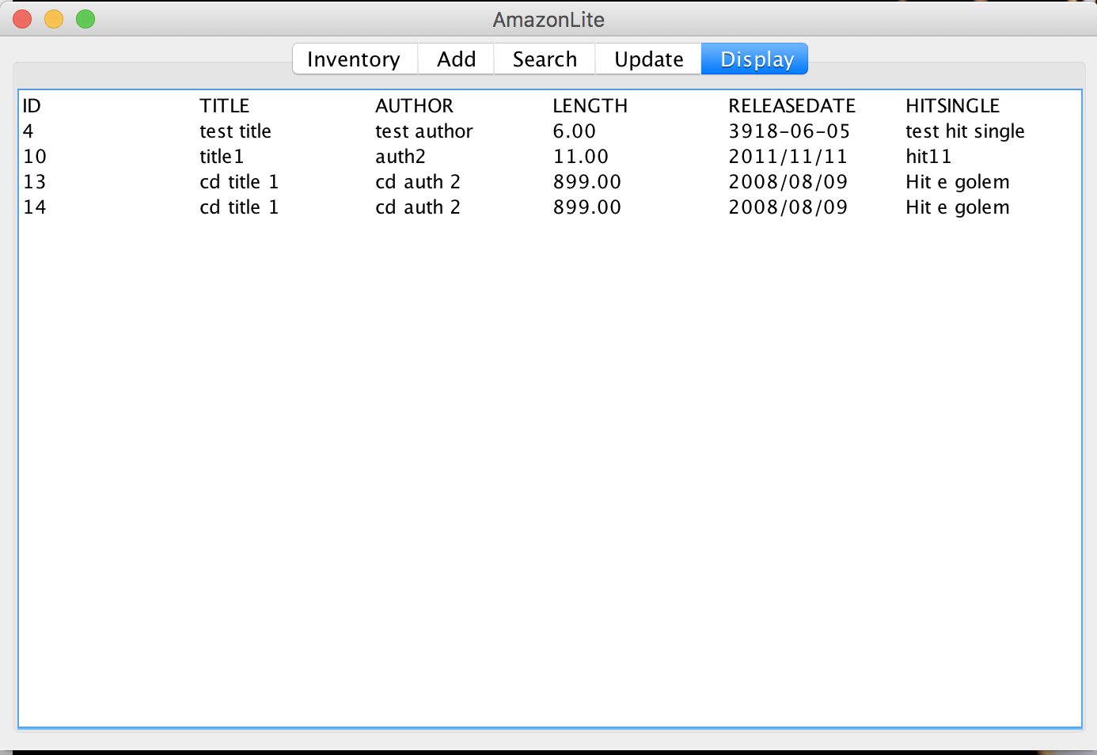

If no search matches the criteria an empty result will be displayed.

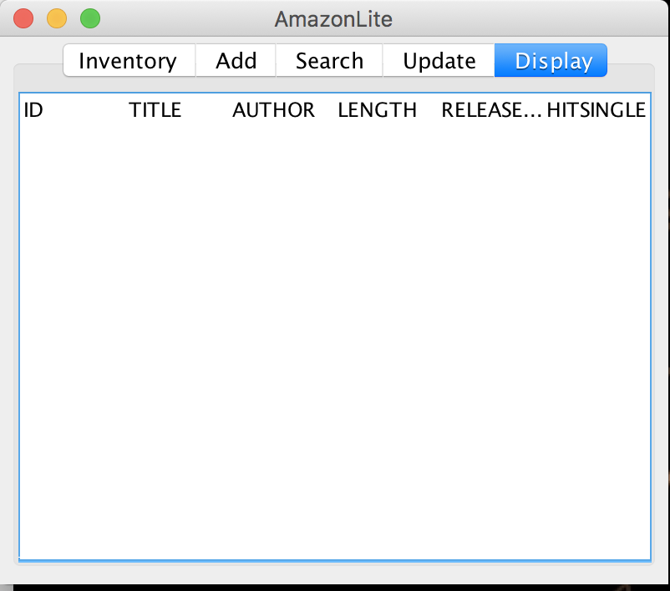

Updating an item record can be done from the Update tab.

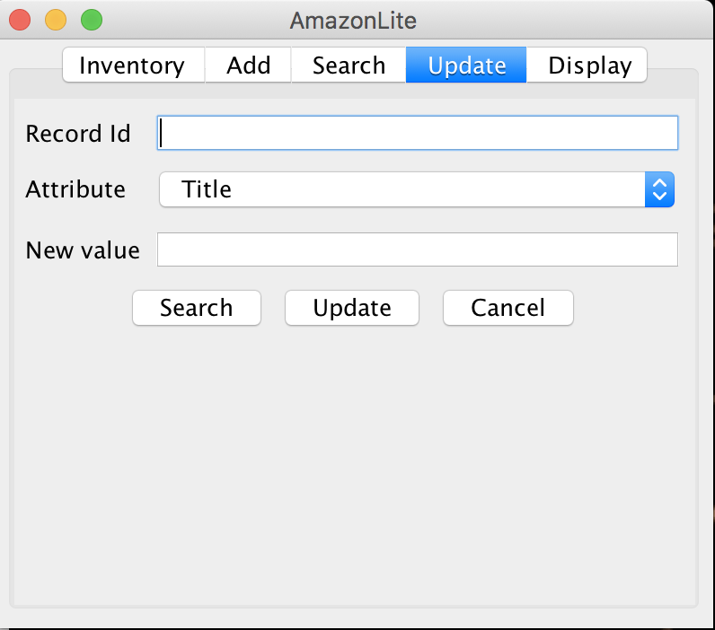

The record is updated by entering the Record ID to update, the Attribute that will be updated and the new value to be entered. If the Record ID is unknown the user has an option to search for an item. Clicking on the Search button will switch to the Search Tab. An item can be searched for and by looking at the displayed results the ID acquired.



Updating an item after the ID is know:

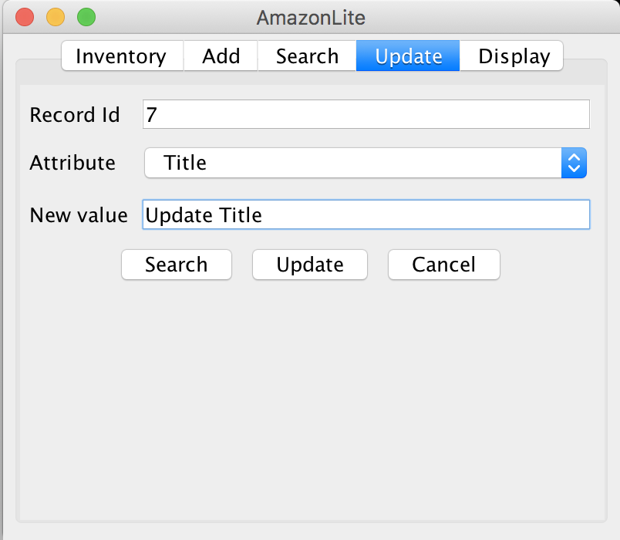

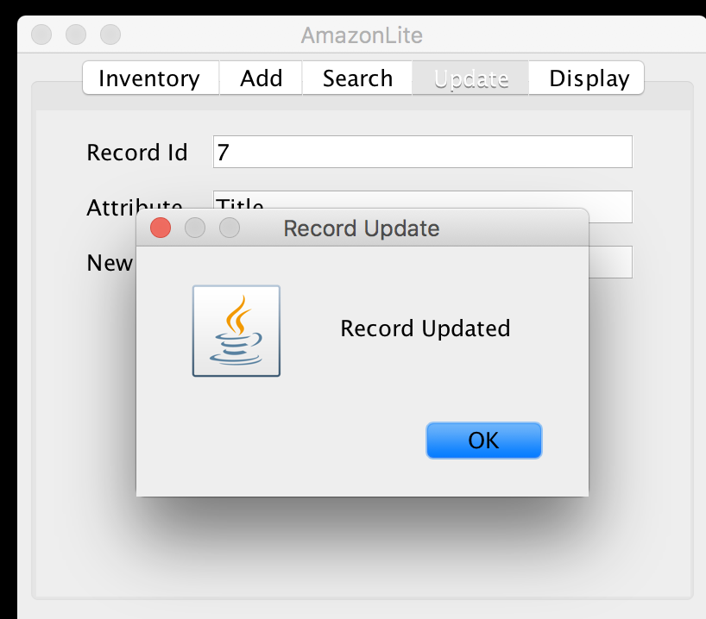

If the record cannot be updated a message will be displayed to the user

