Project Delivery Methodology (PDM)

**System Requirements**

**Java Intermediate**

**AmazonLite**

VERSION: 1.0 REVISION DATE: April 10, 2018

Approval of the System Requirements indicates an understanding of the purpose and content described in this deliverable. By signing this deliverable, each individual agrees with the content contained in this deliverable.

|  |  |  |  |
| --- | --- | --- | --- |
| **Approver Name** | **Title** | **Signature** | **Date** |
| Radoslav Radoev | Author | RR | April 10, 2018 |
|  |  |  |  |
|  |  |  |  |
|  |  |  |  |
|  |  |  |  |

Contents

Section 1 Purpose 3

Section 2 General System Requirements 3

2.1 Major System Capabilities 3

2.2 Major System Conditions 3

2.3 System Interfaces 3

2.4 System User Characteristics 3

Section 3 Initial Capacity Requirements 4

Section 4 System Acceptance Criteria 5

Section 5 Document Revision History 6

Section 6 Appendices 6

# Section 1 Purpose

The purpose of this project is to create an inventory system for a multimedia store such as Amazon (AmazonLite). The system will manage an inventory of CDs, DVDs and Books.

# Section 2 General System Requirements

## 2.1 Major System Capabilities

* *Users must be able to search for an existing item*
* *Users must be able to enter new item*
* *Users must be able to edit an existing item*
* *Data must be persistent*

## 2.2 Major System Conditions

*Specify major system assumptions and/or constraints (aka conditions). The conditions may limit the options available to the designer/developer. For example:*

*- Application will present a console interface*

*- User will respond to series of questions using numeric numpad*

*- User will be able to interact with data (search, add, edit)*

*- Inventory must be saved in Properties file*

## 2.3 System Interfaces

*An interface that describes the actions the users are allowed to do on an Item.*

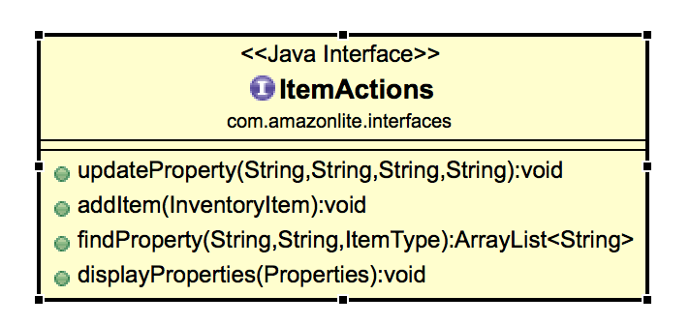

## 2.4 System Classes

Controller  
 Controller.java

Controller will read user actions and execute actions on model  
Model  
 Book.java  
 Book object. Extends InventoryItem class.  
 CD.java  
 CD object. Extends InventoryItem class.

DVD.java  
 DVD object. Extends InventoryItem class.  
 InventoryItem.java

Parent class for inventory item.  
Model.java  
 Performs actions on Inventory Item objects and returns to View

Props

InitializeProps.java  
 Initializes default properties files for CD,DVD and Books if files are missinig

View  
 View.java  
 Views presented to the user  
 Application.java  
 Entry point for application

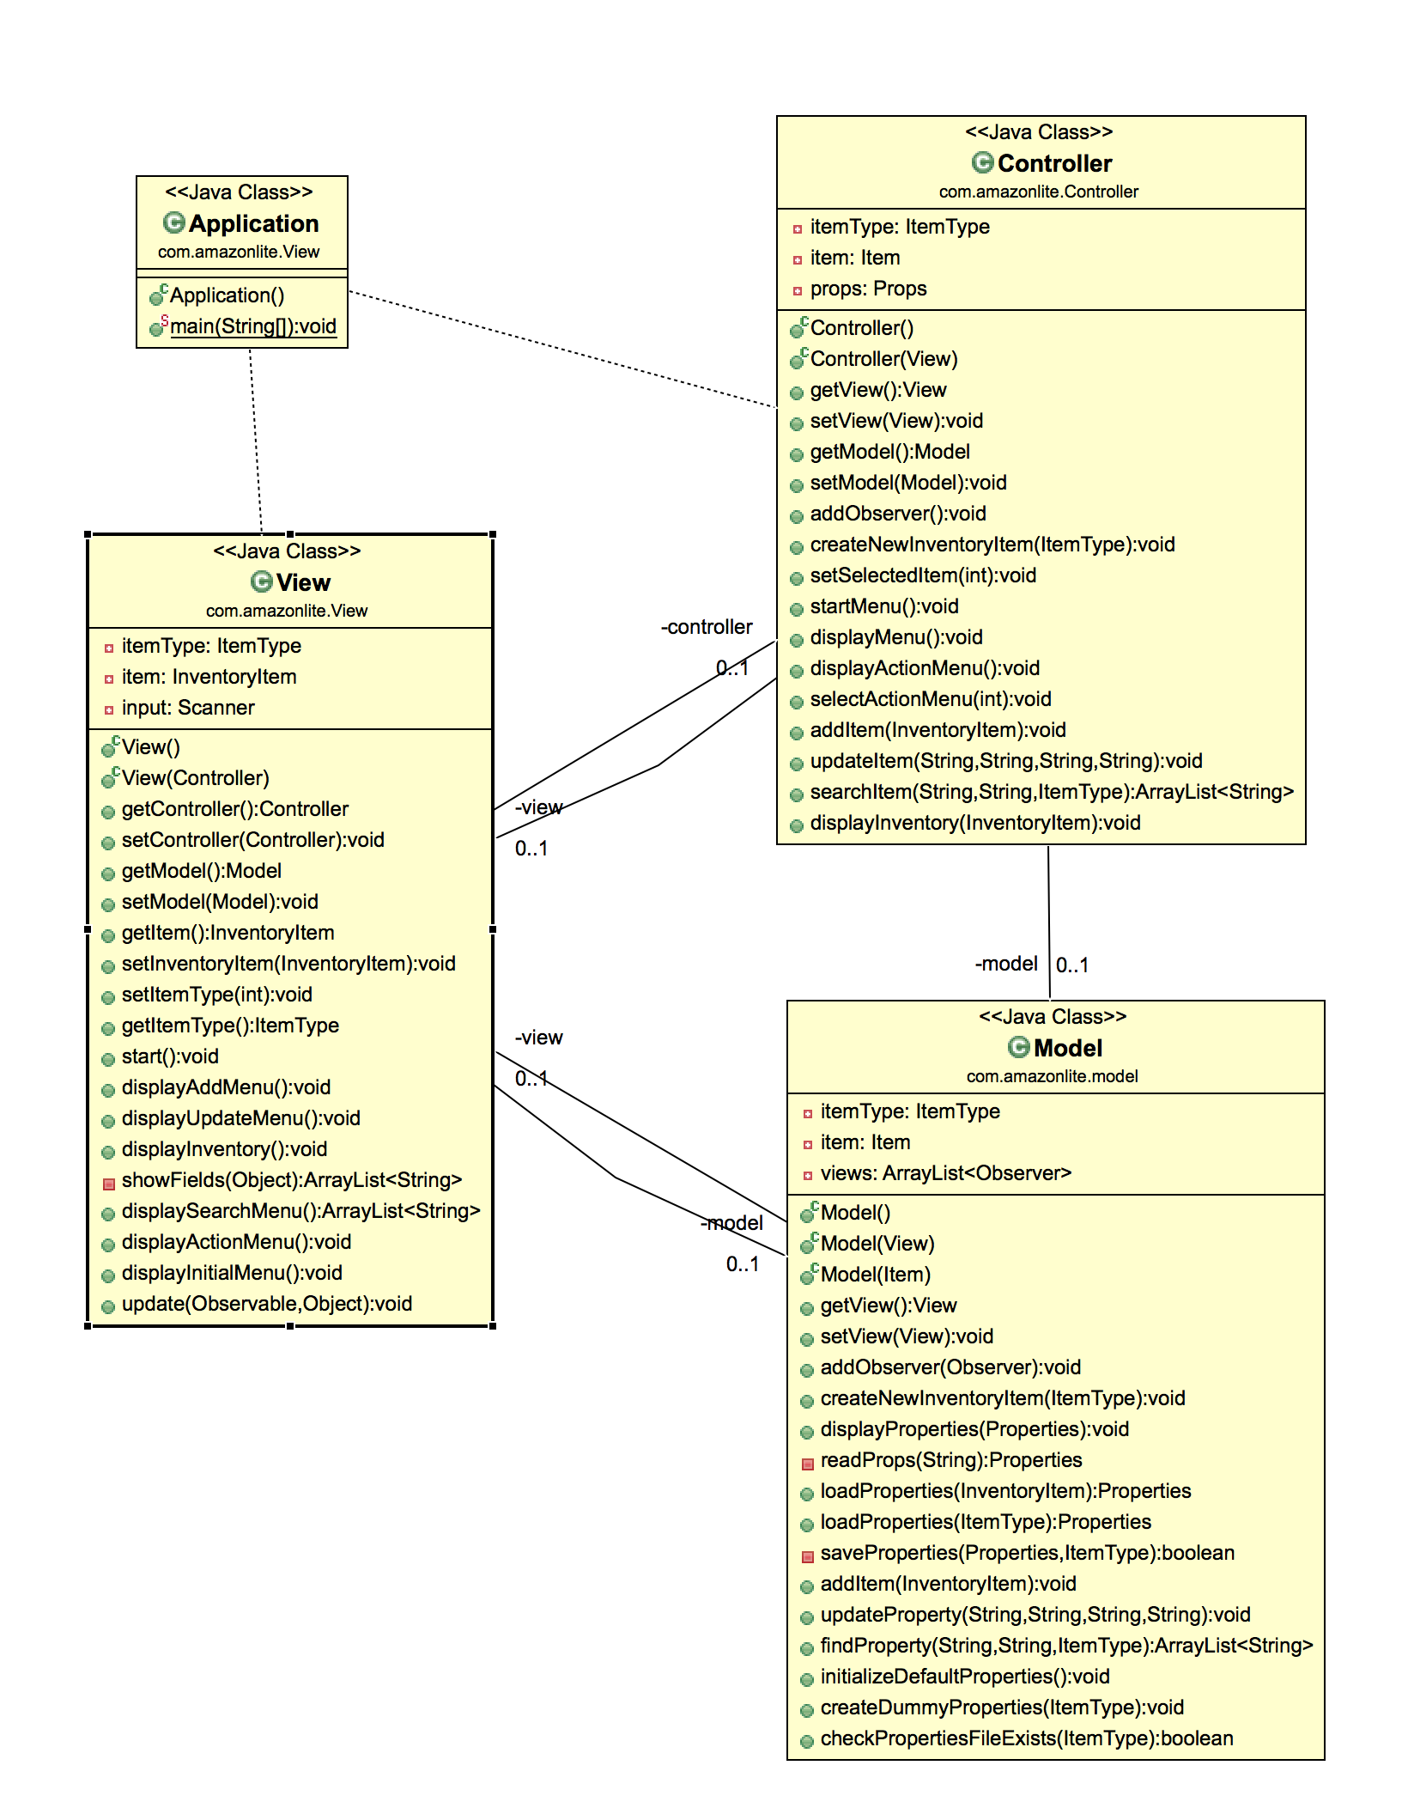

## 2.5 System Enum

ItemType.java  
 Contains 3 Inventory item types – CD, DVD, Book

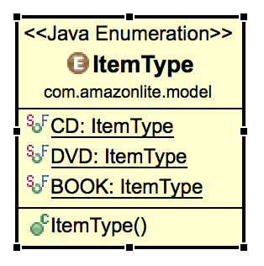

## 2.6 External files

CD.properties   
 DVD.properties  
 BOOK.properties

# Section 3 Initial Capacity Requirements

Only one user can be logged in at a time.   
 Properties file, containing only a handful of objects.

# Section 4 Initial System Architecture

*Specify the data platform, hardware, software, programming languages, tools and operating system requirements for the application or project.*

1. *Application can run on any platform that is able to run Java JAR applications*
2. *This project will be implemented using Java 8.*
3. *Three properties files will be deployed with the runnable JAR file*

# Section 5 System Acceptance Criteria

* *User can access the inventories of CDs, DVDs and Books*
* *User can add, update, search inventories*
* *User is using console view to perform the above tasks*
* *User cannot delete object from the inventory*

⇒

# Section 7 Document Revision History

|  |  |  |  |
| --- | --- | --- | --- |
| **Version** | **Date** | **Name** | **Description** |
| 1.0 | April 10, 2018 | Radoslav Radoev | Author |
|  |  |  |  |

# Section 8 Appendices