**Comenius University, Bratislava**

**Faculty of Mathematics, Physics and Informatics**

**Forest Dump**

Web design Technology and Methodology

**2018/2019**

**Patrícia Marmanová**

**Dana Škorvánková**

**Michal Brcko**

**Radoslav Hečko**

**Content**

1 Goals of the application 3

1.1 Target audience 3

1.2 Similar applications 3

1.2.1 Trash Out 3

1.2.2 “Na skládky nie sme krátki” 3

1.2.3 Applications with GPS location 3

2 User roles 4

2.1 Reporter 4

2.2 Disposal manager 4

3 Requirements specification 5

3.1 Functional requirements 5

3.1.1 Reporter 5

3.1.2 Disposal manager 5

4 Organisation 6

4.1 Schedule 6

4.2 Team members and their responsibilities 7

4.3 Budget 7

5 Personas 8

5.1 Persona Jozef 8

5.2 Persona Ľubica 9

6 Scenarios 10

6.1 Scenario - Jozef, businessman 10

6.1.1 About Jozef 10

6.1.2 Situation 10

6.1.3 Do-goal 10

6.1.4 Be-goal 10

6.1.5 Before Scenario - without application 10

6.1.6 After Scenario - with application (mobile phone) 11

6.2 Jozef scenario wireframes 11

6.3 Scenario - Ľubica, worker at the city administration office 13

6.3.1 About Ľubica 13

6.3.2 Situation 13

6.3.3 Do-goal 13

6.3.4 Be-goal 13

6.3.5 Before Scenario - without application 13

6.3.6 After Scenario - with application (computer) 13

6.5 Ľubica’s scenario wireframes 15

# 1 Goals of the application

The goal of the project is to create a web application, which enables its users to report an occurrence and the location of the illegal dump. To the people responsible for their disposal, it provides the possibility to register the appearance of the dumps and mark the current state of their disposal.

## Target audience

The target audience consists of all the people who care about the environment and actively use web applications and other features of the digital age, willing to contribute to the improvement of the whole society. The application is intended for use by the city administration and people responsible for the illegal dump disposal.

## Similar applications

In this section, we are going through a number of similar applications, that have a purpose close to the one of this very project.

### 1.2.1 Trash Out

*Trash Out* is a mobile application very similar to our application with its functionality. Users can report illegal dumps, participate at their disposal as volunteers, and they have access to various environmentally oriented articles.

The main difference is the fact, that *Trash Out* is available only for the mobile devices, whereas a goal of our project is to create a web application. In case of an ideal implementation for the mobile devices, it is easier for people to use the website, instead of downloading an application.

The other thing is, the application lacks the user role of the person responsible for the dump disposal. Thus, people are not informed about the state of the disposal process of the dumps. [[1](https://play.google.com/store/apps/details?id=me.trashout&hl=sk)]

### 1.2.2 “Na skládky nie sme krátki”

*„Na skládky nie sme krátki“* is a project of the civic association named *TATRY,* which purpose is to increase the illegal dump consciousness. However, the website works only as the information platform for people interested in the environment issues. [[2](http://www.naskladkyniesmekratki.sk/sk/na-skladky-nie-sme-kratki)]

### 1.2.3 Applications with GPS location

Other applications with similar functionality are the ones, where users share their GPS location or other GPS spots on the map. These applications most frequently use the Google Maps API.

# 2 User roles

In our application, we distinguish two main user roles. One is the role of the reporter, and the other one is the role of the disposal manager.

## 2.1 Reporter

This user role reports the discovered illegal dumps or urges the dumps that have already been reported. There is an option to browse the map containing the reported dumps, as well as to report the new ones found. The reporter can upload a photo of the dump, a short comment, its location and other information concerning further description of the dump, such as its range and materials. This user role does not require logging into the system.

## 2.2 Disposal manager

The role of the disposal manager is superior to the role of the reporter. This user role has all the capabilities of the reporter role, and aside of them, the manager can list all the dumps in his assigned area, ordered by priority and mark the stage of their disposal process. This user role requires logging into the system.

# 3 Requirements specification

The web application will provide the option to report the occurrence and location of the illegal garbage dumps, to attach the further description of the garbage (scope, materials, rate of the environment pollution) and a photo of the place. This way, the competent authorities, responsible for the disposal of these dumps, will be informed. These “disposal managers” can sign up and log into the application. Within their own accounts, they are able to update the stage of the disposal process of each particular dump in their assigned area.

## 3.1 Functional requirements

In this section, we are going to present the requirements concerning the functionality of the application, divided by the user roles.

### 3.1.1 Reporter

* Report the illegal dump

To a common user, the application enables to report the location and further information about the discovered illegal garbage dump, such as the scope of the dump, the prevailing materials, and potentially dangerous substances. He has also an option to attach a photo proof to the report.

* List and filter the current and disposed dumps

Users can browse all the records of the reported dumps or filter them by their current state (pending, in the disposal process, disposed etc.).

### 3.1.2 Disposal manager

* Sign up

The disposal manager has an option to register and thus create his own account, through which he can access the disposal process management of the reported garbage dumps.

* Log in

The disposal manager can log into the system using his email address (or alternatively his user name) and password entered during the registration.

* Update the stage of the dump disposal process

The application enables the disposal manager to briefly describe the progress in the dump disposal process, set the state of the garbage dump, or even attach a photo of the current state of the disposal process.

# 4 Organisation

## 4.1 Schedule

Working schedule contains a table of tasks (Table 1), that are necessary in the process of designing and developing the application. Next to each of the tasks, there is the estimated date by which the task should be finished.

| Task | Date |
| --- | --- |
| Scheme of the information architecture of the application | 15.10.2018 |
| Graphical user interface proposal | 22.10.2018 |
| Scheme of the database model | 29.10.2018 |
| Application prototype | 19.11.2018 |
| Programming of the backend part of the application | 26.11.2018 |
| Programming of the frontend part of the application | 03.12.2018 |
| Testing | 10.12.2018 |
| Putting the application into operation (deployment) | 17.12.2018 |

Table 1: Description of the particular tasks and estimated due dates

## 4.2 Team members and their responsibilities

All the team members work on the tasks that were assigned to them after mutual agreement at a team meeting. Every aspect of the application is first consulted and decided by the whole team. The particular tasks assigned for the team members are showed in Table 2.

| Team member | Tasks |
| --- | --- |
| Michal Brcko | Frontend Angular  Google maps API  Photo upload, gallery |
| Radoslav Hečko | Frontend Angular  Firestore backend - authentication, realization of the database |
| Patrícia Marmanová | Frontend Angular  Design proposal  Scheme of the database structure - database model |
| Dana Škorvánková | Frontend Angular  Responsive design  Scheme of the database structure - database model |

Table 2: Team members and their tasks

## 4.3 Budget

The estimated budget for the realization of the application is shown in Table 3.

| Task | Price |
| --- | --- |
| The proposal of architecture and design of the application | 150€ |
| Implementation | 750€ |
| Domain | 8,90€/year |
| Webhosting | 3,89€/month |

Table 3: Estimated budget for the application

# 5 Personas

We created two different personas to better understand our user base and their needs. For both of them we summarized their short biography, their motivations and frustrations which should help us to better design the application.

## 5.1 Persona Jozef

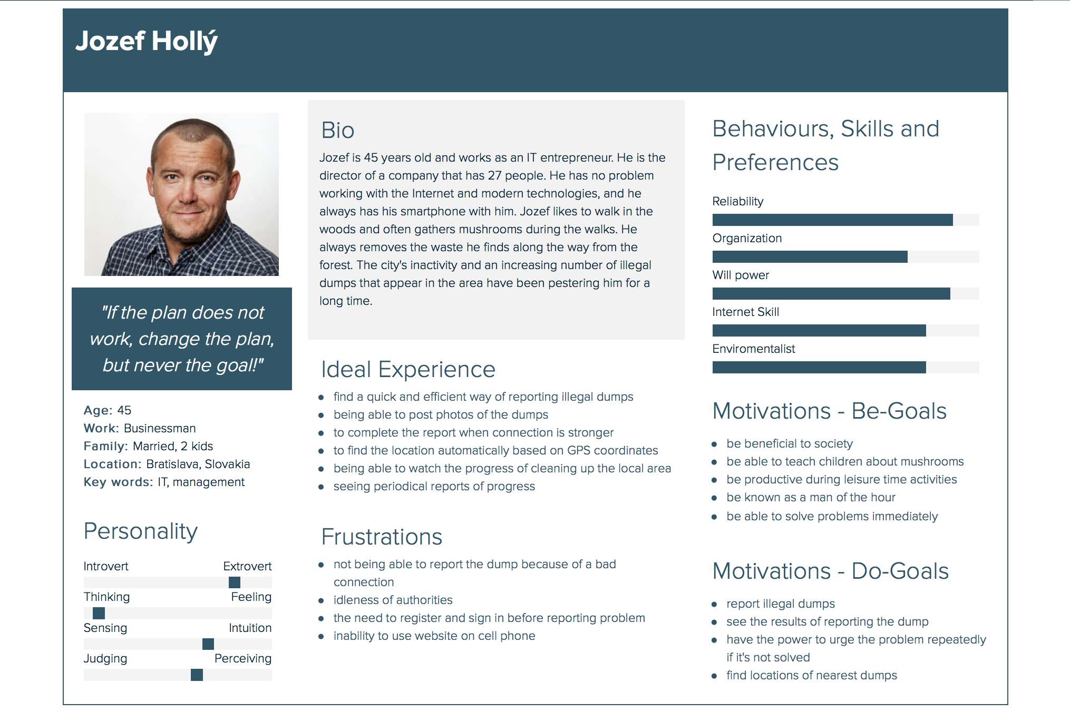Persona Jozef is a businessman and in the scenario represents user role Reporter. His personality and motives are summed up in Fig. 1.

*Fig. 1. Persona Jozef Hollý*

## 5.2 Persona Ľubica

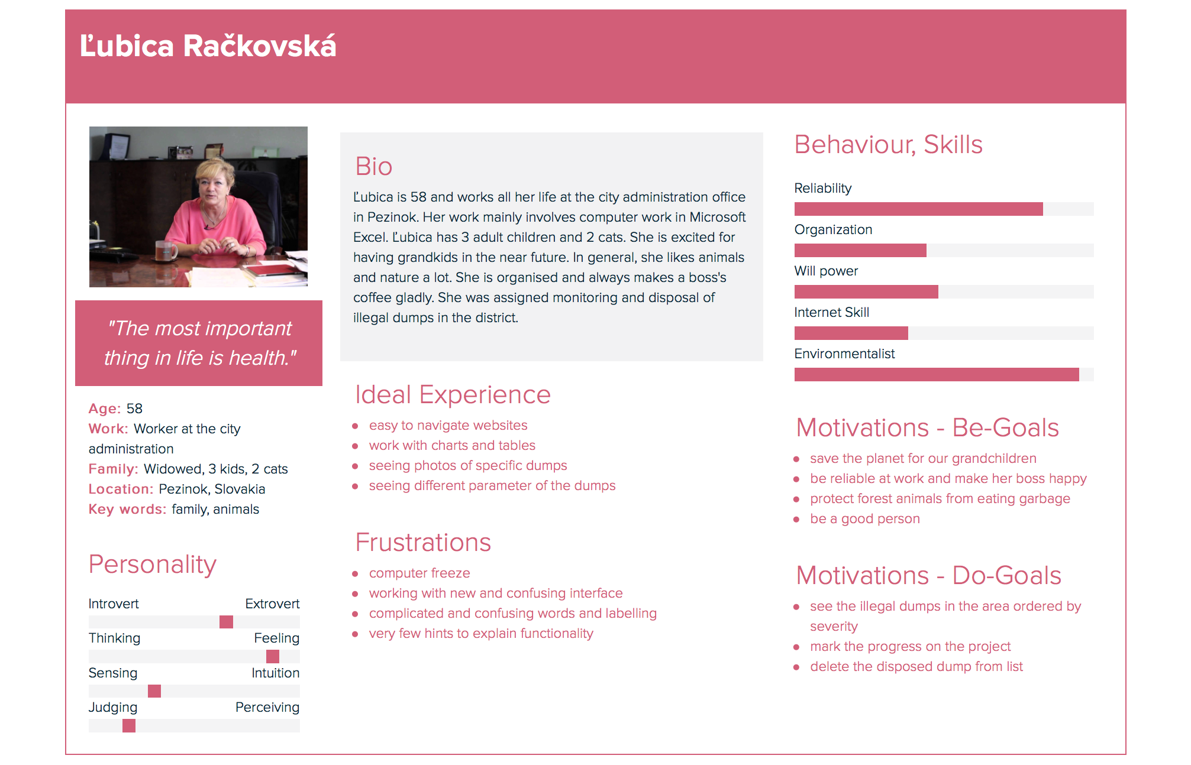Persona Ľubica is an office worker at the city administration in Pezinok and in the scenario represents user role Disposal manager. Her personality and motives are summed up in Fig. 2.

*Fig. 2. Persona Ľubica Račkovská*

# 6 Scenarios

## 6.1 Scenario - Jozef, businessman

### 6.1.1 About Jozef

* Josef is 45 years old and he works as a businessman in the IT sphere. He is a director of a company consisting of 27 workers.
* He has no troubles working with the internet and the modern technologies. He keeps his smartphone always with him.
* Josef likes to go for a walk in the woods and often combines it with collecting mushrooms. He always takes away the garbage he found on his way in the woods.
* He is annoyed by the increasing number of illegal garbage dumps in the area and the inactivity of the city already for a long time.

### 6.1.2 Situation

On Saturday morning, Joseph went for a walk into the woods near the city, wishing to collect some mushrooms for the family for the evening scambled eggs. At the edge of the forest, however, he found an illegal dump containing tires and a refrigenerator.

### 6.1.3 Do-goal

Josef wants to do something with this illegal dump. He does not have time to remove it himself, and he thinks it's the job of competent people who are paid from his taxes.So he would tell them directly to do something with the illegal dump.

### 6.1.4 Be-goal

Josef would like to feel satisfaction for not just passing by the illegal dump, but also doing something to clean the city.

### 6.1.5 Before Scenario - without application

Josef was scandalized by this black dump and he wanted to report it. He learned he could download a mobile app, but his mobile network wasn’t strong enough in forest. On the internet he also learned that the authorities do not really take this application seriously, and when he wants to act, he must fill a written request to the city office. So he decided he would fill the form later at home, and he took a picture of the dump with his mobile phone. However, as Joseph was a busy businessman, he did not get to do any of these and next time he walked through the woods, he found that the dump was growing again.

### 6.1.6 After Scenario - with application (mobile phone)

Since Josef decided to act and do something about the dump, he took out his smartphone and googled the easier option for reporting the illegal dump right at the place. In Forest Dump web application, he can mark the position of the dump right away, by sharing his GPS location. Thus, he adds a new dump record and fills in the parameters. Now he is able to watch the whole process of its disposal right from his home.

## 6.2 Jozef scenario wireframes

The description of each step of the scenario:

* Jozef wants to report a black dump, after opening the web application on the mobile device, the home page appears. He pressed the "Report listing here and now" button (Fig. 1).
* Jozef using the form filled out the data on the black waste dumps, had to fill the fields as waste, the type of waste (Fig. 2).
* He decides to upload a photo document that is an optional part of the report and at the same time wants to have an overview of the status of the report, therefore, he provided an email address to which he receives information on the status of the landfill. The report has ended by pressing the "Submit" button (Fig. 3).
* After reporting the black landfill, Jozef will see all the black dumps in his neighbourhood (Fig. 4).
* Jozef wanted to see the success of all black dumps reports, so he chose "Stats" in the menu. Displayed reports offer Joseph a good overview of the activities of competent authorities in the fight against black dumps (Fig. 5).

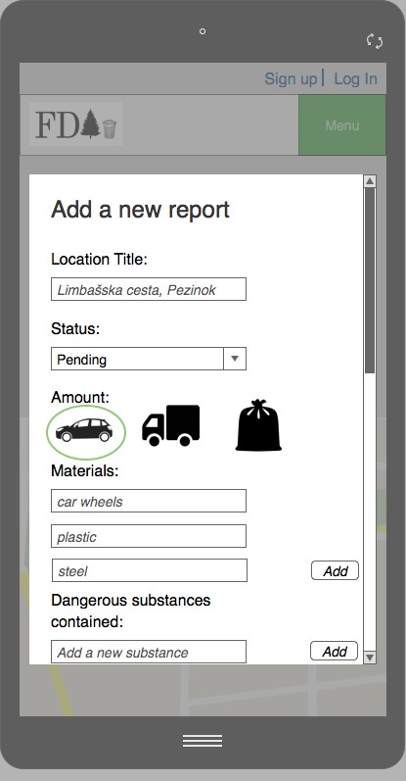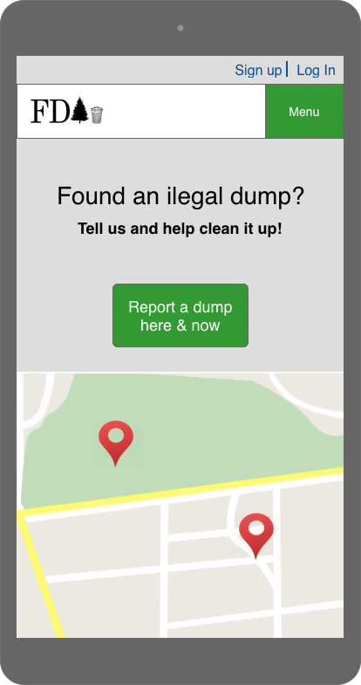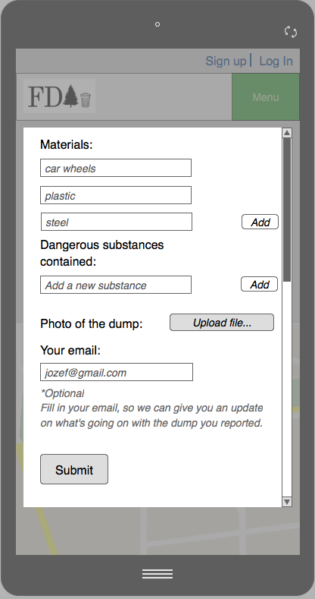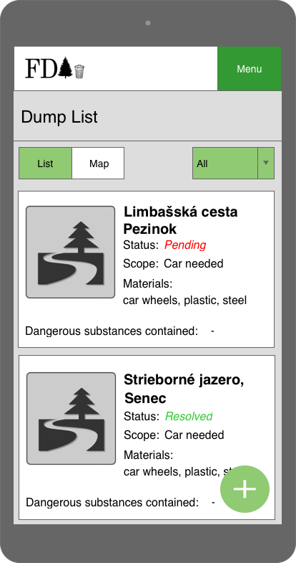

Figure 1

Figure 2

Figure 3

Figure 4

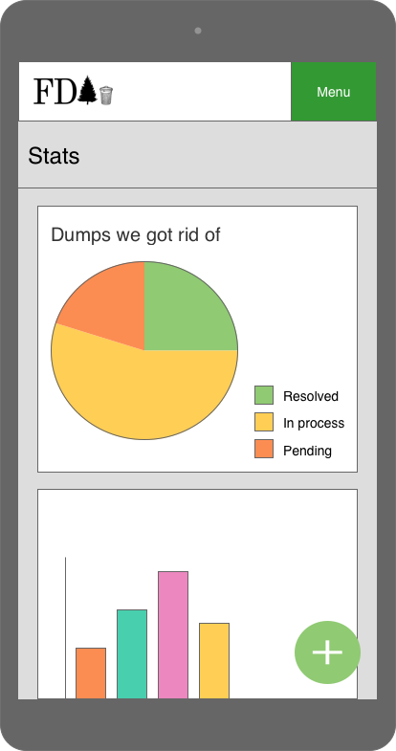

Figure 5

## 6.3 Scenario - Ľubica, worker at the city administration office

### 6.3.1 About Ľubica

* Ľubica is 58 years old and has worked at the city administration office in Pezinok for her whole life. Her job includes mainly working with computer, especially in Excel.
* Ľubica has three adult children and two cats. She adores animals and nature in general.
* She is organized and always willing to make a coffee for her boss.
* At work, she has been commissioned to monitor and manage the disposal of the illegal garbage dumps in the district.

### 6.3.2 Situation

At work, she has been commissioned to monitor and manage the disposal of the illegal garbage dumps in the district, and she has been doing her work responsibly all her life. Within the scope of her work, she needs to categorize the illegal dumps in the area and commission the people responsible for the disposal to clean up the most relevant ones.

### 6.3.3 Do-goal

Ľubica wants an effective way of assessing the severity of existing black dumps. She wants to be able to send a disposal team to a specific location, with the right tools to remove the landfill of a given range.

### 6.3.4 Be-goal

Ľubica wants to do her job responsibly. At Christmas she would like to receive Christmas bonus, and her wish is that the animals in the wild would never eat the man-made waste.

### 6.3.5 Before Scenario - without application

Ľubica has a few requests about illegal dumps on the table that came to them by post. Not all, however, contain an exact location, nor a description of the scope and severity of illegal dumps. Therefore, Ľubica decides to choose the one that has come in the most beautiful envelope and sends a team of workers to the inaccurately described place. Citizens are not informed about the course of liquidation, disposal is inefficient, and Ľubica will never know about most of the illegal dumps in the area.

### 6.3.6 After Scenario - with application (computer)

Ľubica simply opens the web application in the browser and logs into her disposal manager account. The application automatically orders the reported garbage dumps in her district by their relevance – range, number of reports, types of materials and so on. Ľubica will take care of the first listed dump and assign it to a disposal team to clean it up. She will also set the state of the dump in the application as *“in the disposal process”*.

6.5 Ľubica’s scenario wireframes

The description of each step of the scenario:

* Ľubica opens the web application in her browser (Fig. 1).
* She navigates to the upper right corner to log into her account (Fig. 2).
* The pop-up window requiring her email/username and password shows up (Fig. 3).
* She fills-in the data and hits the *log in* button (Fig. 4).
* A page listing all the dumps is loaded (Fig. 5).
* Ľubica chooses the first one on the list and clicks on the edit icon (Fig. 6).
* The pop-up form to edit the record shows up (Fig. 7).
* She changes value of the *status* attribute from *pending* to *in process* by expanding the dropdown menu (Fig. 8 and 9).
* After that, she presses the s*ubmit* button (Fig. 10).
* The pop-up form is closed and the page with the list of the dumps is refreshed, showing the updated data (Fig. 11).
* Ľubica closes the browser [the end].

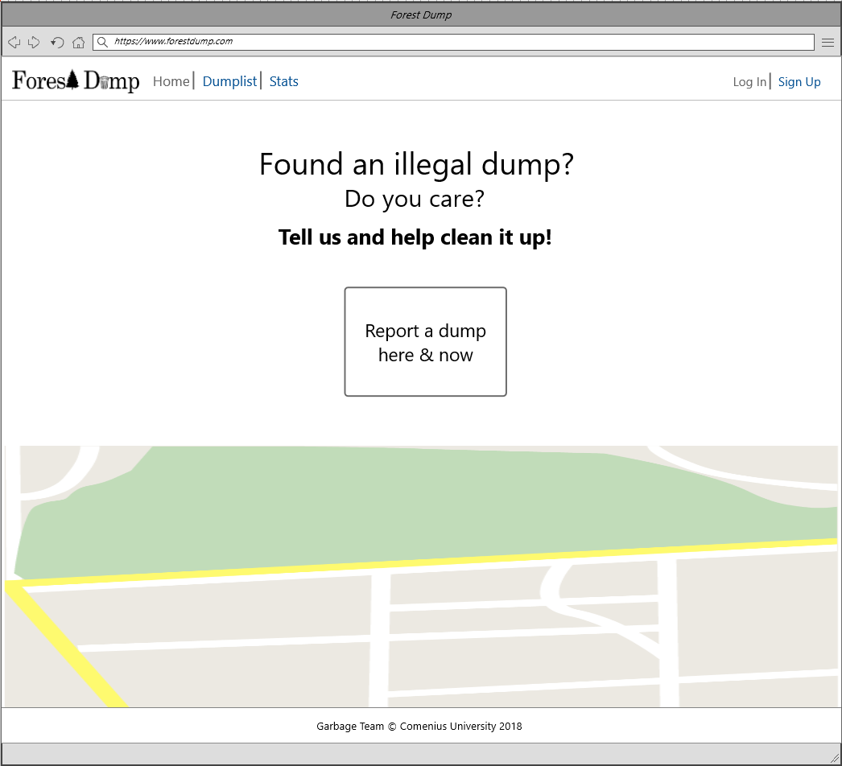

Figure 1

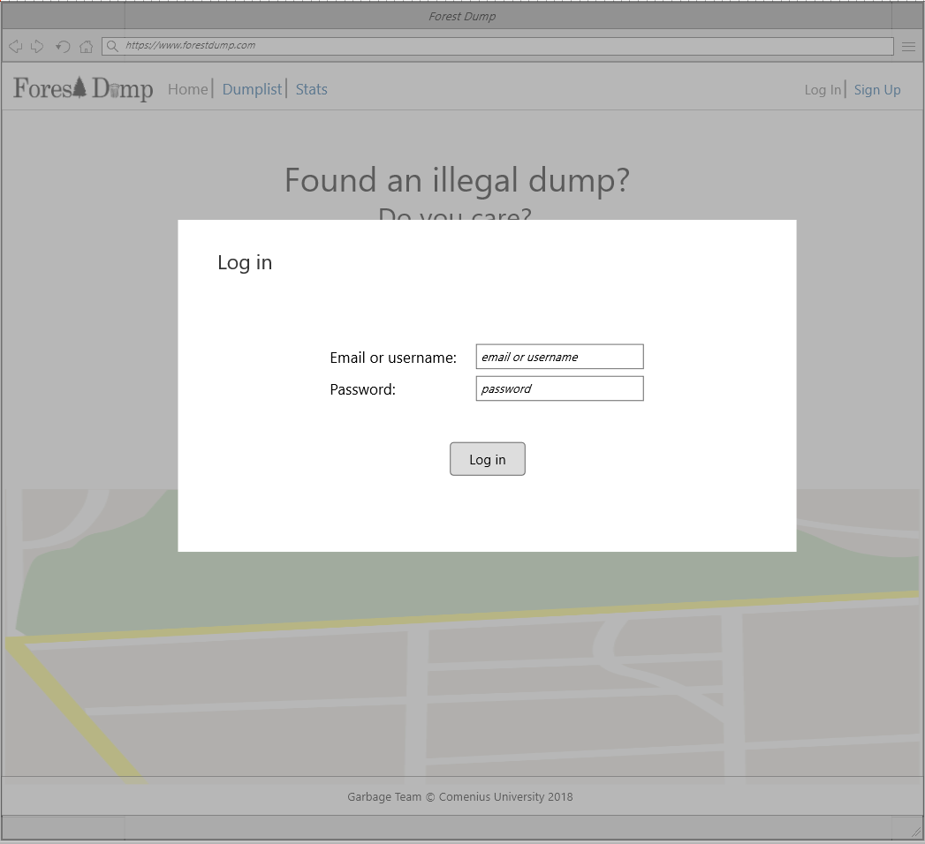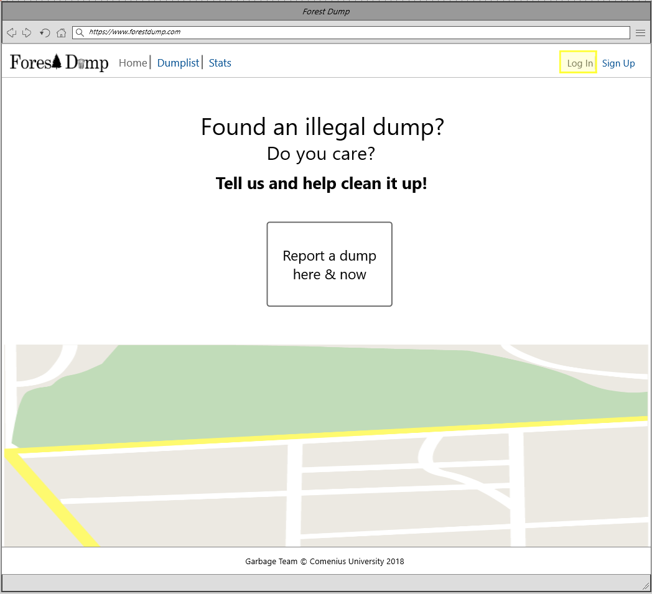

Figure 3

Figure 2

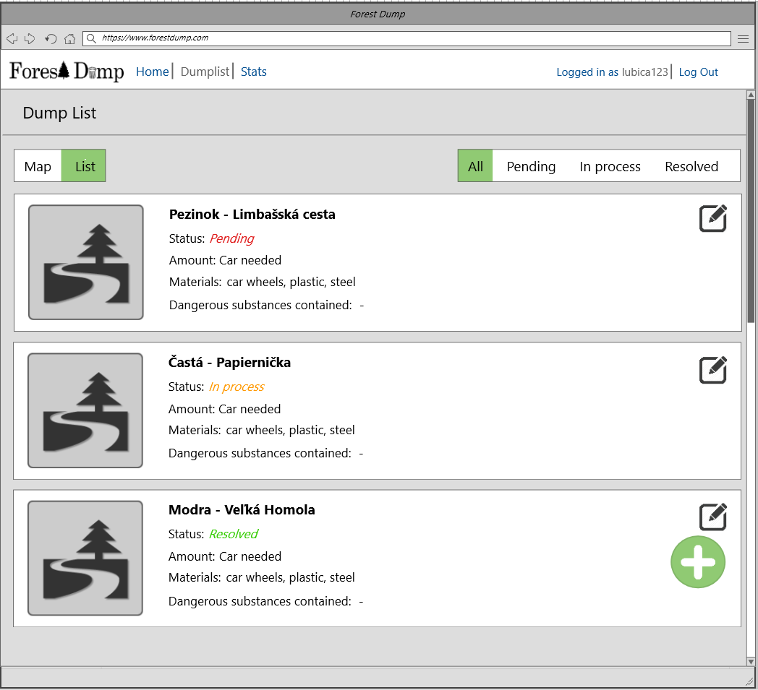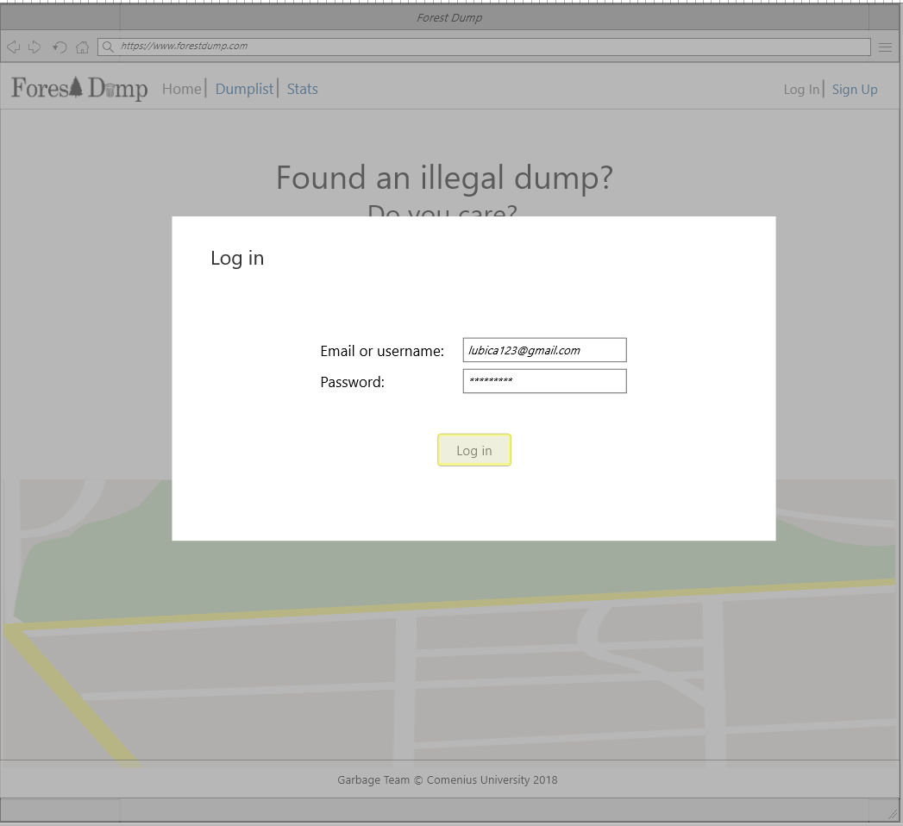

Figure 5

Figure 4

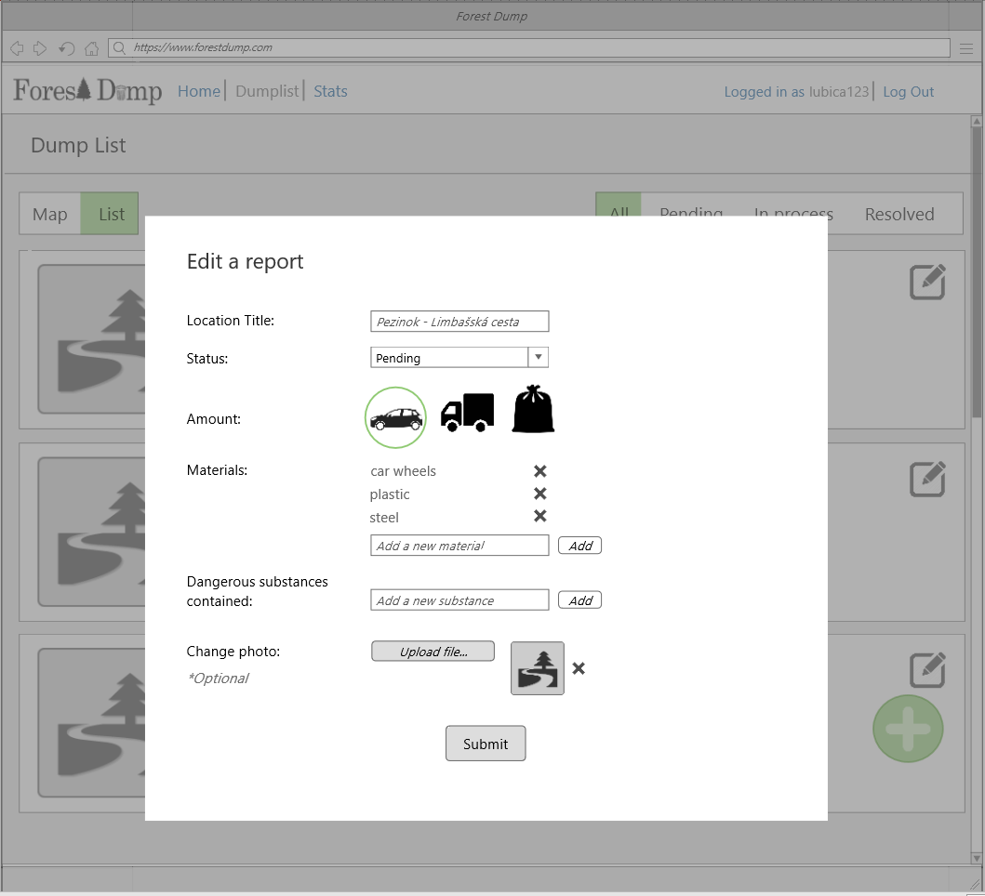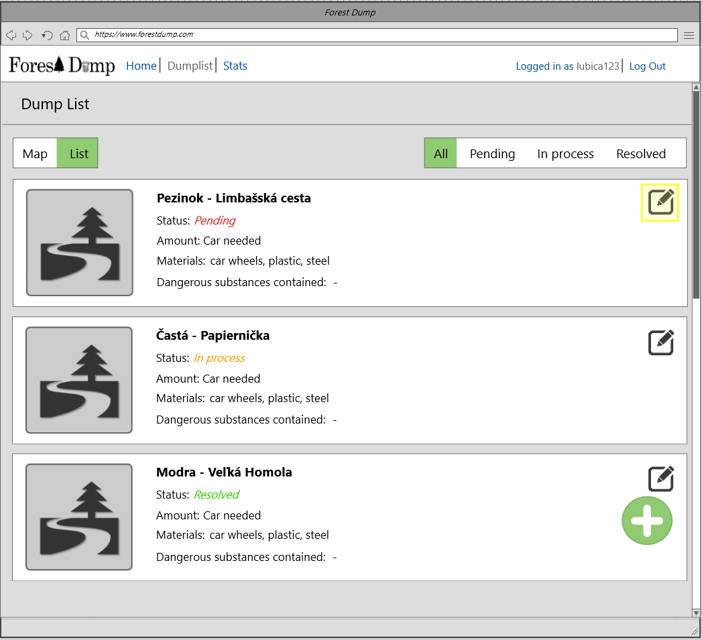

Figure 7

Figure 6

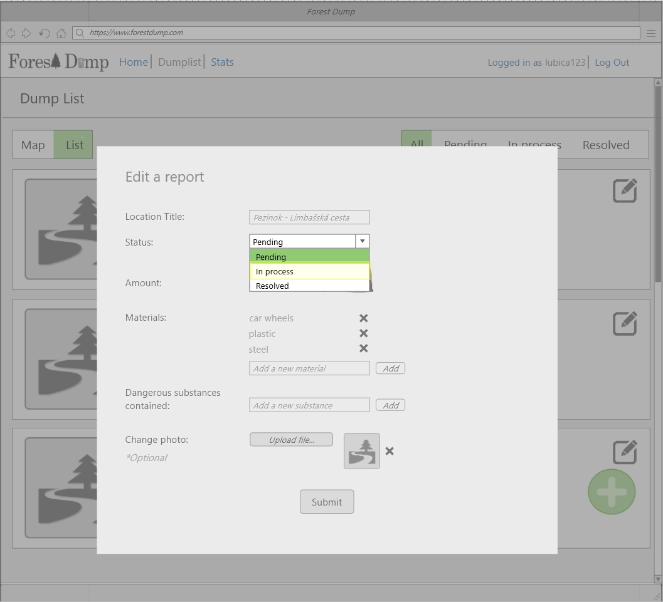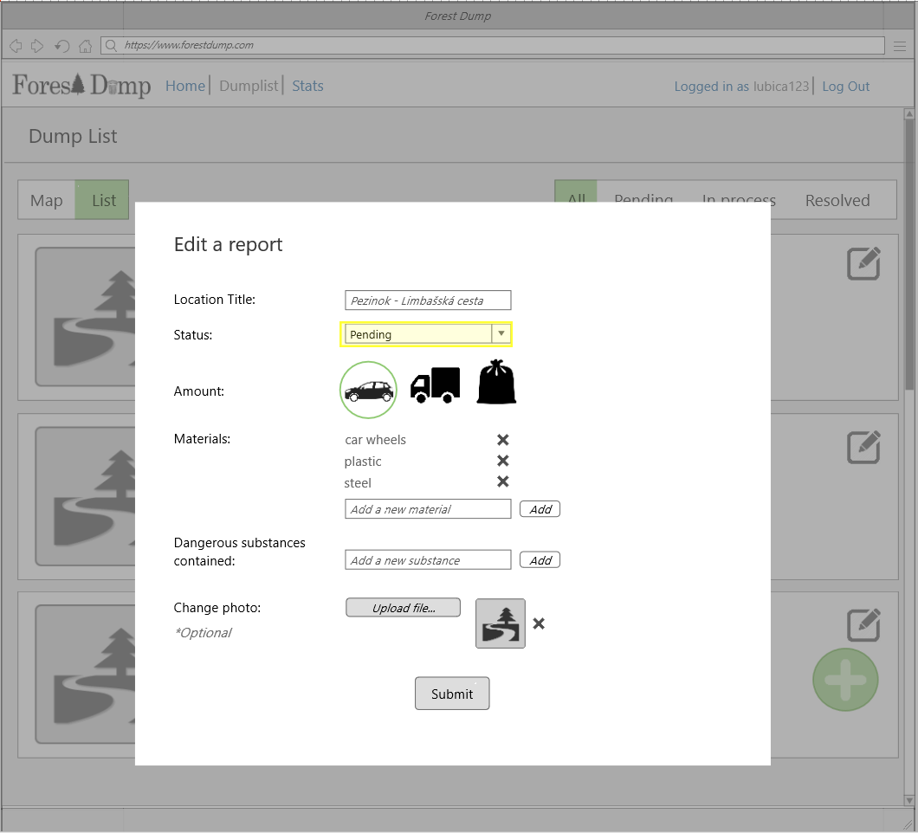

Figure 9

Figure 8

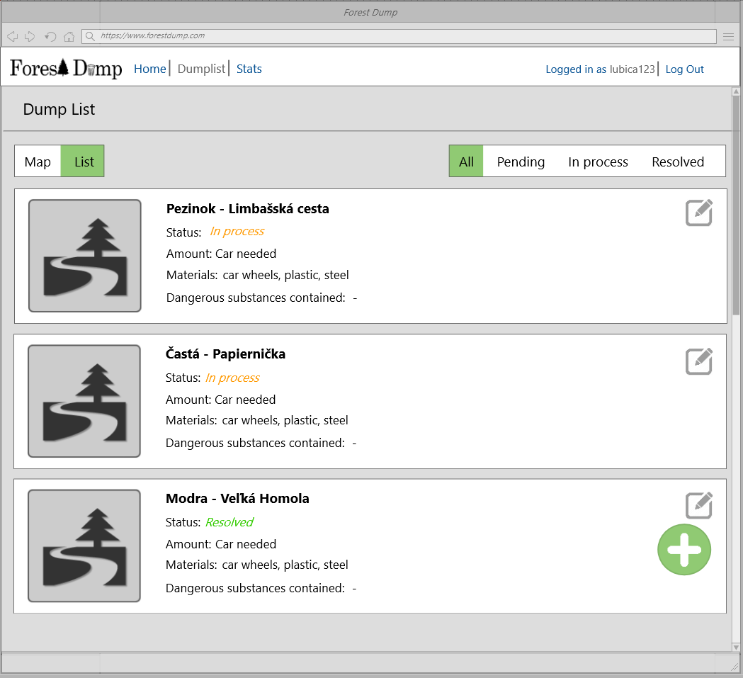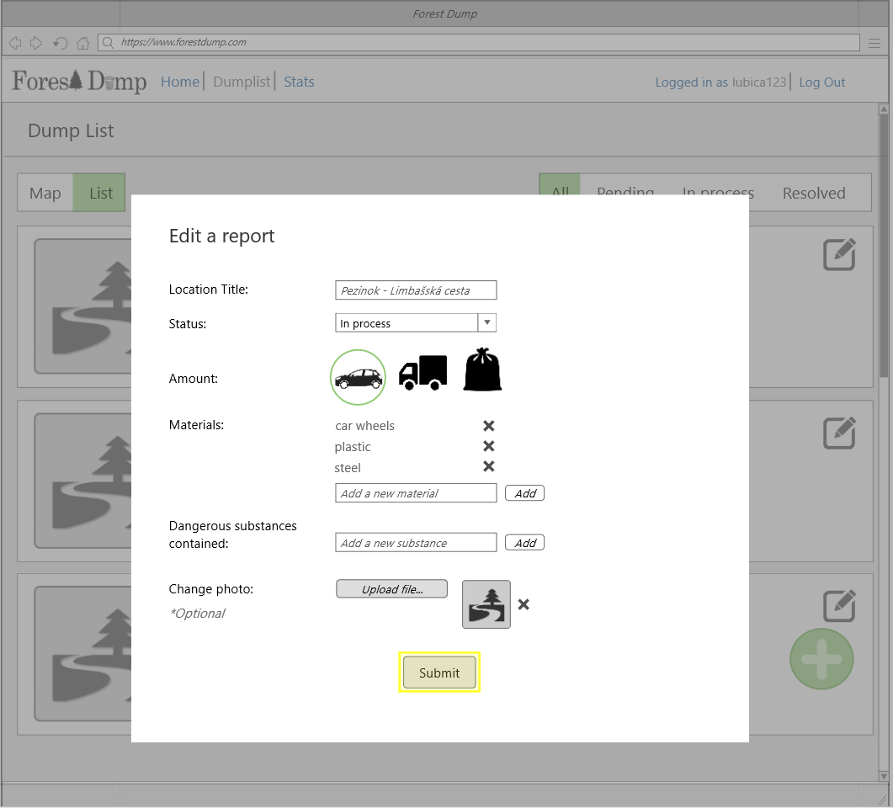

Figure 11

Figure 10