**Comenius University, Bratislava**

**Faculty of Mathematics, Physics and Informatics**

**Wireframes**

Forest Dump

Web design Technology and Methodology

**2018/2019**

**Patrícia Marmanová**

**Dana Škorvánková**

**Michal Brcko**

**Radoslav Hečko**

**Content**

1 Introduction 3

2 Wireframes 4

2.1 Ľubica’s scenario – Desktop application 4

2.2 Joseph’s scenario – Mobile application 4

# 1 Introduction

In this document, we will illustrate two scenarios of two different personas that are using the Forest Dump application. The wireframes of the application will be depicted step by step throughout the whole scenarios.

# Wireframes

In this section, each step of the particular scenario will be visualized and briefly described.

## 2.1 Ľubica’s scenario – Desktop application

The description of each step of the scenario:

* Ľubica opens the web application in her browser (Fig. 1).
* She navigates to the upper right corner to log into her account (Fig. 2).
* The pop-up window requiring her email/username and password shows up (Fig. 3).
* She fills-in the data and hits the *log in* button (Fig. 4).
* A page listing all the dumps is loaded (Fig. 5).
* Ľubica chooses the first one on the list and clicks on the edit icon (Fig. 6).
* The pop-up form to edit the record shows up (Fig. 7).
* She changes value of the *status* attribute from *pending* to *in process* by expanding the dropdown menu (Fig. 8 and 9).
* After that, she presses the s*ubmit* button (Fig. 10).
* The pop-up form is closed and the page with the list of the dumps is refreshed, showing the updated data (Fig. 11).
* Ľubica closes the browser [the end].

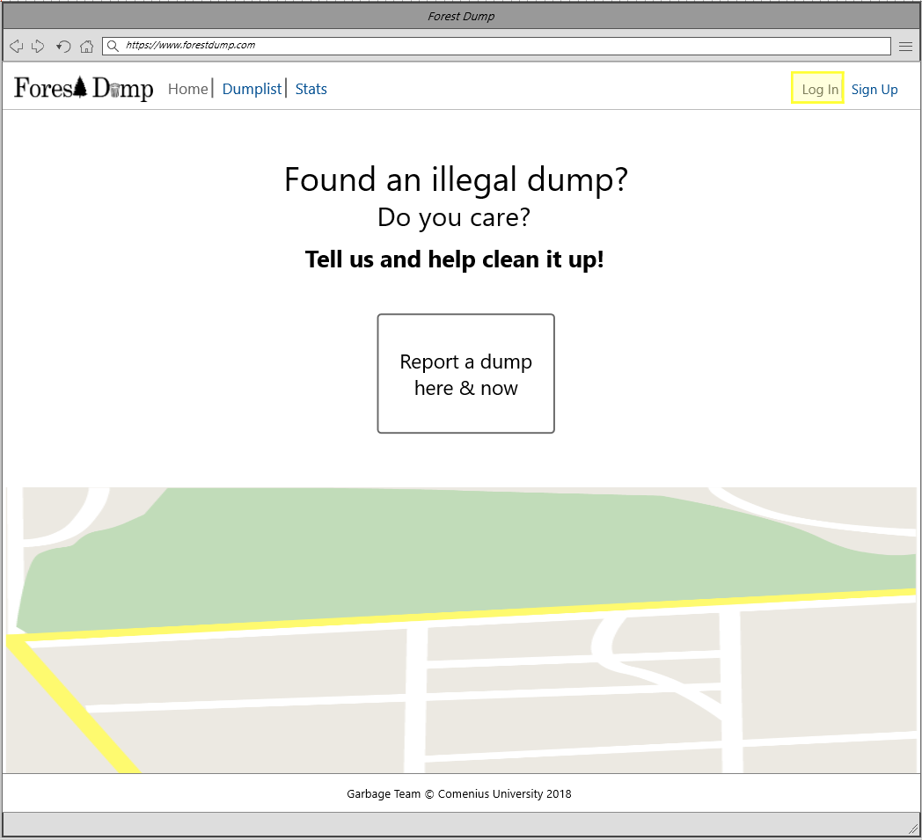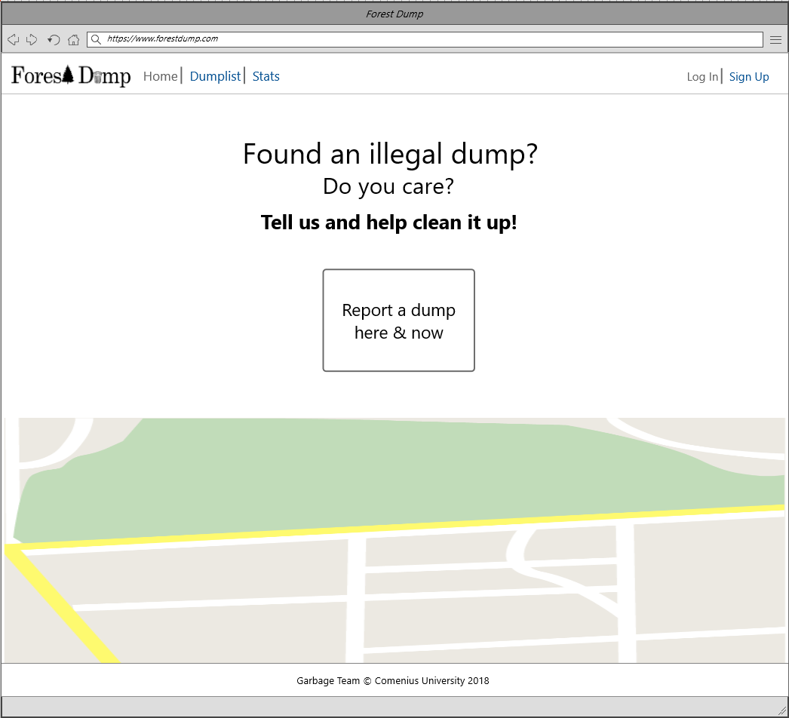

Figure

Figure

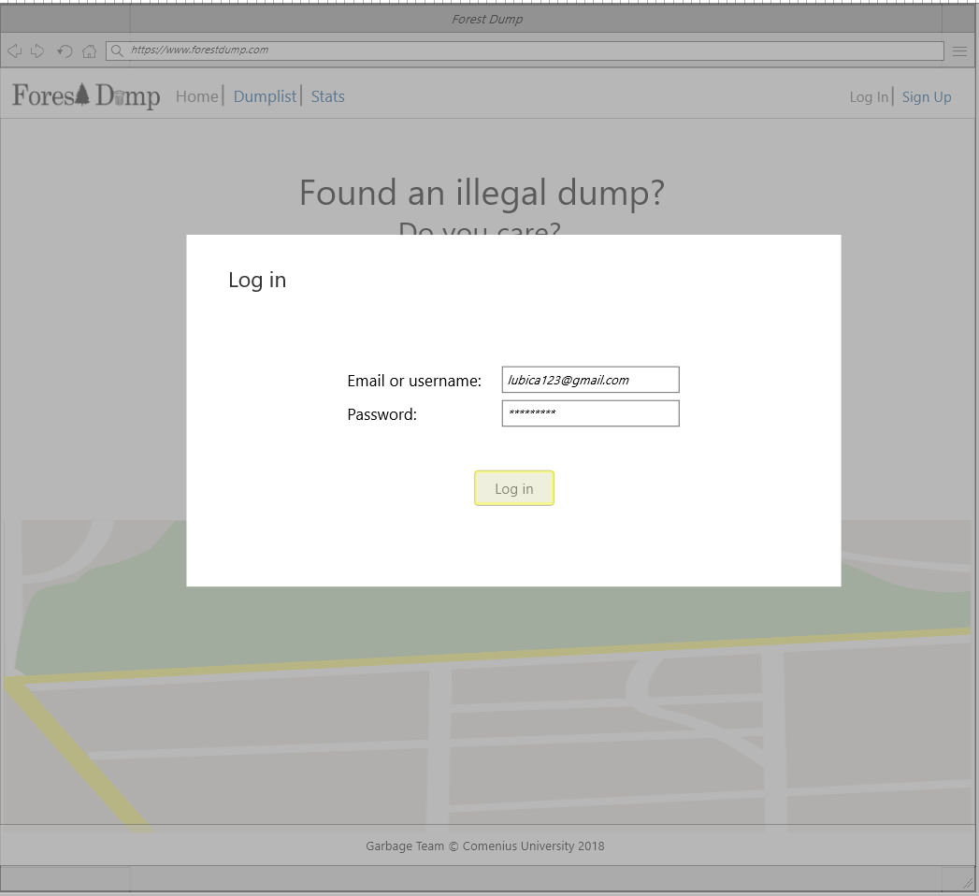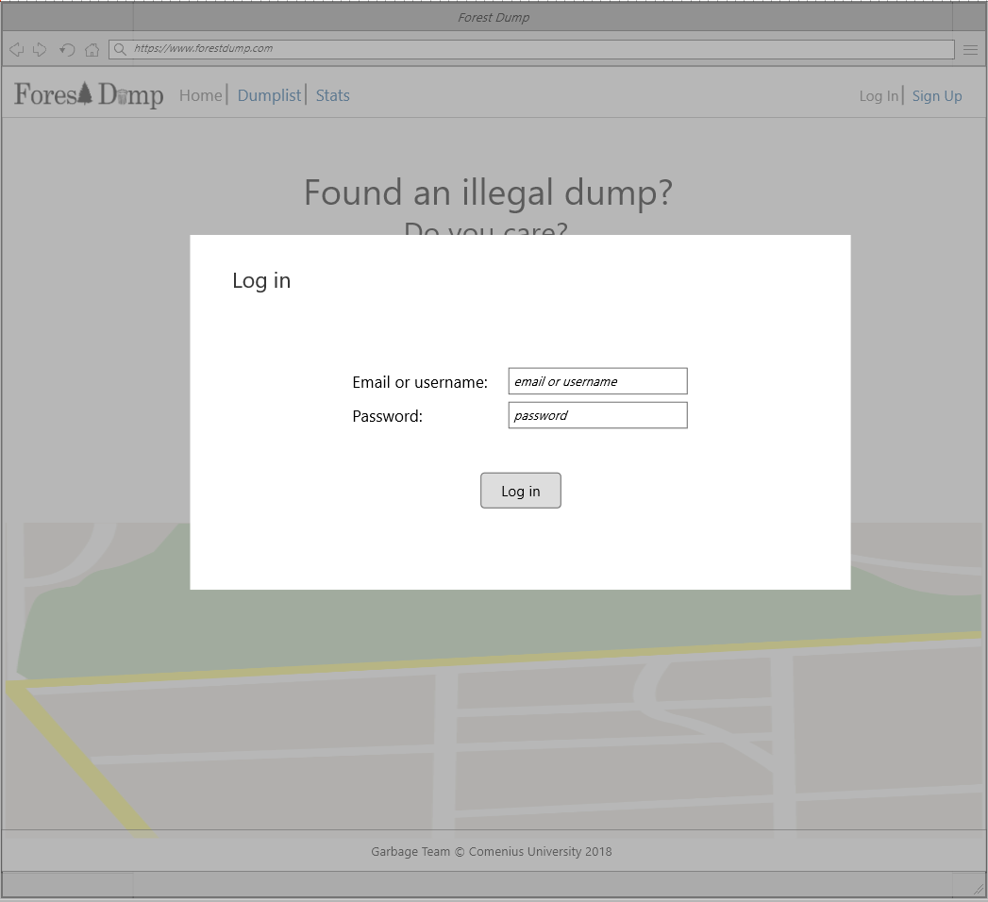

Figure 4

Figure 3

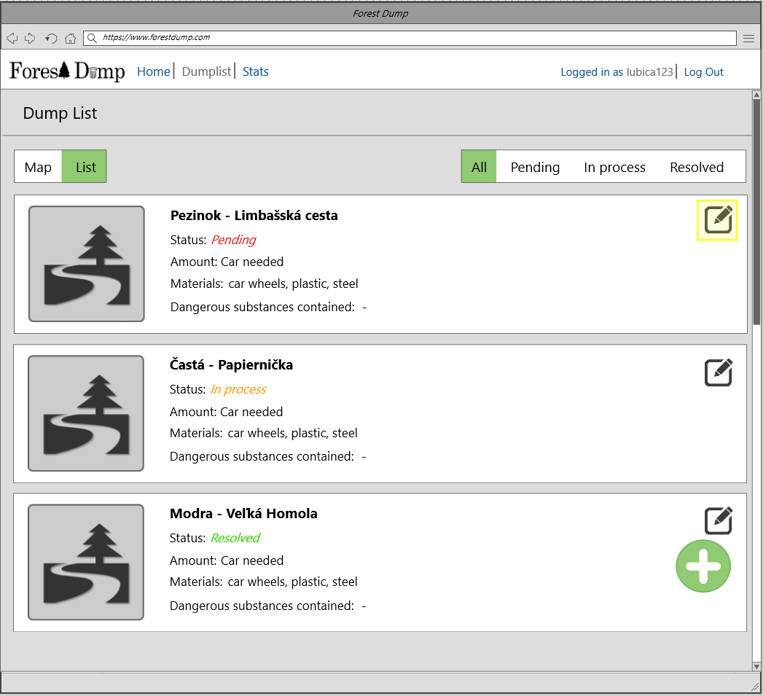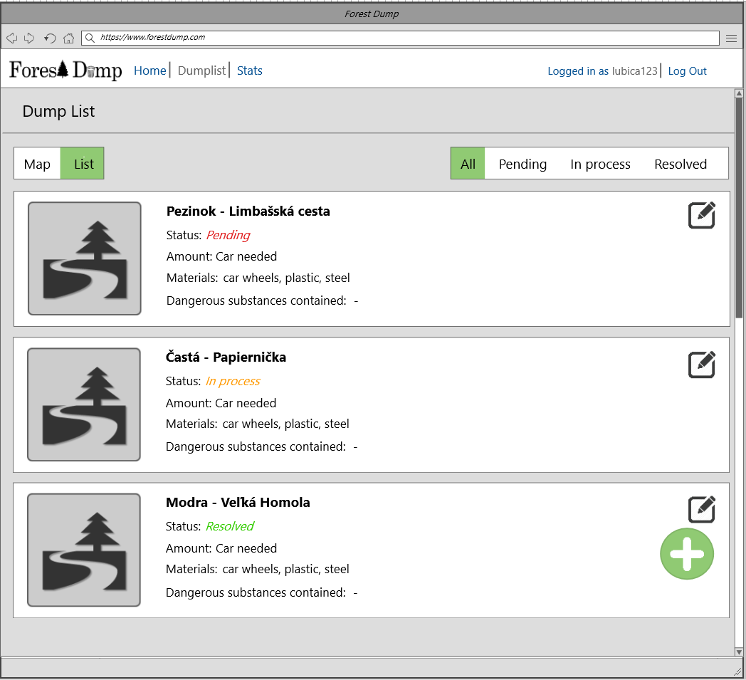

Figure 6

Figure 5

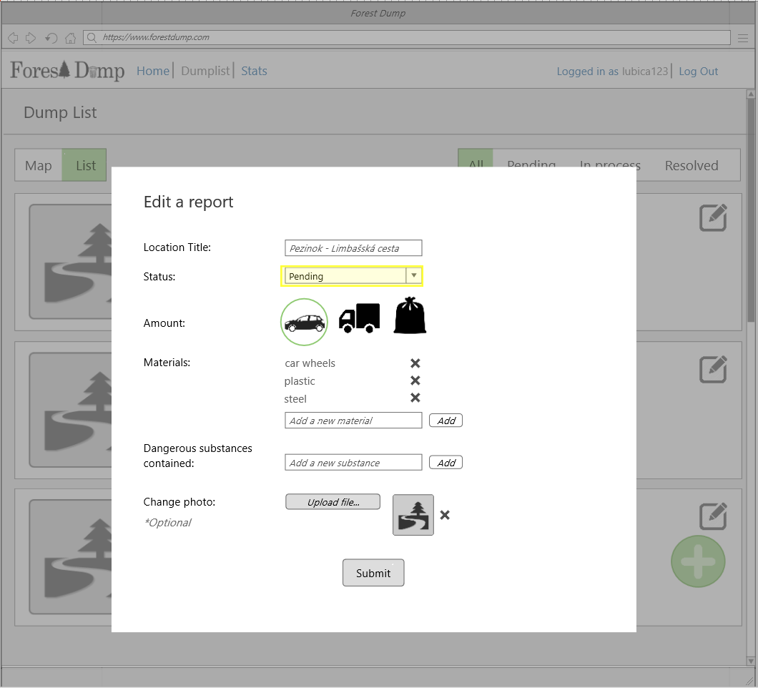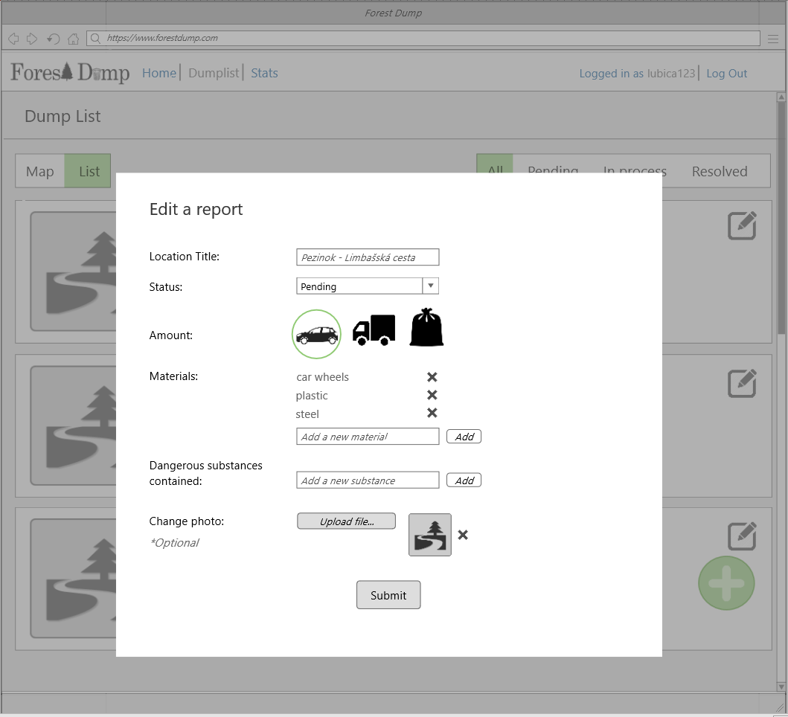

Figure 8

Figure 7

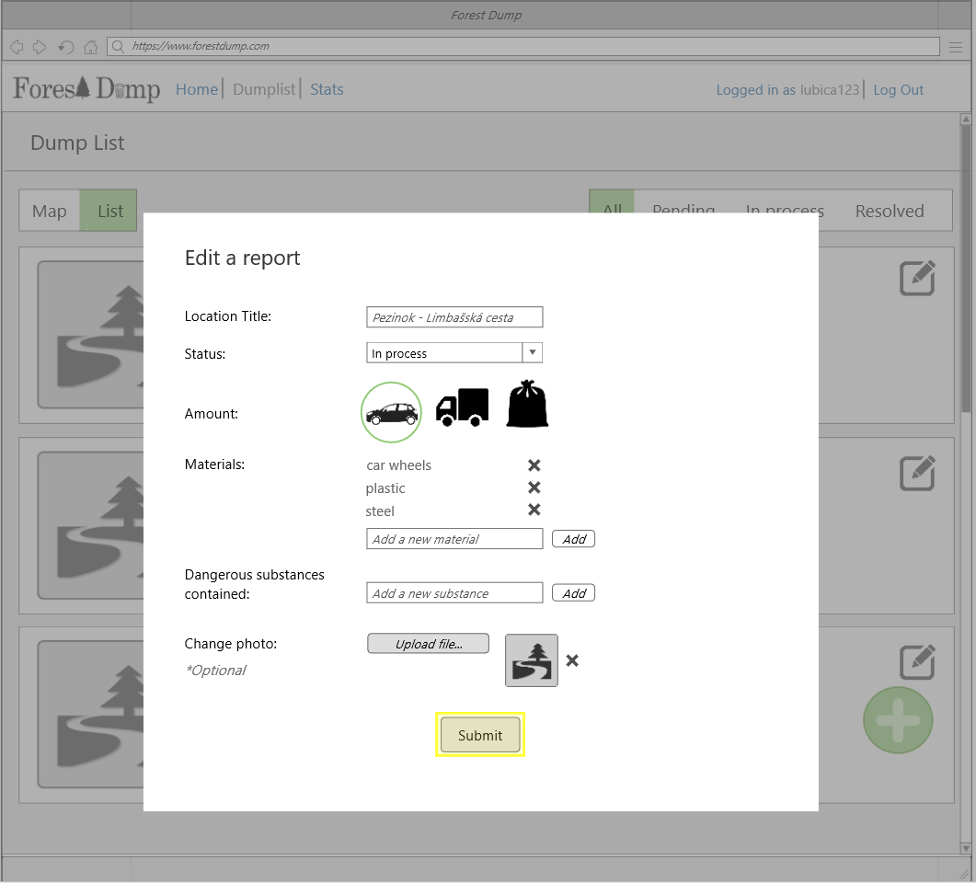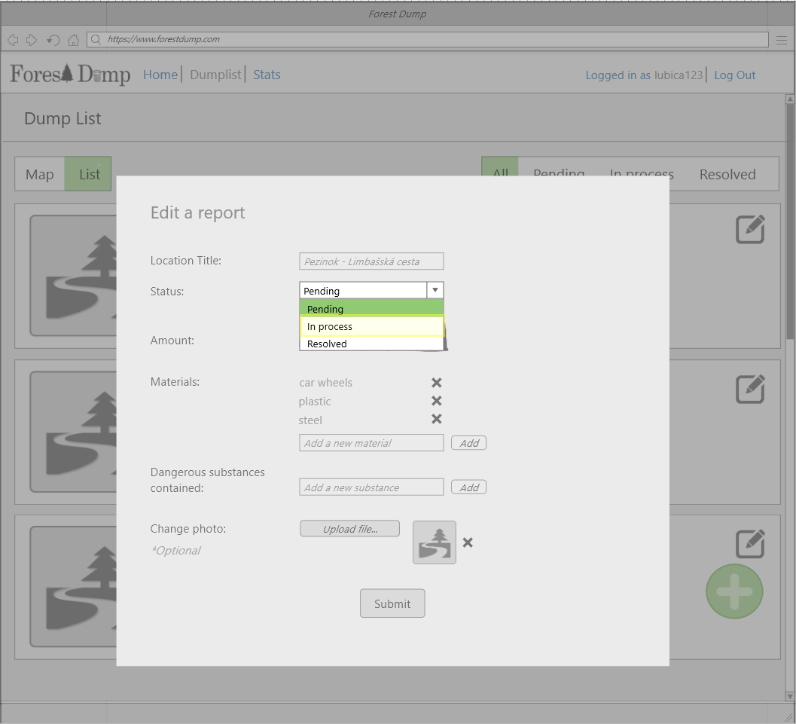

Figure 10

Figure 9

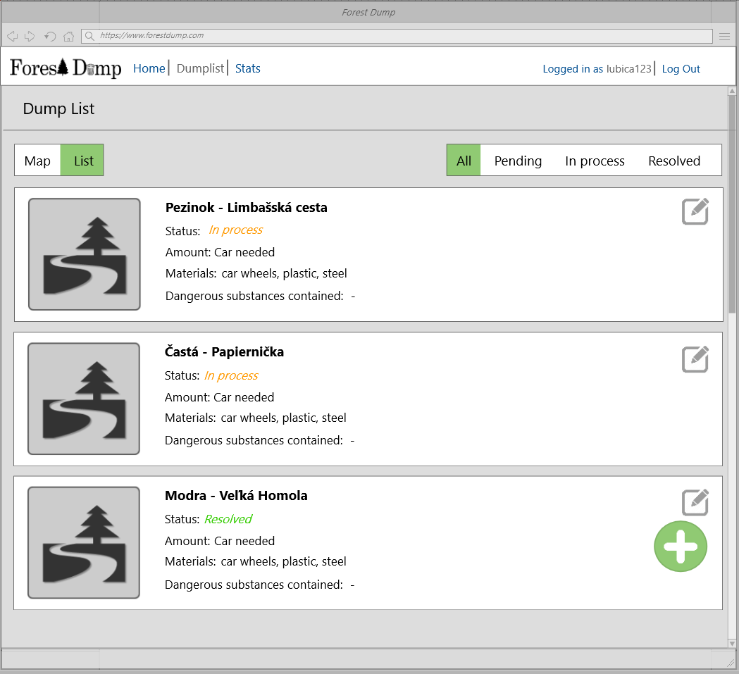

Figure 11

## 

## 2.2 Joseph’s scenario – Mobile application