Embedded Signal Processing System - ENE4069

Final Project

2018111902정상훈

## 문제 1. 출력 데이터에서 MATLAB에서 들을 수 있는 소리에 대한 두 음악을 분리합니다.

그림 1 Matlab 코드

‘twoChannelMusic’는 한 음악은 저역대에 위치해 있고, 한 음악은 고역대에 위치해 있습니다. 한 파일에 두 음악이 존재하지만 고역대에 있는 음악은 사람 귀에 잘 들리지 않기 때문에 저역대에 있는 음악만 들리게 됩니다.

이 두 음악을 분리하기 위해서 low pass filter를 이용하여 저역대에 있는 음악만 필터링하고, high pass filter를 이용하여 고역대에 있는 음악을 필터링한 후 modulation을 이용하여 저역대로 shift하였습니다. Low pass filter는 pi/4에서, high pass filter는 3*pi/4에서 cut-off하였고, 101개의 length를 통해 필터링을 거쳤습니다.

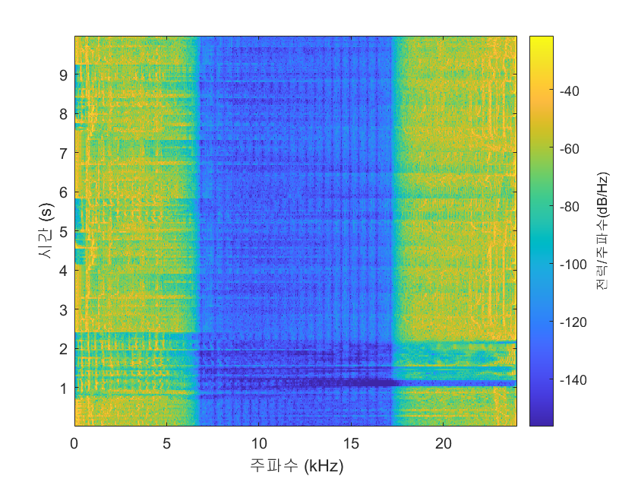

그림 2 output spectrogram

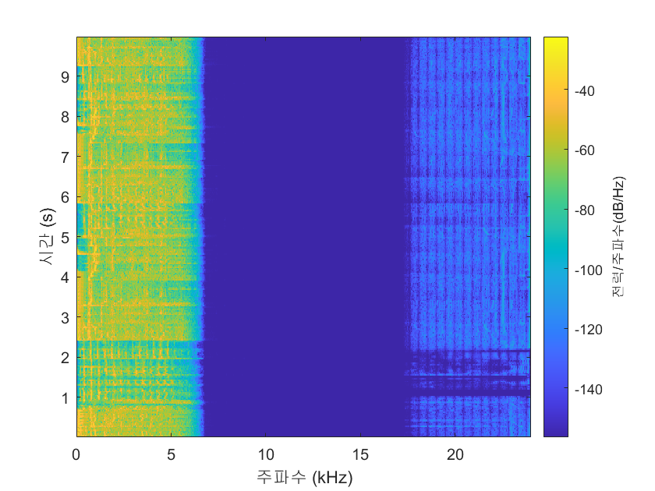

그림 3 DDUDU spectrogram

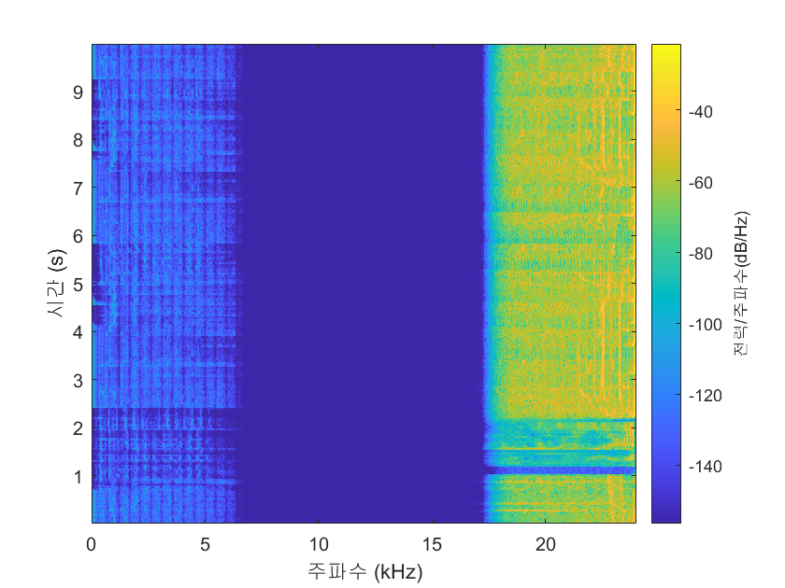

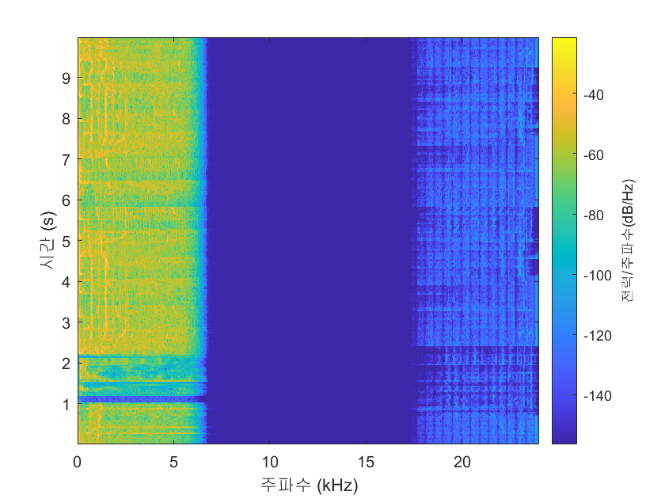그림 4 output2 spectrogram

그림 5 FIRE spectrogram

Output : 두 음악이 합쳐져 있는 출력 spectrogram

DDUDU : Output 출력을 LPF한 출력 spectrogram

Output2 : Output 출력을 HPF한 출력 spectrogram

FIRE : Output2 출력을 shift한 출력 spectrogram

## 문제 2. ARM 프로세서를 사용하여 두 음악을 왼쪽 오른쪽 각각의 채널로 분리합니다.

### CMSIS FIR 기본 코드를 작성

실습 동영상을 통해 설계한 CMSIS FIR 코드를 기반으로 코드를 작성하였습니다.

### 매트랩을 이용한 LPF 계수 추출

매트랩을 이용하여 low pass filter의 계수를 추출하였습니다. Length는 101로 하였고 format(long)을 이용하여 소수점 15자리 까지 추출하여 보다 깔끔한 필터링을 유도하였습니다.

### 매트랩을 이용한 HPF 계수 추출

HPF 계수 또한, 매트랩을 이용하여 추출하였습니다. Length는 101로 하였고 format(long)을 이용하여 소수점 15자리 까지 추출하여 보다 깔끔한 필터링을 유도하였습니다.

### CMSIS FIR 코드 추가 및 변경

1. Length 정의 변경

**#define** **FILTER_LENGTH** 101

Filter_length를 101로 설정했기 때문에 기존 코드에 있는 length 길이 정의를 101로 수정하였습니다.

1. 계수 값 변경 및 HPF 추가

**static** **float** LPF_coeffs[FILTER_LENGTH]

**static** **float** HPF_coeffs[FILTER_LENGTH]

기존에 있던 LPF 외에 추가적으로 HPF가 필요하기 때문에 추가하였습니다.

또한 매트랩에서 LPF, HPF 배열을 “ ‘ “를 이용하여 출력한 텍스트 값을 복사하여 계수값을 정의하였습니다.

1. Main 문 내의 함수의 매개변수 변경

**arm_fir_init_f32**(&fir_instance_left, FILTER_LENGTH, &LPF_coeffs[0], &fir_state_left[0], FRAME_LENGTH_FLOAT); // Init. for left FIR filter

**arm_fir_init_f32**(&fir_instance_right, FILTER_LENGTH, &HPF_coeffs[0], &fir_state_right[0], FRAME_LENGTH_FLOAT); // Init. for right FIR filter

Main 문 내의 함수의 매개변수 변경을 통해서 왼쪽, 오른쪽 필터 각각 적용합니다. 왼쪽은 LPF, 오른쪽은 HPF를 적용합니다.

1. While 문 내의 modulation 구문 추가

//modulation

**for** (**int** i = 0 ; i < FRAME_LENGTH_FLOAT ; i++) {

right_buf_out[i] = **pow**(-1, i)*right_buf_out[i];

}

Modulation 구문을 통해 HPF한 출력버퍼를 쉬프트시켜 저역대로 끌어옵니다.

### Build 및 Run 수행

완성된 코드를 build하고 run하여 ‘twoChannelMusic_46875Hz.mp3’ 을 재생시켜 테스트합니다.

### 최종 전체 코드

1. **#include** "main.h"
2. **#include** "usb_host.h"
3. **#define** **ARM_MATH_CM4** // Define Coretex M4 architecture
4. **#include** "arm_math.h" // Include advanced math header
5. **I2C_HandleTypeDef** hi2c1;
6. **I2S_HandleTypeDef** hi2s2;
7. **DMA_HandleTypeDef** hdma_i2s2_ext_rx;
8. **DMA_HandleTypeDef** hdma_spi2_tx;
9. **SPI_HandleTypeDef** hspi1;
10. **void** **SystemClock_Config**(**void**);
11. **static** **void** **MX_GPIO_Init**(**void**);
12. **static** **void** **MX_DMA_Init**(**void**);
13. **static** **void** **MX_I2C1_Init**(**void**);
14. **static** **void** **MX_SPI1_Init**(**void**);
15. **static** **void** **MX_I2S2_Init**(**void**);
16. **void** **MX_USB_HOST_Process**(**void**);
17. **#define** **FILTER_LENGTH** 101 // Filter length
18. **#define** **FRAME_LENGTH_FLOAT** 512 // Processing frame length
19. **#define** **FRAME_LENGTH_U16** 2048 // integer frame length ( one data = 2 integers * 2 ) left & right
20. **static** **float** LPF_coeffs[FILTER_LENGTH] = { // LPF coefficients
21. 0.000509052345141,
22. 0.000371467877138,
23. -0.000000000000000,
24. -0.000421930966378,
25. -0.000653272863360,
26. -0.000512505037478,
27. 0.000000000000000,
28. 0.000647601620055,
29. 0.001037034522740,
30. 0.000831895989141,
31. -0.000000000000000,
32. -0.001070425301757,
33. -0.001713651304070,
34. -0.001368728488021,
35. 0.000000000000000,
36. 0.001733043896939,
37. 0.002746633796917,
38. 0.002170588290959,
39. -0.000000000000000,
40. -0.002689952801760,
41. -0.004219324720115,
42. -0.003301670957015,
43. 0.000000000000000,
44. 0.004019046406006,
45. 0.006254446687866,
46. 0.004859383930577,
47. -0.000000000000000,
48. -0.005845867111595,
49. -0.009055859070559,
50. -0.007010511370258,
51. 0.000000000000000,
52. 0.008398982088119,
53. 0.013006613956334,
54. 0.010078810760424,
55. -0.000000000000000,
56. -0.012154177342397,
57. -0.018935270880269,
58. -0.014794326344006,
59. 0.000000000000000,
60. 0.018292964523664,
61. 0.029020686598050,
62. 0.023206828997117,
63. -0.000000000000000,
64. -0.030731760980923,
65. -0.051313387567824,
66. -0.043981293968470,
67. 0.000000000000000,
68. 0.074379480369694,
69. 0.158501841074448,
70. 0.224767270549089,
71. 0.249880485591675,
72. 0.224767270549089,
73. 0.158501841074448,
74. 0.074379480369694,
75. 0.000000000000000,
76. -0.043981293968470,
77. -0.051313387567824,
78. -0.030731760980923,
79. -0.000000000000000,
80. 0.023206828997117,
81. 0.029020686598050,
82. 0.018292964523664,
83. 0.000000000000000,
84. -0.014794326344006,
85. -0.018935270880269,
86. -0.012154177342397,
87. -0.000000000000000,
88. 0.010078810760424,
89. 0.013006613956334,
90. 0.008398982088119,
91. 0.000000000000000,
92. -0.007010511370258,
93. -0.009055859070559,
94. -0.005845867111595,
95. -0.000000000000000,
96. 0.004859383930577,
97. 0.006254446687866,
98. 0.004019046406006,
99. 0.000000000000000,
100. -0.003301670957015,
101. -0.004219324720115,
102. -0.002689952801760,
103. -0.000000000000000,
104. 0.002170588290959,
105. 0.002746633796917,
106. 0.001733043896939,
107. 0.000000000000000,
108. -0.001368728488021,
109. -0.001713651304070,
110. -0.001070425301757,
111. -0.000000000000000,
112. 0.000831895989141,
113. 0.001037034522740,
114. 0.000647601620055,
115. 0.000000000000000,
116. -0.000512505037478,
117. -0.000653272863360,
118. -0.000421930966378,
119. -0.000000000000000,
120. 0.000371467877138,
121. 0.000509052345141
122. };
123. **static** **float** HPF_coeffs[FILTER_LENGTH] = { // HPF coefficients
124. 0.000509052345141,
125. -0.000371467877138,
126. -0.000000000000000,
127. 0.000421930966378,
128. -0.000653272863360,
129. 0.000512505037478,
130. -0.000000000000000,
131. -0.000647601620055,
132. 0.001037034522740,
133. -0.000831895989141,
134. 0.000000000000000,
135. 0.001070425301757,
136. -0.001713651304070,
137. 0.001368728488021,
138. -0.000000000000000,
139. -0.001733043896939,
140. 0.002746633796917,
141. -0.002170588290959,
142. -0.000000000000000,
143. 0.002689952801760,
144. -0.004219324720115,
145. 0.003301670957015,
146. -0.000000000000000,
147. -0.004019046406006,
148. 0.006254446687867,
149. -0.004859383930577,
150. -0.000000000000000,
151. 0.005845867111595,
152. -0.009055859070559,
153. 0.007010511370258,
154. -0.000000000000000,
155. -0.008398982088119,
156. 0.013006613956334,
157. -0.010078810760424,
158. -0.000000000000000,
159. 0.012154177342397,
160. -0.018935270880269,
161. 0.014794326344006,
162. -0.000000000000000,
163. -0.018292964523664,
164. 0.029020686598050,
165. -0.023206828997117,
166. -0.000000000000000,
167. 0.030731760980923,
168. -0.051313387567825,
169. 0.043981293968471,
170. -0.000000000000000,
171. -0.074379480369694,
172. 0.158501841074448,
173. -0.224767270549090,
174. 0.249880485591676,
175. -0.224767270549090,
176. 0.158501841074448,
177. -0.074379480369694,
178. -0.000000000000000,
179. 0.043981293968471,
180. -0.051313387567825,
181. 0.030731760980923,
182. -0.000000000000000,
183. -0.023206828997117,
184. 0.029020686598050,
185. -0.018292964523664,
186. -0.000000000000000,
187. 0.014794326344006,
188. -0.018935270880269,
189. 0.012154177342397,
190. -0.000000000000000,
191. -0.010078810760424,
192. 0.013006613956334,
193. -0.008398982088119,
194. -0.000000000000000,
195. 0.007010511370258,
196. -0.009055859070559,
197. 0.005845867111595,
198. -0.000000000000000,
199. -0.004859383930577,
200. 0.006254446687867,
201. -0.004019046406006,
202. -0.000000000000000,
203. 0.003301670957015,
204. -0.004219324720115,
205. 0.002689952801760,
206. -0.000000000000000,
207. -0.002170588290959,
208. 0.002746633796917,
209. -0.001733043896939,
210. -0.000000000000000,
211. 0.001368728488021,
212. -0.001713651304070,
213. 0.001070425301757,
214. 0.000000000000000,
215. -0.000831895989141,
216. 0.001037034522740,
217. -0.000647601620055,
218. -0.000000000000000,
219. 0.000512505037478,
220. -0.000653272863360,
221. 0.000421930966378,
222. -0.000000000000000,
223. -0.000371467877138,
224. 0.000509052345141
225. };
226. **arm_fir_instance_f32** fir_instance_left, fir_instance_right; // Filter instance
227. //FIR state size = processing frame length + filter length - 1
228. **float** fir_state_left [FRAME_LENGTH_FLOAT + FILTER_LENGTH - 1]; // Left filter
229. **float** fir_state_right [FRAME_LENGTH_FLOAT + FILTER_LENGTH - 1]; // Right filter
230. **uint16_t** rxBuf[FRAME_LENGTH_U16*2]; // ADC buffer for left & right (Two buffers for half and full complete callback)
231. **uint16_t** txBuf[FRAME_LENGTH_U16*2]; // DAC buffer for left & right (Two buffers for half and full complete callback)
232. **float** left_buf_in [FRAME_LENGTH_FLOAT]; // Filter input buffer for left
233. **float** right_buf_in [FRAME_LENGTH_FLOAT]; // Filter input buffer for right
234. **float** left_buf_out [FRAME_LENGTH_FLOAT]; // Filter output buffer for left
235. **float** right_buf_out [FRAME_LENGTH_FLOAT]; // Filter output buffer for right
236. **uint8_t** state = 0; // ADC/DAC state for half or full complete callback
237. **int** **main**(**void**)
238. {
239. **int** offset_read_ptr; // Read pointer offset
240. **int** buf_ptr;
241. **HAL_Init**();
242. **SystemClock_Config**();
243. **MX_GPIO_Init**();
244. **MX_DMA_Init**();
245. **MX_I2C1_Init**();
246. **MX_SPI1_Init**();
247. **MX_USB_HOST_Init**();
248. **MX_I2S2_Init**();
249. **arm_fir_init_f32**(&fir_instance_left, FILTER_LENGTH, &LPF_coeffs[0], &fir_state_left[0], FRAME_LENGTH_FLOAT); // Init. for left FIR filter
250. **arm_fir_init_f32**(&fir_instance_right, FILTER_LENGTH, &HPF_coeffs[0], &fir_state_right[0], FRAME_LENGTH_FLOAT); // Init. for right FIR filter
251. **HAL_I2SEx_TransmitReceive_DMA**(&hi2s2, txBuf, rxBuf,FRAME_LENGTH_U16); // DMA setting (CAREFUL in DMA size!!!)
252. **while** (1)
253. {
254. **MX_USB_HOST_Process**();
255. **if** (state != 0) { // If ADC/DAC is not ready, do nothing
256. **if** (state == 1) { // In half complete call back
257. offset_read_ptr = 0;
258. }
259. **else** **if** (state == 2) { // In full complete call back
260. offset_read_ptr = FRAME_LENGTH_U16;
261. }
262. buf_ptr = 0;
263. //Bring data from ADC buffer to floating buffer (2*16bit integer -> one floating data)
264. **for** (**int** i=offset_read_ptr; i<offset_read_ptr+FRAME_LENGTH_U16; i=i+4) {
265. left_buf_in[buf_ptr] = (**float**) ((**int**) (rxBuf[i]<<16)|rxBuf[i+1]);
266. right_buf_in[buf_ptr] = (**float**) ((**int**) (rxBuf[i+2]<<16)|rxBuf[i+3]);
267. buf_ptr++;
268. }
269. //DO FIR
270. **arm_fir_f32** (&fir_instance_left, &left_buf_in[0], &left_buf_out[0],FRAME_LENGTH_FLOAT);
271. **arm_fir_f32** (&fir_instance_right, &right_buf_in[0], &right_buf_out[0],FRAME_LENGTH_FLOAT);
272. //modulation
273. **for** (**int** i = 0 ; i < FRAME_LENGTH_FLOAT ; i++) {
274. right_buf_out[i] = **pow**(-1, i)*right_buf_out[i];
275. }
276. buf_ptr = 0;
277. //Send data to DAC buffer to integer buffer (one floating data -> 2*16bit integer)
278. **for** (**int** i=offset_read_ptr; i<offset_read_ptr+FRAME_LENGTH_U16; i=i+4) {
279. txBuf[i] = (((**int**)left_buf_out[buf_ptr])>>16)&0xFFFF;
280. txBuf[i+1] = ((**int**)left_buf_out[buf_ptr])&0xFFFF;
281. txBuf[i+2] = (((**int**)right_buf_out[buf_ptr])>>16)&0xFFFF;
282. txBuf[i+3] = ((**int**)right_buf_out[buf_ptr])&0xFFFF;
283. buf_ptr++;
284. }
285. state = 0;
286. }
287. }
288. }
289. **void** **HAL_I2SEx_TxRxHalfCpltCallback**(**I2S_HandleTypeDef** *hi2s){
290. state = 1; // Half complete callback state
291. }
292. **void** **HAL_I2SEx_TxRxCpltCallback**(**I2S_HandleTypeDef** *hi2s){
293. state = 2; // Full complete callback state
294. }
295. **void** **SystemClock_Config**(**void**)
296. {
297. **RCC_OscInitTypeDef** RCC_OscInitStruct = {0};
298. **RCC_ClkInitTypeDef** RCC_ClkInitStruct = {0};
299. /** Configure the main internal regulator output voltage
300. */
301. __HAL_RCC_PWR_CLK_ENABLE();
302. __HAL_PWR_VOLTAGESCALING_CONFIG(PWR_REGULATOR_VOLTAGE_SCALE1);
303. /** Initializes the RCC Oscillators according to the specified parameters
304. * in the RCC_OscInitTypeDef structure.
305. */
306. RCC_OscInitStruct.OscillatorType = RCC_OSCILLATORTYPE_HSE;
307. RCC_OscInitStruct.HSEState = RCC_HSE_ON;
308. RCC_OscInitStruct.PLL.PLLState = RCC_PLL_ON;
309. RCC_OscInitStruct.PLL.PLLSource = RCC_PLLSOURCE_HSE;
310. RCC_OscInitStruct.PLL.PLLM = 8;
311. RCC_OscInitStruct.PLL.PLLN = 336;
312. RCC_OscInitStruct.PLL.PLLP = RCC_PLLP_DIV2;
313. RCC_OscInitStruct.PLL.PLLQ = 7;
314. **if** (**HAL_RCC_OscConfig**(&RCC_OscInitStruct) != *HAL_OK*)
315. {
316. **Error_Handler**();
317. }
318. /** Initializes the CPU, AHB and APB buses clocks
319. */
320. RCC_ClkInitStruct.ClockType = RCC_CLOCKTYPE_HCLK|RCC_CLOCKTYPE_SYSCLK
321. |RCC_CLOCKTYPE_PCLK1|RCC_CLOCKTYPE_PCLK2;
322. RCC_ClkInitStruct.SYSCLKSource = RCC_SYSCLKSOURCE_PLLCLK;
323. RCC_ClkInitStruct.AHBCLKDivider = RCC_SYSCLK_DIV1;
324. RCC_ClkInitStruct.APB1CLKDivider = RCC_HCLK_DIV4;
325. RCC_ClkInitStruct.APB2CLKDivider = RCC_HCLK_DIV2;
326. **if** (**HAL_RCC_ClockConfig**(&RCC_ClkInitStruct, FLASH_LATENCY_5) != *HAL_OK*)
327. {
328. **Error_Handler**();
329. }
330. }
331. /**
332. * @brief I2C1 Initialization Function
333. * @param None
334. * @retval None
335. */
336. **static** **void** **MX_I2C1_Init**(**void**)
337. {
338. /* USER CODE BEGIN I2C1_Init 0 */
339. /* USER CODE END I2C1_Init 0 */
340. /* USER CODE BEGIN I2C1_Init 1 */
341. /* USER CODE END I2C1_Init 1 */
342. hi2c1.Instance = I2C1;
343. hi2c1.Init.ClockSpeed = 100000;
344. hi2c1.Init.DutyCycle = I2C_DUTYCYCLE_2;
345. hi2c1.Init.OwnAddress1 = 0;
346. hi2c1.Init.AddressingMode = I2C_ADDRESSINGMODE_7BIT;
347. hi2c1.Init.DualAddressMode = I2C_DUALADDRESS_DISABLE;
348. hi2c1.Init.OwnAddress2 = 0;
349. hi2c1.Init.GeneralCallMode = I2C_GENERALCALL_DISABLE;
350. hi2c1.Init.NoStretchMode = I2C_NOSTRETCH_DISABLE;
351. **if** (**HAL_I2C_Init**(&hi2c1) != *HAL_OK*)
352. {
353. **Error_Handler**();
354. }
355. /* USER CODE BEGIN I2C1_Init 2 */
356. /* USER CODE END I2C1_Init 2 */
357. }
358. /**
359. * @brief I2S2 Initialization Function
360. * @param None
361. * @retval None
362. */
363. **static** **void** **MX_I2S2_Init**(**void**)
364. {
365. /* USER CODE BEGIN I2S2_Init 0 */
366. /* USER CODE END I2S2_Init 0 */
367. /* USER CODE BEGIN I2S2_Init 1 */
368. /* USER CODE END I2S2_Init 1 */
369. hi2s2.Instance = SPI2;
370. hi2s2.Init.Mode = I2S_MODE_MASTER_TX;
371. hi2s2.Init.Standard = I2S_STANDARD_PHILIPS;
372. hi2s2.Init.DataFormat = I2S_DATAFORMAT_24B;
373. hi2s2.Init.MCLKOutput = I2S_MCLKOUTPUT_ENABLE;
374. hi2s2.Init.AudioFreq = I2S_AUDIOFREQ_48K;
375. hi2s2.Init.CPOL = I2S_CPOL_LOW;
376. hi2s2.Init.ClockSource = I2S_CLOCK_PLL;
377. hi2s2.Init.FullDuplexMode = I2S_FULLDUPLEXMODE_ENABLE;
378. **if** (**HAL_I2S_Init**(&hi2s2) != *HAL_OK*)
379. {
380. **Error_Handler**();
381. }
382. /* USER CODE BEGIN I2S2_Init 2 */
383. /* USER CODE END I2S2_Init 2 */
384. }
385. /**
386. * @brief SPI1 Initialization Function
387. * @param None
388. * @retval None
389. */
390. **static** **void** **MX_SPI1_Init**(**void**)
391. {
392. /* USER CODE BEGIN SPI1_Init 0 */
393. /* USER CODE END SPI1_Init 0 */
394. /* USER CODE BEGIN SPI1_Init 1 */
395. /* USER CODE END SPI1_Init 1 */
396. /* SPI1 parameter configuration*/
397. hspi1.Instance = SPI1;
398. hspi1.Init.Mode = SPI_MODE_MASTER;
399. hspi1.Init.Direction = SPI_DIRECTION_2LINES;
400. hspi1.Init.DataSize = SPI_DATASIZE_8BIT;
401. hspi1.Init.CLKPolarity = SPI_POLARITY_LOW;
402. hspi1.Init.CLKPhase = SPI_PHASE_1EDGE;
403. hspi1.Init.NSS = SPI_NSS_SOFT;
404. hspi1.Init.BaudRatePrescaler = SPI_BAUDRATEPRESCALER_2;
405. hspi1.Init.FirstBit = SPI_FIRSTBIT_MSB;
406. hspi1.Init.TIMode = SPI_TIMODE_DISABLE;
407. hspi1.Init.CRCCalculation = SPI_CRCCALCULATION_DISABLE;
408. hspi1.Init.CRCPolynomial = 10;
409. **if** (**HAL_SPI_Init**(&hspi1) != *HAL_OK*)
410. {
411. **Error_Handler**();
412. }
413. /* USER CODE BEGIN SPI1_Init 2 */
414. /* USER CODE END SPI1_Init 2 */
415. }
416. /**
417. * Enable DMA controller clock
418. */
419. **static** **void** **MX_DMA_Init**(**void**)
420. {
421. /* DMA controller clock enable */
422. __HAL_RCC_DMA1_CLK_ENABLE();
423. /* DMA interrupt init */
424. /* DMA1_Stream3_IRQn interrupt configuration */
425. **HAL_NVIC_SetPriority**(*DMA1_Stream3_IRQn*, 0, 0);
426. **HAL_NVIC_EnableIRQ**(*DMA1_Stream3_IRQn*);
427. /* DMA1_Stream4_IRQn interrupt configuration */
428. **HAL_NVIC_SetPriority**(*DMA1_Stream4_IRQn*, 0, 0);
429. **HAL_NVIC_EnableIRQ**(*DMA1_Stream4_IRQn*);
430. }
431. /**
432. * @brief GPIO Initialization Function
433. * @param None
434. * @retval None
435. */
436. **static** **void** **MX_GPIO_Init**(**void**)
437. {
438. **GPIO_InitTypeDef** GPIO_InitStruct = {0};
439. /* USER CODE BEGIN MX_GPIO_Init_1 */
440. /* USER CODE END MX_GPIO_Init_1 */
441. /* GPIO Ports Clock Enable */
442. __HAL_RCC_GPIOE_CLK_ENABLE();
443. __HAL_RCC_GPIOC_CLK_ENABLE();
444. __HAL_RCC_GPIOH_CLK_ENABLE();
445. __HAL_RCC_GPIOA_CLK_ENABLE();
446. __HAL_RCC_GPIOB_CLK_ENABLE();
447. __HAL_RCC_GPIOD_CLK_ENABLE();
448. /*Configure GPIO pin Output Level */
449. **HAL_GPIO_WritePin**(CS_I2C_SPI_GPIO_Port, CS_I2C_SPI_Pin, *GPIO_PIN_RESET*);
450. /*Configure GPIO pin Output Level */
451. **HAL_GPIO_WritePin**(OTG_FS_PowerSwitchOn_GPIO_Port, OTG_FS_PowerSwitchOn_Pin, *GPIO_PIN_SET*);
452. /*Configure GPIO pin Output Level */
453. **HAL_GPIO_WritePin**(GPIOD, LD4_Pin|LD3_Pin|LD5_Pin|LD6_Pin
454. |Audio_RST_Pin, *GPIO_PIN_RESET*);
455. /*Configure GPIO pin : CS_I2C_SPI_Pin */
456. GPIO_InitStruct.Pin = CS_I2C_SPI_Pin;
457. GPIO_InitStruct.Mode = GPIO_MODE_OUTPUT_PP;
458. GPIO_InitStruct.Pull = GPIO_NOPULL;
459. GPIO_InitStruct.Speed = GPIO_SPEED_FREQ_LOW;
460. **HAL_GPIO_Init**(CS_I2C_SPI_GPIO_Port, &GPIO_InitStruct);
461. /*Configure GPIO pin : OTG_FS_PowerSwitchOn_Pin */
462. GPIO_InitStruct.Pin = OTG_FS_PowerSwitchOn_Pin;
463. GPIO_InitStruct.Mode = GPIO_MODE_OUTPUT_PP;
464. GPIO_InitStruct.Pull = GPIO_NOPULL;
465. GPIO_InitStruct.Speed = GPIO_SPEED_FREQ_LOW;
466. **HAL_GPIO_Init**(OTG_FS_PowerSwitchOn_GPIO_Port, &GPIO_InitStruct);
467. /*Configure GPIO pin : B1_Pin */
468. GPIO_InitStruct.Pin = B1_Pin;
469. GPIO_InitStruct.Mode = GPIO_MODE_EVT_RISING;
470. GPIO_InitStruct.Pull = GPIO_NOPULL;
471. **HAL_GPIO_Init**(B1_GPIO_Port, &GPIO_InitStruct);
472. /*Configure GPIO pin : I2S3_WS_Pin */
473. GPIO_InitStruct.Pin = I2S3_WS_Pin;
474. GPIO_InitStruct.Mode = GPIO_MODE_AF_PP;
475. GPIO_InitStruct.Pull = GPIO_NOPULL;
476. GPIO_InitStruct.Speed = GPIO_SPEED_FREQ_LOW;
477. GPIO_InitStruct.Alternate = GPIO_AF6_SPI3;
478. **HAL_GPIO_Init**(I2S3_WS_GPIO_Port, &GPIO_InitStruct);
479. /*Configure GPIO pin : BOOT1_Pin */
480. GPIO_InitStruct.Pin = BOOT1_Pin;
481. GPIO_InitStruct.Mode = GPIO_MODE_INPUT;
482. GPIO_InitStruct.Pull = GPIO_NOPULL;
483. **HAL_GPIO_Init**(BOOT1_GPIO_Port, &GPIO_InitStruct);
484. /*Configure GPIO pins : LD4_Pin LD3_Pin LD5_Pin LD6_Pin
485. Audio_RST_Pin */
486. GPIO_InitStruct.Pin = LD4_Pin|LD3_Pin|LD5_Pin|LD6_Pin
487. |Audio_RST_Pin;
488. GPIO_InitStruct.Mode = GPIO_MODE_OUTPUT_PP;
489. GPIO_InitStruct.Pull = GPIO_NOPULL;
490. GPIO_InitStruct.Speed = GPIO_SPEED_FREQ_LOW;
491. **HAL_GPIO_Init**(GPIOD, &GPIO_InitStruct);
492. /*Configure GPIO pins : I2S3_MCK_Pin I2S3_SCK_Pin I2S3_SD_Pin */
493. GPIO_InitStruct.Pin = I2S3_MCK_Pin|I2S3_SCK_Pin|I2S3_SD_Pin;
494. GPIO_InitStruct.Mode = GPIO_MODE_AF_PP;
495. GPIO_InitStruct.Pull = GPIO_NOPULL;
496. GPIO_InitStruct.Speed = GPIO_SPEED_FREQ_LOW;
497. GPIO_InitStruct.Alternate = GPIO_AF6_SPI3;
498. **HAL_GPIO_Init**(GPIOC, &GPIO_InitStruct);
499. /*Configure GPIO pin : OTG_FS_OverCurrent_Pin */
500. GPIO_InitStruct.Pin = OTG_FS_OverCurrent_Pin;
501. GPIO_InitStruct.Mode = GPIO_MODE_INPUT;
502. GPIO_InitStruct.Pull = GPIO_NOPULL;
503. **HAL_GPIO_Init**(OTG_FS_OverCurrent_GPIO_Port, &GPIO_InitStruct);
504. /*Configure GPIO pin : MEMS_INT2_Pin */
505. GPIO_InitStruct.Pin = MEMS_INT2_Pin;
506. GPIO_InitStruct.Mode = GPIO_MODE_EVT_RISING;
507. GPIO_InitStruct.Pull = GPIO_NOPULL;
508. **HAL_GPIO_Init**(MEMS_INT2_GPIO_Port, &GPIO_InitStruct);
509. /* USER CODE BEGIN MX_GPIO_Init_2 */
510. /* USER CODE END MX_GPIO_Init_2 */
511. }
512. /* USER CODE BEGIN 4 */
513. /* USER CODE END 4 */
514. /**
515. * @brief This function is executed in case of error occurrence.
516. * @retval None
517. */
518. **void** **Error_Handler**(**void**)
519. {
520. /* USER CODE BEGIN Error_Handler_Debug */
521. /* User can add his own implementation to report the HAL error return state */
522. **__disable_irq**();
523. **while** (1)
524. {
525. }
526. /* USER CODE END Error_Handler_Debug */
527. }
528. **#ifdef** USE_FULL_ASSERT
529. /**
530. * @brief Reports the name of the source file and the source line number
531. * where the assert_param error has occurred.
532. * @param file: pointer to the source file name
533. * @param line: assert_param error line source number
534. * @retval None
535. */
536. **void** assert_failed(uint8_t *file, uint32_t line)
537. {
538. /* USER CODE BEGIN 6 */
539. /* User can add his own implementation to report the file name and line number,
540. ex: printf("Wrong parameters value: file %s on line %d\r\n", file, line) */
541. /* USER CODE END 6 */
542. }
543. **#endif** /* USE_FULL_ASSERT */