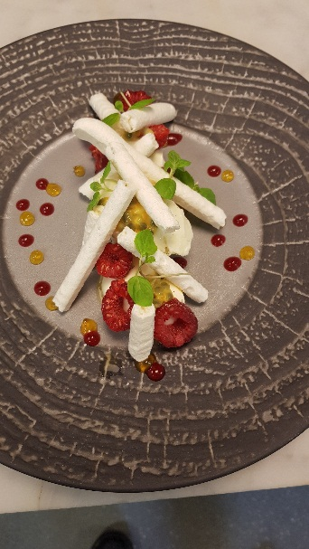

* Chantilly cream x 2 tea spoon quenelles
* Raspberry ripple ice cream
* Lime meringue
* Baby mint
* Fresh raspberry
* Raspberry gel
* Passion fruit gel
* Fresh passion fruit sauce

Yield #10 portion

Chantilly cream :

200 g Double cream

50 g caster sugar

1/3 vanilla pod (2.5 g vanilla pod )

Raspberry ripple ice cream

250 g milk Make an Anglaise and cook till 80ºC

250 g double cream

1/3 vanilla pod

80 g pasteurised yolks

115 g caster sugar

Raspberry gel for the ripple and the plating

125 g Raspberry puree

2 g agar agar

40 g sugar

25 g mirror glaze

Lime meringue

100 g pasteurised egg whites Make French meringue and add lime zest ,

200 g caster sugar then pipe with small plain nozzle .

1 # lime zest Dry in convection oven over night at 80º and low speed fen

Passion fruit gel

125 g Passion fruit puree

2 g agar agar

40 g sugar

25 g mirror glaze

1 punnte of 125 g fresh raspberry

6 fresh passion fruit

1/5 mint cress