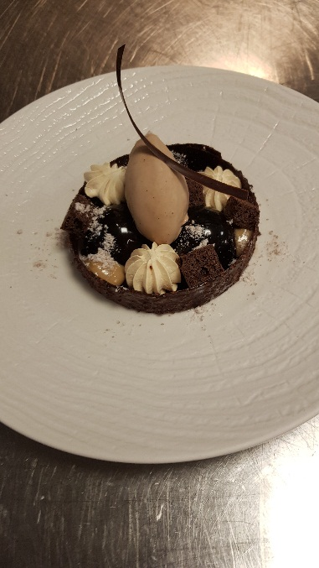

* Gruetine ring (use raspberry jelly ring )
* Chocolate cookie crumbs on the bottom
* Malt meringue
* Valrhona chocolate cremeux x 3 semi spheres glazed
* Baileys gel
* Nutella dust
* Milk chocolate and malt ice cream
* Chocolate cake pieces (AFT cake )

Yields #10

Chocolate cremeux

140 g milk Make an Anglaise pour over the chocolate,

60 g pasteurised yolks then mix with the cream and fill the moulds .

120 g Valrhona chocolate

320 g cream

Feuilletine base

25 g dark chocolate (Callebaut) meld chocolate and cocoa butter then mix with Feuilletine

25 g cocoa butter sprad on the tray and cut in the desired shape

100 g Feuilletine pallets

Malt meringue

100 g pasteurised whites make an Italian meringue (118ºC) ,when sugar is ready add the malt extract

200 g sugar and pour over the whipped egg whites . Pipe and dry at 80ºC over

40 g malt night on a low fan speed

Baileys gel

100 g Baileys

100 g water

3 g agar agar

40 g sugar

50 g mirror glaze

Malt ice cream

250 g milk

250 g double cream make an Anglaise add malt and pour over the chocolate

120 g pasteurised yolks then churn

100 g sugar

200 g milk chocolate (Callebaut)

120 g Malt extract

Chocolate glaze

50 g Mirror glaze

50 g home made chocolate sauce

Choco crumbs

94 g Butter

30 g cocoa

94 g soft flour t55

87 g caster

1 g salt

Nutella dust

30 g Nutella

90 g maltodextrin