**PANDA Delivery Service Project**

**Documentation**

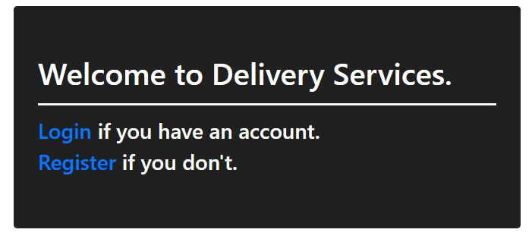

This is a simple documentation showing around my first ever project written in ASP.NET Core 3.1

It inherits the idea and the UI idea from one of the exams in Soft Uni.

I decided to use it as a base and to add some more functionalities, and overriding some of the built-in funtionalities.

**Registering and Logging In**

The first registered user receives a role “Admin”. Every other user is in a “User” role. Registering is simplified due to testing and learning purposes.

**Admin rights**

The index page when you log in as admin gives you the link buttons to the following functionalities:

-Creating a new package

-See all the registered packages, for all users

-See all the receipts for all packages and users

-See information about all the registered users (even the ones that have deleted their accounts).

Admin – Create package -> A form with required fields must be filled in in order to create and register a new package linked to a user. A dynamic dropdown menu generates options with all of the registered addresses for the chosen user. This is done by using AJAX method, communicating with the server asyncroniously and dynamically in accordance with the admin`s selection of user.