**PANDA Delivery Service Project**

**Documentation**

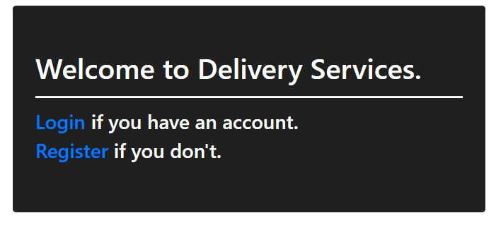

This is a simple documentation showing around my first ever project written in ASP.NET Core 3.1

It inherits the idea and the UI idea from one of the exams in Soft Uni.

I decided to use it as a base and to add some more functionalities, and overriding some of the built-in funtionalities.

**Registering and Logging In**

The first registered user receives a role “Admin”. Every other user is in a “User” role. Registering is simplified due to testing and learning purposes.