**Станции**

## 7080

McDonald Observatory, Texas

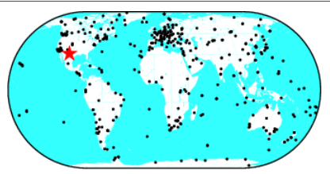

|  |  |  |
| --- | --- | --- |
|  |  |  |
| Филтрирани |  |  |

## 7090

Yarragadee, Australia

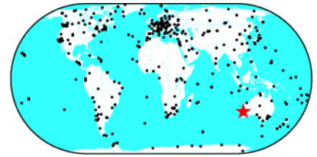

|  |  |  |
| --- | --- | --- |
|  |  |  |
| Филтрирани |  |  |

## 7105

Greenbelt, Maryland

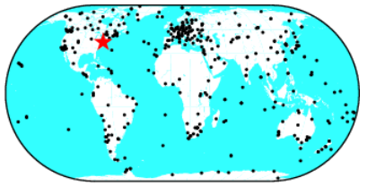

|  |  |  |
| --- | --- | --- |
|  |  |  |
| Филтрирани |  |  |

## 7110

Monument Peak, California

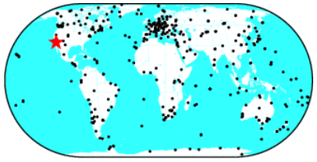

|  |  |  |
| --- | --- | --- |
|  |  |  |
| Филтрирани |  |  |

## 7840

Herstmonceux, United Kingdom

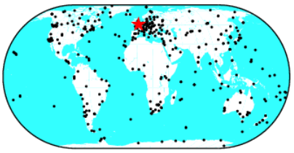

|  |  |  |
| --- | --- | --- |
|  |  |  |
| Филтрирани |  |  |