Econometrics using Matlab

1. Introduction
Matlab is a language particularly good at matrix computation. This makes it ideal for carrying out econometric estimations. This page gives a simple introduction on how to use Matlab.

2. Load Data
First you will have to make a Tab-delimited data file, which we name "input.txt" and looks like this:
1 | 0.39 | 1.88
2 | 0.29 | 2.88
3 | 0.19 | 3.88
4 | 0.09 | 4.88
Type:
load input.txt;
Then there is variable "input" in memory, which is a matrix with 4 rows and 3 columns. We can assign columns of "input" to different variables:
y = input(:, 2);
x = input(:,3);
x = input(1:4, 3)
Now we have two more variables in memory, y and x,
x = | y =
  0.39
  0.29
  0.19
  0.09
  1.88
  2.88
  3.88
  4.88

To see the relationship between x and y, we may plot the scatter plot as follows,

plot(x,y,’*’) - ‘*’用什么符号表示这些点，还可以‘.’或者缺省

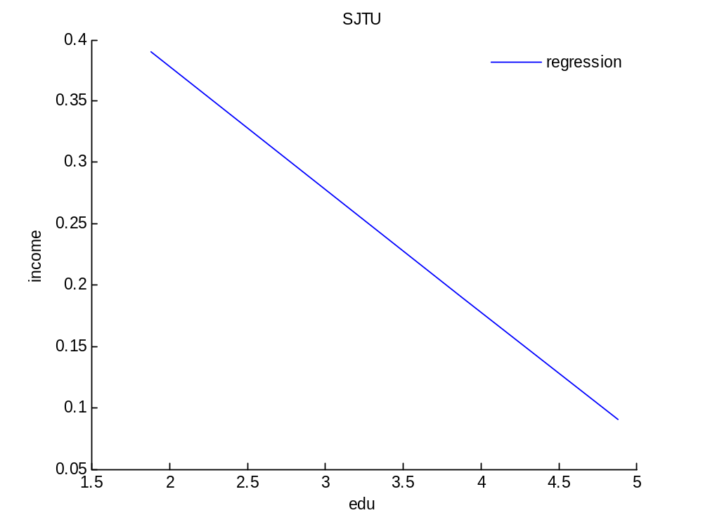

3. Matrix Manipulation
The function "ones(m, n)" creates a matrix of ones with m rows and n columns. If n = 1, it is a vector of ones, which is useful in adding a constant to regressions. For example,
X = [ones(4, 1) x];
Creates a new variable X, which is a matrix of 4 rows and 2 columns:
X=
1 | 0.39
1 | 0.29
1 | 0.19
1 | 0.09
Note that the space between "ones(4,1)" and "x" is important, which denotes horizontal concatenation. If we use ";", which denotes vertical concatenation, we will get a different X which is a column vector with 8 elements.

4. Matrix Computation
The matrix-form econometric fomula can easily be translated into Matlab language. Take the familiar fomula of OLS estimator as an example:
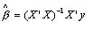
The corresponding Matlab statement is:
beta_hat = inv(X' * X) * X' * y,
where inv(.) is a function that calculates inverse of a square matrix, ' denotes operation of "transpose", and * multiplication. Note that to improve computational efficiency of the above command, we may use:
beta_hat = (X’*X)\(X’*y)
where the backslash \ denotes matrix left divide.

5. Save Results
To save results to a file on hard disk, the first thing to do is to specify a file to write to or create a new file. Both can be accomplished by:
fid = fopen('filename.txt', 'w');
"fid" is a number, called the "handle" of the file, returned by the function fopen(). 'w' gains permission to write to the file, or create a new one if the file 'filename.txt' does not exist.
Then it is ready to write data to the file using function "fprintf()". For example, if we type
fprintf(fid, '%3.2f %3.2f\n', [x y]') ;
then the file "filename.txt" will look like this:
0.39 | 1.88
0.29 | 2.88
0.19 | 3.88
0.09 | 4.88
'%3.2f %3.2f\n' is called the "format string", which tells Matlab to write both x and y in the format of float number with total length of 3 and 2 digits in fraction.
In the end, we should close the file using the funtion "fclose()":
fclose(fid);

6. An Example
Now we can estimate a classical regression model specified as:
or in matrix form,
,

6.1 Data
Copy the following data into a text file, name it "input.txt". The 3th column corresponds to x, random numbers from a uniform distribution with range (0, 1). The second column corresponds to y, random numbers generated by
,
1 | 1.023238 | 0.019640
2 | 2.365127 | 0.681277
3 | 1.748397 | 0.379481
4 | 2.677743 | 0.831796
5 | 1.997575 | 0.502813
6 | 2.424230 | 0.709471
7 | 1.859978 | 0.428892
8 | 1.600016 | 0.304617
9 | 1.357601 | 0.189654
10 | 1.386270 | 0.193431

6.2 Code
Now we pretend not knowing a and b and estimate them from the data using OLS. Copy the following Matlab code into Matlab Editor,
%%%%%work.m%%%%%
% Load data and assign variables:
load input.txt;
y = input(:, 2);
x = input(:, 3);
n = length(x);
X = [ones(n, 1) x]; % Regressor matrix
m = 2; % Number of regressors
% OLS estimate
beta_hat = inv(X'*X)*X'*y;
% Calculates regression statistics
e = y - X*beta_hat; %Estimated disturbances
sse = e'*e; %SSE (Sum of Square Errors)
s2 = sse/(n - m); %Estimate of sigma square
var = inv(X'*X)*s2; %Variance of the OLS estimate
se = sqrt(diag(var)); %Standard Error of the estimates
% Report results
fid = fopen('output.txt', 'w');
fprintf(fid, '%f (%f)\n', [beta_hat se]');
fclose(fid);
%%%%%%End of work.m%%%%%%
and type
work ;

6.3 Result
The output file "output.txt" looks like this:
0.981432 (0.004195)
2.033886 (0.008550)
The estimated value of a is 0.981432 with a standard error of 0.004195, and the estimated value of b is 2.033886 with a standard error of 0.008550. Not bad!

Other Resources
Always consult online documentation for help.
(Joe Junhui Qian 2004.09.08)

