Object Oriented Design

Report

Martin Radoychev

1. **AboutBox**
   1. Used “*StringBuilder*” to make the code more efficient and easier to read and maintain.

Картина, която съдържа текст, екранна снимка, софтуер

Описанието е генерирано автоматично

*Картина, която съдържа текст, екранна снимка, софтуер, дисплей

Описанието е генерирано автоматичноAfter*

1. **BitmapItem**
   1. Added “this.” keyword where needed
   2. The *BitmapItem* class handles the image loading in its constructor, meaning that if no image loads there will be an error.
      1. Картина, която съдържа текст, екранна снимка, софтуер, Шрифт

         Описанието е генерирано автоматичноI separated the image loading in another method and added a safe option if the image can’t load.
2. **SetSlideNumber in Presentation**
   1. It is visible that there are 3 slides only.

Картина, която съдържа текст, екранна снимка, софтуер, дисплей

Описанието е генерирано автоматично

b. Trying to go to slide 500

Картина, която съдържа текст, екранна снимка, софтуер, Операционна система

Описанието е генерирано автоматично

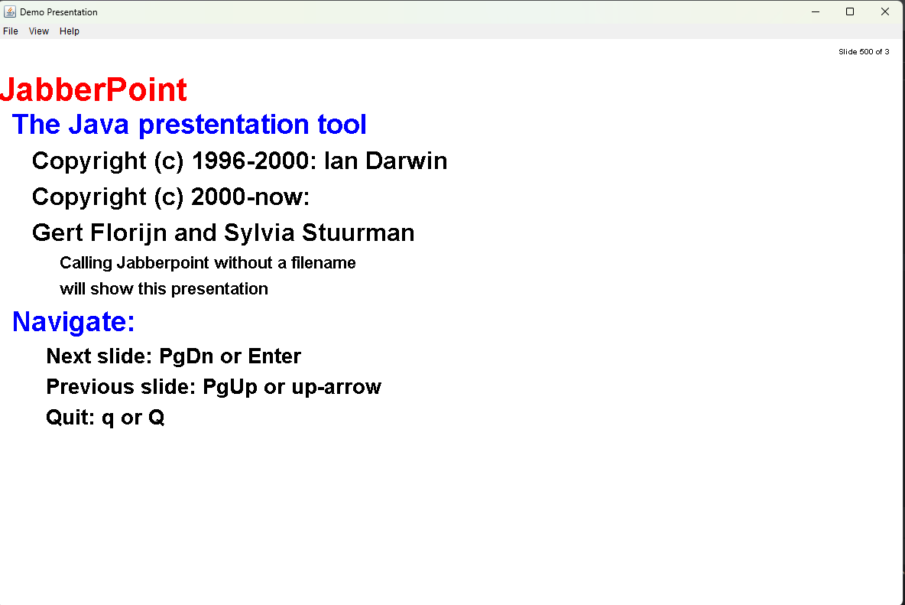

Jjjjjj

-Validates the slide number to ensure that it is in the slides range( If bigger number or smaller is put, the program will open the closest to them slide)

*Example:*

*If the input is -10, the program will open the first slide of the presenation*

*If the input is 100 and there are 10 slides, it will be open the last one ( Slide number* 10)

**4.Removed unused constructors:**

*1.BitMapItem class –*

public BitmapItem() {  
 this(0, null);  
}

* *By removing it Improves performance.*

**5. PresentationController**

- Made a new class called **PresentationController** from Presentation, where all interactions will the presentation will be handled. In this way Presentations will not anymore handle everything in one class( state of the slides, user interactions - navigating between slides and exiting the application.)

* *Moved the user interaction logic in the new class “PresentationController”.*
* *By doing that the code is easier to read and maintain.*

**6.Added extra security when uploading a file.**

- Confirming that the file exists.

- Ensures that the file is a file and not a directory.

- Verifies that the file has the correct extension “.xml”.

Картина, която съдържа текст, екранна снимка, Шрифт

Описанието е генерирано автоматично

7.Removed Vector and replaced it with ArrayList

Картина, която съдържа текст, екранна снимка, Шрифт

Описанието е генерирано автоматично

* Demo presentation was updated as well.
* More suitable and better is to use ArrayList instead of Vector.

**8. Added more *descriptive* comments**

- Using more descriptive comments will help programmers to understand how the program works and her logic.

**9.Removed not needed code from the Accessor class**

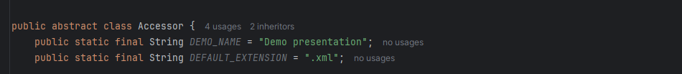

* Makes the code easier to understand and more clear.

**10. Replaced *while* *loop* with *for* *loop* in TextItem Class**

**Картина, която съдържа екранна снимка, текст, Шрифт

Описанието е генерирано автоматично**

* For loop is better option in this scenario, also makes the code easier to read and understand.

**11. Added *Getters* in Styles class.**

**- Added the *“this.”* Keyword in the Styles class where necessary.**