Table of Contents

I. Theory 1

Laser options 2

Port Wine Stains 2

Laser Hair Removal 4

Temperature Measurement 5

II. Design Appproach 6

Android App 7

Initial Design 7

Second Revision 8

Arduino Setup 8

Design Consideration 8

Implementation 9

Hardware Setup 9

Electrostatic Discharge(ESD) Protection 9

Heat Sink 9

Drive Circuit Design 10

MOSFET Driver Circuit Design 12

Conclusion and Discussion 13

APPENDIX 14

References 25

# I. Theory

It is becoming more common for medical issues to be treated through a variety of physical treatments rather than chemical. Popular among those issues are those dealing with skin lesions and their associated negative effects on one’s health- both mental and physical. Somewhat of a broad category, skin lesions can entail Port-Wine stains, spider webbed veins, and more. Many of these are aesthetic in nature and can be treated via laser therapy. Along those same lines is the process of permanent excessive hair removal, which is a very common commercial procedure done by people across the globe. The research done looks through a lens towards these applications of lasers and how a streamlined system with cost-efficiency and ease-of-use would stand to provide an advancement of current methods. It is noted that the design process takes into account the necessary requirements for each separate situation and attempts to draw conclusions as to what parameters are acceptable.

## Laser options

Focus of research: diode laser (pros cons etc; more to be added)

Lasers have a multitude of delivery options, each with a different medium for propagation with different operational parameters and limitation and usages. While the focus of this research will be the diode laser, it is important to understand the other options that are currently employed and have achieved clinical success.

Neodymium doped yttrium-aluminum-garnet lasers, or Nd:YAG for short, are crystal lasers that have a yttrium-aluminum-garnet crystal housing and is doped by neodymium, as suggested by the name. This laser in particular has a wavelength of 1064nm, with different uses in dermatology in treating vascular lesions other such skin disorders. The primary purpose of the laser is the breaking down of the red hemoglobin respiratory pigment. Hemoglobin is a protein that carries oxygen through capillaries and gives blood its red appearance.

Carbon dioxide CO2 lasers are typically used in industrial or surgical settings due to its high power output.

<http://www.troteclaser.com/en-US/Support/FAQs/Pages/Laser-Types.aspx><http://www.dermnetnz.org/topics/pulsed-dye-laser-treatment/>

-Should add more info in this part

## Port Wine Stains

Port Wine stains were the first of the skin lesions researched.  Also categorized as a birthmark, due to the prevalence of appearance during the postpartum period of a newborn’s life, Port Wine stains are discolorations of the skin predominantly in the facial area. The color palette ranges from sanguine tones to more violet ones and the size often increases relative to the size of the face. **Insert photos for ref**. As is the case of many a disorder, these stains are the effect of genetic mutations, specifically in the GNAQ gene1**.**The end result of this mutation is the malformation of proper blood capillaries leading to swelling and characteristic discoloration.

Typically the offending regions lay 0.5mm to 1.5mm beneath the epidermis, which also suggests possibilities of infection and hemorrhaging due to increased vascular activity. Many different treatments have been suggested and tested, but the most effective has been found to be laser treatment. There have been established practices of different laser therapies with the main goal to utilize a pulsed laser to selectively damage the malformed blood vessels while leaving the skin intact. To accomplish this, the hemoglobin inside the vessels would be matched to an appropriate laser irradiation wavelength for the optimal absorption. This method, known as selective photothermolysis, assumes values of the absorption coefficient of the skin to be akin to that of water due to composition ratios2.

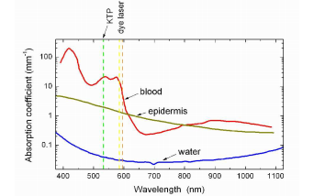

Figure : testing

The chart shown in **figure X** has a relationship between the wavelength of a laser and the associated absorption coefficient of the blood, epidermis, and skin tissue (essentially water). Ideally, the coefficient of the blood would be higher than that of the epidermis and the water coefficient would be minimized. According to the graph, the optimal wavelengths are achieved through either a KTP laser or dye laser at around 530 nm and 595 nm respectively.

It is noted, however, the laser is not only absorbed but also participates in scattering in all directions throughout the tissue, modeled by Rayleigh and Mie theories2. Scattered light can also be internally refracted or exit as reflected light.

Along with the aforementioned parameters, the spot size of a laser is a crucial factor in achieving desired deployment of heat. The spot size is characterized by its diameter, determining the penetration depth of the beam. This penetration depth correlated to the spot size must be balanced with the scattering as well as attenuation that take place due to the distribution of light.

A practical setting also requires that the laser is not continuously on, as it would damage the skin by burning it. Naturally, heat is not a contained package, and will diffuse from the target location to its surroundings, presenting the unwanted possibility of collateral damage, contrary to the end goal of selective photothermolysis. The question that naturally follows is that of pulse duration, asking for a criterion stipulating the allotted time until the surrounding tissue is damaged. Another factor influencing the application is the fluence of the laser pulse. The fluence is defined as the “optical energy delivered per unit area”4, and take the units of [Jcm2]. The pulse duration would work in conjunction with the absorption coefficient, fluence, and penetration depth parameters to form an outline of design constraints necessary for successful laser treatments.

According to a clinical trial done by several researchers at the Cochrane Group, both a pulsed dye laser and an Nd:YAG laser produced successful results in reducing the birthmarks throughout several treatments with the latter laser being slightly favored. They were far from perfect, however, with patients experiencing “Short‐term side‐effects included pain, crusting, and blistering in the first two weeks after treatment.”3

There are a variety of laser delivery systems offered in other clinics such as the Laser & Skin Surgery Center of New York7. Their options include “V-beam” lasers, which are pulsed dye lasers, Alexandrite lasers, Nd:YAG lasers, a combination of a 532nm KTP laser in conjunction with the 1064nm YAG laser in the “Excel V laser”5, and a CO2 fractional laser (“Fraxel”)6. Each of these options has seen clinical success, but offer the disadvantage of being specialized equipment. Often large and cumbersome, the machines required for the operation are not optimized for consumer use, and requires specialized knowledge as well as a hefty investment.

## Laser Hair Removal

Similar to the treatment of skin lesions, laser hair removal uses many different types of lasers and systems. The main goal of is typically to permanently destroy hair growth in targeted locations, an improvement in many ways over the ubiquitous short-term solutions that have a variety of drawbacks. Waxing is extremely painful, for example, with possibilities of infection and skin irritation. Shaving can have similar effects of irritation as well as being only a temporary solution with new growth being prickly and uncomfortable.  The standard has thus been set with the emergence of laser removal as an option.

In the case of a design targeted towards this application, looking at the anatomy of the hair is imperative to the elucidation of proper parameters. The hair follicle is the structure housing the hair shaft, beginning at a bulb in the dermis and terminating at the epidermis. Most relevant to the goal of permanent hair removal is the hair bulb, which dictates the growth of the hair. Inside the hair bulb are cells known as keratinocytes hosted by the hair matrix8. Production of terminal hair (thicker and more pigmented than vellus hair) can be halted with damage to the follicle and its constituents all the way down to the bulb and ultimately the hair matrix.

Mentioned earlier was selective photothermolysis, where a certain chromophore (hemoglobin in the case of port wine stains) was heated through the use of a laser according to the properties differentiating it from its surroundings. Many of the parameters maintain their significance and should be examined accordingly.

## Temperature Measurement

Due to the nature of this application being ultimately towards human skin, care must be taken not to cause excessive damage or harm. As such, a temperature feedback system would be a proficient way of preventing the laser from burning the skin. Theoretically, if the temperature of skin reaches a certain threshold (which would be set lower than the burning point) the laser will be shut off for safety precautions. By monitoring the skin through a sensor, the data can be processed with a microcontroller. Comparing the measured temperature to the set threshold, the microcontroller can shut off the driver circuit for the laser when it reaches the predetermined value.

There are many ways of temperature measurement, but the most practical of them for this application is non-contact infrared sensing. Even among infrared sensors are broad ranges of parameters that must be chosen to fit the design. The first one to account for is the physical size of the package, since it should be able to fit within a housing in conjunction with the laser being used. Ideally, due to the limited housing space, the infrared sensor would have a profile of around 5mm or less.

Several options were examined for their applicability to the design. Initially, Texas Instruments’ TMP006 thermopile sensor was purchased. It fulfilled the parameter of the size, with the device itself being 1.6mm x 1.6mm, which was sufficiently small, and the sensor within it having the dimensions of 0.33mm x 0.33mm. This integrated thermopile was well within the operating range of temperatures, with an operating voltage of 3.3V.  For the responsivity of 50%, an FOV of 90 degrees was stated. As a digital sensor with internal ADC and references, the TMP006 maintains a reasonable response within the range of 4-10um wavelengths IR radiation, which is enough for the temperatures of hair follicle and skin burning. Using the

The problem with this particular sensor was the response time, with the data taken at a period of time that wouldn’t be able to produce comprehensive data. The temperature pulse is too fast for the capture by this sensor. A solution that was explored was that of taking multiple of these sensors (See Schematic A) and “firing” them in succession with each a different capture window. After modeling this on Eagle (Schematic B), there were problems with routing as well as in the intrinsic nature of the chip actively averaging the values taken. Since the pulse-width of the temperature spike is low, it would be rendered null through an average.

Yet another issue with using this sensor is its practicality for prototyping. Due to the ball-grid array package of the chip, mounting on a PCB would be difficult, possibly requiring the use of more than two layers and presenting the chance for the grid to be misplaced. It is offered pre-mounted on a board by Adafruit, but is too large in this case. These considerations resulted in the decision that the TI TMP006 was not going to be fit for this application.

Next sensor examined was the Melexis MLX90615 infrared non-contact sensor. This sensor has a can package with through-hole pin mounting. Internally, the MLX has a digital signaling processing unit amplifier and ADC akin to the TMP006. With a diameter of 5.5mm, the can’s size was reasonably small and within the design parameters.  The range of measurable object temperature also was suitable, being -40 to 115 Celsius.

This sensor was connected to an Arduino and the data was taken, then processed from the MLX. After the data was processed, the resulting temperatures found were displayed on an LCD display. To properly determine the functionality of the sensor, a precursory test was conducted. Water was heated in a glass beaker while the sensor recorded temperatures during heating than during cooling. Room and starting water temperature was 30.1 degrees Celsius and peak temperature was 103.1 degrees Celsius. The time between taken data points was 100ms. As a result, during the time frame, 79053 points were recorded for a comprehensive look at how the device performed over time. Figure M is the graph.

//formatted

# II. Design Appproach

The system needs to be controlled, with the temperature sensor data being outputted to a display, and for the data to be recorded and graphed through MatLab/Arduino Plotter. Similarly, the laser would need to be controlled in terms of its pulse width and current supplied to its driver circuit through an embedded system. These processes were threaded through an Arduino microcontroller to a Bluetooth module. This module communicates with an Android phone though a custom app that was created. Through this app, these parameters could be controlled, and the continuous sensor data could be read. The figure below is the flowchart of the arduino code (Figure 2)

[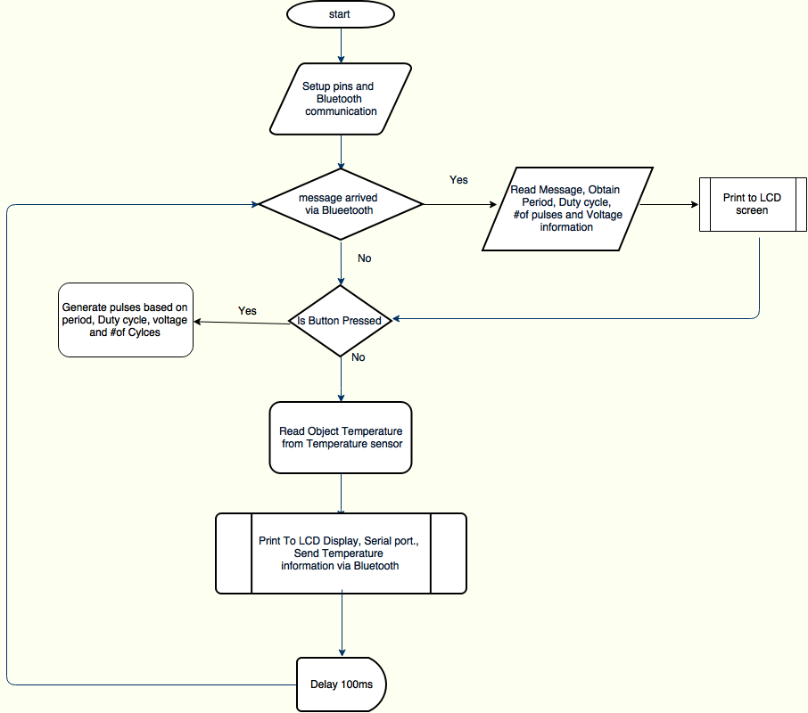](https://drive.draw.io/#G0B_53-s5c1eZtaDRCamEtNm1oVXM)

Figure : Flowchart of the arduino code

## Android App

The end outcome of the project will be to use the laser as an independent module with help of the phone application. The app has to be able to set the Period (ms), Duty Cycle (%), Number of pulses, and the Peak of the pulse(V). In addition, the temperature readings from the sensor has to be displayed and plotted on a graph.

### Initial Design

The GUI has a scroll wheel interface for the setting of the various parameters. The period, duty cycle and number of pulses are set by the scroll wheel while the amplitude of the pulse is set using text box and restricted to a range of 0-5v in increments of 0.1v. These parameters are then sent to the arduino after the send button is tapped, establishing a ready state for when the arduino pushbutton is depressed. The temperature data is displayed in real-time, with the readings sent from the infrared sensor to the app via the arduino Microcontroller. Availability for graphing is also a feature of the app, with the received temperatures plotted against time with the press of the graph button. For debugging purposes and situations of bluetooth communication drops, a software reset button is included. A standard close button is used to end communication manually. The screenshot of the application is shown below along with the picture of the Arduino’s LCD screen displaying values of the settings (Figure 3).

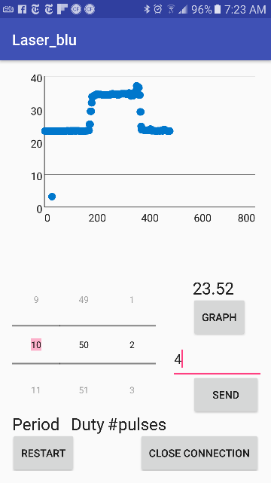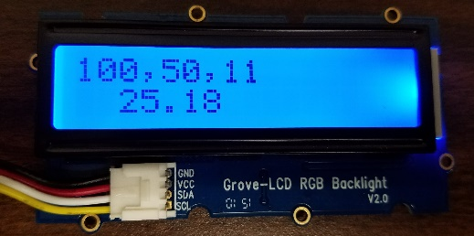

Figure :(a) Screenshot of android app (b) Settings received from the android app is displayed on the arduino's LCD screen.

### Second Revision

After using the app during the experiment, a couple features had to added to the app to make it user friendly. Every time the app was opened, the settings were erased. Although data points of the temperature readings can be graphed, there was no means to save these data points. To include these features and reduce clustering, the app was redesigned to have two different activities/screen. The first screen will allow the users to enter the laser settings and send to the arduino. There is a load option, which will let users to retrieve the last used settings (fig3a). Pressing the graph button will redirect to a second screen. The second screen/activity will be used to display the real time temperature readings along with the graph. The save data button is included to allow for storing the data on google drive (fig 3b).

## Arduino Setup

### Design Consideration

Following the flowchart, operation proceeds from when the arduino receives the parameters set by the application and end user. Initially, the analog output of the arduino was going to be utilized in generating the pulse, but there were issues discovered with its implementation. While the analogWrite() function was available for analog output control, it outputs a pulse width modulated signal. Since the PWM signal provides the appropriate analog voltage by averaging a given signal, using the standard analog output was not conducive to successfully controlling the laser driver circuit, which needs differentiable pulses. The digital outputs could not be used directly either, since the voltage levels were either 5v or 0v and the laser is depended on variable supplied current linked to voltage.

### Implementation

The solution found was to use a 12-bit MCP4725 digital to analog converter to output discrete analog voltages in increments of 0.244mV with a controlled digital input generated by the arduino. Using the I2C communication protocol for microcontroller(MC) to DAC interface, an integer value between 0 and 4095 is sent to the DAC from the MC. The integer value would ideally correspond/be converted to an outputted voltage with the integer value being divided by 819 e.g. 0 to 0v, 2457 to  3v, and 4095 to 5v. After testing was started, there was an issue of a 0.8v constant voltage output despite a lack of input signal to the DAC by the MC. Debugging the software discovered that the error was due to the fact that the LCD screen used to display the laser parameters and temperatures used the same I2C protocol, and happened to share the same address of 0x62 as the DAC. Fixing this error, the DAC address was moved to 0x63 and the output pulses were as desired at the pushbutton depress.

## Hardware Setup

### Electrostatic Discharge(ESD) Protection

The first step in creating the driver circuit was to protect the laser diode and fiber from any electrical/static discharges that could potentially damage the semiconductor device from normal handling. A laser diode-specific ESD absorber was chosen for this purpose. The L44-228-X ESD used from LASORB is a 2-pin package with a through-hole mounting style designed for red lasers. The Lasorb component is designed to protected against both positive and negative static discharges and could withstand 50A during as ESD event. In addition, the laser will also be guarded against any power surges while power up or power down [1]. It was recommended on the datasheet for the component to be placed less than a centimeter from the pins of the laser. During assembly, there was a preliminary ESD band shorting the pins on the laser and, once the LASORB was soldered on with the corresponding anode pin to the laser anode, this band was removed. At this time, twisted strand wires were soldered to the pins of the laser. These were chosen over solid wire due to flexibility and integrity issues that solid wire would have after repeated bending.

### Heat Sink

The next step was to design for operating conditions of the laser as to not damage the equipment. Due to the relatively narrow operating temperature range of  20°C - 30°C, either forced convective or conductive cooling was required. In the case of continuous mode operation of the laser, an effective method would be the use of a thermoelectric peltier cooler running a PID loop. Either positive or negative voltage would then be supplied to control the temperature within the range as desired. Given the nature of the design, however, precise cooling was not required due to the pulsed operation having a maximum pulse width of 100ms. As such, the laser was screw-mounted on a salvaged desktop CPU cooling heatsink with ample thermal paste (Figure 4: The laser attached to the heatsink along with the ESD protection mounted directly on the leadsFigure 4).

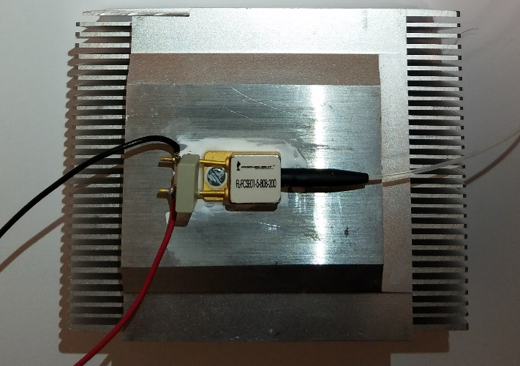

Figure : The laser attached to the heatsink along with the ESD protection mounted directly on the leads

### Drive Circuit Design

The application of this design ultimately calls for usage on skin for either hair removal or skin lesion treatment. As mentioned before, the power output of the laser and subsequent energy absorbed by the skin must thus be accurately controlled using pulse duration and amplitude. The operating voltage of the laser should be less than 2.2V, with operating current range of 0 to 6.5A [2]. A power mosfet had to be implemented in order to be able to withstand current of more than 5A. RFP06N30LE power mosfet was chosen for its ability to handle large currents (30A max) and corresponding power without burning out, as would a typical mosfet used in regular digital circuitry.

Given that the power is directly proportional to current applied after 0.9A, a driver circuit was designed to provide controlled current.

#### Initial Design

The initial design involved a mosfet based current mirror to provide steady current to a load controlled by the arduino MC/DAC combination found. By changing the gate voltage of a mosfet, the drain current would vary as well in a quadratic relationship as long as the mosfet remained in the saturation region. The first approximation of the drain current in saturation was used to find the expected currents obtained from various gate voltages (Equation 1). In the case of a desired current range of 0A to 5A, the necessary voltage range would be 2.97V to 3.7V(Figure 5b)

|  |  |  |
| --- | --- | --- |
|  |  | () |

 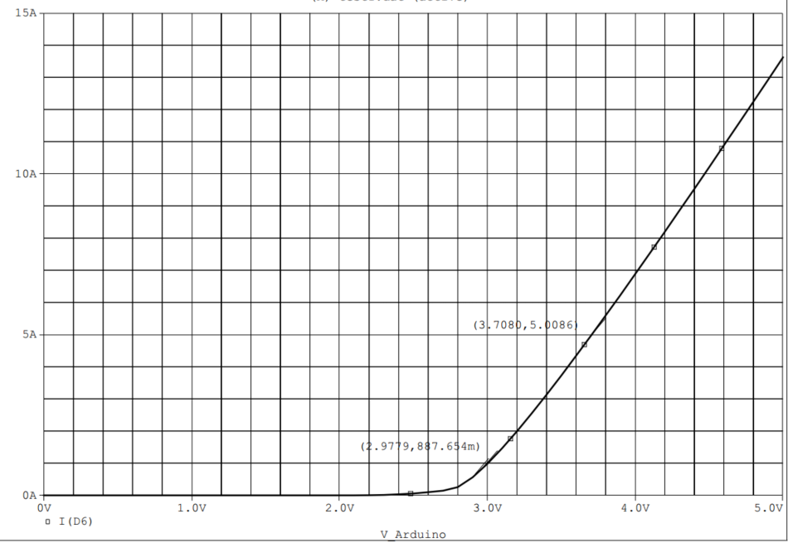

Figure : (a)Initial drive circuit design with one mosfet controlled by a voltage source(arduino) at gate. (b) Simulation result of VGS vs I­­DS: the voltage range is between 2.97V to 3.7V to obtain current range of 0.9A to 5A.

//

For the given design and desired accuracy, the quadratic relationship proved to be an issue. As gate voltage increases, the current and subsequent power is effectively increasing too quickly. The increments of voltage needed to achieve even steps of increased power would then be too small for the DAC resolution (Calculations to be added).  As such, the desired operation would use a linearized input voltage vs. drain current relationship.

Next to accomplish was the characterization of the current, voltage and power relationships of the laser due to the lack of any given in the associated datasheet.

In this case, the control circuit included a variable power supply at the drain of a power mosfet for testing purposes. The gate was set to 5v for continuous mode operation, as opposed to the pulsed operation arduino/DAC output as the gate control. Figure 123123 is a schematic for the testing of power.

The laser output was connected to a Newport Model 835 picowatt power meter and the supplied voltages were varied at the gate of the nMOSFET. Given the limitation of the power meter rated maximum at 2W, the characteristics of the laser were taken to 1.95W. Both the currents and voltages were displayed on the power supply, and the voltages across the laser diode was taken by a Fluke 117 electric multimeter, switching to current when necessary. The data was then tabulated (Table 3, appendix) and graphed (graph 3.1,3.2,3.3). Although the power supply was supplying a voltage greater than the max laser operating voltage of 2.2v suggested by the datasheet, the actual voltage dropped across the diode was below 2.2v.

{The operating voltage specified by the datasheet is ≤2.2V. The voltage supplied by the power supply was higher than that. In order to confirm whether this voltage was applied across the diode, measurement across the diode was taken for select current values. The data indicated a voltage drop across the diode was below 2.2v, thus the voltage supplied is dropped across the mosfet the lasorb device

(Confirm this theory and expand on it). }

Using Ohm’s law, the resistance was found from inverting the slope value of the voltage vs. current graph. As such, the diode laser resistance was found to be suitably low, at around 0.21Ω. The graph of voltage and current also confirms the data sheet listed turn-on threshold being 0.9A. Further extrapolation can be done to predict the power output for higher currents using the linear relationship seen for values above 0.9A.

## MOSFET Driver Circuit Design

The current mirror circuit was then dropped and instead, a single supply LM324 opamp chip was used as a comparator in conjunction with the RFP06N30LE power mosfet between the DAC output and mosfet gate. For the inputs, the DAC output was connected to the noninverting input of the op amp with feedback from the source of the mosfet being taken into the inverting input. The output of the op amp was then wired to the mosfet gate. Adding this negative feedback to the comparator controls the output such that the gate voltage has a linear relationship with the current running through the mosfet drain/source. A simulation on spice was done first to see the expected outputs (figure of schem and sim). A 1ohm resistor was also added in series with the laser diode for the negative feedback of the 0v to 5v drop across it corresponding to the 0A to 5A current range. Understanding that the resistor would be ultimately carrying a max of 5A of current and 25W (P=I2R), the resistor should be rated as such. A KAL25FB1R00 chassis mount resistor was used for its 1ohm resistance and 25W power rating in the simulation. Generally, a resistor with a higher power rating would have been chosen, but due to the short pulsed operation, the 25W rating was fine, and one with a higher rating was much more expensive.

(include schematic screencap)

(include simulation screencap)

With the simulations producing the desired output, a test circuit was built with a 3ohm, 25W resistor used for its availability at the time. Another issue arose at this point, with the Agilent E3631A DC power supply being able to only supply a maximum of 1A when using the +25v output (12v was required to power the single supply op amp and the mosfet drain). An older Tektronix PS280 power supply was used in place of the Agilent one, as it was able to supply the current needed when connecting the outputs in parallel internally. Taking the data resulted in a  relationship strikingly similar to the simulated ones, with a deviation attributed to the inexact resistance of the 3ohm resistor used. Additionally, the power output was consistent with the current supplied as in table 3.1.

As the voltage was increased at the opamp non-inverting terminal, the mosfet was reaching temperatures up to 75°C. As such, the input voltage was increased until 7.5V with an output current of 2.2A.

(include schematic)

Test Equipment used:

* Newport model 835 picowatt power meter
* Agilent E3631A DC power supply
* Fluke 117 electric multimeter

Parts used:

* Arduino Uno
* MLX90615 temperature sensor
* RFP06N30LE power mosfet
* LM324 opamp
* MCP4725 DAC
* 1ohm 25 watt resistor
* Push button
* LCD screen
* Bluetooth module
* android phone

## Conclusion and Discussion

Due to mishap, there was a short circuit causing a power surge. This event caused the MLX90615 infrared sensor to malfunction and shut down the laptop that was used to power the arduino. The lasorb component performed its purpose by guarding the laser against this surge. In addition the mosfets that was used during the testing latched and caused the circuit to act in a continuous mode.

Special thanks to Professor Harbans Dhadwal, and Tony Olivo, and Professor David Westerfield, and Professor Milutin Stanacevic.

**TO DO**

-Add in the figures, pictures, references, schematics and simulations and properly format them

-Format graphs with appropriate titles, captions etc.

-Format citations and sources (add datasheets to citations page)

-Add calculations for voltage range

-Banana peel test results if completed by deadline (temperature measurements on back and front)

-Mount the laser and the lens 8mm from it

-Include equations and calculations for focal length

# APPENDIX

Initial drive circuit design and simulation:

The initial drive circuit design involved using a current mirror to provide the current to the laser. The laser in the below circuit will be placed at the drain of M1. The voltage at V2 will be the DAC output from arduino. In this design the output current increased from 0 to 5A for an input voltage of 3.5V to 4.65V. Controlling the current precisely with this design is very hard.

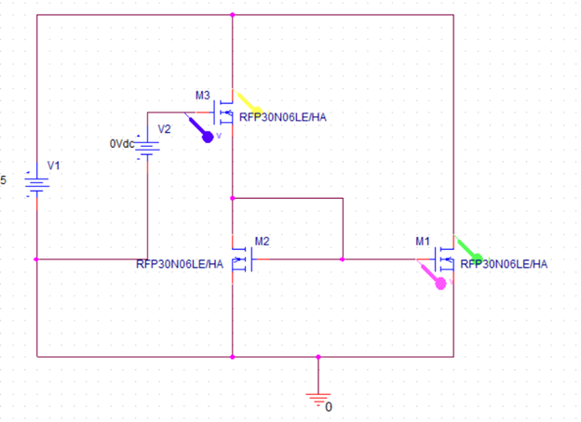

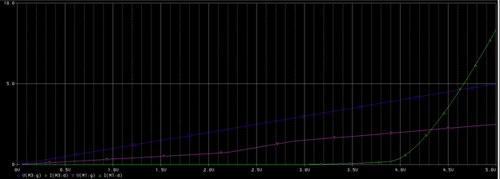

(current across M1(green), voltage at gate M3(blue), voltage at gate M1(magenta))

**final drive circuit and simulation.**

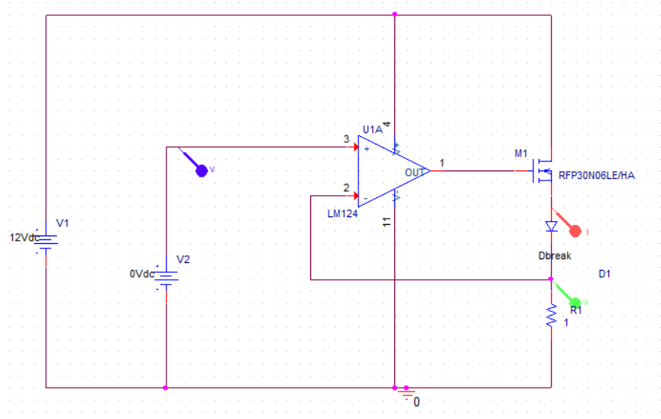

A diode was used instead of the laser diode. The voltage source V2 is used for the DAC output of the arduino. The voltage across the resistor R1 will provide the negative feedback for the opamp, thus controlling the gate voltage of the mosfet providing a current that will linear and equal to the magnitude of the input voltage. This will make it easier to drive the laser with desired amplitude.

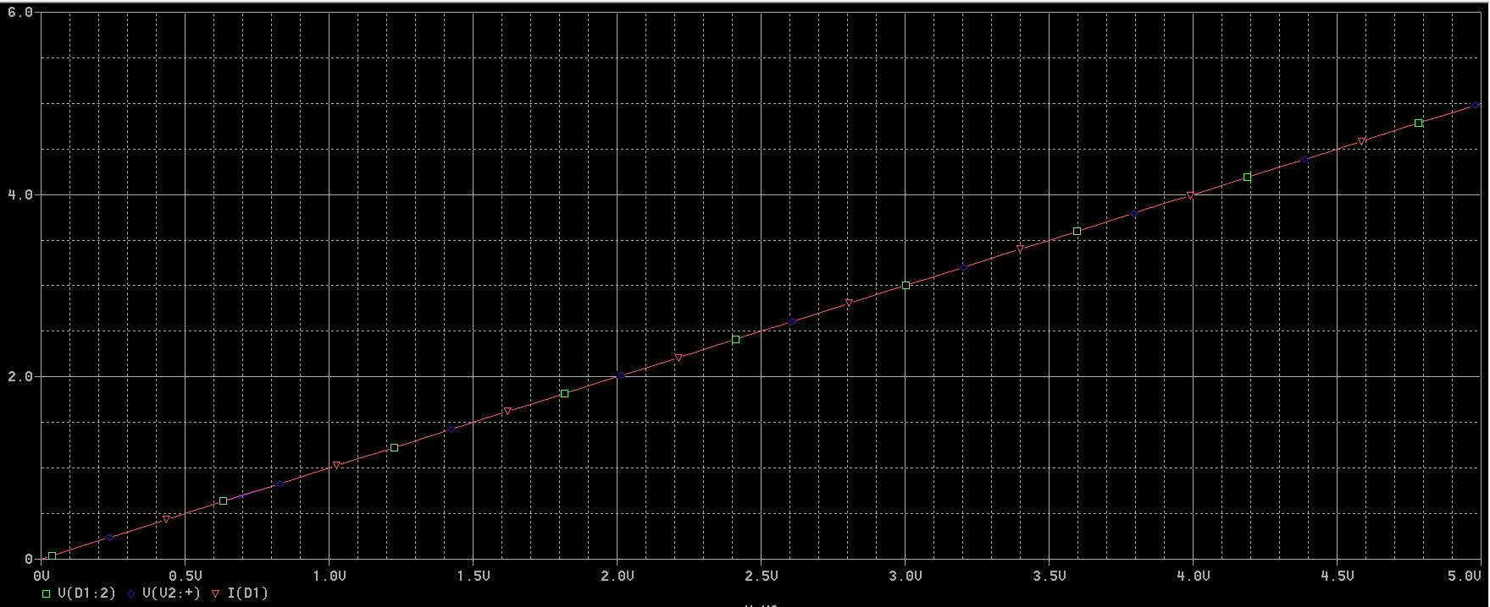

(the voltage is taken across the resistor(or inverting end of the opamp) and the input voltage at the non inverting end of the opamp, and the current is taken at the anode of the laser diode)

Table 3

Power characteristics data

|  |  |  |  |
| --- | --- | --- | --- |
| Voltage (mV) | Current (mA) | Power(mW) | Actual voltage(mV) |
| 0 | 0 | 0 |  |
| 1664 | 100 | 0.11 | 1586 |
| 1787 | 200 | 0.24 | 1630 |
| 1898 | 300 | 0.41 | 1664 |
| 2000 | 400 | 0.63 | 1692 |
| 2115 | 500 | 0.97 | 1717 |
| 2233 | 600 | 1.44 | 1740 |
| 2338 | 700 | 2.21 | 1762 |
| 2443 | 800 | 4.01 | 1781 |
| 2536 | 900 | 32 | 1800 |
| 2598 | 950 | 90.1 |  |
| 2613 | 960 | 97 |  |
| 2625 | 970 | 118 |  |
| 2633 | 980 | 123 |  |
| 2636 | 990 | 134 |  |
| 2643 | 1000 | 152.2 | 1821 |
| 2655 | 1010 | 159.5 |  |
| 2666 | 1020 | 183.4 |  |
| 2670 | 1030 | 184.6 |  |
| 2682 | 1040 | 193.2 |  |
| 2695 | 1050 | 200 |  |
| 2700 | 1060 | 243.8 |  |
| 2820 | 1070 | 250.6 |  |
| 2850 | 1080 | 267 |  |
| 2880 | 1090 | 276.3 |  |
| 2900 | 1100 | 303.3 | 1841 |
| 2910 | 1110 | 305 |  |
| 2930 | 1120 | 311.7 |  |
| 2950 | 1130 | 336 |  |
| 2960 | 1140 | 346.4 |  |
| 2970 | 1150 | 359.3 |  |
| 3040 | 1200 | 424.9 | 1860 |
| 3100 | 1250 | 483.6 |  |
| 3170 | 1300 | 548.1 | 1879 |
| 3226 | 1350 | 607.2 |  |
| 3289 | 1400 | 677.8 | 1898 |
| 3410 | 1450 | 763.4 |  |
| 3460 | 1500 | 824.2 | 1917 |
| 3540 | 1550 | 887.9 |  |
| 3630 | 1600 | 954.2 | 1936 |
| 3689 | 1650 | 1007 |  |
| 3700 | 1700 | 1087.3 | 1955 |
| 3751 | 1750 | 1104.7 |  |
| 3841 | 1800 | 1193.8 | 1971 |
| 3911 | 1850 | 1254.8 |  |
| 3990 | 1900 | 1305.4 | 1990 |
| 4050 | 1950 | 1354.1 |  |
| 4059 | 2000 | 1417.4 | 2025 |
| 4129 | 2050 | 1480.5 | 2035 |
| 4220 | 2100 | 1548.1 | 2047 |
| 4296 | 2150 | 1654.8 | 2056 |
| 4357 | 2200 | 1669.7 | 2062 |
| 4472 | 2250 | 1744.7 | 2072 |
| 4565 | 2300 | 1806.4 | 2081 |
| 4636 | 2350 | 1879.5 | 2090 |
| 4755 | 2400 | 1947.8 | 2113 |

3ohm resistor data

Table 4.1 : Input voltage, ideal output current, measrued output current and power measurements.

|  |  |  |  |
| --- | --- | --- | --- |
| Vin (V) | calculated current(A) | I (A) | Power(W) |
| 0.5 | 0.166666667 | 0.156 | 156u |
| 1 | 0.333333333 | 0.31 | 421u |
| 1.5 | 0.5 | 0.466 | 839u |
| 2 | 0.666666667 | 0.618 | 1.584m |
| 2.5 | 0.833333333 | 0.771 | 3.28m |
| 3 | 1 | 0.925 | 82.4m |
| 3.5 | 1.166666667 | 1.077 | 285m |
| 4 | 1.333333333 | 1.22 | 484m |
| 4.5 | 1.5 | 1.377 | 687m |
| 5 | 1.666666667 | 1.528 | 0.888 |
| 5.5 | 1.833333333 | 1.68 | 1.08 |
| 6 | 2 | 1.82 | 1.277 |
| 6.5 | 2.166666667 | 1.97 | 1.468 |
| 7 | 2.333333333 | 2.125 | 1.67 |
| 7.5 | 2.5 | 2.27 | 1.84 |

Graph 3.1: Voltage vs Current (obtained from power supply display)

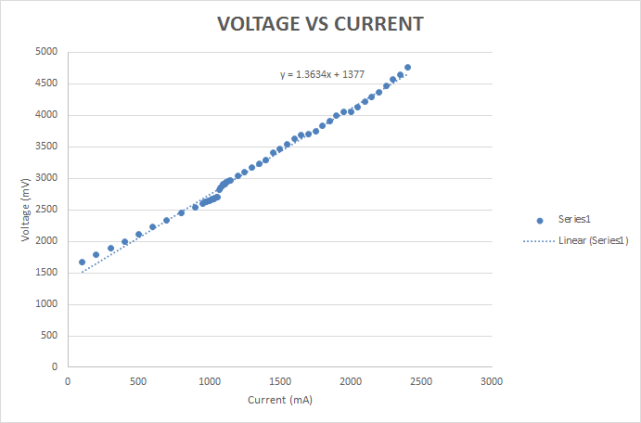

Graph 3.2: Voltage across laser diode vs Current

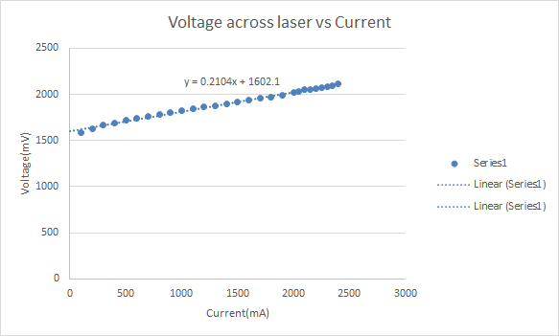

Graph 3.3: Power vs Current

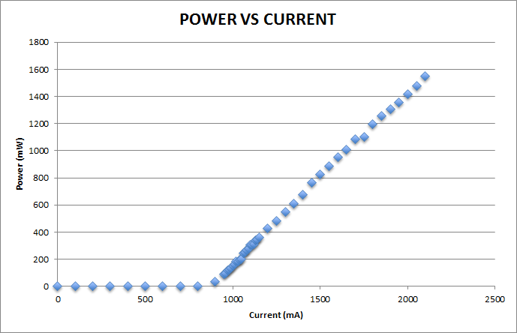

Graph 4.1 Voltage vs ideal current with measured current

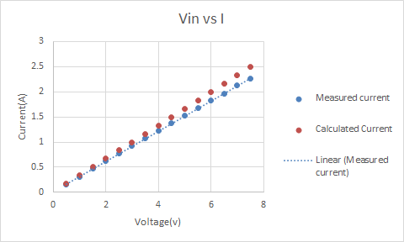

Equations

3.1) P = I2R = 25A*1Ω = 25W

Should this be placed in appendix or inside the paper?????

 (n = 1; air)

Divergence  = SIN-1(0.22)



Lens Used : Aspheric Lens with 8mm (Thor labs: A240TM-A)

Using thin lens approximation, the image distance and the size of the output beam are obtained.

The image distance can be obtained using the below equation:

$$\frac{1}{o} + \frac{1}{i} = \frac{1}{f}$$

Magnification m: $\frac{i}{o} = \frac{diameter of image }{diameter of laser}$

Spot size = $π *$ (Radius of the image)2

The figure below shows, the image produced at infinity when the laser is at focal length.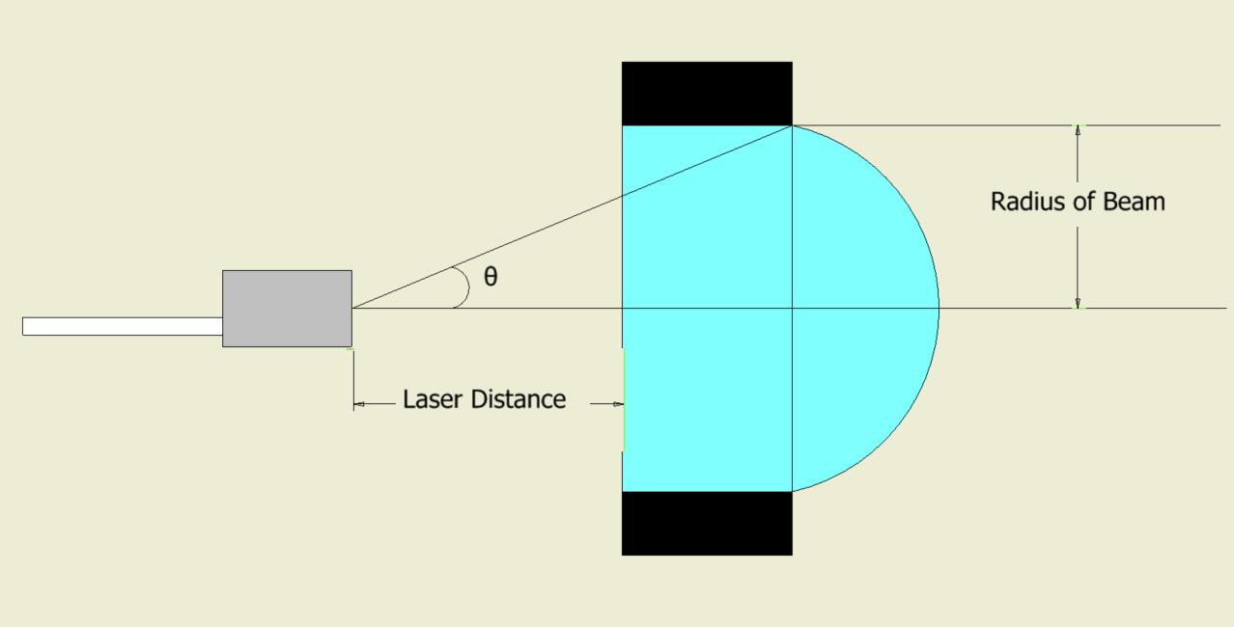

|  |  |  |  |  |
| --- | --- | --- | --- | --- |
| (all calculation in mm) | | | |  |
| Focal length of lens | 8 | Omax | 27.85 |  |
| Diameter of fiber(NA) | 0.22 | θ | 12.709 |  |
|  |  |  |  |  |
| **Laser Distance(o)** | **Image distance(i)** | **magnification** | **Diameter of the output beam** | **Spot size(mm^2)** |
| 1 | -1.142857143 | -1.142857143 | -0.251428571 | 0.198599947 |
| 3 | -4.8 | -1.6 | -0.352 | 0.389255896 |
| 5 | -13.33333333 | -2.666666667 | -0.586666667 | 1.081266378 |
| 7 | -56 | -8 | -1.76 | 9.731397404 |
| 8 | Infinity | - | - | - |
| 9 | 72 | 8 | 1.76 | 9.731397404 |
| 12 | 24 | 2 | 0.44 | 0.608212338 |
| 15 | 17.14285714 | 1.142857143 | 0.251428571 | 0.198599947 |
| 17 | 15.11111111 | 0.888888889 | 0.195555556 | 0.120140709 |
| 19 | 13.81818182 | 0.727272727 | 0.16 | 0.080424772 |
| 21 | 12.92307692 | 0.615384615 | 0.135384615 | 0.057582233 |
| 23 | 12.26666667 | 0.533333333 | 0.117333333 | 0.043250655 |
| 25 | 11.76470588 | 0.470588235 | 0.103529412 | 0.033672655 |
| 27 | 11.36842105 | 0.421052632 | 0.092631579 | 0.02695678 |
| 27.85 | 11.22418136 | 0.40302267 | 0.088664987 | 0.024697568 |

**Power output calculations.**

Plotting the power output vs current of the laser, slope was obtained for the graph plotted after the threshold current. The slope of the line is 1.2756 (mW/mA). Since the power output of the laser is linear after the threshold current, The line can be extended, and the current and corresponding power values can be obtained.

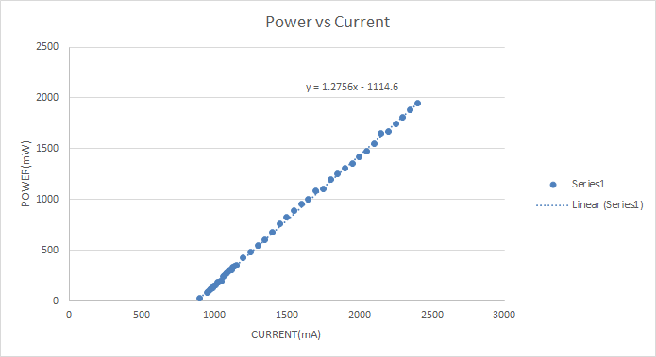

The power values at 1500mA current was taken as the reference. With the slope of 1.2756 the data points were obtained for the values until 5A. The power density was calculated for a spot size of approximately 0.6mm2 (0.609).

|  |  |  |
| --- | --- | --- |
| Current(mA) | Power(mW) | Power density(W/m^2) |
| 900 | 58.84 | 96.61741 |
| 1000 | 186.4 | 306.0755 |
| 1200 | 441.52 | 724.9918 |
| 1400 | 696.64 | 1143.908 |
| 1600 | 951.76 | 1562.824 |
| 1800 | 1206.88 | 1981.741 |
| 2000 | 1462 | 2400.657 |
| 2200 | 1717.12 | 2819.573 |
| 2400 | 1972.24 | 3238.489 |
| 2600 | 2227.36 | 3657.406 |
| 2800 | 2482.48 | 4076.322 |
| 3000 | 2737.6 | 4495.238 |
| 3200 | 2992.72 | 4914.154 |
| 3400 | 3247.84 | 5333.071 |
| 3600 | 3502.96 | 5751.987 |
| 3800 | 3758.08 | 6170.903 |
| 4000 | 4013.2 | 6589.819 |
| 4200 | 4268.32 | 7008.736 |
| 4400 | 4523.44 | 7427.652 |
| 4600 | 4778.56 | 7846.568 |
| 4800 | 5033.68 | 8265.484 |
| 5000 | 5288.8 | 8684.401 |

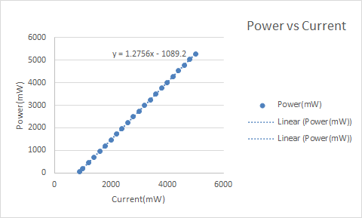

# References

|  |  |
| --- | --- |
| [1] | Pangolin, "Lasorb L44-228-X-9021," Pangolin, Oct 2016. [Online]. Available: http://www.lasorb.com/pdf/228.pdf. |
| [2] | Focuslight, "Fiber Coupled Single Emitter Diode Laser (CW)," [Online]. Available: http://www.focuslight.com.cn/administrator/img/201482013331526214.pdf. |

Works Cited

1."Patient Perspectives: What Is A Port-Wine Stain (Also Known As A Port-Wine Birthmark)?." Pediatric Dermatology 33.4 (2016): 447-448. MEDLINE. Web. 19 Aug. 2016.

2. http://www-f9.ijs.si/~krizan/sola/sempod/0405/milanic.pdf

3. Faurschou A, Olesen AB, Leonardi‐Bee J, Haedersdal M. Lasers or light sources for treating port‐wine stains.*Cochrane Database of Systematic Reviews* 2011, Issue 11. Art. No.: CD007152. DOI: 10.1002/14651858.CD007152.pub2.[Link to Cochrane Libraryhttp://onlinelibrary.wiley.com/doi/10.1002/14651858.CD007152.pub2/full](http://onlinelibrary.wiley.com/doi/10.1002/14651858.CD007152.pub2/full)

<http://onlinelibrary.wiley.com/doi/10.1002/14651858.CD007152.pub2/full>

4. https://www.rp-photonics.com/fluence.html

5.https://stevenfweinermd.wordpress.com/2015/01/10/move-over-vbeam-theres-a-new-gold-standard-for-treating-reds-rosacea-and-vessels-the-excel-v-laser/

6. http://www.fraxel.com/fraxelphysician/fraxel-science/technical-specs

7. http://www.laserskinsurgery.com/Port-Wine-Stain-Treatment

8. Krause, K.; Foitzik, K. Biology of the hair follicle: The basics. Semin. Cutan. Med. Surg. 2006, 25, 2–10

|  |  |  |
| --- | --- | --- |
|  |  | [] |