**Option#1**

**Final Project – Implement a Chatbot for COVID-19 Enquiry**

**Value:** 30%

**Date of Project Group Presentation: 20 April during our class meeting**

**Date of Submitting all necessary Document: 20 April, 11.59 PM**

**Project Objective**:

The objective of the project is to demonstrate the personal abilities and skills required to produce and present an extended piece of work/idea in the field of Artificial Intelligence. Through the project, students are expected to engage in personal inquiry, action and reflection on specific topics and issues to solve a real-world problem. Students build self-confidence, demonstrate independence, and develop professionalism by successfully completing the project.

By completion of the project students will become proficient in building a complete end-to-end machine learning model from loading the data to making predictions.

**Instructions:**

Follow the two diagrams below to build independent components of the chatbot for a specific application using Python libraries/ deep learning framework.

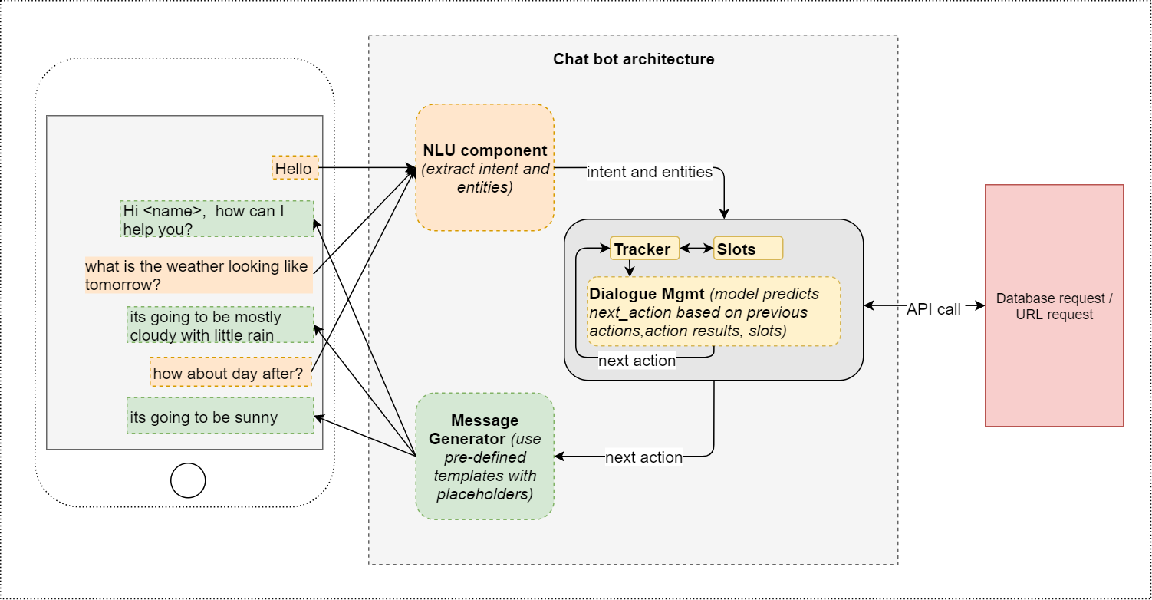

Figure 1

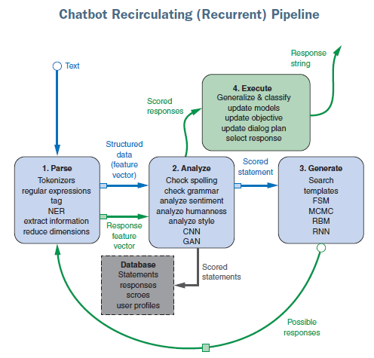

Figure 2

Work in **groups of 3(you can also work individually or in group of 2 )** and do the following.

1. Build a chatbot from scratch (i.e. without using any third party API like Rasa or DialogFlow) for assisting people related to **COVID-19 enquiry**.
2. Identify the current problem which you intend to solve for the above specific scenario using the chatbot. **Provide a very strong problem statement.**
3. Do an analysis of the technologies that can be used to build a chatbot. Eg Rasa, Dialogflow etc{ You should research on atleast 5 such technologies}. Identify the advantages and disadvantages of these technologies from third parties and the reason why you would be building the chatbot from scratch.
4. Build the independent components of the chatbot (refer the figure above) which includes but not limited to the following:
   1. Synthetic building or source the dataset for Intent classification. You should identify a minimum of 5 intent. If the dataset specific for your problem statement is available online you may use that dataset. If not build your own dataset.
   2. Preprocessing the above dataset by using **SpaCy or other Library.**
   3. Building the model for intent classification.
   4. Fetching the response text message or entries from the database according to your Intent.
5. Build a GUI and show the working of a chatbot.
6. Host your chatbot to any cloud providers and make your bot live.

**Required Submissions: (Group Submission)**

1. Each group should submit a single word document for steps 2 and 3.
2. Each group should submit a jupyter notebook for the step 4 and 5 along with the synthetic dataset.
3. Each group should submit a screen recording of their chatbot in action and explanation of their code.
4. The requirement.txt file.
5. URL of the live bot.

**Required Submissions: (Individual Submission)**

1. Each member of the group should submit a peer evaluation form.

**Rubrics:**

1. Has the group identified a strong problem statement?
2. All submitted code are complete and error free. If any error your work will be graded to zero.
3. Does the project give the expected result?
4. All code should be well commented and readable.
5. Has the group submitted all the four mandatory submissions files?
6. Has the group built the chatbot from scratch without using third party technology like Rasa or DialogFlow?

**This exercise relates to the following Course Learning Outcomes:**

CLO1- Apply deep learning frameworks like TensorFlow and Keras to define and train deep-learning model.

CLO2- Identify the promises of deep learning methods for applications in Natural language processing problems and Computer vision.

CLO4- Understand how to apply Sequence model - Recurrent Neural Networks (RNNs), and its variants such as GRUs and LSTMs to Natural language problems.

CLO5- Analyze and review research articles from AI journals and conference proceedings to appraise the advanced concepts and applications of AI.

CLO6- Design an end-to-end model for a potential application that uses Machine learning/Deep Learning as its core by choosing the appropriate ML/Deep learning Algorithm.