Video Game: The Assembler
File: TheAssembler

Abstract

Copyright is held by the author/owner(s).

CHI’13, April 27 – May 2, 2013, Paris, France.
ACM 978-1-XXXX-XXXX-X/XX/XX.
This document describes the specifications of and design process behind the game titled, “The Assembler.” This includes a brief discussion of the computer architecture concepts covered as well as references to related games.
Lee Painton
Montclair State University
1 Normal Ave
Montclair, NJ 07043
paintonl1@mail.montclair.edu

David Heale
Montclair State University
1 Normal Ave
Montclair, NJ 07043
spitfire519x@gmail.com

Thomas Rademaker
Montclair State University
1 Normal Ave
Montclair, NJ 07043
rademakert1@mail.montclair.edu

Author Keywords
Minecraft; intrinsic learning; educational software

ACM Classification Keywords
Macro and assembly language; input/output circuits; simulation

Introduction
Our game, The Assembler, started as a final project for a Computer Architecture course authors Heale, Painton and Rademaker were taking together. The idea was simple, take the major concepts taught in the course and design a game to teach and strengthen them. It is an example of an intrinsic learning game where learning occurs as part of the process of meeting game objectives. To that end we are proud to present The Assembler to the CHI Student Game Competition.

Inspirations of Design
The Assembler is software designed to educate but it targets older students either in secondary school or university. When designing this game we took inspiration from games like Minecraft (www.minecraft.net) that present their players with lightly structured environments in which to play. The educational value of these games is in their modeling of logical concepts in their own simulated environments.
As an example, Minecraft uses a basic set of on/off rules for a substance it calls ‘redstone’ that allows the player to create complex logic gates and circuits. There is little documentation for redstone in Minecraft itself, but despite this the player community has produced a wealth of information about the logic circuits that can be created with redstone. This phenomenon inspired us to create a similar environment in our game. It is our hope that with the sandbox we have provided, students can experiment with and develop an interest in the subject matter.

Background Narrative
The Assembler seeks to engage the player with a storyline and an objective of survival. Because the subject matter is technological we choose a science fiction setting. The player takes on the role of a janitor who is abandoned alone on a spaceship that is adrift in space. In this role he or she must repair the ship systems or be lost forever.
The choice of a janitor as the main character was to reflect a limited technical background in the player. The game is designed to facilitate active learning as the game progresses. The storyline is intended to make the player sympathetic with the main character and feel engaged in the knowledge being learned.
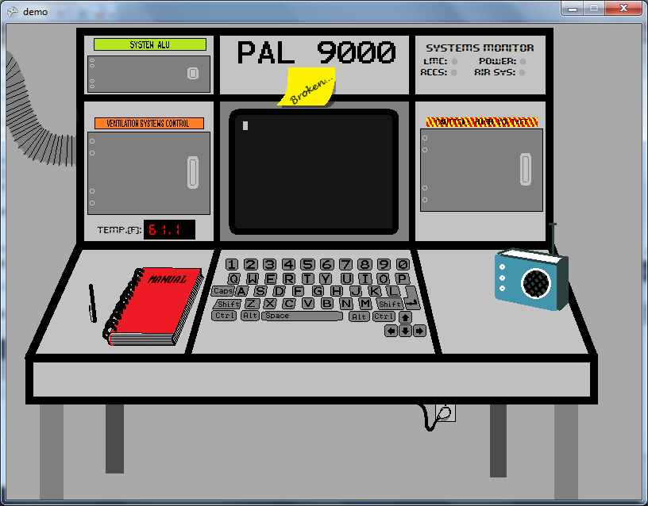
Figure 1: The first game level in The Assembler. It depicts a system console that must be repaired by the player to survive.
The level we have provided for CHI presents the player with a problem solving environment. In this environment players are called on to repair several logic circuits. They must then write assembly programs which interact with the circuits. All of these activities must be completed to fix the air conditioning system so that players do not suffer ill effects as the ship drifts closer to a star.
Further levels are planned that will call on the player to fix the ship’s drive systems and write programs to calculate orbital trajectories. While we place some emphasis on realism in the design, our main goal was to provide consistency between the narrative and environment. While the programs and circuits the player will work with have no practical value outside the game world, the knowledge is portable and will support further study of computer architecture.

Logical Circuits
One of the major concepts covered in The Assembler is combinatorial circuits composed of simple logic gates. The scope of the game includes AND, OR, NOT, XOR and Multiplexer gates (one and two bit). It calls on the player to troubleshoot multiple circuits that serve different critical functions on the ship.
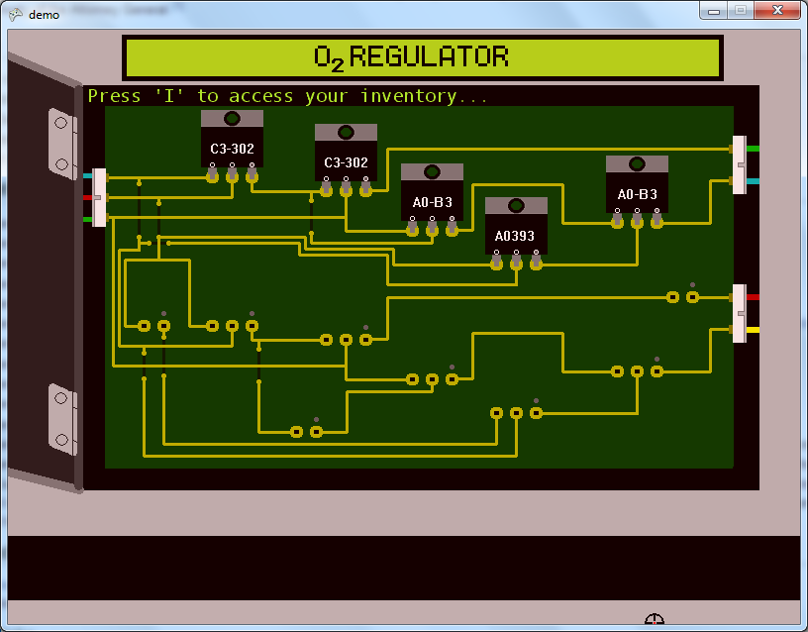
Figure 2: Figure depicts a panel with two logic circuits from the game. The microchips are logic gates. The completed circuit above is a full adder.
For the purposes of this submission we have included a full adder, full subtractor and a complex custom circuit that controls the ambient temperature of the simulated environment. The adder and subtractor are part of an ALU that is used by the assembler based systems to perform binary addition and subtraction. Thus the player will have direct control over the basic logical operations of the ship systems in the game. Developing and understanding of these circuits is critical to successful game play.

Assembly Language
It is perhaps no surprise that The Assembler incorporates assembly language into its learning objectives. The game seeks to assist the player in a basic understanding of how hardware and software interact. Thus we have included a fully functional operating system to run programs which interact with logic circuits in the game. This operating system (called PAL) exists solely for the purposes of managing program files. It includes a basic text editor to write and edit programs and file system commands to manage the order of execution in programs. It also allows the player to check the status of the system’s 100 memory registers.

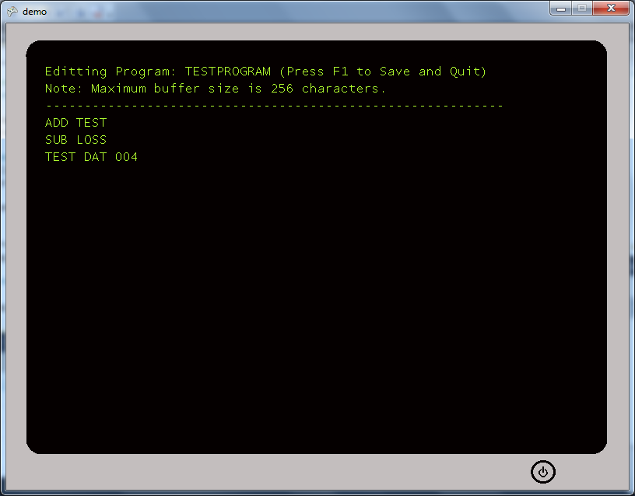
Figure 3: Figure depicts a program written on the in-game text editor provided for the player. This example program is incomplete and would throw an error on execution.
The programs themselves are based on the assembly-like language developed for the Little Man Computer (LMC) (http://www.atkinson.yorku.ca/~sychen/research/LMC/LMCHome.html) We have attempted to implement our LMC as faithfully as possible in order to give the player maximum flexibility in learning to code. Our LMC simulator includes basic error handling to aid in troubleshooting. For the purposes of our game the player will need to write LMC programs to survive. We have reserved registers to either provide information input or accept output from programs. The player will use these reserved registers to interact with the system.
Our decision to use the LMC instead of a more practical language is that LMC serves as a gateway language for assembly. The minimalist philosophy of its architecture keeps programs simple while still communicating the mindset required to write low-level algorithms.

Summary
To summarize, The Assembler was created as both an educational aid and a game. It uses simulated logic circuits and a Little Man Computer assembler environment to help players learn the fundamentals of computer architecture.

Special Thanks
We would like to thank Dr. Ursula Wolz for her encouragement and assistance in bringing this project to CHI. Her encouragement and advice have been invaluable.

Sources
1) [Ault et al. 2009] C. Ault, A. Warner-Ault, U. Wolz, T.M. Nakra (2009) “Kinesthetic Communication for Learning in Immersive Worlds.” in Serious Game Design and Development: Technologies for Training and Learning, edited by Janice Cannon-Bowers and Clint Bowers. Hershey, PA: IGI Global, 2009. [Ault et al. 2009] C. Ault, A. Warner-Ault, U. Wolz, T.M. Nakra (2009) “Kinesthetic Communication for Learning in Immersive Worlds.” in Serious Game Design and Development: Technologies for Training and Learning, edited by Janice Cannon-Bowers and Clint Bowers. Hershey, PA: IGI Global, 2009.

