**Question 2:**

Demonstrate the automation of the spin-up and installation of a multi-machine n-tier architecture. It is up to your interpretation which layers you would like to introduce, provided they can all be automatically started from a single command and serve some basic data.

**Free requisites:-**

1. Install the vagrant software in local system.
2. Install OVM (Oracle Virtual Machine) in Location system.
3. Install git in local system.

**Process to create 3 virtual boxes with Ubuntu OS:-**

1. **Open git bash here then create a folder**

**$mkdir virtualboxes**

**$cd virtualboxes**

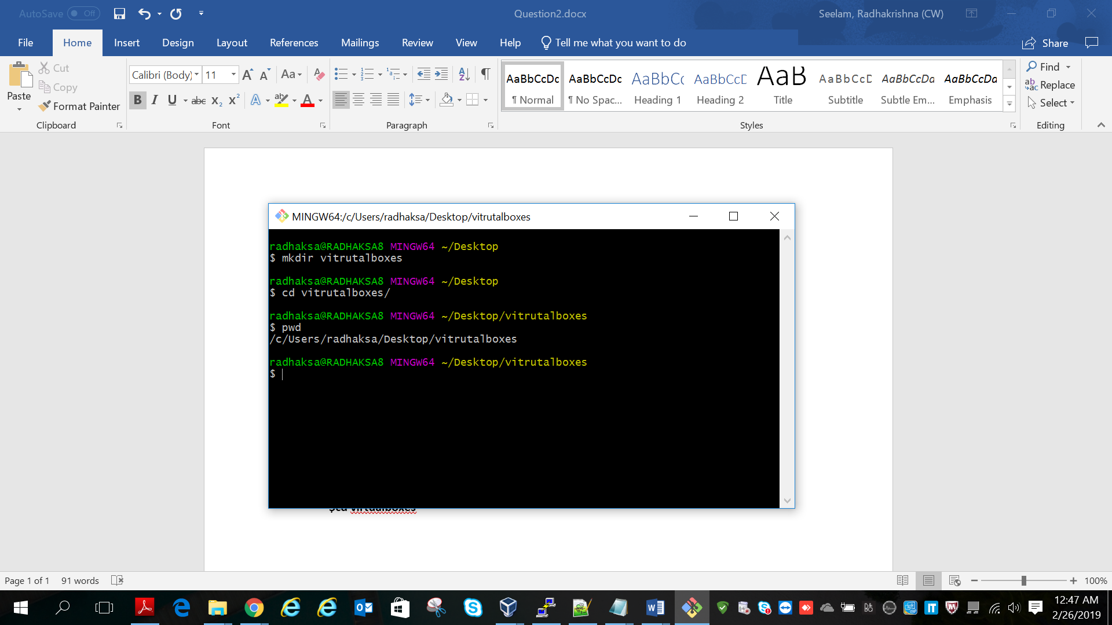

**Copy the vagrant file from git hub**

**By using git clone command:**

**Git clone** [**https://github.com/radseela/vagrant.git**](https://github.com/radseela/vagrant.git) **(Vagrant file path)**

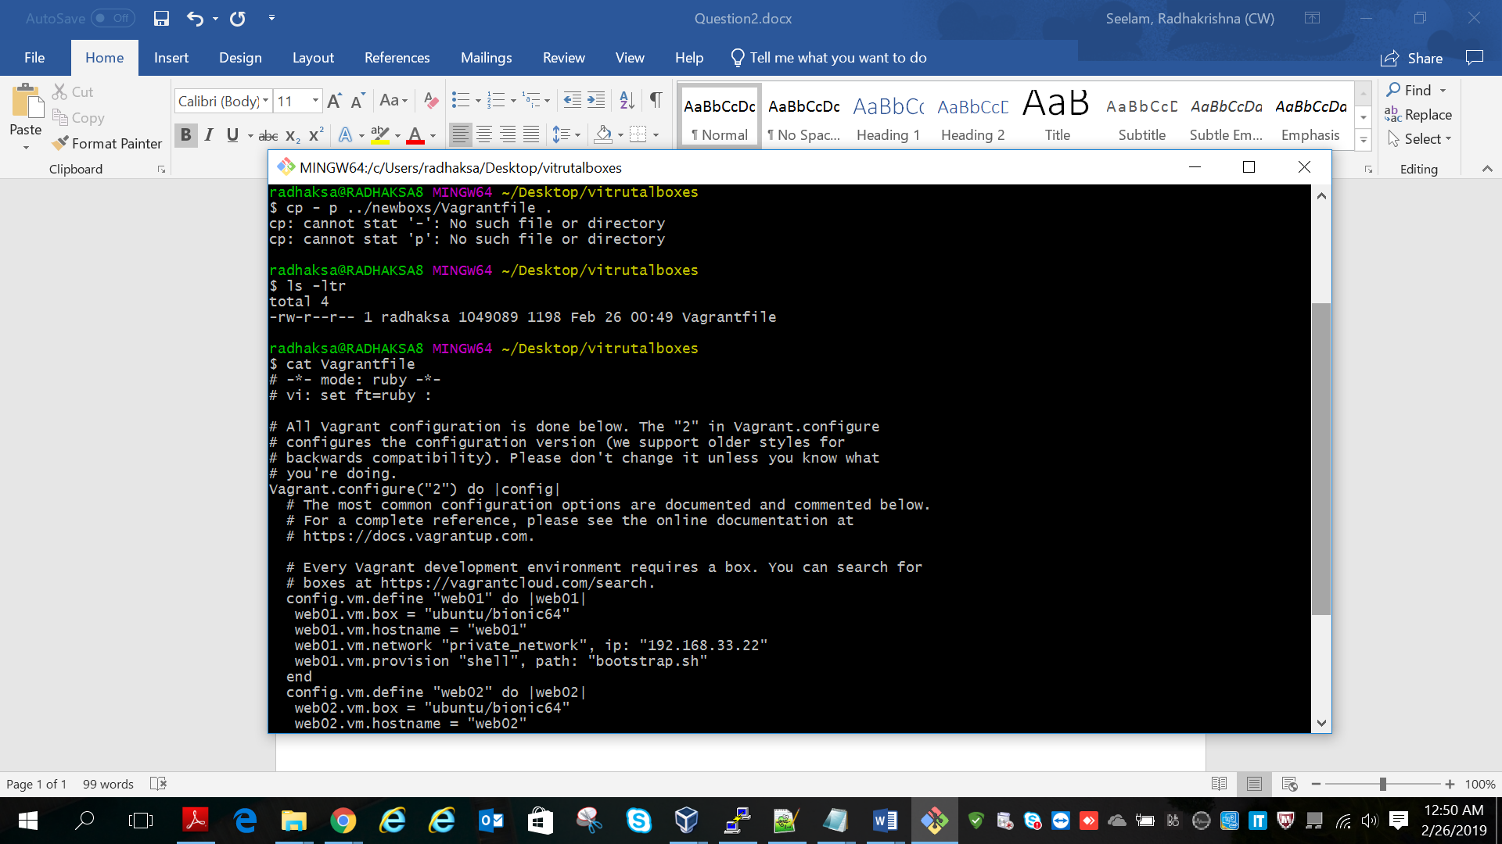

**Then run the command vagrant up it will spin-up 3 virtual boxes.**

**We have created 3 virtual servers i.e web01, web02 and db01**

**And also I have provisioned apache2 in web01 server. By using bootstrap.sh script**

**Similarly we can spin-up n number of virtual boxes.**

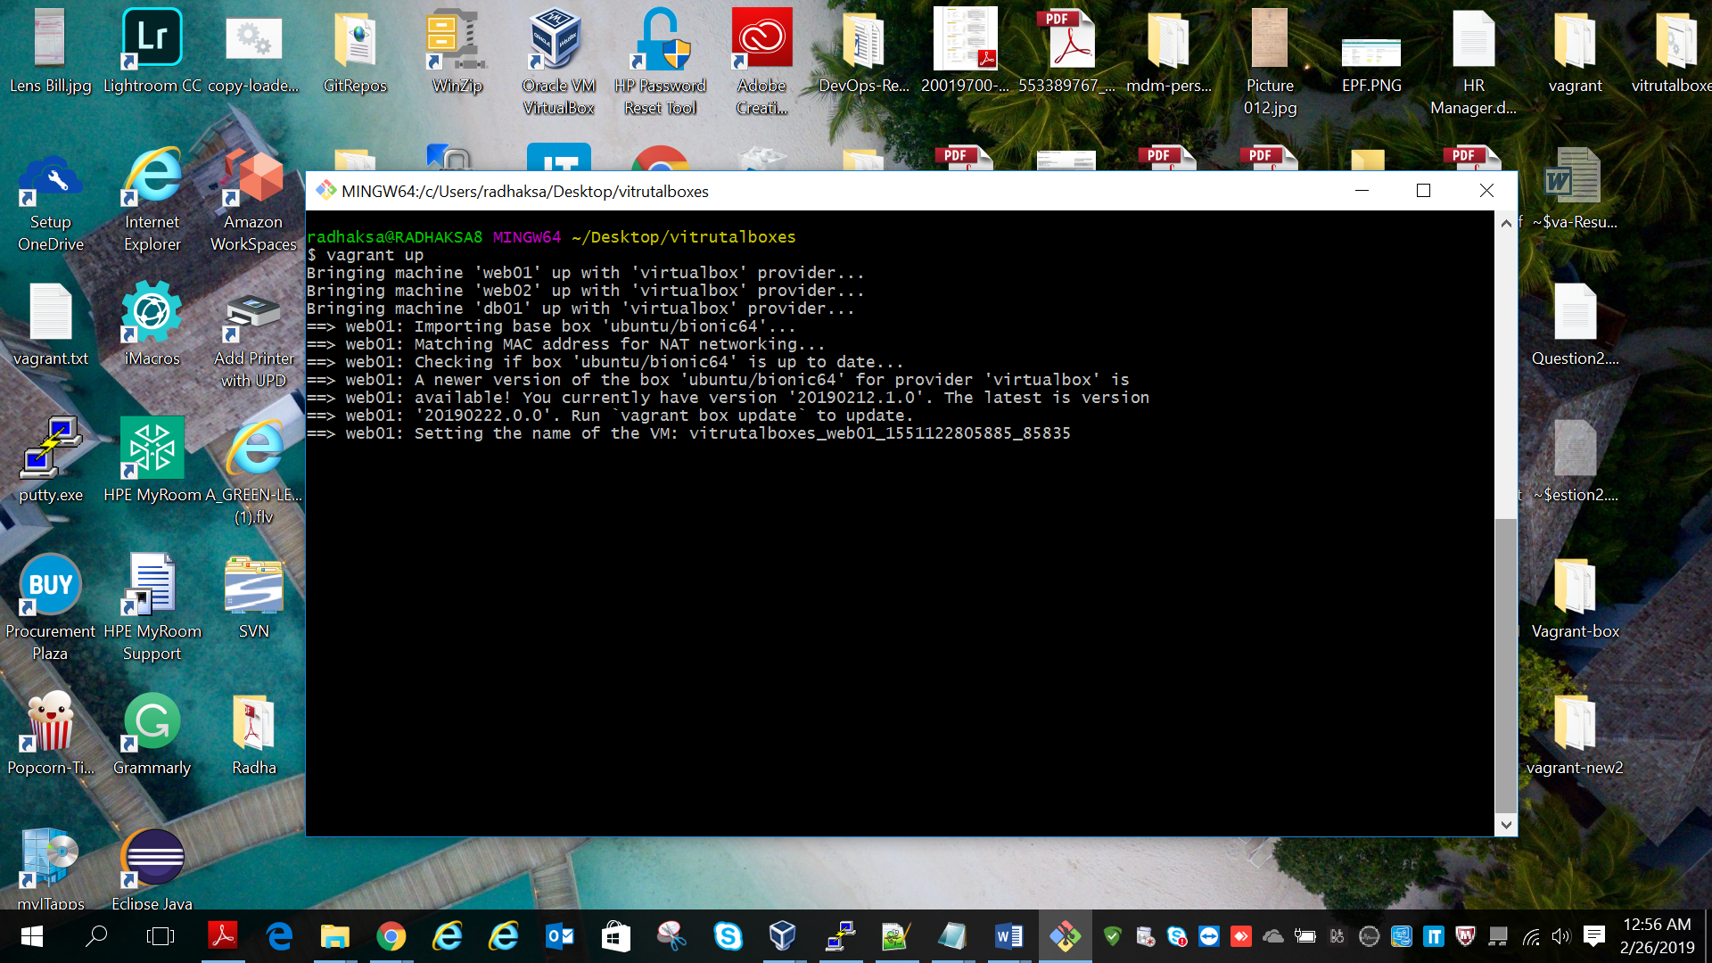

**Successfully login in to web01 server.**

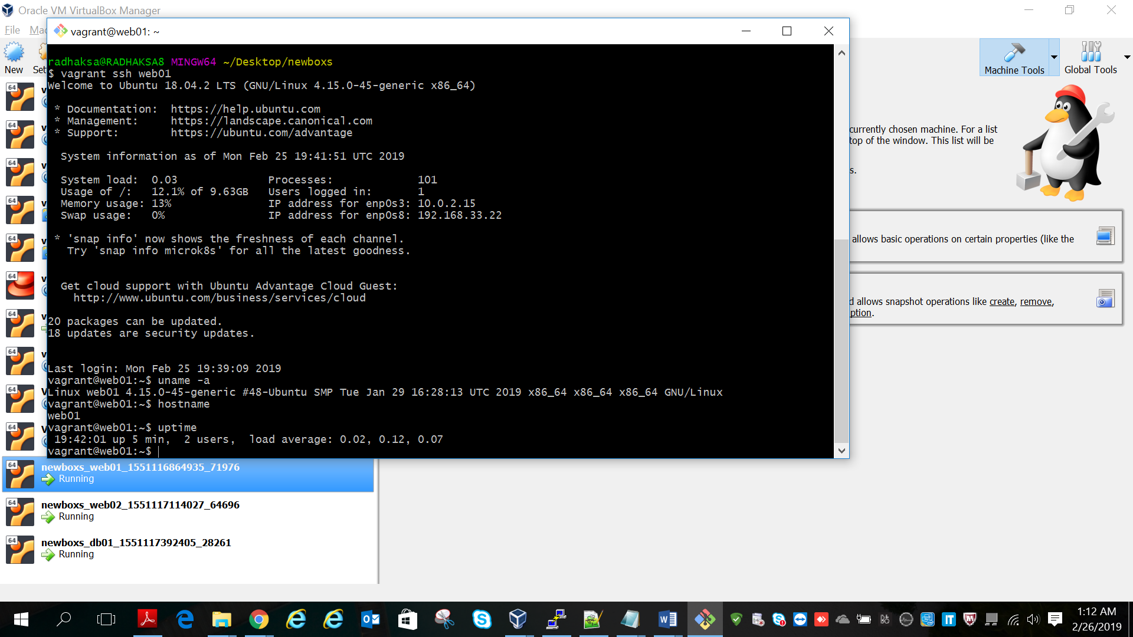

**Successfully login to the web02 server:**

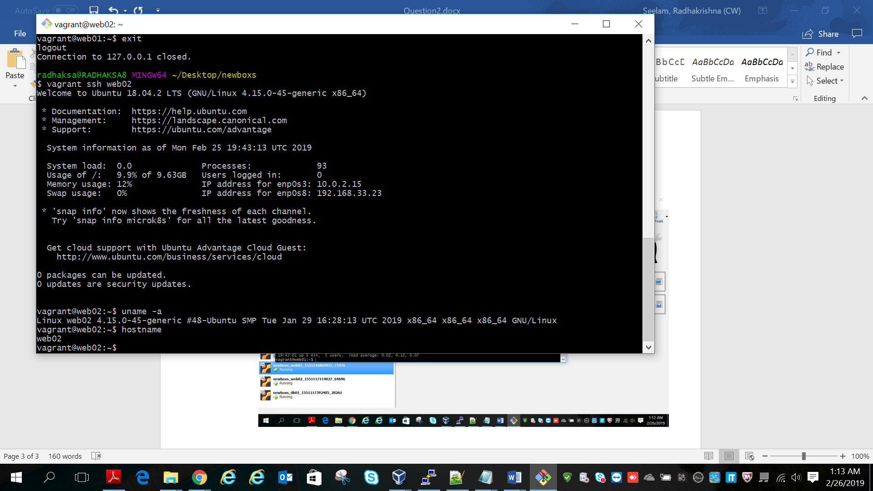

**Successfully login to db01 server.**

