Aradhya Singh Bisht, Pranav Bhushan, Akshay Sharma, Siddhant Soymon

Professor Lee

BUDT703-0506

7 December 2023

BUDT703: APAS Consulting Project Proposal

Business Transactions

APAS Consulting is a sports consulting firm based out of College Park, Maryland, formed by business partners Aradhya Singh Bisht, Pranav Bhushan, Akshay Sharma, and Siddhant Soymon. This firm has had prior successes consulting local K-12 baseball and basketball teams, leading to an average of 20% increase in team wins post-consulting. Recently, this firm was allowed to consult the University of Maryland Division I Men’s Baseball Team.

The business processes are as follows:

1. To analyze past games for the University of Maryland Division I Men’s Baseball Team to build insights on game results among opponents and conferences.
2. This is followed by analyzing the historical and current game results to determine the most formidable opponents, eventually leading to an increase of at least 20% in wins for the 2022-2023 season.

Our objective is to identify trends, successes, and areas for improvement by examining win-loss ratios, winning streaks, and performance against different opponents from 1999-2022. To reach optimal consulting solutions, APAS Consulting has to complete these four mission objectives:

1. Analyze the dataset consisting of four major entities: Game, Opponent, Conference, and Location (The years of focus are from Years 1999-2022)
2. Analyze team Win-Loss records against opponent(s) over the years and identify team(s) which UMD struggles against and teams which UMD performs well against
3. Analyze the team performance by Winning Percentage against Conference and Non-Conference Opponents to determine if there is a significant deviation
4. Determine UMD’s Home VS Away record, and how being in each Conference affects the team’s record and statistics

List of Entities:

Game (**gmeId**, gmeDate, gmeWin, gmeLoss, gmeType)

Opponent (**oppId**, oppName)

Conference (**cnfId**, cnfName, cnfWinP)

Location (**locId**, locName)

Relationships, Attributes, Degrees, Participating Entities and Constraints:

Belong**:** Ternary relationship

* 1 Game and 1 Conference to only 1 Opponent
* 1 Game and 1 Opponent to 1 or more Conference
* 1 Conference and 1 Opponent to 1 or more Game

Play: Binary relationship

* Only one Location to 1 or more Game
* 1 or more Game to only 1 Location

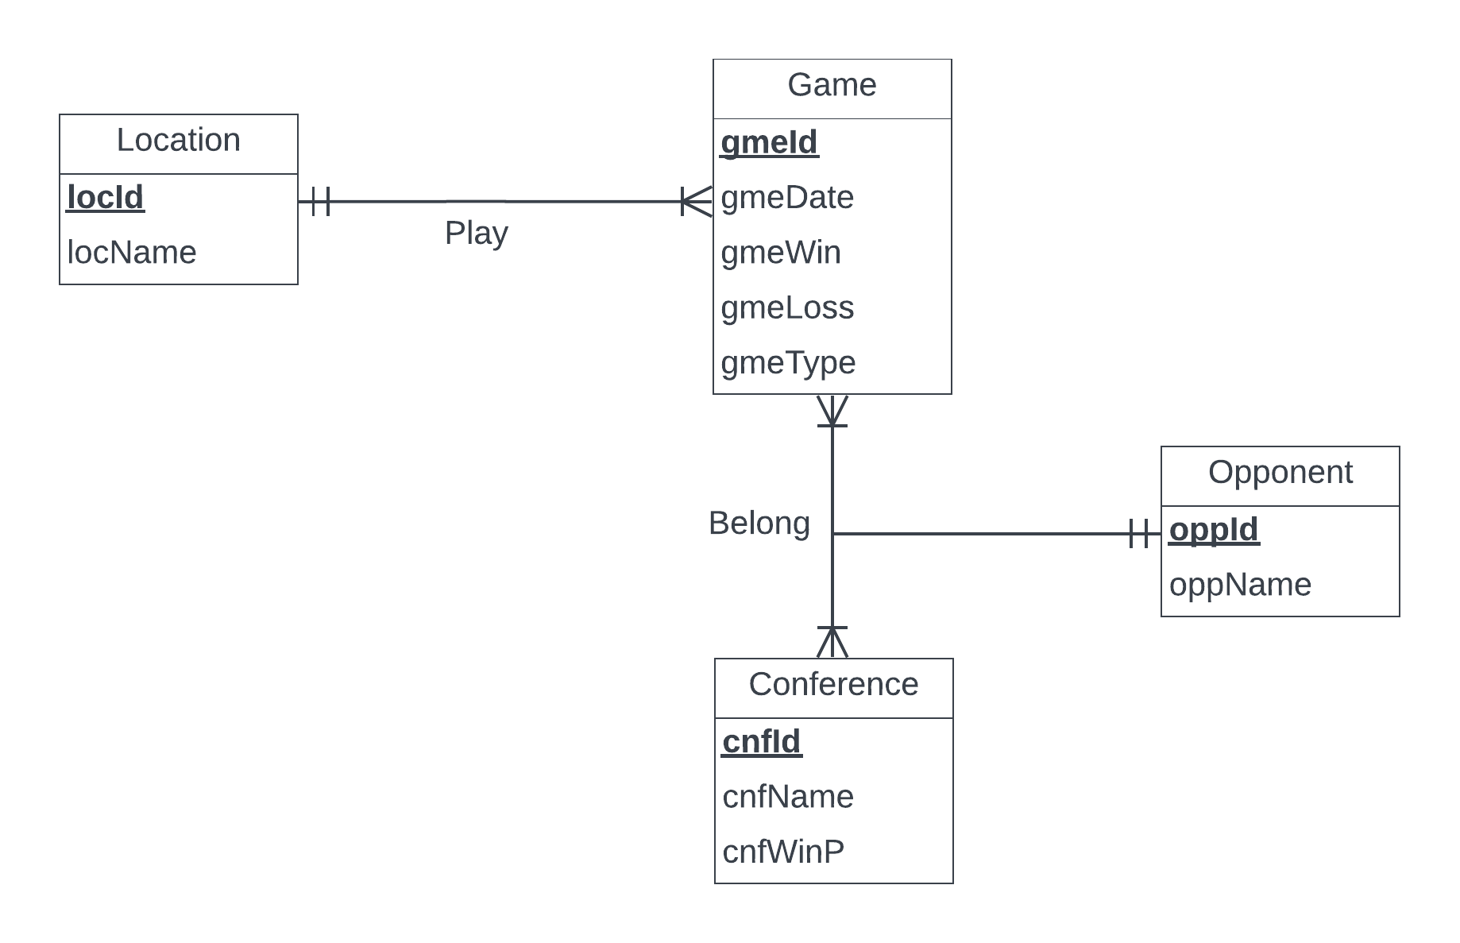

Relations:

Game (**gmeId**, gmeDate, gmeWin, gmeLoss, gmeType)

Belong (***gmeId***, ***oppId***, ***cnfId***)

Opponent (**oppId**, oppName)

Conference (**cnfId**, cnfName, cnfWinP)

Location (**locId**, locName)

Play (***locId, gmeId***)

## 

## Business Rules:

**[R1]** If an opponent is removed from a database, this will remove said opponent’s information for the corresponding game and conference.

**[R2]** If an opponent is updated in a database, this will update said opponent’s information for the corresponding game and conference.

**[R3]** If a game is removed from the database, this will not remove the game information from the opponent and conference.

**[R4]** If a game is updated from the database, this will not update the game information from the opponent and conference.

**[R5]** If the conference is deleted from the database, this will remove the conference information for the corresponding game and opponent.

**[R6]** If the conference is updated in the database, this will update the conference information for the corresponding game and opponent.

**[R7]** When a game is being played at a location, no action will take place.

## Referential Integrities:

| Relation | Foreign Key | Base Relation | Primary Key | Business Rule | Constraint: ON DELETE | Business Rule | Constraint: ON UPDATE |
| --- | --- | --- | --- | --- | --- | --- | --- |
| Belong | oppId | Opponent | oppId | R1 | CASCADE | R2 | CASCADE |
| Belong | gmeId | Game | gmeld | R3 | NO ACTION | R4 | NO ACTION |
| Belong | cnfId | Conference | cnfId | R5 | CASCADE | R6 | CASCADE |
| Play | gmeId | Game | gmeId | R7 | NO ACTION | R7 | NO ACTION |
| Play | oppId | Opponent | oppId | R7 | NO ACTION | R7 | NO ACTION |

Sample data for each relation:

INSERT INTO Game (gmeId, gmeDate, gmeRes, gmeWin, gmeLoss, gmeType)

VALUES

(1, '2023-01-15', 'W', 'UMD', 'PENN', ‘Home’),

(2, '2023-01-20', 'L', 'GWU', 'UMD', ‘Away’);

INSERT INTO Location (locId, locName)

VALUES

(11, 'College Park'),

(22, 'WashingtonDC’);

INSERT INTO Opponent (oppId, oppName)

VALUES

(111, 'Penn State'),

(222, ‘GWU’);

INSERT INTO Conference (cnfId, cnfName, cnfWinP)

VALUES

(1111, 'Big10', ‘80%’),

(2222, 'ACC’, ‘20%’);