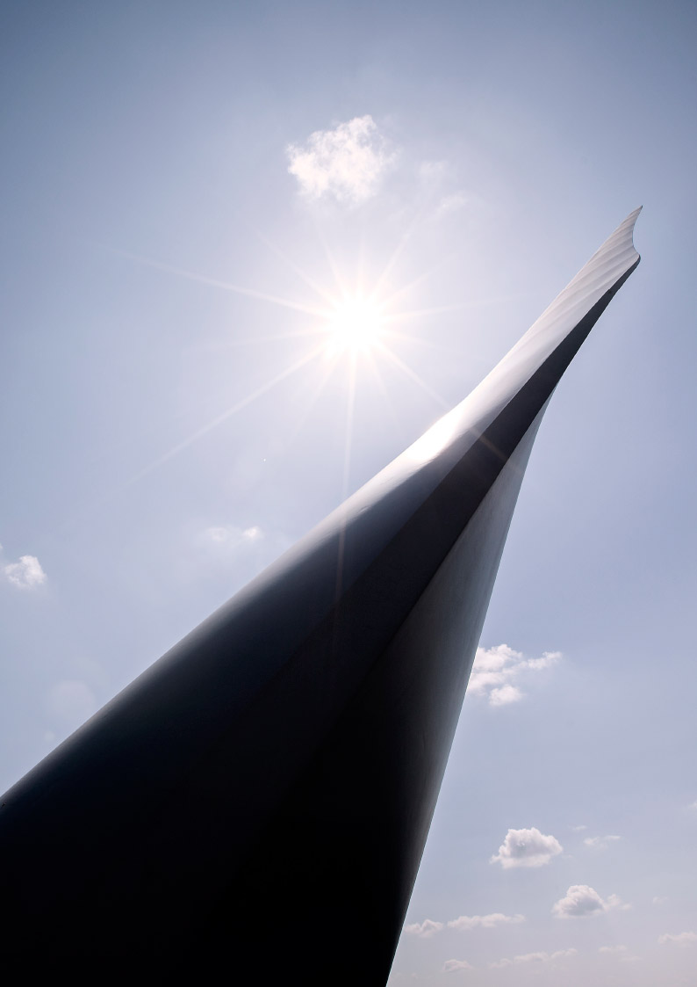

Blade Inspection Report

#SITE# I

Turbine #TURBINENO#

|  |
| --- |
| Table of Content |

|  |
| --- |
| 1 Introduction 3  2 Naming and Definitions 4  3 Overview 5  4 Recommendation 6  4.1 Blade #BLSL1# 6  5 Blade Inspection 7  5.1 Blade #BLSL1# 7 |

# **Introduction**

On #CREATED# blade inspection was performed on turbine no. #TURBINENO# installed in #SITE# I wind farm.

The inspection has been performed from ground with scope and camera.

The aim of this report is to detail the results of the inspection activities held at wind turbine #TURBINENO#, provide assessment of the damages, repair solutions and recommendations, if any.

|  |  |
| --- | --- |
| Site | #SITE# I |
| Wind Turbine Type | #WTGNO# |
| Wind Turbine Number | #TURBINENO# |
| Wind Turbine Local ID | #WTGLOCALID# |
| Blade Rotor | #BLADEROTOR# |
| Inspection Date (dd.mm.yyyy) | #CREATED# |
| Report Creator | #CREATEDBY# |

# **Naming and Definitions**

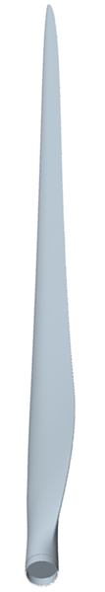

|  |  |
| --- | --- |
| Shell | The function is to give an aerodynamic profile. |
| Laminate Sandwich | The function of the sandwich – laminate/core material/laminate - is to give the shell stiffness in unsupported areas between spar and TE/LE. A sandwich construction provides geometrical stability to the shape of the blade. |
| LW | Leeward - also known as suction side. LW shell is upper side during production. This side faces towards the tower. |
| WW | Windward - also known as pressure side. WW shell is under side during production. This side is facing the wind. |
| LE | The leading edge of the blade, i.e. the “nose” that is heading into the wind during operation. |
| TE | The trailing edge of the blade is the thin edge where the airflow leaves the blade during operation. |
| PPT | Pre-Preg Technology. This term is used for blades where the main structure is the spar |
| Spar | This is the main structural component of PPT blades. It is positioned between the shells and resists loads and forces. |
| SST | Structural Shell Technology. This term is used for blades where the main structure is in the shells. |
| Web | It is positioned between the shells and has to transfer loads and forces. |
| Flap Wise | The flap wise load is the motion of the blade caused by the wind. These loads are normal to the WW and LW shell surfaces of the blade |
| Edge Wise | The edge wise loads are caused by a combination of the rotation of the rotor and the mass of the blade itself. Edgewise loads are in the direction from LE to TE or vice versa. |
| SMT | Solid Metal Tip is a part of lightning protection. |
| AAOs | Aerodynamic Add-Ons |
| GF | Gurney Flap is an Add-On used for production increase. |
| TVG | Tip Vortex Generator is an Add-On for noise reduction |
| RVG | Root Vortex Generator is an Add-On used for production increase. |
| STE | Serrated Trailing Edge is an Add-On for noise reduction |

# **Overview**

Blades have been inspected according to the relevant work instructions and any damage detected has been classified in accordance with *Condition Monitoring of Vestas Blades*. Based on this guideline, detected damages are categorized in accordance with the following categories:

Damage Categorization

|  |  |  |  |
| --- | --- | --- | --- |
| Category | Description | Damage Description | Recommended Action |
| 1 | Cosmetic | No intervention required | No Action |
| 2 | Similar to cosmetic | Intervention is done only if there are other damages on the blade | No Action  Monitor at next inspection |
| 3 | Not Serious | Intervention is done during planned  Inspection of the wind turbine. | Repair within 6 months  Monitor every 3 months |
| 4 | Serious | Blade must be repaired within 3 months or during next planned wind turbine inspection, whichever occurs first. | Repair within 3 months  Monitor monthly |
| 5 | Very Serious | Immediate intervention required to prevent further damage to blade, wind turbine or surrounding area. | Turbine Pause recommended  Immediate repair |

|  |
| --- |
| A modified time frame may be defined by blade specialist. |

Blade #BLSL1#

|  |  |  |  |  |
| --- | --- | --- | --- | --- |
| No | Damage Types | Radius | Blade Edge | Category |
| 1 | #BLSL1DamageType1# | #BLSL1Radius1# | #BLSL1BladeEdge1# |  |
| 2 | #BLSL1DamageType2# | #BLSL1Radius2# | #BLSL1BladeEdge2# |  |
| 3 | #BLSL1DamageType3# | #BLSL1Radius3# | #BLSL1BladeEdge3# |  |
|  | Overall Condition Of The Blade |  |  | **#BLSL1Cate1#** |

# **Recommendation**

## Blade #BLSL1#

#SBURecommendation1#

# **Blade Inspection**

## Blade #BLSL1#

|  |
| --- |
| #TABLE1# |

Confidentiality and Disclaimer

The recipient of this document, including its subsidiaries, related companies, employees, agents and sub-contractors (collectively the “Recipient”) undertakes that Vestas Wind Systems A/S, as trustee for all direct and indirect subsidiaries of Vestas Wind Systems A/S including the sender of this document and all employees, agents and sub-contractors of Vestas Wind Systems A/S (collectively “Vestas”) keep confidential any information contained in this document (including any appendixes) and/or other documents and data to the extent that the same are derived from or related to such information.

This document is a non-binding Indicative Offer and an estimate only and is subject to change, and that it does not constitute an offer to provide any goods or services and, (save only for this disclaimer and confidentiality undertaking which is intended to have legal effect) is of no legal effect.

Vestas accepts no responsibility in any way for, and makes no representation, express or implied, and gives no warranty or undertaking of any kind with respect to the accuracy or completeness of any disclosed Information.

The Recipient cannot rely on the information disclosed in this Indication Offer (including any appendixes and supplements) and/or any oral or written communication in connection with it for any purpose, and accepts and agrees that (save in case of fraud) Vestas shall have no liability in contract, tort (including negligence), for breach of statutory duty or otherwise in connection with any information disclosed herein.

If any undertaking or other provision in this disclaimer and confidentiality undertaking shall be held to be illegal or unenforceable, in whole or in part, under any enactment or rule of law, such undertaking or other provision or part shall to that extent be deemed not to form part of this disclaimer and confidentiality undertaking but the enforceability of the remainder of the undertakings and other provisions in this disclaimer and confidentiality undertaking shall not be affected

©Vestas 2017

This document was created by Vestas Wind Systems A/S and its Affiliates and contains copyrighted material, trademarks and other proprietary information. All rights reserved. No part of the document may be reproduced or copied in any form or by any means such as graphic, electronic or mechanical, including photocopying, taping or information storage and retrieval systems, without the prior written permission of Vestas Wind Systems A/S and its Affiliates. All specifications are for information only and are subject to change without notice. Vestas does not make any representations or extend any warranties, expressed or implied, as to the adequacy or accuracy of this information.