Technical Report

WTG xx

xxxxxx Wind Farm

V/NMxx - x.xMW

Dpt.:

Technical and Operational Support

WTG Engineering and Support

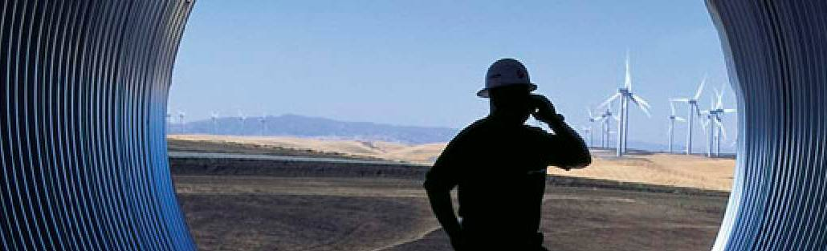



Customer service (approved):

Name

Customer service (approved):

Name

Customer service (approved):

Name

**Copyright Notice**

The documents are created by Vestas Wind Systems A/S and contain copyrighted material, trademarks, and other proprietary information. All rights reserved. No part of the documents may be reproduced or copied in any form or by any means—such as graphic, electronic, or mechanical, including photocopying, taping, or information storage and retrieval systems without the prior written permission of Vestas Wind Systems A/S. The use of these documents by you, or anyone else authorized by you, is prohibited unless specifically permitted by Vestas Wind Systems A/S. You may not alter or remove any trademark, copyright or other notice from the documents. The documents are provided “as is” and Vestas Wind Systems A/S shall not have any responsibility or liability whatsoever for the results of use of the documents by you.

Table of Contents

[1. Introduction 3](#_Toc470009510)

[2. Component definition 3](#_Toc470009511)

[3. General data 6](#_Toc470009512)

[4. Incident description 15](#_Toc470009513)

[4.1 Endoscope Inspection Report 16](#_Toc470009514)

[4.2 VTM-Alarms-Warnings 16](#_Toc470009515)

[4.3 Oil Analysis Report 16](#_Toc470009516)

[4.4 CMS Analysis Report 16](#_Toc470009517)

[5. Analysis 16](#_Toc470009518)

[6. Conclusions 17](#_Toc470009519)

# Introduction

The aim of this document is to present technical information regarding the inspection carried out in the gearbox of WTG xx of xxxxx wind farm.

Reference documents used:

* ANSI/AGMA 1010-E95: “Appearance of Gear Teeth - Terminology of Wear and Failure”
* ISO 81400-4: “Design and specification of gearboxes”
* SKF: “Bearing failures and their causes” Product information 401
* FAG: “Rolling Bearing Damage”

# Component definition

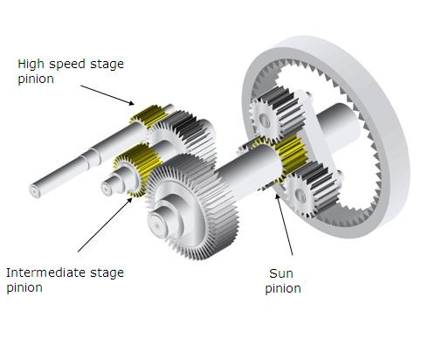 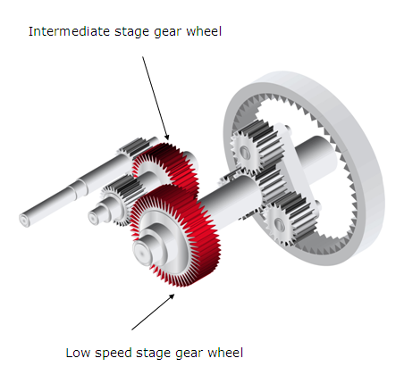

(Gears and pinions)

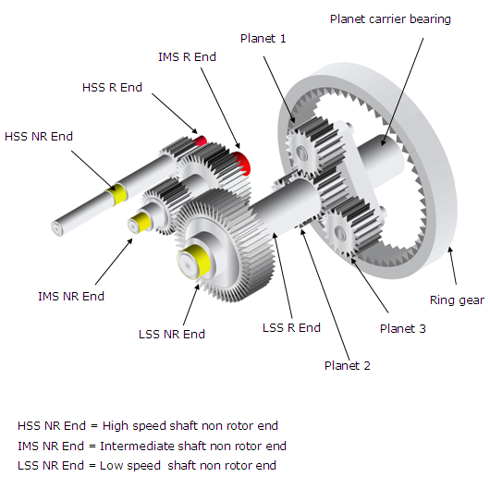

(Bearings)

| In the case that two bearings are mounted on the same side of the shaft, it will be specified which is the “inboard” and “outboard” one.  600px-Gear_words  (Gear nomenclature) |
| --- |
| |  |  | | --- | --- | | Abbreviation | Description | | PLCB RE | Planetary stage – Planet carrier bearing – Rotor end position | | PLB1 RE | Planetary stage – Planet bearing 1 – Rotor end position | | PLB2 RE | Planetary stage – Planet bearing 2 – Rotor end position | | PLB3 RE | Planetary stage – Planet bearing 3 – Rotor end position | | PLB1 NRE | Planetary stage – Planet bearing 1 – Non rotor end position | | PLB2 NRE | Planetary stage – Planet bearing 2 – Non rotor end position | | PLB3 NRE | Planetary stage – Planet bearing 3 – Non rotor end position | | RG | Planetary stage – Ring gear | | PLCB NRE | Planetary stage – Planet carrier bearing – Non rotor end position | | PLG1 | Planetary stage – Planet gear 1 | | PLG2 | Planetary stage – Planet gear 2 | | PLG3 | Planetary stage – Planet gear 3 | | SP | Planetary stage – Sun pinion | | LSSB RE | Parallel stage – Low speed shaft bearing – Rotor end position | | LSSB NRE-I | Parallel stage – Low speed shaft bearing – Non rotor end position, inboard | | LSSB NRE-O | Parallel stage – Low speed shaft bearing – Non rotor end position, outboard | | LSSG | Parallel stage – Low speed shaft gear | | IMSP | Parallel stage – Intermediate shaft pinion | | IMSG | Parallel stage – Intermediate shaft gear | | IMSB RE | Parallel stage – Intermediate shaft bearing – Rotor end position | | IMSB NRE-I | Parallel stage – Intermediate shaft bearing – Non rotor end position, inboard | | IMSB NRE-O | Parallel stage – Intermediate shaft bearing – Non rotor end position, outboard | | HSSP | Parallel stage – High speed shaft pinion | | HSSB RE-I | Parallel stage – High speed shaft bearing – Rotor end position, inboard | | HSSB RE-O | Parallel stage – High speed shaft bearing – Rotor end position, outboard | | HSSB NRE | Parallel stage – High speed shaft bearing – Non rotor end position |   (Abbreviations descriptions) |
|  |

# General data

|  |  |
| --- | --- |
| Site | xxxxx |
| Wind turbine | xx |
| Wind turbine number | xxxxx |
| Wind turbine type | V/NMxx - x.xMW- xxHz/xxxV |
| Wind turbine commissioning date | dd/mm/yyyy |
| Gearbox type | xxxxxxxxx |
| Gearbox revision | XX |
| Gearbox serial number | xxxxxxxx |
| Gearbox installation date | dd/mm/yyyy |
| Inspection date | dd/mm/yyyy |

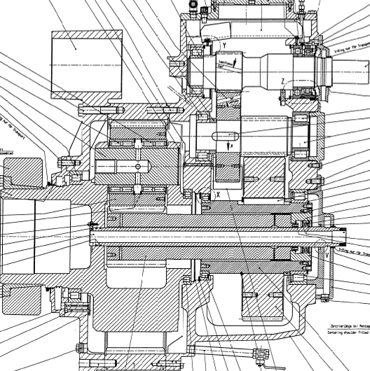

(Winergy PEAC 4300 Gearbox scheme)

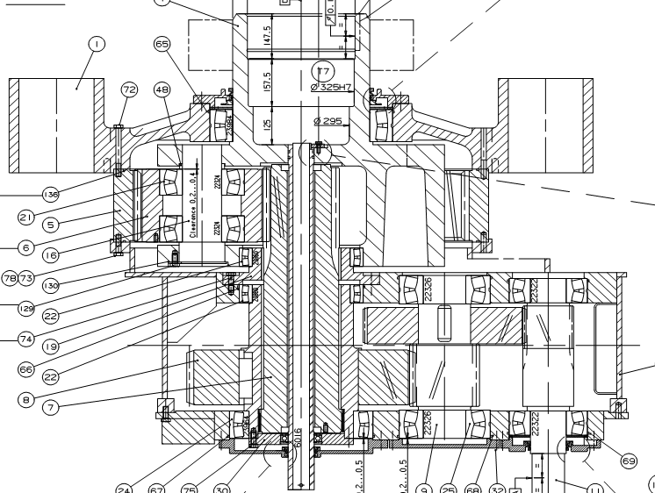

(Moventas PLH 304 Gearbox scheme)

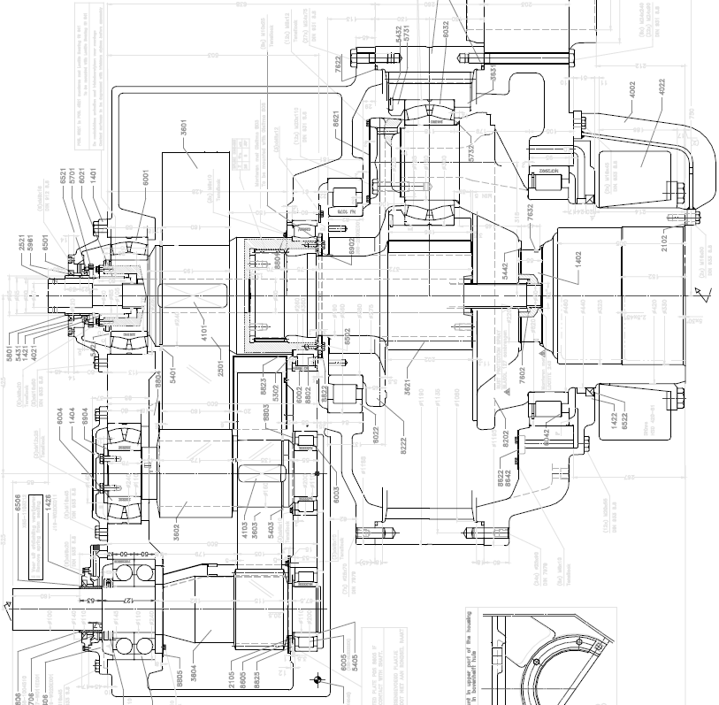

(Hansen EH601 Gearbox scheme)

*[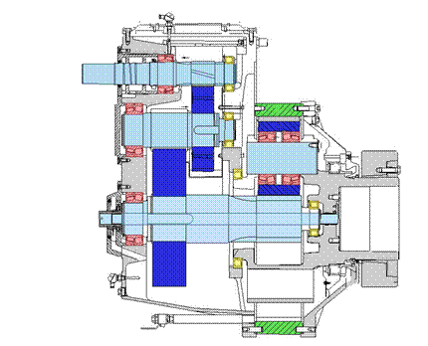](DC_Inspection_Template_Gearbox.docx)*

(JaKe PSC1000/1001 Gearbox scheme)

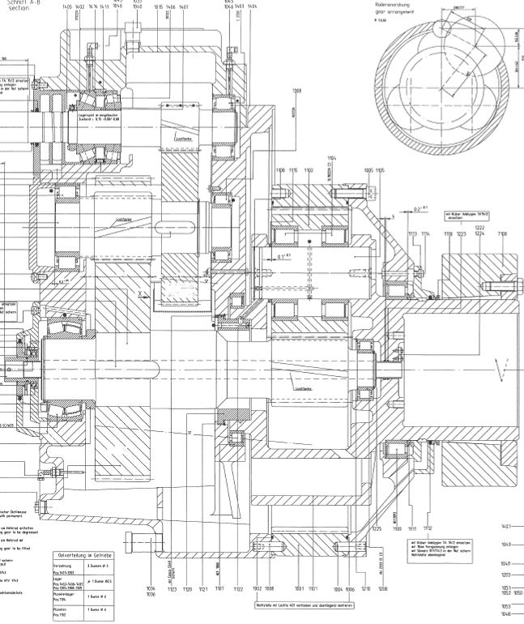

(JaKe PSC 1050-51-52 Gearbox scheme)

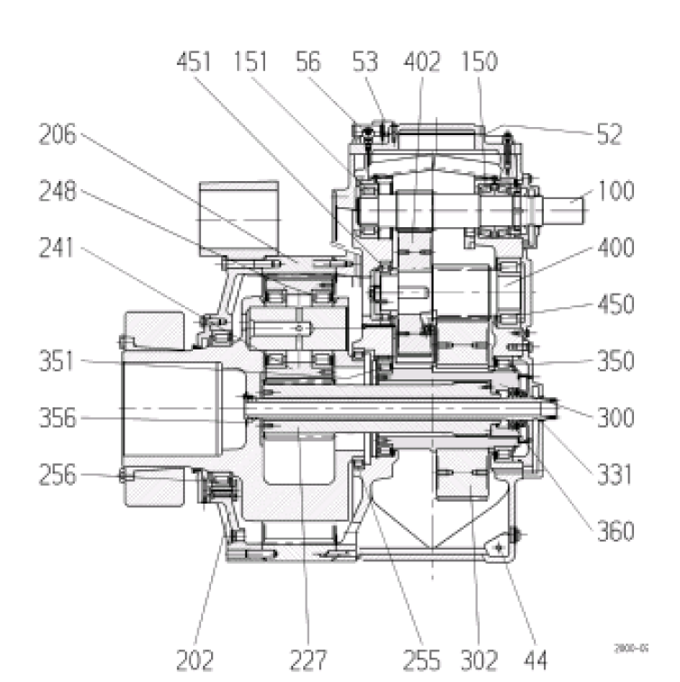

(Winergy PEAB 4320 Gearbox scheme)

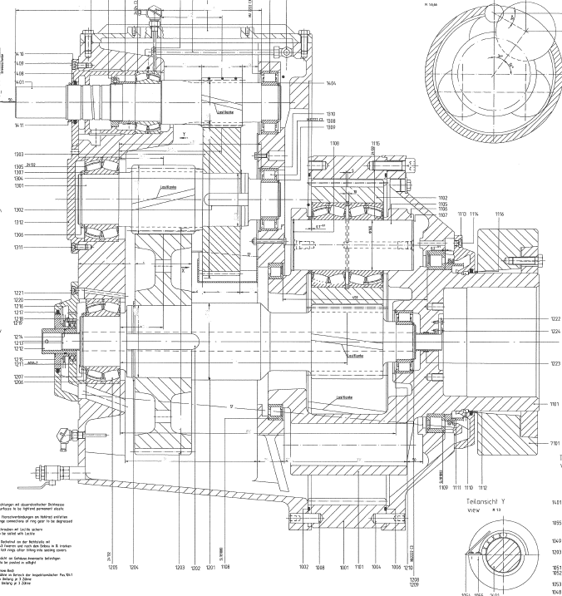

(Jake PSC 1020 Gearbox scheme)

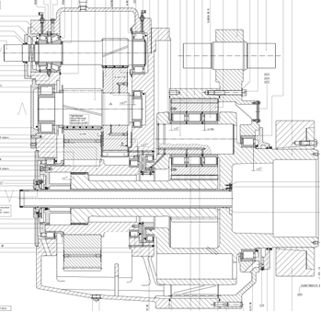

(Jake PSC 1431 Gearbox scheme)

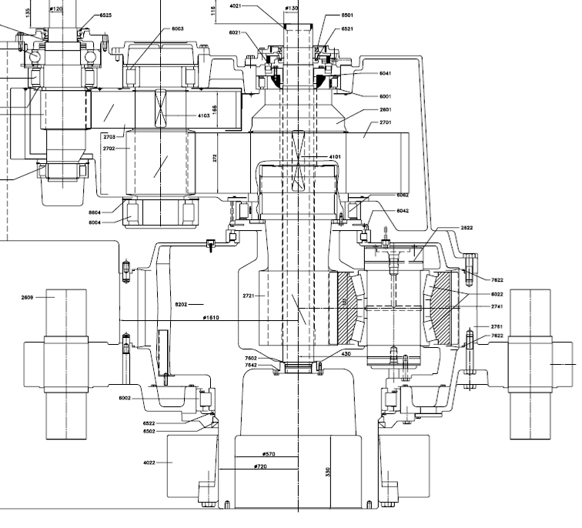

(Hansen EH803 Gearbox scheme)

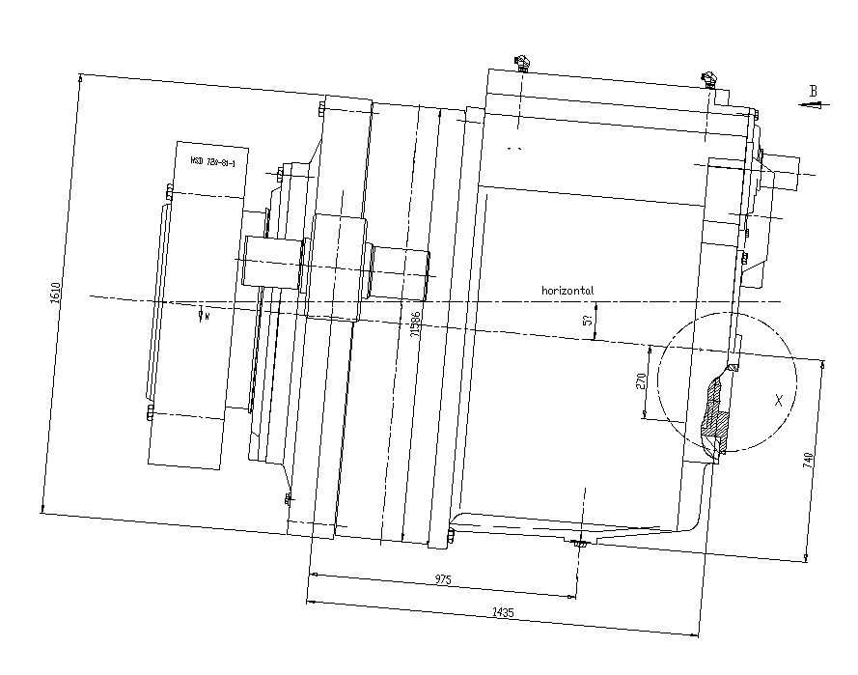

(Winergy PEAB 4420 Gearbox scheme)

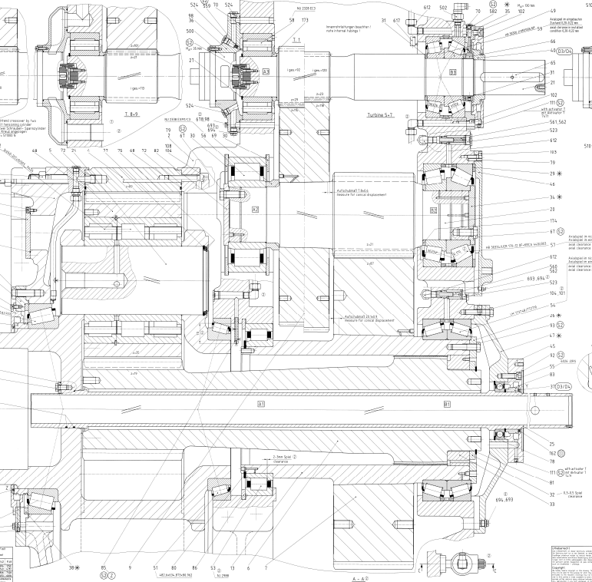

(Bosch-Rexroth GPV 442 Gearbox scheme)

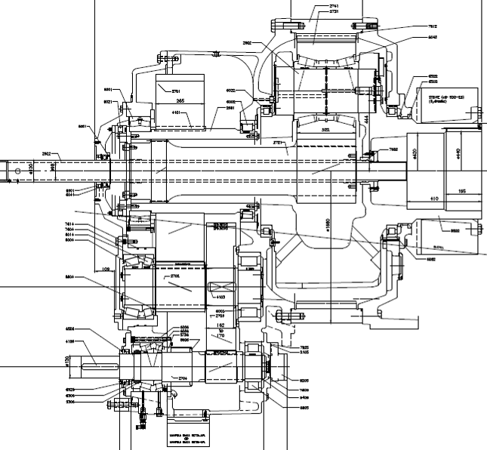

(Hansen EH804 Gearbox scheme)

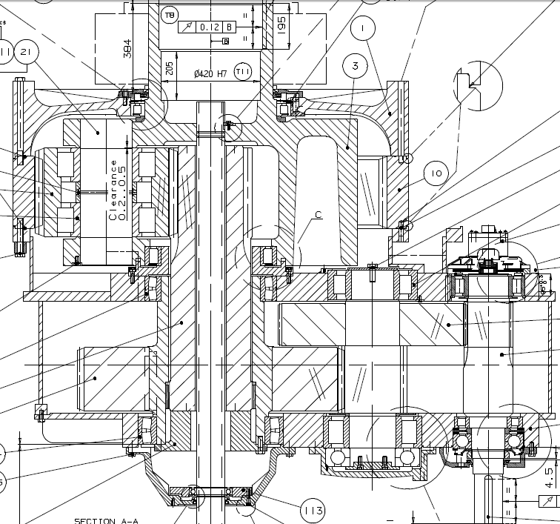

(Moventas PLH1400 Gearbox scheme)

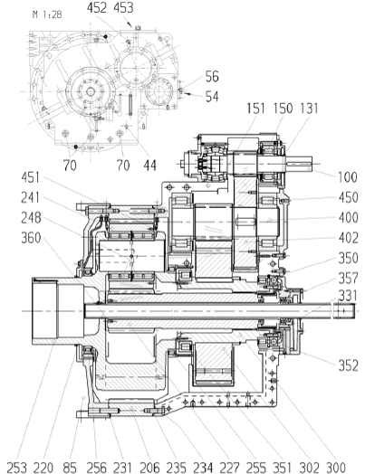

(Winergy PEAB 4435 Gearbox scheme)

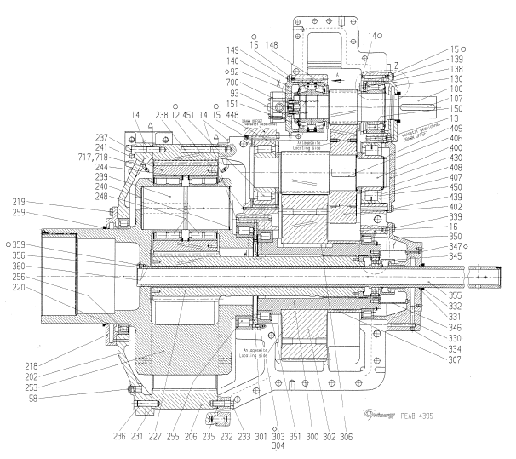

(Winergy PEAB 4395 Gearbox scheme)

# Incident description

Elaborate the incidence description manually by re-writing the information detailed below:

|  |  |
| --- | --- |
| Reason for Service |  |
| Description |  |
| Additional information |  |
| SBU recommendation |  |

The purpose of this inspection was to check specific parts of the gearbox in order to have visual view of them. The results of the inspection are reported in the following pictures.

## Endoscope Inspection Report

The gearbox of wind turbine xx was inspected on the dd/mm/yyyy in xxxxx

#TABLE#

## VTM-Alarms-Warnings

Elaborate manually the information about VTM’s, alarms and warnings, if relevant

## Oil Analysis Report

The Gear Oil of wind turbine xx was analyzed on the dd/mm/yyyy by Tekniker Laboratory and shown the following results.

The analysis concludes that…. Elaborate manually the information about oil analysis, if relevant

## CMS Analysis Report

The drive train of Wind Turbine xxx is continuously followed by a CMS. The following alarm report was released before endoscope inspection.

The analysis concludes that …… Elaborate manually the information about the CMS, if relevant

# Analysis

To be filled by technology

Oil Level is …XXXXXXX

Gearbox overall vibration and sound level XXXXXXX

|  |  |
| --- | --- |
| HSS NRE Bearing: |  |
| HSS Pinion: |  |
| HSS RE Bearing: |  |
| IMS NRE Bearing: |  |
| IMS Gear: |  |
| IMS Pinion: |  |
| IMS RE Bearing: |  |
| LSS NRE Bearing: |  |
| LSS Gear: |  |
| LSS RE Bearing: |  |
| Sun Pinion: |  |
| Planet carrier Bearing: |  |
| Planet Bearings: |  |
| Planet Gears: |  |
| Ring Gear: |  |

# Conclusions

The gearbox was replaced on the dd/mm/yyyy for a gearbox type (s/n xxxxxxxx).

The wind turbine was put into run mode on the dd/mm/yyyy.

To be filled by Technology

A standard pre-defined text at the end could be added:In case you have any question, please feel free to direct them to your Vestas Customer Support Engineer.