Technical Report

WTG #WTGNO#

#SITE# Wind Farm

#TURBINETYPEVNM# - #NOMINELPOWER#

Dpt.:

#Department1 desc#

#Department2 desc#

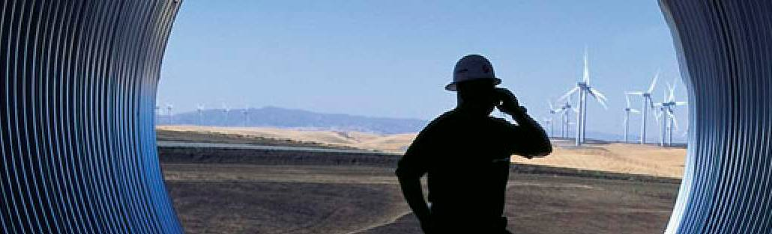



Customer service (approved):

Name

Customer service (approved):

Name

Customer service (approved):

Name

**Copyright Notice**

The documents are created by Vestas Wind Systems A/S and contain copyrighted material, trademarks, and other proprietary information. All rights reserved. No part of the documents may be reproduced or copied in any form or by any means—such as graphic, electronic, or mechanical, including photocopying, taping, or information storage and retrieval systems without the prior written permission of Vestas Wind Systems A/S. The use of these documents by you, or anyone else authorized by you, is prohibited unless specifically permitted by Vestas Wind Systems A/S. You may not alter or remove any trademark, copyright or other notice from the documents. The documents are provided “as is” and Vestas Wind Systems A/S shall not have any responsibility or liability whatsoever for the results of use of the documents by you.

**Table of Contents**

1. [Introduction 3](#_Toc470265347)
2. [Component definition 3](#_Toc470265348)
3. [General data 6](#_Toc470265349)
4. [Incidence description 15](#_Toc470265350)

[4.1 Endoscope Inspection Report 16](#_Toc470265351)

[4.2 VTM-Logs 16](#_Toc470265352)

[4.3 Oil Analysis Report 16](#_Toc470265353)

[4.4 CMS Analysis Report 17](#_Toc470265354)

1. [Analysis 18](#_Toc470265355)
2. [Conclusions 21](#_Toc470265356)

# Introduction

The aim of this document is to present technical information regarding the inspection carried out in the gearbox of WTG #WTGNO# of #SITE# - #COUNTRY# wind farm.

Reference documents used:

* ANSI/AGMA 1010-E95: “Appearance of Gear Teeth - Terminology of Wear and Failure”
* ISO 81400-4: “Design and specification of gearboxes”
* SKF: “Bearing failures and their causes” Product information 401
* FAG: “Rolling Bearing Damage”

# Component definition

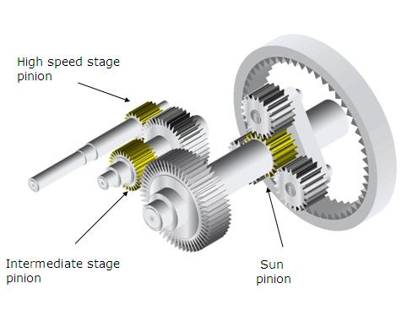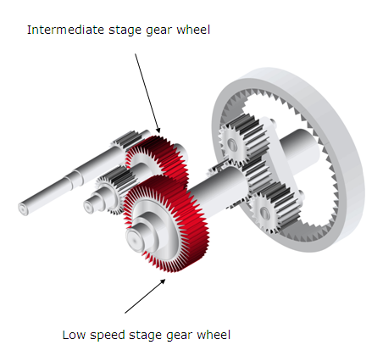

(Gears and pinions)

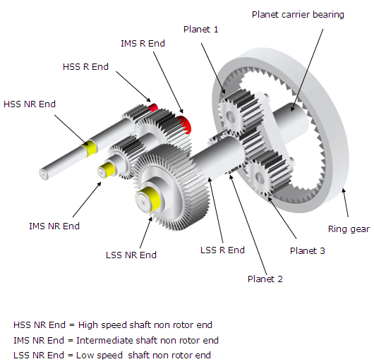

(Bearings)

| In the case that two bearings are mounted on the same side of the shaft, it will be specified which is the “inboard” and “outboard” one.  600px-Gear_words  (Gear nomenclature) |
| --- |
| |  |  | | --- | --- | | Abbreviation | Description | | PLCB RE | Planetary stage – Planet carrier bearing – Rotor end position | | PLB1 RE | Planetary stage – Planet bearing 1 – Rotor end position | | PLB2 RE | Planetary stage – Planet bearing 2 – Rotor end position | | PLB3 RE | Planetary stage – Planet bearing 3 – Rotor end position | | PLB1 NRE | Planetary stage – Planet bearing 1 – Non rotor end position | | PLB2 NRE | Planetary stage – Planet bearing 2 – Non rotor end position | | PLB3 NRE | Planetary stage – Planet bearing 3 – Non rotor end position | | RG | Planetary stage – Ring gear | | PLCB NRE | Planetary stage – Planet carrier bearing – Non rotor end position | | PLG1 | Planetary stage – Planet gear 1 | | PLG2 | Planetary stage – Planet gear 2 | | PLG3 | Planetary stage – Planet gear 3 | | SP | Planetary stage – Sun pinion | | LSSB RE | Parallel stage – Low speed shaft bearing – Rotor end position | | LSSB NRE-I | Parallel stage – Low speed shaft bearing – Non rotor end position, inboard | | LSSB NRE-O | Parallel stage – Low speed shaft bearing – Non rotor end position, outboard | | LSSG | Parallel stage – Low speed shaft gear | | IMSP | Parallel stage – Intermediate shaft pinion | | IMSG | Parallel stage – Intermediate shaft gear | | IMSB RE | Parallel stage – Intermediate shaft bearing – Rotor end position | | IMSB NRE-I | Parallel stage – Intermediate shaft bearing – Non rotor end position, inboard | | IMSB NRE-O | Parallel stage – Intermediate shaft bearing – Non rotor end position, outboard | | HSSP | Parallel stage – High speed shaft pinion | | HSSB RE-I | Parallel stage – High speed shaft bearing – Rotor end position, inboard | | HSSB RE-O | Parallel stage – High speed shaft bearing – Rotor end position, outboard | | HSSB NRE | Parallel stage – High speed shaft bearing – Non rotor end position |   (Abbreviations descriptions) |
|  |

# General data

|  |  |
| --- | --- |
| Site | #SITE# |
| Wind turbine | #WINDTURBINE# |
| Wind turbine number | #TURBINENO# |
| Wind turbine type | #TurbineType# |
| Wind turbine commissioning date | #COMMDATE# |
| Gearbox type | #GEARBOXTYPE# |
| Gearbox revision | #GEARBOXREVISION# |
| Gearbox serial number | #GEARBOXSERIALNO# |
| Gearbox installation date | #INSTALLATIONDATE# |
| Inspection date | #INSPECTIONDATE# |

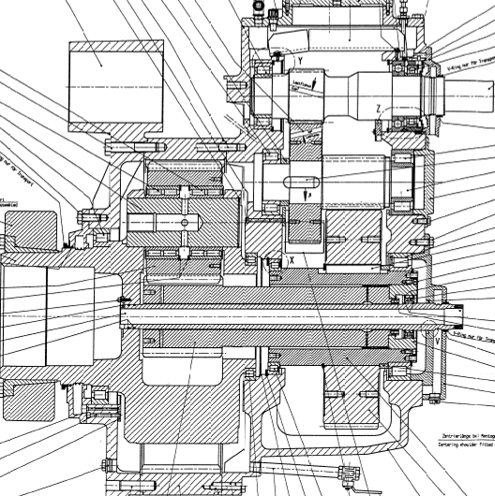

(Winergy PEAC 4300 Gearbox scheme)

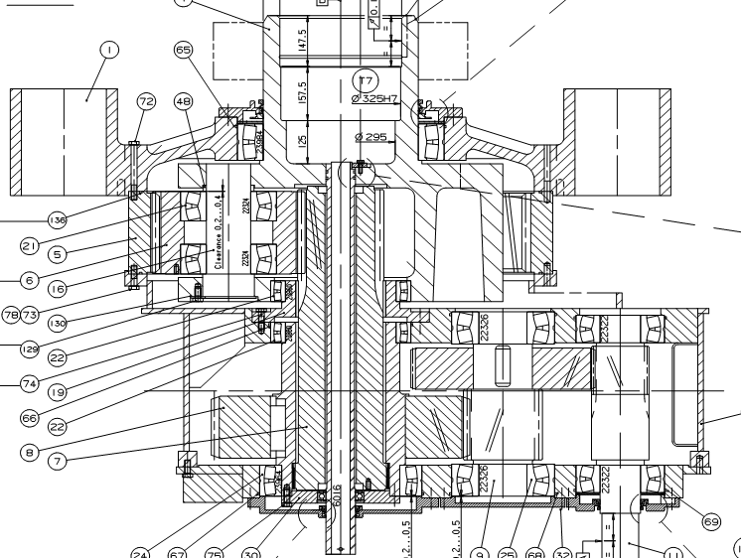

(Moventas PLH 304 Gearbox scheme)

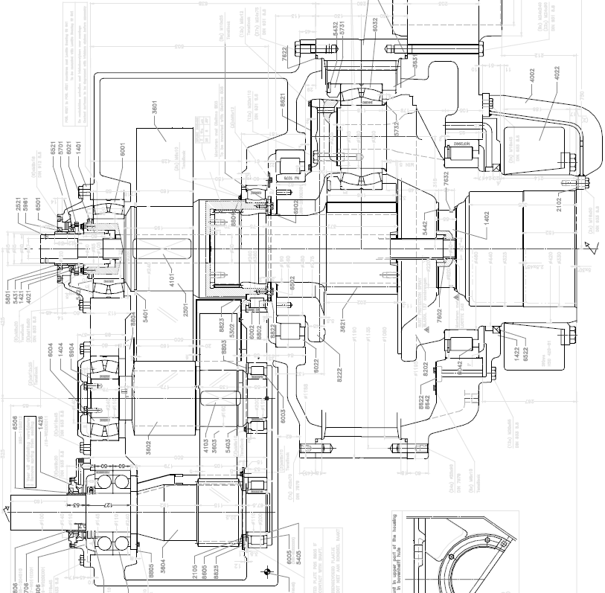

(Hansen EH601 Gearbox scheme)

*[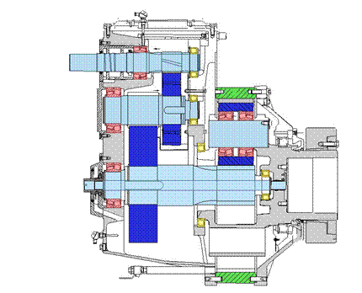](DC_Inspection_Template_Gearbox.docx)*

(JaKe PSC1000/1001 Gearbox scheme)

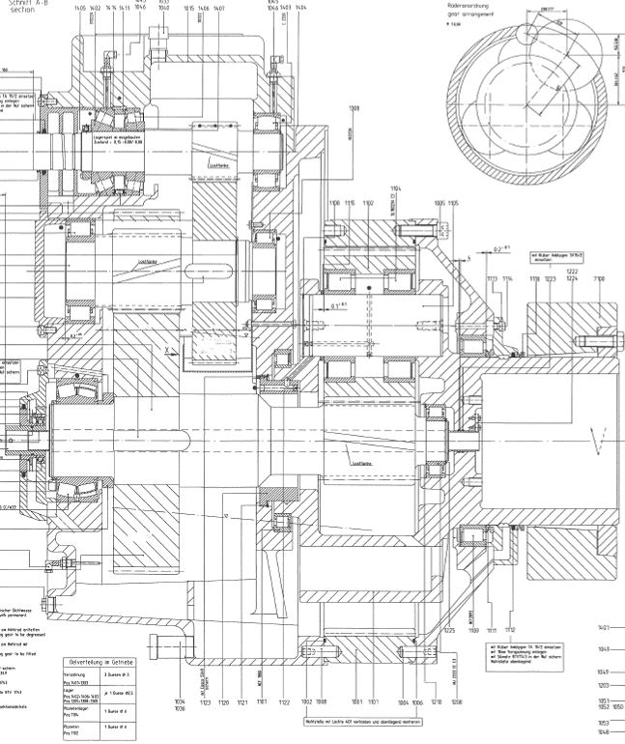

(JaKe PSC 1050-51-52 Gearbox scheme)

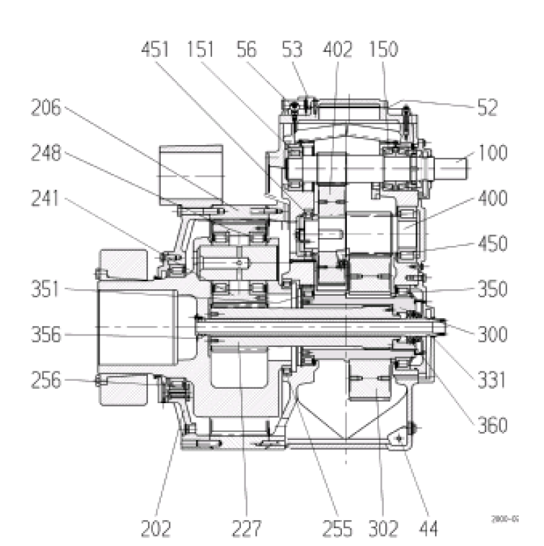

(Winergy PEAB 4320 Gearbox scheme)

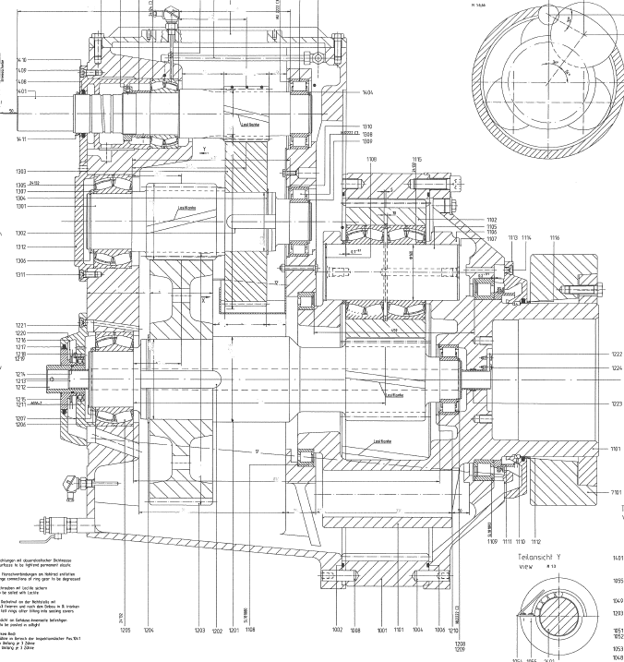

(Jake PSC 1020 Gearbox scheme)

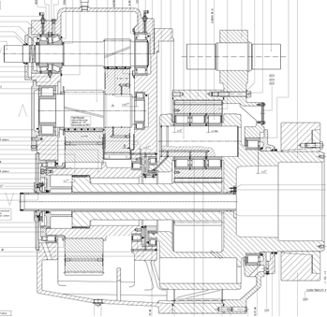

(Jake PSC 1431 Gearbox scheme)

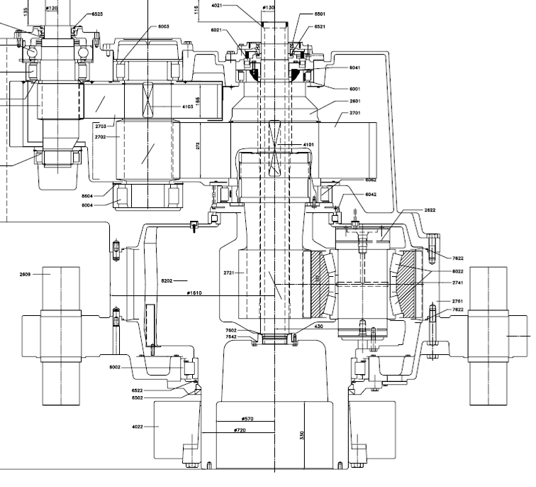

(Hansen EH803 Gearbox scheme)

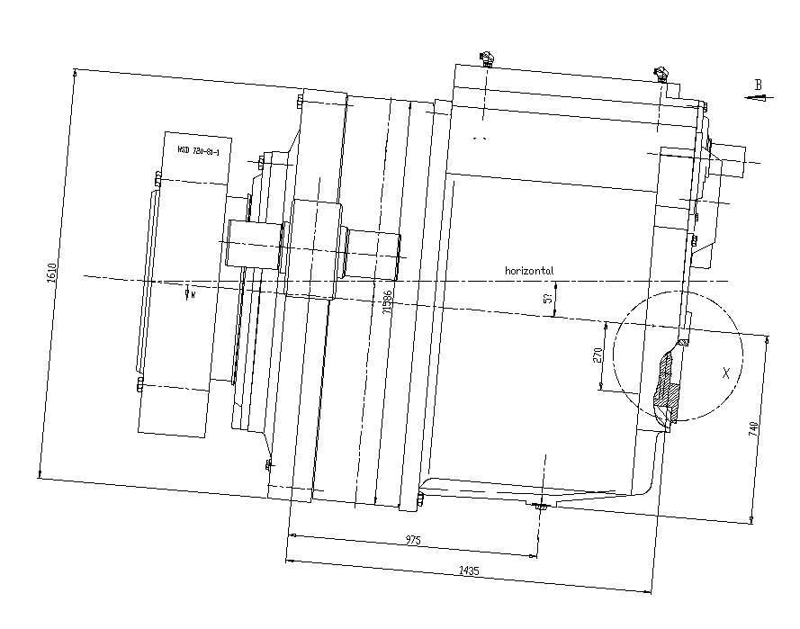

(Winergy PEAB 4420 Gearbox scheme)

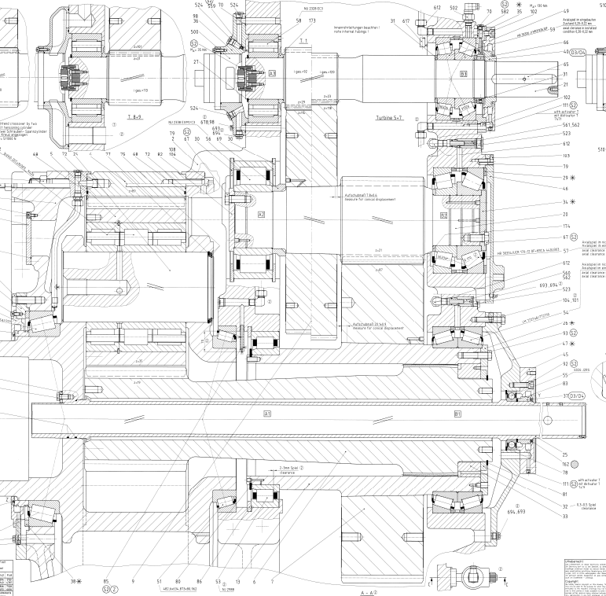

(Bosch-Rexroth GPV 442 Gearbox scheme)

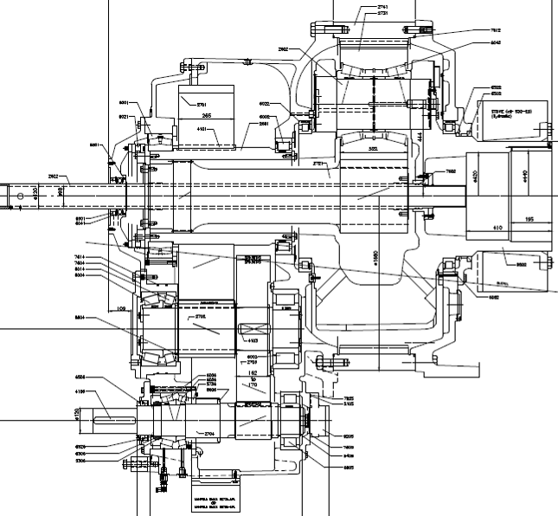

(Hansen EH804 Gearbox scheme)

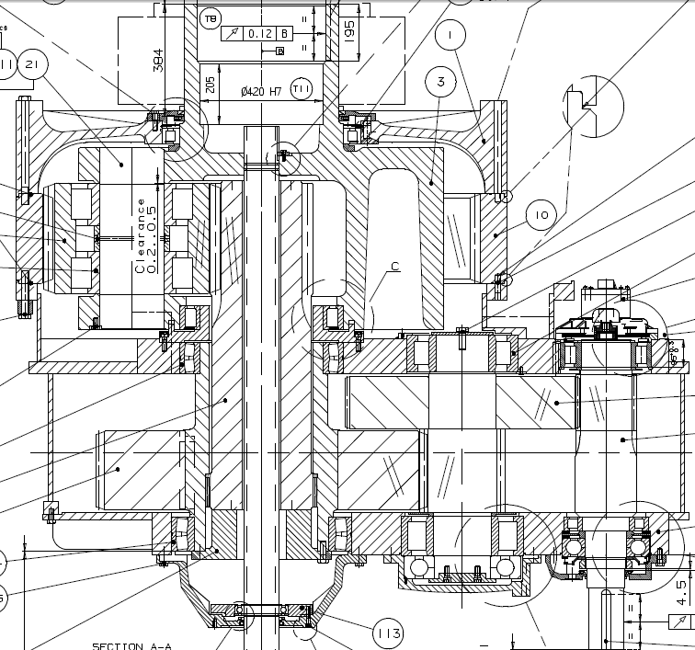

(Moventas PLH1400 Gearbox scheme)

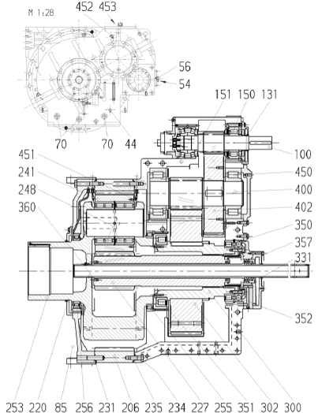

(Winergy PEAB 4435 Gearbox scheme)

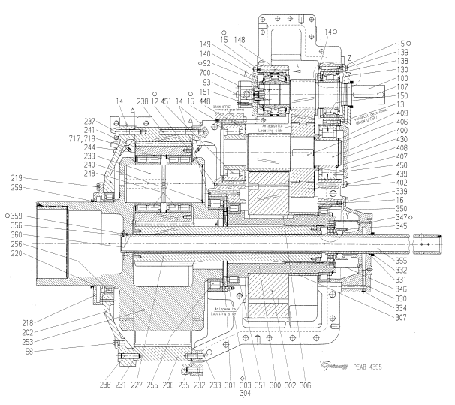

(Winergy PEAB 4395 Gearbox scheme)

# Incidence description

Elaborate the incidence description manually by re-writing the information detailed below:

|  |  |
| --- | --- |
| Reason for Service | #REASONFORSERVICE# |
| Description | #DESCRIPTION# |
| Additional information | #AdditionalInformation# |
| SBU recommendation | #SBURecommendation# |

The purpose of this inspection was to check specific parts of the gearbox in order to have visual view of them. The results of the inspection are reported in the following pictures.

#TABLE1#

## Endoscope Inspection Report

The gearbox of wind turbine #WTGLOCALID# was inspected on the #INSPECTIONDATE# in #SITE#

## VTM-Logs

Elaborate manually the information about VTM’s, alarms and warnings, if relevant

## Oil Analysis Report

The Gear Oil of wind turbine #WTGLOCALID# was analyzed on the #INSPECTIONDATE# by Tekniker Laboratory and shown the following results.

|  |
| --- |
| #OILANALYSIS# |
| **Gear Oil Analysis report** |

## CMS Analysis Report

The drive train of Wind Turbine #WTGLOCALID# is continuously followed by a CMS. The following alarm report was released before endoscope inspection.

|  |
| --- |
| #CMSANALYSIS# |
| **CMS Alarm report** |

# Analysis

To be filled by technology

|  |
| --- |
| #ANALYSIS# |
| **Analysis report** |

Oil Level is …XXXXXXX

Gearbox overall vibration and sound level XXXXXXX

|  |  |  |  |  |
| --- | --- | --- | --- | --- |
| Shafts | | | | |
| **Exact Location** | | **Type of Damage** | | |
| \_GearboxShaftsExactLocation1ShaftTypeId | | \_GearboxShaftsTypeofDamage1ShaftErrorId | | |
| \_GearboxShaftsExactLocation2ShaftTypeId | | \_GearboxShaftsTypeofDamage2ShaftErrorId | | |
| \_GearboxShaftsExactLocation3ShaftTypeId | | \_GearboxShaftsTypeofDamage3ShaftErrorId | | |
| \_GearboxShaftsExactLocation4ShaftTypeId | | \_GearboxShaftsTypeofDamage4ShaftErrorId | | |
| **Gears** | | | | |
| **Exact Location** | **Type of Damage** | | **Damage Class** | **Decision** |
| \_GearboxExactLocation1GearTypeId | \_GearboxTypeofDamage1GearErrorId | | \_GearboxGearDamageClass1DamageId | \_GearboxGearDecision1DamageDecisionId |
| \_GearboxExactLocation2GearTypeId | \_GearboxTypeofDamage2GearErrorId | | \_GearboxGearDamageClass2DamageId | \_GearboxGearDecision2DamageDecisionId |
| \_GearboxExactLocation3GearTypeId | \_GearboxTypeofDamage3GearErrorId | | \_GearboxGearDamageClass3DamageId | \_GearboxGearDecision3DamageDecisionId |
| \_GearboxExactLocation4GearTypeId | \_GearboxTypeofDamage4GearErrorId | | \_GearboxGearDamageClass4DamageId | \_GearboxGearDecision4DamageDecisionId |
| \_GearboxExactLocation5GearTypeId | \_GearboxTypeofDamage5GearErrorId | | \_GearboxGearDamageClass5DamageId | \_GearboxGearDecision5DamageDecisionId |
| \_GearboxExactLocation6GearTypeId | \_GearboxTypeofDamage6GearErrorId | | \_GearboxGearDamageClass6DamageId | \_GearboxGearDecision6DamageDecisionId |
| \_GearboxExactLocation7GearTypeId | \_GearboxTypeofDamage7GearErrorId | | \_GearboxGearDamageClass7DamageId | \_GearboxGearDecision7DamageDecisionId |
| \_GearboxExactLocation8GearTypeId | \_GearboxTypeofDamage8GearErrorId | | \_GearboxGearDamageClass8DamageId | \_GearboxGearDecision8DamageDecisionId |
| \_GearboxExactLocation9GearTypeId | \_GearboxTypeofDamage9GearErrorId | | \_GearboxGearDamageClass9DamageId | \_GearboxGearDecision9DamageDecisionId |
| \_GearboxExactLocation10GearTypeId | \_GearboxTypeofDamage10GearErrorId | | \_GearboxGearDamageClass10DamageId | \_GearboxGearDecision10DamageDecisionId |
| \_GearboxExactLocation11GearTypeId | \_GearboxTypeofDamage11GearErrorId | | \_GearboxGearDamageClass11DamageId | \_GearboxGearDecision11DamageDecisionId |
| \_GearboxExactLocation12GearTypeId | \_GearboxTypeofDamage12GearErrorId | | \_GearboxGearDamageClass12DamageId | \_GearboxGearDecision12DamageDecisionId |
| \_GearboxExactLocation13GearTypeId | \_GearboxTypeofDamage13GearErrorId | | \_GearboxGearDamageClass13DamageId | \_GearboxGearDecision13DamageDecisionId |
| \_GearboxExactLocation14GearTypeId | \_GearboxTypeofDamage14GearErrorId | | \_GearboxGearDamageClass14DamageId | \_GearboxGearDecision14DamageDecisionId |
| \_GearboxExactLocation15GearTypeId | \_GearboxTypeofDamage15GearErrorId | | \_GearboxGearDamageClass15DamageId | \_GearboxGearDecision15DamageDecisionId |
| **Bearings** | | | | |
| **Location** | **Position** | | **Type of Damage** | **Damage Class** |
| \_GearboxBearingsLocation1BearingTypeId | \_GearboxBearingsPosition1BearingPosId | | \_GearboxBearingsDamage1BearingErrorId | \_GearboxBearingDecision1DamageDecisionId |
| \_GearboxBearingsLocation2BearingTypeId | \_GearboxBearingsPosition2BearingPosId | | \_GearboxBearingsDamage2BearingErrorId | \_GearboxBearingDecision2DamageDecisionId |
| \_GearboxBearingsLocation3BearingTypeId | \_GearboxBearingsPosition3BearingPosId | | \_GearboxBearingsDamage3BearingErrorId | \_GearboxBearingDecision3DamageDecisionId |
| \_GearboxBearingsLocation4BearingTypeId | \_GearboxBearingsPosition4BearingPosId | | \_GearboxBearingsDamage4BearingErrorId | \_GearboxBearingDecision4DamageDecisionId |
| \_GearboxBearingsLocation5BearingTypeId | \_GearboxBearingsPosition5BearingPosId | | \_GearboxBearingsDamage5BearingErrorId | \_GearboxBearingDecision5DamageDecisionId |
| \_GearboxBearingsLocation6BearingTypeId | \_GearboxBearingsPosition6BearingPosId | | \_GearboxBearingsDamage6BearingErrorId | \_GearboxBearingDecision6DamageDecisionId |
| **Housing** | | | | |
| **Planet Stage 1** | | | \_GearboxPlanetStage1HousingErrorId | |
| **Planet Stage 2** | | | \_GearboxPlanetStage2HousingErrorId | |
| **Helical/Parallel Stage** | | | \_GearboxHelicalStageHousingErrorId | |
| **Front Plate** | | | \_GearboxFrontPlateHousingErrorId | |
| **Auxilliary Stage** | | | \_GearboxAuxStageHousingErrorId | |
| **HS Stage** | | | \_GearboxHSStageHousingErrorId | |
| **Torque Arm System** | | | | |
| **Loose Bolts** | | | \_GearboxLooseBolts | |
| **Broken Bolts** | | | \_GearboxBrokenBolts | |
| **Defect Damper Elements** | | | \_GearboxDefectDamperElements | |
| **Too Much Clearance** | | | \_GearboxTooMuchClearance | |
| **Cracked Broken Torque Arm** | | | \_GearboxCrackedTorqueArm | |
| **Needs To Be Aligned** | | | \_GearboxNeedsToBeAligned | |
| **Defect Assessories** | | | | |
| **Pt 100 Bearing 1** | | | \_GearboxPT100Bearing1 | |
| **Pt 100 Bearing 2** | | | \_GearboxPT100Bearing2 | |
| **Pt 100 Bearing 3** | | | \_GearboxPT100Bearing3 | |
| **Oil Level sensor** | | | \_GearboxOilLevelSensor | |
| **Oil Pressure (s412)** | | | \_GearboxOilPressure | |
| **Pt 100 Oil Sump** | | | \_GearboxPT100OilSump | |
| **Filter Indicator** | | | \_GearboxFilterIndicator | |
| **Immersion Heater** | | | \_GearboxImmersionHeater | |
| **Drain Valve** | | | \_GearboxDrainValve | |
| **Air Breather** | | | \_GearboxAirBreather | |
| **Sight Glass** | | | \_GearboxSightGlass | |
| **Chip Detector** | | | \_GearboxChipDetector | |

# Conclusions

#CONCLUSIONRECOMMENDATION#

In case you have any question, please feel free to direct them to your Vestas Customer Support Engineer.