Report for Final Project

1. Project Name

Restaurant Recommendation

1. Team Member

* Rong Zhuang(Johnny)
* Marlon Garcia

1. Brief Ideas

This app is used to search restaurants, view the details of them. After login, you can share your experience with others about the restaurant you have been. You can submit ratings and reviews. All of the data are dynamic, which means this app connects backend server to retrieve data.

1. Development Platform & Tools

* Mac, OS X EI Capitan, Version 10.11.1
* Android Studio (IDE), Version 1.4.1
* Genymotion (Emulator), Version 2.5.2

1. Main screens/functions

|  |  |
| --- | --- |
|  | App Name: Restaurant Recommendation  Features:   * Register/Login * Search Restaurant * Restaurant list and details * Rating * Write Comment(Review) * Tablet Support |

* 1. Restaurant List

This is the entry screen of this app. All of the row data is fetched from backend server. Restaurants are grouped to 5 categories: Restaurant, Dessert, CoffeeTea, Bakeries, IceCream.

|  |  |
| --- | --- |
|  | Features:   * Restaurants are displayed in list by each row * Each row item contains name, rating, review counter and address. * Each restaurant has a specific icon according to its category   Actions:   * When touch on any row, it navigates to the detail screen * Search * Login |

* + 1. Login

Click the menu bar, select ‘Sign In’.

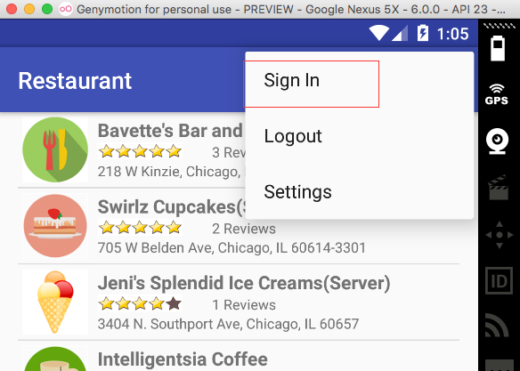

|  |  |
| --- | --- |
|  | Features:   * Input Name and Password to sign in   Actions:   * If you have no account yet, click ‘Register’ button to sign up first. |

* + 1. Register

|  |  |
| --- | --- |
|  | Features:   * Provide Email address, user name and password for registration.   Actions:   * Go back to Login screen |

* 1. Restaurant Details

|  |  |
| --- | --- |
|  | Features:   * Details are displayed in this screen, some of them you’ve already seen in the previous list view. * Three images about this restaurant are shown. They are downloaded from internet dynamically. * Comments(Reviews) are displayed in list view.   Actions:   * Change rating * Write comment |

* + 1. Change Rating

You can change the rating value of this restaurant by touching on the rating bar. The new value will be submitted to server directly.

* + 1. Write Comment

You can write comments to share your experience or thoughts by clicking on the ‘Write Comment’ button. But you have to login first to continue. Otherwise, you will get an error message, see below.

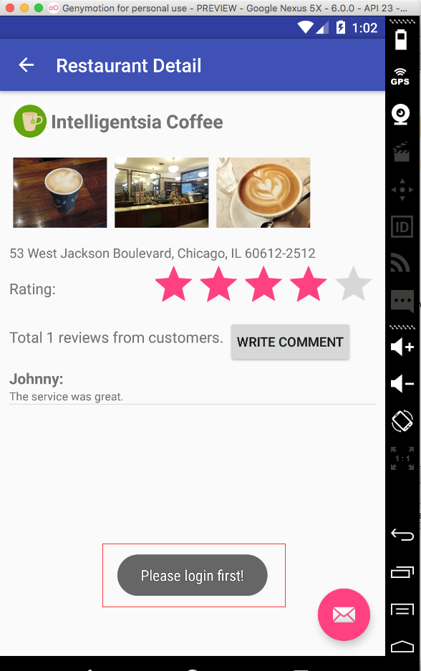

If you’ve already been logged in, you will see the following screen.

|  |  |
| --- | --- |
|  | Features:   * User name is displayed at the top of the screen. * The inputted comments will be submitted to server after clicking ‘Submit’ button.   Actions:   * Cancel, return back to details screen. |

* 1. Search

In the restaurant list view screen, click the ‘Search’ button in the menu bar.

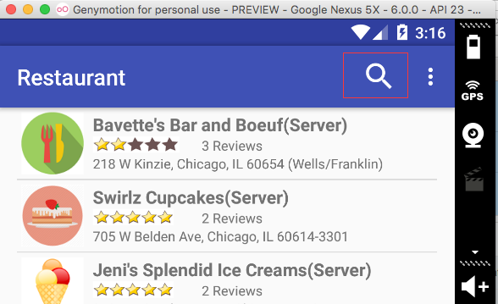

|  |  |
| --- | --- |
|  | Features:   * Input the keyword you want to search, press enter. The list will be refreshed with new result.   Functions:   * Exit Search |

* 1. Email Button

Contact the owner of the app.

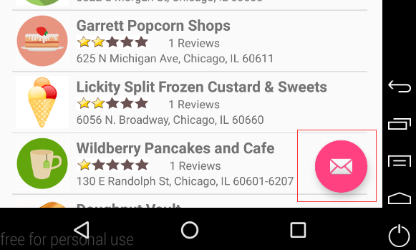

* 1. Rotation

In the landscape mode, the layout still looks pretty.

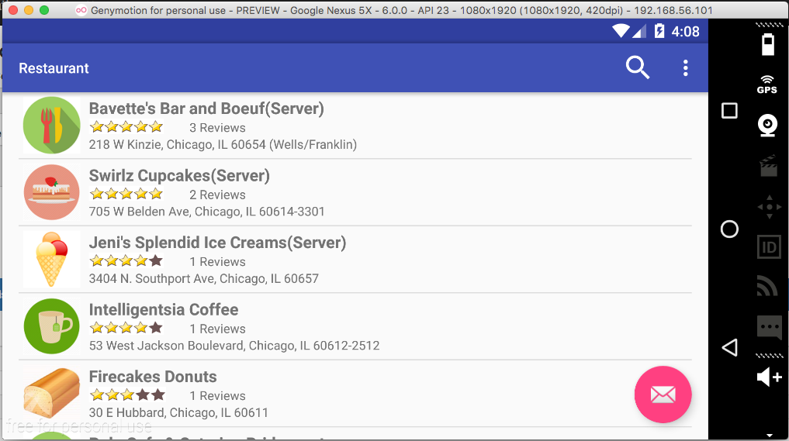

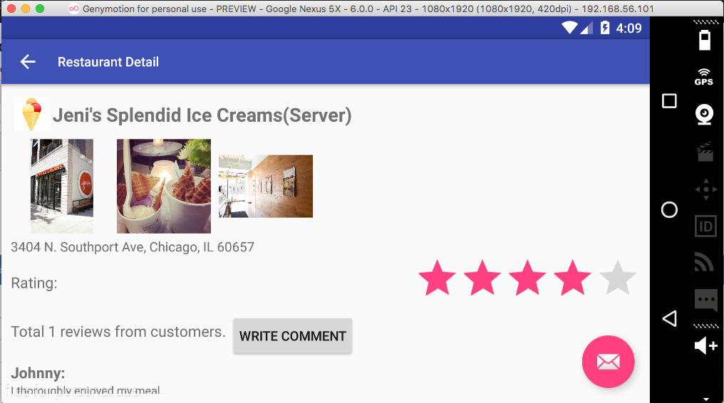

* 1. Tablet Support

The layout of this app is implemented by fragments, so both phone and tablet size are supported by default. The biggest difference is that the details screen is displayed along with the list view screen. You are able to see all of the contents on one screen. If you change the rating value at the right side, you will see the effect at the left side immediately.

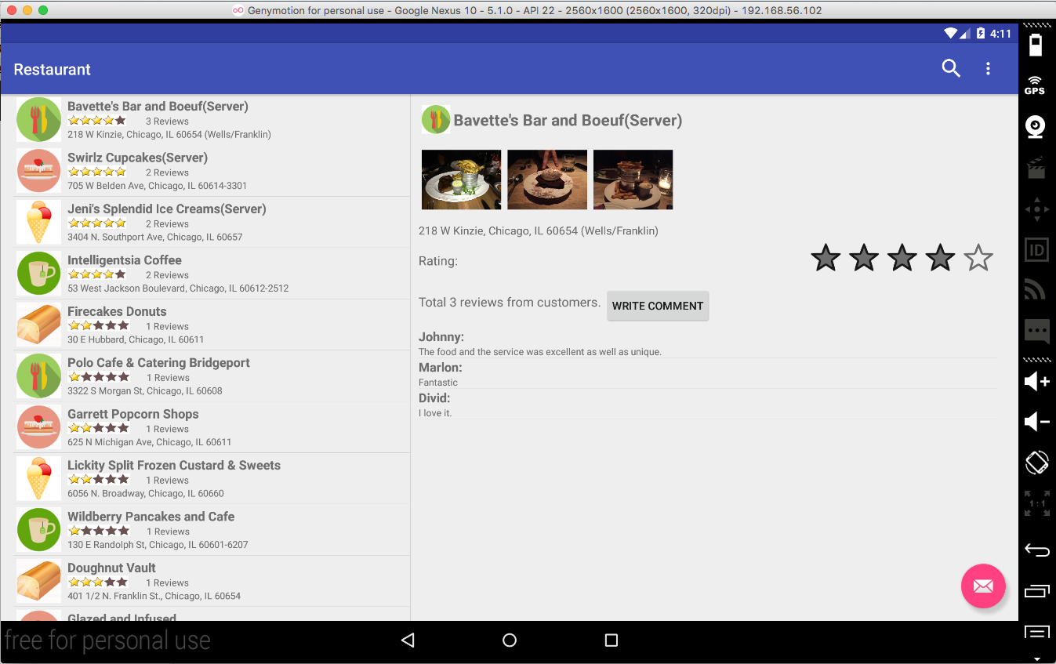

1. APIs for Android
   1. Supporting multiple screen sizes (tablets and handsets)

Based on Fragments, create classes extends ListFragment and Fragment.

* 1. Dynamic Data from Server

Data including restaurant list, restaurant details and images are all fetched from backend asp.net server. And operations including, register/login, rating, submitting comments are also calling the web APIs provided by server. All of http communications are encapsulated in class HttpHelper which contains three main method, Get, Post and GetList. All of the methods return JSON formatted data, JSONObject or JSONArray. Besides, each calling of the http method is asynchronous, by creating a class which extends AsyncTask.

* 1. Implicit intent

Float button for email.

1. Server APIs
   1. Backend Server

The backend server is built with ASP.NET MVC 5.0 in C#. There is a home page where you can get the ideas how to use the APIs. You can try the register and login functions in this page. They are using the same APIs which are also used by our Android app. These are RESTful APIs which send back responses in JSON or XML format. The data format depends on the requester. Both formats are supported by this API server simultaneously.

* 1. Homepage

<http://140.192.34.69/restaurant/>

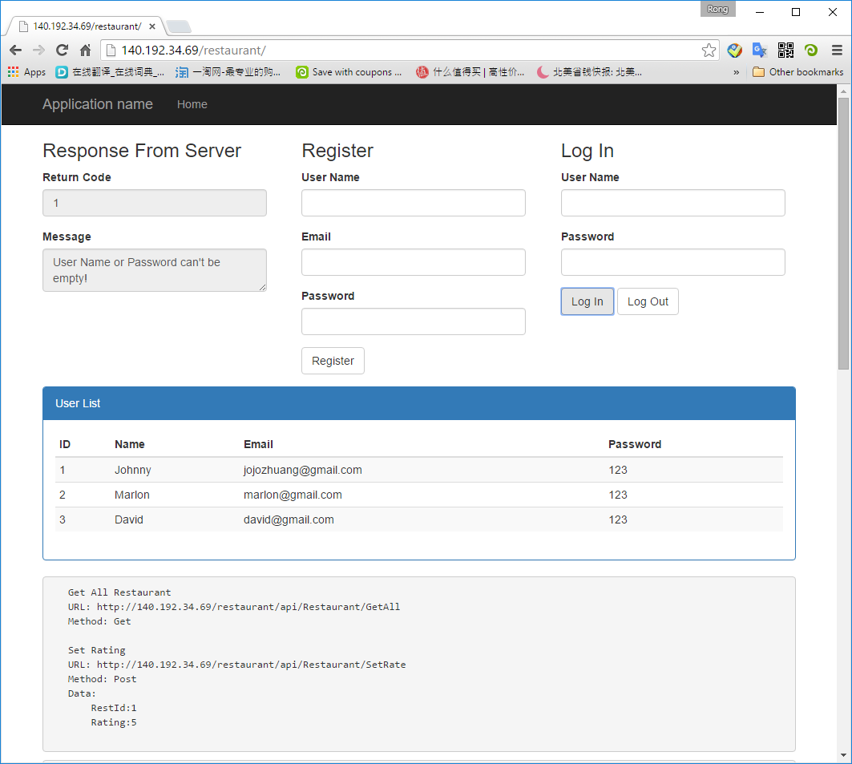

* 1. Server APIs

|  |  |  |  |
| --- | --- | --- | --- |
| **URL** | **Method** | **Parameters** | **Description** |
| /api/User/Register | POST | UserId:0 UserName:johnny Email:jojo@gmail.com  Password:aaa | Register |
| /api/User/Login | POST | UserName:johnny  Password:aaa | Login |
| /api/User/Logout | POST | UserName:johnny | Logout |
| /api/User/GetAll | GET |  | Get All User |
| /api/Restaurant/GetAll | GET |  | Get All Restaurant |
| /api/Restaurant/SetRate | POST | RestId:1  Rating:5 | Set Rating |
| /api/comment/GetAll | GET |  | Get All Comments |
| /api/comment/GetListByRestaurant?restid=1 | GET | restid=1 | Get Comments By Restaurant |
| /api/comment/GetListByUser?id=1 | GET | id=1 | Get Comments By User |
| /api/comment/create | POST | RestId: 1  UserName: Johnny Content: Very good | Submit Comment |

* 1. Response from server
     1. Response for GET methods

Server returns list data in xml or json format.

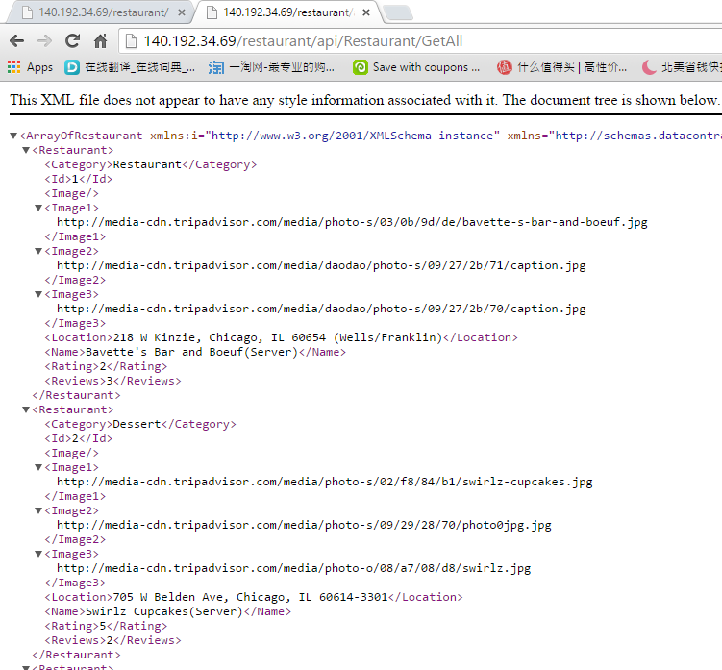

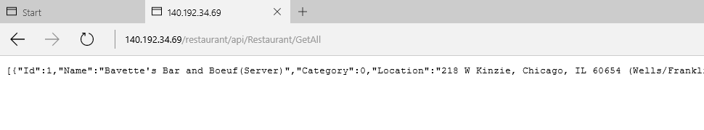

* + 1. Response for POST methods

Server returns the operation result, which contains two attributes: Code and Message. If code equals to 0, meaning: no error, operation succeeded. Otherwise, there are some error or exception occurs. For example:

* {"RetCode":0,"Message":"Registration succeed!"}
* {"RetCode":1,"Message":"User Name, Email or Password can't be empty!"}

1. Final Project Discussion
   1. Biggest Challenges
      1. Tablet Support

This app supports both phone and tablet screens. During the development, we overcome lots of difficulties to achieve this purpose. Fragment is not easy to handle.

* + 1. Dynamic Data

Most of the data for this Android app comes from backend .NET server. It costs us lots of time to finally setup this server and implement all of the APIs. Because of remote APIs, the development becomes complex and more efforts were spent on embedding it into our app.

* 1. Limitation of the app

All of the data are fetched remotely, which means the device running this app must be connected to the internet. Otherwise, you can’t use it, since no data at all is in local memory.

* 1. Limitation of the Android SDK

Not found yet. We found all of the solutions for the requirements of our app.

* 1. Overall experience

Learning how to develop Android app is a fantastic experience, especially when seeing our own app running properly as we expected. Though the functions are simple and there is a long way to go before publishing it to app store, we are still happy and proud of our achievement. Especially, we implement the dynamic data for this app. I like to use Java for developing Android apps. Moreover, the handouts and samples provided by the instructor are really useful. It enables us to learn java and Android development quickly and efficiently.

Regarding this final project, we have tried our best to add as many features as possible. We did encounter some obstacles/issues during the development. But at last, we overcome them and get the results we want. And it is really an indelible experience working together.

As a whole, we enjoyed this course and the Android development.

1. Group Member Contribution
   1. Rong Zhuang

* Discuss and exchange ideas with Marlon in the design phase.
* Setup the framework of the Android APP with fragment, menu bar.
* Search Function, Comment Submission
* Downloading pictures from remote server.
* Setup the framework of the API Sever with asp.net MVC.
* Build the backend APIs for restaurant, comment.
* Create and refine the final document.
  1. Marlon Garcia
* Discuss and exchange ideas with Johnny in the design phase.
* Implement the login/register function in Android
* Implement the email float button
* Implement the rating
* Build the backend APIs for login, logout, registration and rating.
* Record the demo video
* Refine the final document.