**CSC472-Project Proposal**

**Project Title:** Restaurant Recommendation System

**Team Project:** Yes. Rong Zhuang & Marlon Garcia

**Project Description:** This app can let user search the restaurant and submit their reviews/comments to the restaurant they are interested in. This system is made up with two parts, the frontend Android app and a backend web server which is built by .NET MVC.

**Functionalities:**

1. User register/login

|  |  |
| --- | --- |
|  |  |

1. Nearby

Pin the current location in the google map, display nearby restaurants.

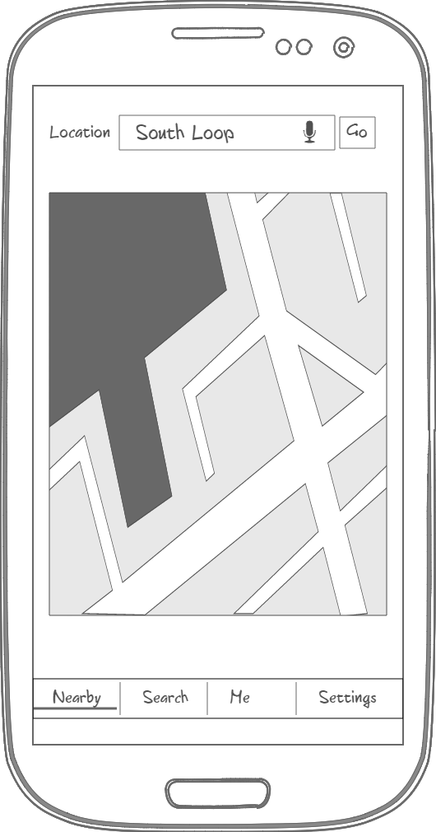

1. Search: Restaurant list.

Input the keyword, choose the type, click go, a list of search result will be displayed. When you click on one line, it navigates to the detail screen.

|  |  |
| --- | --- |
|  |  |

In the detail screen, you can see the restaurant name, rating, reviews. When you click the ‘Write a review’ button, a input dialog will be popped up. After saving your review, it will appear in the review list.

|  |  |
| --- | --- |
|  |  |

1. Me

Display a restaurant list, to which you have submit a review.

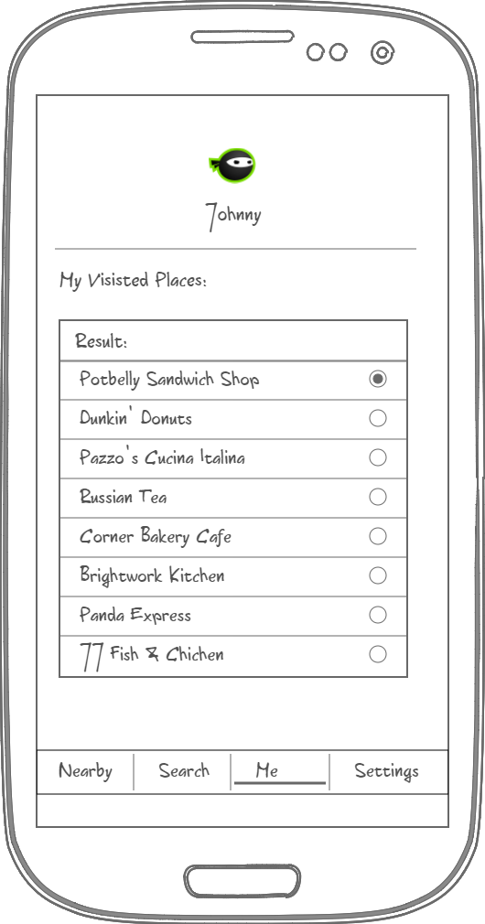

1. Settings: TBD.

**API features:**

* Camera(Take picture for user profile)
* Location awareness(Locate the current position to find restaurants nearby)
* Google Map(Display restaurants in the map)
* Network(Wifi/Cellular, avoid downloading pictures when in cellular connection.)
* Multiple screen sizes support