WA Division

PanCIM Standard Cycle Time Monitoring

Introduction

The PanCIM Standard Cycle Time Monitoring application provides real-time molding machine cycle time information and notification when running outside expected limits. The fully automated monitoring program uses the part specific standard hours value contained in the Setcim workorder record. The standard hour values are converted into a standard (target) cycle time based on the number of mold cavities. This information, along with a calculated high and low cycle time limit is stored and checked against each actual machine cycle time. Default high and low cycle time limits are calculated from the target cycle time but can be over ridden temporarily or permanently for any part.

GCS Screens

MACHINE CYCLE STANDARDS - CycStds.dsp (Fig. 1)

The MACHINE CYCLE STANDARDS screen provides some basic cycle information and a quick way to detect cycle performance for all molding machines in the factory. The following information is displayed for each machine:

- Color coded indication of standard cycle alarm status
- Last machine cycle time in seconds
- Percent of deviation from desired target
- Current part name

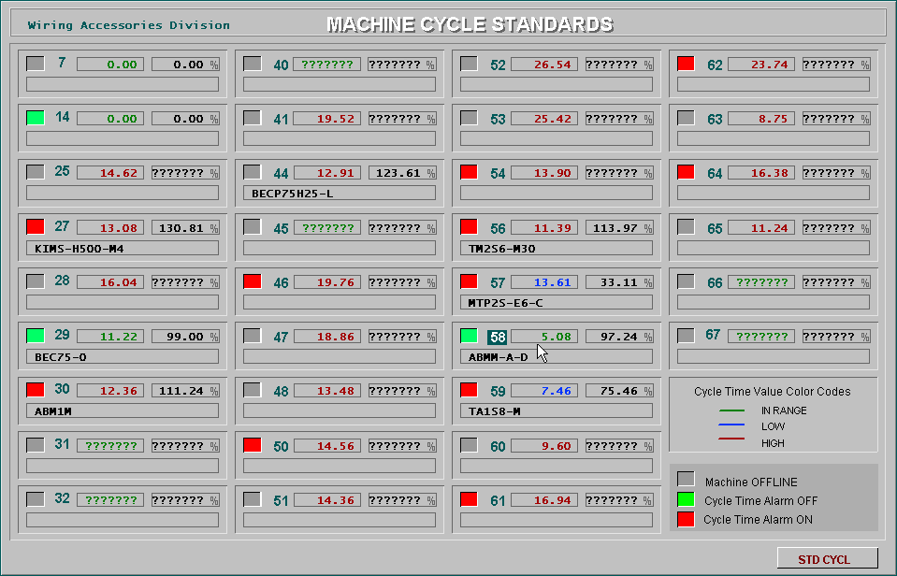
Click Machine Number to display the
STANDARD CYCLE INFORMATION screen
Cycle Alarm Indicator
Last Cycle Time
Deviation Percent
Part Name
Click to Display the
STANDARD CYCLE TIME EXCEPTION MANAGER screen

Fig. 1

STANDARD CYCLE INFORMATION - MM??Std.dsp (Fig. 2)

The STANDARD CYCLE INFORMATION screen contains additional information about the selected molding machine. Cycle time, target, low limit and high limit values for the current part can be temporarily changed from this display. Select and enter the new cycle standard values in the fields under the New Cycle Standards Values heading. Click the UPDATE button to save the new values. These new values will only be in effect for the duration of the current workorder. Note: the UPDATE button will only be visible after the employee number has been entered. (Fig. 3)

Standard Cycle Event Summary
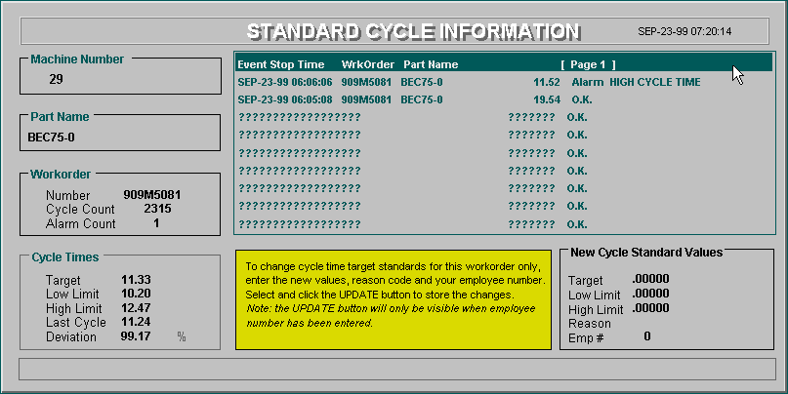
Data Entry Fields for New Temporary Target, High Limit and Low Limit Values
Current Target and Limit Values

Fig. 2

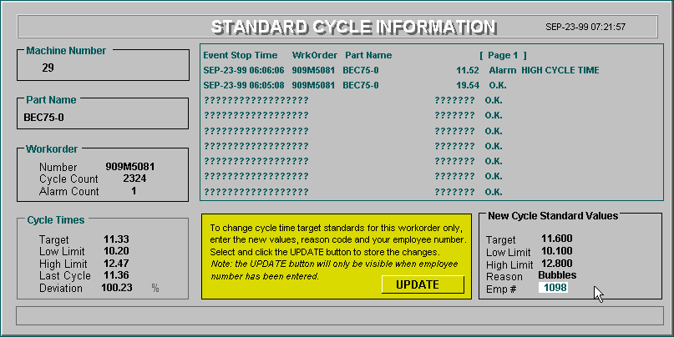
Click to Store New Cycle Standards Values
A Message Will Appear in This Space to Indicate That Temporary Values Have Been Set and Who Set Them

Fig. 3

STANDARD CYCLE TIME EXCEPTION MANAGER - StdExcpt.dsp (Fig. 4)

The STANDARD CYCLE TIME EXCEPTION MANAGER screen is used to modify the default values for the high and low cycle time limit factors and change the cycle rules used to activate and de-activate the alarm indicator. Additionally, part specific target, high limit and low limit exception values can be viewed, modified and added. The target, low limit and high limit values for any part name in this table will always be used instead of the defaults.

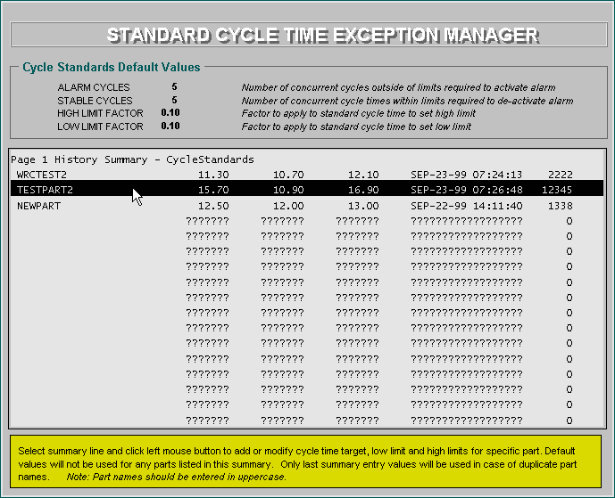
Select and Enter New Default Values for Upper and Lower Cycle Limits and Cycle Alarming Rules
Click Selected Line to Add, Modify or Remove Part Specific Exception Data

Fig. 4

CYCLE TIME EXCEPTION VALUES - ExcptDet.dsp (Fig. 5)

The CYCLE TIME EXCEPTION VALUE detail is the data entry screen used to add, modify or remove part specific exception values. The screen is displayed when clicking any highlighted bar from the STANDARD CYCLE TIME EXCEPTION MANAGER summary screen. Click the right mouse button to exit this screen and store the displayed values.

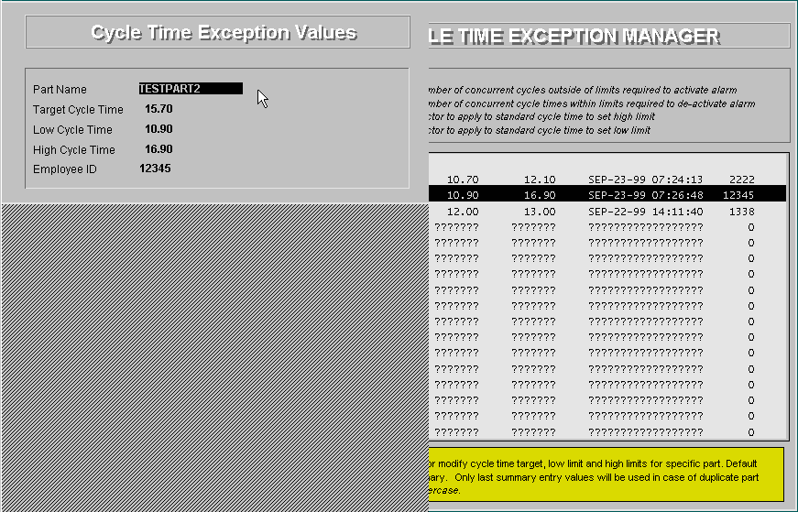
Data Entry for Adding, Modifying or Removing Part Specific Cycle Time Standards

Fig. 5

Setcim Database Records

Record Name: MM??CycleStds Definition Name: MachCycStdsDef

Fixed Area Field | Description
# LOG RECORDS | Number of log occurrences in memory
NAME | Record name (MmxxxCycleStds)
MACHINE NUMBER | Machine number
WorkOrderNumber | Workorder number
PartName | Part name
Std Hours | Standard hours (hours to make 100 parts)
CYCLE TIME | Last cycle time in seconds
CYCLE STATUS | Internal program counter for consecutive cycle status
CYCLE TYPE | Last cycle type (OK, low, high)
CYCLE COUNT | Total workorder cycles
TARGET | Target cycle time
LO-LIMIT | Cycle time low limit
HI-LIMIT | Cycle time high limit
DEVIATION | Ratio of actual cycle time to target
ALARM STATE | Machine standard cycle alarm state
ALARM TYPE | Type of alarm (low cycle, high cycle)
ALARM COUNT | Number of cycle alarms for workorder
ALARM CYCLES | Number of machine cycles run during alarm
ACKNOWLEDGED | Operator acknowledgement (not currently used)
CHANGE REASON | Reason code for temporary cycle time standard change
Emp_ID | Badge number of person making temporary cycle standard change
STORE | History storage activation field
INTEGER VALUE | Machine cycle activation field
NEXT WONum | Number of new workorder
LAST_UPDATE | Last update time of record data
LAST_LOG_TIME | Last update time for history data
LOG_SEQUENCE_NUMBER | Setcim history sequence number
LOGS_ON_DISK | Number of records to keep on disk
TASK IDENTIFIER | Disk history task name
Repeat Area Field | Description
LOG_TIME | Data update time stamp
LOG MACH NUMBER | Machine number
LOG WORK ORDER | Workorder
LOG PART NAME | Part name
LOG STD CYCLE | Actual cycle time
LOG STATE | Alarm state
LOG ALARM TYPE | Alarm type
LOG CYCLE COUNT | Cycle count

Record Name: CycleStandards Definition Name: CycStdsDataDef

Fixed Field | Description
#_OF_REPEAT_AREAS | Number of parts in exception list
NAME | Record name (CycleStandards)
ALARM CYCLES | Number of consecutive high or low cycle time cycles before setting alarm ON
STABLE_CYCLES | Number of consecutive good cycle time cycles before setting alarm OFF
HI-LIMIT FACTOR | Default high limit factor
LO-LIMIT FACTOR | Default low limit factor
Repeat Area Field | Description
MACHINE NUMBER | Machine number (not currently used)
PartName | Part name
TARGET | Cycle time target value
LO-LIMIT | Cycle time low limit
HI-LIMIT | Cycle time high limit
Emp_ID | Employee number of person making exception entry
LAST_UPDATE | Last update time

