Scanning Services – To Do List

Export Form
- What happens when the report option is selected but there is no Report configuration for the one of the selected Customers? . The report option implementation, allow you to selected work orders from different Customers, so what happens when we found a customers that does not have the configuration in place?
We could : Ignore the report, at the end of the process, lit all the customers that

MICRO SERVICES

ADMINISTRATION APP
- Processes
  - Process are configured to run on a scheduled basis.
There will be a Services that, at starts, get records from the database for a particular process name (Indexer, Batch Delivery, Synchronizer, etc.)
The Services will create a Schedule Job if the Process is enabled to run.
The service refresh the Jobs every XYZ seconds. If the Process is disable, the services remove the CRON Job from the Services.
  - There will be a Database table that hold the names of the processes in Scanning Services. The names includes:
    - Synchronizer
    - Indexer
    - Post Validation
    - Batch Auto Import
    - Batch Delivery
    - Batch Load Balancer
    - Batch VFR Renamer
    - Batch VFR Removal
    - Batch VFR Uploader
    - Batch VFR Uploader Monitor
    - Emails Reports
It also includes the following fields: ProcessID, ProcessName, Schedule, and Description
To distribute the services across multiple services, Jobs associated to these process will have a “StationName” denotes the server in which the CRON Job will be executed.
When the Services is installed in a Server XYZ, it queries the Database filtering by Station Name.
TABLE NAME: Processes
    - ProcessID
    - ProcessName
    - Schedule
    - Description
    - EnableFlag: turn on/off the process entirely
    - SleepTimeSlep
  - Provide the functionality to Add/remove Process Names to the SSS Admin UI.
  - The Database table that contains the process for a particular Job JobsProcesses, will also contain an entry for the Station to be used to run the Job. A Job can only be executed by one station.
  - For PDF Conversion stations, we will have a table that contains the names of the servers and some other parameters we want to control such as Max number of Batches per Station per Job Type
ProcessID, StationName, Max Number of Jobs, Enable or Disable flag, and Time Frame per day of the Week (see the example below for more information)
Table definition:
TABLE NAME: PDFConversionServers
    - ProcessID
    - StationName
    - EnableFlag: turn on/off completely PDF Station
    - Max Number of Batches
    - Monday = From to format or “*”
i.e.:
08:30, 10:30 → means from 8:30 am to 10:30 am
“*” → means, any time during the day
    - Tuesday , Wednesday, Thursday, Friday, Saturday , and Sunday
  - Batch Load Balancer Process configuration for a Job
The Administration Interface will provide a menu option for a Job
The option will bring up an interface where the user:
    - Enable/disable the Batch Load Balancer
    - Select which PDF Station can be used for them. So the interface will show a list of PDF Stations and the user can check or uncheck them. The relation between PDF Stations and Jobs can be maintained in a database table with the following fields:
TABLE NAME: JobsPDFServers
a.- PDF Station ID
b.- Job ID
c.- EnableFlag: turn on and off the delivery to this particular PDF Station. The PDF Station EnableFlag supersede this value, in other words, if the PDF Station is off, the Job delivery to this station could be on/off with no effect.
  - For Email Notification Services, the Reports table will include the following fields:
    - Schedule : correspond to the CRON Job schedule time
    - EnableFlag: to turn on or off the report
    - StationName: to define where the Email notification Services will trigger the CRON JOB.
  - The SSS will have an interface that allow the end user to select the Stations that is going to be assign to a particular Job-Process.

Process Type | Job Name | Process Name | Station Name | Enable
Syncronizer | NConsejo | Syncronizer | CDIFS1 | True
Syncronizer | Brooks County | Syncronizer | CDIFS2 | True
Reporting | NConsejo | Batch Status | CDIFS1 | true

The interface will provide dropdown options for Station Name and the Enable Fields
  - Provide the functionality to create/update/delete a PDF Conversion Station
  - Provide the functionality to add/remove/update Reports templates

PROCESS IMPLEMENTATION
- Synchronizer, Indexer
This processes are Database Driven, in other words, they will query the database and filter by Job Name and Batch Status in order to decide what the process will do next
Based on the CRON Job schedule, the process runs, queries the database by Job, and process each Job one at the time, in sequential order, just the way it was retrieved from the Database
- Batch Delivery
This process is a folder driven process, in other words, the process will monitor a watch folder on a schedule basis.
The process will query the database to get the information about the Job and their corresponding watch folders and process them accordingly.
- Load Balancer
This process is also a Folder driven process.
It works the same way as the Batch delivery process but in addition to that, it will check the availability of the PDF Conversion Station to process Conversion to PDF.
The distribution strategy can be summarized as follows:
    - Query the database to get the watch folders for Jobs that has the Load Balancer Enabled
    - Build a list of Batches that are ready for PDF Conversion. The list will be built in ascendant order, Job PDF Conversion Priority First, Creation date First
    - We may need to reorder the Batches list based on Priority and Creation Date.
    - Then distribute the Batch based on PDF Conversion Station Availability
PDF Station Name | Max # of Batches | Current # of Batches | # Left based on Max Capacity
In other words, the services will take the first batch of the list, and will look the availability table for the Server that has more capability in term of Batches that can be processed, then will move the batch to the corresponding PDF Station Queue Folder. The process will also create a Batch Backup and update the availability temporarily table to reflect the capacity of each PDF Station.
The idea is to distribute batches based on priority, date of creation and equally across all the PDF conversion stations
Note, the availability table is created based on the Stations that are enable to process batches based on the Day of the week and operation time defined in the database.

- VFR Process: talk to Richard

- Reporting Implementation

  - Create a Method in SQLFunctionsReports to build Report’s Body in HTML format
  - Implement a Method in SQLFunctionsSMTP, to send an email.
This method requires:
SMTP Info, Recipients, Sender, Subject and Body
  - The Reporting CRON Job, based on the report type it needs to generate, will call the SQLFunctionsReport Method, get the body of the document and request the email notification by calling the SQLFunctionsSMP send email Method

- Export routine: ask for Directory Rule and File name rules
These rules are in a prebuild format
    - Everything between < > denotes a Variable
    - The + sign in the rule string is used to concatenated
    - Special Characters are replaced by : SpecialChar(<new char>)
    - Truncate(#of characters)

Hi Richard,

( I know you prefer all of this in a MS word doc ☺ )

This is the SSS Services Architecture that I have been working on.

I already have the foundation in a prototype to support this functionality

The frameworks and tools that I have selected in my prototype are as follow:
- .NET Core 2.0 for what I call the Database Micro services
- .Net Framework 4.7.1 for Service Implantation
- Quartz.net package a full-featured, open source job scheduling system
- MS Entity Frame work 2.0, easily switchable to MySQL

The VFR process (Renamer, Duplicate Remover, Batch Uploader and Uploader Monitor) could be incorporated under this architecture but I need to discuss that with you since the Uploader is a process that could run on its own , independently from SSSS.
This is a conversation that I would like to have with you to see what is the best way to integrate these services to the new SSS Architecture.

- A Database Micro services Layer (if you prefer to call it Web Services , its ok)
This layer is in charge of any communication to the Database (Get/Delete/Update/Create)
The idea is to separate the all the specifics about the database from any other piece of software. i.e.: if the entity frame work changes from MS SQL to MySQL, none of the software that uses the Micro services will not be affected by that change.
Note:
- Service configuration parameters that it uses to startup or operate, resides in the Database so the first thing the Service does, based on a Micro service entry URL in service.config file, stablishes connection to the Database to get all the information that it needs
- Services configuration parameters are managed from a SSS Wizard UI

- The Architecture support the following scenarios:
  - Control where , in which server, the service is going to be working. The SSS Admin UI will provide the functionality to specified , out of a list of servers, which one is going to be used to run an specific task.
  - An instance of the same service could be running on multiple servers
  - The services execute tasks on a scheduled basis.
  - The SSS Wizard UI will allow you to:
  - Enable/Disable the services in real time
  - Configure a variety of parameters:
    - Services Startup parameters
    - CRON Jobs and Tasks related parameters
  - Define the schedule time for the service and/or Jobs

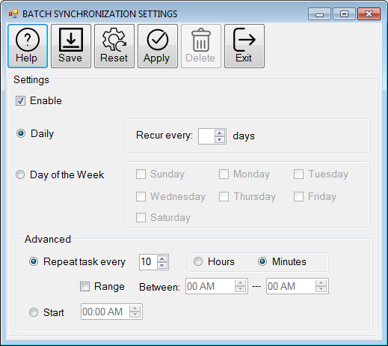

  - The schedule time could be configured at the Service Level, in which case, all the Jobs that are enable to use this services will follow the Schedule time specified at the service level.
In this scenario, the services will perform it functionality, for all the CP Jobs that are enabled to use the service.
  - The schedule time could also be configured at the Job level. In this case, the schedule time at the Job level supersedes the Schedule time at the Service level. In this type of configuration, the services will create a CRON Job for the Capture Pro Job Type and handle the execution of this task whenever it has to.
This functionality allows us to manage a Job in a very particular way.
  - The Services always starts a Master CRON Job (at the service level) and creates additional CP Job Types CRON Jobs for CP Job types with specifics Schedule times
The Services architecture has the capability to remove/add/update CRON Jobs (The master Job and/or CP Jobs) on real time so no need to restart the service.
Each one of these CRON Jobs will trigger a Task or Tasks, depending on the configuration of the Services and Jobs that use the Service. (The Master CRON Job trigger Tasks and the Singe CP CRON Job just one Task)

  - The Following Diagram summarized he concepts described above:

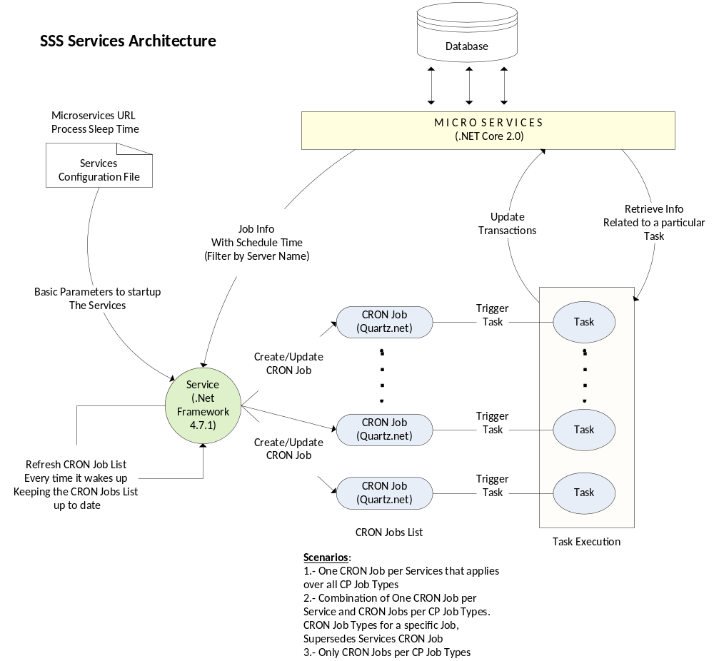

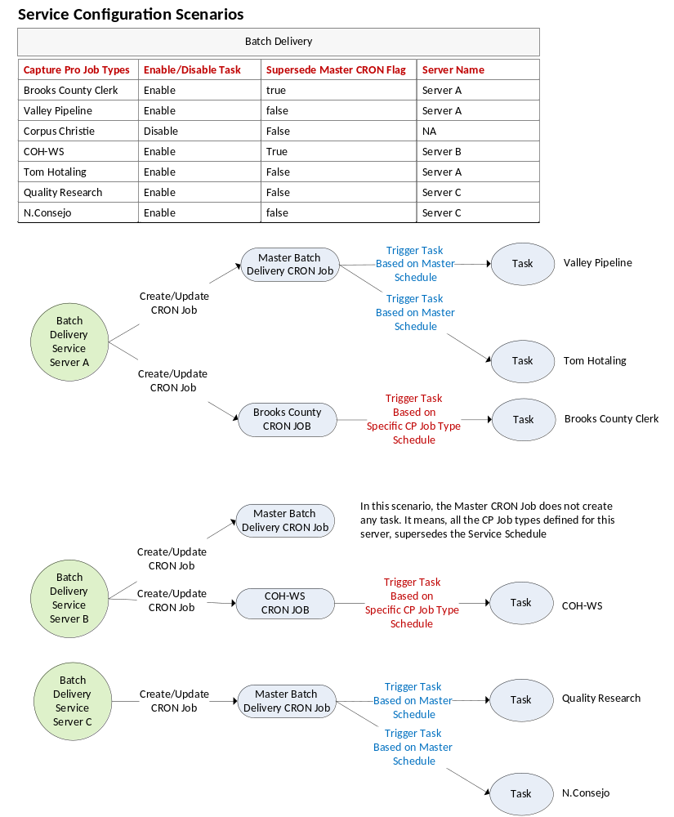

Regards,
Leonardo Carbone, ECM^{P}
See Our Promotional Video!

The Unstructured Information Management Company™
281.292.1333 x:301 (o) 281.966.1598 (f)
Privileged/Confidential Information may be contained in this message. If you are not the addressee indicated in this message (or responsible for delivery of the message to such person), you may not copy or deliver this message to anyone. In such case, you should destroy this message, and notify us immediately. If you or your employer does not consent to Internet email messages of this kind, please advise us immediately. For support please email us at support@cdlac.com

DBE, MBE & SBE Certified by the City of Houston & Houston Metro



Texas DIR Contracts: Software Products: DIR-TSO-3665 Scanners and SharePoint®: DIR-TSO-3902

