Scope:

High Level Design Document of ADAS_AVM_MOD

|  |  |
| --- | --- |
| Document Status: |  |
| Revision: | 0.1 |
| Date: | 06 July 2017 |
| Author: | Lu Guofeng |
| Department: |  |

History

|  |  |  |  |  |  |  |
| --- | --- | --- | --- | --- | --- | --- |
| **Rev.** | **Status** | **Date** | **Author** | **Reviewer** | **Approver** | **Description of Change** |
| 0.1 | Draft | 04/07/2017 | Lu Guofeng |  |  | Initial Version |
|  |  |  |  |  |  |  |
|  |  |  |  |  |  |  |
|  |  |  |  |  |  |  |

Contents

1 General 5

1.1 Purpose 5

1.2 Validity 5

1.2.1 Intended Audience 5

1.3 Related Documents 6

1.4 Abbreviations 6

2 Decisions and Requirement Agreements 7

3 Architecture Model 8

3.1 Use Case Model 8

3.1.1 Description 8

3.1.2 Diagram 8

3.2 Domain Architecture Diagram 8

3.2.1 Description 8

3.2.2 Diagram 8

3.3 Application Architecture Diagram (Optional) 8

3.3.1 Description 8

3.3.2 Diagram 8

3.4 Hardware Assignment Diagram (Optional) 8

3.4.1 Description 8

3.4.2 Diagram 8

3.5 Components Diagram 9

3.5.1 <Component Name 1> 9

3.5.2 <Component Name 2> 9

3.6 Interfaces Diagram 10

4 Dynamic Behavior 11

4.1 External Dependencies 11

4.1.1 Description 11

4.1.2 Diagram 11

4.2 Startup / Shutdown 11

4.2.1 Description 11

4.2.2 Diagram 11

4.3 Use Case Sequences 11

4.3.1 Use Case 1 <name> 11

4.3.2 Use Case n <name> 11

5 Test Environment 12

6 Traceability 13

# General

## Purpose

This document describes High level design on AVM & MOD module design of ADAS domain. It contains description for following questions:

* Decomposition of sub-domain to components
* Description of methods and attributes, which are used in provided/used interfaces and purpose of use.
* List of handled use cases.

## Validity

### Intended Audience

|  |  |  |
| --- | --- | --- |
| **Role** | **Name** | **E-Mail** |
| Developer | Wang xiaole | <Xiaole.wang@harman.com> |
| Developer | Li hui | <Hui.li2@harman.com> |
| Architect | Chen huichao | < huichao.chen@harman.com> |
| Application FO | Guofeng Lu | <guofeng.lu@harman.com> |

## Related Documents

|  |  |
| --- | --- |
| Title | <Referenced Document Title> |
| Link | <Link to Referenced Document> |
| Abstract | <Long Document Description> |
| Release Info | Latest |
| Publication Date | Latest |

## Abbreviations

|  |  |
| --- | --- |
| Item | Description |
| AVM | Around view module |
| MOD | Moving object deletion |
| FCTA | Front cross traffic assist |
| RCTA | Rear cross traffic assist |
| ADAS | Advanced driver assist system |
|  |  |
|  |  |
|  |  |

# Decisions and Requirement Agreements

# Architecture Model

## Use Case Model

### Description

Client interaction with this domain/subdomain indicating major usages and handling failure situations.

### Diagram



## Domain Architecture Diagram

The domain architecture diagram shows the components relationships between the logical function within a domain and to interfaces of other domains.

### Description

Two major layer would be implemented as GWMv2 ADAS presctrl:

* Project Presctrl layer: GWMv2 ADAS presctrl
* Common layer: ADAS Service(Framework)

The purpose of ADAS Service(Framework) is:

* Abase.so: provide baseline ADAS application including RVC, SVC, AVM, MOD, PDC, APA, etc…
* AGraphic.so: driver and graphic processing, including algorithm core for CoC team
* AFoundation.so: basic class and component to support application development
* CaseCleint.so: dedicate to support development use case management

The purpose of GWMv2 ADAS presctrl is:

* To implement GWMv2 project customer requirement.

For GWMv2 project, ADAS feature contains RVC, SVC, AVM, MOD, PDC, APA. All the feature is implemented as a subsystem and maintain a dedicated state machine. ADAS manager module and ADAS control module will schedule and dispatch all the request from system to ADAS subsystem.

The interaction between ADAS presctrl and other process is based on common API , including signals, method all and broadcast notification.

### Diagram

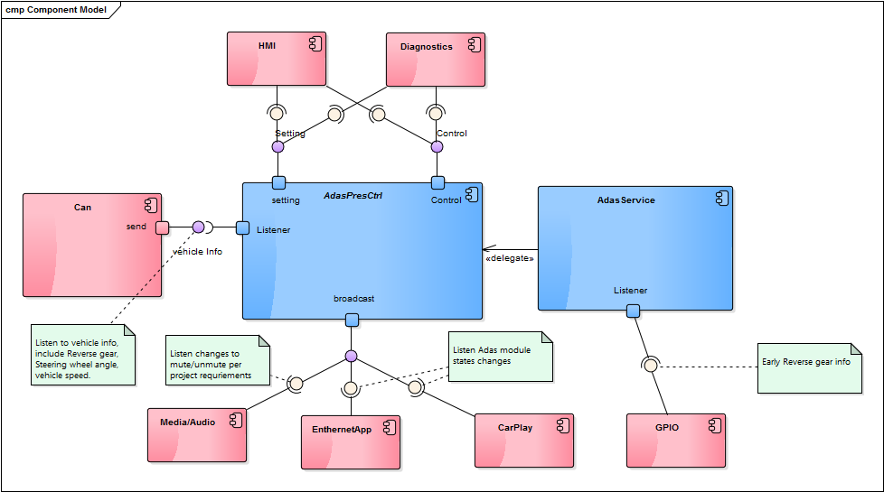

## Application Architecture Diagram (Optional)

### Description

### Diagram

Add ApplicationArchitectureDiagram here, see the EA model guideline.

## Hardware Assignment Diagram (Optional)

### Description

### Diagram

Add HWAssignmentDiagram here, see the EA model guideline

## Components Diagram

### AVM& MOD

#### Description

For GWMv2, a dedicated AVM& MOD subsystem will be implemented. This AVM&MOD module will be created by ADAS control module and scheduled by ADAS manager module.

All the system request of AVM&MOD feature will be dispatched to this subsystem. The sensor driver will be managed by camera hub module and the graphics resources will be handled by graphic thread.

#### Diagram



## Interfaces Diagram

1. Adding the FIDL file linkage path in the server is a MUST requirement item.

e.g.

https://stash1.harman.com/login?next=/projects/INT_GWM_V2MH/repos/contracts-gwm_v2mh/ browse/packages/genivi/intf/fidl/example.fidl

2. Add the interface description in written language or table format.



# Dynamic Behavior

## External Dependencies

### Description

### Diagram

## Startup / Shutdown

Describe the main process or components startup / shutdown behaviour with lifecycle in your domain. What persistency data should recovery and store at the startup / shudown phase.

### Description

### Diagram

## Use Case Sequences

Describe the major and typical use case sequences

### Use Case 1 enable single full camera view

#### Description

User request to show a full screen view of single camera view.

#### Diagram



### Use Case 2 enable cross traffic assist

#### Description

User request to enable cross traffic assist with front view.

#### Diagram



# Test Environment

# Traceability

|  |  |  |  |
| --- | --- | --- | --- |
| **TRS ID** | **TRS Description** | **Component Name** | **Section Number**  **in this Document** |
|  |  |  |  |
|  |  |  |  |
|  |  |  |  |
|  |  |  |  |
|  |  |  |  |