Harman International
Technical Functional Specification
MAN and SCANIA

This document provides the overview of the MAN and Scania system state requirements and the related performance requirements. This also documents how Voltage and Temperature variations are handled.
Version | Date | Author | Reviewer | Comments
0.1 | 2/20/2015 | SJames | Adinath Jadhav | Combined State Machines, KPIs
0.2 | 3/05/2015 | SJames, Adinath Jadhav | Adinath Jadhav | Merged Voltage and Temperature handling information from SW Platform.
0.3 | 03/08/2015 | SJames | Santhosh,Terence | Updated ADAS KPI from ADAS requirements
0.4 | 12/03/2015 | SJames | Santhosh,Terence | Included tempVoltage shutdown in state machines. List of all transitions. Updated timings for Scania.
0.5 | 13/03/2015 | SJames | Santhosh,Terence | Added timing proposals for MAN
0.6 | 30/03/2015 | SJames | Santhosh,Terence | The document contains more information that goes into a TFS. Connections, state machine, etc. Also added MAN camera functionality.
0.11 | 09/05/2015 | SJames/ SHildebrandt | Santhosh,Terence | Added SW Update KPI  Added HW Specifications
0.12 | 12/05/2015 | SHildebrandt | Sjames | Added Mic, Aux and did.indefinitions
0.16 | 10/06/2015 | SJames | Santhosh,Terence | Added USB specs
0.17 | 28/06/2015 | SJames | Santhosh,Terence | Added SWDL KPI, Updated Target KPIs. Update MAN state machine to reflect CR.
0.18 | 22/07/2015 | AYeole  SJames | Sjames | 5.2 Removed diagram which is replaced by excel spreadsheet  Table 2 : Updated table  Table 3 : Updated table  Added Table 4 for connector pinout
0.19 | 24/07/2015 | SJames | Santhosh,Terence | Added SWDL optimisation
0.20 | 24/07/2015 | Santhosh | Sjames | State machine application state updated for MAN. Added Flash memory map for J5Eco
0.21 | 24/07/2015 | TSoares/PBanchor | Sjames | Flash memory map for Jacinto6,Diagnostic KPI updated
0.22 | 21/08/2015 | Santhosh | Sjames | Added new KPI value
0.23 | 23/11/2015 | Terence | Santhosh | Update section 6.0 and 6.1

Table of Contents
1 Introduction 5
2 Scope 5
3 Hardware Interface 5
3.1 Outputs 5
3.1.1 Scania 5
3.1.2 MAN 6
3.2 Inputs 6
3.2.1 Scania 6
3.2.2 MAN 7
3.3 USB Ports 9
3.3.1 Jacinto5 Eco variants (Starter and Basic) 9
3.3.2 Jacinto6 Variants (Advanced and Standard) 9
4 Startup and Shutdown Sequences 10
4.1 Scania System States 10
4.1.1 OFF State 10
4.1.2 Stand By State 10
4.1.3 Standby Power Save 11
4.1.4 ON 11
4.1.5 ONE Hour Mode 11
4.1.6 Scania State Transition details 12
4.1.7 Critical Path for Scania Camera enable when system is OFF 16
4.2 MAN System States 18
4.2.1 States 18
4.2.2 MAN State Transitions 19
4.2.3 MAN Camera wakeup 21
5 Temperature Management 22
5.1 General FAN control 22
5.2 FAN control regarding temperature 22
5.3 States and Actions in the State 24
6 Voltage Management 25
6.1 ECU Voltage States and Actions in the State 27
7 Key Performance Indicators 27
7.1 Key Performance Requirements from CRS 27
7.2 Target KPIs 29
8 System Parameters 34
8.1 Fan specifications 34
8.1.1 Faults 34
8.2 Temperature Range 34
8.2.1 Faults 35
8.3 Supported Voltage ranges 35
8.4 CVBS (Composite Video) 36
8.4.1 CVBS-IN (Camera inputs) 36
8.4.2 CVBS-OUT 37
8.5 Line Out (Audio) 37
8.5.1 Fault 37
8.6 Antenna Power supply 37
8.6.1 AM/FM Antenna 37
8.6.2 DAB Antenna (Only in DAB variants) 37
8.7 Speaker 38
8.8 Microphone 38
8.9 Digital Outputs 38
8.9.1 Faults 38
8.10 Digital Inputs 38
8.11 Aux In / Line In 38
9 Questions 39
10 References 39

Introduction
This document is used to discuss the performance requirements and temperature and voltage handling on MAN and Scania. As these requirements are not fully specified, these need evolve during discussions between Harman, MAN and Scania. As some of these topics are common to MAN and Scania, they are put together into a single document so that there can be an open discussion.
This is a living document and will be updated until all the open points about this are closed. Until then, this document is considered a Draft.
The latest version of this document can be found in Procom. (Document ID: 0001285374)
https://procom.harman.com/EngineeringPortal/servlet/AttachmentsDownloadDirectionServlet?oid=OR:wt.doc.WTDocument:20101203799&oid=OR:wt.content.ApplicationData:20101204101&role=PRIMARY

Scope
This document describes the performance requirements for the MAN (MMT) and Scania (AUS4) head units. This document discusses the requirements and limitations of the hardware/software which might impact some performance measures. The document also discuss how voltage and temperature over and undershoots are managed.

Hardware Interface

Outputs
The head-unit activates or powers on external ECUs. This section describes the status of the digital output pins as expected by MAN and Scania

Scania
PIN | Name | Description
E5 | SW_12V_Out_1  12V output for Camera 1 | This pin should be always ON except when the headunit is in OFF state, irrespective of the actual state of the camera.
E6 | SW_12V_Out_2  12V output for Camera 1 | This pin should be always ON except when the headunit is in OFF state, irrespective of the actual state of the camera.
E12 | SW_12V_Out_3 | This pin should be always ON except when the headunit is in OFF state, irrespective of the actual state of the camera.
E9 | SW_12V_Out_4  Power supply for Camera1 | This PIN is ON only when Camera1 is enabled.
E10 | SW_12V_Out_5  Power supply for Camera2 | This PIN is ON only when Camera2 is enabled.

Depending on the installation, Scania will decide to use either the SW_12V_Out_1 + SW_12V_Out_2 pair or the SW_12V_Out_4 + SW_12V_Out_5 pair to power the camera.

MAN
PIN | Name | Description
E5 | SW_12V_Out_1  12V output for Camera 1 | If the EOL parameter to enable Camera1 is present,  This pin should be always ON except when the headunit is in OFF state, irrespective of the actual state of the camera.
E6 | SW_12V_Out_2  12V output for Camera 1 | If the EOL parameter to enable Camera2 is present,  This pin should be always ON except when the headunit is in OFF state, irrespective of the actual state of the camera.
E12 | SW_12V_Out_3 | This pin should be always ON except when the headunit is in OFF state, irrespective of the actual state of the camera.
E9 | SW_12V_Out_4  Power supply for Camera1 | Unused
E10 | SW_12V_Out_5  Power supply for Camera2 | Unused

Inputs
This section describes the hardware interface inputs that affect the behavior of the head unit. For a detailed list of the connector pin-out, see [0001284989] - MAN_Scania_Connectors .

Scania
PIN | Name | Description
D12 | Wakeup1 | Primary wakeup from ignition
B1 | DigIn1 | Camera1 Wakeup.  This pin requests the functionality of the Camera1.  Wake-up capable. The headunit shall wakeup when this pin is asserted.
B2 | Digin2 | Camera2 Input  This pin requests the functionality of Camera2
B3 | Digin3 | BOL (Black Out Lighting)  All light sources in the headunit shall be switched off if the BOL pin is asserted.
E11 | Wakeup2 | Secondary Wakeup

Camera functionality in Scania Variants

MAN
PIN | Name | Description
D12 | Wakeup1 | Primary wakeup from iginition
B1 | DigIn1 | Camera1 Wakeup.  This pin requests the functionality of the Camera1.  Wake-up capable. The head-unit shall wakeup when this pin is asserted.
B3 | Digin3 | BOL (Black Out Lighting)  All light sources in the head-unit shall be switched off if the BOL pin is asserted.
E11 | Wakeup2 | Camera 2 Wakeup.  This pin requests the functionality of the Camera2.  Wake-up capable. The head-unit shall wakeup when this pin is asserted.

Camera functionality in MAN Variants
MAN Variants are used in coach and truck configurations. The MMT head-unit has a maximum of 2 camera inputs that are supported. The different configurations are enabled using EOL parameters.
Camera | Truck | Coach
Camera1 | Triggered when Rear-gear is active or Camera_HK is pressed | Triggered when rear gear is active or PIN DigIn1 is active. Camera_HK is not operational in this case.
Camera2 | Triggered when Camera_HK is pressed. Camera1 is displayed before Camera2. | Triggered when PIN Wakeup2 is active.

Rear-gear signal is available over CAN. The camera trigger when rear-gear is active should happen only if the Camera_Control EOL parameter is set to “1”.
Camera_HK is not operational on Coach variants.
In case of simultaneous activation, the following table sets the priority for Coach Variants.
Scenario | Rear Gear | DigIn1 | Wakeup2 | Active Camera
1 | Off | Off | Off | No Camera
2 | Off | Off | On | Camera2
3 | Off | On | Off | Camera1
4 | Off | On | On | Camera2
5 | On | Off | Off | Camera1
6 | On | Off | On | Camera2
7 | On | On | Off | Camera1
8 | On | On | On | Camera2
Table 1 Priority Table for Coach
In the case of truck variants, the trigger of reverse gear via CAN always has priority.

USB Ports
The following table describes the USB ports available on the different MAN and Scania variants and their specifications.

Jacinto5 Eco variants (Starter and Basic)

USB1
USB Standard | USB 2.0
Apple Device Support (iAP1 and iAP2) | Yes
Maximum Current | 1500 mA
Hub supported | Yes

Jacinto6 Variants (Advanced and Standard)

USB1
USB Standard | USB 2.0
Apple Device Support (iAP2 with Carplay, iAP1) | Yes
Maximum Current | 1500 mA
Hub Supported | Yes - with exceptions (If this port is used for an apple device, a hub is not supported)

USB2
USB Standard | USB 2.0
Apple Device Support | No
Maximum Current | 500mA
CDC Network interface client | Optional if configured (Only for Scania). This is needed for connection to the C300 Telematics unit.
Hub Supported | Yes

Startup and Shutdown Sequences
Note that these state machines are not fully implemented as on release R6 as they are part of a CR

Scania System States
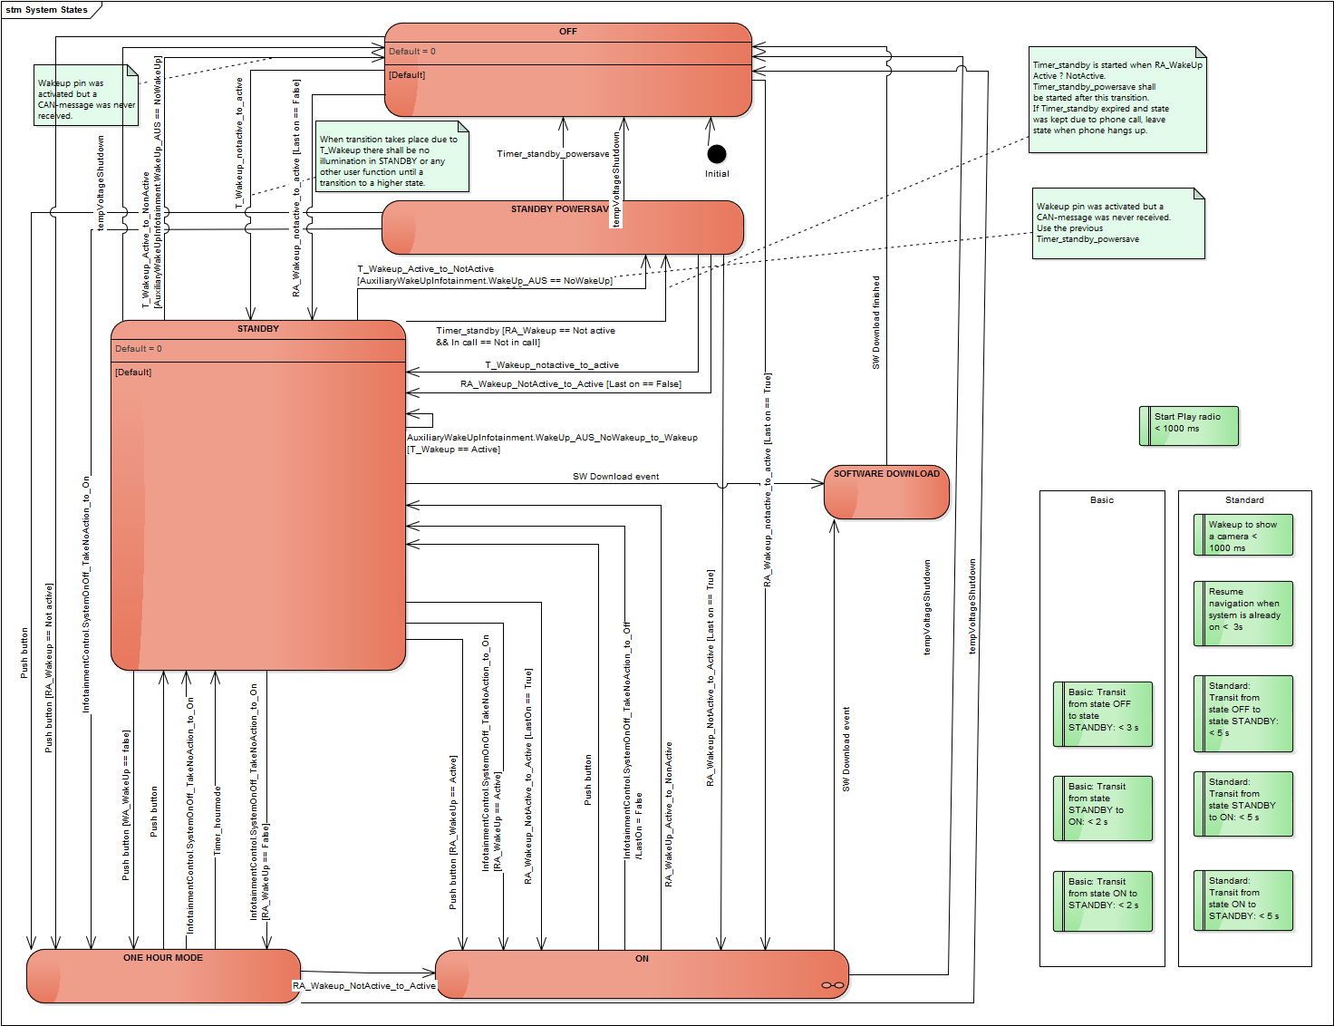

OFF State
In this state the system is powered off. Battery supply is connected by the RA_Wakeup (Clamp 15 ) is not asserted.

Stand By State
In this state the system is active but the screen is turned off, or is showing a sleep screen, and all audio is muted. This state enables short transitions to state ON if the vehicle was shut off with radio not in state ON or if the user temporarily does not want to use the system while driving. This state is also used when the radio is woken up by the 3rd wake-up pin before relevant CAN messages are received.
· Display off or sleep screen
· Bus communication active
· Capable of handling diagnostic services
· Audio muted
· Dimming according to CAN information (only halo around on/off button shall be illuminated)
· Bluetooth connection active if in a phone call

Standby Power Save
After a certain time, defined by Timer_standby, the system shall transit from STANDBY to STANDBY POWER SAVE. This state shall be used to minimize power consumption when not using the infotainment system. In this state only the most necessary functions shall be active and CD-drive, USB-connection, WiFi and other power consuming functions not currently in use shall be shut off. The connection to a mobile phone shall still be active but only for the hands free function to receive phone calls. The infotainment system shall also be able to respond on relevant CAN activity and if necessary wake-up the system.
· Display off
· Bus communication active
· Audio muted
· Dimming off
· Drive and peripherals off
· USB off (USB shall still work as a power source to connected mobile devices)

CRS IDs: AUS4_RFQ_SRS_40_v1
Valid for: Basic, Basic+, Standard

ON
System is on and fully functional.
· Display on
· Bus communication active
· Audio on
· Dimming according to CAN information

CRS IDs: AUS4_RFQ_SRS_41_v1
Valid for: Basic, Basic+, Standard

ONE Hour Mode
System is on and fully functional.
· Display on
· Bus communication active
· Audio on
· Dimming according to CAN information if available. Behavior if not available is TBD
Other systems on the CAN-bus may be switched off when the system is in this state so the Infotainment system shall not be dependent of any CAN traffic to work correctly.
CRS IDs: AUS4_RFQ_SRS_42_v1
Valid for: Basic, Basic+, Standard

Scania State Transition details
# | Source | Destination | Trigger | Description | Performance (ms)
 |  |  |  |  | Basic |  | Standard
 |  |  |  |  | Required | Harman Proposal | Required | Harman Proposal
1 | OFF | STANDBY | T_Wakeup_notactive_to_active  RA_Wakeup_notactive_to_active[Last on == False] |  | 3000 | 10000 | 5000 | 5000
2 | OFF | ONE HOUR MODE | Push button[RA_Wakeup == Not active] |  | NA | 15000 | NA | 10000
3 | OFF | ON | RA_Wakeup_notactive_to_active[Last on == True]  The transition time to On mode will vary depending on the last mode. Even if the system state is ON, it is not guaranteed that the media starts playback at this time. As the medium may need to be scanned, |  | NA | 15000 | NA | 10000
4 | STANDBY POWER SAVE | OFF | Timer_standby_powersave  errorShutdown |  | NA | 5000 | NA | 3000
5 | STANDBY POWER SAVE | STANDBY | T_Wakeup_notactive_to_active  RA_Wakeup_NotActive_to_Active[Last on == False]  (USB, Wifi need to be turned off in Standby power save) |  | NA | 5000 | NA | 3000
6 | STANDBY POWERSAVE | ONE HOUR MODE | Push button  InfotainmentControl.SystemOnOff_TakeNoAction_to_On |  | NA | 3000 | NA | 2000
7 | STANDBY POWER SAVE | ON | RA_Wakeup_NotActive_to_Active[Last on == True] |  | NA | 3000 | NA | 2000
8 | STANDBY | OFF | T_Wakeup_Active_to_NonActive[AuxiliaryWakeUpInfotainment.WakeUp_AUS == NoWakeUp]  tempVoltageShutdown  If trigger is not tempVoltageShutdown, then persistency will be saved. |  | NA | 5000 |  | 3000
9 | STANDBY | STANDBY POWERSAVE | Timer_standby[RA_Wakeup == Not active && In call == Not in call]  T_Wakeup_Active_to_NotActive[AuxiliaryWakeUpInfotainment.WakeUp_AUS == NoWakeUp] |  | NA | 3000 | NA | 2000
10 | STANDBY | ONE HOUR MODE | Push button[WA_WakeUp == false]  InfotainmentControl.SystemOnOff_TakeNoAction_to_On[RA_WakeUp == False] |  | NA | 2000 | NA | 2000
11 | STANDBY | ON | Push button[RA_WakeUp == Active]  InfotainmentControl.SystemOnOff_TakeNoAction_to_On[RA_WakeUp == Active]  If the system has already taken the STANDBY -> ON transition once, then the transition is under 1 second. The timing mentioned here is the worst case for the first time this transition is taken. This occurs during power on. |  | 2000 | 1000 | 5000 | 3000
12 | STANDBY | SOFTWARE DOWNLOAD | SW Download event  Depends on Media detection and trigger from Diagnostice.  Not estimations here. |  | NA | NA | NA | NA
13 | ONE HOUR MODE | OFF | tempVoltageShutdown |  | NA | 5000 | NA | 5000
14 | ONE HOUR MODE | STANDBY | Timer_hourmode  Push button  InfotainmentControl.SystemOnOff_TakeNoAction_to_On |  | 2000 | 2000 | 5000 | 4000
15 | ONE HOUR MODE | ON | RA_Wakeup_NotActive_to_Active  To the end, user this transition is transparent as the system is fully operational in ONE HOUR MODE and in ON. The time take is for the internal transition |  | NA | 1000 | NA | 1000
16 | ON | OFF | tempVoltageShutdown |  | NA | 5000 | NA | 5000
17 | ON | STANDBY | RA_WakeUp_Active_to_NonActive  Push button  InfotainmentControl.SystemOnOff_TakeNoAction_to_Off/LastOn = False |  | 2000 | 2000 | 5000 | 3000
18 | ON | SOFTWARE DOANLOAD | SW Download event |  | NA | NA | NA | NA
19 | SOFTWARE DOWNLOAD | OFF | SW Download finished |  | NA | NA | NA | NA

tempVoltageShutdown
All events in the above table are specified by Scania except tempVoltageShutdown. tempVoltageShutdown is triggered when the system is switched off due to out of bound temperature or voltage conditions.
Once the system goes into OFF state because of an tempVoltageShutdown, only one of the specified wakeup reasons can wake up the system again.
See 5 and 6 for details on temperature and voltage management.

Critical Path for Scania Camera enable when system is OFF
The Scania HU does not have camera wakeups. Camera is triggered via the following means

- Camera 1 GPIO Input – This input can wake-up the system
- Camera 2 GPIO Input - This input cannot wake-up the system
- Explicit request for camera (Front, Back or General Cameras) – 1 second cycle time
- InfotainmentFunctionDisplayControl_ANY(0XDFF06FEx).FrontViewCamera
- InfotainmentFunctionDisplayControl_ANY(0XDFF06FEx).GeneralCamera1
- InfotainmentFunctionDisplayControl_ANY(0XDFF06FEx). GeneralCamera2
- InfotainmentFunctionDisplayControl_ANY(0XDFF06FEx). GeneralCamera3
- InfotainmentFunctionDisplayControl_ANY(0XDFF06FEx). GeneralCamera4
- InfotainmentFunctionDisplayControl_ANY(0XDFF06FEx). RearViewCamera

- Reverse gear engagement (If camera is configured as rear camera) – 100ms cycle time
  - ETC5_ICL(0X1CFEC317x).ReverseSwitch
- 0 > Vehicle Speed < 15 Kmph. (Speed configurable via EOL) – 100ms cycle time
  - CruiseControlVehSpeed_E(0x18FEF100x).WheelBasedVehicleSpeed

As the camera can be enabled only by signals on the CAN bus, there are limitations as to how quickly a camera request can be detected and enabled once the system is powered on. Harman estimate for earliest ADAS camera is visible for Scania is around 4000ms. This includes the time to initialize the composite video encoder over I2C. As the power supply to the camera is provided by the headunit, this time could be impacted in case the camera takes longer to power up.
See Figure 1 Jacinto 6 startup - Camera request via CAN. This diagram shows the worst case scenario when the camera request comes via CAN immediately after wakeup/power on.
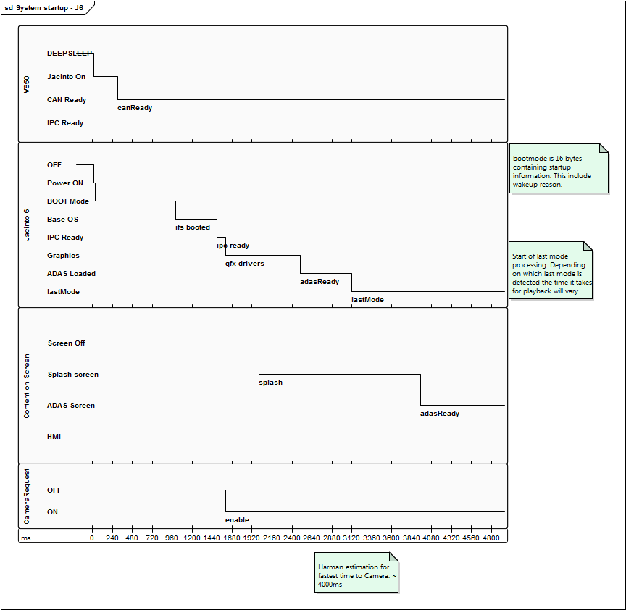
This diagram is no longer valid as the critical path is now via the Digin1 signal waking up the system.
Figure 1 Jacinto 6 startup - Camera request via CAN

MAN System States
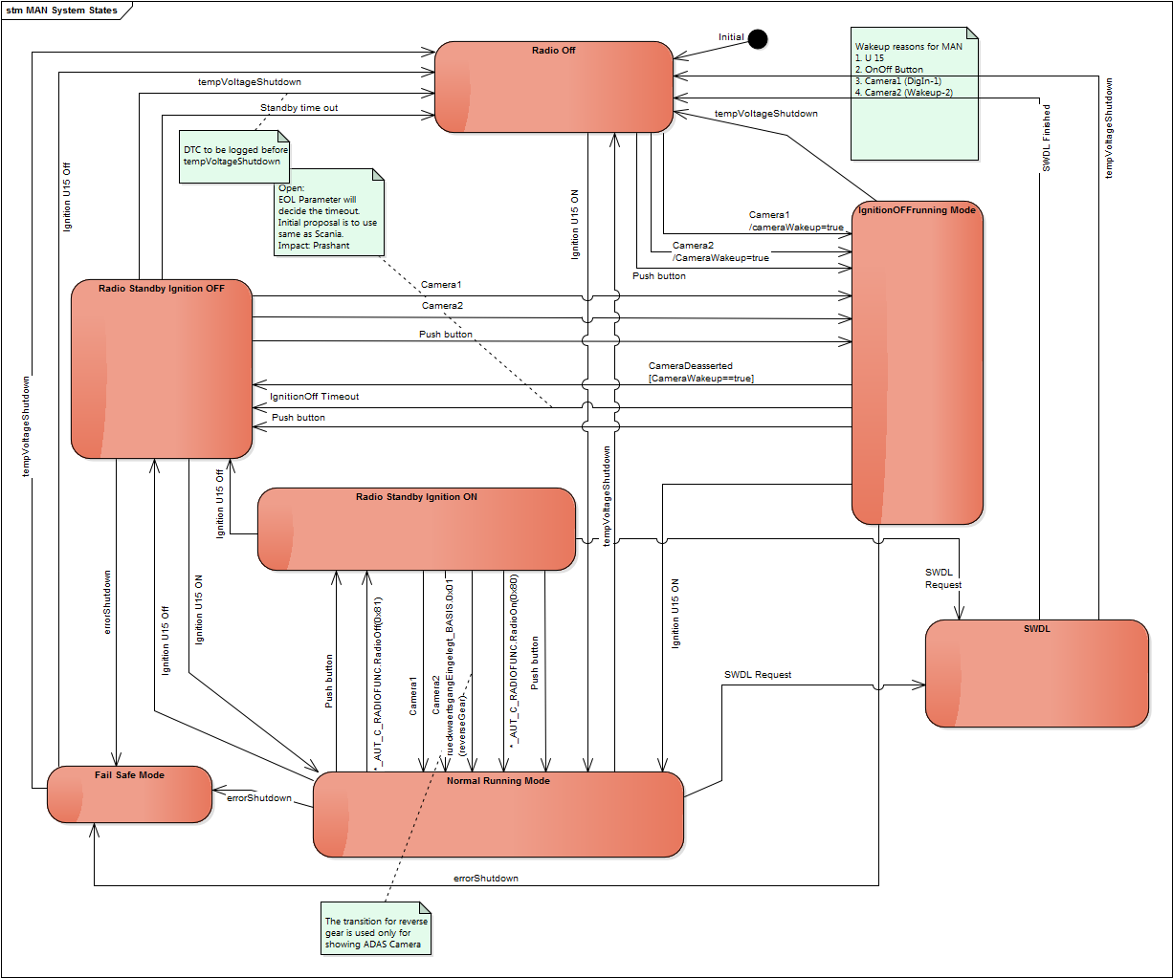

States

Radio Off
- No Application
- No CAN Communication
- V850 in Deep sleep
- All digital outputs are OFF
- Display Off
- Audio Off
- Bluetooth Off
Only possibility to transition from this state is Ignition, Power button and Camera1 and Camera2

Radio Standby Ignition OFF
- Display Off
- Audio Off
- CAN Communication not active
- Power button Halo on
- Bluetooth Active: Incoming call will turn on display
- V850 Active

Radio Standby Ignition ON
- Display Off
- Audio Off , except in case of a phone call
- CAN Communication active
- Power button Halo ON
- Bluetooth Active: Incoming call will turn on display
- V850 Active

IgnitionOffRunningMode
- Display On
- Audio ON
- Application is running
- All Digital outputs that are permanently powered are powered on. See 0001284989, MAN_Scania_Connectors in Procom .
- No CAN Communication, No McNet
- V850 Active
- Bluetooth Active
- All Media Active

Normal Running Mode
- Fully Operational Mode

Fail Safe Mode
- Features are OFF
- No Application CAN messages
- UDS (Diagnostics) messages enabled
- DTC should be logged with reason
- UDS reset trigger possible

SWDL
Software Download mode.
- CAN communication ON (For diagnostics)
- Software Upgrade feature is active

MAN State Transitions
# | Source | Destination | Trigger | Description | Performance (ms)
 |  |  |  |  | Starter |  | Advanced
 |  |  |  |  | Required | Harman Target | Required | Harman Target
1 | Radio Off | IgnitionOffRunningMode | Push Button |  | NA | 17000 | NA | 10000
2 | Radio Off | NormalRunningMode | Ignition U15 ON  Camera1 Wakeup Request  Camera2 Wakeup Request |  | NA | 17000 | NA | 10000
3 | IgnitionOffRunningMode | RadioOff | tempVoltageShutdown |  | NA | 5000 | NA | 5000
4 | IgnitionOffRunningMode | RadioStandby | Push button |  | NA | 3000 | NA | 5000
5 | IgnitionOffRunningMode | NormalRunningMode | Ignition U15 ON  This transition will be transparent to the user. |  | NA | 1000 | NA | 1000
6 | IgnitionOffRunningMode | FailSafeMode | errorShutdown |  | NA | 5000 | NA | 5000
7 | RadioStandby | RadioOff | Standby time out  tempVoltageShutdown |  | NA | 5000 | NA | 3000
8 | RadioStandby | IgnitionOffRunningMode | Push button  If the system has already taken the STANDBY -> ON transition once, then the transition is under 1 second. The timing mentioned here is the worst case for the first time this transition is taken |  | NA | 5000 | NA | 3000
9 | RadioStandby | FailSafeMode | errorShutdown |  | NA | 5000 | NA | 5000
10 | NormalRunningMode | RadioOff | tempVoltageShutdown |  | NA | 5000 | NA | 5000
11 | NormalRunningMode | RadioStandby | Push Button  Ignition U15 ON |  | NA | 5000 | NA | 3000
12 | NormalRunningMode | FailSafeMode | errorShutdown |  | NA | 5000 | NA | 5000
13 | NormalRunningMode | SWDL | SWDL Request |  | NA | NA | NA | NA
14 | FailSafeMode | RadioOff | tempVoltageShutdown |  | NA | 5000 | NA | 5000
15 | SWDL | Radio Off | SWDL Finished  tempVoltageShutdown |  | NA | NA | NA | NA

tempVoltageShutdown
All events in the above table are specified by Scania except tempVoltageShutdown. tempVoltageShutdown is triggered when the system is switched off due to out of bound temperature or voltage conditions.
Once the system goes into OFF state because of an tempVoltageShutdown, only one of the specified wakeup reasons can wake up the system again.
See 5 and 6 for details on temperature and voltage management.

errorShutdown
In case an system error is detected, the system drops into a fail safe mode after logging the relevant DTC.
The following error conditions could trigger this situation.
- Memory test failure.
- Unrecoverable file-system errors
- Continuous heartbeat resets

MAN Camera wakeup
In addition to the ignition and power button, the camera wakeup signal can wakeup the MAN headunit. In case of wakeup from camera, the transition from RadioOff to IgnitionOffRunning Mode is taken. As this is a safety feature, this transition should be executed on priority. In this case, the IgnitionOffRunning Mode will not be fully operational as only the camera will be active.
There are no CAN messages that can trigger a request to enable the cameras.
The wakeup reason is transferred to the Jacinto very early on during the boot process. Because of this, it is possible to optimize when the ADAS application can be loaded in case the wakeup is due to a wakeup by camera.
Harman estimation is that it should be possible to show the camera 3.5 seconds after startup in case the wakeup is due to camera.

Temperature Management
Temperature Management is necessary for ECU as a protection against fatal damages caused by overheating.
Each component used inside the ECU has its own temperature operating range. Thermal Management must ensure that no component can be damaged due to overheating.
The V850 should be used for the complete Thermal Management regarding collecting all the temperature values and controlling the fan and the power supplies. V850 Processor has three temperature sensors embedded directly inside the die-structure.

General FAN control
The fan control resides inside the V850. This µ-processor is able to adjust the fan speed immediately according to the direct available sensor information (temperature sensors from ADC)
Fan speed must be adjusted in such a way that the rotation cannot be heard outside the device when the user is sitting in the vehicle. On the other hand it is necessary to run the fan fast enough to achieve a cooling process.
Three controlling mechanisms are necessary:
- fan control regarding PCB sensor temperatures
- fan control regarding amplifier sensor temperatures
- fan control regarding TFT (Display) sensor temperatures

FAN control regarding temperature
The fan speed needs to be adjusted according to the temperature status. The operation modes of the temperature management are divided into 6 different areas:
As per hardware team specification, the overall control flow of temperature and ECU operation is presented in Figure 1.

Figure 2 Temperature Management
Figure removed

States and Actions in the State

State | Temperature Range | Description
Normal Temp(Temp<60°C) | Temp<60°C | Fully functional, no limitations and FAN is OFF
Temp High( FAN LOW) | 60°C > Temp <70°C | Fully functional, no limitations and FAN stage is LOW
Temp Critical 1 ( FAN High) | Temp<75°C | Fully functional, no limitations and FAN stage is HIGH
Temp Critical 2 ( FAN High | 75 °C > Temp < 80 °C | - Reduce Audio out if Amplifier sensor temperature value greater than 105C  - Reduce back light if display temperature value greater than 85C  - Switch off reduce Audio out if Amplifier sensor temperature less value 95C  - Switch off reduce Audio out if Amplifier sensor temperature less value 95C
Temp Critical 3 ( FAN High) |  | - Deactivate of CVBS out and deactivate the voice control if PCB temperature greater than 85C
ShutDown | Temp = 90°C | Notify user with HMI popup – System will be shutdown due to ECU high temperature.

For MAN and Scania, in case the system is shutdown for any critical temperature situation, the HU will be in the OFF state.

Voltage Management
Voltage management is necessary for ECU as a protection against fatal damages caused by over voltage and under voltage.
ECU voltage state machine is presented in Figure 2.

Figure 3 Voltage Management

Sleep

Voltage check during startup
V850 only
(CAN listening)
Undervoltge check UB<8,5V for t>180sec

Overvoltage check
UB > 22 for t > 4sec

Normal operation
Wakeup condition
3rd Wakeup active or RA Wakeup or Push button pressed Pppressed

UB < 5V
7.5V > UB > 22V

9V < UB < 22V

6,5V < UB < 9V

9V < UB

UB < 5V

UB < 7,5V

Timer elapsed
Timer elapsed
UB < 8,5V

UB > 9V

UB > 22V

UB > 24V

UB < 15,5V

System only starts up within full operational voltage range between 9V and 22V!

ECU Voltage States and Actions in the State

State | Voltage Range | Description
Sleep | 5 V < UB > 22 | ECU is completely Off, V850 is in deep sleep,
V850 Mode | UB < 5V | Jacinto Switched off. Display Audio are all off. No network activity only CAN BUS will be active.
Normal operation | 9V < UB < 22V | Fully functional, no limitations
Under Voltage | 7.5V > UB <8.5V | HMI window will pop-up with under voltage notification and ECU will stay in this state for 180 seconds and after that it will switch into V850 Mode
Over Voltage | 22V > UB < 24 | HMI windows will pop-up with over voltage notification and ECU will stay in this state for seconds and after that it will switch into deep sleep mode.
Startup | 7.5 > UB < 22V | In this mode, based on wakeup event ECU will switch to ECU operating power modes.
Display Off | < 7V | Display will be turned off

For MAN and Scania, in case the system is switched to V850 only mode for any critical voltage situation, the HU will be in the OFF state.

Key Performance Indicators
This section describes the user experienced KPIs. The previous sections discussed the timings between the transitions between different system states.

Key Performance Requirements from CRS

Start Play radio < 1000 ms
The assumption is that radio should start playing within 1000ms of requesting the radio functionality. Radio functionality can be requested in the following ways. In all cases, this happens once the Radio is in ON state, .ie, the transition from OFF to ON or STANDBY to ON has already taken place.
- Auto play in ON state if last playback mode was Radio (AM/FM)
- Radio requested via HMI
- Radio requested via CAN or McNet
Harman Response: Once the system is in ON or STANDBY state, then it is possible to have the radio playing under 1 second. The first transition from STANDBY to ON will be an exception as it will take longer.

Wakeup to show a camera < 1000 ms
On the Scania HU, the system cannot be woken up by a request for Camera wakeup. The only way to wakeup the HU is:
- Power button
- RA Wakeup or T_Wakeup.
- DigIn1 connected for Camera1.
Camera can be requested in the following ways:
- Vehicle is moving and below a specified threshold. This is applicable if a camera is configured as a front camera.
- Explicit request to show a camera via CAN
- Hard key request for Camera.
- DigIn1 pin
Harman Response: As per the explanation in 3.2.2 , the Harman estimation for this is 3500ms.

Scania Camera OFF to ON (FRS523_53)
The start-up time on the system, from State = Off until a camera-image is showing on the display shall be no more than 2s. See Ref. 1 SRS for ECU states.
Harman Response: This time is not achievable on the current system in the case of a cold start. For the details of this see 3.2.2 . Once the system is in ON or STANDBY state, this time is achievable.

Software update
AUS4_RFQ_SRS_272_v1 : A full SW reprogramming via USB and SD-card shall not exceed 10 min

For Starter and Basic (J5) this requirement can be fulfilled.
For Advanced and Standard the SWDL currently takes 12 min. This is because the advanced and standard variants also need to update the Voice database for multiple languages. The voice database is about 1.2GB. Efforts are underway to optimize this to bring it below 10.
Jacinto5Eco variant update has already been reduced to under 10 minutes.

Next steps for optimizing J6 variant to under 10 minutes. (Content inserted from
https://confluence.harman.com/confluence/display/COCSYSIDC/%5BCoC+Systems%5D+%5BSoftware+Update%5D+Optimizing+the+overall+time)

Proposal (based on Terence's and Kaushik's Ideas)
  - When the software update is triggered, SoftwareUpdate will perform following steps:
  - Do a full MD5 authentication of the selected ISO
  - On successful authentication, SoftwareUpdate will send invoke softwareUpdateTriggered() to OnOff
  - OnOff will send shutdown to all services except SoftwareUpdate.
  - HMI needs to be killed but before that Black-Screen should be shown (via utility used for showing logo)
  - SoftwareUpdate HMI is started
  - SoftwareUpdate will copy ioc app and ioc bolo to /fs/etfs
  - SoftwareUpdate will update all firmwares, /fs/etfs/ and IFS.
  - SoftwareUpdate then triggers update and updates IOC bolo
  - IOC app update requires a reset, so SoftwareUpdate will reset again
  - SoftwareUpdate then triggers update of IOC app.

Benefits
  - ISO is validated before triggering the update.
  - No validation after reset.
  - So, overall 1 validation is saved (at least a reduction of approx 2 min on J6).
In addition to the above optimisation, compression of files will also be experimented. LZO compression with fast decompression times will be tested.

Target KPIs
# | Domain | Testcase | Description | Precondition | Action | Target (ms)
 |  |  |  |  |  | J5Eco Variants | J6 Variants
ST-1 | Startup | Splash Screen | Time until MAN/SCANIA splash screen  visible (MAN//SCANIA logo) | Lastmode Tuner FM, no active route  guidance, Shutdown | Startup, Clamp 15 | 4000 | 2000
ST-2 | Startup | Time to home screen | Time until MAN/SCANIA lands on visible Home screen first after startup | No Last Mode,System Turned on for the first time,no route guidance,no phone connected,no media device connected | Startup, Clamp 15 | 15000 | 7000
ST-3 | Startup | Time to FM tuner | FM audio available after system activation. | Lastmode FM Tuner, no active route guidance, Shutdown | Startup, Clamp 15 | 17000 | 5000
ST-4 | Startup | Time to AM tuner | Tuner AM audio available after system activation. | Lastmode Tuner AM, no active route guidance, Shutdown | Startup, Clamp 15 | 17000 | 5000
ST-5 | Startup | Time to DAB | DAB audio available after system activation. | Lastmode Tuner DAB, no active route guidance, Shutdown | Startup, Clamp 15 | 20000 | 6000
ST-6 | Startup | Time to Navigation | Navigation available after system activation. | Lastmode Tuner, no active route guidance, Shutdown. Startup to Last mode, press Navigation HK. | Startup, Clamp 15 | NA | TBD
ST-7 | Startup | Time to Camera | Rear view camera pictures shall be visible within the target value after system activation. | RVC enabled, Lastmode Tuner, no active route guidance, Shutdown | Startup, Clamp 15, Reverse gear activated | NA | 7000
ST-7 | Startup | Time to Camera | Camera picture shall be visible within the target value after wakeup via digital input pin | System wakeup by DigIn1 for Scania.  DigIn1 and Wakeup2 for MAN. Relevant camera must be connected and configured. | Clamp 30  Digital Pin trigger | NA | 3500
SO-1 | Switching | Switch to USB | System fully operable, no active route guidance, EntServer active source playing a music track | Last play mode FM |  | 2000 | 1000
SO-2 | Switching | Switching between USB1 to 2 | System fully operable, no active route guidance, EntServer active source playing a music track | Last play mode USB |  | 3000 | 3000
SO-2 | Switching | Switching to Tuner | System fully operable, no active route guidance, EntServer active source playing a music track | Last play mode USB |  | 2000 | 850
SO-3 | Switching | Switching to Navigation | System fully operable, no active route guidance, EntServer active source playing a music track | Last play mode USB |  | NA | 1500
SO-4 | Switching | Switch to SD | System fully operable, no active route guidance, EntServer active source playing a music track | Last play mode USB |  | 3000 | 1000
SO-5 | Switching | Switch to iPOD | System fully operable, no active route guidance, EntServer active source playing a music track | iPOD connected, last mode FM |  | 4000 | 3500
SO-6 | Switching | Switch to Media with BT in backgroound | System fully operable, no active route guidance, BT is active in background | Last mode could be any media source |  | 12000 | 4000
MD-1 | Media | USB Media - Skip Next | System fully operable, no active route guidance, EntServer active source playing a music track | Skip next |  | 1500 | 1000
MD-2 | Media | SD Card - Skip Next | System fully operable, no active route guidance, EntServer active source playing a music track | Skip next |  | 1500 | 1000
MD-3 | Media | Time to autoplay iPOD | System fully operable, no active route guidance, EntServer active source playing a music track | Lastmode IPOD, no active route guidance, Shutdown | Startup, Clamp 15 | 28000 | 15000
MD-4 | Media | Time to autoplay USB | System fully operable, no active route guidance, EntServer active source playing a music track – No USB hub connected | Lastmode USB, no active route guidance, Shutdown | Startup, Clamp 15 | 22000 |  |  | 10000
DG-1 | Diag | Time between Request and Response in Extended session | Time between Request and Response in Extended session | Diagnostics Extended session is on,  send the Diagnostic physical request for different services | Send the diag physical request and observe the response time | MAN:50ms  Scania:100ms |  |  | MAN:50ms  Scania:100ms
DG-2 | Diag | Time between Request and Response in Programming Session | Time between Request and Response in Programming Session | Diagnostics Programming session is on,  send the Diagnostic physical request for different services | Send the diag physical request and observe the response time | MAN:50ms  Scania:100ms |  |  | MAN:50ms  Scania:100ms
DG-3 | Diag | Time between two consecutive frames reception in Multiframe data reception | Time between two consecutive frames reception in Multiframe data reception | Diagnostics Extended session is on,  send the Diagnostic physical request for different services | Enable Multiple frame message for an identifier which has more than 8 bytes | 1000ms |  |  | 1000ms
DG-4 | Diag | Time between Flowcontrol transmission and  reception of consecutive frame | Time between Flowcontrol transmission and  reception of consecutive frame | Diagnostics Extended session is on,  send the Diagnostic physical request for different services | Enable Multiple frame message for an identifier which has more than 8 bytes | 1000ms |  |  | 1000ms
DG-5 | Diag | Time between Firstframe reception and  Flowcontrol Transmission | Time between Firstframe reception and  Flowcontrol Transmission | Diagnostics Extended session is on,  send the Diagnostic physical request for different services | Enable Multiple frame message for an identifier which has more than 8 bytes | 1000ms |  |  | 1000ms
DG-6 | Diag | Time between Firstframe  Transmission and reception of FlowControl | Time between Firstframe  Transmission and reception of FlowControl | Diagnostics Extended session is on,  write the identifier which has moret han 8 bytes | send the identifier which has more than 8 bytes | 1100ms |  | 1100ms
BT-1 | Bluetooth | BT device pairing time | Time a device takes to pair after pass key selection on both devices | System fully operable, active playback tuner FM | Connect Bluetooth player | 2000 |  | 1200
BT-2 | Bluetooth | Phonebook | All entries of the users mobile phonebook must be available within the target value after power on. Assumption is that the mobile phone had been paired and synced completely in an earlier lifecycle. | Last source Tuner, last menu Phonebook, no active route guidance, mobile phone (2500 entries) already paired and connected, Shutdown | Startup, Clamp 15 with bluetooth activated at mobile phone | 30000 |  | 25000
BT-3 | Bluetooth | Phonebook  first download | All entries of the users mobile phonebook must be available within the target value after first time pairing. Assumption is that the mobile phone itself delivers the data within this time. Test device Nokia N8 | System fully operable, no active route guidance, mobile phone (2500 entries defined), | Start pairing,on accepting contact sync info on phone side | 160000 |  | 115000
SWDL-1 | Software download | Full software download triggered via HMI | A USB device with a single ISO image. | System fully operable. No active route guidance. No BT device connected. No media playback ongoing. Wireless Off | Enable software update from engineering menu HMI | 10000 |  | 10000

System Parameters

Fan specifications
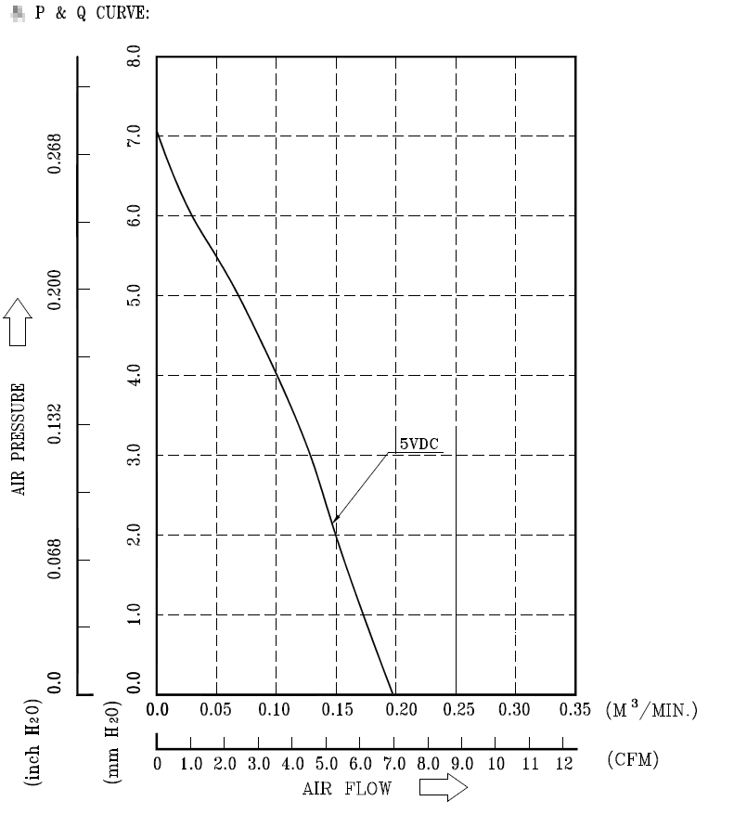
Model No: KSB04505LD-00A1S
Rated Voltage: 6VDC
Operating Voltage: 4.0 – 6.5 VDC
Input current 0.16A (max 0.25A)
Speed 3100 RPM ±15%

Fan can run at two speeds, based on the system temperature 2325 RPM (Speed 0) and 3100 RPM (Speed 1). If the temperature is lower than the threshold, the fan will not be turned on.

Faults
A Fan defect will be logged if the fan speed is not within the range of the specified speed with a tolerance of 15%.

Temperature Range

Surrounding temperature: -40°C - +70°C Cabin
Temp-sensors: -40°C - +85°C

Faults
PCB Temperature fault, Amplifier Temperature fault, Display temperature fault. See the section on temperature management above for more details. For details on faults, refer to [2] Diagnostic Specification Document (MAN)

Supported Voltage ranges

 | Functionarea |  | Timer | Effected Modul | Reaction
 |  |  | (sampling time=10ms) | Effected Modul | Reaction
25V | E | Forbiddenarea | immediately | All | System Shutdown
<25V | A/B | Functionarea B | t <=2500ms? | Power Amplifier | Switch off PowerAmp, Displaybacklight
18,0V | A/B | Functionarea B | t <=2500ms? | Display Backlight | Switch off PowerAmp, Displaybacklight
18,0V |  |  |  |  | Hysteresis (Dead band)
16V |  |  |  |  | Hysteresis (Dead band)
16V |  |  |  |  | All functionality working without restrictions
 | A | Functionarea A |  |  | All functionality working without restrictions
9.0V |  |  |  |  | All functionality working without restrictions
 |  |  |  |  | Hysteresis (Dead band)
8,5V |  | Functionarea A (MSA) | t<=2500ms | Power Amplifier | Switch off PowerAmp, Displaybacklight
8,5V | A/B | Functionarea A (MSA) | t<=2500ms | Display Backlight | Switch off PowerAmp, Displaybacklight
8,5V |  | Functionarea B | t>2500ms |  | Switch off PowerAmp, Displaybacklight
7,0V |  | Functionarea B (MSA | t <= 500ms | All except V850 | Switch off all, exceptV850
7,0V | B
7,0V |  | Functionarea C | t>500ms | All except V850 | Switch off all, exceptV850
5V |  |  | immediately | V850 | System Shutdown
 | C | Resetarea | immediately | V850 | System Shutdown
0V |  |  | immediately | V850 | System Shutdown
Table 2 Supported Voltage Ranges
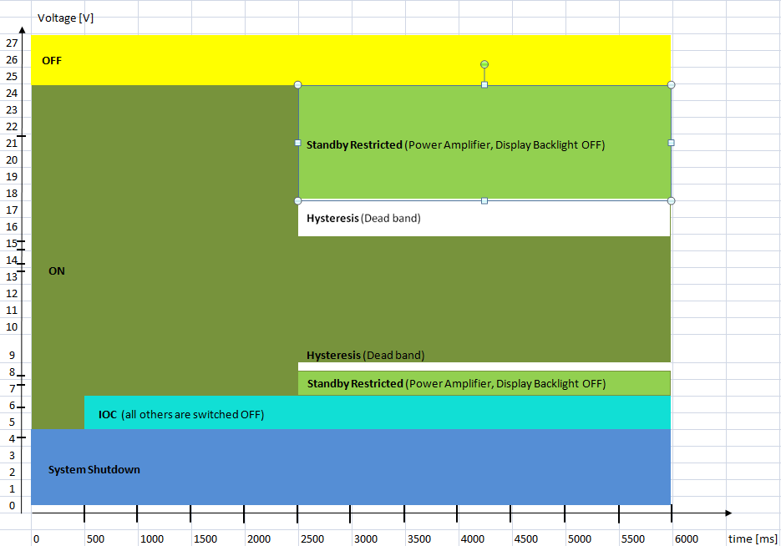
Table 3 Power States

CVBS (Composite Video)

CVBS-IN (Camera inputs)
Tolerant up to 2V (Will be in internally normalized to 1V). PAL and NTSC standards supported.
An Analog Devices ADV 7192 video decoder is used to digitize the incoming video signal. Once this device is able to lock on to a valid composite video signal and start the digitizing, an event is sent to the main processor via its I2C interface. This signal is used to detect the presence or absence of a video signal.
Camera faults rely on a combination of this signal and the EOL parameters that specify the camera configuration.

CVBS-OUT
- Voltage : 1V
- Standard PAL Standard by default.

Line Out (Audio)
The range is defined as ½ VDD – ¼ VDD (max: ¾ VDD)

Fault
Line out short to ground and short to battery are detected.

Antenna Power supply

AM/FM Antenna

Current
Scanario | Unit | Value
Open | mA | < 15
OK | mA | 15 – 50
Typical | mA | 35
Short to ground | mA | >50

Supply Voltage
Scanario | Unit | Value
Min | V | 8
Typical | V | 12
Max | V | 16

DAB Antenna (Only in DAB variants)

Current
Scanario | Unit | Value
Open | mA | < 15
OK | mA | 15 – 45
Typical | mA | 35
Short to ground | mA | >45

Supply Voltage
Scanario | Unit | Value
Min | V | 8
Typical | V | 12
Max | V | 16

GPS

Supply Voltage
Scanario | Unit | Value
Min | V | 4.5
Typical | V | 5.0
Max | V | 5.5

Speaker
Speaker not connected, short to ground and short to battery faults are detected. For details on the fault criteria, refer to section “Fault Criteria” in the document [2] Diagnostic Specification Document (MAN)

Microphone
- Phantom feed 8V - 10V (5V ± 10% as an option)
- Max. input voltage = 1.36Vrms
- Input impedance ~680OOhm

Digital Outputs
The digital outputs (DigOut 1 to DigOut 5) are basically lines from UBATT switched by the HU. The voltages of these outputs are the same as the UBATT voltage.

Faults
Short circuit to UBATT and GND are detected. These faults however rely on the state of the digital outputs. Short to ground can be detected only of the signal is set to high. Short to BATT can be detected only if the signal is set to low.

Digital Inputs
The Digital Inputs are tolerant up to 24V
- Max 2Vas logic 0
- Min. 8V as logic 1
No faults are detected for the Digital Inputs.

Aux In / Line In
- Max. Input voltage = 2Vrms
- Input Impedance ~10KOhm

Questions

References

- [0001284989] - MAN_Scania_Connectors
- [0001313719] - Diagnostic_Specification

Appendix

Connector pinout (extract from document ID 0001284989)
Table 4 MAN/Scania Connector pinout

Memory Information

Jacinto 6 (Advanced and Standard)

RAM (1 GB)

11.2.1.2 Flash (8MB + 8GB)

Jacinto 6 (Basic and Starter)
11.2.2. 1 RAM (512 MB)

11.2.2.2 Flash (256 MB)

Open points
Page 18 Chapter 4.2:
- There is the timing parameter and his interaction with e.g. telephony missing for all system state changes that are reacting on a time out

Page 18 Chapter 4.2.1:
- Please refer explain in every state audio and display (on/off)
- And state the explicit applications that are available (“all applications” is sufficient if the whole system is running)

Page 19 Chapter 4.2.2:
- Please double check the systems state diagram and match it to the table. All transistions from the state diagram must be visible in the table as well.
- Also the states are not aligned anymore with the diagram

Page 22 Chapter 4.2.3:
- Please also draw a diagram with the steps done during start up to show why we have the 3.5 seconds (like the Scania diagram)

Page 23 Chapter 5.2:
- The value for temp shut down is equal to 90 degree. Please state that this is happening >= 90 degree (it is a little bit confusing); also valid for the diagram on page 24
- If referring to shut down because of temperature please link it to the trigger stated in the state diagram; there it is stated as tempVoltageShutdown (it is better to read if names are the same)

Page 24 Chapter 5.2:
- The diagram is only referring to the PCB sensor, this is not stated
- Please also refer to other trigger conditions, e.g. if temp is < 85 and no ignition is on, then the system does not restart

Page 34 Chapter 8.2:

- Temp ranges must be aligned

Page 35 Chapter 8.3:
- Alignment of table and graphic missing, esp. the colors are not matched

Page 36 Chapter 8.6:
- Please refer to the values of the respective CR

Missing chapters:
- For diagnostic: please state at which point the disgnostic measures are done; e.g. speaker diagnostics at start up
- Last user mode; please describe when which value for Last User Mode is stored
- Please add overview of respective video path (including the chips and interfaces)
- Please also add the system SW architecture
- Please also describe the illuminating feature, esp. the hysteresis for dimming if information is used by CAN messages
- Include memory map
- Include performance meassurements

