[Event]
新版值班紀錄 查詢 (新增 FAB T0T1*/T2* 選項)
[DateTime]
From 2011/11/07 17:30~
[WebSite]
值班紀錄查詢

http://10.56.131.22/onduty_dotnet2

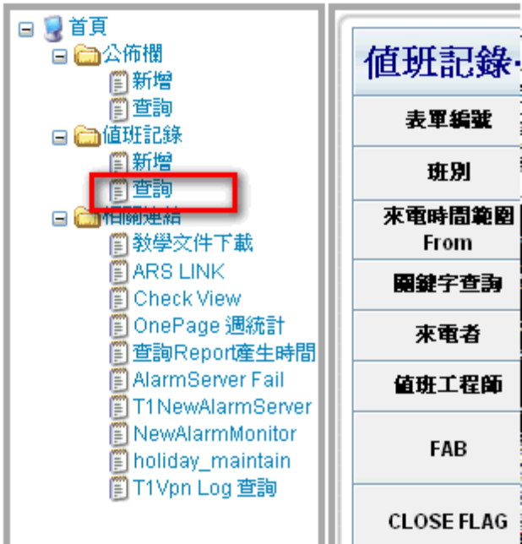
[Action]
1.FAB 點選 T0T1* => Filter 出 T0T1 值班紀錄
2.FAB 點選 T2* => Filter 出 T2 值班紀錄
[Pic]

