**Rapid Realization of Communication Services System**

**USER MANUAL**

**Group #5 – Healthcare**

**Jean Rodriguez**

**Harika Chirumamilla**

**Denis Antoine**

**Marcelo R. Lopez, Jr.**

**Table of Contents:**

INTRODUCTION 3

Hardware and Software Requirements 3

Hardware: 3

Software: 3

Development Environment 4

The Toolbar 4

Shapes: 4

Lines: 5

The Canvas 5

Execution Environment 6

Executing a Model 6

# INTRODUCTION

Welcome to RRCommSSys. This system’s main purpose is to develop and execute communication schemas and instances for the Health Care Professionals.

RRCommSSys allows a communications developer to create schemas of interesting scenarios and save them to a repository for later execution. The users such as the Doctors, Referring Physicians and the surgeons can use the application to execute schemas already saved in the repository.

This allows an inexperienced user to materialize complex communication scenarios at the touch of a button. Using Skype as the communication layer, RRCommSSys delivers the best quality voice and video calls.

# Hardware and Software Requirements

## Hardware:

* 1GHz processor
* 256MB RAM
* 200MB Disk Space
* 32-bit Sound Card
* Speakers
* Microphone
* Webcam (for video)
* Internet connection (broadband is best)

## Software:

* Java SDK 1.4
* Skype 3.0 and up
* Microsoft Windows XP

# Development Environment

## The Toolbar

* The Toolbar holds all the available shapes and lines that compose a valid GCML model.

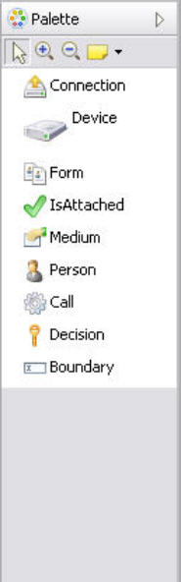

### Shapes:

* Person – The person can be the one who wants to make communication and the one to whose communication has to be established. The person is a health care professional.
* Connection – The main element. Devices are attached to it.
* Device – Represents the communication device used in the call. Devices are connected with medium types such audio, video etc.
* IsAttached – Connects a person to a communication device
* LiveAudio - Mediatype
* LiveVideo - Mediatype
* InstantMessage – Mediatype

### Lines:

* PtoI – Person to IsAttached
* ItoD – IsAttached to Device
* DtoC – Device to Connection
* MtoC – Mediatype to Connection

## 

## The Canvas

* By selecting a tool from the ToolBar and clicking on the Canvas, you can start creating your schema visually.

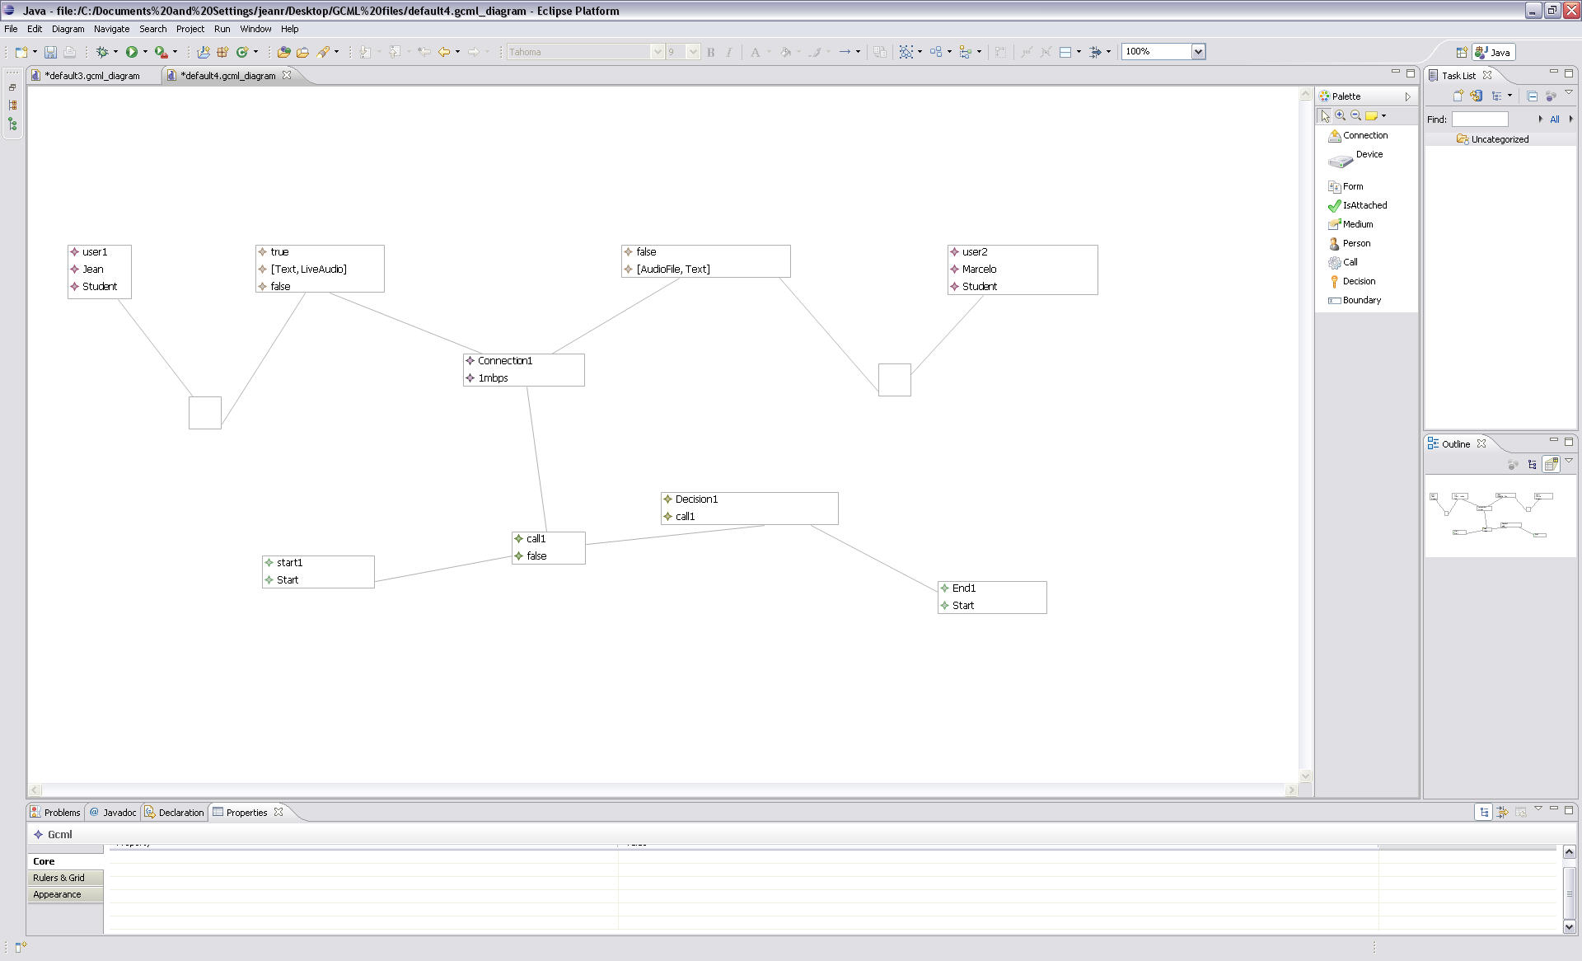

# Execution Environment

## Executing a Model

**IMPORTANT:** Before executing a model, make sure Skype is running and the desired user is logged in.

* After the model is saved then a login screen will appear so that you have to enter the username and password.

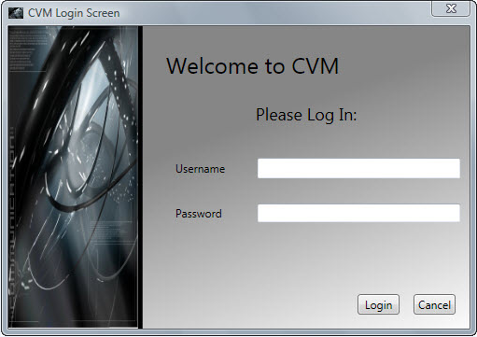

* After the login screen if the user successfully logins then the ExecutionWindow will be opened where you can see the load button to browse the gcml files that are saved by the developers or the users.

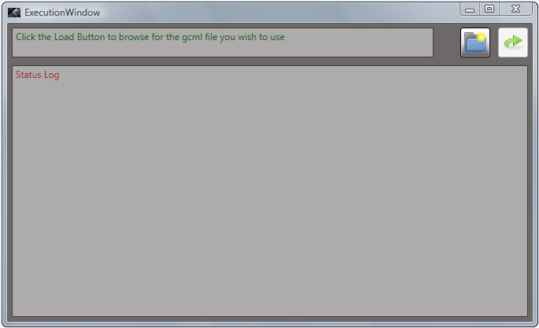

* When the user clicks on the Load button then a File Loader will appear by which we loads the gcml file.

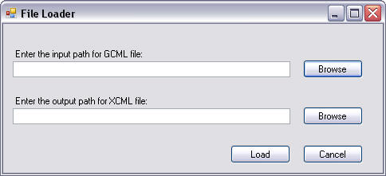

* An Open screen will appear. Select the Model to be executed and click *“Open”*.

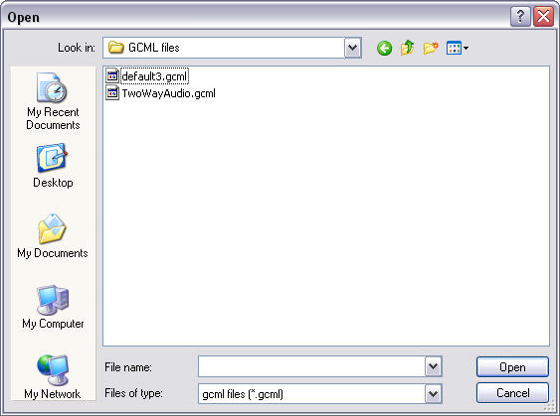

* If there are any missing attributes, the system will prompt and their values must be entered for the execution to complete.

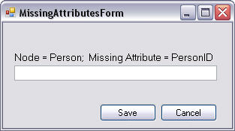

* Once all missing attributes are entered, the system will place the call. At this point Skype will pop up on the screen. Any actions from this point on will be done through Skype.

