CEN 5064 Software Design

Rapid Realization of Communication Services System

Group #5 – Healthcare
Jean Rodriguez
Harika Chirumamilla
Denis Antoine
Marcelo R. Lopez, Jr.

February 17, 2009

Professor: Dr. Peter Clarke

Abstract
With so many options available to the user today in the realm of online communication and collaboration, it’s difficult for the user to not only make a choice from the available alternatives, but The considerable number of communication and collaborative applications available today makes it hard for the active consumer to define an optimal platform in terms of existing mediums. Each of these services provide unique features, such as chat, audio, video-conferencing, and file transferring, but not one offers them all at once. Furthermore, they have been created independently therefore no connections exist among them.
The Rapid Realization of Communication Services System (RRComSSys) proposes a system that is a self-configuring, user-centric, communication service that brings together the available communication services, such as Skype, GoogleTalk, and others, chosen by the user. In addition, it provides access to all their capabilities, and it takes care of the creation of the connection protocols relieving the user of such burden.

Table of Contents
1 Introduction 5
1.1 Introduce the introduction 5
1.2 Purpose of system. 5
1.3 Scope of system. 6
1.4 Definitions, acronyms, and abbreviations. 6
1.5 Overview of document 7
2 Proposed Software Architecture 8
3 Project Plan 9
3.1 Project organization – assignment of roles for the entire project. 9
3.2 Hardware and software requirements to complete the project. 10
3.2.1 Hardware needed 10
3.2.2 Software needed 10
3.3 Work breakdown 11
4 Proposed system 12
4.1 Overview 12
4.2 Functional Requirements 13
4.2.1 The system shall: 13
4.3 Non functional requirements 14
4.4 System models showing both the static and dynamic views of the systems. 14
4.4.1 Scenarios. 14
4.4.2 Use case model ( See Appendix B ) 28
4.4.3 Object model – data dictionary*, 31
4.4.4 Object diagrams (one per scenario) 34
4.4.5 Class diagrams Error! Bookmark not defined.
4.4.6 Dynamic model 38
4.4.7 User Interfaces. 54
5 Glossary 55
6 Appendix 57
6.1 Appendix A - Project schedule 57
6.2 Appendix B - Use Cases 58
Use Case – Create a General Connection 58
Use Case – Create a Text Only Connection 59
Use Case – Create a Audio Connection 61
Use Case – Create a Audio Connection 62
Use Case: Change Password 64
Use Case – Create a New Canvas 65
Use Case - Login 66
Use Case - Logout 67
Use Case – Send File 69
Use Case – Send File Failed 70
Use Case – Receive File 71
Use Case – Receive File Failed 72
Use Case – Reject Unwanted File 73
Use Case – File Transfer Cancelled 74
Use Case – Security File Transfer 76
Use Case – Select File To Send 77
Use Case – Workflow with Alternate Connection 79
Use Case – Workflow with Retry 81
6.3 Appendix C – User Interface designs. 83
6.4 Appendix D – Diary of meeting and tasks. 86

Introduction

Introduce the introduction
This paper constitutes the Software Requirements and Analysis Document for the Rapid Realization of Communication Services System (RRComSSys). RRComSSys is part of the Communication Virtual Machine (CVM) project developed at the School of Computer and Information Science at Florida International University.
This chapter covers the general description of the system including its purpose and its scope from the user’s point of view, as well as the definitions, acronyms and abbreviations used in this paper. It concludes with an overview of the general structure of the document.

Purpose of system.

The RRComSSys has four phases: 1) The creation of the communication model by the user thru a visual environment based on a meta-model defined by the system, 2) the transformation of this model, a Graphical communication model (G-CML), into an XML communication model (X-CML), 3) the validation of the communication model for realization, and 4) the realization of the model by making the appropriate calls to the communication services.
The domain of our project is healthcare. (Other teams participating in this course cover other domains such as education, disaster management, financial and scientific collaboration. Refer to the course webpage for more information). This implies that our use cases and scenarios are based on situations that take place in a healthcare environment.

Scope of system.
The scope of the system is defined by the time a user starts the system and establishes communication with other users. An active session may include but is not limited to chat, audio, file transfer and video conference. The scope of the system will end when all users are disconnected from the system and therefore there is no more interaction.

Definitions, acronyms, and abbreviations.

CVM: Communication Virtual Machine.
RRComSSys: Rapid Realization of Communication Services System.
VE: Visual Environment
MT: Model Transformer
STE: Schema Transformation Environment
NCB: Network Communication Broker.
SE: Synthesis Engine
CML: Communication Modeling Language
XML: eXtensible Markup Language.
G-CML: Graphical Communication Modeling Language
X-CML: XML-based Communication Modeling Language.
System: self configuration communication tool.
MDSD: Model-Driven Software Development
USDP: Unified Software Development Process
Project Stakeholder: Professor Peter Clarke

Overview of document
The remainder of this document contains detailed information about the components and development process of RRComSSys, and is laid out in four more chapters and an appendix chapter.
Chapter 2: This chapter discusses existing system(s) that performs tasks similar to the ones of RRComSSys. The limitations of such applications and the need for RRComSSys are expressed.
Chapter 3: Chapter 3 covers the organization of the project in terms of the distribution of the tasks among the team members, as well as expressing milestones throughout the project, and what expectations for delivery are associated with each milestone. Furthermore, the hardware and software requirements to develop the system, as well as the team and role breakdown.
Chapter 4: This chapter presents the core development effort of the system, as well as an overview of RRComSSys, the functional and non-functional requirements governing its design and feature functions. In addition it will include the associated scenarios put forth by this implementation of RRComSSys.
Chapter 5: This chapter includes a glossary of terms used in this document for reader not specifically versed in the terminology of the implementation.
Chapter 6: This last chapter contains appendices consisting of supporting documentation and visual aids for the previous chapters.
Appendix A – Project schedule.
Appendix B – Use Cases
Appendix C – User Interface design
Appendix D – Diary of meeting and task assignments

Proposed Software Architecture
The RRCommSSys will be designed using the two following architecture patterns. Model View Control(MVC) architecture and Repository architecture.

Project Plan
This section presents the general organizational structure of the RRComSSys development plan. This includes the various work distributions during each phase of the project, the hardware and software requirements to develop and test the system, as well as milestones and deliverables produced during each stage.

Project organization – assignment of roles for the entire project.
The following figure displays the organizational structure of the roles involved in the RRComSSys project for each of the three phases of development:
Project Leader
Jean Rodriguez
VModel Developer
Marcelo Lopez
Transform Developer
Jean Rodriguez
Synthesis/Workflow Engine Developer
Denis Antoine
Synthesis/Workflow Engine Developer – Harika Chirumamilla
Minute Taker – Harika
Chirumamilla

Leader: Organize and appropriately distribute the tasks according to members’ area of expertise; ensures that all milestones are met accordingly and with sufficient time to complete corrections as complete for the professor.
VModel Developer: Creates the Visual Modeling Environment within the Eclipse framework. This refers to the creation of the meta model, or GCML, by developing all the necessary visual entities to produce the communication models, bound by the designer’s constraints.
Transformer Developer: The Transformer developer will create the necessary classes and infrastructure necessary to ensure that the transformations, and subsequent validation and parsing of the G-CML and XCML models is proper and meets the requirements of the modelers designs.
SE/Workflow Developer: The Synthesis/Workflow Engine developers create the classes that will implement the core entities of both the communication models, and the workflow infrastructure. Also, they develop those classes that bridge to the communication services (Skype and Google Talk) APIs.
Minute/Note Taker: Keeps record of the details of every meeting, including time and date, attendance, and the topics discussed during each meeting. This information is distributed to the rest of the group by the end of each week.

Hardware and software requirements to complete the project.

Hardware needed
Processor: Intel or AMD 2Ghz or faster
Memory: 1 GB of RAM (minimum), 2Gb (recommended)
Hard Drive: 80 GB
Headset with built-in microphone (optional)
Webcam (optional)

Software needed
Windows XP Professional / Windows Vista
Microsoft Word 2007
Microsoft Visio / Star UML
Microsoft Project 2007
Eclipse 3.4.1 IDE
Skype Java API
Google Talk/Smack API (optional, but recommended)

Work breakdown
Tasks and Milestones: Refer to Project Plan in Appendix A, and Team Diary in Appendix D.
Milestone 1 consists of the completion of the Use Case specification and Analysis Phase. This results in a software requirements document handed in to the professor. This deliverable also includes and should cover the necessary object models.
Milestone 2 consists of the completion of Design Phase, the creation of the meta model and the design and implementation of the RRComSSys in general. This includes the implementation of the parsers and the validators as well. The result of this phase is presented in a design document handed in to professor.
Finally, Milestone 3, which is to say the final deliverable of RRComSSys will consist of the final tasks to complete the system and the testing/validation phase. The final deliverable document includes the two previous deliverable plus the details of this last milestone.

Proposed system

Overview
The domain of the RRComSSys developed by Team 5 for this project is the operation of the system within a healthcare environment. The user base would therefore be targeted to typically be doctors, nurses or assistants to the doctors, and possibility non-physician specialists of some sort. The RRComSSys system provides direct communication using the published APIs from other services such as Skype (and possibly Smack). These services allow the ability to transfer files between the various participants within a conversation, as well as various connection types such as video and/or audio conferencing also among multiple users, in addition to the creation of modeled communication instances by users authorized within the system. Access to the system is secured by an authentication mechanism with specific validation parameters assigned to all users of the system.
The internals to the system are adaptable to allow for fall over from one communication service to another in situations where communication via one or the other is not possible or inadvisable due to imposed constraints (bandwidth, cost, etc). It is expected that the system should be able to choose and switch to a different API without requiring user intervention, and should also a user with sufficient privilege to create communication models to specify such constraints.
To build such models a visual editing environment will be created using Eclipse as a base, and extending it with tools for the creation of G-CML specific models, which will then be transformed by the system into their equivalent X-CML communication models for execution within the communication environment. The resultant X-CML is validated, parsed and then executed by the communication environment, and the result is the ability to make calls, chat with users via video, text, audio or a combination of them, using the Skype( and possibly Smack ) API’s.

Functional Requirements

The system shall:

- Allow health care professionals to create communication models based on the CML language.
Use cases: All use cases related to General Connection.
Use Case ID(s): C01_GeneralConnection, C02_TextOnlyConnection, C03_TextAudioConnection and C04_Audio Video Connection.

- Allow health care professionals to communicate with one or many users using audio, video and text conversations.
Use cases: All use cases related to General Connection.
Use Case ID(s): C01_GeneralConnection, C02_TextOnlyConnection, C03_TextAudioConnection and C04_Audio Video Connection.

- Allow health care professionals to establish a conversation with either Skype or GoogleTalk.
Use cases: All use cases related to General Connection.
Use Case ID(s): C01_GeneralConnection, C02_TextOnlyConnection, C03_TextAudioConnection and C04_Audio Video Connection.

- Allow health care professionals to use a workflow model to establish communication models that can execute alternate conversation activities.
Use cases: All use cases related to General Connection and Workflow Connection.
Use Case ID(s): C01_GeneralConnection, C02_TextOnlyConnection, C03_TextAudioConnection, C04_Audio Video Connection, W01_WorkflowWithAlternate and W02_WorkflowWithRetry.

- Allow health care professionals to use workflow to build communication models that can try a conversation activity repeatedly until a connection is established.
Use cases: All use cases related to General Connection and Workflow Connection.
Use Case ID(s): C01_GeneralConnection, C02_TextOnlyConnection, C03_TextAudioConnection, W01_WorkflowWithAlternate and W02_WorkflowWithRetry.

- Allow health care professionals to send and receive files within a conversation.
Use cases: All use cases related to File Transfer.
Use Case ID(s): F01_SendFile, F02_SendFileFailed, F03_ReceiveFile, F04_ReceiveFileFailed, F05_ RejectUnwantedFile, T506, F07_FileTransferCancelled

Non functional requirements

- Usability:
  - The users interface should be efficient. The user is expected to have an above average level of expertise. The system shall require a minimum of an hour of training.
- Reliability:
- 1% Downtime for every twenty four hours of operation is acceptable.
- Performance:
  - All requests should be received within a maximum of 3 seconds.
  - The validation of the communication model shall last less than 1 second for 500 shapes.
- Supportability:
  - The system should be implemented in java and supported by all systems which support JVM.
  - A microphone for the audio connection.
  - A video camera for the video connection.
5. Implementation:
a. The system shall be implemented in Java and other supporting
libraries.
b. The modeling environment shall be created likely with Eclipse GMF.

System models showing both the static and dynamic views of the systems.

Scenarios.

Scenario 1: Pre-Surgery Consult between, Specialist or Alternate Specialist, and Surgeon with
Text

Summary: This scenario describes a sequence of events prior to a surgical procedure to remove a growth of indeterminate state (benign or malignant), which takes place a few days before the patient, Mr. Smith, is scheduled for an exploratory biopsy surgery at Jackson Memorial Hospital, Sylvester Cancer Center. The surgeon, Dr. Richards, is consulting with a colleague, Dr. Clarke, a Urological Cancer specialist at the Sylvester Cancer center, because the growth is on the patients bladder, and there are concerns about trying to maintain as much normal function for the patient as possible. In this scenario, Dr. Richards starts the conversation with Dr. Clarke, with only text format and discusses some of the possible approaches to maximizing and maintaining the patient’s normal urinary functioning. After the conversation Dr. Richards disconnects which disconnects the active connection. If Dr. Clarke is not present then Dr. Richard connects to Dr. Lopez.
Actors: Dr. Richards (surgeon), Dr. Clarke (referring physician) and Dr. Lopez (physician).

Scenario Description
Preconditions:
- The RRComSSys system is activated in Dr. Richards’s office and he has logged into the system.
- Dr. Richards has activated the CVM as a client in the RRComSSys system.
- Dr. Richards has opened a new canvas and is ready to create a communication model.

Description of the scenario:
- Dr. Richards drags the shape for “Participant” onto the canvas and fills in his user information.
- Dr. Richards drags the shape for “IsAttahced” onto the canvas and then attaches it to the “Participant” node.
- Dr. Richards drags the shape for “Device” onto the canvas and then attaches it to the “IsAttached” node.
- Dr. Richards drags the capability shape for “Text” onto the canvas and then attaches them to the “Device” node.
- Dr. Richards repeats step 1-4 with Dr. Clarke as the other participant and device capabilities.
- Dr. Richards drags the shape for “Connection” onto the canvas and attaches it to both, Dr. Richards’s and Dr. Clarke’s, “Device” nodes, which were created earlier.
- Dr. Richards repeats the process described in steps 1-6 with Dr. Lopez as the other participant.
- Now the connection model is executed and Dr Richards is connected to Dr Clarke and they are discussing about the patient record. If not he is connected to Dr. Lopez.
- After the discussion Dr Richards selects “Disconnect”, which terminates the active connection with the Doctor.

Post Condition:

- Both Dr. Richards and either Dr. Clarke CVM clients remain active and available for communication session.

G-CML Representation of the communication instance:

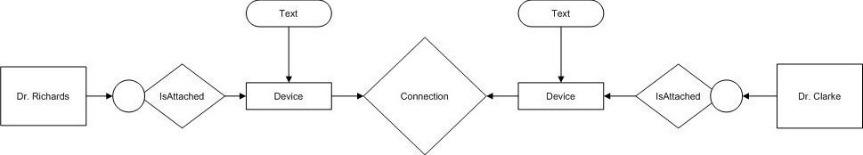

Scenario 2: Pre-Surgery Communication between, Specialist or Alternate Specialist, and Surgeon such as Text and Audio

Summary: This scenario describes a sequence of events prior to a surgical procedure to remove a growth of indeterminate state (benign or malignant), which takes place a few days before the patient, Mr. Smith, is scheduled for an exploratory biopsy surgery at Jackson Memorial Hospital, Sylvester Cancer Center. The surgeon, Dr. Richards, is consulting with a colleague, Dr. Clarke, a Urological Cancer specialist at the Sylvester Cancer center, because the growth is on the patients bladder, and there are concerns about trying to maintain as much normal function for the patient as possible. In this scenario, Dr. Richards starts the conversation with Dr. Clarke, with only text and audio. Dr Richard discusses about the patient condition and sends some information via chat. Dr. Clarke suggests some of the possible solutions. After the conversation Dr. Richards disconnects which disconnects the active connection. If Dr. Clarke is not present then Dr. Richard connects to Dr. Lopez
Actors: Dr. Richards (surgeon), Dr. Clarke (referring physician) and Dr. Lopez (physician).

Scenario Description
Preconditions:
- The RRComSSys system is activated in Dr. Richards’s office and he has logged into the system.
- Dr. Richards has activated the CVM as a client in the RRComSSys system.
- Dr. Richards has opened a new canvas and is ready to create a communication model.

Description of the scenario:

- Dr. Richards drags the shape for “Participant” onto the canvas and fills in his user information.
- Dr. Richards drags the shape for “IsAttahced” onto the canvas and then attaches it to the “Participant” node.
- Dr. Richards drags the shape for “Device” onto the canvas and then attaches it to the “IsAttached” node.
- Dr. Richards drags the capability shape for “Text” and “Audio” onto the canvas and then attaches them to the “Device” node.
- Dr. Richards repeats step 1-4 with Dr. Clarke as the other participant and device capabilities.
- Dr. Richards drags the shape for “Connection” onto the canvas and attaches it to both, Dr. Richards’s and Dr. Clarke’s, “Device” nodes, which were created earlier.
- Dr. Richards repeats the process described in steps 1-6 with Dr. Lopez as the other participant.
- Now the connection model is executed and Dr Richards is connected to Dr Clarke with Text and Audio. If Dr. Clarke is not present then he connects to Dr Lopez.
- Dr Richard discusses with the Dr Clarke and sends some information about the patient so that Dr Clarke would suggest him.
- Dr. Richards thanks Dr. Clarke for his time and selects “Disconnect”, which terminates the active connection with the Doctor.

Post Condition:

- Both Dr. Richards and either Dr. Clarke CVM clients remain active and available for communication sessions.

G-CML Representation of the communication instance:

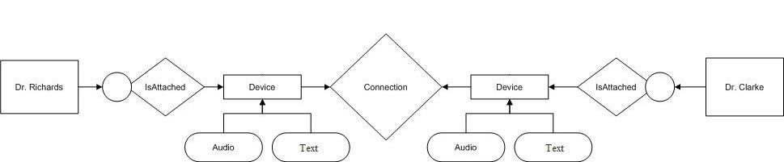

Scenario 3: Surgery Communication between, Specialist or Alternate Specialist, and Surgeon such as Text, Audio and Video
Summary: This scenario describes a sequence of events prior to a surgical procedure to remove a growth of indeterminate state (benign or malignant), which takes place a few days before the patient, Mr. Smith, is scheduled for an exploratory biopsy surgery at Jackson Memorial Hospital, Sylvester Cancer Center. The surgeon, Dr. Richards, is consulting with a colleague, Dr. Clarke, a Urological Cancer specialist at the Sylvester Cancer center, because the growth is on the patients bladder, and there are concerns about trying to maintain as much normal function for the patient as possible. In this scenario, Dr. Richards is in the middle of the surgery and starts the conversation with Dr. Clarke, with only text, audio and video regarding the patient condition. Dr. Clarke suggests some of the possible solutions and the surgery is successful. After the conversation Dr. Richards disconnects which disconnects the active connection. If Dr. Clarke is not present then Dr. Richard connects to Dr. Lopez
Actors: Dr. Richards (surgeon), Dr. Clarke (referring physician) and Dr. Lopez (physician).

Scenario Description

Preconditions:
- The RRComSSys system is activated in Dr. Richards’s office and he has logged into the system.
- Dr. Richards has activated the CVM as a client in the RRComSSys system.
- Dr. Richards has opened a new canvas and is ready to create a communication model.

Description of the scenario:

- Dr. Richards drags the shape for “Participant” onto the canvas and fills in his user information.
- Dr. Richards drags the shape for “IsAttahced” onto the canvas and then attaches it to the “Participant” node.
- Dr. Richards drags the shape for “Device” onto the canvas and then attaches it to the “IsAttached” node.
- Dr. Richards drags the capability shape for “text”, “Audio” and “Video” onto the canvas and then attaches them to the “Device” node.
- Dr. Richards repeats step 1-4 with Dr. Clarke as the other participant and device capabilities.
- Dr. Richards drags the shape for “Connection” onto the canvas and attaches it to both, Dr. Richards’s and Dr. Clarke’s, “Device” nodes, which were created earlier.
- Dr. Richards repeats the process described in steps 1-6 with Dr. Lopez as the other participant.
- Now the connection model is executed and Dr Richards is connected to Dr Clarke with Audio and Video. If not he is connected to Dr Lopez.
- During the surgery Dr Richard communicates with Dr. Clarke about the patient condition and Dr Clarke gives the suggestions so that the surgery is successful.
- Dr. Richards thanks Dr. Clarke for his time and selects “Disconnect”, which terminates the active connection with the Doctor.

Post Condition:
- Both Dr. Richards and Dr. Clarke’s CVM clients remain active and available for communication sessions.

G-CML showing the instance for the Scenario:

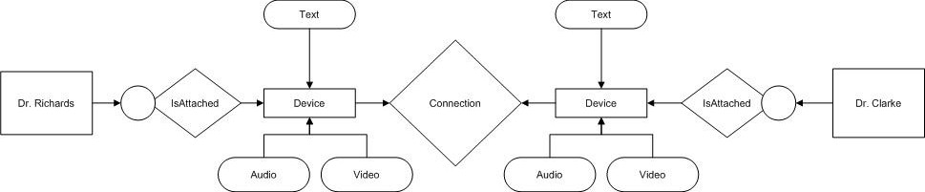

Scenario 4: Pre-Surgery Consult between, Specialist or Alternate Specialist, and Surgeon

Summary: This scenario describes a sequence of events prior to a surgical procedure to remove a growth of indeterminate state (benign or malignant), which takes place a few days before the patient, Mr. Smith, is scheduled for an exploratory biopsy surgery at Jackson Memorial Hospital, Sylvester Cancer Center. The surgeon, Dr. Richards, is consulting with a colleague, Dr. Clarke, a Urological Cancer specialist at the Sylvester Cancer center, because the growth is on the patients bladder, and there are concerns about trying to maintain as much normal function for the patient as possible. In this scenario, Dr. Richards desires to discuss with Dr. Clarke, some of the possible approaches to maximizing and maintaining the patient’s normal urinary functioning. Dr. Lopez is also knowledgeable on this procedure, so Dr. Richards wants to start a conversation with him, if Dr. Clarke is not available.
Actors: Dr. Richards (surgeon), Dr. Clarke (referring physician) and Dr. Lopez (physician).
Scenario Description
Preconditions:
- The RRComSSys system is activated in Dr. Richards’s office and he has logged into the system.
- Dr. Richards has activated the CVM as a client in the RRComSSys system.
- Dr. Richards has opened a new canvas and is ready to create a communication model.
Description of the scenario:
- Dr. Richards drags the shape for “Participant” onto the canvas and fills in his user information.
- Dr. Richards drags the shape for “IsAttahced” onto the canvas and then attaches it to the “Participant” node.
- Dr. Richards drags the shape for “Device” onto the canvas and then attaches it to the “IsAttached” node.
- Dr. Richards drags the capability shape for “Text” onto the canvas and then attaches them to the “Device” node.
- Dr. Richards repeats step 1-4 with Dr. Clarke as the other participant and device capabilities.
- Dr. Richards drags the shape for “Connection” onto the canvas and attaches it to both, Dr. Richards’s and Dr. Clarke’s, “Device” nodes, which were created earlier.
- Dr. Richards repeats the process described in steps 1-6 with Dr. Lopez as the other participant.
- Dr. Richards drags a “StartFlowBar” shape into the canvas.
- Dr. Richards holds the left mouse button down and draws a rectangle that encapsulates the model created in step 1-6. The connection is now a “ConversationActivity” shape.
- Dr. Richards connects the “ConversationActivity” created in step 9 to the “StartFlowBar” shape.
- Dr. Richards drags a “DecisionPoint” shape onto the canvas and connects it to the “ConversationActivity” created in step 9.
- Dr. Richards repeats the process described in step 9 with the model created in step 7. This is now the second “ConversationActivity” in the canvas. Dr. Richards connects this “ConversationActivity” to the “DecisionPoint” node.
- Dr. Richards drags an “EndFlowBar” shape onto the canvas and attaches it to the “ConversationActivity” created on step 12 and to the “DecisionPoint” node.
Post Condition:
- The canvas now holds a communication model that can be executed. When executed a connection is attempted between Dr. Richards and Dr. Clarke. If that connection is successful, the connection is established. If that connection fails, the connection between Dr. Richards and Dr. Lopez is executed.

G-CML Representation of the communication instance:

Model1
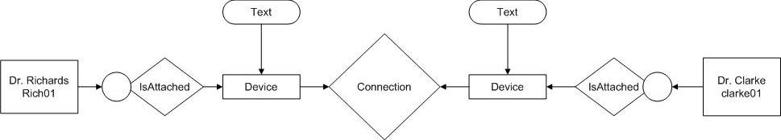
Model2
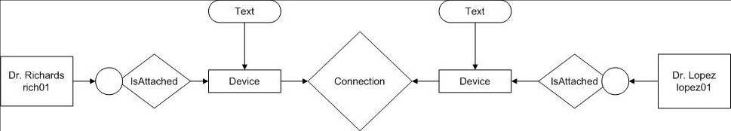
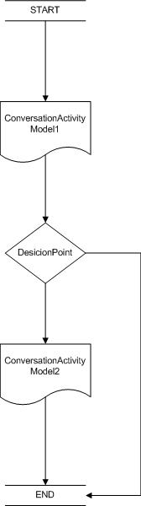 Workflow Model (contains model1 and model2)

Scenario 5 : Secure Transfer keyword, Post-Surgery Consult, Specialist or Alternate Specialist, & Surgeon
Summary: This scenario describes a sequence of events after a surgical procedure to remove a growth of indeterminate state (benign or malignant), which takes place a day after the patient, Mr. Smith, was scheduled for an exploratory biopsy surgery at Jackson Memorial Hospital, Sylvester Cancer Center. The surgeon, Dr. Richards, is consulting with a colleague, Dr. Clarke, a Urological Cancer specialist at the Sylvester Cancer center, because the growth was detected on the patients bladder, and there were concerns about trying to maintain as much normal function for the patient as possible. In this scenario, Dr. Richards discusses the outcome of the surgery. Dr. Richards also wants to send an MRI (jpeg Format). Dr. Lopez is also knowledgeable on this area, so Dr. Richards wants to start a conversation with him, if Dr. Clarke is not available.
Actors: Dr. Richards (surgeon), Dr. Clarke (referring physician) and Dr. Lopez (physician).
Scenario Description
Preconditions:
- The RRComSSys system is activated in Dr. Richards’s office and he has logged into the system.
- Dr. Richards has activated the CVM as a client in the RRComSSys system.
- Dr. Richards has opened a new canvas and has created a communication model.
- Dr. Richards is ready to send a file.
- Dr. Clarke is ready to send a file.
Description of the scenario:

- Dr. Richards drags the mouse pointer to the file menu option and clicks it.
- Dr. Richards selects the send file securely option from the drop down list.
- A dialog opens requesting the keyword from Dr. Richards.
- Dr. Richards enters a keyword which is already known by Dr. Clarke and presses the enter button.
- Dr. Richards repeats the process described in steps 1-7 for each MRI file.
- Dr. Clarke. Is then requested to input the keyword before he can accept the file transfer.
- Upon successful input of the keyword both users a notified of the transfer initiation and the file transfer begins.
- Upon a successful file transfer both users a notified of success.
Post Condition:
- Dr. Richards and Dr. Clarke both have a copy of the transferred file. If the file correct keyword is input a file transfer is established. If that transfer fails, Dr. Richards and Dr. Lopez are notified of the failed transfer.

G-CML Representation of the Secure Transfer Scenario:

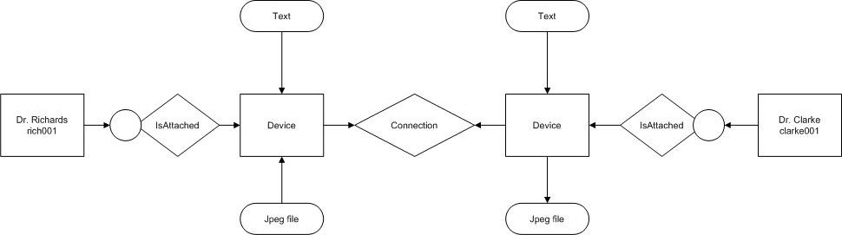

Scenario 6: Send File, Post-Surgery Consult between, Specialist or Alternate Specialist, and Surgeon
Summary: This scenario describes a sequence of events after a surgical procedure to remove a growth of indeterminate state (benign or malignant), which takes place a day after the patient, Mr. Smith, was scheduled for an exploratory biopsy surgery at Jackson Memorial Hospital, Sylvester Cancer Center. The surgeon, Dr. Richards, is consulting with a colleague, Dr. Clarke, a Urological Cancer specialist at the Sylvester Cancer center, because the growth was detected on the patients bladder, and there were concerns about trying to maintain as much normal function for the patient as possible. In this scenario, Dr. Richards discusses the outcome of the surgery. Dr. Richards also wants to send an MRI (jpeg Format). Dr. Lopez is also knowledgeable on this area, so Dr. Richards wants to start a conversation with him, if Dr. Clarke is not available.
Actors: Dr. Richards (surgeon), Dr. Clarke (referring physician) and Dr. Lopez (physician).
Scenario Description
Preconditions:
- The RRComSSys system is activated in Dr. Richards’s office and he has logged into the system.
- Dr. Richards has activated the CVM as a client in the RRComSSys system.
- Dr. Richards has opened a new canvas and is ready to create a communication model.
- Dr. Richards is ready to send a file
- Dr. Clarke is ready to receive a file
Description of the scenario:
- Dr. Richards drags the mouse pointer to the file menu option.
- Dr. Richard clicks the file menu opening up a drop down menu.
- Dr. Richard selects the send file option which itself opens up a dialog requesting the file to be sent be selected.
- Dr. Richards selects the file to be sent with the mouse pointer.
- Dr. Clarke is than prompted to select the file.
Post Condition:
- The canvas now holds a communication model that can be executed. When executed a dialog requests Dr. Clarke accepts the file from Dr. Richards. If the file is accepted a file transfer is established. If that transfer fails, Dr. Richards and Dr. Lopez are notified of the failed transfer.
G-CML Representation of the Send File Scenario:
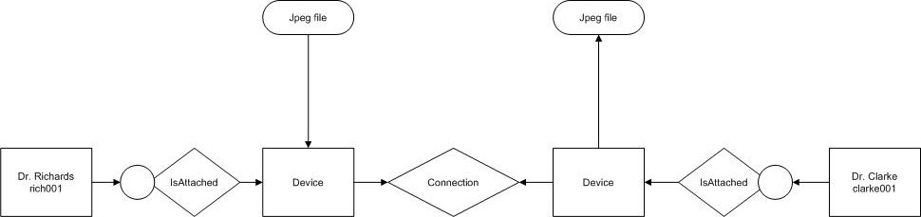

Scenario 7: Pre-Surgery Consult between, Specialist or Alternate Specialist, and Surgeon: with the Ability to try until a connection is established
Summary: This scenario describes a sequence of events prior to a surgical procedure to remove a growth of indeterminate state (benign or malignant), which takes place a few days before the patient, Mr. Smith, is scheduled for an exploratory biopsy surgery at Jackson Memorial Hospital, Sylvester Cancer Center. The surgeon, Dr. Richards, is consulting with a colleague, Dr. Clarke, a Urological Cancer specialist at the Sylvester Cancer center, because the growth is on the patients bladder, and there are concerns about trying to maintain as much normal function for the patient as possible. In this scenario, Dr. Richards desires to discuss with Dr. Clarke, some of the possible approaches to maximizing and maintaining the patient’s normal urinary functioning. This connection is tried in that order until a connection is established or Dr. Richards closes the application.
Actors: Dr. Richards (surgeon), Dr. Clarke (referring physician).
Scenario Description
Preconditions:
- The RRComSSys system is activated in Dr. Richards’s office and he has logged into the system.
- Dr. Richards has activated the CVM as a client in the RRComSSys system.
- Dr. Richards has opened a new canvas and is ready to create a communication model.
Description of the scenario:
- Dr. Richards drags the shape for “Participant” onto the canvas and fills in his user information.
- Dr. Richards drags the shape for “IsAttahced” onto the canvas and then attaches it to the “Participant” node.
- Dr. Richards drags the shape for “Device” onto the canvas and then attaches it to the “IsAttached” node.
- Dr. Richards drags the capability shape for “Text” onto the canvas and then attaches them to the “Device” node.
- Dr. Richards repeats step 1-4 with Dr. Clarke as the other participant and device capabilities.
- Dr. Richards drags the shape for “Connection” onto the canvas and attaches it to both, Dr. Richards’s and Dr. Clarke’s, “Device” nodes, which were created earlier.
- Dr. Richards repeats the process described in steps 1-6 with Dr. Lopez as the other participant.
- Dr. Richards drags a “StartFlowBar” shape into the canvas.
- Dr. Richards holds the left mouse button down and draws a rectangle that encapsulates the model created in step 1-6. The connection is now a “ConversationActivity” shape.
- Dr. Richards connects the “ConversationActivity” created in step 9 to the “StartFlowBar” shape.
- Dr. Richards drags a “DecisionPoint” shape onto the canvas and connects it to the “ConversationActivity” created in step 9. The “DecisionPoint” is also connected to the “ConversationActivity” because if the connection is unsuccessful it is tried again.
- Dr. Richards drags an “EndFlowBar” shape onto the canvas and attaches it to the to the “DecisionPoint” node.
Post Condition:
- The canvas now holds a communication model that can be executed. When executed a connection is attempted between Dr. Richards and Dr. Clarke. If that connection is successful, the connection is established. If that connection fails, the system attempts to connect again.

G-CML Representation of the communication instance:
Model1
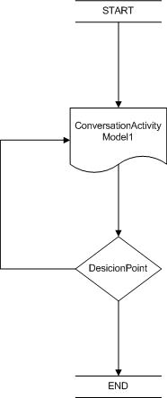 Workflow Model (contains model1)

Scenario 8: Receive File: Post-Surgery Consult between, Specialist or Alternate Specialist, and Surgeon
Summary: This scenario describes a sequence of events after a surgical procedure to remove a growth of indeterminate state (benign or malignant), which takes place a day after the patient, Mr. Smith, was scheduled for an exploratory biopsy surgery at Jackson Memorial Hospital, Sylvester Cancer Center. The surgeon, Dr. Richards, is consulting with a colleague, Dr. Clarke, a Urological Cancer specialist at the Sylvester Cancer center, because the growth was detected on the patients bladder, and there were concerns about trying to maintain as much normal function for the patient as possible. In this scenario, Dr. Richards discusses the outcome of the surgery. Dr. Richards also wants to send an MRI (jpeg Format). Dr. Lopez is also knowledgeable on this area, so Dr. Richards wants to start a conversation with him, if Dr. Clarke is not available.
Actors: Dr. Richards (surgeon), Dr. Clarke (referring physician) and Dr. Lopez (physician).
Scenario Description
Preconditions:
- The RRComSSys system is activated in Dr. Richards’s office and he has logged into the system.
- Dr. Richards has activated the CVM as a client in the RRComSSys system.
- Dr. Richards has opened a new canvas has created a communication model.
- Dr. Richards is ready to send a file.
- Dr. Clarke is ready to receive a file.
Description of the scenario:
- Dr. Richard has selected the file to be sent and Dr. Clarke receives a dialog of the file transfer request.
- Dr. Clarke accepts the file transfer requests.
- The file transfer begins.
- Dr. Richards and Dr. Clarke are notified of the initiation of the file transfer.
- Upon completion of the file transfer Dr. Richards and Dr. Clarke are notified of the successful file transfer.
Post Condition:
- Dr. Richards and Dr. Clarke both have an identical copy of the transferred file. The RRComSSys remains activated as in the pre-condition. The communication model also remains the same.

G-CML Representation of the Receive File Scenario:

Use case model (See Appendix B)

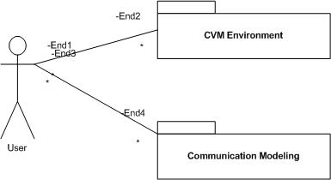
Figure 4-1 Use Case Diagram
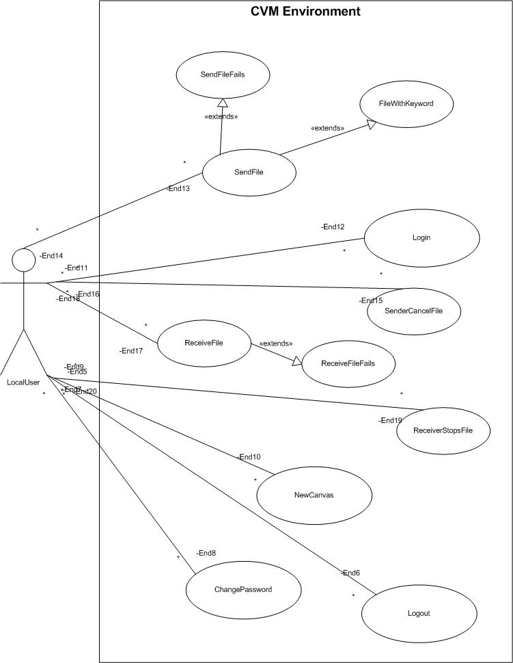
Figure 4-2 CVM Environment Use Case Diagram
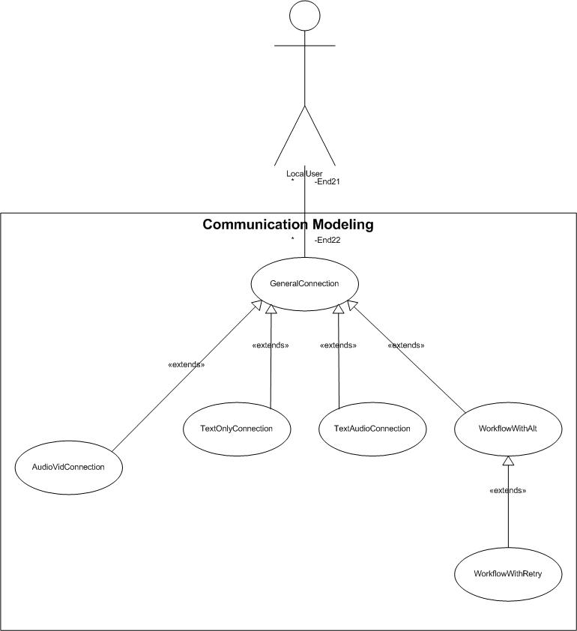
Figure 4-3 Communication Modeling Use Case Diagram

Object model – data dictionary*

Person:

Sno | Attributes | Data Types | Constraints | Description
1 | Person Id | varchar2(10) | Primary key
2 | Person Name | varchar2(10) | Not Null
3 | Person Role | varchar2(10) | Not Null
4 | Person Address | varchar2(20) | Not Null
5 | Person Phone Number | number(10) | Not Null
6 | Person Password | varchar2(10) | Not Null

Device:

Sno | Attributes | Data Types | Constraints | Description
1 | Device Id | varchar2(10) | Primary key
2 | Device Capability | varchar2(20) | Not Null
3 | Is Local | Varchar2(10) | Not Null
4 | Person Id | Varchar2(10) | Foreign Key | Person Id references Person

Connection:

Sno | Attributes | Data Types | Constraints | Description
1 | Connection id | varchar2(10) | Primary key
2 | Devices | varchar2(10) | Not Null
3 | Bandwidth | varchar2(10) | Not Null
4 | Device Id | Varchar2(20) | Foreign Key | Device Id References Device

Is Attached:

Sno | Attributes | Data Types | Constraints | Description
1 | Person Id | varchar2(10) | Foreign key | Semester Id references Person
2 | Device Id | Varchar2(10) | Foreign key | Device Id references  Device

This section discusses the details of the Object model for RRComSSys. That includes a description of the subsystem interfaces, the component classes, and other objects that will be designed to then implement the system from. A detailed class diagram and object diagrams for the use cases that interact with the API are presented following.
The RRComSSys for use within the healthcare or medical environment contains four subsystems: Visual Environment (that is to say the component which allows the user to create a model of the communication session or sessions he or she wishes to establish), a Model Transformer which converts the native GMF format representation for the visual model into a grammatically equivalent model (in XML) for the communication session. A Schema Transformation Environment, and Synthesis Engine, which transform this communication grammar into an equivalent grammar which can be validated and executed by the CVM. Following, each of these components is revealed along with the classes that comprise each subsystem.
The class diagram depicted have been designed on the basis of the requirements described by the stakeholder for the project, and following the general architecture of the system by the development team. The schema used follows the schema guidelines provided by the project facilitator. Here is a description of the diagram:
Component 1: Visual Environment (VE) in GMF – This portion will be implemented as a specialized OSGi modeling workbench application based on the Eclipse GMF, and in and of itself does not comprise actual code ( though it’s specification is implied by the underlying visual model set forth by the developers).
Component 2: Model Transformer (MT):
The ModelTransformer class which will be implemented essentially takes on the responsibility of transforming the G-CML model described in the VE into an equivalent X-CML model.
The FileSystemHelper class – A helper class used by the ModelTransformer class to retrieve the files generated by the VE (Eclipse), and to save the XML files generated by the software.
The ModelValidator class – is used by the ModelTransformer class and the SchemaTransformer classes to perform validation against the underlying schemas of the models generated by the.
ModelParser class - used by the ModelTransformer class and the SchemaTransformer class to parse the models generated by our software.
Component 3: Schema Transformation Environment (STE)
SchemaTransformer class- used to implement the validation of the communication model for realization. This class will use the helper classes described above.
Component 4: Synthesis Engine (SE)
SynthesisEngine class - used to implement the realization of the X-CML communication model by making the appropriate calls to the Skype and Smack APIs. This class will use the following classes: Person, isAttached, Device, Connection, capabilityType, mediumType.
Other classes such as NCBridge, SmackAdapter, SkypeAdapter, Smack, and Skype are from existing libraries provided by the stakeholder and by the communication services’ APIs.

Object diagrams (one per scenario)
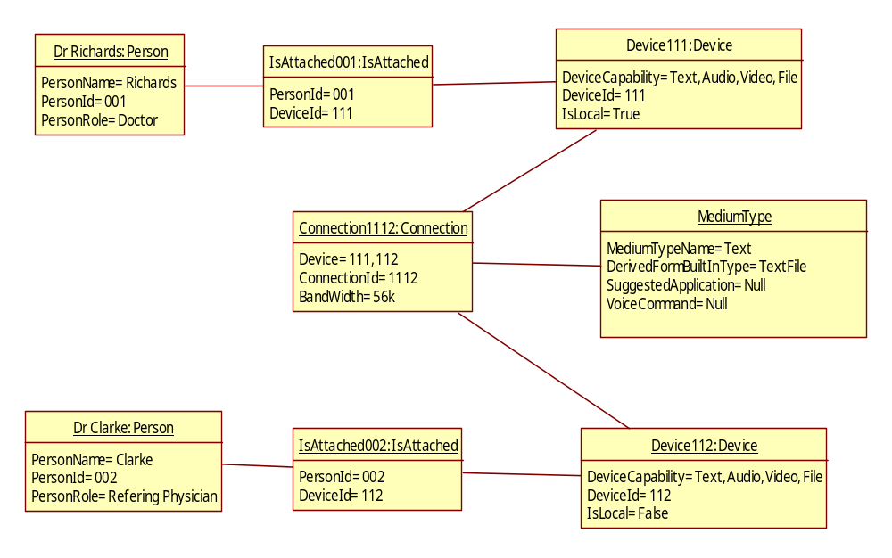
Figure 4.4.4.1: Object diagram for the Scenario-Text Only

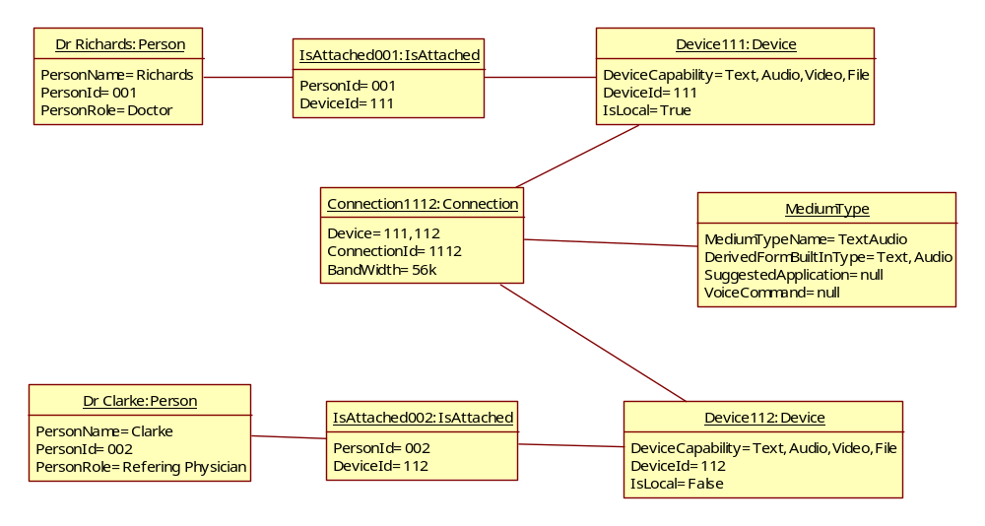
Figure 4.4.4.2: Object diagram for the Scenario-Text and Audio

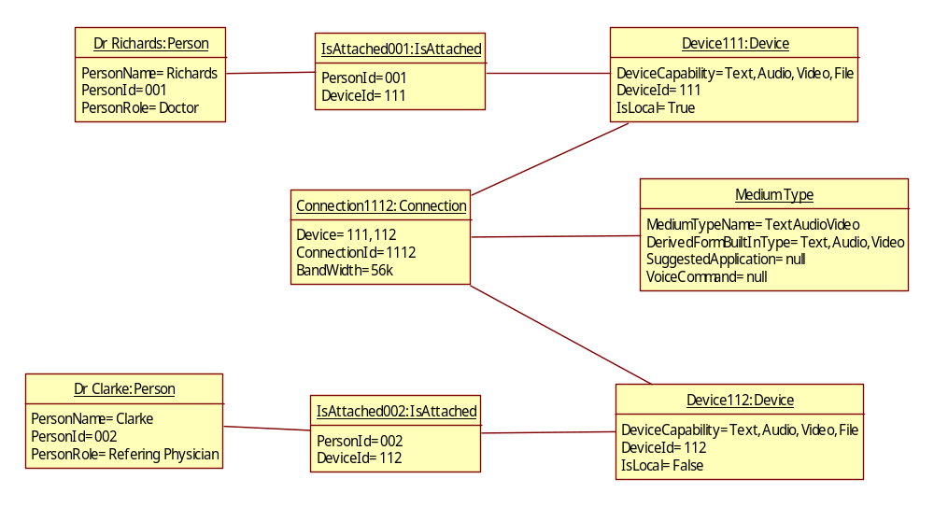
Figure 4.4.4.3: Object diagram for the Scenario-Text, Audio and video

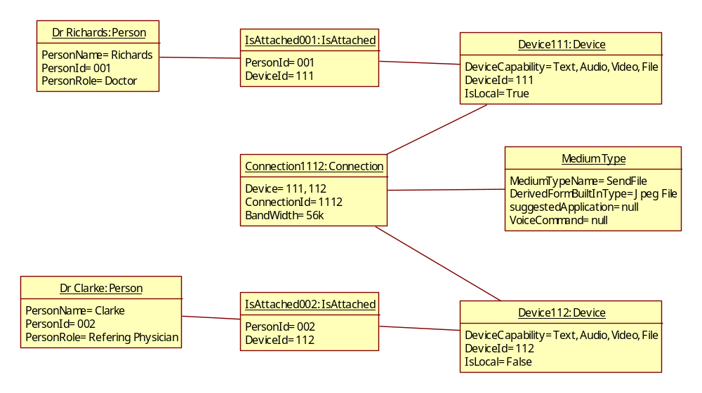
Figure 4.4.4.4: Object diagram for the Scenario-Sending a File

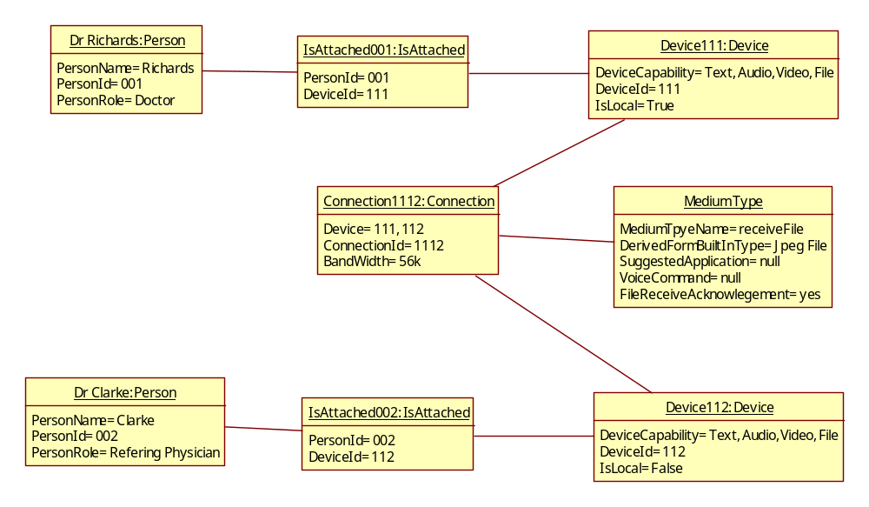
Figure 4.4.4.5: Object diagram for the Scenario-Receive a File

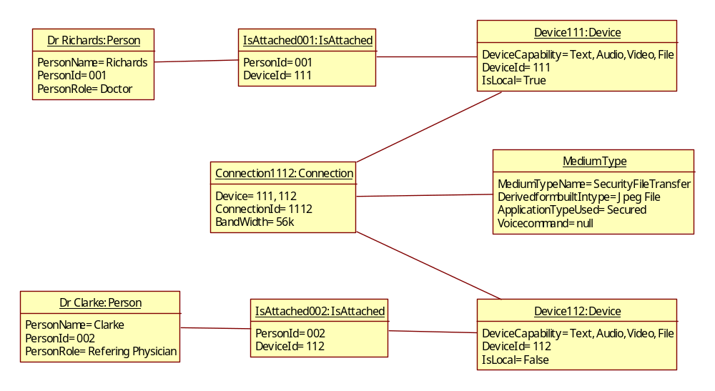
Figure 4.4.4.6: Object diagram for the Scenario-Secured File Transfer

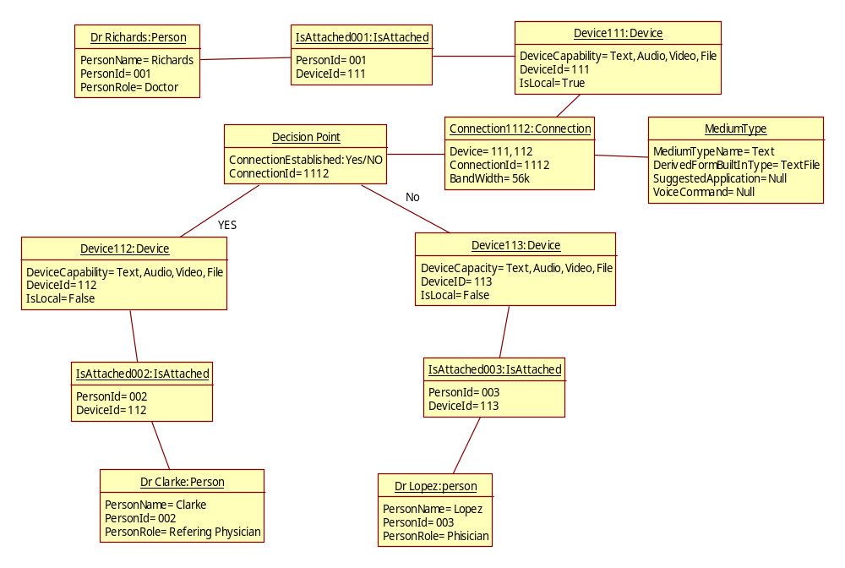
Figure 4.4.4.7: Object diagram for the Scenario-Work Flow Model

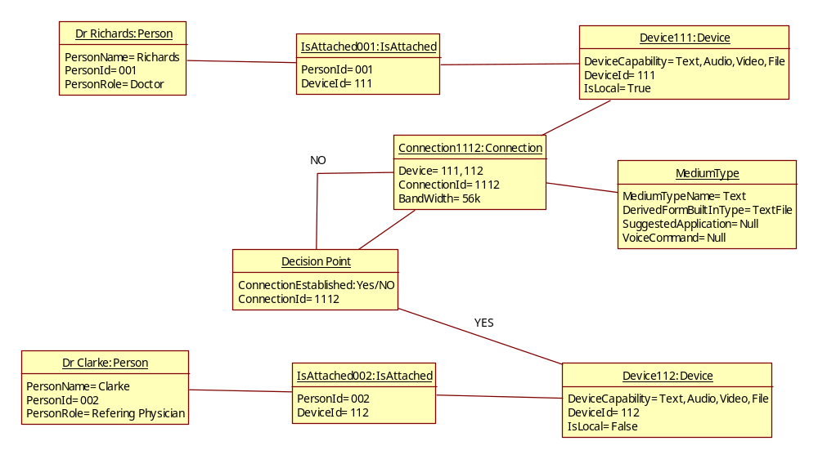
Figure 4.4.4.8: Object diagram for the Scenario- Ability to try until a connection is established

Dynamic model

Sequence diagrams (one per use case)

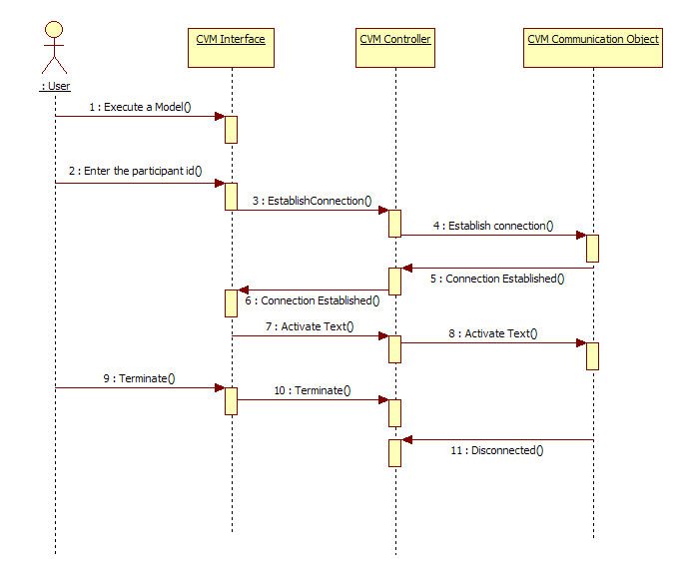
Figure 4.4.6.1.1: Text Connection Scenario Sequence Diagram

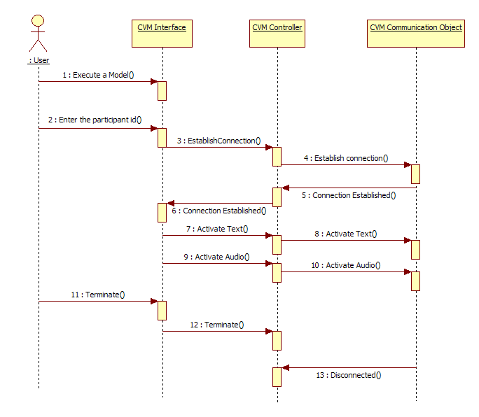
Figure 4.4.6.1.2: Text Connection Scenario Sequence Diagram

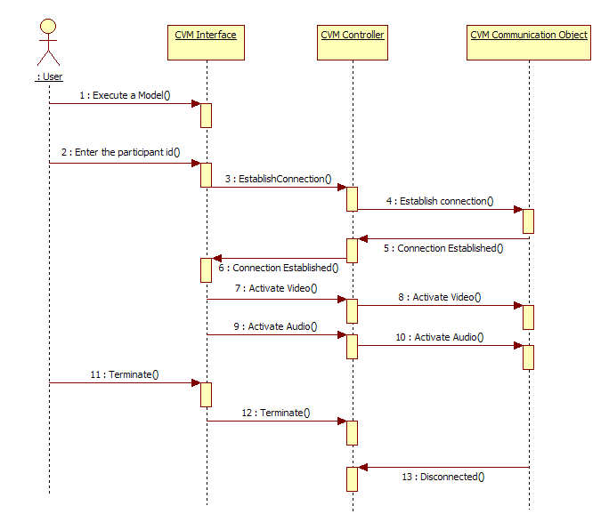
Figure 4.4.6.1.3: Audio Video Scenario Sequence Diagram

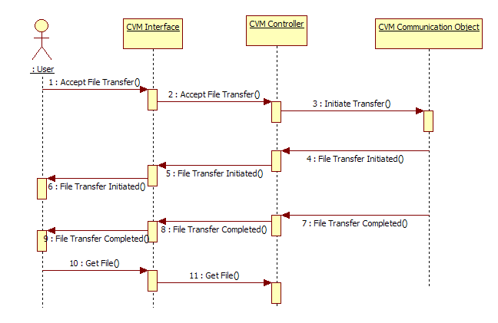
Figure 4.4.6.1.4: Receive File Scenario Sequence Diagram

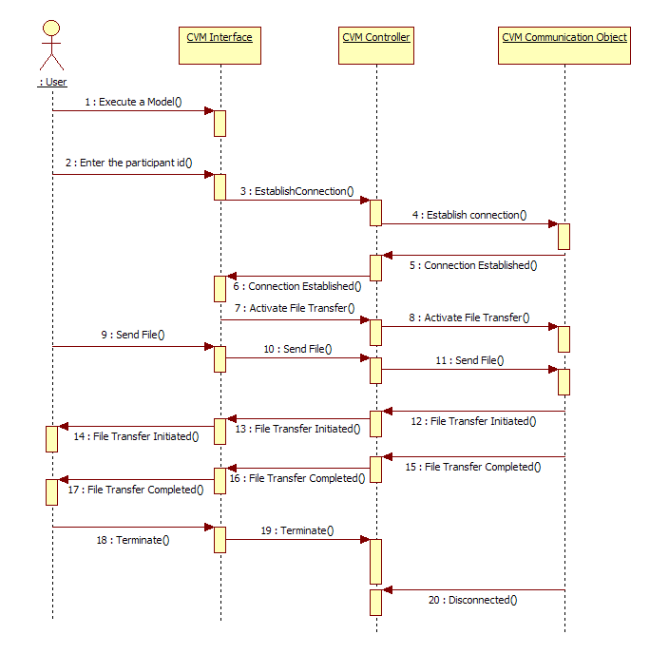
Figure 4.4.6.1.5: Send File Scenario Sequence Diagram

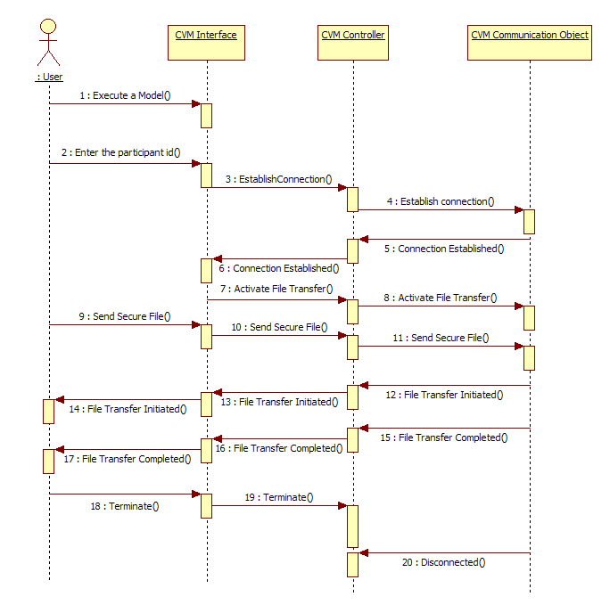
Figure 4.4.6.1.6: Secure File Transfer Scenario with Keyword Sequence Diagram

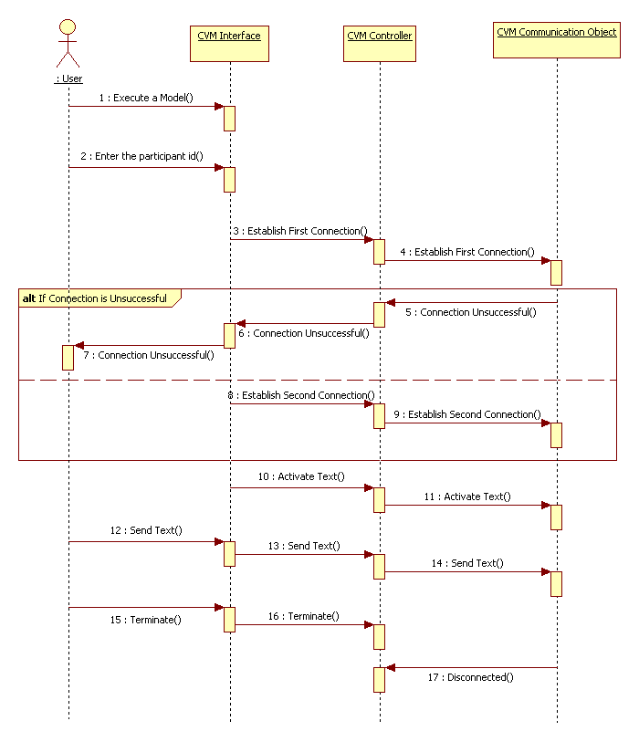
Figure 4.4.6.1.7: Workflow with Alternate Scenario Sequence Diagram

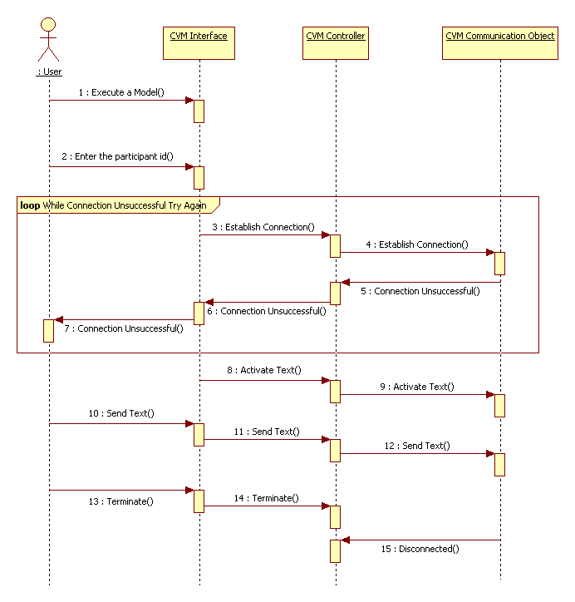
Figure 4.4.6.1.8: Workflow with Retry Scenario

State machines* and activity diagrams (one per use case).

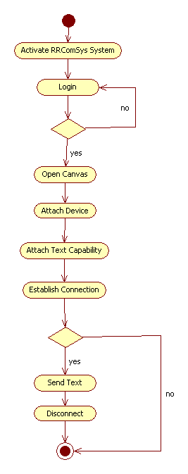
Figure 4.4.6.2.1: Text Connection Scenario Activity Diagram

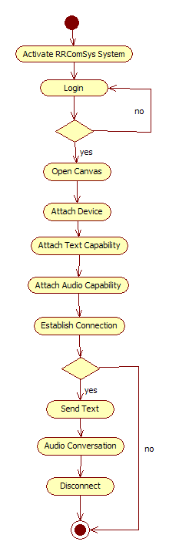
Figure 4.4.6.2.2: Text Audio Connection Scenario Activity Diagram

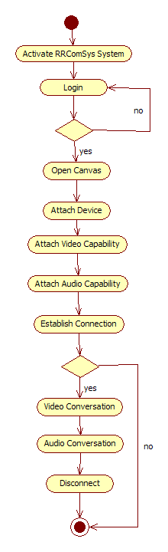
Figure 4.4.6.2.3: Video Audio Connection Scenario Activity Diagram

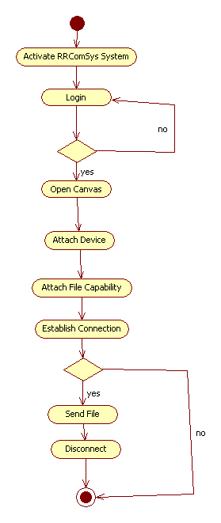
Figure 4.4.6.2.4: Send File Scenario Activity Diagram

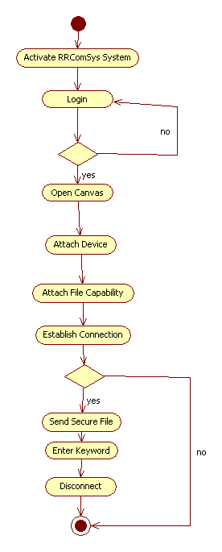
Figure 4.4.6.2.5: Send Secure File Scenario

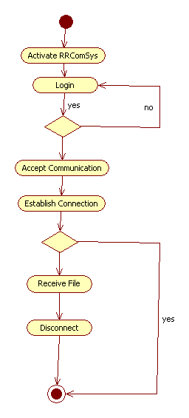
Figure 4.4.6.2.6: Receive File Scenario Activity Diagram

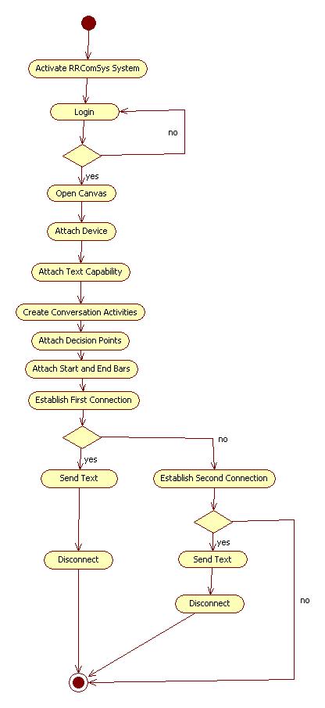
Figure 4.4.6.2.7: Workflow with Alternate Scenario

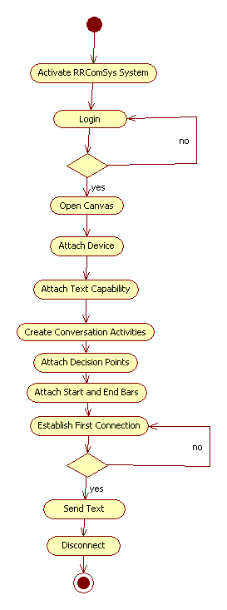
Figure 4.4.6.2.8: Workflow with Retry Scenario Activity Diagram

User Interfaces.

Communication Modeling Environment

Description: This is where the communication models are created. The local user drags and drops different shapes and connections to build a valid model. Once the model is created the user can execute the model in order to establish a communication with other users. Refer to figure C1 in Appendix C. Refer to figure C2 and C3 for some example communication models.

Send File Form
Description: This is the form the user uses to browse for the file to be sent. Refer to figure C4 in Appendix C.

Send Secure File Form
Description: This is the form the user uses to browse for the file to be sent with a security keyword. Refer to figure C4 in Appendix C.

Receive File Form
Description: This is the form the user uses to receive a file. Refer to figure C4 in Appendix C.

Glossary

Class Diagram – A model representing the different classes within a software system and how they interact with each other.
Component – A physical and replaceable part of a system that conforms to and provides the realization of a set of interfaces.
Model – an abstract representation of a system that enables us to answer questions about the system.
Post condition – A predicate that must be true after an operation is invoked.
Precondition – A predicate that must be true before an operation is invoked.
Sequence Diagram – A model representing the different objects and/or subsystems of a software project and how they relate to each other during different operations for a given use case.
Unified Modeling Language (UML) – A standard set of notations for representing models.
Use Case – A general sequence of events that defines all possible actions between one or many actors and the system for a given piece of functionality.
Model Driven Development Software – Software development paradigm that roots in software product line engineering, which is the discipline of designing and building families of applications.
Workflow Model - A representation of actions, and activities that comprise a communication model that involve the usage of decision points that allow greater flexibility in describing models which can support more than one communication instance.
Object Diagram - A diagram that shows a complete or partial view of the structure of a modeled system or portion thereof.
Shape – An image that can be dragged into the canvas in the Visual Environment. It can be connected with other nodes using connections in order to build a communication model.
Connections – A line that connects one shape with another.
Participant – A special shape that represents a local or remote user of the communication system. One or more participants can establish a conversation using a communication model.
Device – A special shape that represents what the user is using to connect to the system.
Canvas – The area where the user drags shapes and connections to build a communication model.
Capability – The ways in which the device allows the user to communicate with other users.
StartFlowBar – Represents the starting point of a workflow model.
EndFlowBar – Represents the ending point of a workflow model.
ConversationActivity – A complete communication model that can be executed. If it fails, an alternate communication activity can be executed.
DecisionPoint – A special model component, denoted by a diamond shape, that dictates flow of a sequence of actions on the basis of the outcome of a previous action or activity.

Appendix

Appendix A - Project schedule

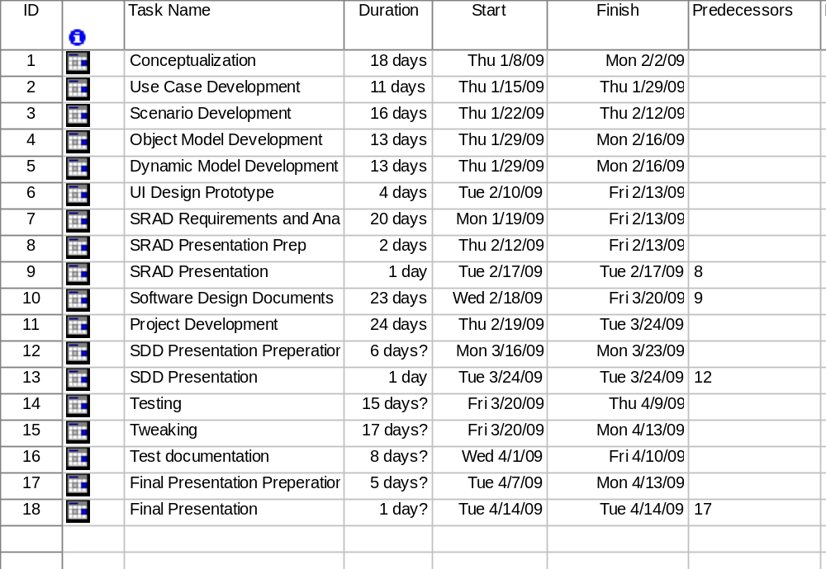

Figure 6-4 - Project Deliverable Schedule

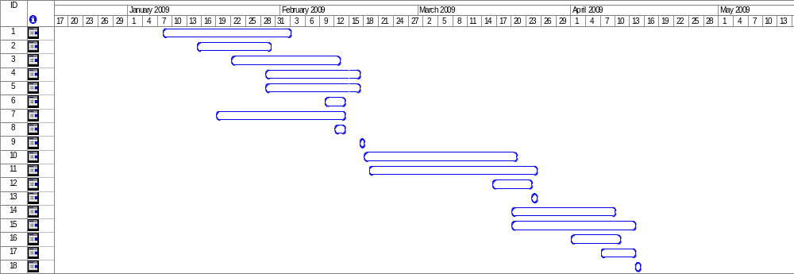
Figure 6-5 - Project Plan Schedule Gantt Chart

Appendix B - Use Cases

Use Case – Create a General Connection
Use Case ID: C01_GeneralConnection
Use Case Level: High-level
Details: Dr. Urbani wants to establish a connection with Dr. Salk.
- Actor(s): Dr. Urbani and Dr.Salk
- Pre-conditions: Dr. Urbani must have logged on (Log in use case), a new file must be open (create a new file use case) and the canvas is set and ready to accept the new communication model.
- Description:
Trigger:
1. Dr. Urbani drags the shape for “Participant” onto the canvas and fills in the required information.
2. Dr. Urbani drags the shape for “IsAttahced” onto the canvas and fills in
the required information. Dr. Urbani then attaches it to the “Participant” node.
3. Dr. Urbani drags the shape for “Device” onto the canvas and fills in the
required information. Dr. Urbani then attaches it to the “IsAttached” node.
4. Repeats step 1-3 with Dr. Salk’s required information.
5. Dr. Urbani drags the shape for “Connection” onto the canvas and fills
in the required information, and connects it to both, Dr. Urbani’s and Dr. Salk’s, “Device” shapes, which were created earlier.
- Post-conditions: The canvas now holds a communication model that can be executed. When executed a connection must be created between Dr. Urbani and Dr. Salk.
Alternative Courses of Action: Dr. Urbani can add more participants using the same procedure to establish a multi-way connection.
Extensions: Depending on the “Device” that the participants are using to create this model a Text only, Audio or Audio/Video connection (See C02_TextOnlyConnection, C03_TextAudioConnection, C04_AudioVideoConnection) can be establish when the communication model is executed. This connection can also be used to send/receive files.
Exceptions: The connection can’t be established.
Concurrent Uses: N/A
Related Use Cases: C02_TextOnlyConnection, C03_TextAudioConnection, C04_AudioVideoConnection, Log in Use Case.
---------------------------------------------------------------------------------------------------------------------
Decision Support
Frequency: This use case will occur at least once per application use. That is, every time that that an actor wants to create a communications model to connect to another actor.

Criticality: High. It allows an actor to connect to another participant.

Risk: Low. There is little to no risk in this use case.

Constraints:
Each participant can only connect to (1) IsAttached shape. Each
IsAttached shape can only be connected to (1) device shape. Each device shape
must have at least (1) capability shape connected to it, and can only connect to (1) connection terminal.

- Usability: Easy to use. No need for technical knwoledge.
- Reliability: Connection must be established 90% of the time.
- Performance: Drawing a shape or connection shouldn’t take more than 1 second.
- Supportability: The device should have the latest Java Runtime Environment installed.
- Implementation: Implemented using Eclipse’s EMF and GMF plugins.
---------------------------------------------------------------------------------------------------------------------
Modification History – v1
Owner: Jean Rodriguez, Marcelo Lopez
Initiation date: 01/28/09
Date last modified: 01/29/09

Use Case – Create a Text Only Connection
Use Case ID: C02_TextOnlyConnection
Use Case Level: High-level
Details: Dr. Urbani wants to establish a text only connection with Dr. Salk.
- Actor(s): Dr. Urbani and Dr.Salk
- Pre-conditions: Dr. Urbani must have logged on (Log in use case), a new file must be open (create a new file use case) and connection model has been set up using the procedure defined in use case C01_GeneralConnection.
- Description:
Trigger:
1. Dr. Urbani drags the shape for text only capability onto the canvas. Dr. Urbani then attaches it to the “Device” node.
2. Dr. Salk must also have a device with the text only capability.
- Post-conditions: The canvas now holds a communication model that can be executed. When executed a connection must be created between Dr. Urbani and Dr. Salk and they should be able to chat using text.
Alternative Courses of Action: Dr. Urbani can add more participants using the same procedure to establish a multi-way connection.
Extensions: Depending on the “Capabilities” attached to the “Device” that the participants are using to create this model a Audio or Audio/Video connection (C03_TextAudioConnection, C04_AudioVideoConnection) can be establish when the communication model is executed. This connection can also be used to send/receive files.
Exceptions: The connection can’t be established.
Concurrent Uses: N/A
Related Use Cases: C01_ GeneralConnection, C03_TextAudioConnection, C04_AudioVideoConnection, Log in Use Case.
---------------------------------------------------------------------------------------------------------------------
Decision Support
Frequency: This use case will occur very often per application use. That is, every time that an actor wants to create a communications model with chat support.

Criticality: High. It allows an actor to chat with another participant.

Risk: Low. There is little to no risk in this use case.

Constraints:
Each participant can only connect to (1) IsAttached shape. Each
IsAttached shape can only be connected to (1) device shape. Each device shape
must have at least (1) capability shape connected to it, and can only connect to (1) connection terminal. Each capability shape can only connect to (1) device shape.

- Usability: Easy to use. No need for technical knwoledge.
- Reliability: Connection must be established 90% of the time.
- Performance: Drawing a shape or connection shouldn’t take more than 1 second.
- Supportability: The device should have the latest Java Runtime Environment installed.
- Implementation: Implemented using Eclipse’s EMF and GMF plugins.
---------------------------------------------------------------------------------------------------------------------
Modification History – v1
Owner: Jean Rodriguez
Initiation date: 01/28/09
Date last modified: 01/29/09

Use Case – Create a Audio Connection
Use Case ID: C03_TextAudioConnection
Use Case Level: High-level
Details: Dr. Urbani wants to establish a Audio connection with Dr. Salk.
- Actor(s): Dr. Urbani and Dr.Salk
- Pre-conditions: Dr. Urbani must have logged on (Log in use case), a new file must be open (create a new file use case) and connection model has been set up using the procedure defined in use case C01_GeneralConnection.
- Description:
Trigger:
1. Dr. Urbani drags the shape for audio capability onto the canvas. Dr. Urbani then attaches it to the “Device” node.
2. Dr. Salk must also have a device with the audio capability.
- Post-conditions: The canvas now holds a communication model that can be executed. When executed a connection must be created between Dr. Urbani and Dr. Salk and they should be able to speak with one another.
- Alternative Courses of Action: Dr. Urbani can add more participants using the same procedure to establish a multi-way connection.
Extensions: Depending on the “Capabilities” attached to the “Device” that the participants are using to create this model a Audio or Audio/Video connection (C02_TextOnlyConnection, C04_AudioVideoConnection) can be establish when the communication model is executed. This connection can also be used to send/receive files.
Exceptions: The connection can’t be established.
Concurrent Uses: N/A
Related Use Cases: C01_ GeneralConnection, C02_TextOnlyConnection, C04_AudioVideoConnection, Log in Use Case.
---------------------------------------------------------------------------------------------------------------------
Decision Support
Frequency: This use case will occur very often per application use. That is, every time that an actor wants to create a communications model with audio chat support.

Criticality: High. It allows an actor to chat with another participant.

Risk: Low. There is little to no risk in this use case.

Constraints:
Each participant shape can only connect to (1) IsAttached shape. Each
IsAttached shape can only be connected to (1) device shape. Each device shape
must have at least (1) capability shape connected to it, and can only connect to (1) connection terminal. Each capability shape can only connect to (1) device shape.

- Usability: Easy to use. No need for technical knwoledge.
- Reliability: Connection must be established 90% of the time.
- Performance: Drawing a shape or connection shouldn’t take more than 1 second.
- Supportability: The device should have the latest Java Runtime Environment installed.
- Implementation: Implemented using Eclipse’s EMF and GMF plugins.
---------------------------------------------------------------------------------------------------------------------
Modification History – v1
Owner: Jean Rodriguez
Initiation date: 01/28/09
Date last modified: 01/29/09

Use Case – Create a Audio Connection

Use Case ID: C04_AudioVideoConnection
Use Case Level: High-level
Details: Dr. Urbani wants to establish a Audio/Video connection with Dr. Salk.
- Actor(s): Dr. Urbani and Dr.Salk
- Pre-conditions: Dr. Urbani must have logged on (Log in use case), a new file must be open (create a new file use case) and connection model has been set up using the procedure defined in use case C01_GeneralConnection.
- Description:
Trigger:
1. Dr. Urbani drags the shape for audio/video capability onto the canvas. Dr. Urbani then attaches it to the “Device” node.
2. Dr. Salk must also have a device with the audio/video capability.
- Post-conditions: The canvas now holds a communication model that can be executed. When executed a connection must be created between Dr. Urbani and Dr. Salk and they should be able to speak and see one another.
- Alternative Courses of Action: Dr. Urbani can add more participants using the same procedure to establish a multi-way connection.
Extensions: Depending on the “Capabilities” attached to the “Device” that the participants are using to create this model a Audio or Text-only connection (C02_TextOnlyConnection, C04_AudioVideoConnection) can be establish when the communication model is executed. This connection can also be used to send/receive files.
Exceptions: The connection can’t be established.
Concurrent Uses: N/A
Related Use Cases: C01_ GeneralConnection, C02_TextOnlyConnection, C03_AudioVideoConnection, Log in Use Case.
---------------------------------------------------------------------------------------------------------------------
Decision Support
Frequency: This use case will occur very often per application use. That is, every time that an actor wants to create a communications model with audio/video support.

Criticality: High. It allows an actor to see and hear another participant.

Risk: Low. There is little to no risk in this use case.

Constraints:
Each participant shape must can only connect to (1) IsAttached shape. Each
IsAttached shape can only be connected to (1) device shape. Each device shape
must have at least (1) capability shape connected to it, and can only connect to (1) connection terminal. Each capability shape can only connect to (1) device shape.

- Usability: Easy to use. No need for technical knwoledge.
- Reliability: Connection must be established 90% of the time.
- Performance: Drawing a shape or connection shouldn’t take more than 1 second.
- Supportability: The device should have the latest Java Runtime Environment installed.
- Implementation: Implemented using Eclipse’s EMF and GMF plugins.
---------------------------------------------------------------------------------------------------------------------
Modification History – v1
Owner: Jean Rodriguez , Marcelo Lopez
Initiation date: 01/28/09
Date last modified: 01/29/09

Use Case: Change Password
Use Case ID: CP_001
Detail: Change password. The users can change their password in “password change web page”.
- Actor: Users

Pre-conditions:
- User has successfully logged in.
- Home page has been loaded.

Description:
- User clicks on “Change Password” on the interface.
- The system would redirect to password change webpage.
- User inputs current password, new password, and confirm password fields.
- User clicks on submit button.
- The system notifies the user of successful password change.

Post-conditions:
- The system is activated according to the user’s role.
- The user’s password is updated in system.

Alternative Courses of Action:
- In step 4, user clicks on cancel button.
- In step 5, if the “new password” is not the same as “confirm new password”, system will notify the User that the passwords do not match.

Exceptions:
- Password change web page is not activated.
- After the User presses “Confirm” button, the web page does not redirect to notify the User of password change.

Related Uses Case:
- L01

---------------------------------------------------------------------------------------------------------------------

Decision Support
- Frequency: 40 times a day.
- Criticality: High. Allow the users to keep their accounts safe.
- Risk: Medium. Implementing this use case employs standard web-based technology.

Constraints:
- Usability: No previous training time.
- Reliability: Mean time to Failure-5% failures for every twenty four hours of operation is acceptable.
- Performance: After press the “forget password” button, system would send email to this user’s registered email address in 5 seconds. After press the “Confirm” button, system would notify the user in 5 seconds.
  - Supportability: The webpage and data should be loaded correctly in Internet Explorer 5 or higher and Mozilla Firefox version 2.5 or higher.

---------------------------------------------------------------------------------------------------------------------
Modification History:
Owner: Harika Chirumamilla
Initiation date: 02/14/09
Date last modified: 02/14/09

Use Case – Create a New Canvas
Use Case ID: F01-Create a new canvas
Use Case Level: High-level
Details: Dr. Urbani was logged in and wants to open a new file.
- Actor(s): Dr. Urbani
- Pre-conditions: Dr. Urbani must have logged on (Log in use case) and the home page must be displayed.
- Description:
Trigger:
1. Dr. Urbani initiates the action by pressing on the button on the tool bar and it opens into some buttons such as “open”.
2. Dr. Urbani then presses the button “open”.
3. A new canvas is created so that he can accept the new communication model.

Post-conditions: By pressing the “open” button a new canvas is created so that he can make a connection.
Alternative Courses of Action: NO
Extensions: After the user pressing the “open” button a new canvas is created so that he can make a connection such as Text only, Audio or Audio/Video connection.
Exceptions: The system is not responding due to any problem in the syst
Concurrent Uses: N/A
Related Use Cases: Log in Use Case.
---------------------------------------------------------------------------------------------------------------------
Decision Support:
Frequency: This use case will occur at least once per application use. That is, every time that an actor wants to open a communications model.

Criticality: Medium. It allows the opening a canvas. The absence of the use case the user cannot be
Connected to a communication model.
Risk: Low. There is little to no risk in this use case.

Constraints:
- Usability: Easy to use. No need for technical knwoledge.
- Reliability: Connection must be established 90% of the time.
- Performance: Must be able to open the canvas within 30 seconds of execution.
- Supportability: The device should have the latest Java Runtime Environment installed.
- Implementation: Implemented using Eclipse’s EMF and GMF plugins.
---------------------------------------------------------------------------------------------------------------------
Modification History
Owner: Harika Chirumamilla, Marcelo Lopez
Initiation date: 02/14/09
Date last modified: 02/14/09

Use Case - Login

Use Case ID: L01
Use Case Level:
Detail: The user can log into the system with their username and password.

Actor: Users
- Pre-conditions: Web page has been activated. User has registered in the system.
- Description:
- User gives input such as the Username and Password.
- User clicks on “Sign in” button on main page.
- System authenticates the user.
- Use case ends when user’s home page is loaded and receives successfully logged in message.
- Post-conditions: The correct home page is loaded according to the role of the user.
- Alternative Courses of Action: None
Extensions:

Exceptions:
- Log in web page is not activated
- After the User presses “Sign in” button, the web page does not redirect
- User enters incorrect Username or Password and gets invalid login message.
Concurrent Uses: Login can be successful.
Related Use Cases:

---------------------------------------------------------------------------------------------------------------------

Decision Support:
- Frequency: On average 100 times log in are made daily.
- Criticality: High. It allows the User to have access to the system.
- Risk: Medium. Implementing this use case employs standard web-based technology.

Constraints:
- Usability: No training needed by user.
- Reliability: Mean time to Failure-5% failures for every twenty four hours of operation is acceptable.
- Performance: After press the sign in button, system would respond in 5 seconds.
- Supportability: The webpage and data should be loaded correctly in Internet Explorer 5 or higher and Mozilla Firefox version 2.5 or higher.
- Implementation: Implemented using Eclipse’s EMF and GMF plug-ins.

---------------------------------------------------------------------------------------------------------------------
Modification History:
Owner: Harika Chirumamilla
Initiation date: 02/06/09
Date last modified: 02/06/09

Use Case - Logout
Use Case ID: L02
Details: The user clicks the “log out” button to log off the system properly.
- Actor: User
- Pre-Condition: The user has successfully logged into the system. The home page has been loaded.

Description:
Trigger:
- The user case begins when the user finishes his job with the system and wishes to close his account safely.
- The user clicks on “Log Out” button.
- Use case ends when system log off user and successfully logged off message is sent.
- Post-Conditions: The page redirects to the login page.

Alternate Course of Action: None.
Extensions:
Exceptions: None.
Concurrent Users:
Related Use Cases: L01

---------------------------------------------------------------------------------------------------------------------

Decision Support:
- Frequency: The users can logout every time he/she logs in.
- Criticality: High. Users should be logging out for their profile security.
- Risk: Anybody can use the users profile if the user doesn’t logout before leaving the system.

Constraints:
- Usability: No training needed by user.
- Reliability: Mean time to Failure-5% failures for every twenty four hours of operation is acceptable.
- Performance: System should handle request in 5 seconds or less.
- Supportability: The webpage and data should be loaded correctly in Internet Explorer 5 or higher and Mozilla Firefox version 2.5 or higher.
- Implementation: Implemented using Eclipse’s EMF and GMF plug-ins.

---------------------------------------------------------------------------------------------------------------------
Modification History:
Owner: Harika Chirumamilla
Initiation date: 02/06/09
Date last modified: 02/06/09

Use Case – Send File
Use Case ID: F01_SendFile
Use Case Level: High
Details: This is a complete description of the use. Each subsection is explained below.
- Actor(s): Dr. Urbani and Dr. Salk
- Pre-conditions: A connection must be established(see Create a General Connection use case). Dr. Urbani must have rights to send the file. Dr. Urbani must have the send file capability. Dr. Urbani and Dr. Salk must be logged onto the system. Dr. Salk must accept the file.
- Description:
Trigger:
- Dr. Urbani Executes the Select File use case.
- Dr. Urbani than selects the file to be sent.
- Relevant requirements: The file is scanned if it is a compressed or executable file Dr. Salk recieves a warning of the potential danger.
- Post-conditions: The user receives a dialog conforming a succesful file transfer.

Alternative Courses of Action The file is too large. The file can not be sent. File transfer interupted. Dr. Salk or Dr. Salk exits application. Go to Error use case.
Extensions: Multiple files can be sent see use case F05_RejectUnwantedFile.
Exceptions: File is too large. File can’t be read. File not found. Transfer failed. User disconected.
Concurrent Uses: N/A
Related Use Cases: F02_SendFileFailed, F03_ ReceiveFile, F04_ ReceiveFileFailed, F05_RejectUnwantedFile, F06_SenderCancelsFile, F07_,F08_
------------------------------------------------------------------------------------------------------------------
Decision Support
Frequency: This is mainly a messaging system so this will not be executed frequently. Approxamately 1 time pre execution.
Criticality: This function is only secondary towards live chat and live video.
Risk: High. This use case is key to providing this use.

Constraints:
- There will be a file size limit to a few MB. It must be reliable. Performance will not overwhelm system. Implemented on all systems that support file transfers. Not necessarily implemented on modile devices.
--------------------------------------------------------------------------------------------------------------
Modification History
Owner: Denis Antoine, Marcelo Lopez
Initiation date: 1/29/2009
Date last modified: 2/14/2009

Use Case – Send File Failed

Use Case ID: F02_SendFileFailed
Use Case Level: High
Details:
- Actor(s): Dr. Urbani and Dr. Salk
- Pre-conditions: A connection must be established(see Create a General Connection use case). The users must have rights to send the file. The user must have the send file capability. Dr. Urbani and Dr. Salk must be logged onto the system. Dr. Salk must accept the file.
- Description:
Trigger:
- Dr. Urbani initiates the action by Executing the Send File use case.
2. The file transfer is interupted.
3. The sending of the file is unsuccesful.
- Relevant requirements: The file is scanned if it is a compressed or executable file Dr. Salk recieves a warning of the potential danger.
- Post-conditions: All users receives a dialog warning of a unsuccesful file transfer.

Alternative Courses of Action The file is succesfully sent.
Extensions: A variety of error conditions can occur requiring a variety of error messages.
Exceptions: The failure goes undectected.
Concurrent Uses: Other file transfers can be succesful.
Related Use Cases: F01_SendFile, F02_SendFileFailed, F03_ReceiveFile, F04_ReceiveFileFailed, F05_ RejectUnwantedFile, F06_SenderCancelsFile, F07_FileTransferCancelled, F08_SecurityFileTransfer
---------------------------------------------------------------------------------------------------------------------
Decision Support
Frequency: Always less than or equal to the frequency of F01_SendFile.
Criticality: Not necessary Dr. Urbani would likely notice the failed file transfer without this use case.
Risk: Low. This use has low risk.

Constraints:
- User simply clicks OK and the message goes away. It should appear after any failed file transfer. It is implemented in all systems that support file transfer.
----------------------------------------------------------------------------------------------------------------
Modification History -- Follow the standard corporate document versioning template
Owner: Denis Antoine
Initiation date: 1/29/2009
Date last modified: 2/15/2009

Use Case – Receive File
Use Case ID: F03_ReceiveFile
Use Case Level: High
Details:
- Actor(s): Dr. Salk and Dr. Urbani
- Pre-conditions: Receiver initiates the use case by accepting the file sent by Dr. Salk.
- Description:
Trigger:
1. Dr. Salk sends the file.
2. Dr. Salk accepts the file sent.
3. The file is than downloaded by Dr. Salk.
- Relevant requirements: Dr. Salk must be asked whether he or she wants the file.
- Post-conditions: The user receives a dialog conforming a succesful file transfer.
Alternative Courses of Action Dr. Salk does not accept the file.
Extensions: Multiple files can be received.
Exceptions: The file transfer is unsuccesful.
Concurrent Uses: Failed file transfers can occur. Files can be declined.
Related Use Cases: F01_SendFile, F02_SendFileFailed, F04_ReceiveFileFailed, F05_RejectUnwantedFile, F06_SenderCancelsFile, F07_ FileTransferCancelled, F08_ SecurityFileTransfer
---------------------------------------------------------------------------------------------------------------------
Decision Support
Frequency: Always less than or equal to the frequency of F01_SendFile.
Criticality: This function is only secondary towards live chat and live video.
Risk: High. All users must users must have the capability to accept file transfer requests.

Constraints:
- There will be a file size limit to a few MB. It must be reliable. Performance will not overwhelm system. Implemented on all systems that support file transfers. Not necessarily implemented on modile devices.
----------------------------------------------------------------------------------------------------------------
Modification History
Owner: Denis Antoine
Initiation date: 1/29/2009
Date last modified: 2/14/2009

Use Case – Receive File Failed

Use Case ID: F04_ReceiveFileFailed
Use Case Level: High
Details:
- Actor(s): Dr. Salk and Dr. Urbani
- Pre-conditions: Dr. Urbani must of executed the send file use case (see send file use case). Dr. Urbani initiates the use case by accepting the file sent by Dr. Salk.
- Description:
Trigger:
1. Dr. Urbani sends the file.
2. Dr. Salk accepts the file sent.
- The file transfer is unsuccesful.
- Relevant requirements: Dr. Salk must be notified of the failed transfer.
- Post-conditions: The users receives a dialog notifying of an unsuccesful file transfer.

Alternative Courses of Action Dr. Salk does not accept the file.
Extensions: Multiple files can fail.
Exceptions: The users are not notified of the failed transfer.
Concurrent Uses: Succesful file transfers can occur. Files can be declined.
Related Use Cases: F01_SendFile, F02_SendFileFailed, F03_ReceiveFile, F05_RejectUnwantedFile, F06_SenderCancelsFile, F07_ FileTransferCancelled, F08_SecurityFileTransfer
---------------------------------------------------------------------------------------------------------------------
Decision Support
Frequency: Always less than or equal to the frequency of F01_SendFile.
Criticality: Not necessary the user would likely notice the failed file transfer without this use case.
Risk: Low. Failure would be likely noticed by Dr. Salk.

Constraints:
- User simply clicks OK and the message goes away. It should appear after any failed file transfer. It is implemented in all systems that support file transfer.
----------------------------------------------------------------------------------------------------------------
Modification History
Owner: Denis Antoine
Initiation date: 1/29/2009
Date last modified: 2/14/2009

Use Case – Reject Unwanted File

Use Case ID: F05_RejectUnwantedFile
Use Case Level: High
Details:
- Actor(s): Dr. Salk and Dr. Urbani
- Pre-conditions: Dr. Urbani must of executed the send file use case (see send file use case). A connection must be established(see Create a General Connection use case). Dr. Salk and Dr. Urbani must be logged on. Dr. Salk has attempted to send the file.
- Description:
Trigger:
- Dr. Urbani initiates the use case by decling to accept the file.
- Dr. Salk declines the file sent.
- The system responds by notifying both users of the declined request.
- Relevant requirements: Dr. Salk and Dr. Urbani are notified of the failed file transfer.
- Post-conditions: Dr. Salk and Dr. Urbani receives a dialog conforming a unsuccesful file transfer.

Alternative Courses of Action Dr. Salk cancels the file sent.
Extensions: Multiple files can be declined.
Exceptions: Dr. Salk and Dr. Urbani are not notified of the failed transfer.
Concurrent Uses: Files can be accepted.
Related Use Cases: F01_SendFile, F02_SendFileFailed, F03_ReceiveFile, F04_ReceiveFileFailed , F06_SenderCancelsFile, F07_ FileTransferCancelled, F08_SecurityFileTransfer
---------------------------------------------------------------------------------------------------------------------
Decision Support
Frequency: Always less than or equal to the frequency of F01_SendFile.
Criticality: User must be able to decline file receipts otherwise the user can just not accept files (leaving sent file requests penging).
Risk: Medium. Instead of declining files Dr. Salk can simply not accept the requests.

Constraints:
- It is simple to use with a mouse or via touch screen depending on the system type. It is supported on all system that can transfer files. It is implemented on all system that can transfer files.
----------------------------------------------------------------------------------------------------------------
Modification History
Owner: Denis Antoine
Initiation date: 1/29/2009
Date last modified: 2/14/2009

Use Case – File Transfer Cancelled

Use Case ID: F07_FileTransferCancelled
Use Case Level: High
Details:
- Actor(s): Dr. Salk and Dr. Urbani
- Pre-conditions: A connection must be established(see Create a General Connection use case). Dr. Salk and Dr. Urbani must be logged on. Dr. Salk has sent the file. Dr. Salk has accepted the file and the transfer has begun
- Description:
Trigger:
1. Dr. Salk initiates the action by executing the Select File use case..
2. The system responds by opening up a window to the desktop in which the user selects the file.
3. Dr. Salk accepts the file transfer request.
4. The file transfer begins.
5. Durring the file transfer Dr. Salk cancels the file transfer.
- Relevant requirements: Dr. Salk and Dr. Urbani are notified of the canceled file transfer.
- Post-conditions: Dr. Salk and Dr. Urbani receives a dialog conforming a canceled file transfer.

Alternative Courses of Action Dr. Salk cancels the file sent.
Extensions: Multiple files can be canceled.
Exceptions: Dr. Salks request does not go through and the file is succesfully transfered.
Concurrent Uses: Succesful file transfers can occur.
Related Use Cases: F01_SendFile, F02_SendFileFailed, F03_ReceiveFile, F04_ReceiveFileFailed, F05_ RejectUnwantedFile, T506, F08_ SecurityFileTransfer
---------------------------------------------------------------------------------------------------------------------
Decision Support
Frequency: Always less than or equal to the frequency of F01_SendFile.
Criticality: Users must be able to decline file transfers for cases when the wrong file is sent.
Risk: Medium. It allows to users cancel file transfers.

Constraints:
- It is simple to use with a mouse or via touch screen depending on the system type. It is supported on all system that can transfer files. It is implemented on all system that can transfer files.
----------------------------------------------------------------------------------------------------------------
Modification History
Owner: Denis Antoine
Initiation date: 1/29/2009
Date last modified: 2/14/2009

Use Case – Security File Transfer

Use Case ID: F08_SecurityFileTransfer
Use Case Level: High
Details:
- Actor(s): Dr. Salk and Dr. Urbani
- Pre-conditions: A connection must be established(see Create a General Connection use case). Dr. Salk and Dr. Urbani must be logged on. Dr. Urbani has sent the file. Dr. Salk has accepted the file and a dialog asks Dr. Salk for an keyword
- Description:
Trigger:
- Dr. Urbani initiates the action by executing the select secured file use case.
- The system responds by prompting Dr. Urbani to enter a keyword than opens up a window to the desktop in which he selects the file.
- Dr. Salk is than prompted to enter a keyword.
- Upon a keyword match Dr. Salk is than prompted a file transfer request.

Relevant requirements: Dr. Salk and Dr. Urbani are notified of the initiated file transfer.
Post-conditions: The users receives a dialog conforming a succesful file transfer.

Alternative Courses of Action Dr. Salk or Dr. Urbani cancels the file sent. Dr. Salk enters an incorrect keyword.
Extensions:
Exceptions: Dr. Salk enters the correct keyword but it is incorrectly declined.
Concurrent Uses: N/A.
Related Use Cases: F01_SendFile, F02_SendFileFailed, F03_ReceiveFile, F04_ReceiveFileFailed, F05_ RejectUnwantedFile, T506, F07_FileTransferCancelled
------------------------------------------------------------------------------------------------------------
Decision Support
Frequency: Always less than or equal to the frequency of F01_SendFile.
Criticality: Dr. Salk and Dr. Urbani must be able to send secure files to assure that the request is being received by a user who knows the keyword.
Risk: High. It allows only the intended recipetent to receive the sent file.

Constraints:
- It is simple to use with a mouse or via touch screen depending on the system type. It is supported on all system that can transfer files. It is implemented on all system that can transfer files.
-------------------------------------------------------------------------------------------------------
Modification History
Owner: Denis Antoine
Initiation date: 2/14/2009
Date last modified: 2/14/2009

Use Case – Select File To Send

Use Case ID: F09_SelectFileToSend
Use Case Level: High
Details:
- Actor(s): Dr. Urbani
- Pre-conditions: Dr. Urbani must have logged on (Log in use case), a new file must be open (create a new file use case) and A connection must be established(see Create a General Connection use case).
- Description:
Trigger:
- Dr. Urbani initiates an action by dragging the mouse button to the File Menu Option or by pressing the Alt button and the down arrow on the keyboard.
- Dr. Urbani than selects the drop down option titled “send file”.
3. The system responds by opening a dialog to the default location so that Dr. Urbani can select the file.

- Relevant requirements: Users are warned of the potential dangers of sending compressed files and executable files.
- Post-conditions: The dialog is open and pending Dr. Urbani’s selection.
Alternative Courses of Action {This section presents other scenarios that are related to the main scenario but that differ in small ways.}
Extensions: Dr. Urbani can also select to send a file securely.
Exceptions: The default location can be inacceaible.
Concurrent Uses: N/A
Related Use Cases: F01_SendFile, F02_SendFileFailed, F03_ReceiveFile, F04_ReceiveFileFailed, F05_ RejectUnwantedFile, F06_SenderCancelsFile, F07_FileTransferCancelled, F08_ SecurityFileTransfer.

---------------------------------------------------------------------------------------------------------------------
Decision Support
Frequency: This use case will occur the same amount of times that the send file use case will occur.
Criticality: High. Its absence will disable file transfers. It will disable any use cases that have to do with file transfering.
Risk: Low Risk.

Constraints:
- It must be reliable. Performance will not overwhelm system. Implemented on all systems that support file transfers. Not necessarily implemented on modile devices.Usability
---------------------------------------------------------------------------------------------------------------------
Modification History
Owner: Denis Antoine
Initiation date: 2/15/2009
Date last modified: 2/15/2009

Use Case – Sender Cancels File
Use Case ID: F06_SenderCancelsFile
Use Case Level: High
Details:
- Actor(s): Dr. Salk and Dr. Urbani
- Pre-conditions: Pre-conditions: Dr. Urbani must of executed the send file use case (see send file use case). A connection must be established(see Create a General Connection use case). Dr. Salk and Dr. Urbani must be logged on. Dr. Salk has sent the file and Dr. Urbani has accepted the request.
- Description:
Trigger:
- Dr. Urbani initiates the use case by sending the file.
- Dr. Salk accepts the file transfer.
- While the file is being transferd Dr. Salk cancels the transfer.
- The system responds by notifying both users of the canceled transfer.
- Relevant requirements: Dr. Salk and Dr. Urbani are notified of the canceled file transfer.
- Post-conditions: Dr. Salk and Dr. Urbani receives a dialog conforming a unsuccesful file transfer.

Alternative Courses of Action Dr. Urbani cancels the file sent.
Extensions: Multiple files can be declined.
Exceptions: Dr. Salk and Dr. Urbani are not notified of the canceled transfer.
Concurrent Uses: Files can be accepted.
Related Use Cases: F01_SendFile, F02_SendFileFailed, F03_ReceiveFile, F04_ReceiveFileFailed, F05_ RejectUnwantedFile, F07_FileTransferCancelled, F08_SecurityFileTransfer.
---------------------------------------------------------------------------------------------------------------------
Decision Support
Frequency: Always less than or equal to the frequency of F01_SENDFILE.
Criticality: User must be able to decline file transfers.
Risk: Medium. The user can simply disconect or delete the transferred file.

Constraints:
- It is simple to use with a mouse or via touch screen depending on the system type. It is supported on all system that can transfer files. It is implemented on all system that can transfer files.
----------------------------------------------------------------------------------------------------------------
Modification History
Owner: Denis Antoine
Initiation date: 1/29/2009
Date last modified: 2/16/2009

Use Case – Workflow with Alternate Connection

Use Case ID: W01_WorkflowWithAlternateConnection
Use Case Level: High-level
Details: Dr. Urbani wants to establish a connection with Dr. Salk, but if the connection is unsuccesful he wants to connect with Dr. Clarke.
- Actor(s): Dr. Urbani, Dr.Salk and Dr. Clarke
- Pre-conditions: Dr. Urbani must have logged on (L01_Login), a new file must be open (F01_CreateNewCanvas) and the canvas is set and ready to accept the new communication model.
- Description:
Trigger:
1. Dr. Urbani drags a “StartFlowBar” shape into the canvas.
2. Dr. Urbani sets up a general connection model following the procedure described in use case C01_GeneralConnection. In this connection the other participant is Dr. Salk.
3. Dr. Urbani holds the left mouse button down and draws a rectangle that encapsulates the model created in step two. The connection is now a “ConversationActivity” shape.
4. Dr. Urbani connects the “ConversationActivity” shape created in step 3 with the “StartFlowBar” shape dragged in step 1.
5. Dr. Urbani drags a “DecisionPoint” shape into the canvas and connects it to the “ConversationActivity” created in step 3.
4. Repeats step 1-3 with Dr. Clarke as the other participant in the connection.
5. Dr. Urbani connects the “DecisionPoint” shape to the “ConversationActivity” created in step 4.
6. Dr. Urbani drags an “EndFlowBar” shape into the canvas.
7. Dr. Urbani connects both the “ConversationActivity”, created in step 5, and the “DecisionPoint” shape, to the “EndFlowBar” shape added in step 6.
- Post-conditions: The canvas now holds a communication model that can be executed. When executed a connection is attempted between Dr. Urbani and Dr. Salk. If that connection is successful, the connection is established. If that connection fails, the connection between Dr. Urbani and Dr. Clarke is executed.
Alternative Courses of Action: Dr. Urbani can add more participants using the same procedure to have multiple back up communication models. However, there must only be one start point and end point.
Extensions: Depending on the “Device” that the participants are using to create this model a Text only, Audio or Audio/Video connection (See C02_TextOnlyConnection, C03_TextAudioConnection, C04_AudioVideoConnection) can be establish when the communication model is executed. This connection can also be used to send/receive files. The connections can be retried as in use case W02_WorkflowWithRetry.
Exceptions: Both connections can’t be established.
Concurrent Uses: N/A
Related Use Cases: C02_TextOnlyConnection, C03_TextAudioConnection, C04_AudioVideoConnection, L01_Login, W02_WorkflowWithRetry.
---------------------------------------------------------------------------------------------------------------------
Decision Support
Frequency: This use case will occur at least 50% of the time per application use. That is, every time that an actor wants to create a communications model to connect to another actor, with a backup connection in case that one fails.

Criticality: High. It allows an actor to create complex workflow connections with one or more participants.

Risk: High. The implementation is complex and some aspects are not clear.
Constraints:
Each StartFlowBar and EndFlowBar shape can only connect to one other DecisionPoint or ConversationActivity shape. Furthermore, there can only be one StartFlowBar and one EndFlowBar in the canvas. A DecisionPoint shape can only connect to a ConversationActivity or EndFlowBar shape. A ConversationActivity shape can connect to a DecisionPoint or EndFlowBar shape.

- Usability: Easy to use. No need for technical knwoledge.
- Reliability: Connection with one or the other participant must be established 90% of the time.
- Performance: Drawing a shape or connection shouldn’t take more than 1 second.
- Supportability: The device should have the latest Java Runtime Environment installed.
- Implementation: Implemented using Eclipse’s EMF and GMF plugins.
---------------------------------------------------------------------------------------------------------------------
Modification History – v1
Owner: Jean Rodriguez
Initiation date: 01/28/09
Date last modified: 01/29/09

Use Case – Workflow with Retry

Use Case ID: W02_Workflow with Retry
Use Case Level: High-level
Details: Dr. Urbani wants to establish a connection with Dr. Salk, but if the connection is unsuccesful Dr. Urbani wants to connect with Dr. Clarke. If both are unsuccsesful Dr. Urbani wants to try again.
- Actor(s): Dr. Urbani, Dr.Salk and Dr. Clarke
- Pre-conditions: Dr. Urbani must have logged on (L01_Login), a new file must be open (F01_CreateNewCanvas) and the canvas is set and ready to accept the new communication model.
- Description:
Trigger:
1. Dr. Urbani sets up a workflow conversation as described in use case W01_WorkflowWithAlternateConnection.
2. Dr. Urbani connects the “DecisionPoint” shape to the “ConversationActivity” shape in which Dr. Salk is the other participant, as described in use case W01_WorkflowWithAlternateConnection.

- Post-conditions: The canvas now holds a communication model that can be executed. When executed a connection is attempted between Dr. Urbani and Dr. Salk. If that connection is succesful, the connection is established. If that connection fails, the connection between Dr. Urbani and Dr. Clarke is executed. If the connection between Dr. Urbani and Dr. Clarke also fails, the connections are retried until one of the connections is succesful.
Alternative Courses of Action: Dr. Urbani can add more participants using the same procedure to have multiple back up communication models. However, there must only be one start point and end point.
Extensions: Depending on the “Device” that the participants are using to create this model a Text only, Audio or Audio/Video connection (See C02_TextOnlyConnection, C03_TextAudioConnection, C04_AudioVideoConnection) can be establish when the communication model is executed. This connection can also be used to send/receive files.
Exceptions: Both connections can’t be established.
Concurrent Uses: N/A
Related Use Cases: C02_TextOnlyConnection, C03_TextAudioConnection, C04_AudioVideoConnection, L01_Login, W02_WorkflowWithAlternateConnection.
---------------------------------------------------------------------------------------------------------------------
Decision Support
Frequency: This use case will occur at least 50% of the time per application use. That is, every time that an actor wants to create a communications model to connect to another actor, with a backup connection in case that one fails and with the ability to retry the connections.

Criticality: High. It allows an actor to create complex workflow connections with one or more participants and the ability to retry connections.

Risk: High. The implementation is complex and some aspects are not clear.
Constraints:
Each StartFlowBar and EndFlowBar shape can only connect to one other DecisionPoint or ConversationActivity shape. Furthermore, there can only be one StartFlowBar and one EndFlowBar in the canvas. A DecisionPoint shape can only connect to a ConversationActivity or EndFlowBar shape. A ConversationActivity shape can connect to a DecisionPoint or EndFlowBar shape.

- Usability: Easy to use. No need for technical knwoledge.
- Reliability: Connection with one or the other participant must be established 90% of the time.
- Performance: Drawing a shape or connection shouldn’t take more than 1 second.
- Supportability: The device should have the latest Java Runtime Environment installed.
- Implementation: Implemented using Eclipse’s EMF and GMF plugins.
---------------------------------------------------------------------------------------------------------------------
Modification History – v1
Owner: Jean Rodriguez
Initiation date: 01/28/09
Date last modified: 01/29/09

Appendix C – User Interface designs.

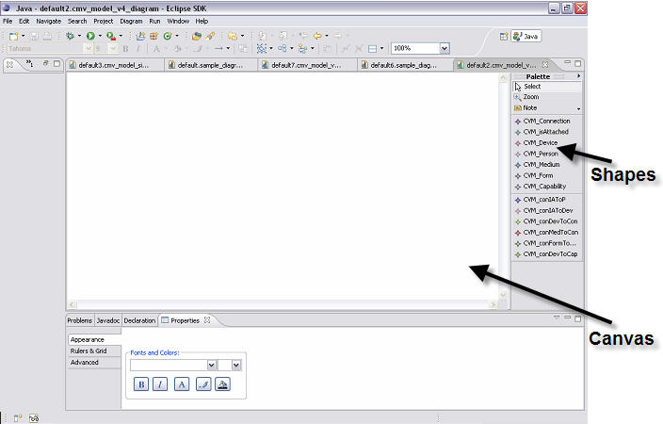
Figure C1. Communication Modeling Environment

Figure C2. Example Model Created using the Communication Modeling Environment.
Figure C3. Example Workflow Model
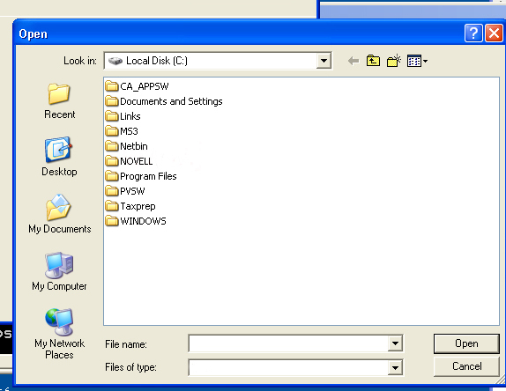
Figure C4. Example Browse

Appendix D – Diary of meeting and tasks.

Diary of Meetings

Place: Software Design Class
Date: 1/06/2009
Start: 8:30PM
End: 9:00PM
Facilitator: Jean Rodríguez
Attending: Jean, Denis, Marcelo, Barbara
Minute Taker: Jean

1. Objective
Project kick off meeting.
2. Status
Everyone participated in coming up with ideas for the project.
3. Discussion
Discussion about how GMF works, and where to setup a group website for the project.

---------------------------------------------------------------------------------------------------

Place: Software Design Class
Date: 1/13/2009
Start: 8:30PM
End: 9:00PM
Facilitator: Jean Rodríguez
Attending: Jean, Denis, Marcelo, Goutami
Minute Taker: Jean

1. Objective
Come to a decision about the development/modeling environment.
2. Status
Everyone participated in coming up with ideas for the project.
3. Discussion
Discussion about the Project. Decision to go with Eclipse 3.4.1 Modeling Distribution.
Everyone in the group should get a Skype account.

---------------------------------------------------------------------------------------------------

Place: Graduate Lab
Date: 1/20/2009
Start: 8:30 PM
End: 9:30 PM
Facilitator: Jean Rodríguez
Attending: Jean, Denis, Harika, Marcelo
Minute Taker: Harika

1. Objective
Become familiar with EMF/GMF model construction, and establish some of the
Use cases and scenarios to be derived for the project.
2. Status
Everyone participated in coming up with ideas for the project.
3. Discussion
Discussion about the creation of GMF projects in Eclipse and, the overall breakdown of project to the new member.

---------------------------------------------------------------------------------------------------

Place: Graduate Lab
Date: 1/23/2009
Start: 4:00 PM
End: 4:30 PM
Facilitator: Jean Rodríguez
Attending: Jean, Denis, Harika
Minute Taker: Harika

1. Objective
Determine the viable use cases for specifying our
2. Status
Everyone participated in coming up with ideas for the project, and specification of several use cases for the deliverable.
3. Discussion
Discussion about how the GMF works.

---------------------------------------------------------------------------------------------------

Place: Graduate Lab
Date: 1/24/2009
Start: 11:00 AM
End: 2:00 PM
Facilitator: Jean Rodríguez
Attending: Jean, Denis, Harika, Marcelo
Minute Taker: Harika

1. Objective
Discuss on the Use Case Diagrams
2. Status
Use Case has been discussed and has an idea about the project.
3. Discussion
Saw a live demonstration of GMF usage. Discussed about the possible Use Cases for the project.
4. Tasks
All team members have to do the Use Case diagram given to them.
---------------------------------------------------------------------------------------------------

Place: Software Design Class
Date: 1/27/2009
Start: 8:30 PM
End: 9:00 PM
Facilitator: Jean Rodríguez
Attending: Jean, Denis, Harika, Marcelo
Minute Taker: Harika

1. Objective
Discuss on the presentation that should be given in next week.
2. Status
We discussed about the work to be done by each member.
3. Discussion
We discussed in detail about the presentation that will be given in next week.
4. Tasks
All team members have to do the work given to them.

Place: Graduate Lab
Date: 1/30/2009
Start: 4:00 PM
End: 6:00 PM
Facilitator: Jean Rodríguez
Attending: Jean, Denis, Harika, Marcelo
Minute Taker: Harika

1. Objective
Discuss on the presentation that should be given in next week.
2. Status
We discussed about the work to be done by each member.
3. Discussion
We discussed in detail about the presentation that will be given in next week.
4. Tasks
All team members have to do the work given to them.
---------------------------------------------------------------------------------------------------

Place: Graduate Lab
Date: 02/02/2009
Start: 5:30 PM
End: 6:30 PM
Facilitator: Jean Rodríguez
Attending: Jean, Denis, Harika, Marcelo
Minute Taker: Harika

1. Objective
Get the final touch on the presentation.
2. Status
Everyone had done the work assigned to them.
3. Discussion
Discussion about the scenarios and the related diagrams.

Place: Software Design Class
Date: 02/02/2009
Start: 8:30 PM
End: 9:15 PM
Facilitator: Jean Rodríguez
Attending: Jean, Denis, Harika, Marcelo
Minute Taker: Harika

1. Objective
Discuss about the First deliverable
2. Status
Got a clear idea about the first deliverable.
3. Discussion
Work to be done for the deliverable.

---------------------------------------------------------------------------------------------------
Place: Graduate Lab
Date: 02/06/2009
Start: 6:00 PM
End: 7:00 PM
Facilitator: Jean Rodríguez
Attending: Jean, Denis, Harika, Marcelo
Minute Taker: Harika

1. Objective
Discuss about the First deliverable.
2. Status
Assigned work to be done for the deliverable.
3. Discussion
About the things to be done for the deliverable.

---------------------------------------------------------------------------------------------------

Place: Software Design Class
Date: 02/10/2009
Start: 8:30 PM
End: 9:00 PM
Facilitator: Jean Rodríguez
Attending: Jean, Denis, Harika, Marcelo
Minute Taker: Harika

1. Objective
Discuss about the First deliverable presentation.
2. Status
Assigned work to be done for the deliverable.
3. Discussion
The things to be done for the deliverable are discussed.

---------------------------------------------------------------------------------------------------

Place: Graduate Lab
Date: 02/14/2009
Start: 2:00 PM
End: 5:00 PM
Facilitator: Jean Rodríguez
Attending: Jean, Denis, Harika
Minute Taker: Harika

1. Objective
Discuss about the First deliverable.
2. Status
Work to be done for the deliverable such as the scenarios are discussed.
3. Discussion
We have discussed about the 8 most important use cases and writing the scenarios.

---------------------------------------------------------------------------------------------------

Place: Graduate Lab
Date: 02/15/2009
Start: 2:00 PM
End: 7:45 PM
Facilitator: Jean Rodríguez
Attending: Jean, Denis, Harika, Marcelo
Minute Taker: Harika

1. Objective
Discuss about the First deliverable. Collaborate to bring the SRAD together
2. Status
Work to be done for the deliverable such as the scenarios are discussed.
3. Discussion
We have discussed about the 8 most important use cases and writing the scenarios, as well as the use cases, object, class. We also discussed the design of the workflow model.

