CEN 5064 Software Design

Rapid Realization of Communication Services System

Group #5 – Healthcare
Jean Rodriguez
Harika Chirumamilla
Denis Antoine
Marcelo R. Lopez, Jr.

Final Deliverable
April 14, 2009

Professor: Dr. Peter Clarke

Abstract
Users have so many options available to the today in the realm of online communication and collaboration; it’s difficult for the user to make a choice from the available alternatives. The considerable number of communication and collaborative applications available today makes it hard for the active consumer to define an optimal platform in terms of existing mediums. Each of these services provide unique features, such as chat, audio, video-conferencing, and file transferring, but not one offers them all at once. Furthermore, they have been created independently therefore no connections exist among them.
The Rapid Realization of Communication Services System (RRComSSys) proposes a system that is a self-configuring, user-centric, communication service that brings together the available communication services, such as Skype, GoogleTalk, and others, chosen by the user. In addition, it provides access to all their capabilities, and it takes care of the creation of the connection protocols relieving the user of such burden. This document builds from the Software Requirements Document and contains the proposed software architecture (which includes the Metamodel). This document also focuses on the object design. The object design consists mainly of the minimal class diagram(s), sequence diagrams, and state machines.
.

Table of Contents
1 Introduction 4
1.1 Introduce the introduction 4
1.2 Functional Requirements 5
1.2.1 The system shall: 5
1.3 Design Methodology Used 7
1.4 Definitions, acronyms, and abbreviations. 9
1.5 Overview of document 10

2 Proposed Software Architecture 11
2.2 Metamodel 15
2.3 UML profile 16
2.4 Generative Architecture 17
3 Object Design 18
3.1 Overview – minimal class diagrams for the subsystems 19
3.2 Object Interaction - 20
3.2.1 Sequence diagrams 20
3.2.2 State Machines 28

3.3 Detailed Class Design 28
4 Glossary 30
5 Appendix 34
5.1 Appendix A – Use case diagram 34
5.2 Appendix B - Use Cases 36
Use Case – Create a Text Only Connection 36
Use Case – Create a Text Audio Connection 38
Use Case – Create a Audio Video Connection 39
Use Case – Send File 42
Use Case – Receive File 43
Use Case – Security File Transfer 44
Use Case – Workflow with Alternate Connection 45
Use Case – Workflow with Retry 47
5.3 Appendix C – Detailed Class Diagram 49
5.4 Appendix E – Generated Code. 57
5.5 Appendix E – Diary of meeting and tasks. 57

Introduction

Introduce the introduction
This document constitutes the Software Requirements and Analysis Document for the Rapid Realization of Communication Services System (RRComSSys). RRComSSys is part of the Communication Virtual Machine (CVM) project developed at the School of Computer and Information Science at Florida International University.
This chapter covers the general description of the system including its purpose and its scope from the user’s point of view, as well as the definitions, acronyms and any abbreviations used in this paper. It concludes with an overview of the general structure of the document.

Functional Requirements

The system shall:

- Allow health care professionals to create communication models based on the CML language.
Use cases: All use cases related to General Connection.
Use Case ID(s): C01_GeneralConnection, C02_TextOnlyConnection, C03_TextAudioConnection and C04_Audio Video Connection.

- Allow health care professionals to communicate with one or many users using audio, video and text conversations.
Use cases: All use cases related to General Connection.
Use Case ID(s): C01_GeneralConnection, C02_TextOnlyConnection, C03_TextAudioConnection and C04_Audio Video Connection.

- Allow health care professionals to establish a conversation with either Skype or GoogleTalk.
Use cases: All use cases related to General Connection.
Use Case ID(s): C01_GeneralConnection, C02_TextOnlyConnection, C03_TextAudioConnection and C04_Audio Video Connection.

- Allow health care professionals to use a workflow model to establish communication models that can execute alternate conversation activities.
Use cases: All use cases related to General Connection and Workflow Connection.
Use Case ID(s): C01_GeneralConnection, C02_TextOnlyConnection, C03_TextAudioConnection, C04_Audio Video Connection, W01_WorkflowWithAlternate and W02_WorkflowWithRetry.

- Allow health care professionals to use workflow to build communication models that can try a conversation activity repeatedly until a connection is established.
Use cases: All use cases related to General Connection and Workflow Connection.
Use Case ID(s): C01_GeneralConnection, C02_TextOnlyConnection, C03_TextAudioConnection, W01_WorkflowWithAlternate and W02_WorkflowWithRetry.

- Allow health care professionals to send and receive files within a conversation.
Use cases: All use cases related to File Transfer.
Use Case ID(s): F01_SendFile, F02_SendFileFailed, F03_ReceiveFile, F04_ReceiveFileFailed, F05_ RejectUnwantedFile, T506, F07_FileTransferCancelled

1.2.2 Non functional requirements

- Usability:
  - The users interface should be efficient. The user is expected to have an above average level of expertise. The system shall require a minimum of an hour of training.
- Reliability:
- 1% Downtime for every twenty four hours of operation is acceptable.
- Performance:
  - All requests should be received within a maximum of 3 seconds.
  - The validation of the communication model shall last less than 1 second for 500 shapes.
- Supportability:
  - The system should be implemented in java and supported by all systems which support JVM.
  - A microphone for the audio connection.
  - A video camera for the video connection.
5. Implementation:
a. The system shall be implemented in Java and other supporting
libraries.
b. The modeling environment shall be created likely with Eclipse GMF.

Design Methodology Used

The software development model that has been used in the project is Unified Software Development Process (USDP). It is a component-based, use case driven, architecture centered, iterative and incremental developmental process that uses the Unified Modeling Language (UML) to represent models of the software system to be developed.
The main reason is because it provides traceability features, which is important as it provides means for mapping model artifacts among several stages of the project, and it is use case driven.
The iterative and incremental features help refine the final product as we get to know specific implementation platforms, namely Eclipse GMF and the Skype library. The use case approach for gathering the systems requirements was also suitable to collect the functional requirements in this project.
In addition, we eased the design of the system by using architectural and design patterns. The architectural patterns used are: Model View Controller, Pipe and Filter. We used the UML 2.0 notation for specifying the different artifacts of the system. The UML models used in the project are: uses case diagrams, class diagrams, sequence diagrams, UML profiles.

The following figure shows how the different phases of the USDP process are related.

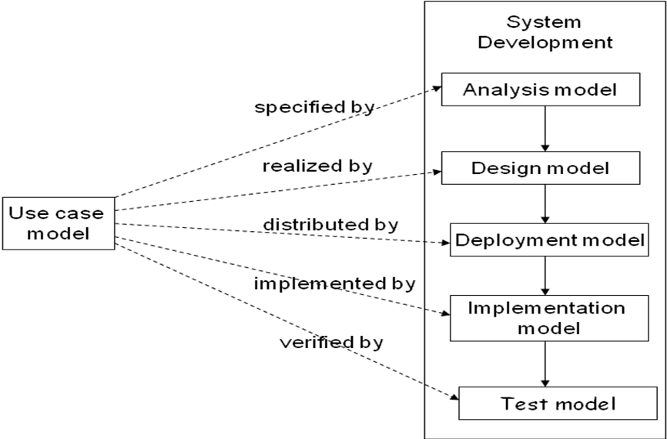

Fig 1.3.1 Unified Software Development Process

The USDP approach was complemented with the use of the Model Driven Software Development (MDSD) approach. Domain analysis, meta modeling, model-driven generation, template languages, domain-driven framework design, and the principles for agile software development form the backbone of this approach. MDSD models have the exact meaning of program code in the sense that the bulk of the final implementation can be generated from them. The main reason for using the MDSD approach was to increase the development speed. Since by automation run able code is generated from the formal models using one or more transformation steps. MDSD manages the complexity through abstraction since modeling languages enable programming or configuration on a more abstract level. Reusability was another big reason this approach was chosen, once all our architectures, transformations, and modeling languages have been defined they can be later used in a software product line for manufacturing diverse software systems.
The following figure shows how the different phases of the MDSD process are related.

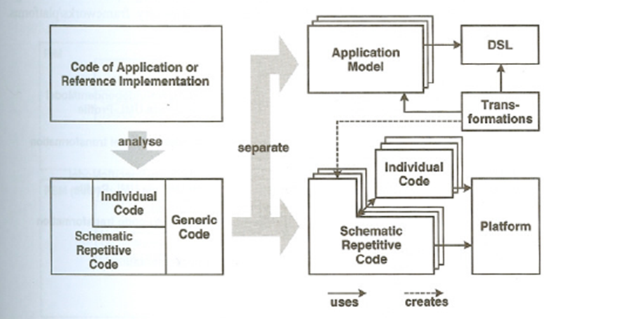

Fig Model Driven Software Development

The total approach is the combination of the unified software development process and the model driven software development process. Unified Software Development Process uses the Model Driven Software Development which results in an increase in development speed, better software quality, reusability, interoperability and the portability.

Definitions, acronyms, and abbreviations.

CVM: Communication Virtual Machine.
RRComSSys: Rapid Realization of Communication Services System.
VE: Visual Environment
MT: Model Transformer
STE: Schema Transformation Environment
NCB: Network Communication Broker.
SE: Synthesis Engine
CML: Communication Modeling Language
XML: eXtensible Markup Language.
G-CML: Graphical Communication Modeling Language
X-CML: XML-based Communication Modeling Language.
System: self configuration communication tool.
MDSD: Model-Driven Software Development
USDP: Unified Software Development Process
Project Stakeholder: Professor Peter Clarke

Overview of document
The rest of this document contains more detailed information about the components and development process of RRComSSys, and is laid out in four more chapters and an appendix chapter.
Chapter 2: This chapter discusses existing system(s) that performs tasks similar to the ones of RRComSSys. The limitations of such applications and the need for RRComSSys are expressed.
Chapter 3: Chapter 3 covers the organization of the project in terms of the distribution of the tasks among the team members, as well as expressing milestones throughout the project, and what expectations for delivery are associated with each milestone. Also covered are the hardware and software requirements to develop the system, as well as the team and role breakdown.
Chapter 4: This chapter presents the core development effort of the system, as well as an overview of RRComSSys, the functional and non-functional requirements governing its design and feature functions. In addition it will include the associated scenarios put forth by this implementation of RRComSSys.
Chapter 5: This chapter includes a glossary of terms used in this document for reader not specifically versed in the terminology of the implementation.
Chapter 6: This last chapter contains appendices consisting of supporting documentation and visual aids for the previous chapters.
Appendix A – Project schedule.
Appendix B – Use Cases
Appendix C – User Interface design
Appendix D – Diary of meeting and task assignments

Proposed Software Architecture
The RRComSSys will be broken down into several subsystems. These subsystems will be represented in a package diagram, according to two architectural patterns that were chosen with proper justification. Then the metamodel for the domain specific language will be specified. Also, the architecture will be represented by some UML profiles, which will consequently lead to the transformations expected from the architecture to the platform. Finally, the subsystems will be explained.
2.1 Overview
The following figure presents the package diagram of the proposed system:

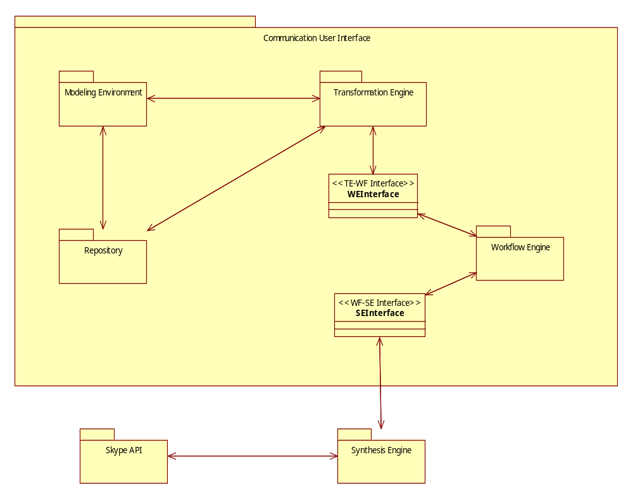
Fig 2.1 RRComSSys Package diagram

Description: This is the package diagram for RRComSSys. It contains 6 subsystems. At first glance it can be seen that the pattern we are using is the Repository Architecture pattern. This pattern is used for maintaining the complex central body of information and it can be manipulated in wide variety of ways. In the project repository pattern holds the metadata for the models as well as the rule for our modeling languages.

2.2 Metamodel

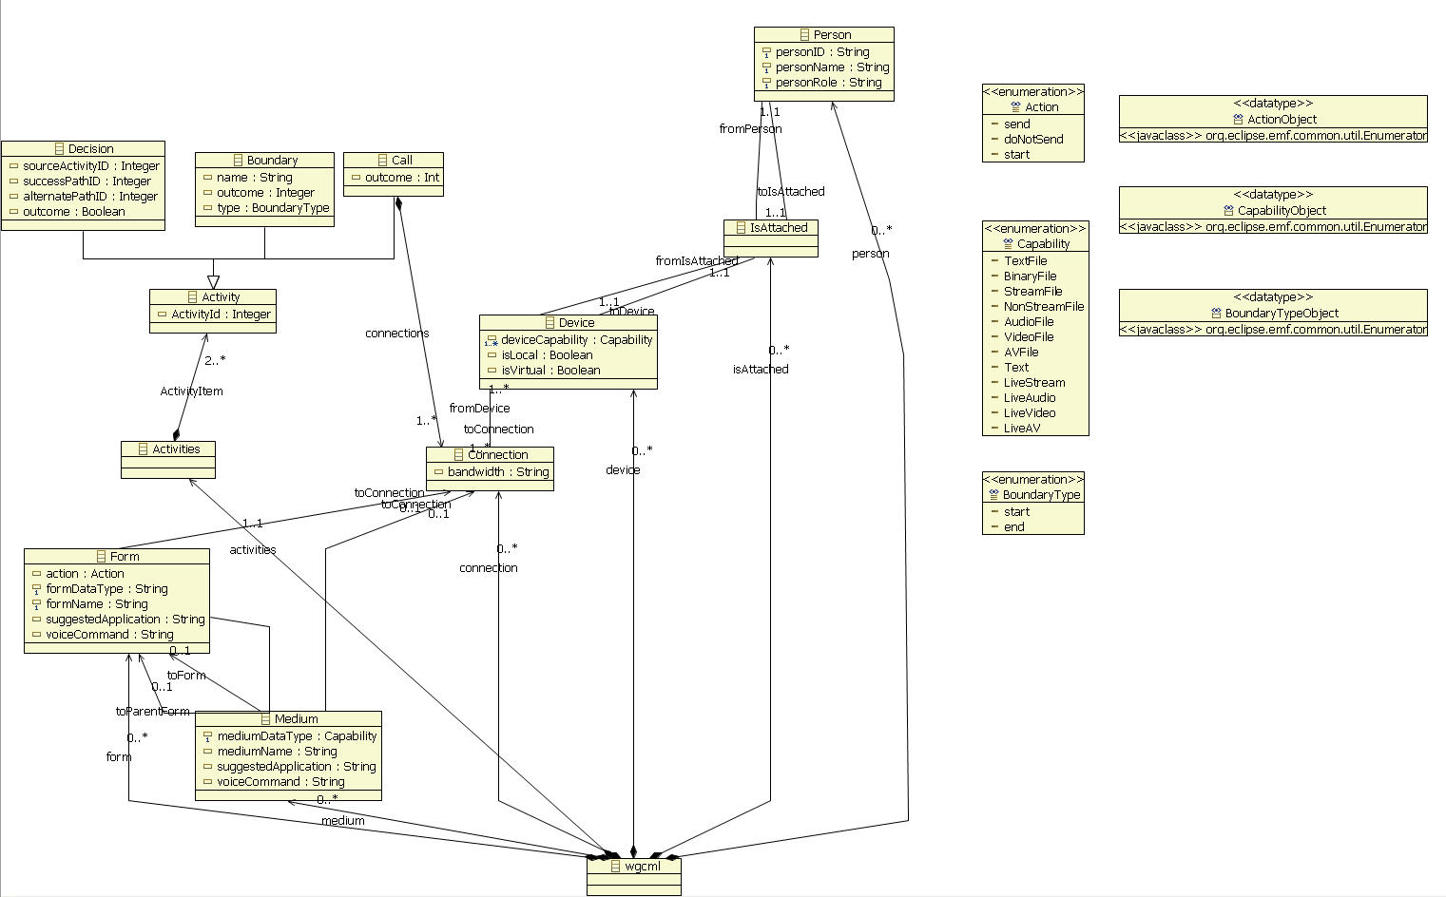

Figure 2.2 Class diagram for the metamodel

Description: This class diagram represents the metamodel used to create the model in the Communication Modeling Environment. It defines the grammar for model creation.

2.3 UML Profile for the Architecture

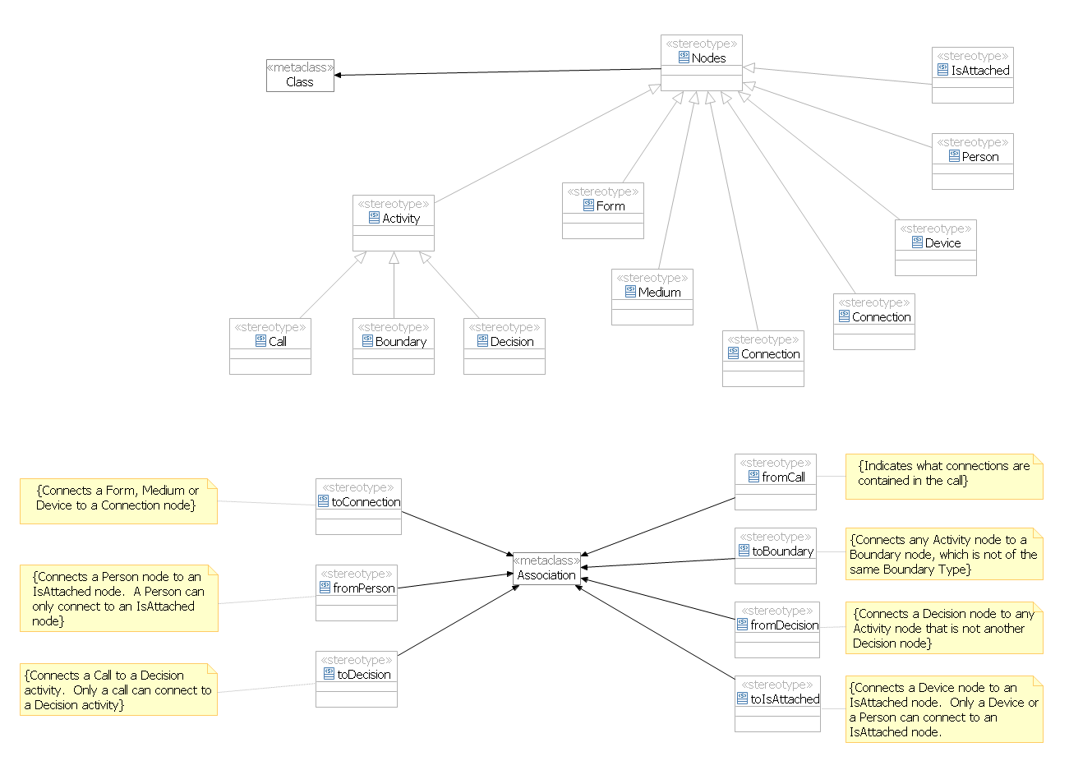

Figure 2.3 UML Profile for Model Construction

Description: This UML profile defines constraints when constructing a model.

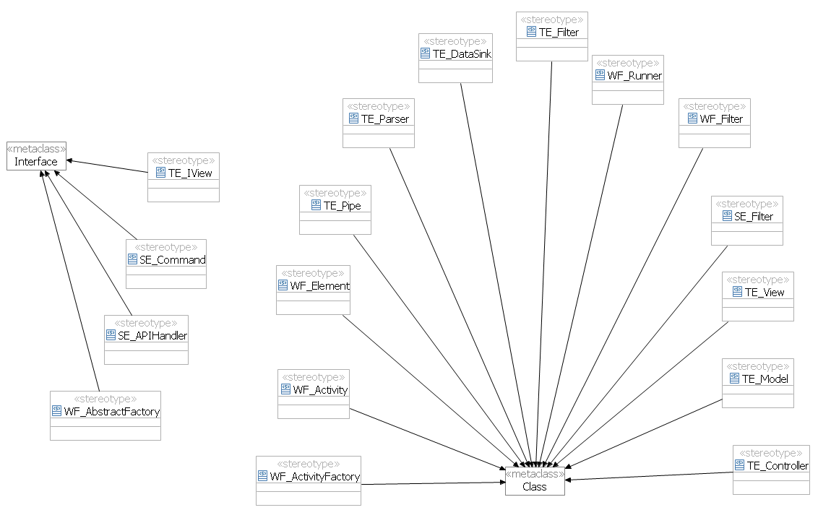
Figure 2.4 UML Profile for the Execution Architecture

Description: This UML Profile represents the architecture constraints on the components for the execution of a model.

4.4 Generative Architecture
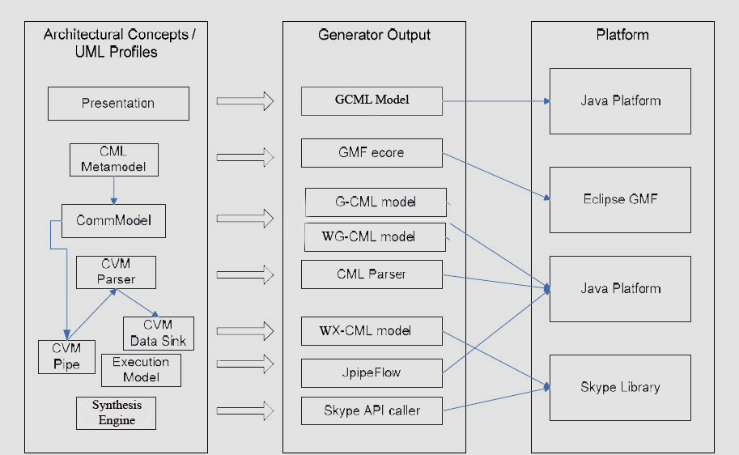
Figure 2.4.1 Generative architecture Transformation(s) expected from the architecture to the platform.

4.5 Subsystem Decomposition – describe each of the major subsystems

Communication User Interface – This is one of the main subsystems in the diagram. This subsystem contains all of the subsystems required to handle the creation of the user communication models. It also is responsible for the parsing and transformation of models. The workflow control is also performed here.

Modeling Environment – This subsystem deals with all that is the related to the modeling environment. This subsystem represents in the case of this project the Eclipse GMF and EMF. This subsystem is inherently Model-View-Control (MVC) as it inherits this from Eclipse itself.

Transformation Engine – This subsystem contains all the modules and classes related to the transformation of schemas into instances. This subsystem handles the conversion GXML into XCML and WXCML that will then be interpreted for execution.

Workflow Engine – This subsystem parses the WXCML data and creates the activity which can call or decides what should be done. It interacts with the synthesis engine to determine the order and process the activities.

Synthesis Engine – This subsystem hold all the classes required to transform XCML syntax into execution calls that can then be interpreted by a Communications Virtual Machine. In the case of this project this CVM is Skype.

Skype API – This subsystem represent our Communication Virtual Machine. This subsystem represents the Skype tool that we will be using in this project.

RRComSSys uses three architectural patterns justified below:

Model View Controller – This pattern is identified in the software architecture since it contains of three components such as model, view and controller. The model is used to contain the core functionality and the data. View obtains the data from the model. Controller receives the user input and translates the requests from the view or the model. This will later handled by the Pipe and Filter architecture. This pattern was chosen also because the target implementation platform GMF Eclipse is also Model View Controller. In conclusion, it comprises of the model, view and controller.

Pipe and Filter – This pattern provides a structure for the systems that process the stream of data. This pattern is essential for capturing the processing functionality needed for our system. Communication models have several stages and formats, so we push the input through a series of filters as the filter performs the function on the data and outputs the desired format. Filter also simplifies the implementation by having several stages in which the data will be in, making filter implementation and testing much easier. In conclusion, it comprises of a Pipe, Filter, Data Source, and Data Sink Subsystems.

Façade – This pattern uses an interface of a subsystem to facilitate the communication between subsystems.

Object Design

This chapter will cover the Object Design process for the system by providing an overview of the minimal class diagram for the subsystems which are to be implemented. The sequence diagrams illustrate Object interactions. Furthermore, in the detailed class design the purpose of each class will be thoroughly explained.

Overview – minimal class diagrams for the subsystems

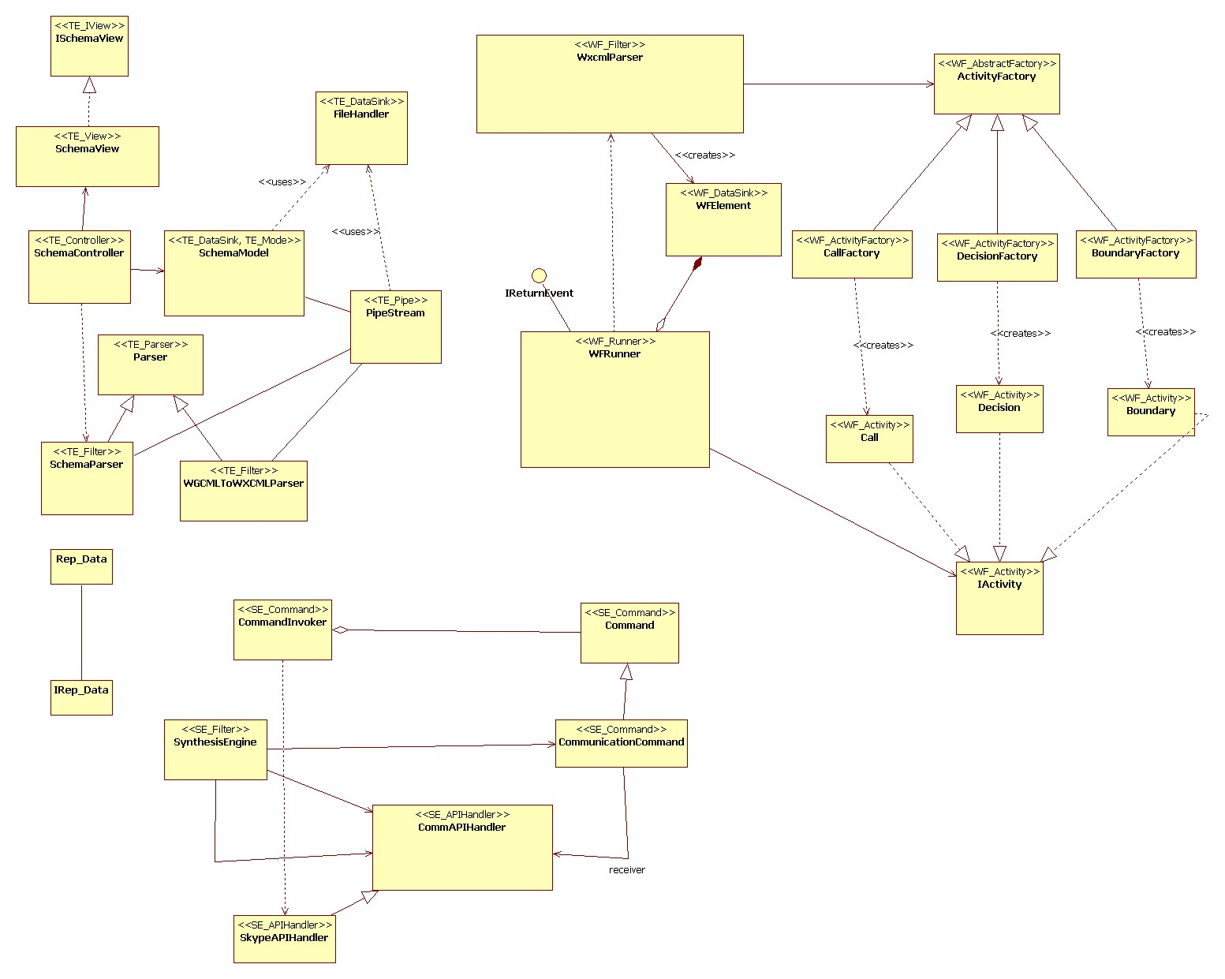

Figure 3.1 Minimal Class Diagram for RRComSSys

Object Interaction -

Sequence diagrams
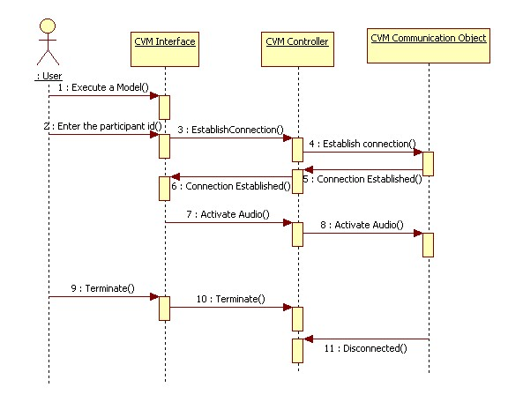
Figure 3.2.1 Audio/Video sequence diagram
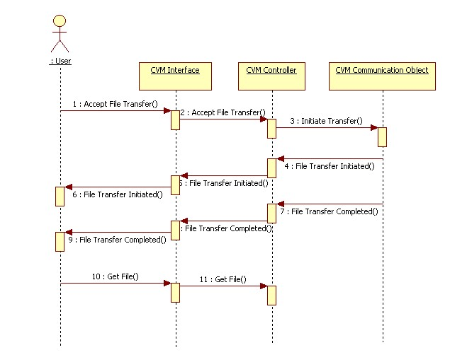
Figure 3.2.2 Receive file sequence diagram
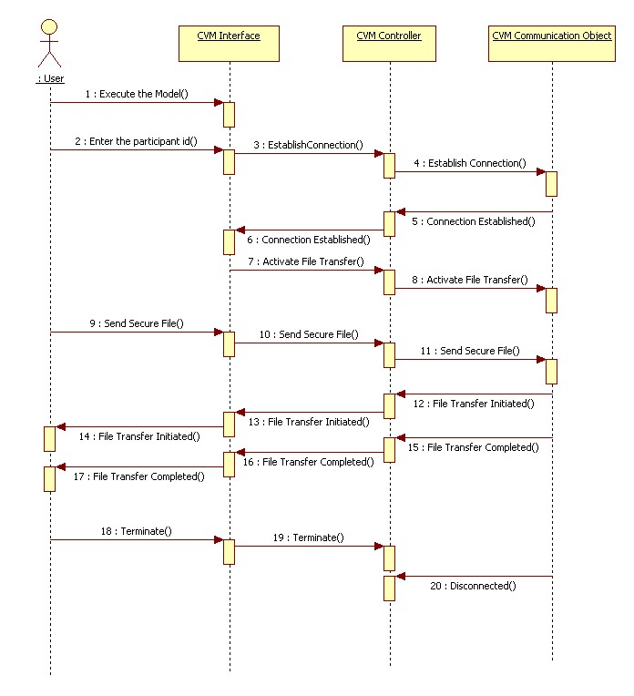
Figure 3.2.3 Secure file transfer sequence diagram

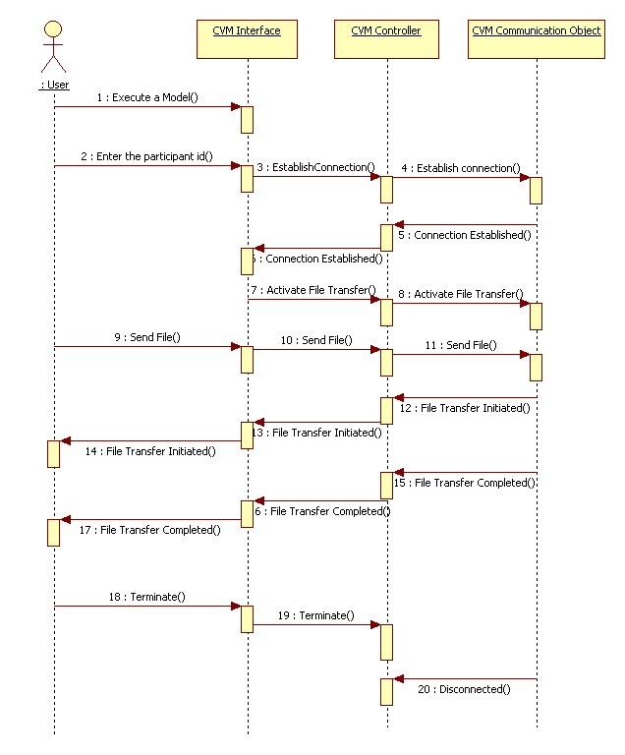 Figure 3.2.4 Send file sequence diagram

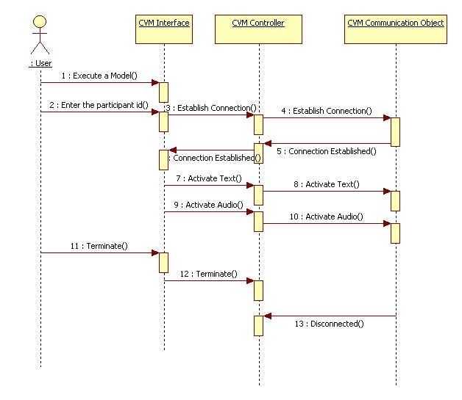
Figure 3.2.5 Text and Audio Connection sequence diagram

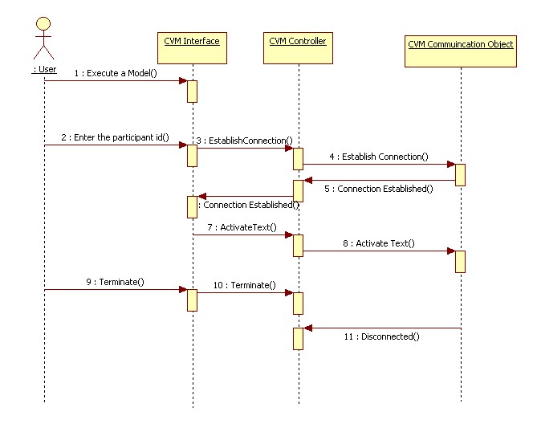
Figure 3.2.6 Text Connection sequence diagram

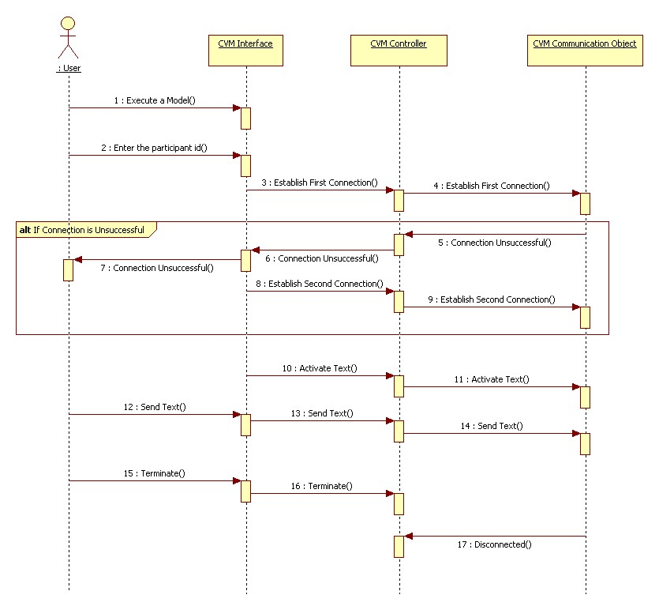
Figure 3.2.7 Workflow with Alternate Connection sequence diagram

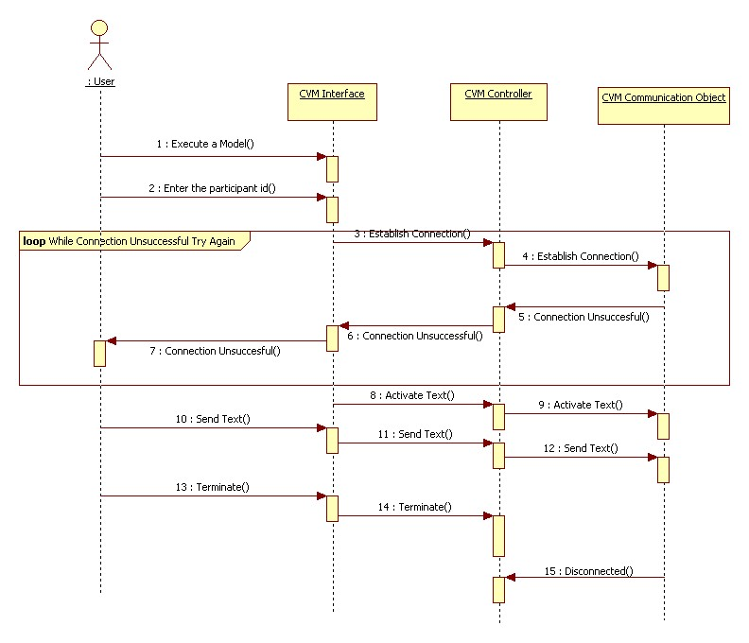
Figure 3.2.8 Workflow with Retry Connection sequence diagram

State machine for the main control object in each of the major subsystems

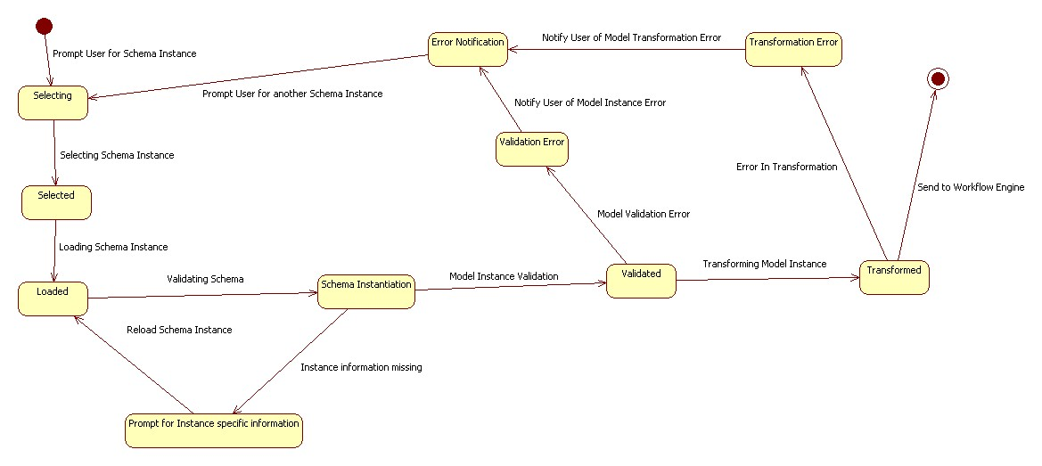
Figure 3.2.2.1 Transformation Engine State Machine

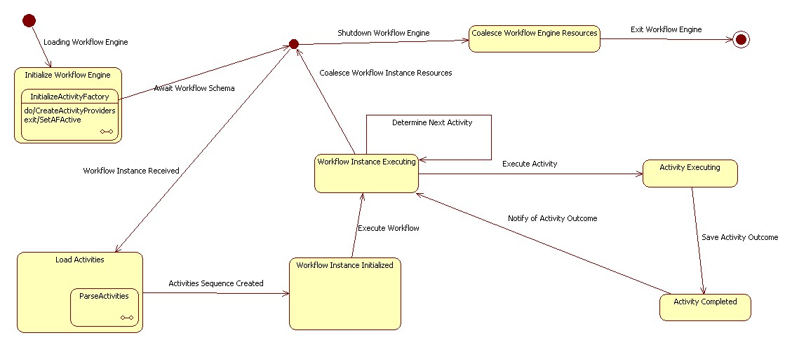
Figure 3.2.2.2 Workflow Engine State Machine

Detailed Class Design
This section describes the purpose of each class in RRComSSys. Refer to the detailed class diagram in appendix C.

Parser: This abstract class extracts the similarities between the WGCMLToWXCMLParser and the SchemaParser. It dissects some xml source into an object model. Refer to Figure C1 in Appendix C.

WGCMLToWXCMLParser: This class transforms the WGCML source to WXCML. Refer to Figure C1 in Appendix C.

SchemaParser: This class validates the resulting WXCML schema and notifies the controller of any missing data in the schema. Refer to Figure C1 in Appendix C.

FileHandler: This class handles any interaction with filesystem. Refer to Figure C1 in Appendix C.

PipeStream: This class connects the output stream of a filter to the input stream of another filter or a datasink. Refer to Figure C1 in Appendix C.

SchemaModel: This class holds the validated model and gets updated with any missing data by the SchemaController. Eventually this class will hold an instance of WXCML. Refer to Figure C1 in Appendix C.

SchemaController: This class controls the SchemaView and updates the SchemaModel with new data. Refer to Figure C1 in Appendix C.

SchemaView: This class presents the user with the forms necessary to get data missing from the schema. Refer to Figure C1 in Appendix C.

ISchemaView: This interface extracts all relevant members and methods from the SchemaView. The SchemaController uses this data to control the SchemaView. Refer to Figure C1 in Appendix C.

WXCMLParser: This class creates WFElements with the corresponding factory for a specific activity. Refer to Figure C2 in Appendix C.

WFRunner: This class decides the order in which WFElements get processed. Refer to Figure C2 in Appendix C.

WFElement: This class has an instance of the factory that will allow the WFRunner to create the appropriate Activity. Refer to Figure C2 in Appendix C.

IActivity: This interface defines an Activity. Refer to Figure C2 in Appendix C.

Boundary: This class represents a Boundary Activity. It also has logic to process a Boundary activity. Refer to Figure C2 in Appendix C.

Decision: This class represents a Decision Activity. It also has logic to process a Decision activity. Refer to Figure C2 in Appendix C.

Call: This class represents a Call Activity. It also has logic to process a Call activity. Refer to Figure C2 in Appendix C.

AbstractFactory: This class encapsulates a group of factories that can create one of three Activities. Refer to Figure C2 in Appendix C.

CallFactory: This class creates a Call Activity. Refer to Figure C2 in Appendix C.

BoundaryFactory: This class creates a Boundary Activity. Refer to Figure C2 in Appendix C.

DesicionFactory: This class creates a Decision Activity. Refer to Figure C2 in Appendix C.

IReturnEvent: This interface defines the return event that will be triggered by the synthesis engine when a Call passes or fails. Refer to Figure C2 in Appendix C.

CommandInvoker: This class asks the command to execute and in case of failure rollback. Refer to Figure C3 in Appendix C.

Command: This class defines an interface for executing a CommunicationCommand. Refer to Figure C3 in Appendix C.

CommunicationCommand: This class defines a binding between a CommAPIHandler object and an action. It also implements Execute by invoking the corresponding operations on Receiver. Refer to Figure C3 in Appendix C.

SynthesisEngine: This class extracts and creates the commands out of an instance of a Call Activity. Refer to Figure C3 in Appendix C.

SkypeAPIHandler: This is the receiver; it knows how to handle the commands through the Skype API. Refer to Figure C3 in Appendix C.

Glossary

Class Diagram – A model representing the different classes within a software system and how they interact with each other.
Component – A physical and replaceable part of a system that conforms to and provides the realization of a set of interfaces.
Model – an abstract representation of a system that enables us to answer questions about the system.
Post condition – A predicate that must be true after an operation is invoked.
Precondition – A predicate that must be true before an operation is invoked.
Sequence Diagram – A model representing the different objects and/or subsystems of a software project and how they relate to each other during different operations for a given use case.
Unified Modeling Language (UML) – A standard set of notations for representing models.
Use Case – A general sequence of events that defines all possible actions between one or many actors and the system for a given piece of functionality.
Model Driven Development Software – Software development paradigm that roots in software product line engineering, which is the discipline of designing and building families of applications.
Workflow Model - A representation of actions, and activities that comprise a communication model that involve the usage of decision points that allow greater flexibility in describing models which can support more than one communication instance.
Object Diagram - A diagram that shows a complete or partial view of the structure of a modeled system or portion thereof.
State Machine - Formalism for describing computation, consisting of a set of states and a transition function describing when to move from one state to another.
Model–View–Controller (MVC) is an architectural pattern - the model represents the information (the data) of the application; the view corresponds to elements of the user interface such as text, checkbox items, and so forth; and the controller manages the communication of data and the business rules used to manipulate the data to and from the model.
Pipe and Filter is an architectural pattern - provides a structure for systems that process a stream of data. Each processing step is encapsulated in a filter component. Data is passed through pipes between adjacent filters.
Package diagram - in UML depicts the dependencies between the packages that make up a model.
Metamodel - describes the possible structure of models – in an abstract way, it defines the constructs of a modeling language and their relationships, as well as the constraints and rules – but not the concrete syntax of the language.
Shape – An image that can be dragged into the canvas in the Visual Environment. It can be connected with other nodes using connections in order to build a communication model.
Connections – A line that connects one shape with another.
Participant – A special shape that represents a local or remote user of the communication system. One or more participants can establish a conversation using a communication model.
Device – A special shape that represents what the user is using to connect to the system.
Canvas – The area where the user drags shapes and connections to build a communication model.
Capability – The ways in which the device allows the user to communicate with other users.
StartFlowBar – Represents the starting point of a workflow model.
EndFlowBar – Represents the ending point of a workflow model.
ConversationActivity – A complete communication model that can be executed. If it fails, an alternate communication activity can be executed.
DecisionPoint – A special model component, denoted by a diamond shape, that dictates flow of a sequence of actions on the basis of the outcome of a previous action or activity.

Appendix

Appendix A – Use case diagram

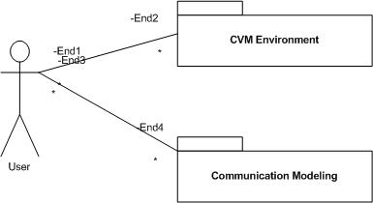
Figure 5.1.1 Use Case Diagram
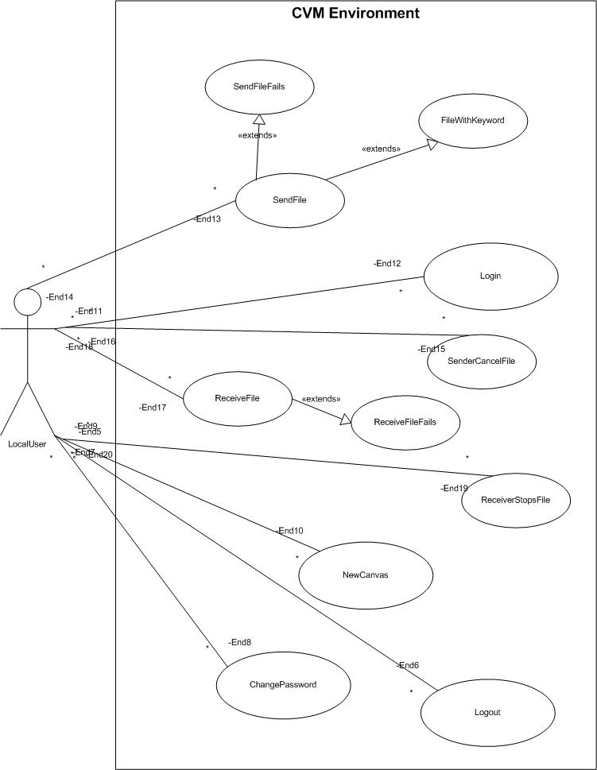
Figure 5.1.2 CVM Environment Use Case Diagram
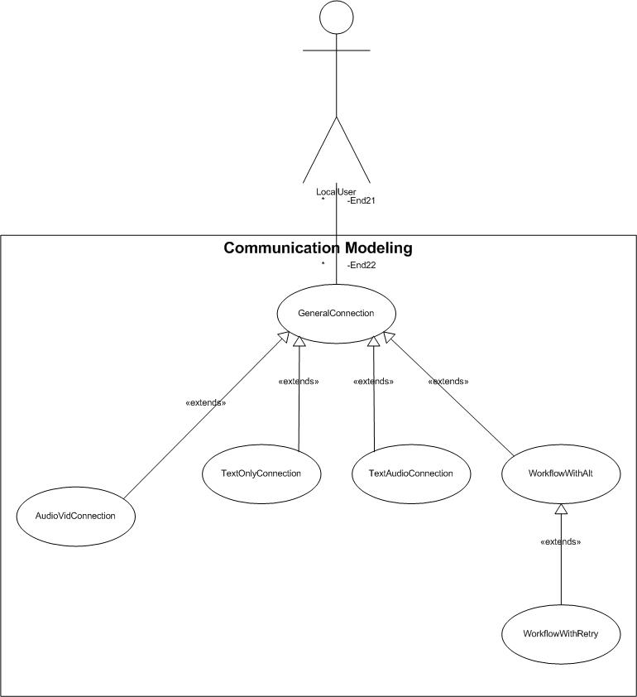
Figure 5.1.3 Communication Modeling Use Case Diagram

Appendix B - Use Cases

Use Case – Create a Text Only Connection
Use Case ID: C02_TextOnlyConnection
Use Case Level: High-level
Details: Dr. Urbani wants to establish a text only connection with Dr. Salk.
- Actor(s): Dr. Urbani and Dr.Salk
- Pre-conditions: Dr. Urbani must have logged on (Log in use case), a new file must be open (create a new file use case) and connection model has been set up using the procedure defined in use case C01_GeneralConnection.
- Description:
Trigger:
1. Dr. Urbani drags the shape for text only capability onto the canvas. Dr. Urbani then attaches it to the “Device” node.
2. Dr. Salk must also have a device with the text only capability.
- Post-conditions: The canvas now holds a communication model that can be executed. When executed a connection must be created between Dr. Urbani and Dr. Salk and they should be able to chat using text.
Alternative Courses of Action: Dr. Urbani can add more participants using the same procedure to establish a multi-way connection.
Extensions: Depending on the “Capabilities” attached to the “Device” that the participants are using to create this model a Audio or Audio/Video connection (C03_TextAudioConnection, C04_AudioVideoConnection) can be establish when the communication model is executed. This connection can also be used to send/receive files.
Exceptions: The connection can’t be established.
Concurrent Uses: N/A
Related Use Cases: C01_ GeneralConnection, C03_TextAudioConnection, C04_AudioVideoConnection, Log in Use Case.
---------------------------------------------------------------------------------------------------------------------
Decision Support
Frequency: This use case will occur very often per application use. That is, every time that an actor wants to create a communications model with chat support.

Criticality: High. It allows an actor to chat with another participant.

Risk: Low. There is little to no risk in this use case.

Constraints:
Each participant can only connect to (1) IsAttached shape. Each
IsAttached shape can only be connected to (1) device shape. Each device shape
must have at least (1) capability shape connected to it, and can only connect to (1) connection terminal. Each capability shape can only connect to (1) device shape.

- Usability: Easy to use. No need for technical knwoledge.
- Reliability: Connection must be established 90% of the time.
- Performance: Drawing a shape or connection shouldn’t take more than 1 second.
- Supportability: The device should have the latest Java Runtime Environment installed.
- Implementation: Implemented using Eclipse’s EMF and GMF plugins.
---------------------------------------------------------------------------------------------------------------------
Modification History – v1
Owner: Jean Rodriguez
Initiation date: 01/28/09
Date last modified: 01/29/09

Use Case – Create a Text Audio Connection
Use Case ID: C03_TextAudioConnection
Use Case Level: High-level
Details: Dr. Urbani wants to establish a Audio connection with Dr. Salk.
- Actor(s): Dr. Urbani and Dr.Salk
- Pre-conditions: Dr. Urbani must have logged on (Log in use case), a new file must be open (create a new file use case) and connection model has been set up using the procedure defined in use case C01_GeneralConnection.
- Description:
Trigger:
1. Dr. Urbani drags the shape for audio capability onto the canvas. Dr. Urbani then attaches it to the “Device” node.
2. Dr. Salk must also have a device with the audio capability.
- Post-conditions: The canvas now holds a communication model that can be executed. When executed a connection must be created between Dr. Urbani and Dr. Salk and they should be able to speak with one another.
- Alternative Courses of Action: Dr. Urbani can add more participants using the same procedure to establish a multi-way connection.
Extensions: Depending on the “Capabilities” attached to the “Device” that the participants are using to create this model a Audio or Audio/Video connection (C02_TextOnlyConnection, C04_AudioVideoConnection) can be establish when the communication model is executed. This connection can also be used to send/receive files.
Exceptions: The connection can’t be established.
Concurrent Uses: N/A
Related Use Cases: C01_ GeneralConnection, C02_TextOnlyConnection, C04_AudioVideoConnection, Log in Use Case.
---------------------------------------------------------------------------------------------------------------------
Decision Support
Frequency: This use case will occur very often per application use. That is, every time that an actor wants to create a communications model with audio chat support.

Criticality: High. It allows an actor to chat with another participant.

Risk: Low. There is little to no risk in this use case.

Constraints:
Each participant shape can only connect to (1) IsAttached shape. Each
IsAttached shape can only be connected to (1) device shape. Each device shape
must have at least (1) capability shape connected to it, and can only connect to (1) connection terminal. Each capability shape can only connect to (1) device shape.

- Usability: Easy to use. No need for technical knwoledge.
- Reliability: Connection must be established 90% of the time.
- Performance: Drawing a shape or connection shouldn’t take more than 1 second.
- Supportability: The device should have the latest Java Runtime Environment installed.
- Implementation: Implemented using Eclipse’s EMF and GMF plugins.
---------------------------------------------------------------------------------------------------------------------
Modification History – v1
Owner: Jean Rodriguez
Initiation date: 01/28/09
Date last modified: 01/29/09

Use Case – Create a Audio Video Connection

Use Case ID: C04_AudioVideoConnection
Use Case Level: High-level
Details: Dr. Urbani wants to establish a Audio/Video connection with Dr. Salk.
- Actor(s): Dr. Urbani and Dr.Salk
- Pre-conditions: Dr. Urbani must have logged on (Log in use case), a new file must be open (create a new file use case) and connection model has been set up using the procedure defined in use case C01_GeneralConnection.
- Description:
Trigger:
1. Dr. Urbani drags the shape for audio/video capability onto the canvas. Dr. Urbani then attaches it to the “Device” node.
2. Dr. Salk must also have a device with the audio/video capability.
- Post-conditions: The canvas now holds a communication model that can be executed. When executed a connection must be created between Dr. Urbani and Dr. Salk and they should be able to speak and see one another.
- Alternative Courses of Action: Dr. Urbani can add more participants using the same procedure to establish a multi-way connection.
Extensions: Depending on the “Capabilities” attached to the “Device” that the participants are using to create this model a Audio or Text-only connection (C02_TextOnlyConnection, C04_AudioVideoConnection) can be establish when the communication model is executed. This connection can also be used to send/receive files.
Exceptions: The connection can’t be established.
Concurrent Uses: N/A
Related Use Cases: C01_ GeneralConnection, C02_TextOnlyConnection, C03_AudioVideoConnection, Log in Use Case.
---------------------------------------------------------------------------------------------------------------------
Decision Support
Frequency: This use case will occur very often per application use. That is, every time that an actor wants to create a communications model with audio/video support.

Criticality: High. It allows an actor to see and hear another participant.

Risk: Low. There is little to no risk in this use case.

Constraints:
Each participant shape must can only connect to (1) IsAttached shape. Each
IsAttached shape can only be connected to (1) device shape. Each device shape
must have at least (1) capability shape connected to it, and can only connect to (1) connection terminal. Each capability shape can only connect to (1) device shape.

- Usability: Easy to use. No need for technical knwoledge.
- Reliability: Connection must be established 90% of the time.
- Performance: Drawing a shape or connection shouldn’t take more than 1 second.
- Supportability: The device should have the latest Java Runtime Environment installed.
- Implementation: Implemented using Eclipse’s EMF and GMF plugins.
---------------------------------------------------------------------------------------------------------------------
Modification History – v1
Owner: Jean Rodriguez , Marcelo Lopez
Initiation date: 01/28/09
Date last modified: 01/29/09

Use Case – Send File
Use Case ID: F01_SendFile
Use Case Level: High
Details: This is a complete description of the use. Each subsection is explained below.
- Actor(s): Dr. Urbani and Dr. Salk
- Pre-conditions: A connection must be established(see Create a General Connection use case). Dr. Urbani must have rights to send the file. Dr. Urbani must have the send file capability. Dr. Urbani and Dr. Salk must be logged onto the system. Dr. Salk must accept the file.
- Description:
Trigger:
- Dr. Urbani Executes the Select File use case.
- Dr. Urbani than selects the file to be sent.
- Relevant requirements: The file is scanned if it is a compressed or executable file Dr. Salk recieves a warning of the potential danger.
- Post-conditions: The user receives a dialog conforming a succesful file transfer.

Alternative Courses of Action The file is too large. The file can not be sent. File transfer interupted. Dr. Salk or Dr. Salk exits application. Go to Error use case.
Extensions: Multiple files can be sent see use case F05_RejectUnwantedFile.
Exceptions: File is too large. File can’t be read. File not found. Transfer failed. User disconected.
Concurrent Uses: N/A
Related Use Cases: F02_SendFileFailed, F03_ ReceiveFile, F04_ ReceiveFileFailed, F05_RejectUnwantedFile, F06_SenderCancelsFile, F07_,F08_
------------------------------------------------------------------------------------------------------------------
Decision Support
Frequency: This is mainly a messaging system so this will not be executed frequently. Approxamately 1 time pre execution.
Criticality: This function is only secondary towards live chat and live video.
Risk: High. This use case is key to providing this use.

Constraints:
- There will be a file size limit to a few MB. It must be reliable. Performance will not overwhelm system. Implemented on all systems that support file transfers. Not necessarily implemented on modile devices.
--------------------------------------------------------------------------------------------------------------
Modification History
Owner: Denis Antoine, Marcelo Lopez
Initiation date: 1/29/2009
Date last modified: 2/14/2009

Use Case – Receive File
Use Case ID: F03_ReceiveFile
Use Case Level: High
Details:
- Actor(s): Dr. Salk and Dr. Urbani
- Pre-conditions: Receiver initiates the use case by accepting the file sent by Dr. Salk.
- Description:
Trigger:
1. Dr. Salk sends the file.
2. Dr. Salk accepts the file sent.
3. The file is than downloaded by Dr. Salk.
- Relevant requirements: Dr. Salk must be asked whether he or she wants the file.
- Post-conditions: The user receives a dialog conforming a succesful file transfer.
Alternative Courses of Action Dr. Salk does not accept the file.
Extensions: Multiple files can be received.
Exceptions: The file transfer is unsuccesful.
Concurrent Uses: Failed file transfers can occur. Files can be declined.
Related Use Cases: F01_SendFile, F02_SendFileFailed, F04_ReceiveFileFailed, F05_RejectUnwantedFile, F06_SenderCancelsFile, F07_ FileTransferCancelled, F08_ SecurityFileTransfer
---------------------------------------------------------------------------------------------------------------------
Decision Support
Frequency: Always less than or equal to the frequency of F01_SendFile.
Criticality: This function is only secondary towards live chat and live video.
Risk: High. All users must users must have the capability to accept file transfer requests.

Constraints:
- There will be a file size limit to a few MB. It must be reliable. Performance will not overwhelm system. Implemented on all systems that support file transfers. Not necessarily implemented on modile devices.
----------------------------------------------------------------------------------------------------------------
Modification History
Owner: Denis Antoine
Initiation date: 1/29/2009
Date last modified: 2/14/2009

Use Case – Security File Transfer

Use Case ID: F08_SecurityFileTransfer
Use Case Level: High
Details:
- Actor(s): Dr. Salk and Dr. Urbani
- Pre-conditions: A connection must be established(see Create a General Connection use case). Dr. Salk and Dr. Urbani must be logged on. Dr. Urbani has sent the file. Dr. Salk has accepted the file and a dialog asks Dr. Salk for an keyword
- Description:
Trigger:
- Dr. Urbani initiates the action by executing the select secured file use case.
- The system responds by prompting Dr. Urbani to enter a keyword than opens up a window to the desktop in which he selects the file.
- Dr. Salk is than prompted to enter a keyword.
- Upon a keyword match Dr. Salk is than prompted a file transfer request.

Relevant requirements: Dr. Salk and Dr. Urbani are notified of the initiated file transfer.
Post-conditions: The users receives a dialog conforming a succesful file transfer.

Alternative Courses of Action Dr. Salk or Dr. Urbani cancels the file sent. Dr. Salk enters an incorrect keyword.
Extensions:
Exceptions: Dr. Salk enters the correct keyword but it is incorrectly declined.
Concurrent Uses: N/A.
Related Use Cases: F01_SendFile, F02_SendFileFailed, F03_ReceiveFile, F04_ReceiveFileFailed, F05_ RejectUnwantedFile, T506, F07_FileTransferCancelled
------------------------------------------------------------------------------------------------------------
Decision Support
Frequency: Always less than or equal to the frequency of F01_SendFile.
Criticality: Dr. Salk and Dr. Urbani must be able to send secure files to assure that the request is being received by a user who knows the keyword.
Risk: High. It allows only the intended recipetent to receive the sent file.

Constraints:
- It is simple to use with a mouse or via touch screen depending on the system type. It is supported on all system that can transfer files. It is implemented on all system that can transfer files.
-------------------------------------------------------------------------------------------------------
Modification History
Owner: Denis Antoine
Initiation date: 2/14/2009
Date last modified: 2/14/2009

Use Case – Workflow with Alternate Connection

Use Case ID: W01_WorkflowWithAlternateConnection
Use Case Level: High-level
Details: Dr. Urbani wants to establish a connection with Dr. Salk, but if the connection is unsuccesful he wants to connect with Dr. Clarke.
- Actor(s): Dr. Urbani, Dr.Salk and Dr. Clarke
- Pre-conditions: Dr. Urbani must have logged on (L01_Login), a new file must be open (F01_CreateNewCanvas) and the canvas is set and ready to accept the new communication model.
- Description:
Trigger:
1. Dr. Urbani drags a “StartFlowBar” shape into the canvas.
2. Dr. Urbani sets up a general connection model following the procedure described in use case C01_GeneralConnection. In this connection the other participant is Dr. Salk.
3. Dr. Urbani holds the left mouse button down and draws a rectangle that encapsulates the model created in step two. The connection is now a “ConversationActivity” shape.
4. Dr. Urbani connects the “ConversationActivity” shape created in step 3 with the “StartFlowBar” shape dragged in step 1.
5. Dr. Urbani drags a “DecisionPoint” shape into the canvas and connects it to the “ConversationActivity” created in step 3.
4. Repeats step 1-3 with Dr. Clarke as the other participant in the connection.
5. Dr. Urbani connects the “DecisionPoint” shape to the “ConversationActivity” created in step 4.
6. Dr. Urbani drags an “EndFlowBar” shape into the canvas.
7. Dr. Urbani connects both the “ConversationActivity”, created in step 5, and the “DecisionPoint” shape, to the “EndFlowBar” shape added in step 6.
- Post-conditions: The canvas now holds a communication model that can be executed. When executed a connection is attempted between Dr. Urbani and Dr. Salk. If that connection is successful, the connection is established. If that connection fails, the connection between Dr. Urbani and Dr. Clarke is executed.
Alternative Courses of Action: Dr. Urbani can add more participants using the same procedure to have multiple back up communication models. However, there must only be one start point and end point.
Extensions: Depending on the “Device” that the participants are using to create this model a Text only, Audio or Audio/Video connection (See C02_TextOnlyConnection, C03_TextAudioConnection, C04_AudioVideoConnection) can be establish when the communication model is executed. This connection can also be used to send/receive files. The connections can be retried as in use case W02_WorkflowWithRetry.
Exceptions: Both connections can’t be established.
Concurrent Uses: N/A
Related Use Cases: C02_TextOnlyConnection, C03_TextAudioConnection, C04_AudioVideoConnection, L01_Login, W02_WorkflowWithRetry.
---------------------------------------------------------------------------------------------------------------------
Decision Support
Frequency: This use case will occur at least 50% of the time per application use. That is, every time that an actor wants to create a communications model to connect to another actor, with a backup connection in case that one fails.

Criticality: High. It allows an actor to create complex workflow connections with one or more participants.

Risk: High. The implementation is complex and some aspects are not clear.
Constraints:
Each StartFlowBar and EndFlowBar shape can only connect to one other DecisionPoint or ConversationActivity shape. Furthermore, there can only be one StartFlowBar and one EndFlowBar in the canvas. A DecisionPoint shape can only connect to a ConversationActivity or EndFlowBar shape. A ConversationActivity shape can connect to a DecisionPoint or EndFlowBar shape.

- Usability: Easy to use. No need for technical knwoledge.
- Reliability: Connection with one or the other participant must be established 90% of the time.
- Performance: Drawing a shape or connection shouldn’t take more than 1 second.
- Supportability: The device should have the latest Java Runtime Environment installed.
- Implementation: Implemented using Eclipse’s EMF and GMF plugins.
---------------------------------------------------------------------------------------------------------------------
Modification History – v1
Owner: Jean Rodriguez
Initiation date: 01/28/09
Date last modified: 01/29/09

Use Case – Workflow with Retry

Use Case ID: W02_Workflow with Retry
Use Case Level: High-level
Details: Dr. Urbani wants to establish a connection with Dr. Salk, but if the connection is unsuccesful Dr. Urbani wants to connect with Dr. Clarke. If both are unsuccsesful Dr. Urbani wants to try again.
- Actor(s): Dr. Urbani, Dr.Salk and Dr. Clarke
- Pre-conditions: Dr. Urbani must have logged on (L01_Login), a new file must be open (F01_CreateNewCanvas) and the canvas is set and ready to accept the new communication model.
- Description:
Trigger:
1. Dr. Urbani sets up a workflow conversation as described in use case W01_WorkflowWithAlternateConnection.
2. Dr. Urbani connects the “DecisionPoint” shape to the “ConversationActivity” shape in which Dr. Salk is the other participant, as described in use case W01_WorkflowWithAlternateConnection.

- Post-conditions: The canvas now holds a communication model that can be executed. When executed a connection is attempted between Dr. Urbani and Dr. Salk. If that connection is succesful, the connection is established. If that connection fails, the connection between Dr. Urbani and Dr. Clarke is executed. If the connection between Dr. Urbani and Dr. Clarke also fails, the connections are retried until one of the connections is succesful.
Alternative Courses of Action: Dr. Urbani can add more participants using the same procedure to have multiple back up communication models. However, there must only be one start point and end point.
Extensions: Depending on the “Device” that the participants are using to create this model a Text only, Audio or Audio/Video connection (See C02_TextOnlyConnection, C03_TextAudioConnection, C04_AudioVideoConnection) can be establish when the communication model is executed. This connection can also be used to send/receive files.
Exceptions: Both connections can’t be established.
Concurrent Uses: N/A
Related Use Cases: C02_TextOnlyConnection, C03_TextAudioConnection, C04_AudioVideoConnection, L01_Login, W02_WorkflowWithAlternateConnection.
---------------------------------------------------------------------------------------------------------------------
Decision Support
Frequency: This use case will occur at least 50% of the time per application use. That is, every time that an actor wants to create a communications model to connect to another actor, with a backup connection in case that one fails and with the ability to retry the connections.

Criticality: High. It allows an actor to create complex workflow connections with one or more participants and the ability to retry connections.

Risk: High. The implementation is complex and some aspects are not clear.
Constraints:
Each StartFlowBar and EndFlowBar shape can only connect to one other DecisionPoint or ConversationActivity shape. Furthermore, there can only be one StartFlowBar and one EndFlowBar in the canvas. A DecisionPoint shape can only connect to a ConversationActivity or EndFlowBar shape. A ConversationActivity shape can connect to a DecisionPoint or EndFlowBar shape.

- Usability: Easy to use. No need for technical knwoledge.
- Reliability: Connection with one or the other participant must be established 90% of the time.
- Performance: Drawing a shape or connection shouldn’t take more than 1 second.
- Supportability: The device should have the latest Java Runtime Environment installed.
- Implementation: Implemented using Eclipse’s EMF and GMF plugins.
---------------------------------------------------------------------------------------------------------------------
Modification History – v1
Owner: Jean Rodriguez
Initiation date: 01/28/09
Date last modified: 01/29/09

Appendix C – Detailed Class Diagram

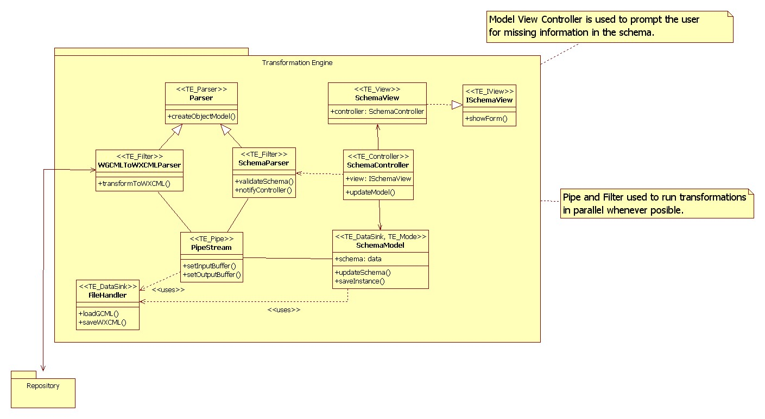

Figure C1 Detailed Class Diagram for the Transformation Engine
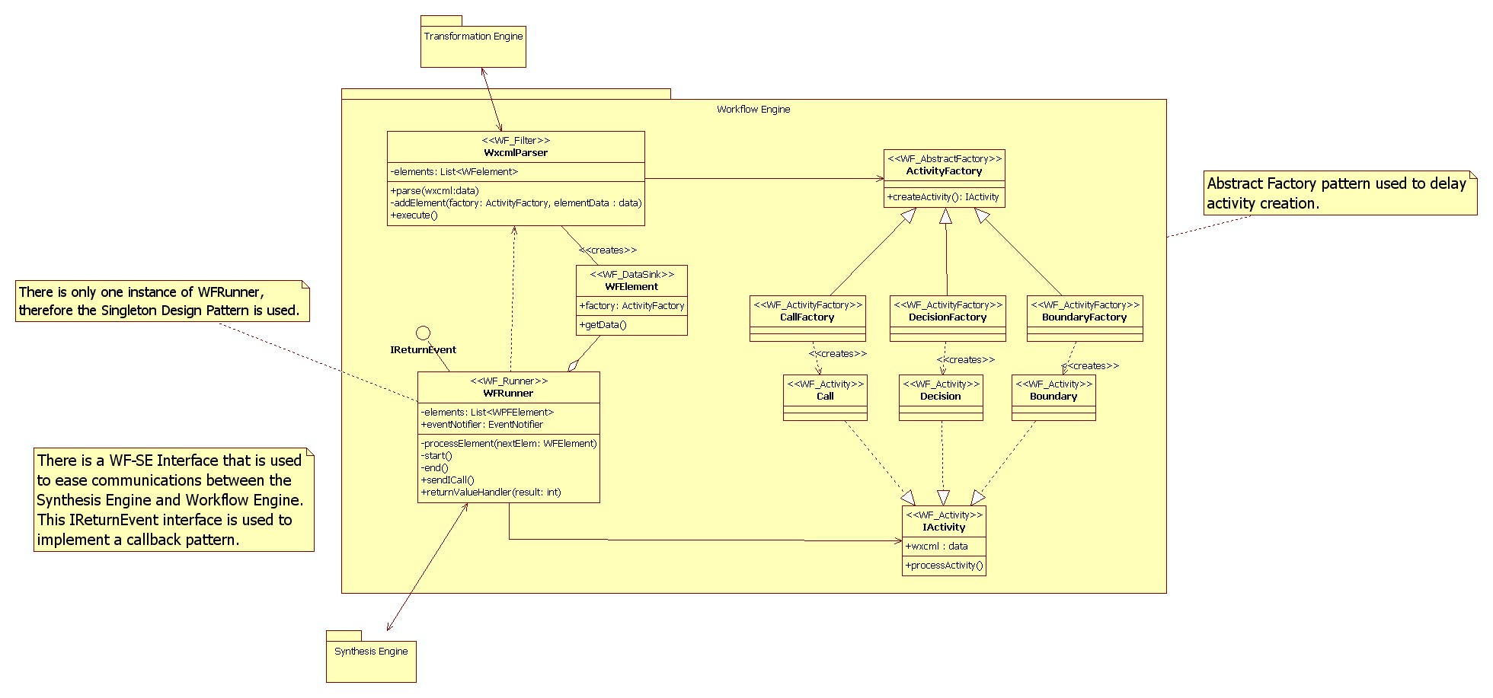

Figure C2 Detailed Class Diagram for the Workflow Engine
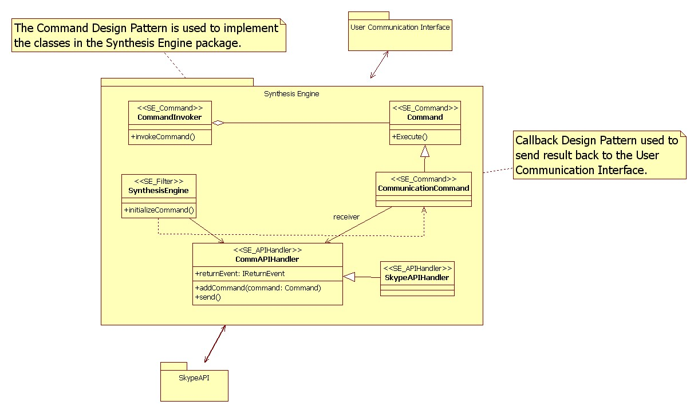

Figure C3 Detailed Class Diagram for the Synthesis Engine
5.4 Appendix D – Generated Code

//
//
// Generated by StarUML(tm) Java Add-In
//
// @ Project : Design Document
// @ File Name : ActivityFactory.java
// @ Date : 3/24/2009
// @ Author : RRComSSys Team five
//
//

/*This class encapsulates a group of factories
* that can create one of three Activities.*/
public class ActivityFactory {
public IActivity createActivity() {

}
}

/*This class represents a Boundary Activity.
* It also has logic to process a Boundary activity.*/
public class Boundary implements IActivity {
}

/*This class creates a Boundary Activity.*/
public class BoundaryFactory extends ActivityFactory {
}

/*This class represents a Call Activity.
* It also has logic to process a Call activity.*/
public class Call extends IActivity {
}

/*This class represents a Call Activity.
* It also has logic to process a Call activity.*/
public class Call extends IActivity {
}

/*This class creates a Call Activity. */
public class CallFactory extends ActivityFactory {
}
/*This class defines an interface
* for executing a CommunicationCommand.*/
public class Command {
public void Execute() {

}
}

/*This class asks the command to execute and in case of failure rollback.*/
public class CommandInvoker {
public void invokeCommand() {

}
}

/*This class defines a binding between a CommAPIHandler object and an action.
* It also implements Execute by invoking the corresponding operations on Receiver.*/
public class CommunicationCommand extends Command {
}

/*This class represents a Decision Activity.
* It also has logic to process a Decision activity.*/
public class Decision implements IActivity {
}

/*This class creates a Decision Activity.*/
public class DecisionFactory extends ActivityFactory{
}

/*This class handles any interaction with filesystem.*/
public class FileHandler {
public void loadGCML() {

}

public void saveWXCML() {

}
}

/*This interface defines an Activity.*/
public class IActivity {
public Object wxcml : data;
public void processActivity() {

}
}

/*This interface defines the return event that
* will be triggered by the synthesis engine when a Call passes or fails.*/
public interface IReturnEvent {
boolean ReturnEvent();
}

/*This interface extracts all relevant members and methods
* from the SchemaView. The SchemaController uses this data
* to control the SchemaView.*/
public class ISchemaView {
public void showForm() {

}
}

/*This abstract class extracts the similarities between the WGCMLToWXCMLParser and the SchemaParser.
* It dissects some xml source into an object model.*/
public class Parser {
public void createObjectModel() {

}
}

/*This class connects the output stream of a filter to
* the input stream of another filter or a datasink.*/
public class PipeStream {
public void setInputBuffer() {

}

public void setOutputBuffer() {

}
}

/*This class controls the SchemaView and updates
* the SchemaModel with new data.*/
public class SchemaController {
public ISchemaView view;
public void updateModel() {

}
}

/*This class holds the validated model and gets updated
* with any missing data by the SchemaController.*/
public class SchemaModel {
public data schema;
public void updateSchema() {

}

public void saveInstance() {

}
}

/*This class validates the resulting WXCML schema and notifies
* the controller of any missing data in the schema.*/
public class SchemaParser extends Parser {
public void validateSchema() {

}

public void notifyController() {

}
}

/*This class presents the user with the forms
* necessary to get data missing from the schema.*/
public class SchemaView implements ISchemaView {
public SchemaController controller;
}

/*This class extracts and creates the commands
* out of an instance of a Call Activity.*/
public class SynthesisEngine {
public void initializeCommand() {

}
}

/*This class has an instance of the factory that
* will allow the WFRunner to create the appropriate Activity.*/
public class WFElement {
public ActivityFactory factory;
public void getData() {

}
}

/*This class decides the order in which WFElements get processed.*/
public class WFRunner implements IReturnEvent{
private List<WPFElement> elements;
public EventNotifier eventNotifier;
private void processElement(WFElement nextElem) {

}

private void start() {

}

private void end() {

}

public void sendICall() {

}

public void returnValueHandler(int result) {

}
}
/*This class transforms the WGCML source to WXCML. */
public class WGCMLToWXCMLParser extends Parser {
public void transformToWXCML() {

}
}

/*This class creates WFElements with the corresponding
* factory for a specific activity.*/
public class WxcmlParser {
private List<WFelement> elements;
public void parse(Object wxcml:data) {

}

private void addElement(ActivityFactory factory, Object elementData : data) {

}

public void execute() {

}
}

5.5 Appendix E – Diary of meeting and tasks.

Place: Software Design Class
Date: 1/06/2009
Start: 8:30PM
End: 9:00PM
Facilitator: Jean Rodríguez
Attending: Jean, Denis,Marcelo,Barbara
Minute Taker:

1. Objective
Project kick off meeting.
2. Status
Everyone participated in coming up with ideas for the project.
3. Discussion
Discussion about how the GMF works.

Place: Software Design Class
Date: 1/13/2009
Start: 8:30PM
End: 9:00PM
Facilitator: Jean Rodríguez
Attending: Jean, Denis, Marcelo, Goutami
Minute Taker:

1. Objective
Project kick off meeting.
2. Status
Everyone participated in coming up with ideas for the project.
3. Discussion
Discussion about the Project.

Place: Graduate Lab
Date: 1/20/2009
Start: 8:30 PM
End: 9:30 PM
Facilitator: Jean Rodríguez
Attending: Jean, Denis, Harika, Marcelo
Minute Taker: Harika

1. Objective
Project kick off meeting.
2. Status
Everyone participated in coming up with ideas for the project.
3. Discussion
Give a brief explanation about the project to the new member.

Place: Graduate Lab
Date: 1/23/2009
Start: 4:00 PM
End: 4:30 PM
Facilitator: Jean Rodríguez
Attending: Jean, Denis, Harika
Minute Taker: Harika

1. Objective
Project kick off meeting.
2. Status
Everyone participated in coming up with ideas for the project.
3. Discussion
Discussion about how the GMF works.

Place: Graduate Lab
Date: 1/24/2009
Start: 11:00 AM
End: 2:00 PM
Facilitator: Jean Rodríguez
Attending: Jean, Denis, Harika, Marcelo
Minute Taker: Harika

1. Objective
Discuss on the Use Case Diagrams
2. Status
Use Case has been discussed and has an idea about the project.
3. Discussion
Saw a live demonstration of GMF usage. Discussed about the possible Use Cases for the project.
4. Tasks
All team members have to do the Use Case diagram given to them.

Place: Software Design Class
Date: 1/27/2009
Start: 8:30 PM
End: 9:00 PM
Facilitator: Jean Rodríguez
Attending: Jean, Denis, Harika, Marcelo
Minute Taker: Harika

1. Objective
Discuss on the presentation that should be given in next week.
2. Status
We discussed about the work to be done by each member.
3. Discussion
We discussed in detail about the presentation that will be given in next week.
4. Tasks
All team members have to do the work given to them.

Place: Graduate Lab
Date: 1/30/2009
Start: 4:00 PM
End: 6:00 PM
Facilitator: Jean Rodríguez
Attending: Jean, Denis, Harika, Marcelo
Minute Taker: Harika

1. Objective
Discuss on the presentation that should be given in next week.
2. Status
We discussed about the work to be done by each member.
3. Discussion
We discussed in detail about the presentation that will be given in next week.
4. Tasks
All team members have to do the work given to them.

Place: Software Design Class
Date: 02/03/2009
Start: 8:30 PM
End: 9:15 PM
Facilitator: Jean Rodríguez
Attending: Jean, Denis, Harika, Marcelo
Minute Taker: Harika

1. Objective
Discuss about the First deliverable
2. Status
We have got a clear idea about the first deliverable.
3. Discussion
Work to be done for the deliverable.

Place: Graduate Lab
Date: 02/06/2009
Start: 6:00 PM
End: 7:00 PM
Facilitator: Jean Rodríguez
Attending: Jean, Denis, Harika, Marcelo
Minute Taker: Harika

1. Objective
Discuss about the First deliverable.
2. Status
Work is assigned that is to be done for the deliverable.
3. Discussion
General discussion about expectations.

Place: Software Design Class
Date: 02/10/2009
Start: 8:30 PM
End: 9:00 PM
Facilitator: Jean Rodríguez
Attending: Jean, Denis, Harika, Marcelo
Minute Taker: Harika

1. Objective
Discuss about the First deliverable presentation.
2. Status
Various tasks assigned to each member.
3. Discussion
The things to be done for the deliverable are discussed.

Place: Graduate Lab
Date: 02/14/2009
Start: 2:00 PM
End: 5:00 PM
Facilitator: Jean Rodríguez
Attending: Jean, Denis, Harika, Marcelo
Minute Taker: Harika

1. Objective
Discuss about the First deliverable.
2. Status
Work to be done for the deliverable such as the scenarios are discussed.
3. Discussion
We have discussed about the 8 most important use cases and writing the scenarios.

Place: Graduate Lab
Date: 02/15/2009
Start: 2:00 PM
End: 7:45 PM
Facilitator: Jean Rodríguez
Attending: Jean, Denis, Harika, Marcelo
Minute Taker: Harika

1. Objective
Discuss about the First deliverable. Collaborate to bring the SRAD together
2. Status
Work to be done for the deliverable such as the scenarios are discussed.
3. Discussion
We have discussed about the 8 most important use cases and writing the scenarios as well as the use cases, object, class. We also discussed the design of the work flow model.

Place: Graduate Lab
Date: 02/16/2009
Start: 7:00 PM
End: 11:00 PM
Facilitator: Jean Rodríguez
Attending: Jean, Denis, Harika, Marcelo
Minute Taker: Harika

1. Objective
Discuss about the First deliverable. Collaborate to bring the SRAD together
2. Status
Work to be done for the deliverable such as the scenarios are discussed.
3. Discussion
We have done all use cases, object and class diagrams. We also discussed the design of the work flow model.

Design Document Meetings:

Place: Graduate Lab
Date: 02/21/2009
Start: 8:00 PM
End: 9:00 PM
Facilitator: Denis Antoine
Attending: Jean, Denis, Harika, Marcelo
Minute Taker: Harika

1. Objective
Discuss the workflow.
2. Status
We have a clear idea of the workflow to be done.
3. Discussion
The workflow model has been discussed.

Place: Software Design Class
Date: 02/24/2009
Start: 8:30 PM
End: 9:00 PM
Facilitator: Denis Antoine
Attending: Jean, Denis, Harika, Marcelo
Minute Taker: Harika

1. Objective
Discuss about the Patterns and the work flow.
2. Status
Work to be done for the deliverable such as the workflow and the patterns are discussed.
3. Discussion
We have discussed the design of the work flow model. We have identified the patterns for our project.

Place: Graduate Lab
Date: 02/27/2009
Start: 6:00 PM
End: 7:30 PM
Facilitator: Denis Antoine
Attending: Jean, Denis, Harika
Minute Taker: Harika

1. Objective
Discuss about how to generate a GMF model.
2. Status
Tried to generate a GMF model from an sample example.
3. Discussion
We have tried how to create a Meta model in EMF, convert it to GMF and generate a final model.

Place: Software Design Class
Date: 03/03/2009
Start: 8:30 PM
End: 9:00 PM
Facilitator: Denis Antoine
Attending: Jean, Denis, Harika, Marcelo
Minute Taker: Harika

1. Objective
Discuss the Meta model and the Package diagram.
2. Status
We have discussed details about the Meta model such as the DSL.
3. Discussion
Talk about the Domain, Meta model, syntax, semantics, DSL.

Place: Graduate Lab
Date: 03/07/2009
Start: 2:00 PM
End: 6:30 PM
Facilitator: Denis Antoine
Attending: Jean, Denis, Harika, Marcelo
Minute Taker: Harika

1. Objective
Study for exam 2.
2. Status
We have discussed the exam by creating the DSL and the profile for the scenario of our project.
3. Discussion
We have created the DSL by considering syntax and semantics and also tried to draw a UML Profile by considering the scenario of our project.

Place: Software Design Class
Date: 03/10/2009
Start: 8:30 PM
End: 9:00 PM
Facilitator: Denis Antoine
Attending: Jean, Denis, Harika, Marcelo
Minute Taker: Harika

1. Objective
Split the sections off to the users.
2. Status
Work to be done for the deliverable
3. Discussion
Various sections assigned to all members.

Place: Graduate Lab
Date: 03/14/2009
Start: 2:00 PM
End: 7:45 PM
Facilitator: Denis Antoine
Attending: Jean, Denis, Marcelo
Minute Taker: Harika

1. Objective
Discuss the Object design.
2. Status
We tried to run the canvas.
3. Discussion
We tried to get the canvas running but it is partially running.

Place: Graduate Lab
Date: 03/22/2009
Start: 2:00 PM
End: PM
Facilitator: Denis Antoine
Attending: Jean, Denis, Marcelo
Minute Taker: Harika

1. Objective
Discuss various discrepancies.
2. Status
We have done with most of the part in the second deliverable.
3. Discussion
We have discussed about the state machine, Meta model. The remaining work that should be done is also assigned.

Place: Graduate Lab
Date: 03/22/2009
Start: 2:00 PM
End: PM
Facilitator: Denis Antoine
Attending: Jean, Denis, Marcelo
Minute Taker: Harika

1. Objective
Discuss the Second deliverable.
2. Status
Section 1, 4, and 5 are complete.
3. Discussion
Finalize the remaining sections.

