江苏是有场景实例的：

一、性能查询的自定义区域分组就有，如下图

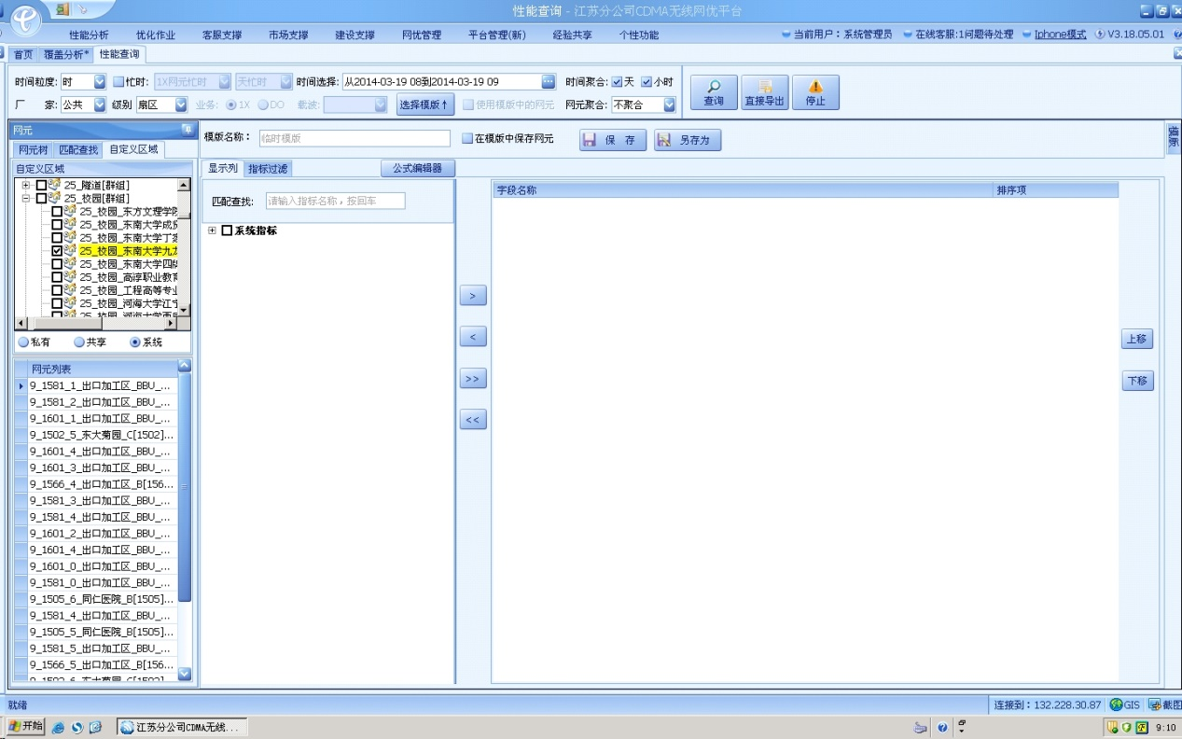

二、可以从皓盈台账获取场景实例：

1、皓盈台账场景实例表：select * from ne_uway_vip_customer t

(1)、场景类型F_TYPE，对应到集团21种场景的方法，请严格按以下方法对应归类，否则会有数据遗漏或错误：

      ,case when (F_NAME like '%高铁%' or F_NAME like '%城际%' or F_NAME like '%城铁%') and F_NAME not like '%站%'  and F_NAME not like '%隧道%' then '高铁'

            when F_NAME like '%宾馆%' or F_NAME like '%酒店%' then '宾馆'

            when F_NAME like '%体育%' and F_NAME not like '%巷%' and F_NAME not like '%超市%' then '体育场'

            when F_NAME like '%批发%' or F_NAME like '%小商品%' then '聚类市场'

            when F_NAME like '%娱乐%' or F_NAME like '%休闲%' or F_NAME like '%电影%' or F_NAME like '%KTV%' or F_NAME like '%会所%' then '休闲娱乐'

            when F_TYPE in ('酒店宾馆','宾馆酒店') then '宾馆'

            when F_TYPE in ('港口码头','汽车站','机场车站','火车站') and (F_NAME like '%港%' or F_NAME like '%闸%' or F_NAME like '%站%' or F_NAME like '%码头%' or F_NAME like '%客运%' or F_NAME like '%渡%') then '车站港口码头'

            when F_TYPE = '地铁'  and F_NAME in ('地铁2号线_南京_','地铁1号线_南京_','一号南延线_南京_','一号线_苏州_') then '地铁'

            when F_TYPE in ('干道','道路','公路')  and (F_NAME like '%国道%' or F_NAME like '%省道%' or F_NAME like '%高速%' or F_NAME like '%桥%' or F_NAME like '%公路%') then '高速公路'

            when F_TYPE in ('工业园') then '工业园区'

            when F_TYPE in ('海域') then '海域'

            when F_TYPE in ('机场') and F_NAME like '%机场%' then '机场'

            when F_TYPE in ('景区') then '景区'

            when F_TYPE in ('村镇','农村','郊区') then '农村'

            when F_TYPE in ('商场') then '商场'

            when ((F_TYPE in ('水域','水运','航道') or F_NAME like '%航道%')) and (F_NAME like '%江%' or F_NAME like '%河%' or F_NAME like '%湖%' or F_NAME like '%海%') then '水运'

            when F_TYPE in ('隧道') and F_NAME like '%隧道%' then '隧道'

            when F_TYPE in ('校园','学校') then '校园'

            when F_TYPE in ('CBD') then '写字楼'

            when F_TYPE in ('医院') then '医院'

            when F_TYPE in ('政府机关','政企') and (F_NAME like '%政府%' or F_NAME like '%图书馆%' or F_NAME like '%行政%' or F_NAME like '%局%' or F_NAME like '%厅%'or F_NAME like '%监狱%'or F_NAME like '%税%'or F_NAME like '%委%'or F_NAME like '%所%'or F_NAME like '%人防%'or F_NAME like '%处%'or F_NAME like '%海关%'or F_NAME like '%邮政%'or F_NAME like '%事%'or F_NAME like '%消防%'or F_NAME like '%武警%') then '政府机关'

            when F_TYPE in ('居民区') then '住宅'

            else '其他' end as F_TYPE--此类数据直接删除

(2)、场景名称F_NAME：按集团要求需包含地市、场景名称F_NAME、场景级别，前两个好办，场景级别按以下方法添加后缀

      ,case when F_TYPE = '高铁' then F_NAME+'高铁'

            when F_TYPE = '高速公路' then F_NAME+'高速'

            when F_TYPE = '机场' then F_NAME+'1级'

            when F_TYPE = '车站港口码头' and F_NAME like '%货运%' then F_NAME+'大型货运'

            when F_TYPE = '车站港口码头' and F_NAME not like '%货运%' then F_NAME+'客运'

            when F_TYPE = '住宅' and F_NAME like '%别墅%' then F_NAME+'别墅'

            when F_TYPE = '住宅' and F_NAME not like '%别墅%' then F_NAME+'多层'

            when F_TYPE = '景区' and (F_NAME like '%恐龙%' or F_NAME like '%夫子庙%' or F_NAME like '%中山陵%'or F_NAME like '%同里%'

or F_NAME like '%周庄%' or F_NAME like '%灵山大佛%'or F_NAME like '%瘦西湖%') then F_NAME+'5A'

            when F_TYPE = '景区' and (F_NAME like '%4A%' or F_NAME like '%红梅公园%' or F_NAME like '%天宁寺%' or F_NAME like '%亚细亚影视城%'

or F_NAME like '%中华恐龙园%'or F_NAME like '%天目湖%'or F_NAME like '%南山竹海%'or F_NAME like '%淹城%'or F_NAME like '%黄花塘%'or F_NAME like '%周恩来纪念馆%'

or F_NAME like '%铁山寺%'or F_NAME like '%花果山%'or F_NAME like '%孔望山%'or F_NAME like '%连岛%'or F_NAME like '%渔湾%'or F_NAME like '%朝天宫%'

or F_NAME like '%玄武湖%'or F_NAME like '%雨花台%'or F_NAME like '%阅江楼%'or F_NAME like '%总统府%'or F_NAME like '%南通博物苑%'or F_NAME like '%濠河%'

or F_NAME like '%狼山%'or F_NAME like '%尚湖%'or F_NAME like '%沙家浜%'or F_NAME like '%锦溪%'or F_NAME like '%亭林园%'or F_NAME like '%苏州乐园%'

or F_NAME like '%木渎%'or F_NAME like '%盘门%'or F_NAME like '%寒山寺%'or F_NAME like '%虎丘%'or F_NAME like '%留园%'or F_NAME like '%狮子林%'

or F_NAME like '%网师园%'or F_NAME like '%西园戒幢律寺%'or F_NAME like '%拙政园%'or F_NAME like '%静思园%'or F_NAME like '%西山%'or F_NAME like '%用直古镇%'

or F_NAME like '%虞山%'or F_NAME like '%雪峰%'or F_NAME like '%洪泽湖%'or F_NAME like '%溱湖%'or F_NAME like '%凤城河%'or F_NAME like '%滨江要塞%'

or F_NAME like '%江苏学政文化%'or F_NAME like '%蠡园%'or F_NAME like '%鼋头渚%'or F_NAME like '%惠园林文物%'or F_NAME like '%薛福成%'or F_NAME like '%善卷洞%'

or F_NAME like '%龙背山%'or F_NAME like '%团氿%'or F_NAME like '%竹海%'or F_NAME like '%淮海战役%'or F_NAME like '%云龙湖%'or F_NAME like '%马陵山%'

or F_NAME like '%大纵湖%'or F_NAME like '%大明寺%'or F_NAME like '%个园%'or F_NAME like '%何园%'or F_NAME like '%宝华山%'or F_NAME like '%焦山%'

or F_NAME like '%茅山%'or F_NAME like '%金山%'or F_NAME like '%镇江博物馆%') then F_NAME+'4A'

            when F_TYPE = '景区' and (F_NAME like '%3A%'or F_NAME like '%华罗庚%'or F_NAME like '%竺山%'or F_NAME like '%大伊山%'or F_NAME like '%石棚山%'or F_NAME like '%桃花涧%'

or F_NAME like '%淳溪老街%'or F_NAME like '%将军山%'or F_NAME like '%傅家边%'or F_NAME like '%南山湖旅游%'or F_NAME like '%天生桥%'or F_NAME like '%银杏湖%'or F_NAME like '%定慧禅寺%'or F_NAME like '%内外城河风光带%'

or F_NAME like '%水绘园景区%'or F_NAME like '%南园公园%'or F_NAME like '%太仓公园%'or F_NAME like '%东渡苑景区%'or F_NAME like '%乾隆行宫%'or F_NAME like '%马陵公园%'or F_NAME like '%柳山湖公园%'or F_NAME like '%新四军黄桥战役%'

or F_NAME like '%引江河%'or F_NAME like '%徐霞客%'or F_NAME like '%鹅鼻嘴%'or F_NAME like '%东林书院%'or F_NAME like '%龙寺生态园%'or F_NAME like '%龙头渚%'or F_NAME like '%太湖花卉园%'or F_NAME like '%唐城%'

or F_NAME like '%龟山汉墓%'or F_NAME like '%滨湖公园%'or F_NAME like '%戏马台%'or F_NAME like '%大丰麋鹿%'or F_NAME like '%新四军纪念馆%'or F_NAME like '%凤凰岛%'or F_NAME like '%汉陵苑%'or F_NAME like '%茱萸湾%') then F_NAME+'3A'

            when F_TYPE = '景区' then F_NAME+'2A'

            when F_TYPE = '宾馆' then F_NAME+'四星'

            when F_TYPE = '写字楼' then F_NAME+'大型'

            when F_TYPE = '商场' then F_NAME+'大型'

            when F_TYPE = '体育场' and (F_NAME like '%馆%' or F_NAME like '%中心%') then F_NAME+'室内综合体育馆'

            when F_TYPE = '体育场' and not (F_NAME like '%馆%' or F_NAME like '%中心%') then F_NAME+'室外综合体育场'

            when F_TYPE = '地铁' then F_NAME+'地下&地上'

            when F_TYPE = '海域' then F_NAME+'无级别'

            when F_TYPE = '校园' and F_NAME like '%大学%' then F_NAME+'大学'

            when F_TYPE = '校园' and F_NAME like '%学院%' then F_NAME+'学院'

            when F_TYPE = '校园' and (F_NAME like '%职业%' or F_NAME like '%技%' or F_NAME like '%学校%' or F_NAME like '%卫%' or F_NAME like '%电大%') then F_NAME+'职业学校'

            when F_TYPE = '校园' and F_NAME like '%高中%' then F_NAME+'高中'

            when F_TYPE = '校园' and F_NAME like '%初中%' then F_NAME+'初中'

            when F_TYPE = '校园' and F_NAME like '%小学%' then F_NAME+'小学'

            when F_TYPE = '隧道' and (F_NAME not like '%高铁%' and F_NAME not like '%城际%') then F_NAME+'公路'

            when F_TYPE = '隧道' and (F_NAME like '%高铁%' or F_NAME like '%城际%') then F_NAME+'铁路'

            when F_TYPE = '医院' then F_NAME+'二甲'

            when F_TYPE = '政府机关' then F_NAME+'地级市'

            when F_TYPE = '工业园区' then F_NAME+'市级'

            when F_TYPE = '农村' then F_NAME+'其他'

            when F_TYPE = '水运' then F_NAME+'三级'

            when F_TYPE = '聚类市场' then F_NAME+'无级别'

            when F_TYPE = '休闲娱乐场所' then F_NAME+'全地上'

            end as F_NAME

（3）、场景编号、场景名称、场景类型：要在各上报文件中涉及这三个字段的地方（至少包括场景、扇区、场景性能等文件）保持一致，否则集团解析后无法匹配

2、皓盈台账场景实例与扇区的对应关系

select * from ne_uway_vip_cust_sector t

其中，F_VIP_CUST_ID对应ne_uway_vip_customer中的F_ID；F_SECTOR_ID对应ne_taizhang_cell中的F_ID

3、皓盈扇区台账

select * from ne_taizhang_cell t