IT 2045C Computer Programming II  
Prof. Tom Wulf   
Fall 2024 v1.5

# Lab 02 Inherit the Wind

**20 points**

## Learning Goals:

* Practice using inheritance to create sub-classes
* Create UML Class Diagrams to show the Inheritance Relationship

You will need the Person class from the previous lab!

## Functional requirements:

* Create each of the classes below in a single IntelliJ IDEA project. Name the Project **Inheritance.**
* Use GitHub to pull your Person.java file from your previous Lab.
* Create JUnit test suite for each of your classes. (You should already have one for Person.java from the last lab.)
* Note that there is a single java main program you will write to use all of the classes.

Here is the Person class from the previous lab:

### Person:

Project: Person  
Files: Person.java

Fields:

String firstName  
String lastName  
String ID // should never change  
String title // a prefix: Mr. Mrs. Ms, Prof. Dr. Hon. Etc.  
int YOB // Year of birth

### 2. Worker Class (inherits from Person):

Files: Worker.java WorkerTest.java

Fields:

double hourlyPayRate

Methods:

double calculateWeeklyPay(double hoursWorked)  
void displayWeeklyPay(double hoursWorked)

The constructor for Worker should use super() to call the constructor for Person and then go on to set the rest of the fields.

calculateWeeklyPay should return the pay total. Hours under 40 are at the HourlyRate, hours above 40 are at time and a half (1.5)

displayWeeklyPay should print to the console and show the number of hours of regular pay (40) and the total and the number of hours of overtime pay and the total as well as the total combined pay.

You have to overload the toCSV(), toXML(), toJSON() methods to include the new data field

### 3. SalaryWorker (inherits from Worker)

Files: SalaryWorker.java SalaryWorkerTest.java

Fields:

double annualSalary  
  
Methods:

The constructor for SalaryWorker should use super() to call the constructor for Worker  
double calculateWeeklyPay(double hoursWorked)

Override calculateWeeklyPay and displayWeeklyPay calculateWeeklyPay returns the pay total. Note that the parameter hoursWorked is not used here but is retained for polymorphism. Take the annualSalary and divide by 52 to get the weekly pay**.**

displayWeeklyPay should indicate that the weekly pay is a fraction of the yearly salary.

You have to overload the toCSV(), toXML(), toJSON() methods to include the new data field

### 4. Main Program:

Create a new java main class within your same IntelliJ IDEA project **InheritanceDemo**

1. Create 3 workers and 3 salaryWorker instances and add them to an ArrayList<Worker>. Pick reasonable hourly rates for the workers and reasonable salary rates for the salaryworkers. Of course all workers have names, ids, and YOBs.

2. Write a loop that simulates 3 weekly pay periods. Week 1 is a 40 hour week. For week 2 assume it is crunch time and everyone worked 50 hours. Week 3 is back to normal with 40 hours. Generate a display showing the weekly pay for each of the workers for each week in a reasonable tabular format.

Screen shots: record screen shots of your Test file output for each of your test program at the end of this file.

### 4. UML Class Diagram:

Create a single UML diagram that shows the Inheritance hierarchy for Person Worker and SalaryWorker  
  
Insert the diagram here along with your screen shots.

Inheritance Demo Output

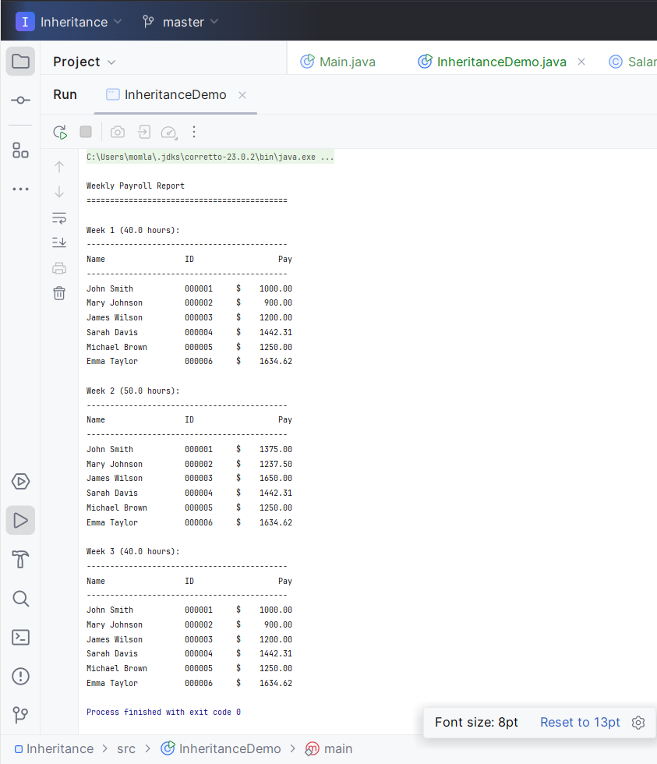

SalaryWorkerTest

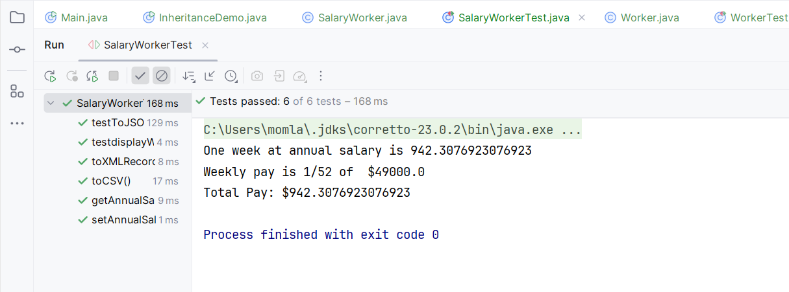

Worker Test

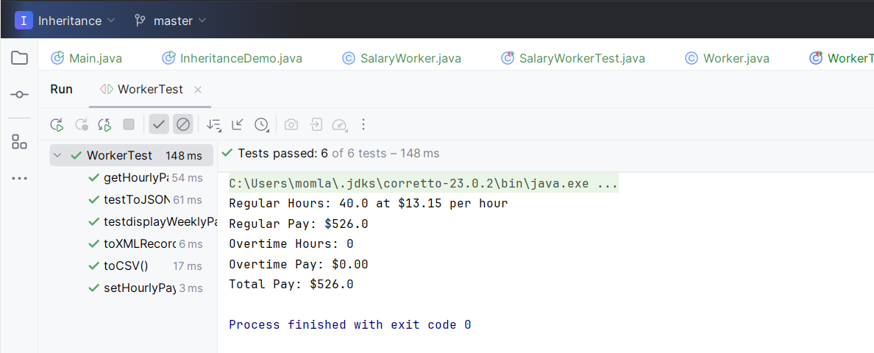

**UML DIAGRAM**

## 

## Submission:

Submit the link to your GitHub repo for this Lab. (Check the link to insure that it works correctly.)  
Submit this document with your screen shots and UML as **LastName_Firstname_Lab02.docx** using your name.