Proiectarea și Gestionarea unei Baze de Date

Clinică privată

Versiune: Oracle Database 19c

Cuprins

Introducere: 3

Cerinta 1: 5

Cerinta 2: 6

Cerinta 3: 7

Cerinta 4: 8

Cerinta 5: 11

Cerinta 6: 15

Cerinta 7: 19

Cerinta 8: 22

Cerinta 9: 25

Cerinta 10: 30

Cerinta 11: 32

Cerinta 12: 37

Cerinta 13: 39

## Cerinta 1:

Prezentați pe scurt baza de date (utilitatea ei).

Modelul de date va gestiona informatiile legate de activitatea unei clinici

private. Clinica are mai multi angajati, printre care asistente si doctori.

Fiecare asistenta se ocupa de mai multe camere, respectiv de paturile din

acele camere in care pot fi internati pacientii.

Pacientii isi pot programa o consultatie cu un anumit doctor.

Doctorii prescriu tratamente pentru pacienti.

Pacientii, care pot suferi de mai multe boli, vor primi cate un tratament

pentru fiecare boala de care sufera (consideram in plus ca un tratament poate

fi acordat mai multor pacienti odata ce s-a dovedit eficient si ca unele tratamente pot fi

folosite pentru combaterea mai multor boli).

Se vor pastra informatii despre numarul de pacienti care au fost tratati

pentru o anumita boala, cat si stocul clinicii de medicamente necesare pentru

tratarea bolilor.

## Cerinta 2:

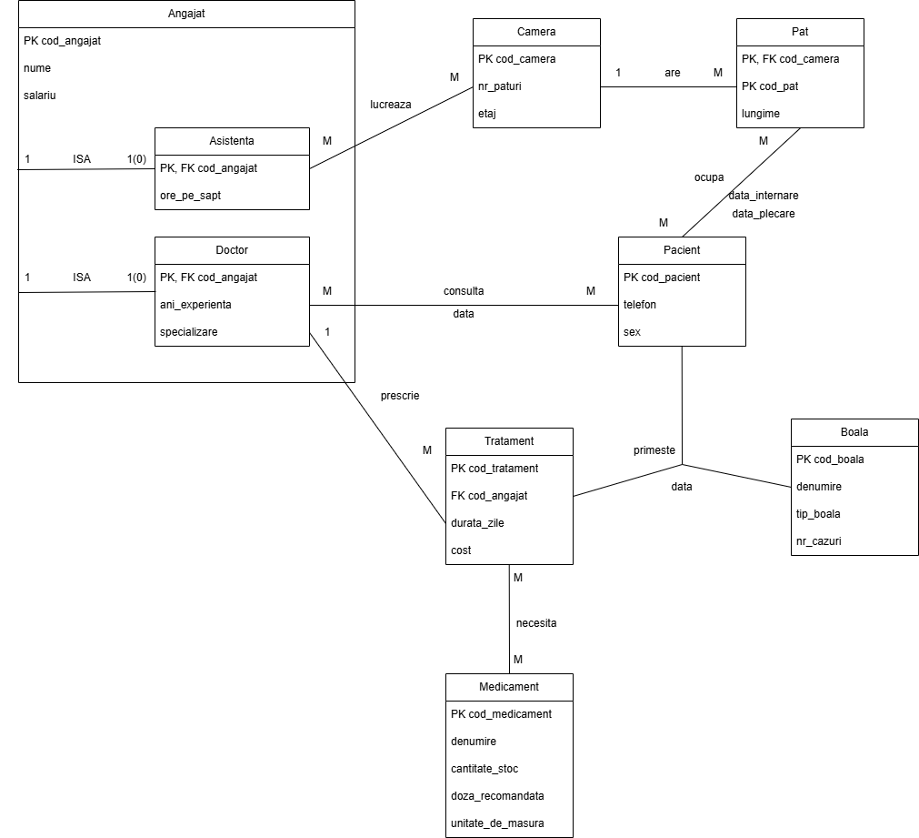Diagrama ER:

## Cerinta 3:

Diagrama conceptuala:

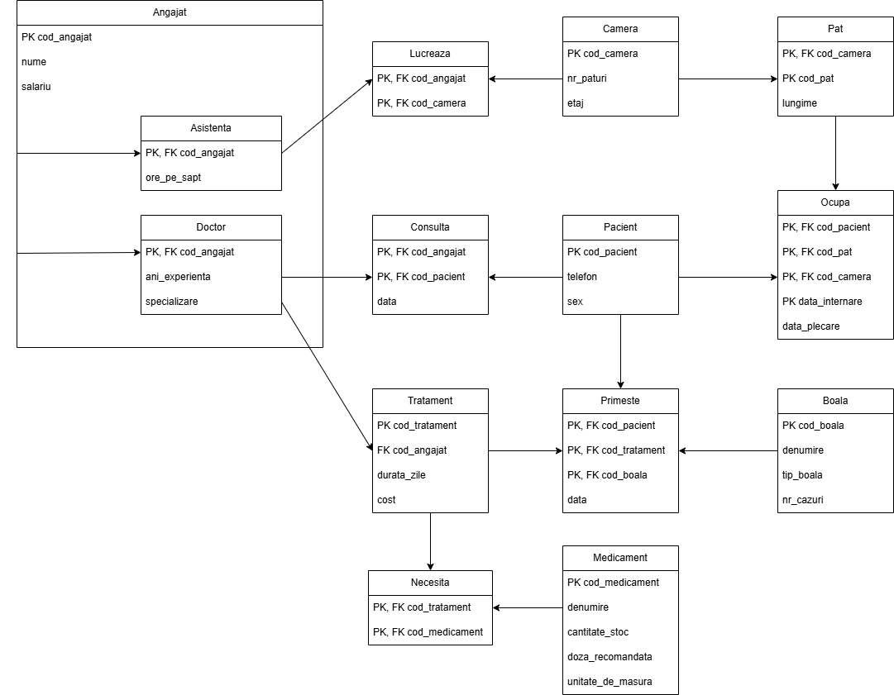

## Cerinta 4:

Creare tabel (+ constrangeri):

|  |
| --- |
| CREATE TABLE angajat(  cod_angajat NUMBER(4) PRIMARY KEY,  nume VARCHAR2(50) NOT NULL,  salariu NUMBER(6),  CONSTRAINT salariu_pozitiv CHECK (salariu > 0));    CREATE TABLE asistenta(  cod_angajat NUMBER(4) PRIMARY KEY REFERENCES angajat(cod_angajat) ON DELETE CASCADE,  ore_pe_sapt NUMBER(3));    CREATE TABLE doctor(  cod_angajat NUMBER(4) PRIMARY KEY REFERENCES angajat(cod_angajat) ON DELETE CASCADE,  ani_experieta NUMBER(3),  specializare VARCHAR2(50));    CREATE TABLE camera(  cod_camera NUMBER(4) PRIMARY KEY,  nr_paturi NUMBER(2),  etaj NUMBER(2));    CREATE TABLE lucreaza(  cod_angajat NUMBER(4),  cod_camera NUMBER(4),  CONSTRAINT lucreaza_pk PRIMARY KEY (cod_angajat, cod_camera),  CONSTRAINT fk_cod_angajat FOREIGN KEY (cod_angajat) REFERENCES asistenta(cod_angajat) ON DELETE CASCADE,  CONSTRAINT fk_cod_camera FOREIGN KEY (cod_camera) REFERENCES camera(cod_camera) ON DELETE CASCADE);    CREATE TABLE pat(  cod_pat NUMBER(4) PRIMARY KEY,  cod_camera NUMBER(4),  lungime NUMBER(4, 2),  PRIMARY KEY (cod_pat, cod_camera),  FOREIGN KEY (cod_camera) REFERENCES camera(cod_camera) ON DELETE CASCADE);    CREATE TABLE pacient(  cod_pacient NUMBER(4) PRIMARY KEY,  telefon VARCHAR2(10) NOT NULL,  sex CHAR(1),  CONSTRAINT verif_sex CHECK (sex IN ('M', 'F')));    CREATE TABLE ocupa(  cod_pacient NUMBER(4),  cod_pat NUMBER(4),  cod_camera NUMBER(4),  data_internare DATE NOT NULL,  data_plecare DATE NOT NULL,  PRIMARY KEY (cod_pacient, cod_camera, cod_pat),  FOREIGN KEY (cod_pacient) REFERENCES pacient(cod_pacient) ON DELETE CASCADE,  FOREIGN KEY (cod_pat, cod_camera) REFERENCES pat(cod_pat, cod_camera) ON DELETE CASCADE);  -- am schimbat niste detalii  ALTER TABLE ocupa MODIFY data_plecare NULL;  ALTER TABLE ocupa DROP PRIMARY KEY;  ALTER TABLE ocupa  ADD CONSTRAINT pk_ocupa PRIMARY KEY (cod_pacient, cod_pat, cod_camera, data_internare);    CREATE TABLE consulta(  cod_angajat NUMBER(4),  cod_pacient NUMBER(4),  data DATE DEFAULT SYSDATE,  PRIMARY KEY (cod_angajat, cod_pacient),  FOREIGN KEY (cod_angajat) REFERENCES doctor(cod_angajat) ON DELETE CASCADE,  FOREIGN KEY (cod_pacient) REFERENCES pacient(cod_pacient) ON DELETE CASCADE);    CREATE TABLE tratament(  cod_tratament NUMBER(4) PRIMARY KEY,  cod_angajat NUMBER(4),  durata_zile NUMBER(5),  cost NUMBER(5,2),  FOREIGN KEY (cod_angajat) REFERENCES doctor(cod_angajat));    CREATE TABLE medicament(  cod_medicament NUMBER(4) PRIMARY KEY,  denumire VARCHAR2(30),  cantitate_stoc INT DEFAULT 0,  doza_recomandata NUMBER(10, 2),  unitate_de_masura VARCHAR2(10) NOT NULL);    CREATE TABLE necesita(  cod_tratament NUMBER(4),  cod_medicament NUMBER(4),  PRIMARY KEY (cod_tratament, cod_medicament),  FOREIGN KEY (cod_tratament) REFERENCES tratament(cod_tratament) ON DELETE CASCADE,  FOREIGN KEY (cod_medicament) REFERENCES medicament(cod_medicament) ON DELETE CASCADE);    CREATE TABLE boala(  cod_boala NUMBER(4) PRIMARY KEY,  denumire VARCHAR2(50) UNIQUE,  tip_boala VARCHAR2(30),  nr_cazuri INT);    CREATE TABLE primeste(  cod_pacient NUMBER(4),  cod_tratament NUMBER(4),  cod_boala NUMBER(4),  data DATE default SYSDATE,  PRIMARY KEY (cod_pacient, cod_tratament, cod_boala),  FOREIGN KEY (cod_pacient) REFERENCES pacient(cod_pacient) ON DELETE CASCADE,  FOREIGN KEY (cod_tratament) REFERENCES tratament(cod_tratament) ON DELETE CASCADE,  FOREIGN KEY (cod_boala) REFERENCES boala(cod_boala) ON DELETE CASCADE); |

## Cerinta 5:

Adaugare informatii (unele intrari care apar in screen shot-uri au fost introduse/schimbate cand testam cerintele):

|  |
| --- |
| -- Inseram in tabelul 'angajat' pentru asistente  INSERT INTO angajat (cod_angajat, nume, salariu) VALUES (101, 'Maria Popescu', 3000);  INSERT INTO angajat (cod_angajat, nume, salariu) VALUES (102, 'Ion Ionescu', 3200);  INSERT INTO angajat (cod_angajat, nume, salariu) VALUES (103, 'Elena Vasilescu', 3100);  INSERT INTO angajat (cod_angajat, nume, salariu) VALUES (104, 'Carmen Dumitru', 3050);  INSERT INTO angajat (cod_angajat, nume, salariu) VALUES (105, 'Ana Mihai', 3150);  -- Inseram in tabelul 'asistenta'  INSERT INTO asistenta (cod_angajat, ore_pe_sapt) VALUES (101, 40);  INSERT INTO asistenta (cod_angajat, ore_pe_sapt) VALUES (102, 36);  INSERT INTO asistenta (cod_angajat, ore_pe_sapt) VALUES (103, 38);  INSERT INTO asistenta (cod_angajat, ore_pe_sapt) VALUES (104, 35);  INSERT INTO asistenta (cod_angajat, ore_pe_sapt) VALUES (105, 37);  -- Inseram in tabelul 'angajat' pentru doctori  INSERT INTO angajat (cod_angajat, nume, salariu) VALUES (201, 'Dan Gheorghe', 7000);  INSERT INTO angajat (cod_angajat, nume, salariu) VALUES (202, 'Radu Iliescu', 7500);  INSERT INTO angajat (cod_angajat, nume, salariu) VALUES (203, 'Alina Tudor', 7200);  INSERT INTO angajat (cod_angajat, nume, salariu) VALUES (204, 'Victor Pavel', 7300);  INSERT INTO angajat (cod_angajat, nume, salariu) VALUES (205, 'Andreea Marin', 7400);  -- Inseram in tabelul 'doctor'  INSERT INTO doctor (cod_angajat, ani_experieta, specializare) VALUES (201, 10, 'Cardiologie');  INSERT INTO doctor (cod_angajat, ani_experieta, specializare) VALUES (202, 12, 'Neurologie');  INSERT INTO doctor (cod_angajat, ani_experieta, specializare) VALUES (203, 8, 'Pediatrie');  INSERT INTO doctor (cod_angajat, ani_experieta, specializare) VALUES (204, 15, 'Oncologie');  INSERT INTO doctor (cod_angajat, ani_experieta, specializare) VALUES (205, 20, 'Ortopedie');  -- Inseram in tabelul 'camera'  INSERT INTO camera (cod_camera, nr_paturi, etaj) VALUES (1, 2, 1);  INSERT INTO camera (cod_camera, nr_paturi, etaj) VALUES (2, 3, 1);  INSERT INTO camera (cod_camera, nr_paturi, etaj) VALUES (3, 4, 2);  INSERT INTO camera (cod_camera, nr_paturi, etaj) VALUES (4, 2, 2);  INSERT INTO camera (cod_camera, nr_paturi, etaj) VALUES (5, 1, 3);  -- Inseram in tabelul 'lucreaza'  INSERT INTO lucreaza (cod_angajat, cod_camera) VALUES (101, 1);  INSERT INTO lucreaza (cod_angajat, cod_camera) VALUES (101, 2);  INSERT INTO lucreaza (cod_angajat, cod_camera) VALUES (102, 2);  INSERT INTO lucreaza (cod_angajat, cod_camera) VALUES (102, 3);  INSERT INTO lucreaza (cod_angajat, cod_camera) VALUES (103, 3);  INSERT INTO lucreaza (cod_angajat, cod_camera) VALUES (103, 4);  INSERT INTO lucreaza (cod_angajat, cod_camera) VALUES (104, 4);  INSERT INTO lucreaza (cod_angajat, cod_camera) VALUES (104, 5);  INSERT INTO lucreaza (cod_angajat, cod_camera) VALUES (105, 1);  INSERT INTO lucreaza (cod_angajat, cod_camera) VALUES (105, 5);  -- Inseram in tabelul 'pat'  INSERT INTO pat (cod_pat, cod_camera, lungime) VALUES (101, 1, 2.00);  INSERT INTO pat (cod_pat, cod_camera, lungime) VALUES (102, 1, 1.95);  INSERT INTO pat (cod_pat, cod_camera, lungime) VALUES (103, 2, 2.10);  INSERT INTO pat (cod_pat, cod_camera, lungime) VALUES (104, 2, 1.85);  INSERT INTO pat (cod_pat, cod_camera, lungime) VALUES (105, 2, 2.00);  INSERT INTO pat (cod_pat, cod_camera, lungime) VALUES (106, 3, 2.00);  INSERT INTO pat (cod_pat, cod_camera, lungime) VALUES (107, 3, 2.10);  INSERT INTO pat (cod_pat, cod_camera, lungime) VALUES (108, 3, 1.90);  INSERT INTO pat (cod_pat, cod_camera, lungime) VALUES (109, 3, 2.05);  INSERT INTO pat (cod_pat, cod_camera, lungime) VALUES (110, 4, 1.80);  INSERT INTO pat (cod_pat, cod_camera, lungime) VALUES (111, 4, 1.95);  INSERT INTO pat (cod_pat, cod_camera, lungime) VALUES (112, 5, 2.20);  -- Inseram in tabelul 'pacient'  INSERT INTO pacient (cod_pacient, telefon, sex) VALUES (201, '0712345678', 'M');  INSERT INTO pacient (cod_pacient, telefon, sex) VALUES (202, '0723456789', 'F');  INSERT INTO pacient (cod_pacient, telefon, sex) VALUES (203, '0734567890', 'M');  INSERT INTO pacient (cod_pacient, telefon, sex) VALUES (204, '0745678901', 'F');  INSERT INTO pacient (cod_pacient, telefon, sex) VALUES (205, '0756789012', 'M');  -- Inseram in tabelul 'ocupa'  INSERT INTO ocupa (cod_pacient, cod_pat, cod_camera, data_internare, data_plecare) VALUES (201, 101, 1, TO_DATE('2024-01-01', 'YYYY-MM-DD'), TO_DATE('2024-01-10', 'YYYY-MM-DD'));  INSERT INTO ocupa (cod_pacient, cod_pat, cod_camera, data_internare, data_plecare) VALUES (201, 102, 1, TO_DATE('2024-01-11', 'YYYY-MM-DD'), TO_DATE('2024-01-20', 'YYYY-MM-DD'));  INSERT INTO ocupa (cod_pacient, cod_pat, cod_camera, data_internare, data_plecare) VALUES (202, 103, 2, TO_DATE('2024-01-05', 'YYYY-MM-DD'), TO_DATE('2024-01-15', 'YYYY-MM-DD'));  INSERT INTO ocupa (cod_pacient, cod_pat, cod_camera, data_internare, data_plecare) VALUES (202, 104, 2, TO_DATE('2024-01-16', 'YYYY-MM-DD'), TO_DATE('2024-01-25', 'YYYY-MM-DD'));  INSERT INTO ocupa (cod_pacient, cod_pat, cod_camera, data_internare, data_plecare) VALUES (202, 105, 2, TO_DATE('2024-01-26', 'YYYY-MM-DD'), TO_DATE('2024-02-05', 'YYYY-MM-DD'));  INSERT INTO ocupa (cod_pacient, cod_pat, cod_camera, data_internare, data_plecare) VALUES (203, 106, 3, TO_DATE('2024-01-10', 'YYYY-MM-DD'), TO_DATE('2024-01-20', 'YYYY-MM-DD'));  INSERT INTO ocupa (cod_pacient, cod_pat, cod_camera, data_internare, data_plecare) VALUES (204, 110, 4, TO_DATE('2024-01-15', 'YYYY-MM-DD'), TO_DATE('2024-01-25', 'YYYY-MM-DD'));  INSERT INTO ocupa (cod_pacient, cod_pat, cod_camera, data_internare, data_plecare) VALUES (204, 111, 4, TO_DATE('2024-01-26', 'YYYY-MM-DD'), TO_DATE('2024-02-05', 'YYYY-MM-DD'));  INSERT INTO ocupa (cod_pacient, cod_pat, cod_camera, data_internare, data_plecare) VALUES (205, 112, 5, TO_DATE('2024-01-01', 'YYYY-MM-DD'), TO_DATE('2024-01-10', 'YYYY-MM-DD'));  INSERT INTO ocupa (cod_pacient, cod_pat, cod_camera, data_internare, data_plecare) VALUES (205, 102, 1, TO_DATE('2024-01-11', 'YYYY-MM-DD'), TO_DATE('2024-01-20', 'YYYY-MM-DD'));  -- Inseram in tabelul 'consulta'  INSERT INTO consulta (cod_angajat, cod_pacient, data) VALUES (201, 201, TO_DATE('2024-01-01', 'YYYY-MM-DD'));  INSERT INTO consulta (cod_angajat, cod_pacient, data) VALUES (201, 202, TO_DATE('2024-01-02', 'YYYY-MM-DD'));  INSERT INTO consulta (cod_angajat, cod_pacient, data) VALUES (201, 203, TO_DATE('2024-01-03', 'YYYY-MM-DD'));  INSERT INTO consulta (cod_angajat, cod_pacient, data) VALUES (202, 201, TO_DATE('2024-01-04', 'YYYY-MM-DD'));  INSERT INTO consulta (cod_angajat, cod_pacient, data) VALUES (202, 204, TO_DATE('2024-01-05', 'YYYY-MM-DD'));  INSERT INTO consulta (cod_angajat, cod_pacient, data) VALUES (203, 205, TO_DATE('2024-01-06', 'YYYY-MM-DD'));  INSERT INTO consulta (cod_angajat, cod_pacient, data) VALUES (204, 202, TO_DATE('2024-01-07', 'YYYY-MM-DD'));  INSERT INTO consulta (cod_angajat, cod_pacient, data) VALUES (204, 203, TO_DATE('2024-01-08', 'YYYY-MM-DD'));  INSERT INTO consulta (cod_angajat, cod_pacient, data) VALUES (205, 204, TO_DATE('2024-01-09', 'YYYY-MM-DD'));  INSERT INTO consulta (cod_angajat, cod_pacient, data) VALUES (205, 205, TO_DATE('2024-01-10', 'YYYY-MM-DD'));  -- Inseram in tabelul 'tratament'  INSERT INTO tratament (cod_tratament, cod_angajat, durata_zile, cost) VALUES (401, 201, 10, 150.00);  INSERT INTO tratament (cod_tratament, cod_angajat, durata_zile, cost) VALUES (402, 202, 15, 200.00);  INSERT INTO tratament (cod_tratament, cod_angajat, durata_zile, cost) VALUES (403, 203, 7, 800.50);  INSERT INTO tratament (cod_tratament, cod_angajat, durata_zile, cost) VALUES (404, 204, 20, 900.75);  INSERT INTO tratament (cod_tratament, cod_angajat, durata_zile, cost) VALUES (405, 205, 5, 500.00);  -- Inseram in tabelul 'medicament'  INSERT INTO medicament (cod_medicament, denumire, cantitate_stoc, doza_recomandata, unitate_de_masura) VALUES (501, 'Paracetamol', 500, 2.00, 'mg');  INSERT INTO medicament (cod_medicament, denumire, cantitate_stoc, doza_recomandata, unitate_de_masura) VALUES (502, 'Ibuprofen', 300, 1.50, 'mg');  INSERT INTO medicament (cod_medicament, denumire, cantitate_stoc, doza_recomandata, unitate_de_masura) VALUES (503, 'Amoxicilina', 200, 3.00, 'capsule');  INSERT INTO medicament (cod_medicament, denumire, cantitate_stoc, doza_recomandata, unitate_de_masura) VALUES (504, 'Vitamina C', 1000, 1.00, 'g');  INSERT INTO medicament (cod_medicament, denumire, cantitate_stoc, doza_recomandata, unitate_de_masura) VALUES (505, 'Omeprazol', 150, 0.50, 'capsule');  -- Inseram in tabelul 'necesita'  INSERT INTO necesita (cod_tratament, cod_medicament) VALUES (401, 501);  INSERT INTO necesita (cod_tratament, cod_medicament) VALUES (401, 502);  INSERT INTO necesita (cod_tratament, cod_medicament) VALUES (402, 503);  INSERT INTO necesita (cod_tratament, cod_medicament) VALUES (402, 504);  INSERT INTO necesita (cod_tratament, cod_medicament) VALUES (402, 505);  INSERT INTO necesita (cod_tratament, cod_medicament) VALUES (403, 501);  INSERT INTO necesita (cod_tratament, cod_medicament) VALUES (404, 502);  INSERT INTO necesita (cod_tratament, cod_medicament) VALUES (404, 503);  INSERT INTO necesita (cod_tratament, cod_medicament) VALUES (405, 504);  INSERT INTO necesita (cod_tratament, cod_medicament) VALUES (405, 505);  -- Inseram in tabelul 'boala'  INSERT INTO boala (cod_boala, denumire, tip_boala, nr_cazuri) VALUES (601, 'Gripa', 'Virala', 250);  INSERT INTO boala (cod_boala, denumire, tip_boala, nr_cazuri) VALUES (602, 'Pneumonie', 'Bacteriala', 180);  INSERT INTO boala (cod_boala, denumire, tip_boala, nr_cazuri) VALUES (603, 'Diabet', 'Cronica', 300);  INSERT INTO boala (cod_boala, denumire, tip_boala, nr_cazuri) VALUES (604, 'Cancer pulmonar', 'Neoplazica', 120);  INSERT INTO boala (cod_boala, denumire, tip_boala, nr_cazuri) VALUES (605, 'Hipertensiune arteriala', 'Cardiovasculara', 400);  -- Inseram in tabelul 'primeste'  INSERT INTO primeste (cod_pacient, cod_tratament, cod_boala, data) VALUES (201, 401, 601, TO_DATE('2024-01-01', 'YYYY-MM-DD'));  INSERT INTO primeste (cod_pacient, cod_tratament, cod_boala, data) VALUES (201, 402, 601, TO_DATE('2024-01-05', 'YYYY-MM-DD'));  INSERT INTO primeste (cod_pacient, cod_tratament, cod_boala, data) VALUES (202, 403, 602, TO_DATE('2024-01-10', 'YYYY-MM-DD'));  INSERT INTO primeste (cod_pacient, cod_tratament, cod_boala, data) VALUES (202, 404, 602, TO_DATE('2024-01-12', 'YYYY-MM-DD'));  INSERT INTO primeste (cod_pacient, cod_tratament, cod_boala, data) VALUES (202, 405, 602, TO_DATE('2024-01-15', 'YYYY-MM-DD'));  INSERT INTO primeste (cod_pacient, cod_tratament, cod_boala, data) VALUES (203, 401, 603, TO_DATE('2024-01-20', 'YYYY-MM-DD'));  INSERT INTO primeste (cod_pacient, cod_tratament, cod_boala, data) VALUES (204, 402, 604, TO_DATE('2024-01-22', 'YYYY-MM-DD'));  INSERT INTO primeste (cod_pacient, cod_tratament, cod_boala, data) VALUES (204, 403, 604, TO_DATE('2024-01-25', 'YYYY-MM-DD'));  INSERT INTO primeste (cod_pacient, cod_tratament, cod_boala, data) VALUES (205, 404, 605, TO_DATE('2024-01-30', 'YYYY-MM-DD'));  INSERT INTO primeste (cod_pacient, cod_tratament, cod_boala, data) VALUES (205, 405, 601, TO_DATE('2024-02-01', 'YYYY-MM-DD'));  INSERT INTO primeste (cod_pacient, cod_tratament, cod_boala, data) VALUES (205, 401, 603, TO_DATE('2024-02-05', 'YYYY-MM-DD')); |

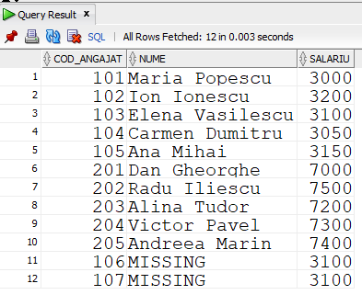

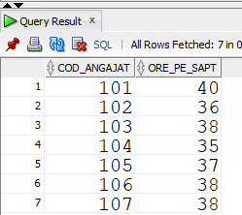

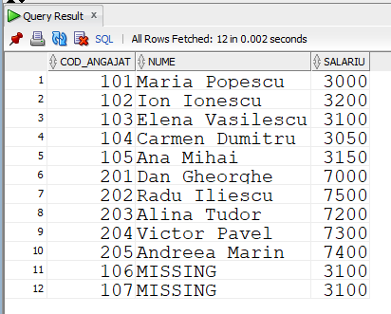

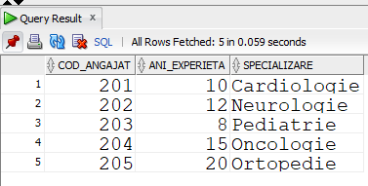

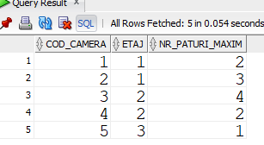

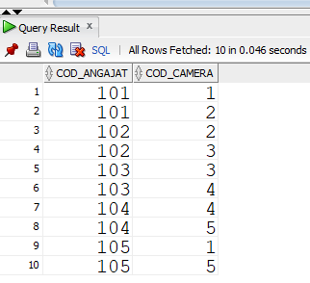

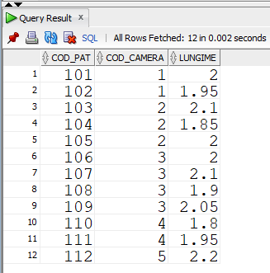

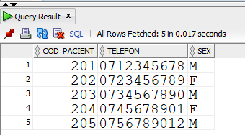

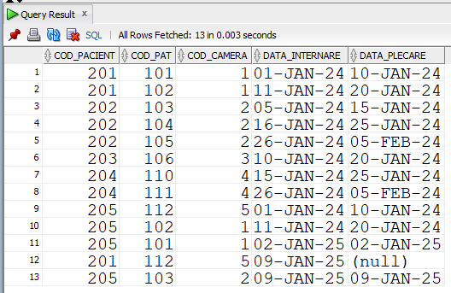

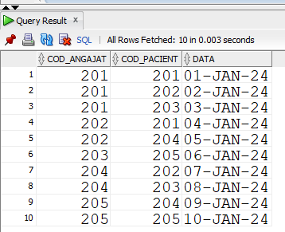

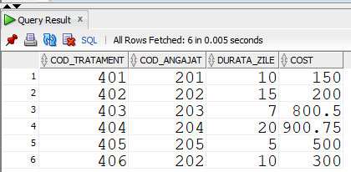

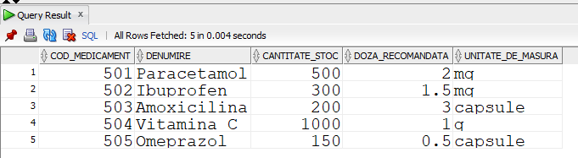

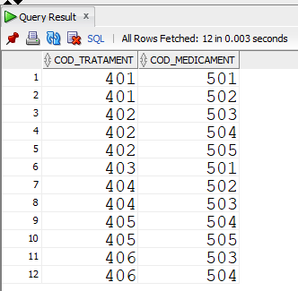

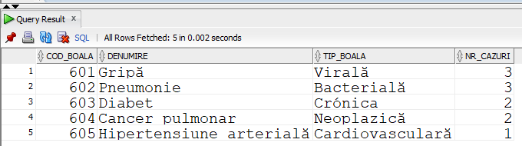

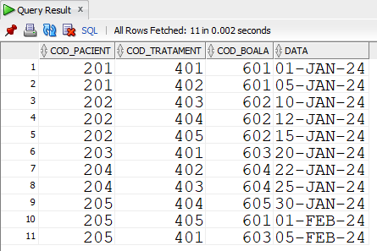

## Cerinta 6:

Sa se creeze un tabel pacient_istoric_boli in care sa se retina toate bolile unui paicent si data

la care a fost diagnosticat cu aceasta (10 cele mai recente pentru fiecare boala). Sa se creeze

o procedura care primeste numele unui pacient si le update-aza istoricul.

|  |
| --- |
| CREATE OR REPLACE TYPE istoric_boala IS OBJECT (d DATE, denumire VARCHAR2(50));  /  CREATE OR REPLACE TYPE istoric_boli IS TABLE OF istoric_boala;  /  CREATE TABLE pacient_istoric_boli AS  SELECT cod_pacient FROM pacient;  ALTER TABLE pacient_istoric_boli  ADD (istoric istoric_boli) NESTED TABLE istoric STORE AS boli_tab; |

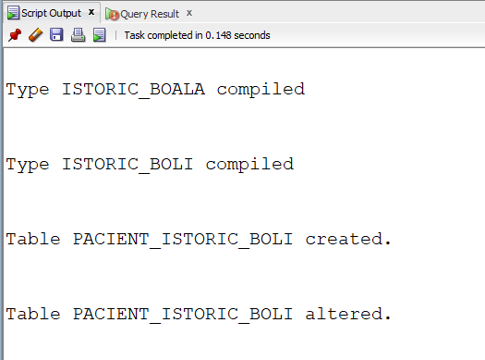

|  |
| --- |
| CREATE OR REPLACE PROCEDURE update_istoric (cod pacient.cod_pacient%TYPE) IS  TYPE tab_imb IS TABLE OF boala.cod_boala%TYPE;  TYPE tab_ind IS TABLE OF boala.denumire%TYPE INDEX BY PLS_INTEGER;  TYPE vec IS VARRAY(10) OF primeste.data%TYPE;  boli tab_imb := tab_imb();  boala_denumire tab_ind;  date_boli vec := vec();  denumire boala.denumire%TYPE;  cheie boala.cod_boala%TYPE;  istoric_nou istoric_boli := istoric_boli();  BEGIN  -- colectez codurile bolilor pacientului  SELECT cod_boala  BULK COLLECT INTO boli  FROM primeste  WHERE cod_pacient = cod;    -- salvez in 'boala_denumire' perechi de forma -> cod_boala : denumire  FOR i IN boli.FIRST..boli.LAST LOOP  SELECT denumire  INTO denumire  FROM boala  WHERE cod_boala = boli(i);    boala_denumire(boli(i)) := denumire;  END LOOP;    -- iterez prin toate cheile tabelului 'boala_denumire'  cheie := boala_denumire.FIRST;    WHILE cheie IS NOT NULL LOOP  -- salvez in vectorul 'date' ultimelele 10 date pentru pacientul si boala respectiva  SELECT *  BULK COLLECT INTO date_boli  FROM (  SELECT data  FROM primeste  WHERE cod_pacient = cod  AND cod_boala = cheie  ORDER BY data DESC  )  WHERE ROWNUM <= 10;  -- adaug intrarile gasite in noul istoric  FOR i IN date_boli.FIRST..date_boli.LAST LOOP  istoric_nou.EXTEND;  istoric_nou(istoric_nou.LAST) := istoric_boala(date_boli(i), boala_denumire(cheie));  END LOOP;  cheie := boala_denumire.NEXT(cheie);  END LOOP;    -- update pe coloana  UPDATE pacient_istoric_boli  SET istoric = istoric_nou  WHERE cod_pacient = cod;    EXCEPTION  WHEN TOO_MANY_ROWS THEN  RAISE_APPLICATION_ERROR(20001, 'Nu exista angajatul cu codul ' || cod);  WHEN OTHERS THEN  RAISE_APPLICATION_ERROR(20000, 'Nu s-a putut updata istoricul pacientului ' || cod);  END;  / |

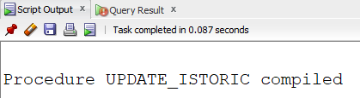

Testez:

|  |
| --- |
| EXECUTE update_istoric(201);  EXECUTE update_istoric(202);  EXECUTE update_istoric(205);  select * from pacient_istoric_boli;  SELECT p.cod_pacient, t.*  FROM pacient_istoric_boli p, TABLE (p.istoric) t; |

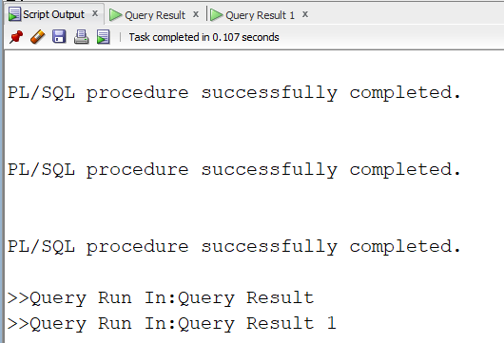

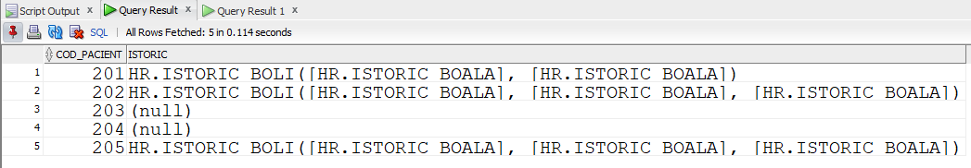

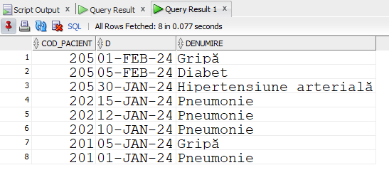

## Cerinta 7:

Sa se creeze o procedura care sa afiseze toate asistentele care lucreaza in cel putin o camera cu mai mult de x paturi si cel putin y ore pe saptamana.

|  |
| --- |
| CREATE OR REPLACE PROCEDURE afisare_asistente(nr_paturi NUMBER, ore_minime asistenta.ore_pe_sapt%TYPE) IS  TYPE tab_imb IS TABLE OF asistenta.cod_angajat%TYPE;  asistente_afisate tab_imb := tab_imb();  ang asistenta.cod_angajat%TYPE;  -- cursor cu parametru care intoarce asistentele care lucreaza intr-o anumita camera si au mai mult de y ore pe sapt  CURSOR c_asistente(cod camera.cod_camera%TYPE) IS  SELECT cod_angajat  FROM asistenta a JOIN lucreaza l USING(cod_angajat)  WHERE a.ore_pe_sapt >= ore_minime  AND l.cod_camera = cod;  BEGIN  -- cicilu cursor cu subcerere care intoarce camerele cu mai mult de x paturi  FOR i IN (SELECT cod_camera  FROM camera c JOIN pat p USING(cod_camera)  GROUP BY cod_camera  HAVING COUNT(*) > nr_paturi)  LOOP  OPEN c_asistente(i.cod_camera);  LOOP  FETCH c_asistente INTO ang;  EXIT WHEN c_asistente%NOTFOUND;  -- verific daca am afisat deja asistenta  IF ang MEMBER OF asistente_afisate THEN  CONTINUE;  END IF;  DBMS_OUTPUT.PUT_LINE('Asistenta: ' || ang || ', lucreaza in camera: ' || i.cod_camera);  -- adaug asistenta in lista pentru a nu mai fi luata in considerare ulterior  asistente_afisate.EXTEND;  asistente_afisate(asistente_afisate.LAST) := ang;  END LOOP;  CLOSE c_asistente;  END LOOP;  END;  / |

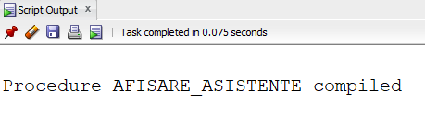

Testez:

|  |
| --- |
| select * from asistenta join angajat using (cod_angajat);  select * from pat;  select * from lucreaza;  EXECUTE afisare_asistente(2, 37); |

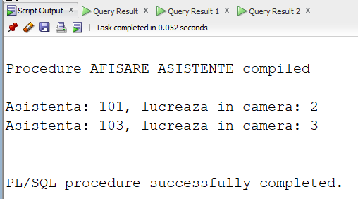

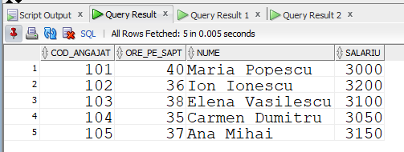

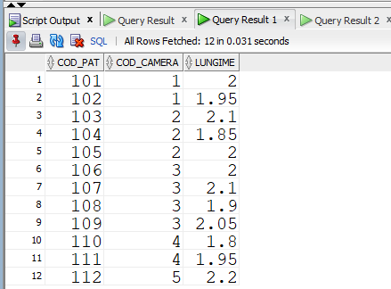

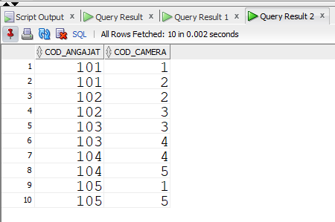

## Cerinta 8:

Sa se creeze o functie care returneaza numele doctorului care a consultat cei mai multi

pacienti de sex masculin incepand cu o data primita ca parametru.

|  |
| --- |
| CREATE OR REPLACE FUNCTION doctor_consultatii_max(data_inceput VARCHAR2) RETURN angajat.nume%TYPE IS  nume angajat.nume%TYPE;  data_validata consulta.data%TYPE;  BEGIN  -- validez mai intai data  BEGIN  data_validata := TO_DATE(data_inceput, 'DD-MON-YY');  EXCEPTION  WHEN OTHERS THEN  RAISE_APPLICATION_ERROR(-20002, 'Data nu este valida');  END;  SELECT a.nume  INTO nume  FROM angajat a JOIN doctor d USING(cod_angajat)  JOIN consulta c USING(cod_angajat)  JOIN pacient p USING(cod_pacient)  WHERE c.data > TO_DATE(data_inceput, 'DD-MON-YY')  AND p.sex = 'M'  GROUP BY cod_angajat, nume  HAVING COUNT(*) = (  SELECT MAX(COUNT(*))  FROM doctor d JOIN consulta c USING(cod_angajat)  JOIN pacient p USING(cod_pacient)  WHERE c.data > TO_DATE(data_inceput, 'DD-MON-YY')  AND p.sex = 'M'  GROUP BY cod_angajat);  RETURN nume;  EXCEPTION  WHEN TOO_MANY_ROWS THEN  RAISE_APPLICATION_ERROR(-20000, 'Sunt mai multi doctori cu numarul maxim de consultatii');  WHEN NO_DATA_FOUND THEN  RAISE_APPLICATION_ERROR(-20001, 'Nu exista consultatii atat de recente');  WHEN OTHERS THEN  IF SQLCODE = -20002 THEN  RAISE_APPLICATION_ERROR(-20002, 'Data nu este valida');  ELSE  RAISE_APPLICATION_ERROR(-20003, 'Nu stiu ce s-a intamplat ' || SQLERRM);  END IF;  END doctor_consultatii_max;  / |

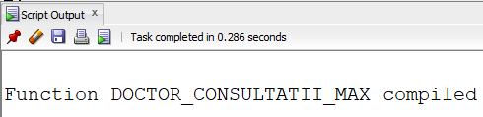

Testez:

|  |
| --- |
| BEGIN  DBMS_OUTPUT.PUT_LINE('Doctorul este '|| doctor_consultatii_max('nu o data'));  END;  / |

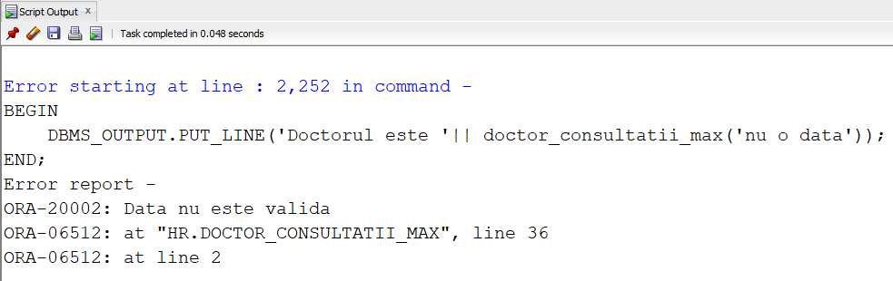

|  |
| --- |
| BEGIN  DBMS_OUTPUT.PUT_LINE('Doctorul este '|| doctor_consultatii_max('01-JAN-24'));  END;  / |

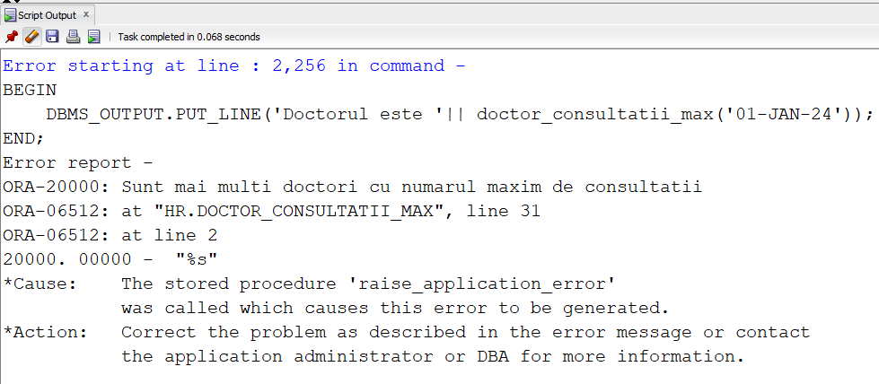

|  |
| --- |
| BEGIN  DBMS_OUTPUT.PUT_LINE('Doctorul este '|| doctor_consultatii_max('01-JAN-25'));  END;  / |

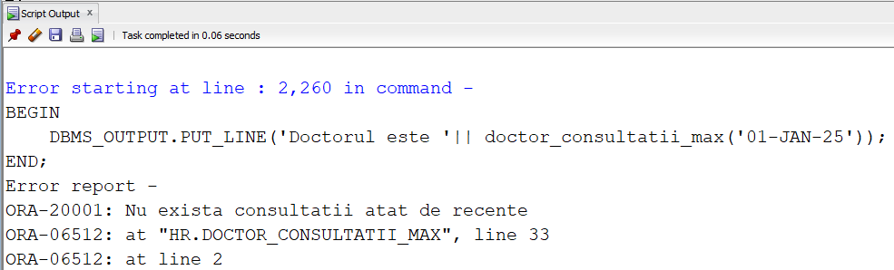

|  |
| --- |
| BEGIN  DBMS_OUTPUT.PUT_LINE('Doctorul este '|| doctor_consultatii_max('09-JAN-24'));  END;  / |

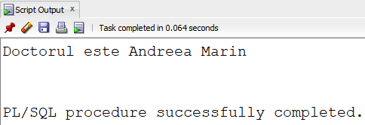

## Cerinta 9:

Sa se creeze o procedura care primeste ca parametri numele unui doctor si un string x (care

reprezinta un numar) si intoarce prin al doilea parametru primele x cele mai folosite

medicamente in tratamentele prescrise de acesta.

|  |
| --- |
| CREATE OR REPLACE PROCEDURE medicamente_folosite(nume_doctor angajat.nume%TYPE, nr_medicamente IN OUT VARCHAR2) IS  v_nr NUMBER;  v_ang angajat.nume%TYPE;  NU_DOCTOR EXCEPTION;  PREA_PUTINE_MEDICAMENTE EXCEPTION;  TYPE refc IS REF CURSOR;  c_medicamente refc;  denumire_med medicament.denumire%TYPE;  rez VARCHAR2(100) := '';  BEGIN  -- verific ca parametrul al doilea e numar  v_nr := TO_NUMBER(nr_medicamente);  -- verific ca primul parametru e numele unui angajat  SELECT nume  INTO v_ang  FROM angajat  WHERE nume = nume_doctor;  -- verific ca primul parametru e numele unui doctor  SELECT COUNT(*)  INTO v_nr  FROM angajat a JOIN doctor d USING(cod_angajat)  WHERE a.nume = nume_doctor;    IF v_nr = 0 THEN  RAISE NU_DOCTOR;  ELSIF v_nr > 1 THEN  RAISE TOO_MANY_ROWS;  END IF;    -- verific ca sunt destule medicamente diferite folosite de acel doctor  SELECT COUNT(COUNT(*))  INTO v_nr  FROM angajat a JOIN doctor d USING(cod_angajat)  JOIN tratament t USING(cod_angajat)  JOIN necesita n USING(cod_tratament)  JOIN medicament m USING(cod_medicament)  WHERE a.nume = nume_doctor  GROUP BY cod_medicament;    IF v_nr < TO_NUMBER(nr_medicamente) THEN  RAISE PREA_PUTINE_MEDICAMENTE;  END IF;    v_nr := TO_NUMBER(nr_medicamente);  v_ang := nume_doctor;  -- cursor dinamic care returneaza denimrea si numarul celor mai folosite x medicamente  OPEN c_medicamente FOR  'SELECT denumire, COUNT(*) "numar"  FROM angajat a JOIN doctor d USING(cod_angajat)  JOIN tratament t USING(cod_angajat)  JOIN necesita n USING(cod_tratament)  JOIN medicament m USING(cod_medicament)  WHERE nume = :v_ang AND  cod_medicament IN (  SELECT cod_medicament  FROM (  SELECT cod_medicament  FROM angajat a JOIN doctor d USING(cod_angajat)  JOIN tratament t USING(cod_angajat)  JOIN necesita n USING(cod_tratament)  JOIN medicament m USING(cod_medicament)  WHERE nume = :v_ang  GROUP BY cod_medicament  ORDER BY COUNT(*) DESC)  WHERE ROWNUM < :v_nr)  GROUP BY denumire  '  USING v_ang, v_ang, v_nr;  LOOP  FETCH c_medicamente INTO denumire_med, v_nr;  EXIT WHEN c_medicamente%NOTFOUND;  rez := rez || ' ' || denumire_med || ':' || TO_CHAR(v_nr);  END LOOP;  DBMS_OUTPUT.PUT_LINE(rez);  nr_medicamente := rez;  CLOSE c_medicamente;  EXCEPTION  WHEN VALUE_ERROR THEN  DBMS_OUTPUT.PUT_LINE('Parametrul nu este un numar valid');  nr_medicamente := '-1';  WHEN NO_DATA_FOUND THEN  DBMS_OUTPUT.PUT_LINE('Numele dat nu este al unui angajat');  nr_medicamente := '-1';  WHEN TOO_MANY_ROWS THEN  DBMS_OUTPUT.PUT_LINE('Mai multi doctori cu acest nume');  nr_medicamente := '-1';  WHEN NU_DOCTOR THEN  DBMS_OUTPUT.PUT_LINE('Numele dat nu este al unui doctor');  nr_medicamente := '-1';  WHEN PREA_PUTINE_MEDICAMENTE THEN  DBMS_OUTPUT.PUT_LINE('Nu sunt destule medicamente diferite folosite de doctor');  nr_medicamente := '-1';  WHEN OTHERS THEN  DBMS_OUTPUT.PUT_LINE('Alta eroare: ' || SQLERRM);  END;  / |

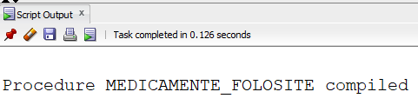

Testez:

|  |
| --- |
| DECLARE  nr_medicamente VARCHAR2(20) := 'nu numar';  BEGIN  medicamente_folosite('Dan Gheorghe', nr_medicamente);  DBMS_OUTPUT.PUT_LINE(nr_medicamente);  END;  / |

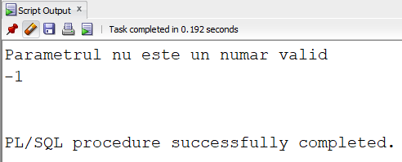

|  |
| --- |
| DECLARE  nr_medicamente VARCHAR2(20) := '3';  BEGIN  medicamente_folosite('Gigel', nr_medicamente);  DBMS_OUTPUT.PUT_LINE(nr_medicamente);  END;  / |

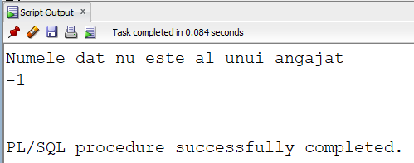

|  |
| --- |
| DECLARE  nr_medicamente VARCHAR2(20) := '3';  BEGIN  medicamente_folosite('Maria Popescu', nr_medicamente);  DBMS_OUTPUT.PUT_LINE(nr_medicamente);  END;  / |

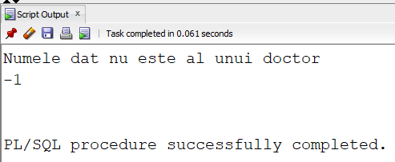

|  |
| --- |
| DECLARE  nr_medicamente VARCHAR2(20) := '11';  BEGIN  medicamente_folosite('Radu Iliescu', nr_medicamente);  DBMS_OUTPUT.PUT_LINE(nr_medicamente);  END;  / |

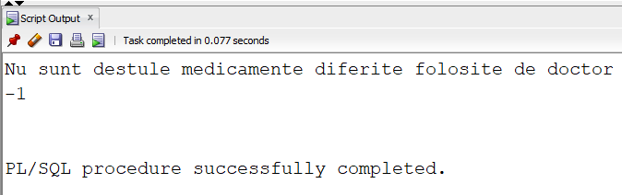

|  |
| --- |
| DECLARE  nr_medicamente VARCHAR2(50) := '3';  BEGIN  medicamente_folosite('Radu Iliescu', nr_medicamente);  DBMS_OUTPUT.PUT_LINE(nr_medicamente);  END;  / |

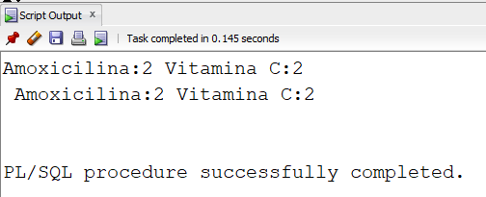

|  |
| --- |
| -- pentru teste am mai inserat:  INSERT INTO tratament VALUES(406, 202, 10, 300);  INSERT INTO necesita VALUES(406, 503);  INSERT INTO necesita VALUES(406, 504); |

## Cerinta 10:

Pentru orice schimbari in tabelul 'primeste', sa se actualizeze in tabelul 'boala' numarul de

cazuri

|  |
| --- |
| CREATE OR REPLACE TRIGGER actualizare_boli  AFTER UPDATE OR DELETE OR INSERT ON primeste  DECLARE  v_nr NUMBER;  BEGIN  FOR i IN (SELECT cod_boala FROM boala) LOOP  SELECT COUNT(*)  INTO v_nr  FROM primeste  WHERE cod_boala = i.cod_boala;    UPDATE boala  SET nr_cazuri = v_nr  WHERE cod_boala = i.cod_boala;  END LOOP;  END;  / |

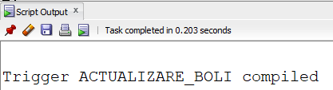

Testez:

|  |
| --- |
| select * from boala; |

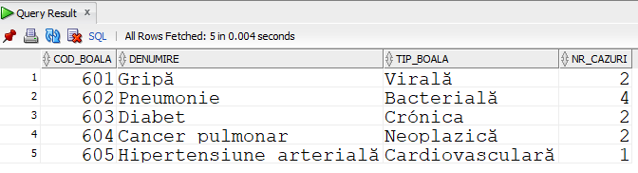

|  |
| --- |
| UPDATE primeste  SET cod_boala = 602  WHERE cod_pacient = 201 AND cod_tratament = 401 AND cod_boala = 601; |

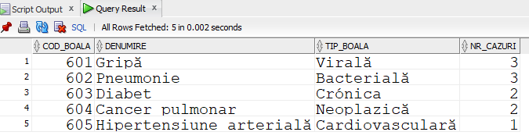

|  |
| --- |
| INSERT INTO primeste(cod_pacient, cod_tratament, cod_boala) VALUES (201, 402, 605); |

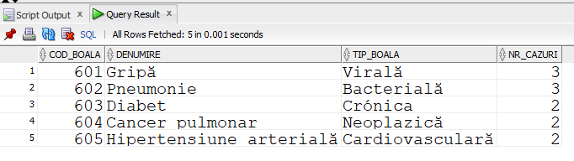

|  |
| --- |
| DELETE FROM primeste WHERE cod_pacient = 201 AND cod_tratament = 402 AND cod_boala = 605; |

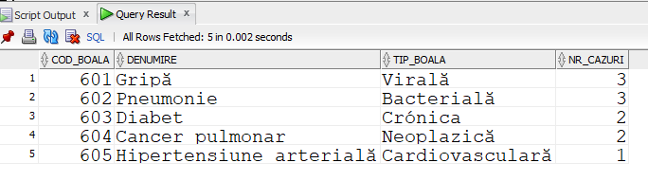

## Cerinta 11:

Sa se creeze un trigger care sa introduca automat o intrare in tabelul 'angajat' atunci cand o

noua asistenta este introudsa in baza de date. Noua asistenta va avea salariul mediu al tuturor

asistentelor.

|  |
| --- |
| CREATE OR REPLACE PACKAGE salariu_mediu AS  salariu_mediu NUMBER;  END;  /  CREATE OR REPLACE TRIGGER calcul_salariu  BEFORE INSERT ON asistenta  BEGIN  SELECT AVG(salariu)  INTO salariu_mediu.salariu_mediu  FROM angajat JOIN asistenta USING(cod_angajat);  END;  /  CREATE OR REPLACE TRIGGER adaug_asistenta  BEFORE INSERT ON asistenta  FOR EACH ROW  DECLARE  v_avg NUMBER;  v_nr NUMBER;  nume_salvat angajat.nume%TYPE := '&p_nume';  BEGIN  -- verific ca nu exista deja angajatul  SELECT COUNT(*)  INTO v_nr  FROM angajat  WHERE cod_angajat = :NEW.cod_angajat;    IF v_nr = 1 THEN  RAISE_APPLICATION_ERROR(-20000, 'Angajatul cu codul ' || :NEW.cod_angajat || ' exista deja');  END IF;  INSERT INTO angajat VALUES (:NEW.cod_angajat, nume_salvat, salariu_mediu.salariu_mediu);  END;  / |

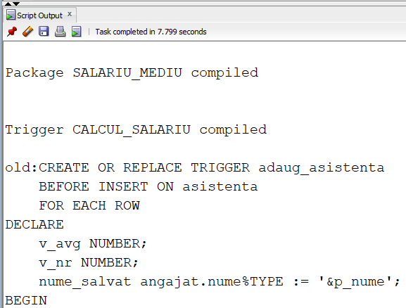

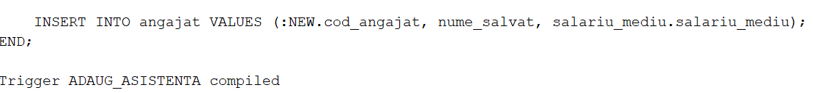

Testez:

|  |
| --- |
| select * from asistenta;  select * from angajat; |

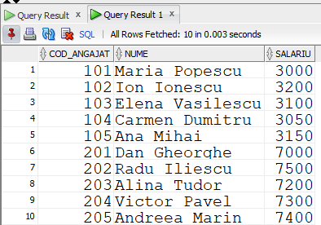

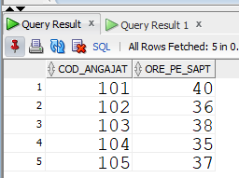

|  |
| --- |
| -- merge daca inserez doar o linie  INSERT INTO asistenta VALUES (105, 38); |

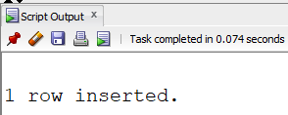

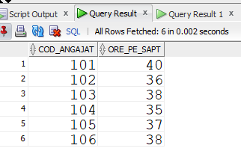

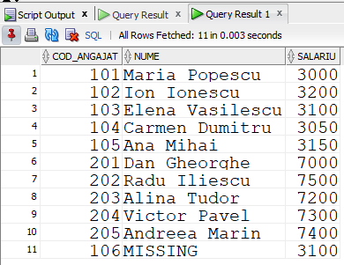

|  |
| --- |
| -- ar fi aparut eroarea mutating table daca folosesc un select (posibil inserez mai multe linii)  INSERT INTO asistenta SELECT 107, 38 FROM DUAL; |

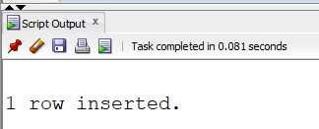

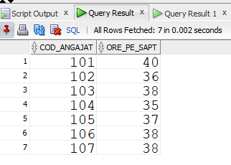

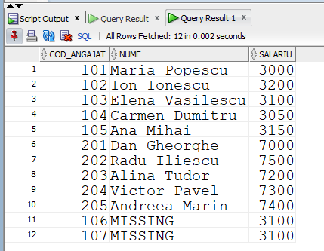

## Cerinta 12:

Sa se creeze backup-uri automate pentru tabelele medicament, boala si pacient in cazul in

care sunt sterse

|  |
| --- |
| CREATE OR REPLACE TRIGGER backup_tabele  BEFORE DROP ON SCHEMA  DECLARE  nume VARCHAR2(100);  BEGIN  IF SYS.DICTIONARY_OBJ_TYPE = 'TABLE'  AND LOWER(SYS.DICTIONARY_OBJ_NAME) IN ('medicament', 'boala', 'pacient', 'test_trig_delete') THEN  DBMS_OUTPUT.PUT_LINE('Se creeaza backup pentru: ' || SYS.DICTIONARY_OBJ_NAME);  nume := SYS.DICTIONARY_OBJ_NAME || '_backup_' || TO_CHAR(SYSDATE, 'YYYYMMDDHH24MISS');  EXECUTE IMMEDIATE 'CREATE TABLE ' || nume || ' AS SELECT * FROM ' || SYS.DICTIONARY_OBJ_NAME;  END IF;  END;  / |

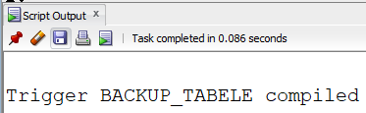

Testez (folosesc tabelul test_trig_delete pentru ca nu vreau sa imi sterg tabelele importante):

|  |
| --- |
| CREATE TABLE test_trig_delete AS SELECT cod_angajat FROM angajat;  DROP TABLE test_trig_delete;  CREATE OR REPLACE PROCEDURE testare_ex12 IS  v_nr NUMBER;  BEGIN  SELECT COUNT(*)  INTO v_nr  FROM USER_TABLES  WHERE TABLE_NAME = 'TEST_TRIG_DELETE';  IF v_nr = 0 THEN  EXECUTE IMMEDIATE 'CREATE TABLE test_trig_delete AS SELECT cod_angajat FROM angajat';  END IF;  EXECUTE IMMEDIATE 'DROP TABLE test_trig_delete';  END;  / |

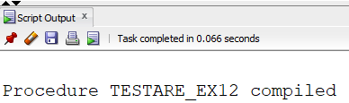

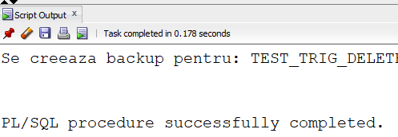

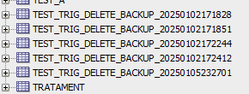

(L-am rulat de mai multe ori)

|  |
| --- |
| DROP TABLE boala CASCADE CONSTRAINTS; |

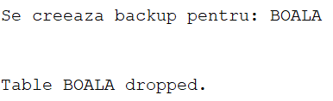

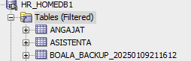

## Cerinta 13:

Sa se creeze un pachet cu 3 proceduri: actualizare a valabilitatii tuturor paturilor

(stocata ca tabel imbricat in pachet), afisare paturi disponibile, eliberare pat.

In plus, 2 functii: verificare daca o camera este plina (returneaza boolean), alocare pat pentru

un pacient nou internat, intr-o anumita camera (returneaza numarul patului in care va fi

internat)

|  |
| --- |
| CREATE OR REPLACE PACKAGE alocare_paturi AS  TYPE rec_pat IS RECORD (  cod_pat pat.cod_pat%TYPE,  valabil NUMBER(1)  );  TYPE tab_paturi IS TABLE OF rec_pat;  paturi tab_paturi := tab_paturi();    PROCEDURE ACTUALIZARE_PATURI_VALABILE;  FUNCTION CAMERA_PLINA(cod camera.cod_camera%TYPE) RETURN BOOLEAN;  PROCEDURE AFISARE_PATURI_VALABILE;  FUNCTION ALOCARE_PAT(  p_cod_pacient NUMBER,  p_cod_camera NUMBER,  p_data_internare DATE  ) RETURN pat.cod_pat%TYPE;  PROCEDURE ELIBERARE_PAT(  p_cod_pat NUMBER  );  END alocare_paturi;  / |

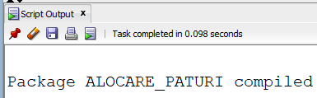

|  |
| --- |
| CREATE OR REPLACE PACKAGE BODY alocare_paturi AS  PROCEDURE ACTUALIZARE_PATURI_VALABILE IS  BEGIN  -- initial setez pentru fiecare pat ca e gol (valoare '0')  SELECT cod_pat, 0  BULK COLLECT INTO paturi  FROM pat;  -- trec prin fiecare pat si verific daca e cineva internat in el  FOR i IN paturi.FIRST..paturi.LAST LOOP  SELECT CASE  WHEN NOT EXISTS (SELECT 1  FROM ocupa  WHERE cod_pat = paturi(i).cod_pat  AND data_plecare IS NULL)  THEN 1  ELSE 0  END  INTO paturi(i).valabil  FROM dual;  END LOOP;  END ACTUALIZARE_PATURI_VALABILE;    PROCEDURE AFISARE_PATURI_VALABILE IS  BEGIN  FOR i IN paturi.FIRST..paturi.LAST LOOP  DBMS_OUTPUT.PUT_LINE(paturi(i).cod_pat || ':' || TO_CHAR(paturi(i).valabil));  END LOOP;  END AFISARE_PATURI_VALABILE;    FUNCTION CAMERA_PLINA(cod camera.cod_camera%TYPE) RETURN BOOLEAN IS  paturi_totale NUMBER;  paturi_ocupate NUMBER;  BEGIN  -- numar paturi totale din camera  SELECT COUNT(*) INTO paturi_totale FROM pat WHERE cod_camera = cod;  -- numar paturi ocupate din camera  SELECT COUNT(*) INTO paturi_ocupate  FROM ocupa  WHERE cod_camera = cod AND data_plecare IS NULL;  RETURN paturi_totale = paturi_ocupate;  END CAMERA_PLINA;      FUNCTION ALOCARE_PAT(p_cod_pacient IN NUMBER, p_cod_camera IN NUMBER, p_data_internare IN DATE) RETURN pat.cod_pat%TYPE IS  v_pat pat.cod_pat%TYPE := 1;  internat NUMBER;  BEGIN  ACTUALIZARE_PATURI_VALABILE;  -- verific daca pacientul nu e deja internat  SELECT COUNT(*)  INTO internat  FROM ocupa  WHERE cod_pacient = p_cod_pacient AND data_plecare IS NULL;    IF internat > 0 THEN  RAISE_APPLICATION_ERROR(-20001, 'Pacientul este deja internat');  END IF;  -- verifica ca camera in care vrea sa fie internat nu e plina  IF CAMERA_PLINA(p_cod_camera) THEN  RAISE_APPLICATION_ERROR(-20000, 'Camera e plina, pacientul nu poate fi internat');  END IF;  -- gasesc primul pat neocupat din acea camera  SELECT cod_pat  INTO v_pat  FROM TABLE (paturi)  WHERE ROWNUM <= 1 AND valabil = 1 AND cod_pat IN (  SELECT cod_pat  FROM camera c JOIN pat p USING(cod_camera)  WHERE cod_camera = p_cod_camera  );    DBMS_OUTPUT.PUT_LINE(v_pat);    INSERT INTO ocupa (cod_pacient, cod_camera, cod_pat, data_internare, data_plecare)  VALUES (p_cod_pacient, p_cod_camera, v_pat, p_data_internare, NULL);    ACTUALIZARE_PATURI_VALABILE;  RETURN v_pat;  END ALOCARE_PAT;      PROCEDURE ELIBERARE_PAT(p_cod_pat NUMBER) IS  v_nr NUMBER(1);  BEGIN  ACTUALIZARE_PATURI_VALABILE;  -- verific daca patul e ocupat  SELECT valabil  INTO v_nr  FROM TABLE (paturi)  WHERE cod_pat = p_cod_pat;    IF v_nr = 1 THEN  RAISE_APPLICATION_ERROR(-20001, 'Patul nu este ocupat');  END IF;    UPDATE ocupa  SET data_plecare = SYSDATE  WHERE cod_pat = p_cod_pat AND data_plecare IS NULL;    ACTUALIZARE_PATURI_VALABILE;    END ELIBERARE_PAT;  END alocare_paturi;  / |

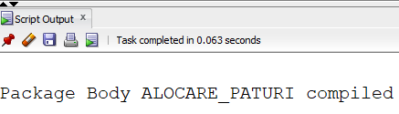

Testez:

|  |
| --- |
| -- ocup camera 5 (are un singur pat)  INSERT INTO ocupa VALUES (201, 112, 5, SYSDATE, NULL);  EXECUTE alocare_paturi.ACTUALIZARE_PATURI_VALABILE;  EXECUTE alocare_paturi.AFISARE_PATURI_VALABILE; |

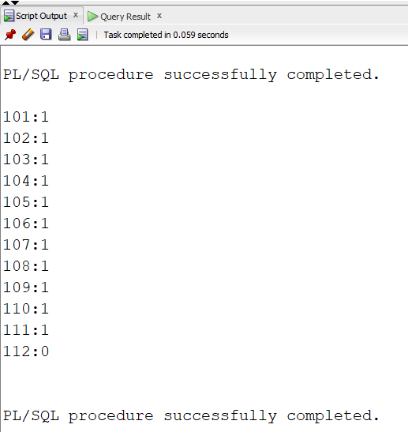

|  |
| --- |
| DECLARE  x BOOLEAN;  BEGIN  x := alocare_paturi.CAMERA_PLINA(1);  IF x THEN  DBMS_OUTPUT.PUT_LINE('Camera plina');  ELSE  DBMS_OUTPUT.PUT_LINE('Camera nu e plina');  END IF;  END;  / |

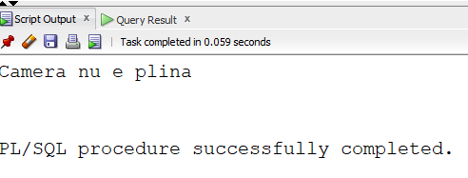

|  |
| --- |
| DECLARE  x BOOLEAN;  BEGIN  x := alocare_paturi.CAMERA_PLINA(5);  IF x THEN  DBMS_OUTPUT.PUT_LINE('Camera plina');  ELSE  DBMS_OUTPUT.PUT_LINE('Camera nu e plina');  END IF;  END;  / |

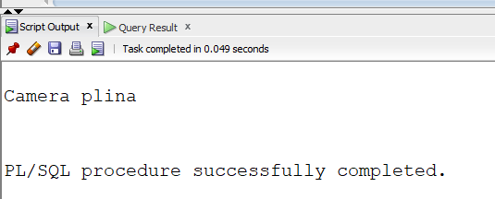

|  |
| --- |
| BEGIN  DBMS_OUTPUT.PUT_LINE('Camera gasita: ' || TO_CHAR(alocare_paturi.ALOCARE_PAT(205, 2, SYSDATE)));  END;  / |

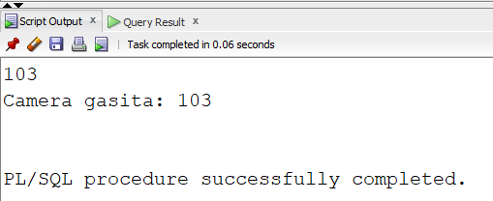

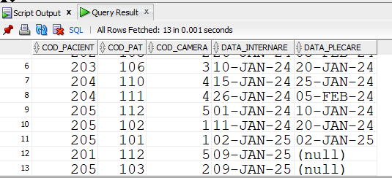

Dam acelasi input (acum pacientul e deja internat):

|  |
| --- |
| BEGIN  DBMS_OUTPUT.PUT_LINE('Camera gasita: ' || TO_CHAR(alocare_paturi.ALOCARE_PAT(205, 2, SYSDATE)));  END;  / |

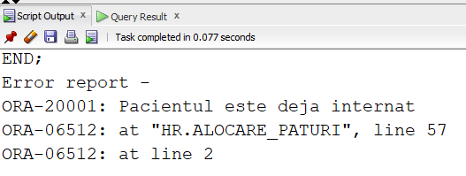

|  |
| --- |
| EXECUTE alocare_paturi.AFISARE_PATURI_VALABILE; |

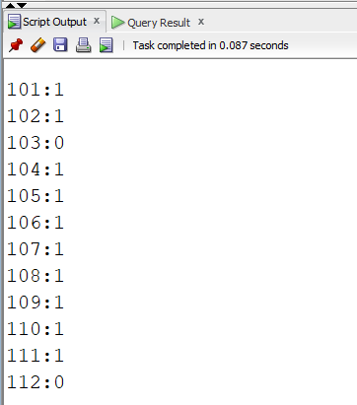

|  |
| --- |
| EXECUTE alocare_paturi.ELIBERARE_PAT(103); |

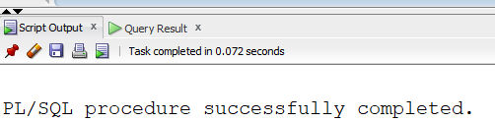

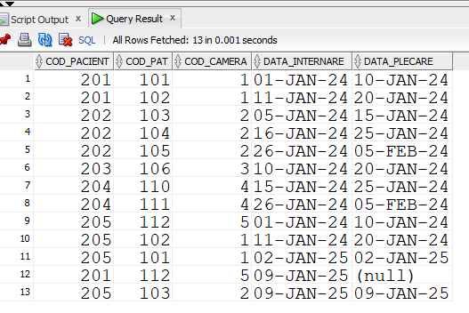

Acelasi input (patul e acum liber):

|  |
| --- |
| EXECUTE alocare_paturi.ELIBERARE_PAT(103); |

